# Quick example about signing in Github and creating first repository.

Contents

Quick example about signing in Github and creating first repository. 1

Purpose of document 2

Setting up git hub at https://github.com/. 3

Create an account 4

GitHub welcomes into system. 5

Fill in some information 6

Account created successefully 7

Verification 8

Sign into system. 10

Create repository 11

Initialize repository 12

Give access to collaborators 14

Collaborator accept 15

## Purpose of document

This document describes very straight forward the steps needed when creating an account into Github, creating repository and giving collaborators access to that. Note that there are other settings in system also, that may need to be set sooner or later.

## Setting up git hub at <https://github.com/>.

Give account information and “Sign up for GtHub” on main page.

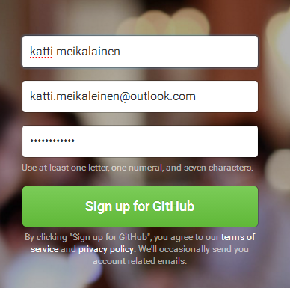

## Create an account

Check login information again and press ”Create an account” button.

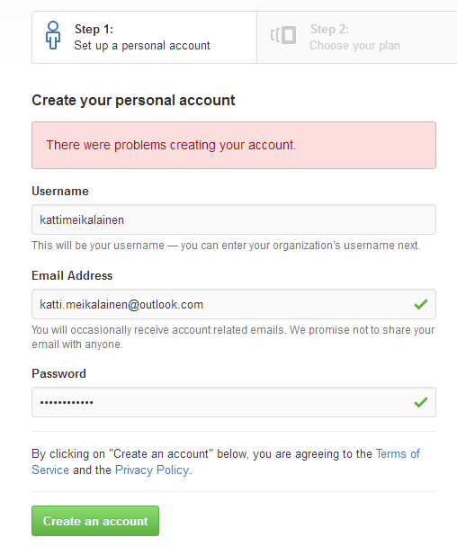

## GitHub welcomes into system.

Check the settings and push “Continue”.

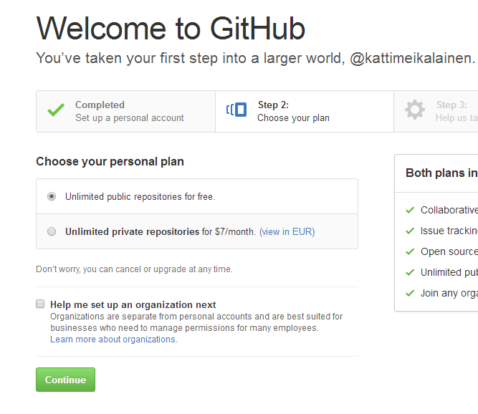

## Fill in some information

Make some selections if you wish and “Submit”.

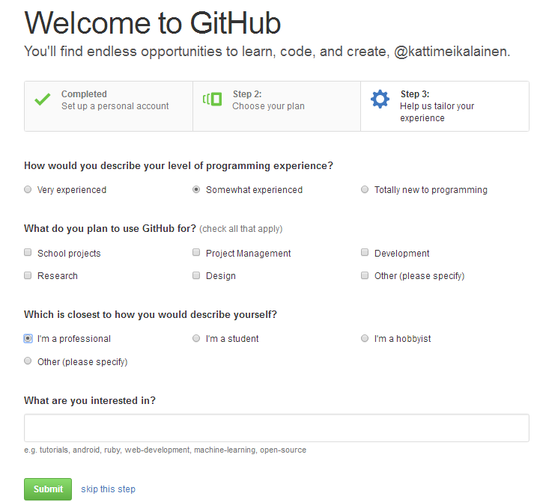

## Account created successefully

Push “New repository” to start.

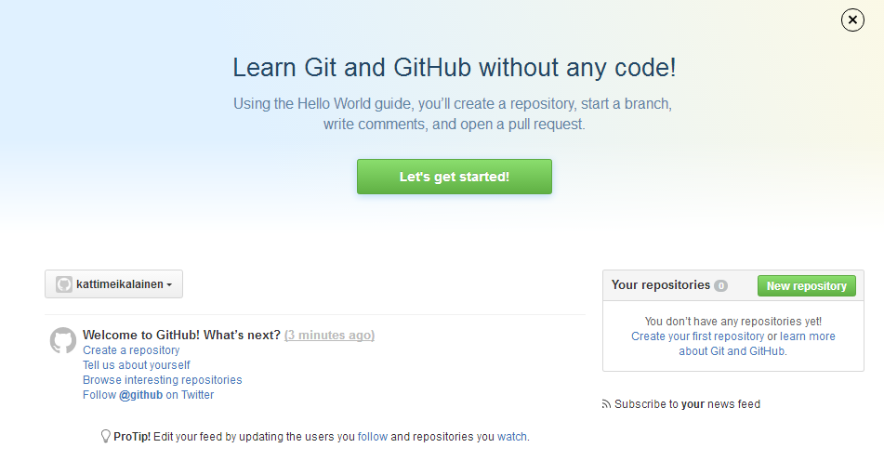

## Verification

System wants to check that everything was fine and asks you for verification. Start the e-mail you gave for the account.

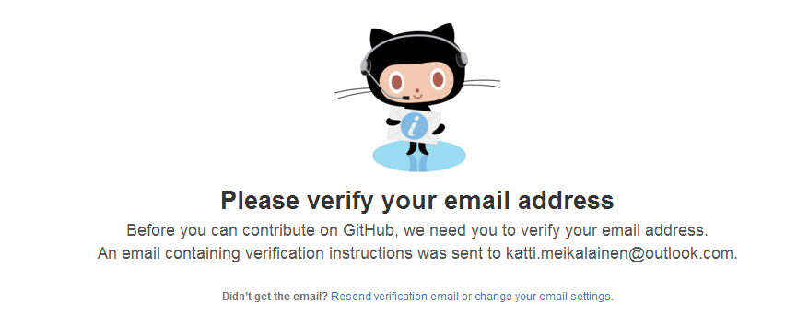

You should have received an e-mail from GitHub.

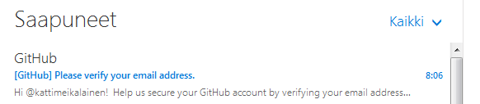

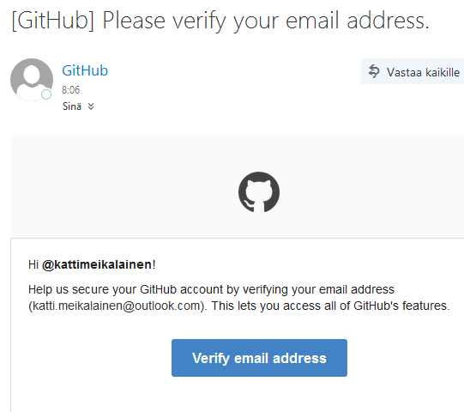

## Sign into system.

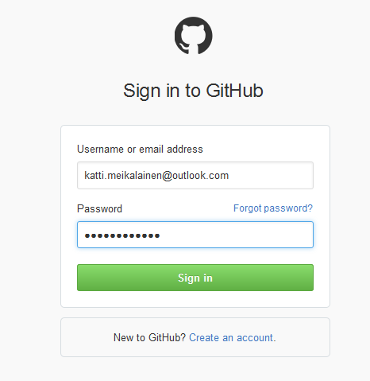

## Create repository

Browser takes you back to repository creator. Fill in new repository name and push “Create repository”.

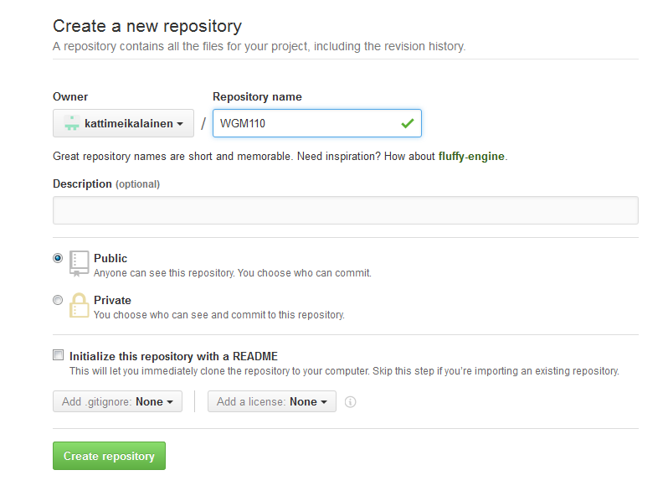

## Initialize repository

Now repository is ready. Let’s make some settings. Select “Settings” in menu.

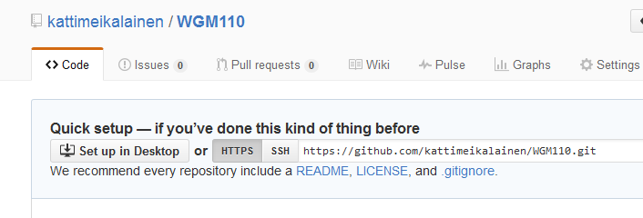

Select “Collaborators” in menu.

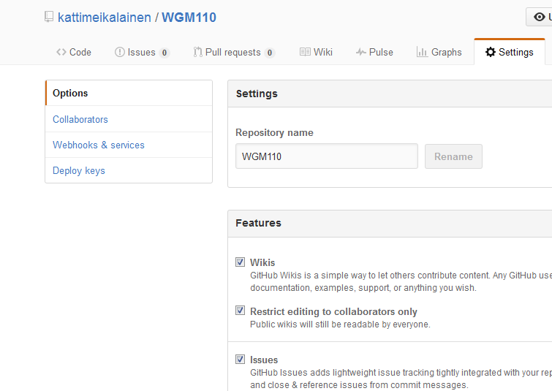

## Give access to collaborators

Select usernames you want to give access to your project and press “Add collaborator” button.

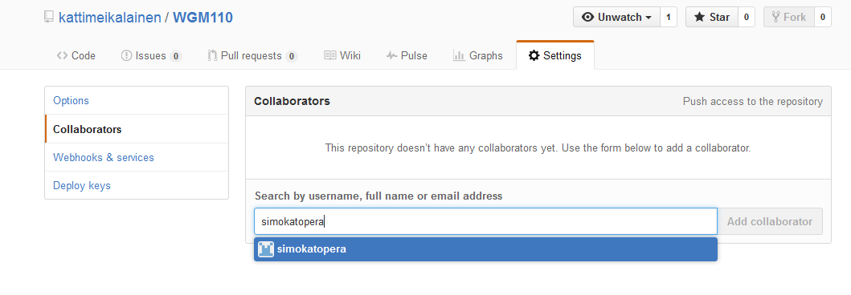

All collaborators do now have access to project, once they first have accepted the request.

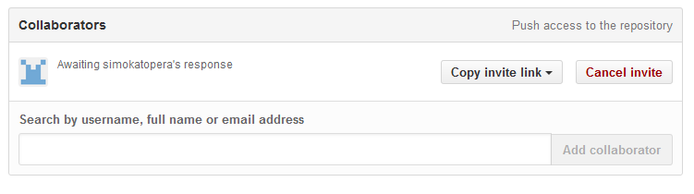

## Collaborator accept

