StarBase

The Science Fiction Mapping Application

By Simon Dominic Hibbs

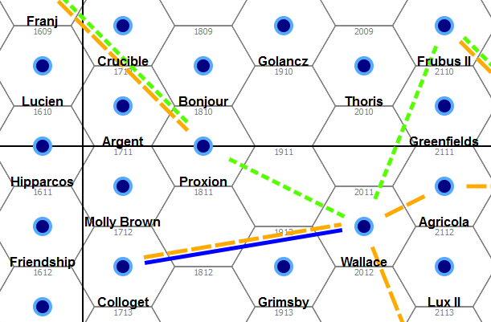

Contents

Table of Contents

StarBase 1
Contents 2
Getting Started 5
Creating your First Project 5
Saving Progress 7
The Map Window Toolbar 8
Map Navigation 9
Renaming Subsectors and Sectors 9
Working with Subsectors 10
Working with Sectors 11
Working with Hexes and Worlds 11
Editing World Details 14
World Reports 15
Subsector Map Export 16
Sector Map Export 17
Statistics Report 17
Saving Your Work 18
Advanced Tools 19
The Allegiance Editor 19
The Hex Group Toolbar 20
Network Links 21
The World Group Editor 22
Custom Rules Files 24
Creating or Modifying a Rules File 24
Creating a Project with Custom Rules 25
Rules File Structure 26
World Name Generation 28
Running StarBase From Source 28

StarBase is Copyright 2013 Simon Dominic Hibbs

This program is free software; you can redistribute it and/or modify it under the terms of the GNU General Public License as published by the Free Software Foundation; either version 2 of the License, or (at your option) any later version.

This program is distributed in the hope that it will be useful, but WITHOUT ANY WARRANTY; without even the implied warranty of MERCHANTABILITY or FITNESS FOR A PARTICULAR PURPOSE. See the GNU General Public License for more details.

You should have received a copy of the GNU General Public License along with this program; if not, write to the Free Software Foundation, Inc., 51 Franklin Street, Fifth Floor, Boston, MA 02110-1301, USA.

All files distributes with this application are covered by the GPL V2 license, unless explicitly stated in the file. A copy of the licesne is provided in the file GPL-2.txt distributed with it.
Introduction

StarBase is an open source mapping application for science fiction roleplaying games. It has a fully-featured modern interface and allows you to create, analyse and modify your campaign map and world data and descriptions with ease. You can select a few sectors or subsectors and populate them with worlds in just a few clicks, then drill down to inspect individual worlds, or define your own custom regions of space to work with. StarBase makes creating your own unique science fiction campaign setting easier and more fun than ever before.

Here are a few of its most useful features.

- Use a mouse wheel to zoom in and out, or select a specific zoom level from the toolbar.
- Switch to the ‘grab’ tool to navigate across the map using the familiar click-and-drag gesture.
- Dynamically adjusts the detail level to match the zoom level
- Select hexes, subsectors or whole sectors and automatically populate them with named worlds.
- Clear whole regions of worlds, or add worlds exactly where you want them.
- Inspect and modify the features of a single world in detail, including customisable descriptive text, or re-generate a world instantly.
- Define your own colour-coded world allegiances appropriate to your setting and display them on the map.
- Select a group of worlds, subsectors or whole sectors and change the allegiance of all the worlds in that region at the same time.
- Create custom, named regions of hexes to work with conveniently.
- Create a one-page report of the details for a single world including a graphic of its map hex, attributes and description. Save the report as a PDF, or cut-and-paste it into a world processor.
- Save sector and subsector maps as PNG files.
- Generate detailed statistical report for any region, sector or subsector.
- Write or customise your own rules file, including custom world attributes and generation in the Python scripting language. Sample rules files are provided.

Getting Started

Creating your First Project

Navigate into the StarBase directory and run Starbase.exe

Alternatively you can create a shortcut and run it from elsewhere if you like. On start-up you will see the Project Manager window.

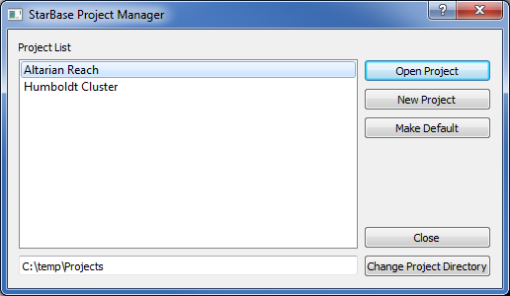

Select “Change Project Directory” and navigate to and select a directory to contain your StarBase projects.

Select the ‘New Project’ button.

The New Project dialogue lets you configure your new project to your liking. It provides options to set the project name, it’s dimensions in dectors (up to 3x3) and you can also select the rules set you wish to use.

Enter the name for the project. When the project is created, a directory with the same name will be created in the projects directory, to contain all the project files.. If you copy a downloaded project into your projects directory, it will appear in the list in the Project Manager the next time you start StarBase.

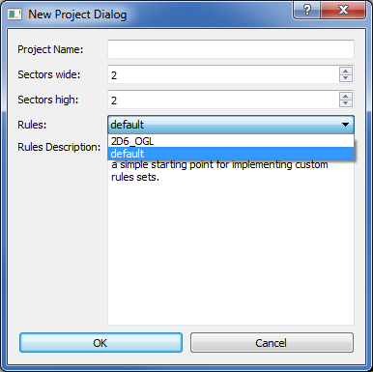

The new project should appear in the Project List. Select it and click ‘Open Project’. You will now see the main application window.

You can make a project the default using the ‘Make Default’ button, so that it will be already selected next time the Project Manager starts.

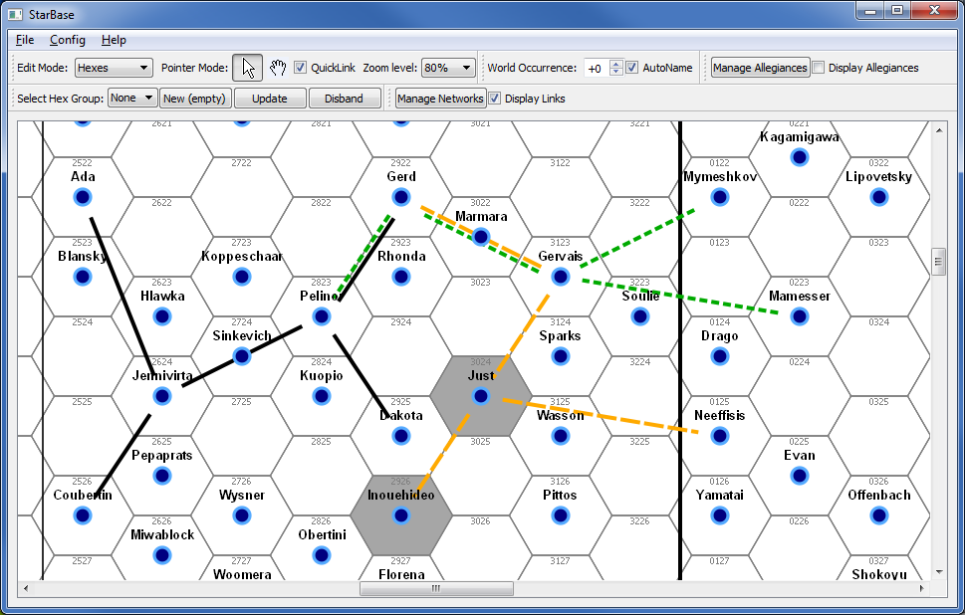

Saving Progress

To save the project state, including the current map view position and zoom level, open the File menu and select Save. You are also given the option to save on exiting the application.

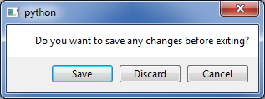

The Map Window Toolbar

The Map Window is the main window of the StarBase application. It shows a scrollable, zoomable view of the campaign map. Above that is a toolbar of handy controls, and above that are the main application menus.

Tool | Description
Select  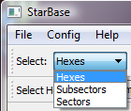 | You can select Hexes, Subsectors or Sectors and then perform actions on your selections. Shift-Click to select more than one at a time.  Most actions are performed using right-click context menus in the map view.  E.g. To rename a Sector choose Sectors in the drop-down Select menu, click on the sector in the map window, right-click and choose ‘Rename Sector’ in the drop-down menu.  Choosing a different selection mode clears the current selection.
Pointer Mode  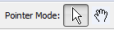 | 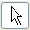 | The pointer tool, used to select Hexes, Subsectors or Sectors.
 |  | The Map Drag tool. In this mode you can click on the map and drag it around to move the view to a new area.
QuickLink | Whenever a selection change results in two worlds being selected, the Link Editor for connections between them automatically opens. This can be convenient when making a series of changes to links between several worlds.
Zoom Level | Allows direct selection of a zoom level for the map view. Note that when zoomed out some details are omitted to improve map redraw speed.
World Occurrence  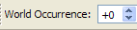 | The Die Modifier when rolling to see if a given Hex contains a world.
Display Allegiance | Checkbox to display coloured hexes indicating world allegiance to various factions.

Map Navigation

There are two ways to change the zoom level of the map view.

- Select a zoom level from the toolbar.
- Turn the scroll wheel on the mouse, while pointing at the map window.

Using the mouse wheel is by far the most convenient method. Doing so also re-centres the map on the position of the mouse pointer.

Panning the map to view a different area is also possible in three ways.

- Zoom out, then zoom back in while pointing at the area of interest.
- Use the scroll-hand tool to drag across the map.

- Adjust the scroll bars along the bottom or right-hand sides of the map view.

Renaming Subsectors and Sectors

Let’s start customising our map. By default, subsectors and sectors are simply named after their ‘grid’ position. Let’s assign meaningful names to some of them.

- Scroll out a little so you can see the subsector names (say, Zoom level 35%).
- Switch the ‘Select’ tool in the toolbar so that you are working with Subsectors.
- Make sure the pointer tool is active.
- Now select a subsector by clicking anywhere inside it. The subsector will go grey.
- Now right-click to view the context menu.

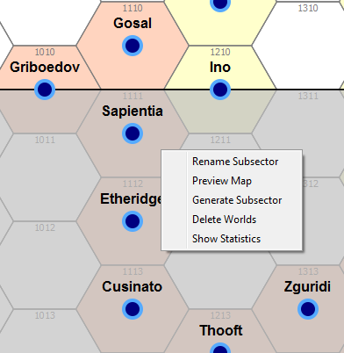

- Select ‘Rename Subsector’ and type in a new name.

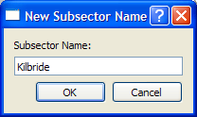

Click OK and the subsector name in the map window will be updated.

Try renaming some of the other subsectors. Also change the Select tool to ‘Sectors’, zoom out a bit and rename some of the Sectors as well.

Working with Subsectors

Select the 37% Zoom Level in the toolbar and make sure you are in Subsector Selection mode .

Click on a subsector to highlight it and right-click to reveal the context menu.

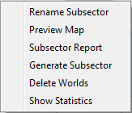

To select several subsectors at the same time, hold down the Ctrl key and click on the subsectors you want to select.

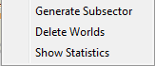

Note that you get fewer options with multiple selections, as Rename and Preview Map are only available for one subsector at a time.

Rename Subsector | Opens a dialog to enter a new name for the Subsector
Preview Map | Opens a dialog to view the subsector map, and save it as a PNG image file.
Subsector Report | Opens a dialog with a report showing the UWPs of all worlds in the subsector. This can be saved to PDF.
Generate Subsector | Populates the subsector with worlds. Choosing it again removes the existing worlds and generates new ones.
Delete Worlds | Deletes all the worlds in the subsector
Show Statistics | Calculate statistics for the worlds in the region

Working with Sectors

The options for working with sectors are basically the same as for a subsector, with the exception that you currently can't generate a UWP report.

Working with Hexes and Worlds

Right-clicking on the map area presents a context menu of options. The list of options depends on what you currently have selected, which could a single hex, a group of hexes, a subsector or a sector. Additionally for a group of hexes some, none or all of them might contain worlds and each situation will present different options relevant to that situation.

Generate worlds for a region (a sector or subsector say), then zoom into that region to the 80% or 100% zoom level. Make sure you have ‘Hexes’ and ‘Pointer mode selected.

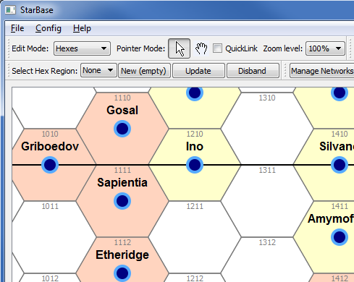

Click on a single hex that does not contain a world and right-click.

Select ‘Add World’ to populate the hex with a randomly generated world. Note that there is no roll to see if the hex is populated when you create a world this way.

Now hold down the Ctrl key and click on several empty hexes to select them all. Now right-click. There are four options:

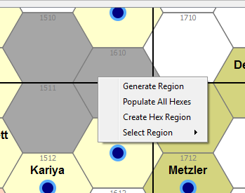

Generate Region – The application rolls for each hex to decide whether to populate it.

Populate All Hexes – Every selected hex will be populated.

Create Hex Region – You can create a named region of hexes based on your selection.

Select Region – You can instead choose an existing named region and change the current selection.

Select “Populate All Hexes” and without changing the selection, right-click again now that some of the hexes contain worlds. These are the options available.

Delete Selected Worlds | Deletes all the worlds in the region
Re-Generate Selected Worlds | Re-rolls the stats for the worlds in the selected region. Hexes will remain either populated or not as before, but the worlds will have new details.  Useful if you like the locations of the worlds, but want to re-generate them.
Populate All Hexes | Every hex will be populated with a random world.
Re-Generate Selected Worlds | Only the worlds in the region will be re-generated, empty hexes will stay empty.
Re-Generate Region | Deletes all the worlds in the region, then re-rolls for each hex to determine if it will contain a new random world.
Statistics | Calculate statistics for the worlds in the region
Create Hex Region | Create a named region of hexes based on your selection
Select Region | Change the current selection to an existing named region

Select a single hex containing a world and right-click. The options are as follows.

Edit World | Opens a dialog box with all the details of the world, which you can edit or adjust as you see fit.
View Report | Opens a dialog showing a report of the world’s details, which can be saved to PDF or printed.
Remove World | Removes the world and empties the hex.

Editing World Details

Select a single hex containing a world, right-click and select ‘Edit World’.

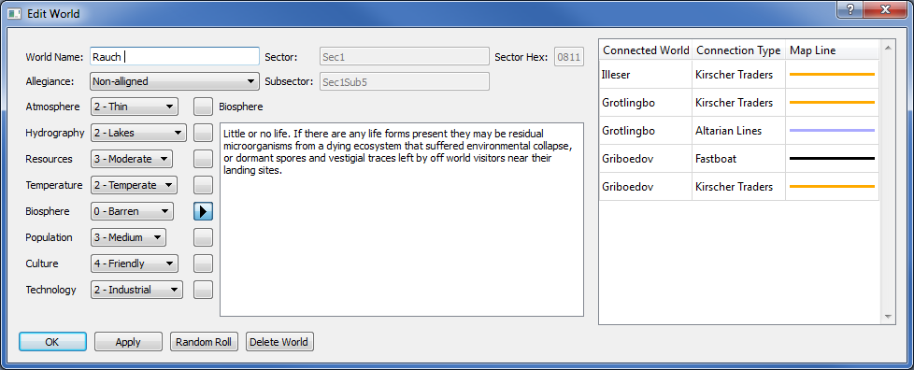

You will see a dialog box showing all the details of the selected world. Move the dialog box to one side so that you can see it, and the world in the map view at the same time. Select the World Name, change it and click Apply. Note that the map display is immediately updated with the new information.

The following details are not editable in the Edit World dialog

Sector Hex
Sector
Subsector

The world’s attributes are listed down the left hand side of the dialog. And descriptive text for the currently selected attribute is displayed to the right of the attribute list. You can view the descriptive text for a different attribute using the pointer button next to the attribute.

Different values can be assigned to attributes using the drop-down combo boxes. Note that when you do this the descriptive text for that attribute changes to the default text for that option.

The text descriptions for each attribute can also be customised for that particular world. Just click in the text box and start typing and editing. Click ‘Apply’ to save your edits. Note that if you later change the attribute value, the description will be reset to the default for the new attribute value. You can also reset the text to the default by deleting all the text and clicking ‘Apply’.

On the right hand side of the dialog there is a table of all the links between this world and any others.

These are the buttons in the Edit World dialog:

OK | Confirms all changes and closes the dialog.
Apply | Applies all changes, but keep the dialog open
View Report | Opens a World Report, which can be printed or saved to PDF.
Random Roll | Re-generates all the world’s details using the Traveller rules.
Delete World | Removes the world from the map and closes the dialog.

World Reports

There are two ways to access a world report.

- Click on the world’s hex, right click and select ‘View Report’ from the context menu.
- As above, but select ‘Edit World’ from the context menu, then click on the ‘View Report’ button in the Edit World dialog.

This report is a text description of a specific world, showing all the world details. It also displays a small graphic image of the world hex.

The contents of the report can be selected and then cut-and-pasted into another application, such as Microsoft Word. The reports can also be saved to a PDF file, or printed directly.

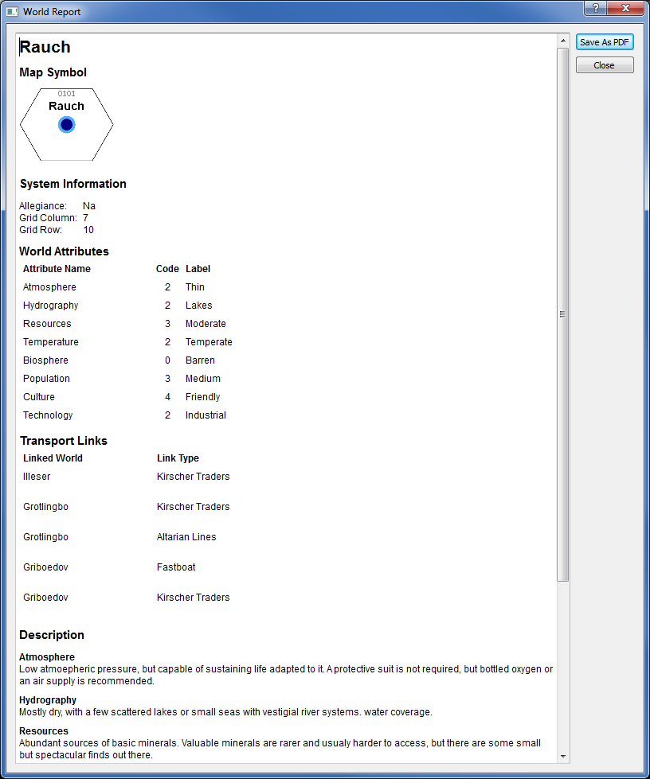

Subsector Map Export

Select a single subsector, and select ‘Preview map’ from the context menu.

Display a graphical image of the subsector map, with the name of the subsector at the bottom and the names of neighbouring subsectors along the sides. These names can be disabled by unselecting the ‘Decorate’ checkbox, for an un-cluttered view of the subsector map.

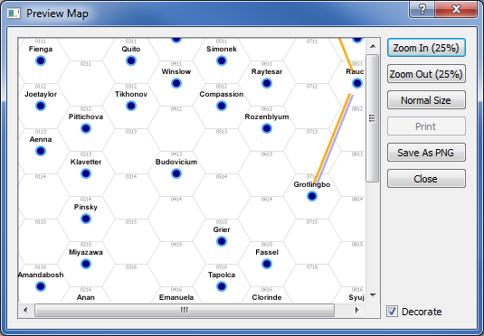

The map can be printed directly, or saved as a PNG image file.

Sector Map Export

Select a single sector, and select ‘Preview map’ from the context menu.

Display a graphical image of the sector map, with the name of the sector at the bottom and the names of neighbouring sectors along the sides. These names can be disabled by unselecting the ‘Decorate’ checkbox, for an un-cluttered view of the sector map.

The map can be printed directly, or saved as a PNG image file.

Statistics Report
A statistics report for an area of hexes, subsectors or sectors can be accessed from the context menu. This creates a document showing calculated statistics for that region. This includes the total population of the region, the number of worlds with each world attribute value.

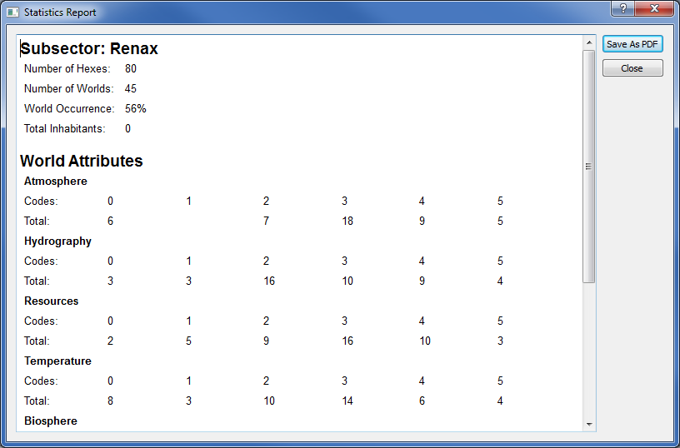

Saving Your Work
Use the menu option File->Save to write all your changes so far to disk.

If you close the application using the File->Exit menu option, you are presented with a dialog giving the option to save before closing the program.

Advanced Tools

The Allegiance Editor

The Allegiance Editor can be accessed from the toolbar or from the Config menu.

An allegiance is an interstellar political union or nation that worlds can belong to. The dialog provides options for managing the allegiances of your worlds.

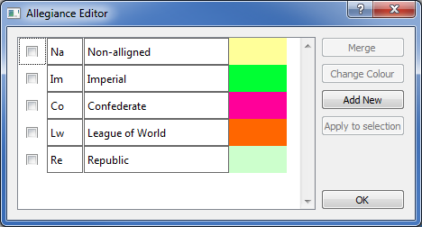

By default a few generic allegiances are provided, but you can easily replace them with factions from your own setting.

Allegiance names and two-letter abbreviations can be edited at any time simply by clicking in the appropriate text box and making the change you want. It will be applied when you hit the ENTER key, or click away from the text box.

The option buttons available depend on how many allegiances you have selected using the check boxes on the left hand column.

Add New | Available at any time. Creates a new allegiance with a blank name and abbreviation, and a default colour.
Change Colour | Only available when a single allegiance is checked. Opens a colour-picker to change the allegiance display colour in the map.
Merge | Only available when one or more allegiances is selected using the check boxes.  Opens a new dialog listing just the checked allegiances. Pick one of the checked allegiances. The other selected allegiances will be merged into it. This is how allegiances are deleted, as worlds must always have an allegiance.
Apply To Selection | Available only when a single allegiance is checked.  This option applies the checked allegiance to all the worlds in the currently selected region of the map, e.g. a subsector, sector or group of hexes.
OK | Closes the Allegiance Editor

The Hex Group Toolbar

This toolbar makes it easy to work with a particular group of hexes, such as a cluster of worlds. Once you have configured a group of hexes, you can select all of them quickly using the drop-down list, or context menu.

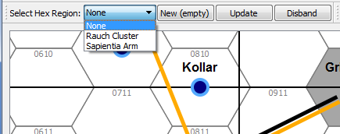

You can create an empty region containing no hexes then populate it, or you can select the hexes first and then use the selection to create a new group using the context menu.

Drop-down Group List | Allows selection of a hex group. The current selection is cleared and changed to just the hexes in the group.  The currently selected group will be referred to as the Working Group.  Note that once the Working Group has been changed, you can change the hexes that are actually selected so that it is different. To re-select just the hexes in the group, select it again in the drop-down.
New (empty) | Creates a new empty hex group and add it to the drop-down list.
Update | Updates the current Working Group so that it contains just the currently selected hexes.
Disband | Deletes the current Working Group. The worlds in the group are not deleted or changed.

Network Links

The Network Manager

Open the Network Manager from the tool bar. From here you can create new types of links to connect worlds together. You can also customise these link types to change their names and also to adjust the colour and line style used to display them on the map.

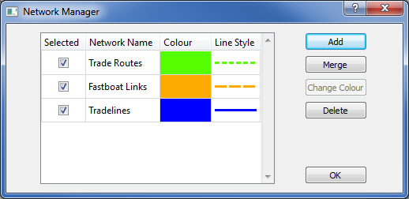

Use the check boxes on the left to select which line types are displayed on the map.

The Merge button is used to combine two or more link types into a single link type, while the Delete button removes a link type completely. These options work with the link types currently selected using the check boxes, and display a confirmation dialog first so that you can inspect the affected link types on the map before applying the change.

N.B. Merge currently not implemented.

Creating Links

Switch to hex selection mode and the pointer tool . Select two nearby worlds using Ctrl-Click. Call up the context menu by right-clicking and select Edit Links. This opens the Link Editor.

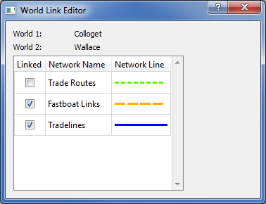
You can create links between these worlds by just selecting their check boxes. If you have the World Editor open on one of these worlds, you should see the links popping up in the editor dialog as soon as you select them!

Likewise, if the selected link types are selected in the Network manager, the new links will instantly appear on the map. There is no need to manually perform a refresh.

As a convenience, if the QuickLink check box on the toolbar is checked, the every time a selection change results in two worlds being selected, the World Link Editor for links between those worlds is opened automatically.

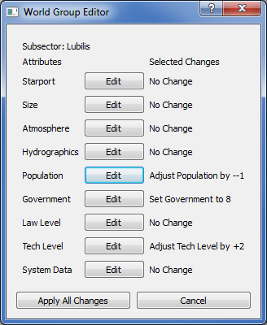
The World Group Editor

This tool enables adjustments to world attributes to be applied to more than one world at a time. In fact this editor is available via the context menu when you select multiple hexes, or one or more subsectors or sectors. The changes you define will be applied to every world in the selection area. It is advisable to make a backup copy of your project before applying sweeping changes of this kind.

Changes to an attribute are configured using an edit dialogue and the changes you have configured are displayed in the world group editor so you can review them before choosing to apply, adjust them or cancel.

The available modifications are:

Set Value
Every world will have the attribute adjusted to the specified attribute code.

Adjust Value
The world attributes is adjusted up or down the attribute value scale by the specified offset.

Set Maximum
Any worlds with the specified attribute at a higher value will have it reduced to the given maximum value.

Set Minimum
Any worlds with the specified attribute at a lower value will have it raised to the given minimum value.

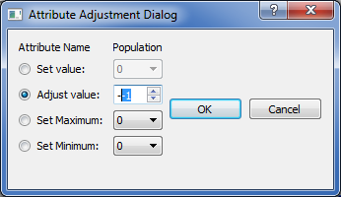

Custom Rules Files

When StarBase opens a project, it looks in the project directory for a directory called Rules, containing a Python script called Rules.py. If one exists then StarBase imports that file into its application code, otherwise it uses a built-in default rules file.

The rules file is a Python script that does two things. First is defines the world attributes and the values used by the application to describe worlds. Secondly it provides a function to randomly generate world attribute values.

The StarBase application comes with a directory called ‘rules_templates’. This contains rules sets for use with StarBase projects, each in it’s own subdirectory named after the rules set. When a new project is created, the selected rules set is copied into the project directory as a subdirectory called ‘Rules’.

StarBase
Rules_templates
default
2D6_OGL

Not that the actual rules sets present in the rules_templates directory are not used by any project. Instead, they are copied into a project when it is created and the local copy is loaded into StarBase when the project is opened.

Be very careful when modifying a rules file for an existing project. This is important because if you drop a modified rules file into a project directory with existing worlds, those worlds may have attribute values that don't match those defined in the rules file. This could lead to erratic behavior by the application and corrupted data.

Important: Please always take backups of your projects before making rules file changes.

Creating or Modifying a Rules File

The rules_templates directory contains a rules set called ‘default’ that is a simple, minimal rules set suitable for use as a basis for creating a custom rules set of your own. The Rules.py file has plenty of comments explaining what each part of the file does.

To create a new rules set, first make a copy of the default rules folder in the rules_templated directory with a new name, modify the Rules.py file and then use your new rules set to make a new project.

Some key points:

World attributes are defined using Python dictionaries and lists. These are data structures the application uses to look up information about the attribute and specific attribute values. If you are an experienced programmer, or are familiar with Python you shouldn’t have any problems, but if you are new to programming the details of the data structure format might be confusing. It could be useful to look up the Python documentation for dictionaries and lists, or read some of the many excellent Python tutorials available on the internet.

When modifying a rules file, check it still works by opening the project in StarBase, modify some world values and generate some new worlds. Save the project, re-open it and check the new values are still there. This basic check should catch most problems and verify the rules file is working correctly, but subtle bugs can take time to show up. Always keep backups of your projects before every rules file change.

It’s also a good idea to add a comment at the top of the rules file identifying it, such as a title or version number. Maintaining a list of changes in the comments at the top of the file can also be useful.

Creating a Project with Custom Rules

In many cases existing projects will not work with a new rules file, for example if you have changed the number of world attributes, or significantly altered the attribute codes. A world might have an attribute value, or even an attribute that no longer exists. After creating a custom rules file, you will want to create a new project to use it with.

Open StarBase and create a new project, but don’t open it. This will populate the project directory with a set of data and configuration files.

Copy the new rules file into the newly created project folder and make sure it is called 'Rules.py'.

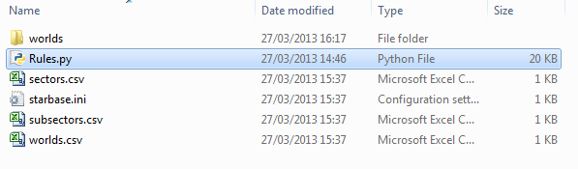

At this point you can open the project and start creating worlds.

Rules File Structure

A rules file, or rules script must make available certain data structures and functions which are loaded and used by the StarBase application. There are only a few of them and they are described here.

In practice a rules file needs to contain a bit more than is described in this chapter, such as functions for generating random numbers. You might want to import some modules from the Python standard library, which is available. Another option is to split the functionality of your script into several files and import them into your Rules.py file. For example you might have one file that contains all the attribute definitions, and another that contains the world generation algorithm. You might even want to call out to an external application written in another programming language that does world generation for you.

Attribute Definitions

An attribute definition is a Python dictionary that defines the name of the attribute, a list of the possible code values the attribute might have, and text descriptions of what each code value means. Here’s short, but technically complete example:

resource_data = \
{"Name": "Resources",
"Codes": ["0", "1”],
"Code Data": \
{"0": {"Label": " Poor",
"Description": " A few scattered deposits of useful " +\
"minerals, but they are often hard to extract. "},
"1": {"Label": " Plentiful",
"Description": A variety of rare and valuable minerals " +\
"are easy to access. Most are moderate in size but " +\
"there are a few extensive deposits of one or two " +\
"unusual resources."}
}
}

This attribute describes the level of mineral resources available on the world. It has two possible values, Poor and Rich, which have codes of “0” and “1” respectively. This example is a much simplified version of the resource attribute in the sample rules file provided with the application.

Note that the “\” character at the end of some lines just means “continue on the next line”. It is just used to help make the code formatting more readable.

You can define as many or as few world attributes as you like. Each can also have just one code or as many as you like, although a lot of attributes may make the user interface a unwieldy.

Attribute definitions are passed to the StarBase application in a list called ”attributeDefinitions”.

attributeDefinitions = [resource_data]

SEC File Compatibility Flag

supportsSecFileImport = False

This feature is currently not implemented.

The generateWorld Function

This function is called by StarBase whenever it needs to generate a random world. The function has no parameters, and returns two lists. Here is a minimal implementation that always returns a world with poor resources:

def generateWorld():
codes = [’0’]
descriptions = [’’]
return (codes, descriptions)

The order the code values and descriptions are returned in must match the order of the attribute definitions in the attributeDefinitions list.

Again, the sample file includes a much more complete example. Note that we are returning an empty description string. This tells StarBase to use the default description text for that attribute code. If you generate custom description text, perhaps with some randomly generated details or aspects derived from the values of other attributes, you can return that instead.

World Name Generation

World naming is controlled by an option called AutoName, which can be selected or deselected in the toolbar. By default AutoName is selected.

The StarBase application directory contains a text file called WorldNames.txt which lists well over 10,000 unique names. When a new world is created in StarBase, by if AutoName is selected the world is given a random name from this list. Each time the name is checked to make sure none of the worlds already created has that name. If AutoName is not selected, newly generated worlds are given a name based on the grid location of the hex they occupy.

Customizing AutoName is fairly easy, just replace WorldNames.txt with a file containing your own choice of names. Just make sure the file doesn’t contain any empty lines, and that there are enough names for the size of project you intend to create.

StarBase does not currently support name generation scripts. If you do want to use a script to generate names, currently you will need to use the script output to pre-populate a WorldNames.txt file.

Running StarBase From Source

StarBase is developed in the Python programming language, and is open source software released under the GPL version 2 license. The source files and associated data files are all available on Github from the following URL:

https://github.com/simon-hibbs/StarBase

In order to run StarBase you will need a copy of the Python programming language and several third party modules for Python. These are:

Python 2.7
Pywin32
PySide-1.1 - Qt GUI framework bindings for Python
NetworkX – a network graph library

Optionally, if you wish to build the application as a Windows executable yourself, you will also need:

Py2exe

