Practical: River Dolphins

Author
Simon Ho, School of Biological Sciences, University of Sydney

Aims
The aim of this practical exercise is to investigate the phylogenetic placement of river dolphins in the cetacean tree. To do this, you will:
- Set up a Bayesian phylogenetic analysis in MrBayes
- Examine the sensitivity of the phylogenetic results to the choice of models and priors

Background
River dolphins are a group of marine mammals that are found in fresh or brackish water in various parts of the world. They are members of the order Cetacea, which includes other dolphins, whales, and porpoises. There are four extant species of river dolphin, each in it own genus and even in its own family:
- Amazon River dolphin (Inia geoffrensis, family Iniidae)
- Baiji (Lipotes vexillifer, family Lipotidae)
- La Plata dolphin (Pontoporia blainvillei, family Pontoporiidae)
- South Asian river dolphin (Platanista gangetica, family Platanistidae)

River dolphins are smaller than other dolphins, ranging from 1.5 m to 2.5 m. They have good hearing in both air and water, possibly because the murky conditions of riverine habitats reduce visibility. As a result of living in shallow and generally warm water, river dolphins have lost most or all of their blubber.

The distribution of river dolphins is highly restricted and they are only found in a few locations. This makes them particularly vulnerable to anthropogenic pressures, particularly habitat destruction. Indeed, the baiji (or Chinese river dolphin) is now believed to be extinct. The last reported sighting of this species was in 2007.

The relationships among the river dolphins have been controversial at times. At first glance, their highly disjunct distributions make a close relationship seem implausible; however, they share many morphological similarities. Nevertheless, these similarities might have come about through convergent adaptation to similar habitats.

In this practical, you will examine the relationships among the 4 river dolphins using a data set comprising 2 mitochondrial and 2 nuclear genes.

In Part 1, you will set up and run a phylogenetic analysis interactively in MrBayes. In Part 2, you will examine the robustness of the phylogenetic results to changes in the models and priors.

MrBayes
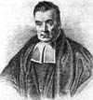
MrBayes is a widely used program for Bayesian phylogenetic analysis. The main purpose of the program is to infer evolutionary relationships, but it can also estimate divergence times under various models of rate variation across lineages. A wide range of evolutionary models are available in MrBayes, including various tree priors and molecular-clock models. The user has considerable flexibility in setting up the various components of the Bayesian hierarchical model. Although it is most often used to analyse nucleotide or amino acid sequences, MrBayes can handle other types of data, including discrete morphological characters.

MrBayes reads data from Nexus-formatted files. This is a data format commonly used in phlyogenetics. The analysis of the data can then be controlled interactively from the MrBayes command line. Alternatively, the commands can be included in a MrBayes block at the end of the Nexus data file.

By default, MrBayes runs multiple Markov chains. This includes multiple independent MCMC analyses as well as Metropolis coupling (heated chains). Running multiple independent analyses, each from a different starting point, allows the user to check for convergence to the stationary distribution.

Following the MCMC analysis, MrBayes can summarise the estimates of parameters and the tree. A number of MCMC diagnostics have been incorporated into the program. For example, MrBayes can monitor convergence in tree sampling across analyses by calculating the standard deviation of split frequencies.

A parallel version of MrBayes is also available. This uses message-passing interface (MPI) to distribute the computational load across the available processors. The multi-chain nature of most MrBayes analyses makes them particularly amenable to parallelisation.

MrBayes was originally written by John Huelsenbeck, with Fredrik Ronquist contributing to the program from 2001 onwards. Many other researchers have subsequently contributed to the development of the program.

Part 1: Bayesian analysis using MrBayes

Setting up the model and priors
Before you begin, check that you have a recent version of MrBayes and the data file cetaceans.nex. Create a folder called “cetaceans” and put the MrBayes executable and the data file into this folder.

Open the data file cetaceans.nex in a text editor and have a look at its contents. The file contains 15 nucleotide sequences sampled from the 4 river dolphins, 10 other cetaceans, and an outgroup taxon (hippopotamus). The 3876 nucleotides comprise sequences of the mitochondrial genes cytb and bd4 and the nuclear genes alb and irbp. The sequence alignment is in Nexus format. Now bring up a command prompt and run MrBayes by typing
./mb
You are now at a command prompt in MrBayes. Load the sequence data by typing
execute cetaceans.nex

The screen output should reveal that MrBayes has recognised the file successfully. It prints out a list of the taxa in the file. Have a look at the model options in MrBayes by typing
help lset

The current settings are shown on the screen:
Nucmodel 4by4/Doublet/Codon/Protein 4by4
Nst 1/2/6/Mixed 1
Code Universal/Vertmt/Mycoplasma/
Yeast/Ciliates/Metmt Universal
Ploidy Haploid/Diploid/Zlinked Diploid
Rates Equal/Gamma/Propinv/Invgamma/Adgamma Equal
Ngammacat <number> 4
Nbetacat <number> 5
Omegavar Equal/Ny98/M3 Equal
Covarion No/Yes No
Coding All/Variable/Noabsencesites/Nopresencesites All
Parsmodel No/Yes No

There are some useful descriptions of these settings in the MrBayes screen output, in case you are interested in reading more about any of them. For now, we’ll just focus on three of the settings.

“nst” indicates the number of distinct substitution types in the substitution model. The current setting is “1”, which corresponds to the F81 substitution model (similar to the Jukes-Cantor or JC model, but without the assumption of equal base frequencies). We want to change this to the general time-reversible (GTR) model. Remember that there are 6 distinct reversible substitution types in the GTR model (A↔C, A↔G, etc.). You can choose the GTR model by typing
lset nst=6
Next, see that “rates” are currently assumed to be equal across sites. For this analysis, we might prefer to allow gamma-distributed rates across sites. Change the model of among-site rate variation by typing
lset rates=gamma
The number of rates categories in the gamma distribution is given by “ngammacat”. We can leave this at the default value of 4. Some studies have shown that using 4 rate categories is sufficient for most data sets. We can increase the accuracy of the likelihood calculations by raising the number of rate categories to 6 or 8, but this also proportionally increases the time needed for the analysis. So the best option is to stick to 4 categories in this exercise.

Q. Consider a data set that has evolved with considerable rate variation across sites. What are the potential consequences of failing to account for this?

. . . . . . . . . . . . . . . . . . . . . . . . . . . . . . . . . . . . . . . . . . . . . . . . . . . . . . . . . . . . . . . . . . . . . . . . .

. . . . . . . . . . . . . . . . . . . . . . . . . . . . . . . . . . . . . . . . . . . . . . . . . . . . . . . . . . . . . . . . . . . . . . . . .

. . . . . . . . . . . . . . . . . . . . . . . . . . . . . . . . . . . . . . . . . . . . . . . . . . . . . . . . . . . . . . . . . . . . . . . . .

. . . . . . . . . . . . . . . . . . . . . . . . . . . . . . . . . . . . . . . . . . . . . . . . . . . . . . . . . . . . . . . . . . . . . . . . .

. . . . . . . . . . . . . . . . . . . . . . . . . . . . . . . . . . . . . . . . . . . . . . . . . . . . . . . . . . . . . . . . . . . . . . . . .

. . . . . . . . . . . . . . . . . . . . . . . . . . . . . . . . . . . . . . . . . . . . . . . . . . . . . . . . . . . . . . . . . . . . . . . . .

. . . . . . . . . . . . . . . . . . . . . . . . . . . . . . . . . . . . . . . . . . . . . . . . . . . . . . . . . . . . . . . . . . . . . . . . .

To see the updated model, type
help lset
The next step is to specify the priors for the analysis. The default priors should be fine for the current analysis. To see the priors, type
help prset

For the tree topology, you can see that there is a uniform prior by default. This puts equal probability on all distinct, resolved tree topologies. This is coupled with an exponential prior on branch lengths. The exponential prior has a parameter of 10, which means that the prior mean is 0.1. In other words, the prior mean of each branch length is 0.1 substitutions per site. This seems like a reasonable prior.

There are six types of parameters in the model, and all of these will be estimated in the analysis. You can view these before starting the MCMC sampling by typing
showmodel

Setting up the analysis
Now that we have set up our evolutionary model, we can proceed to the MCMC analysis. In the MCMC analysis, we draw samples of parameter values and trees from the posterior distribution. When the analysis is complete, we are left with a set of samples from the posterior. We can summarise and plot these to produce estimates of the posterior distributions of parameters and the tree.

First, we should see what MCMC options are in MrBayes. Type
help mcmc
“ngen” gives the number of generations, or steps, for which the MCMC analysis will be run. The current setting is 1,000,000 steps, which is fine for this exercise. However, we want to change the frequency with which samples are drawn from the MCMC and the frequency of printing to the screen. Type
mcmcp samplefreq=100 printfreq=100

By default, MrBayes will run 2 simultaneous, independent analyses, each starting from a different random tree (“nruns” = 2). This is helpful for checking convergence to the stationary distribution. If both of the analyses converge on the same estimates of the parameters, we can be fairly confident that we are sampling from the stationary distribution. We can also monitor the frequencies of splits in the sampled trees to see if the estimates of the tree topology are converging.

Running multiple simultaneous analyses is computationally expensive. To work within our time constraints, we will only run a single analysis. Type
mcmcp nruns=1

By default, MrBayes also runs multiple chains per analysis. This is known as Metropolis coupling and generally improves the performance of the MCMC in sampling from the stationary distribution. The default setting is 4 chains (“nchains” = 4). We only record samples from one of these chains, known as the ‘cold’ chain. The remaining chains are heated and are more likely to accept proposals that lead to low-probability regions of parameter space. The additional chains are incrementally heated, and the hotter chains are more likely to move into ‘valleys’ of low probability. Every “swapfreq” generation in the MCMC, MrBayes picks 2 chains at random and attempts to swap their states. Unless we are running MrBayes in parallel, the time needed for analysis increases linearly with the number of chains.

In the interests of time, we will only use 2 chains in our analysis (1 cold and 1 heated). Type
mcmcp nchains=2

Now we can start the MrBayes analysis by typing
mcmc

Q. Given limited computational resources, do you think that it would be better to use Metropolis-coupling with 4 chains, or to run 4 independent replicates of the MCMC with 1 chain each?

. . . . . . . . . . . . . . . . . . . . . . . . . . . . . . . . . . . . . . . . . . . . . . . . . . . . . . . . . . . . . . . . . . . . . . . . .

. . . . . . . . . . . . . . . . . . . . . . . . . . . . . . . . . . . . . . . . . . . . . . . . . . . . . . . . . . . . . . . . . . . . . . . . .

. . . . . . . . . . . . . . . . . . . . . . . . . . . . . . . . . . . . . . . . . . . . . . . . . . . . . . . . . . . . . . . . . . . . . . . . .

. . . . . . . . . . . . . . . . . . . . . . . . . . . . . . . . . . . . . . . . . . . . . . . . . . . . . . . . . . . . . . . . . . . . . . . . .

. . . . . . . . . . . . . . . . . . . . . . . . . . . . . . . . . . . . . . . . . . . . . . . . . . . . . . . . . . . . . . . . . . . . . . . . .

. . . . . . . . . . . . . . . . . . . . . . . . . . . . . . . . . . . . . . . . . . . . . . . . . . . . . . . . . . . . . . . . . . . . . . . . .

When the analysis is complete, MrBayes will ask whether you want to continue sampling from the MCMC. We might consider this if we have not yet drawn a sufficient sample to allow reliable estimation of the posterior distribution. For the purpose of this exercise, we will stop the analysis here.

We now have two main output files: the .p file, which contains the samples of the model parameters, and the .t file, which contains the samples of the tree. The next step in our analysis is to summarise these samples. We will discard the first 1000 samples (10%) as burn-in. Type
sump burnin=1000

Q. Why do we need to discard a portion of the MCMC samples as burn-in?

. . . . . . . . . . . . . . . . . . . . . . . . . . . . . . . . . . . . . . . . . . . . . . . . . . . . . . . . . . . . . . . . . . . . . . . . .

. . . . . . . . . . . . . . . . . . . . . . . . . . . . . . . . . . . . . . . . . . . . . . . . . . . . . . . . . . . . . . . . . . . . . . . . .

. . . . . . . . . . . . . . . . . . . . . . . . . . . . . . . . . . . . . . . . . . . . . . . . . . . . . . . . . . . . . . . . . . . . . . . . .

. . . . . . . . . . . . . . . . . . . . . . . . . . . . . . . . . . . . . . . . . . . . . . . . . . . . . . . . . . . . . . . . . . . . . . . . .

At the bottom of the “sump” output, you will see a summary table of the parameter estimates. The values include the mean and the 95% credible interval of the estimate of each model parameter. The rightmost column reports the effective sample size (ESS) of each parameter. Values below 100 indicate that more samples are needed for a reliable estimate of the posterior distribution.

Now we want to summarise the sample of trees. Type
sumt burnin=1000

MrBayes will print out various statistics and an ASCII portrayal of the summary tree, but we will use a tree-viewing program to look at the tree instead.

Estimate of the phylogeny
After processing the .t file, MrBayes has produced a majority-rule consensus tree based on the MCMC samples. This tree is in a file called cetaceans.nex.con.tre. Open this file in the tree-viewing program FigTree.

You can play around with the settings and FigTree will display some of the information associated with the tree. Try clicking on the three symbols in the “Layout” menu. From left to right, these allow you to display the tree as a rooted tree, circular tree, and unrooted tree, respectively.

Reroot the tree using the hippopotamus as the outgroup. Then check the box next to “Node Labels” and click on the triangle to show the associated menu. From the drop-down menu next to “Display”, select “prob”. This will display the posterior probabilities next to the nodes in the tree.

Q. Do the baleen whales (bowhead, common minke, and grey) form a monophyletic group?

. . . . . . . . . . . . . . . . . . . . . . . . . . . . . . . . . . . . . . . . . . . . . . . . . . . . . . . . . . . . . . . . . . . . . . . . .

Q. Do the toothed whales (all taxa except the baleen whales and the hippopotamus) form a monophyletic group?

. . . . . . . . . . . . . . . . . . . . . . . . . . . . . . . . . . . . . . . . . . . . . . . . . . . . . . . . . . . . . . . . . . . . . . . . .

Q. Where have the four species of river dolphin been placed in the tree? Are these placements well supported?

. . . . . . . . . . . . . . . . . . . . . . . . . . . . . . . . . . . . . . . . . . . . . . . . . . . . . . . . . . . . . . . . . . . . . . . . .

. . . . . . . . . . . . . . . . . . . . . . . . . . . . . . . . . . . . . . . . . . . . . . . . . . . . . . . . . . . . . . . . . . . . . . . . .

. . . . . . . . . . . . . . . . . . . . . . . . . . . . . . . . . . . . . . . . . . . . . . . . . . . . . . . . . . . . . . . . . . . . . . . . .

. . . . . . . . . . . . . . . . . . . . . . . . . . . . . . . . . . . . . . . . . . . . . . . . . . . . . . . . . . . . . . . . . . . . . . . . .

. . . . . . . . . . . . . . . . . . . . . . . . . . . . . . . . . . . . . . . . . . . . . . . . . . . . . . . . . . . . . . . . . . . . . . . . .

. . . . . . . . . . . . . . . . . . . . . . . . . . . . . . . . . . . . . . . . . . . . . . . . . . . . . . . . . . . . . . . . . . . . . . . . .

. . . . . . . . . . . . . . . . . . . . . . . . . . . . . . . . . . . . . . . . . . . . . . . . . . . . . . . . . . . . . . . . . . . . . . . . .

Q. Do river dolphins form a monophyletic, paraphyletic, or polyphyletic group?

. . . . . . . . . . . . . . . . . . . . . . . . . . . . . . . . . . . . . . . . . . . . . . . . . . . . . . . . . . . . . . . . . . . . . . . . .

. . . . . . . . . . . . . . . . . . . . . . . . . . . . . . . . . . . . . . . . . . . . . . . . . . . . . . . . . . . . . . . . . . . . . . . . .

Part 2: Models and priors in MrBayes

MrBayes command block
We will look at the models and priors in MrBayes in more detail. We can speed up this process by putting all of the settings for the models and priors into a MrBayes command block at the bottom of the data file, rather than having to type them on the command line. For this part of the practical, we will be working with the data file cetaceans.part.nex. Open this file in a text editor. Below the sequence alignment, you’ll see a MrBayes command block. The first section of the command block activates data partitioning. The subsets are defined according to the 4 genes in the data set:

charset cytb = 1-1140;
charset nd4 = 1141-2517;
charset alb = 2518-2797;
charset irbp = 2798-3876;

partition bygene = 4: cytb, nd4, alb, irbp;
set partition = bygene;

Next, we assign a GTR+G model to all of the data subsets and unlink the parameters of this model across the subsets, such that each has an independent GTR+G model:

Lset applyto=(all) nst=6 rates=gamma ngammacat=4;
unlink shape=(all) revmat=(all) statefreq=(all);

Next, we tell MrBayes to allow each data subset to evolve at a different rate. For example, cytb might evolve at twice the rate of nd4. However, the model is quite simplistic in that it assumes that the relative rates across subsets are constant across the tree.

Prset applyto=(all) ratepr=variable;

The next part of the MrBayes block sets up the MCMC analysis. We are drawing samples every 100 steps over a total of 1,000,000 steps. As in the first section of this practical, we are running a single analysis with two Metropolis-coupled Markov chains.

mcmc ngen=1000000 printfreq=100 samplefreq=100 savebrlens=yes nruns=1 nchains=2;

The final part of the block tells MrBayes to summarise the samples drawn in the MCMC analysis. We summarise the trees (“sumt”) and the parameter values (“sump”), after discarding the first 1000 samples (10%) as burn-in.

sumt burnin=1000;
sump burnin=1000;

From the command line, run a MrBayes analysis by typing
./mb cetaceans.part.nex

Investigating the impact of model choice
Now we will investigate the effects of changing some of the models and priors in the analysis. Make 2 copies of cetaceans.part.nex and call them cetaceans.part_hky.nex and cetaceans.part_bl.nex.

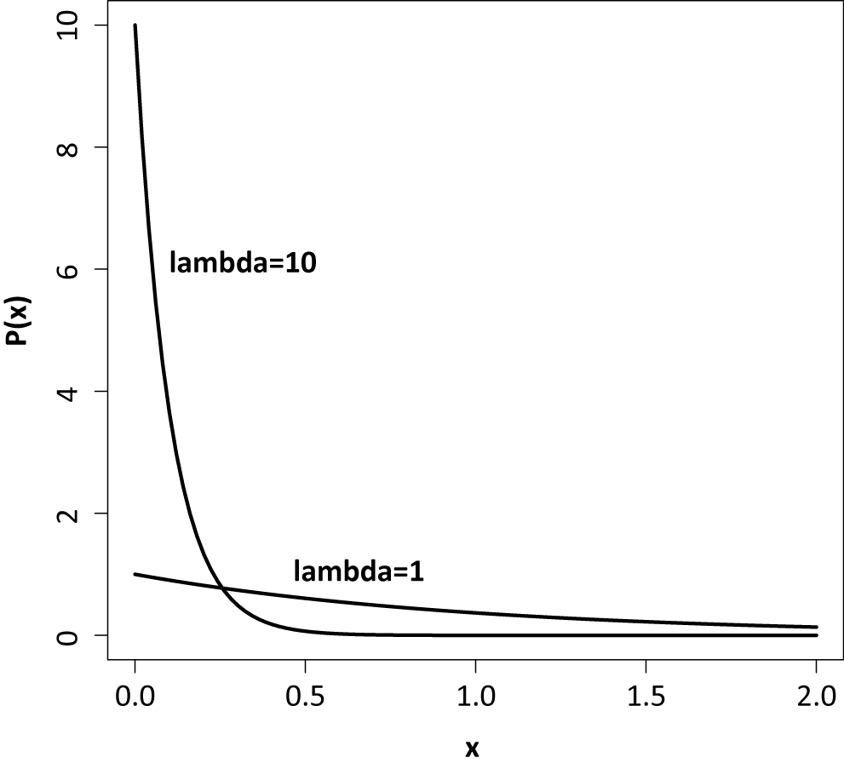
Open cetaceans.part_hky.nex in a text editor and change the GTR+G model to an HKY+G model.

Open cetaceans.part_bl.nex in a text editor. For this file, we want to change the exponential prior on branch lengths. The original prior on branch lengths had a mean of 0.1 and favoured shorter branches. We will try changing this prior so that it has a mean of 1 and is more diffuse, giving less prior probability to short branches. You can see the difference in the two probability densities in the plot on the right. The prior can be changed by adding a “prset” line:

prset brlenspr=unconstrained:exponential(1);

Run MrBayes using these two files.

You should now have the results of 4 analyses:
- Single GTR+G model across all 4 genes (from Part 1 of this practical).
- Separate GTR+G model for each gene.
- Separate HKY+G model for each gene.
- Separate GTR+G model for each gene, with exponential(1) prior rather than exponential(10) prior on branch lengths.

Each analysis has produced a number of output files, containing various samples and summaries. Here we are interested in the .lstat files, which report the harmonic means of the marginal likelihoods. These values can be used for model comparison in a Bayesian framework. Open these files in a text editor.

Q. What are the marginal likelihoods for the unpartitioned GTR+G, partitioned GTR+G, and HKY+G models?

. . . . . . . . . . . . . . . . . . . . . . . . . . . . . . . . . . . . . . . . . . . . . . . . . . . . . . . . . . . . . . . . . . . . . . . . .

. . . . . . . . . . . . . . . . . . . . . . . . . . . . . . . . . . . . . . . . . . . . . . . . . . . . . . . . . . . . . . . . . . . . . . . . .

. . . . . . . . . . . . . . . . . . . . . . . . . . . . . . . . . . . . . . . . . . . . . . . . . . . . . . . . . . . . . . . . . . . . . . . . .

We can examine the support for the different models by computing Bayes factors, which are the ratios of the marginal likelihoods under the different models. Because we are working with log values, we need to subtract one value from the other (rather than dividing one by the other). This will give the log Bayes factor.
First, calculate the log marginal likelihood of the unpartitioned GTR+G model minus the log marginal likelihood of the partitioned GTR+G model. This gives the log Bayes factor for the partitioned GTR+G against the unpartitioned GTR+G model. Values of log(BF) can be interpreted as follows: 1–3 positive support, 3–5 strong support, >5 decisive support.

Q. Is there support for the partitioned GTR+G model compared with the unpartitioned GTR+G model?

. . . . . . . . . . . . . . . . . . . . . . . . . . . . . . . . . . . . . . . . . . . . . . . . . . . . . . . . . . . . . . . . . . . . . . . . .

Q. Is there support for the partitioned GTR+G model compared with the partitioned HKY+G model?

. . . . . . . . . . . . . . . . . . . . . . . . . . . . . . . . . . . . . . . . . . . . . . . . . . . . . . . . . . . . . . . . . . . . . . . . .

Next, we can look at the effect of changing the prior on branch lengths. Open the .pstat files produced from analyses (2) and (4) given in the list above. We are interested in the estimate of the tree length (TL), which is the sum of all of the branch lengths in the tree. The tree length is given in substitutions per site and reflects the total amount of evolutionary change.

Q. Is the estimate of the tree length affected by our choice of prior on branch lengths?

. . . . . . . . . . . . . . . . . . . . . . . . . . . . . . . . . . . . . . . . . . . . . . . . . . . . . . . . . . . . . . . . . . . . . . . . .

We should now see whether changing the prior on branch lengths has affected our estimate of the phylogeny. Open the .con.tre file in FigTree and label the internal nodes with their posterior probabilities.

Q. Describe any differences between the two trees.

. . . . . . . . . . . . . . . . . . . . . . . . . . . . . . . . . . . . . . . . . . . . . . . . . . . . . . . . . . . . . . . . . . . . . . . . .

. . . . . . . . . . . . . . . . . . . . . . . . . . . . . . . . . . . . . . . . . . . . . . . . . . . . . . . . . . . . . . . . . . . . . . . . .

. . . . . . . . . . . . . . . . . . . . . . . . . . . . . . . . . . . . . . . . . . . . . . . . . . . . . . . . . . . . . . . . . . . . . . . . .

. . . . . . . . . . . . . . . . . . . . . . . . . . . . . . . . . . . . . . . . . . . . . . . . . . . . . . . . . . . . . . . . . . . . . . . . .

Q. How do we know which of the exponential priors on branch lengths is more appropriate in our analysis?

. . . . . . . . . . . . . . . . . . . . . . . . . . . . . . . . . . . . . . . . . . . . . . . . . . . . . . . . . . . . . . . . . . . . . . . . .

. . . . . . . . . . . . . . . . . . . . . . . . . . . . . . . . . . . . . . . . . . . . . . . . . . . . . . . . . . . . . . . . . . . . . . . . .

. . . . . . . . . . . . . . . . . . . . . . . . . . . . . . . . . . . . . . . . . . . . . . . . . . . . . . . . . . . . . . . . . . . . . . . . .

. . . . . . . . . . . . . . . . . . . . . . . . . . . . . . . . . . . . . . . . . . . . . . . . . . . . . . . . . . . . . . . . . . . . . . . . .

