Market-Sentiment Classification of Financial Tweets
Text Mining Project Report — Group 12
Bearish (0) - Bullish (1) - Neutral (2) | NOVA IMS — Spring 2025/2026

Abstract
We develop and evaluate an end-to-end NLP system that classifies financial tweets by market sentiment into Bearish (0), Bullish (1) or Neutral (2). Working from a corpus of 9,543 labelled tweets, we treat every design decision as a hypothesis tested on a fixed stratified validation set and compare the three representation families taught in the course — Bag-of-Words, static word embeddings (word2vec/GloVe) and Transformer-encoder embeddings — across a suite of classical and neural classifiers, with declared extra work on domain-specialised encoders, a generative decoder used as a classifier, and an agentic orchestration layer. Because the data is strongly imbalanced (65% Neutral), we adopt macro-F1 as the headline metric and apply stratified splitting and class weighting throughout. The submitted pipeline — a concatenation of FinBERT and twitter-roberta CLS embeddings feeding an MLP — reaches validation macro-F1 0.808 (accuracy 0.859). Our main takeaway is that performance depended above all on the encoder — the component that turns each tweet into numbers. A general-purpose encoder performed poorly, whereas encoders already trained on finance or tweets (FinBERT and twitter-roberta) were far stronger out of the box, and a general encoder matched them only after being fine-tuned on our own data. Once the encoder understood financial language, the choice of classifier and the remaining refinements added little.

1. Introduction
Market indices rise and fall on a mix of internal and external factors, and investors read the same movements in opposite ways: optimism that gains will continue is described as bullish, while the fear that good times are about to end is described as bearish. Social media — financial Twitter in particular — is a dense, real-time stream of exactly these opinions, which makes automatic sentiment classification of tweets valuable for gauging market mood. The goal of this project is to build an NLP model that, given a single tweet, predicts whether it expresses a Bearish (0), Bullish (1) or Neutral (2) attitude.
The data is split into a labelled training set of 9,543 tweets (text + label) and a blind test set of 2,388 tweets (id + text) for which we submit predictions. We divide the training set into stratified train and validation partitions, use the validation partition to select among preprocessing schemes, feature representations and classifiers, and only then refit the chosen pipeline on the full training set to label the test tweets. Throughout, the problem's strong class imbalance drives our methodological choices — the headline metric, the splitting strategy and the class weighting.
The remainder of the report follows the structure recommended in the handout. Section 2 explores the corpus and draws the conclusions that motivate later choices; Section 3 describes the preprocessing; Section 4 covers feature engineering across the three representation families; Section 5 presents the classification models; and Section 6 evaluates and compares them. Section 7 documents the declared extra work (domain encoders, a decoder-as-classifier and an agentic workflow) and Section 8 concludes with the final-model decision. Supporting tables and all remaining figures are collected in Appendices A–C.

2. Data Exploration
The training corpus contains 9,543 tweets, each with a text field and a label in {0,1,2}; the blind test set contains 2,388 tweets with an explicit id column and no labels. A sanity pass found no nulls, no empty strings and no duplicate tweets, so deduplication removed zero rows and there is no risk of identical tweets leaking across the train/validation boundary. One discrepancy with the handout is worth noting: the test set holds 2,388 rows rather than the 299 mentioned in the brief, and the id is a real column that we pass straight through to the prediction file. Clean, de-duplicated data with a trustworthy id field means the validation scores reported throughout this report are reliable.
Note on the test-set size. We verified the 2,388 test rows directly: the ids form a contiguous sequence 0–2,387, all texts are unique with no nulls or empties, none overlap the training set, and every row is a genuine tweet (the shortest are bare cashtags such as "$WKHS"). There is no flag or subset that isolates 299 rows, and 299 is not a divisor of 2,388, so the "299" in the handout appears to be a legacy figure carried over from an earlier version of the brief rather than a hidden filtering step. Following the operative instruction to predict "each tweet in this set", we therefore label all 2,388 test tweets.

2.1 Class distribution sets the evaluation strategy
The single most consequential property of the corpus is its strong class imbalance: Neutral accounts for 64.7% of tweets (6,178), Bullish 20.2% (1,923), and Bearish 15.1% (1,442). The gap between two majority-class baselines makes the danger concrete — always predicting Neutral scores 0.647 accuracy but only 0.262 macro-F1 (F1 = 0 on both Bearish and Bullish). That 0.385 gap is the fact that justifies our entire evaluation and class-weighting strategy.
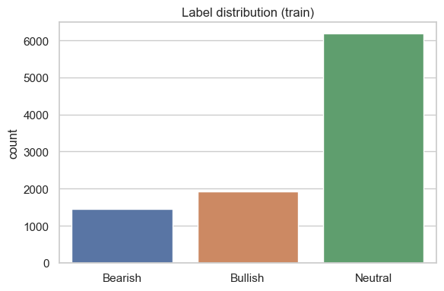
Figure 1. Training-set label distribution: Neutral dominates at ~65%.
This imbalance forces four decisions used consistently downstream:
- Headline metric = macro-F1, never accuracy — a model can hit 65% accuracy and be useless on the two classes investors care about.
- Stratified split and stratified 5-fold CV, so the minority classes stay represented at every stage.
- Class weighting (class_weight='balanced' on linear models, a class-weight dict on the BiLSTM and the fine-tuned encoder).
- Minority-class monitoring — Bearish/Bullish recall and the full confusion matrix are inspected for every model.

2.2 Lexical separability and per-class vocabulary
Word clouds built from a throwaway lowercase + stopword tokenisation (used for visualisation only) show that the three classes use clearly distinct vocabulary, which bodes well for word-based features. Bearish tweets cluster around misses, cut, slip, slide, fall, downgraded, loss, weak and warns, plus crisis terms such as coronavirus and oil. Bullish tweets carry earnings-beat language: beats, target, raised, higher, upgraded, strong, jump and eps. Neutral tweets are factual and report-like: declares, dividend, results, reports, q3 and data-vendor boilerplate such as marketscreener.
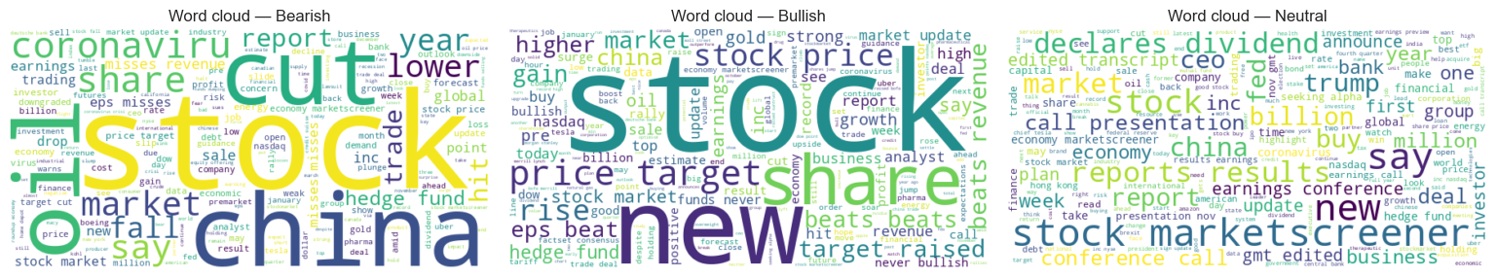
Figure 2. Per-class word clouds (left to right: Bearish, Bullish, Neutral). Distinct vocabularies suggest word-based features will be competitive.
There is a visible generalisation risk: company and data-source names (e.g. marketscreener, individual tickers) appear among the most frequent tokens, so a model could latch onto names rather than sentiment. This directly motivates normalising every cashtag to a generic ticker token during preprocessing, so the model learns sentiment, not specific symbols.

2.3 Finance-specific signals carry class information
The lab pipelines shown in class were built for product/COVID text and simply delete every non-letter character. Financial tweets carry signal in exactly those characters — cashtags ($AAPL), percentages (5%), dollar amounts, hashtags, mentions and URLs — so we measured how often each appears per class before deciding what to discard.
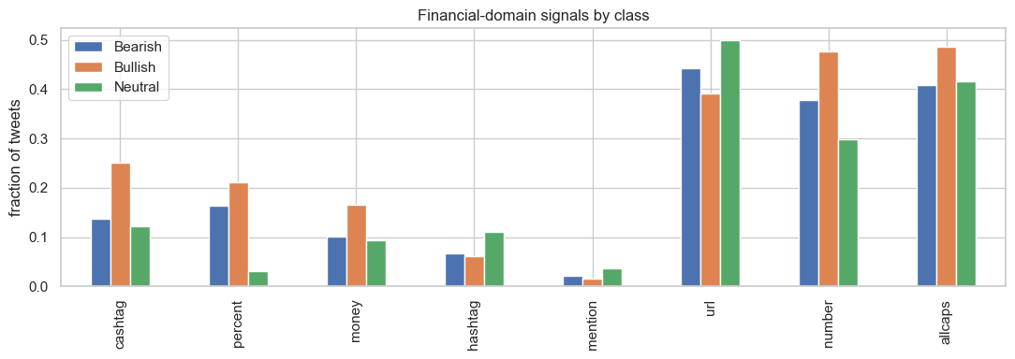
Figure 3. Frequency of finance-specific token types per class. Percentages are the sharpest discriminator.
Percentages are the sharpest discriminator: present in 21.2% of Bullish and 16.3% of Bearish tweets but only 3.1% of Neutral — directional moves (+5%, –8%) signal opinion. Cashtags lean Bullish (25.1% vs 13.8% Bearish, 12.2% Neutral), as do numbers (Bullish 47.7% vs Neutral 29.8%). Neutral tweets are the most news-like, with the highest URL (49.8%), hashtag and mention rates. The implication is decisive: the lab default cleaner deletes every digit, % and $, which would erase the percent signal entirely. The 21.2% vs 3.1% gap is concrete evidence that "delete all non-letters" throws away discriminative information — which is why Section 3 tests a finance-aware cleaning variant against the lab-style one.

3. Data Preprocessing
We implemented six preprocessing operations as independent toggles — lowercasing, regex normalisation, punctuation removal, stopword removal, lemmatisation and stemming — satisfying the requirement of at least four techniques, then composed them into two contrasting variants and let the validation score choose between them. An important scope rule applies throughout: the chosen cleaning feeds the BoW and word2vec features only. The Transformer encoders in Section 4 receive raw, untouched text, because each brings its own WordPiece/BPE subword tokenizer; aggressive cleaning would strip the casing, sub-words and finance tokens those models were trained to understand.

3.1 Two competing cleaning philosophies
AGGRESSIVE (lab baseline). Lowercase, strip URLs, keep letters only (re.sub('[^a-zA-Z]', ' ', text)), remove all stopwords, lemmatise. This discards numbers, cashtags and percentages, and removes negation words (not, no, never) via the standard stoplist.
CONSERVATIVE (finance-aware). Lowercase, strip URLs and mentions, normalise $AAPL → "ticker", 5% → "pct" and bare numbers → "num", keep negation words (which can flip sentiment, e.g. "not bullish"), and lemmatise.

3.2 The cleaning decision was made empirically
Holding a cheap probe (TF-IDF + Logistic Regression) and the fixed train/validation split constant, we ran each cleaned variant and compared validation macro-F1 and vocabulary size. The conservative variant won by +0.0074 macro-F1 (0.7092 vs 0.7018) at essentially identical vocabulary size (11,368 vs 11,364), confirming the Section 2.3 reading that the percent/number signal is worth keeping. We therefore adopt conservative cleaning for all BoW and word2vec features. This is later vindicated directly: the normalised tokens pct and ticker surface among the most Bullish-discriminative TF-IDF features in Section 4.
Cleaning variant | Validation macro-F1 | Vocabulary size | Decision
Conservative (normalise ticker/pct/num, keep negation) | 0.7092 | 11,368 | Kept
Aggressive (lab-style, delete digits/cashtags) | 0.7018 | 11,364 | Discarded

4. Feature Engineering
We built and characterised the three required representation families — Bag-of-Words, word2vec, and Transformer-encoder embeddings — and probed each with a fixed Logistic Regression so representations are compared on equal footing. Mean-pooled transformer embeddings and the two domain-specialised encoders are declared extra work (see Section 7).

4.1 Bag-of-Words family
We compared four BoW variants: binary counts, frequency counts, TF-IDF unigrams, and TF-IDF (1,2)-grams (min_df=2 to control vocabulary explosion). TF-IDF down-weighting beat raw counts as expected (0.709–0.712 vs 0.697–0.700), solving BoW's "all words weighted equally" weakness by discounting ubiquitous words like stock, market and says. The most class-discriminative terms were exactly the right ones — Bearish: downgraded, miss, target cut, warns; Bullish: beat, upgraded, raised, bullish, pct, ticker; Neutral: declares, dividend, q3, marketscreener. Crucially, our normalised pct and ticker tokens appear as Bullish signals, directly validating the conservative preprocessing. Bigrams essentially tied unigrams (0.7120 vs 0.7092, within noise): on ~7.6k short tweets most bigrams are too rare to estimate well, so the phrase signal barely moves the needle. We carry TF-IDF unigram forward as the BoW representative, trading a negligible –0.003 macro-F1 for lower dimensionality.

4.2 Static word embeddings (word2vec)
We built two averaged-vector variants: Word2Vec trained from scratch on our corpus and pre-trained GloVe-Twitter. Both were the weakest representations in the study (0.592 and 0.569 macro-F1), well below TF-IDF. Surprisingly, from-scratch beat pretrained GloVe (+0.023) for two reasons: our normalised tokens (ticker, pct, num) and finance jargon are out-of-vocabulary for GloVe, which skips them, whereas the from-scratch model learned them; and averaging destroys word order while diluting the few sentiment-bearing words in a tweet. We nonetheless carry GloVe-Twitter forward for the BiLSTM, where per-token vectors over the whole sequence make broad vocabulary coverage (from ~2B tweets) matter more than the averaged-probe result.

4.3 Transformer-encoder embeddings
Encoders produce contextual embeddings — the same word gets different vectors in different sentences — addressing BoW's "context changes meaning" weakness. We extracted frozen embeddings from three encoders with two pooling strategies each: generic DistilBERT, finance-tuned FinBERT, and Twitter-tuned RoBERTa. Domain encoders clearly beat the generic one by about +0.05 macro-F1: both FinBERT and twitter-roberta understand market language and our ticker/pct tokens better than vanilla DistilBERT, with twitter-roberta the single strongest representation in the study. CLS vs mean pooling was essentially a tie (≤0.001 for every encoder) — an honest null result for short tweets, where the two pooling strategies capture nearly the same information.

4.4 Representation summary
Ranked by probe macro-F1, the representations form a coherent hierarchy from contextual domain encoders down to averaged static embeddings:
Representation | Dim | Type | Order? | Contextual | Domain fit | Probe F1
twitter-roberta cls/mean | 768 | dense | yes | yes | tweets | 0.751 / 0.752
FinBERT cls/mean | 768 | dense | yes | yes | finance | 0.737 / 0.738
TF-IDF (1,2)-gram / unigram | ~10–11k | sparse | no | no | generic | 0.712 / 0.709
DistilBERT cls | 768 | dense | yes | yes | generic | 0.697
Word2Vec-avg (scratch) | 100 | dense | no | no | in-domain (tiny) | 0.592
GloVe-Twitter avg | 100 | dense | no | no | generic | 0.569

We advance the two domain transformers (strongest classifiers), TF-IDF (linear/KNN models) and GloVe sequences (BiLSTM) into the model section. The domain-matched contextual embeddings are the most promising, while TF-IDF is a surprisingly strong, cheap baseline.

5. Classification Models
We trained traditional ML classifiers (KNN, Logistic Regression, Gaussian Naive Bayes, MLP) and Transformer-encoder classifiers (frozen embeddings + a light head, plus an end-to-end fine-tune), each paired with the representation it suits and all scored through one shared evaluate() routine so results are directly comparable. Multiclass and imbalance adaptations — 3-way softmax, class weighting, macro-averaged metrics, stratified CV — are applied throughout. Every model is compared against the majority-class baseline (macro-F1 0.262).

5.1 Traditional ML classifiers
KNN (TF-IDF, cosine). Best k=5 (smaller neighbourhoods help because minority classes are sparse): val macro-F1 0.668. It recovers Neutral well (F1 0.86) but struggles to recall the minority classes (Bearish recall 0.47) — in a 65%-Neutral space, a new point's neighbourhood is usually Neutral-dominated.
Logistic Regression (TF-IDF, class-weighted, C=1.0). Val macro-F1 0.709 — the best non-neural, non-transformer model, beating even frozen generic DistilBERT (0.697). Its per-class F1 is the most balanced so far (Bearish 0.59, Bullish 0.68, Neutral 0.86), because a class-weighted linear boundary over a high-dimensional sparse lexicon is well matched to a keyword-driven task. This is the model to beat for anything costlier.
Gaussian Naive Bayes (averaged GloVe). Val macro-F1 0.543 — the weakest classical model. GaussianNB assumes independent, Gaussian features, but embedding dimensions are correlated and non-Gaussian.
MLP (averaged GloVe, tuned). Val macro-F1 0.605 — better than NB but still below TF-IDF. A nonlinear head can only exploit information present in its input; averaged GloVe has already discarded order and OOV tokens, so even a tuned MLP plateaus. The ceiling is the features, not the classifier.

5.2 Bidirectional LSTM on GloVe sequences
The BiLSTM is the missing rung between averaged embeddings (no order) and contextual transformers: it reads the GloVe vector sequence left-to-right and right-to-left, adding word order. With a 3-way softmax output and a class-weight dict, it reached val macro-F1 0.638 — beating averaged GloVe (0.569), which confirms that reading word order recovers signal that averaging destroys, but losing to TF-IDF and the transformers. Validation loss bottomed around epoch 5 then rose (mild overfitting; EarlyStopping restored the best weights). With only ~7.6k short tweets there is not enough data for a from-scratch recurrent model to beat a strong bag-of-features.

5.3 Transformer-encoder classifiers
Using frozen encoder embeddings with progressively stronger heads reveals where the gains come from. Swapping a linear head for a tuned MLP is the big lever, and it pays off far more on the domain encoders: twitter-roberta + MLP(256,128) reaches 0.784 and FinBERT + MLP(128) 0.776, versus DistilBERT + MLP at only 0.722. Ensembling the two domain encoders (extra work) goes further: concatenating FinBERT and twitter-roberta CLS vectors into a single MLP reaches val macro-F1 0.808 (accuracy 0.859), the best frozen-encoder model, with a soft-vote close behind at 0.802. Finally, end-to-end fine-tuning of distilbert-base-uncased (3 epochs, class-weighted cross-entropy, best checkpoint at epoch 2; extra work) reaches val macro-F1 0.811 — the single highest score, narrowly edging the concat ensemble (+0.003). The transformer space is information-rich and nonlinearly separable, so a nonlinear head extracts far more than a linear one, but only when the embedding actually contains the signal (large gains on FinBERT/twitter-roberta, small on DistilBERT, none on averaged GloVe). The two domain encoders were pretrained on complementary corpora — financial filings vs tweets — so concatenating them gives the classifier both views and lifts every class, especially the minorities.
Combining the two encoders is simpler than it sounds. Each one reads a tweet and condenses it into a single summary of 768 numbers, one from FinBERT and one from twitter-roberta. Concatenation joins these two summaries end to end into one vector of 1,536 numbers, which becomes the input to the MLP. Every tweet is therefore described from two angles at once, and because the encoders were pre-trained on different material — financial filings on one side, tweets on the other — they emphasise different cues, giving the classifier more to work with than either could supply alone.

6. Evaluation and Results
We evaluate every model with Precision, Recall, Accuracy and macro-F1 on the same fixed 1,909-tweet stratified validation set. Because the data is 65% Neutral, accuracy alone is misleading; macro-F1 averages the three per-class F1 scores equally, so it directly rewards correct handling of the minority Bearish and Bullish classes that an investor actually cares about. The full model × feature grid below makes the best combination obvious.
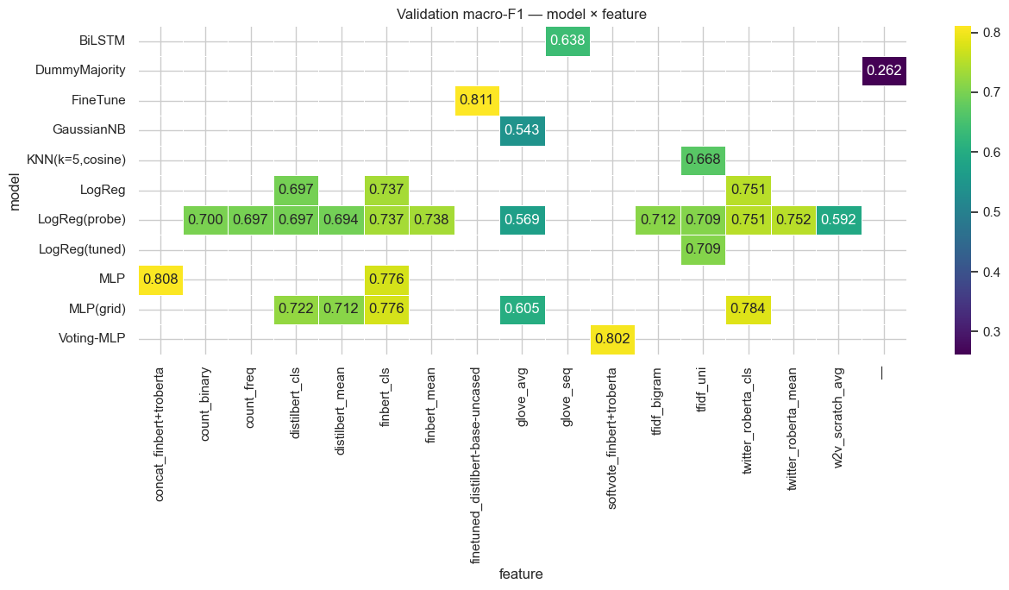
Figure 4. Validation macro-F1 for every model × feature combination tested. Brighter = higher.

6.1 Final scoreboard
Every approach beats the 0.262 majority baseline, and the ordering is coherent from fine-tuned and ensembled domain transformers at the top, through the strong TF-IDF linear baseline, down to recurrent and averaged-embedding models and the generative decoders.
Model (representative) | Feature | Macro-F1 | Accuracy
Fine-tuned DistilBERT (end-to-end) — extra | raw text | 0.811 | 0.853
Concat FinBERT ⊕ twitter-roberta → MLP — submitted | frozen CLS | 0.808 | 0.859
Soft-vote of the two domain encoders | frozen CLS | 0.802 | 0.851
twitter-roberta (frozen) → MLP | frozen CLS | 0.784 | -
FinBERT (frozen) → MLP | frozen CLS | 0.776 | -
twitter-roberta (frozen) → LogReg | frozen CLS | 0.751 | -
FinBERT (frozen) → LogReg | frozen CLS | 0.737 | -
TF-IDF → LogReg (best non-transformer) | TF-IDF uni | 0.709 | 0.781
DistilBERT (frozen, generic) → LogReg | frozen CLS | 0.697 | -
KNN (k=5, cosine) | TF-IDF uni | 0.668 | 0.765
BiLSTM | GloVe seq | 0.638 | 0.722
MLP | GloVe avg | 0.605 | 0.742
Gaussian Naive Bayes | GloVe avg | 0.543 | 0.660
Decoder — Ollama llama3.2:3b (zero-shot) | prompt | 0.446 | -
Decoder — GPT-2 (best of 3 modes) | prompt | 0.247 | -
Majority-class baseline | - | 0.262 | 0.647

For the submitted model, the four required metrics broken down per class (validation set, n = 1,909) are shown below. Recall is the share of each true class the model actually recovers — the metric that matters most given the imbalance, because it exposes whether the minority Bearish and Bullish classes are being missed.
Class | Precision | Recall | F1 | Support
Bearish | 0.807 | 0.667 | 0.730 | 288
Bullish | 0.779 | 0.790 | 0.785 | 385
Neutral | 0.892 | 0.925 | 0.908 | 1,236
Macro avg | 0.826 | 0.794 | 0.808 | 1,909
Accuracy |  |  | 0.859 | 1,909

Recall reads directly in context: the model recovers 92.5% of Neutral tweets, 79.0% of Bullish, but only 66.7% of Bearish — the rarest class is the hardest to catch, and the third of missed Bearish tweets are overwhelmingly labelled Neutral rather than Bullish (see error analysis below). Per-class recall, precision and F1 for every one of the 11 models tested are tabulated in Appendix A.

6.2 Error analysis of the submitted model
Of the 1,909 validation tweets the submitted concat ensemble misses 270 (14%), and the mistakes are almost entirely about the Neutral boundary. Directional → Neutral dominates (Bearish → Neutral 71, Bullish → Neutral 67 = 138), Neutral → directional is next (93 total), and cross-directional Bull ↔ Bear confusions are rare (39). The model is conservative: it labels factual-sounding headlines Neutral even when they imply direction (e.g. "HollyFrontier OKs new $1 billion stock buyback..." → Neutral), and it almost never flips bullish ↔ bearish. The genuinely ambiguous Neutral class — arguably the hardest, most subjective boundary in financial-news sentiment — is the main reason ~14% of headlines remain misclassified.
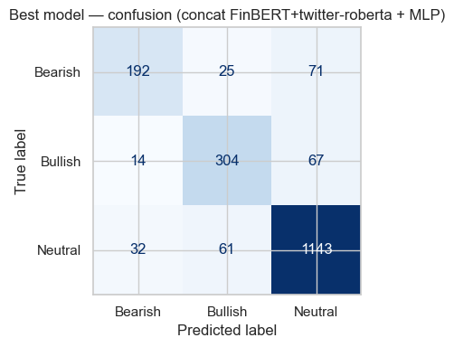
Figure 5. Confusion matrix of the submitted model on the 1,909-tweet validation set.

6.3 What the evaluation means
Imbalance handling was decisive. Choosing macro-F1 as the headline metric, stratifying the split and CV, and class-weighting took Bearish F1 from 0.00 under the always-Neutral baseline to 0.74 in the best model, and no model collapsed to the majority class once weighting or a nonlinear head was in play (the concat ensemble reaches Bearish 0.73, Bullish 0.78, Neutral 0.91). For an investor reading these tweets, that means the system is genuinely usable on the directional classes that carry trading signal, not just on the easy Neutral majority.

7. Extra Work (declared)

7.1 Extra feature-engineering and decoder-for-classification methods
Three items count as declared extra work under the handout's feature-engineering and decoder provisions: (i) two domain-specialised Transformer encoders (FinBERT, twitter-roberta) beyond the in-class DistilBERT; (ii) mean-pooling as an alternative to CLS pooling for every encoder; and (iii) turning a generative decoder into a classifier. For the decoder we ran a non-instruction-tuned GPT-2 and a local instruct model (Ollama llama3.2:3b) side by side on the same 300-tweet validation sample, using an output indicator ("reply with ONLY 0/1/2") and in-context learning (zero-/one-/few-shot).
Backend | Zero-shot | One-shot | Few-shot | Best
GPT-2 (base, non-instruct) | 0.247 | 0.112 | 0.221 | 0.247
Ollama llama3.2:3b (instruct) | 0.446 | 0.271 | 0.359 | 0.446
Majority-class baseline | 0.262 | - | - | 0.262
Best encoder (Section 6) | - | - | - | 0.811

Four findings emerge. Instruction-tuning is the decisive factor (+0.20 zero-shot macro-F1): given an identical prompt, only the instruct model reliably emits a valid 0/1/2, while GPT-2 — pretrained purely to continue text — stays at or below the 0.262 baseline in every mode. One-shot actually hurt the instruct model (0.271 < 0.446): a single Bearish example destabilised it into predicting Neutral for all 300 samples, a well-known in-context instability for small models. Few-shot partially recovered it (0.359), but Bearish, the rarest class, was never predicted by either model in any mode. And even the instruct model's best (0.446) trails the fine-tuned encoder (0.811) by ~45% relative — generating a label from a language prior is structurally weaker than discriminative features optimised directly on the task. For short, lexicon-driven financial tweets, encoders are the right tool and the decoder is an instructive baseline.

7.2 Agentic orchestration of the pipeline (Challenge 2)
We wrapped the trained classifiers as tools and built a conversational agent that performs non-trivial coordination rather than a single direct LLM classification. It routes by confidence — returning the fast TF-IDF + LogReg prediction when its top probability is ≥ 0.60, otherwise escalating to the twitter-roberta + LogReg model — reconciles agreement and disagreement by handing genuine fast-vs-deep conflicts to a GPT-2 adjudicator, exposes an automated-evaluation intent, and replies through a chat loop with a full decision trace. A LangChain Tool/agent wrapper is also provided to meet the framework requirement, while the primary implementation is explicit orchestration because small CPU models are unreliable as fully autonomous ReAct agents. On demo tweets the routing behaves sensibly, confidently answering clear Bullish/Bearish/Neutral cases and the auto-eval intent reports macro-F1 0.814 on a 100-tweet subsample. We are honest about the limit: that 0.814 is a small-sample number and not comparable to the full-validation scores; the agent's wrapped classifiers (0.709 and 0.751) are each weaker than the concat ensemble (0.808), so orchestration delivers no macro-F1 gain over the best single model. Its value is the workflow — a usable conversational interface, confidence-based triage, disagreement reconciliation and automated evaluation.

8. Conclusions and Final Model
The clearest lesson from our experiments concerns the reader rather than the decider — the encoder that turns a tweet into numbers, not the classifier that labels them. Financial tweets are full of specialised language, from cashtags such as $AAPL to percentage moves and phrases like 'downgraded' or 'beats estimates', and a general-purpose reader simply misses it. Our results form a short ladder. A general reader with no financial knowledge (frozen DistilBERT) paired with a simple decider scores 0.697. Switching to a reader already trained on finance and tweets (twitter-roberta) is the single largest step, lifting the score to 0.751. A stronger decider — an MLP in place of logistic regression — raises it to 0.784, and combining our two finance readers takes it to 0.808. A separate route, fine-tuning the general reader on our own data, reaches 0.811, essentially the same level. Both paths that make the reader finance-aware converge near 0.81, and once that point is reached the decider and the remaining refinements matter only at the margin. Because the gains shrink at every step (+0.05, then +0.03, then +0.02), we submit the lighter, cache-friendly pair of frozen finance readers rather than the heavier fine-tuned model.
The same ladder, with the plain description and the exact models used at each step:
Step | What we changed | Reader (encoder) | Decider (classifier) | Macro-F1 | Gain
Start | plain reader, no finance + simple decider | DistilBERT – frozen, general-purpose | Logistic Regression | 0.697 | —
1 | swap to a finance-aware reader | twitter-roberta – frozen, finance/tweets | Logistic Regression | 0.751 | +0.05
2 | give it a smarter decider | twitter-roberta – frozen | MLP (256, 128) | 0.784 | +0.03
3 | combine two finance readers (submitted) | FinBERT + twitter-roberta – frozen, combined | MLP (256, 128) | 0.808 | +0.02
Alt | instead: fine-tune the plain reader | DistilBERT – fine-tuned end-to-end | built-in head (end-to-end) | 0.811 | ≈ step 3

Read top to bottom, the score climbs 0.697 → 0.751 → 0.784 → 0.808 as we first give the reader finance knowledge, then a smarter decider, then a second finance reader; the “Alt” row is the separate fine-tuning route, which lands at essentially the same 0.81.
Submitted model: concatenation of FinBERT and twitter-roberta CLS embeddings → MLP(256,128), validation macro-F1 0.808, accuracy 0.859 (Bearish 0.73 / Bullish 0.78 / Neutral 0.91).
Fine-tuned DistilBERT scores marginally higher (0.811) but only by +0.003 macro-F1, within noise. We submit the concat ensemble because its frozen embeddings are already cached, it needs no full-model inference at test time, and the margin is negligible. Refitting this pipeline on the full 9,543-tweet training set and predicting the 2,388 blind test tweets yields pred_12.csv (columns exactly id,label, labels in {0,1,2}) with a predicted distribution of Bearish 14.0%, Bullish 18.7%, Neutral 67.3% — close to the training distribution and consistent with the model's mild conservative Neutral bias, with no class collapse. On the blind test we expect performance a little below 0.808, with the same conservative Neutral boundary as the main risk.

Appendix A — Full per-class evaluation of all models
Per-class Precision, Recall and F1 on the fixed 1,909-tweet validation set (support: Bearish 288, Bullish 385, Neutral 1,236), reproduced from the scikit-learn classification reports printed by the shared evaluate() routine in tm_tests_12.ipynb. Models are ordered by macro-F1. The submitted model is the concatenation ensemble; the fine-tuned encoder is declared extra work.
Model / Feature | Class | Precision | Recall | F1 | Accuracy | Macro-F1
Fine-tuned DistilBERT (extra)  raw text | Bearish | 0.72 | 0.76 | 0.74 | 0.853 | 0.811
 | Bullish | 0.82 | 0.77 | 0.79
 | Neutral | 0.89 | 0.90 | 0.90
Concat FinBERT+twitter-roberta + MLP (submitted)  frozen CLS | Bearish | 0.81 | 0.67 | 0.73 | 0.859 | 0.808
 | Bullish | 0.78 | 0.79 | 0.78
 | Neutral | 0.89 | 0.92 | 0.91
Soft-vote of the two domain encoders  frozen CLS | Bearish | 0.75 | 0.71 | 0.73 | 0.851 | 0.802
 | Bullish | 0.81 | 0.75 | 0.78
 | Neutral | 0.88 | 0.92 | 0.90
twitter-roberta (frozen) + LogReg  frozen CLS | Bearish | 0.59 | 0.77 | 0.67 | 0.797 | 0.751
 | Bullish | 0.68 | 0.79 | 0.73
 | Neutral | 0.92 | 0.81 | 0.86
FinBERT (frozen) + LogReg  frozen CLS | Bearish | 0.59 | 0.76 | 0.67 | 0.786 | 0.737
 | Bullish | 0.65 | 0.74 | 0.69
 | Neutral | 0.90 | 0.81 | 0.85
TF-IDF + LogReg (class-weighted)  TF-IDF uni | Bearish | 0.57 | 0.60 | 0.59 | 0.781 | 0.709
 | Bullish | 0.68 | 0.69 | 0.68
 | Neutral | 0.87 | 0.85 | 0.86
DistilBERT (frozen, generic) + LogReg  frozen CLS | Bearish | 0.51 | 0.69 | 0.59 | 0.757 | 0.697
 | Bullish | 0.62 | 0.71 | 0.67
 | Neutral | 0.90 | 0.79 | 0.84
KNN (k=5, cosine)  TF-IDF uni | Bearish | 0.62 | 0.47 | 0.53 | 0.765 | 0.668
 | Bullish | 0.62 | 0.61 | 0.61
 | Neutral | 0.83 | 0.89 | 0.86
BiLSTM  GloVe seq | Bearish | 0.40 | 0.69 | 0.51 | 0.722 | 0.638
 | Bullish | 0.68 | 0.49 | 0.57
 | Neutral | 0.87 | 0.80 | 0.84
MLP (tuned)  GloVe avg | Bearish | 0.61 | 0.32 | 0.42 | 0.742 | 0.605
 | Bullish | 0.60 | 0.51 | 0.55
 | Neutral | 0.79 | 0.91 | 0.85
Gaussian Naive Bayes  GloVe avg | Bearish | 0.38 | 0.31 | 0.34 | 0.660 | 0.543
 | Bullish | 0.43 | 0.58 | 0.49
 | Neutral | 0.83 | 0.76 | 0.79

Reading note: across every model, Neutral recall is the highest and Bearish recall the lowest, and class-weighting plus a nonlinear head is what lifts Bearish recall from 0.31 (Gaussian NB) to 0.67–0.76 in the top models — the central evaluation story of the project.

Appendix B — Confusion-matrix gallery
Validation-set confusion matrices (true label by row, predicted by column) for every classifier in Section 5 not already shown in the main body. The exploratory-analysis charts (label distribution, word clouds, domain signals), the model × feature heatmap and the submitted model's confusion matrix appear as Figures 1–5 in the main report.
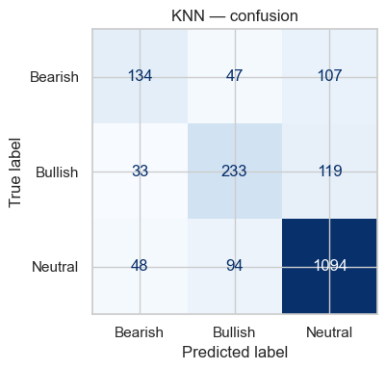  B-1. KNN (k=5) on TF-IDF | 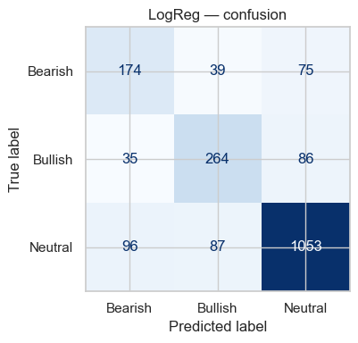  B-2. Logistic Regression on TF-IDF

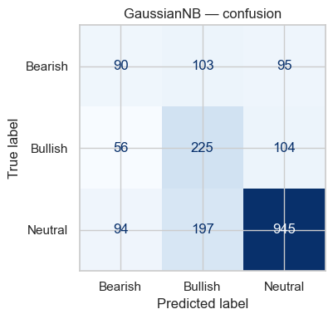  B-3. Gaussian Naive Bayes on averaged GloVe | 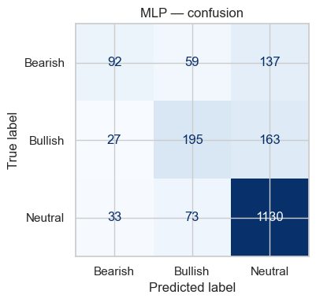  B-4. MLP on averaged GloVe

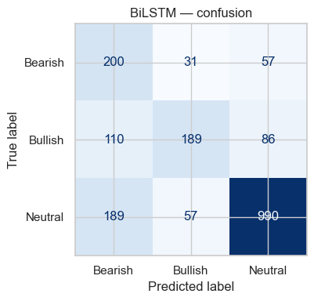  B-5. BiLSTM on GloVe sequences | 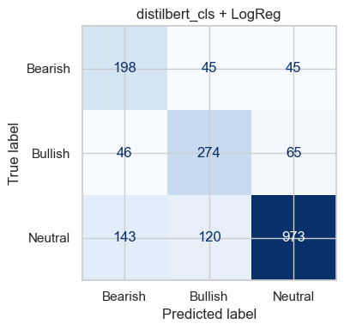  B-6. DistilBERT (frozen) + LogReg

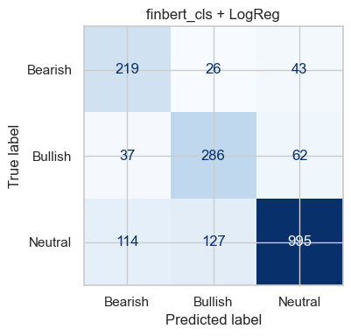  B-7. FinBERT (frozen) + LogReg | 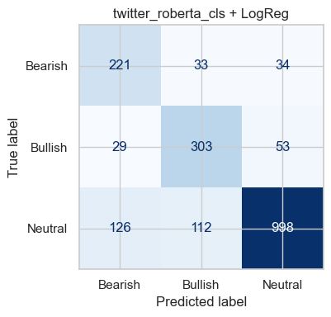  B-8. twitter-roberta (frozen) + LogReg

Appendix C — Supplementary experimental data

C.1 Preprocessing and feature-engineering probe scores
Each representation was scored with a fixed Logistic Regression probe on the same split, so representations are compared on equal footing.
Stage / Representation | Variant | Validation macro-F1 | Notes
Preprocessing | Conservative (ticker/pct/num, keep negation) | 0.7092 | kept; vocab 11,368
Preprocessing | Aggressive (lab-style) | 0.7018 | vocab 11,364
BoW | TF-IDF (1,2)-gram | 0.7120 | best BoW; vocab 10,422
BoW | TF-IDF unigram | 0.7092 | carried forward
BoW | Count (binary / frequency) | 0.7003 / 0.6973 | -
word2vec | Word2Vec from scratch (avg) | 0.5916 | -
word2vec | GloVe-Twitter (avg) | 0.5689 | carried to BiLSTM
Transformer | twitter-roberta (mean / cls) | 0.7517 / 0.7510 | strongest representation
Transformer | FinBERT (mean / cls) | 0.7376 / 0.7372 | -
Transformer | DistilBERT (cls / mean) | 0.6970 / 0.6942 | generic baseline

C.2 Best hyperparameters (grid/CV search)
Model | Selected hyperparameters | CV macro-F1 | Val macro-F1
KNN | k = 5 (cosine) | - | 0.668
Logistic Regression | C = 1.0, class_weight=balanced | - | 0.709
MLP (GloVe) | activation=tanh, hidden=(64,), lr=0.01 | - | 0.605
twitter-roberta + MLP | alpha=1e-4, hidden=(256,128) | 0.793 | 0.784
FinBERT + MLP | alpha=1e-4, hidden=(128,) | 0.779 | 0.776
DistilBERT + MLP | alpha=1e-3, hidden=(256,128) | 0.706 | 0.722
Fine-tuned DistilBERT | 3 epochs, class-weighted CE, best @ epoch 2 | - | 0.811

C.3 Decoder-as-classifier and submission distribution
The decoder comparison (validation macro-F1, 300-tweet sample) is reported in Section 7.1. The final submitted pipeline, refit on all 9,543 training tweets, predicts the 2,388 blind test tweets with the following class distribution, close to the training prior (15.1 / 20.2 / 64.7%):
Predicted class | Count | Share
Bearish (0) | 335 | 14.0%
Bullish (1) | 447 | 18.7%
Neutral (2) | 1,606 | 67.3%
Total | 2,388 | 100%

