1, February 2017  
Simon Popecki  
Sydney Michalak  
SensitiviT Industries Ltd.  
Nowhere, YS 66666

Mr. Cake,

As you have requested, we have reviewed the methods for determining the thermal time constant τ of your temperature sensors in water under varying conditions. In addition to your current method of determining the onset of the temperature change, the five-sigma method, we have devised a method which defines the onset of temperature change as the point where the slope of the temperature vs. time curve is the greatest. We call this method the max slope method, and we have determined that is provides the best results.

In this report, we compare the results of the five-sigma method with the results of the max slope method. Our computer program analyzes the response of aluminum, steel, and bare wire thermocouples and outputs the results as plots temperature vs. time, along with a solution of the time constant for each trial.

This report contains information about our experimental methods, experimental results, equipment used, a summary, and other useful figures and information. Please contact us with any questions you may have.

Best Regards,



Simon Popecki & Sydney Michalak  
University of New Hampshire  
College of Engineering and Physical Sciences  
Department of Mechanical Engineering  
Durham NH, 03824

STATIC AND DYNAMIC CHARACTERISTICS OF THERMOCOUPLE MEASUREMENT SYSTEMS

Sydney Michalak  
Simon Popecki

UNIVERSITY of NEW HAMPSHIRE

26, February 2017

EXECUTIVE SUMMARY

Text here

TABLE OF CONTENTS

EXECUTIVE SUMMARY 3

INTRODUCTION 5

EXPERIMENTAL METHODS 7

EXPERIMENTAL RESULTS AND DISCUSSION 11

SUMMARY AND CONCLUSIONS 12

APPENDIX 13

REFERENCES 14

**INTRODUCTION**

The purpose of this experiment was to review and analyze different methods for determining the thermal time constant, (τ), in water, for different thermocouple temperature sensors. All thermocouples were exposed to a step change in temperature, either from boiling water to an ice bath or from an ice bath to boiling water. To determine the start time of the response due to the change in temperature, we used two unique methods.

The first method was defined by the time corresponding to the point when the temperature differed by more than 5 standard deviations from the baseline temperature. The baseline temperature is defined as the average of the temperature values prior to the event onset. Note that the five-sigma method, figure 1 (a), captures the event onset upon transfer from water to air. The second method was the maximum slope onset method, which we found to be more accurate. It involved finding the time corresponding to the point of maximum slope in the temperature vs. time plot. Figure 1 demonstrates the higher accuracy of the maximum slope onset method vs. the 5σ onset method - the max slope method captures the event onset upon transfer from air to water.



Figure 1 - Bare Wire Thermocouple Transition from boiling water to ice bath. (a) 5σ onset method; ln(Γ) vs. t best fit method to calculate τ. (b) Maximum slope onset method; ln(Γ) vs. t best fit method to calculate τ.

Using the time found by each separate onset method, we determined the time constant by finding the time it took the temperature to reach 63.2% of the final value, as well as finding the linear regression best fit line of ln(Γ) vs. time, knowing that the slope of this line, (a­o) is inversely proportionate to the time constant (equation 1). The relationship between gamma (Γ), the time constant, Tinitial, and Tfinal is shown in equation 2. We found in general, the most exact way to determine the time constant was by using the maximum slope onset method in combination with the best fit line’s slope of ln(Γ) vs. time.

(1)

(2)

We evaluated the accuracy of each analytic procedure (to find the time constant) by comparing plots of the residuals vs. time, as well as relating the actual data to the prediction (*resulting from any given procedure*), by comparing standard errors of the fit.

**EXPERIMENTAL METHODS**

The measurement system we used in this experiment consisted of the following equipment:

* NI (National Instruments) PXIE-8360 – Computer Interface
* NI PXI-5412 – Function Generator
* NI PXI-4110 – DC Power Supply
* NI PXI-5142 – Oscilloscope
* NI-4065 – Digital Multimeter
* NIUSB-6212 – Data Acquisition Module
* Oster Deep Fryer (for hot water bath)
* Precise Temperature Baths
* Thermocouples – a bare wire thermocouple, a thermocouple embedded in 304 Stainless Steel, and a thermocouple embedded in a 6061 Aluminum alloy (the embedded thermocouples were buried in ½” diameter, 2” long metal slugs)
* Omega Thermistor
* AD594 Monolithic Instrumentation Amplifier (for thermocouple output)
* MATLAB and NI software for data acquisition and interpretation

**Measuring Thermocouple Output**

We connected each thermocouple to the instrumentation amplifier such to supply a more easily measurable voltage output (thermocouples were connected one at a time, for the duration of each test). We used an input of +15 V and -15 V to power the AD594 instrumentation amplifier. The amplifier output was sent to an analog to digital converter, where a computer interpreted the data. Thermocouple measurements were taken by reading the output voltage with the NI software.

Figure 2 – A block diagram of the experimental setup

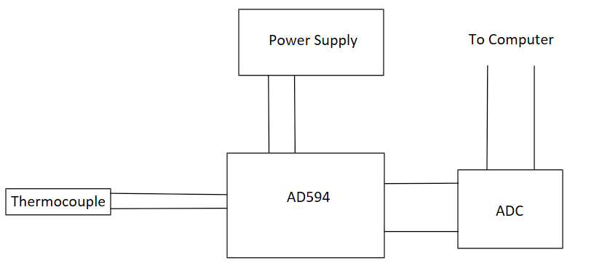

**Measuring Thermistor Output**

We used a thermistor to calibrate the output of the thermocouple. The accuracy of the thermistor’s measurements are within ±0.2 ℃. We calibrated the thermistor by immersing it in two baths of known temperatures – an ice bath, assumed to be 0 ℃, and boiling water, assumed to be 100 ℃. The thermistor constants are: Ro: 9647.88 Ω and β: 3617.58 K, calculated using the thermistor equation which is shown below, where To is 298.15 K.

(3)

**Hot and Cold Water Baths**

We used an Oster deep fryer to heat 1.5 L of water to a boil, liquid water was replaced periodically to keep the volume relatively constant. The cold water bath was a bowl of ice filled with water. When sensors were immersed in the hot water bath, they were placed in such a way that they would not touch the bottom or sides of the container. When placed in the cold water bath, the sensors came into direct contact with ice. The assumption that the ice water bath is 0 ℃ can be maintained to the confidence of ±0.1 ℃ based on the purity of city water in the town of Durham NH, where we conducted this experiment. The local air pressure can affect the boiling point of water. The National Oceanic and Atmospheric Administration operates a weather station near the location of this experiment (Station IOSN3). The barometric pressure at sea level at the exact time of the experiment was 1009.5 mBar. The sea level pressure in the seacoast region of New Hampshire historically varies between 1005 mBar and 1025 mBar during the month of February [1]. The calculated boiling point range is therefore between 99.77 ℃ and 100.32 ℃, leaving an uncertainty of ±0.27 ℃ [2]. The expected boiling point at the time of the experiment is 99.90 ℃.

**Methods of Data Analysis**

We determined static sensitivity by immersing both the bare wire thermocouple, and the thermistor in water baths of known temperatures. We then plotted their Temperature data together such that a perfect response from each sensor would yield a line with a slope of 1. This plot can be found in the appendix. We determined the confidence intervals to 95% confidence. 10 data points were used for this calculation.

**Determination of Time Constants**

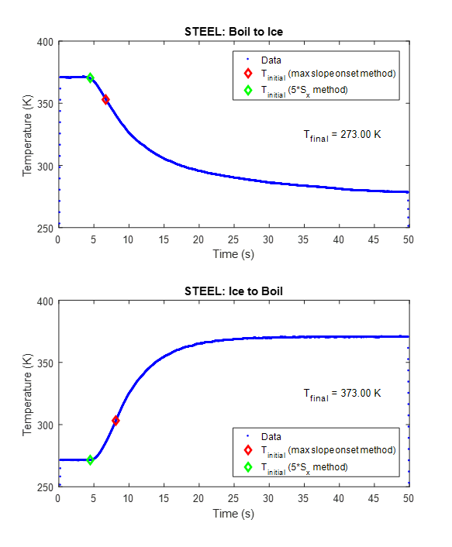

Figure 3 – A Temperature vs. Time curve of the stainless steel embedded thermocouple transitioning from the ice water bath to the boiling water bath.

The error fraction ln(Γ) used to obtain the time constant τ is found by taking the natural log of Γ, shown below (equation 2)

(2)

We plotted time vs. ln(Γ), then found the best fit line using the method of linear regression. The slope of this best fit line is equal to the negative inverse of the time constant, ao. We then manipulated ao to solve for the time constant, τ (equation 1).

(1)

The data inputted to the best fit line function in MATLAB were truncated to prevent imaginary numbers in the predicated value of ln(Γ), which would be caused by taking the natural log of a negative number. The y-intercept of our time value was forced to zero because the MATLAB function we used required this assumption to work properly (i.e. the beginning of the temperature change event occurred at time t=0, and any time leading up to this event is negative).

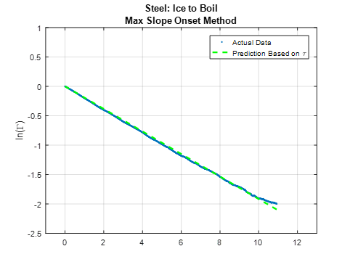

Figure 4 – A typical plot of ln(Γ) vs. time. The slope of the green dashed line is used to directly calculate the time constant, τ

A second method used the assumption that the time constant is the time at the index of the time/temperature array, where the following condition is true (equation 4)

(4)

In MATLAB, the temperature at the point where time is equal to one time constant can be solved for by equation 4, and the time constant is at the same index in the time array that this temperature is at in the temperature array. See figure 1 in introduction.

EXPERIMENTAL RESULTS AND DISCUSSION

SUMMARY AND CONCLUSIONS

APPENDIX

REFERENCES

|  |  |
| --- | --- |
| [1] | National Oceanic and Atmospheric Administration, "National Data Buoy Center," 26 February 2017. [Online]. Available: www.ndbc.noaa.gov/view_climplot.php?station=iosn3&meas=sl. [Accessed 26 February 2017]. |
| [2] | A. Shipway and S. Shipway, "Boiling Points," 2008. [Online]. Available: www.calctool.org/CALC/chem/substance/boiling. [Accessed 26 February 2017]. |