Simon Popecki
ME646
3 April 2017
INTERNAL COMBUSTION ENGINE LAB

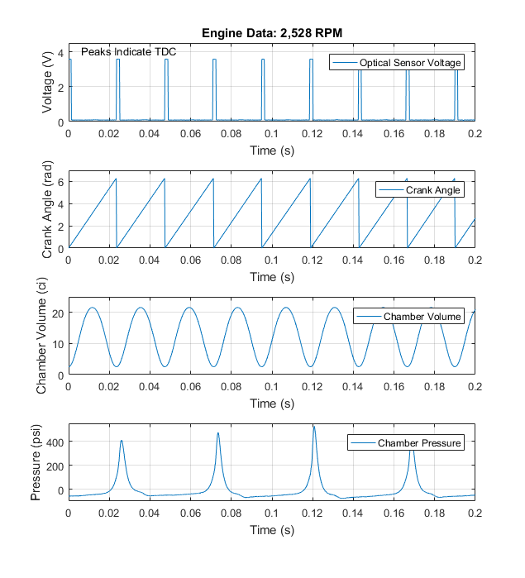
Figure 1 – Engine activity with respect to time. These data were recorded from the Kohler CH20s two cylinder, four stroke engine.
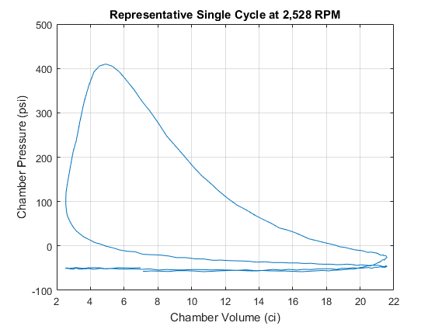
Figure 2 – A representative thermodynamic cycle at 2,528 RPM (800 RPM after the gearbox). The cycle bears some resemblance to the ideal Otto cycle from which it is based.

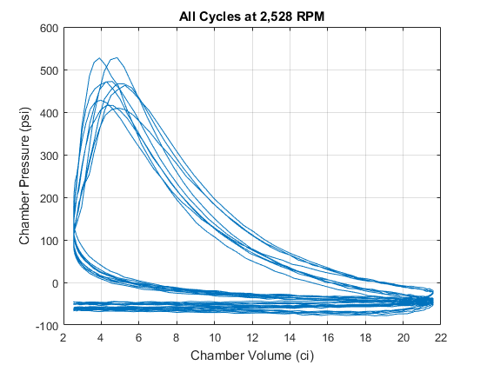
Figure 3 – For the same engine speed, all cycles are overlaid to give an idea of what the average thermodynamic cycle looks like. The thermodynamic cycle takes place over two mechanical crankshaft revolutions.

