Simon Popecki  
27 March 2017  
ME 646, J-Lab

PRESSURE TAP LAB

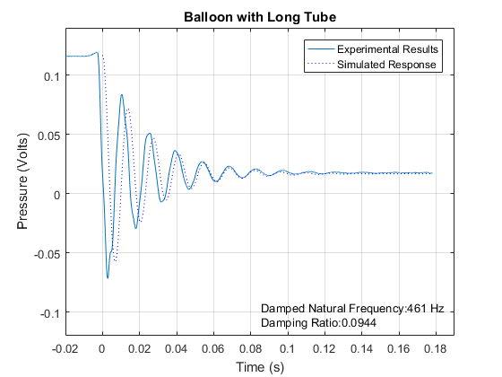

Figure – Experimental results were obtained by popping a balloon attached to a long tube (42.75”). The popping of the balloon simulates a step function. The damping ratio was found using the two methods used in lab 3, method 1, the least squares method was used for all trials. After finding the damping ratio and the damped natural frequency, a simulated response was plotted and compared to the original. For this trial the simulated results were very close to the experimental results. Pressure was measured in voltage – actual pressure shares a linear relationship however no calibration was done in the lab.

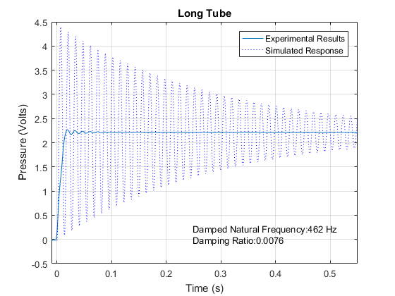

Figure – This figure shows a scenario similar to figure 1, however these data were collected by releasing a valve instead of popping a balloon. The less aggressive release of air does not simulate a step response as well, and the resulting data do not match the simulated response as well as other trials. This is likely because the real system is more of a ramp function than a step function.

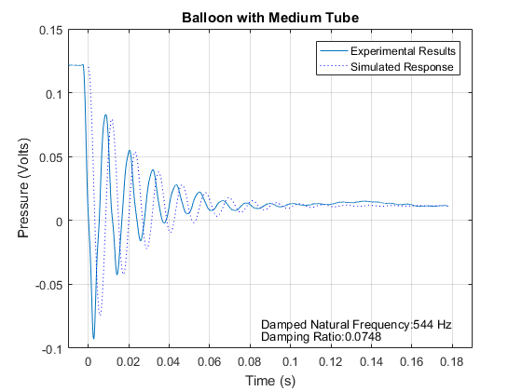

Figure – This scenario used a balloon to generate a step response with the medium tube (34”). The experimental response matches the simulated response well. It does make sense however, that the medium balloon has a higher natural frequency – there is less air in the tube, and therefore less mass.

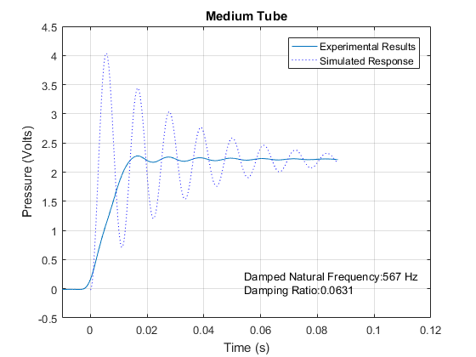

Figure – This figure shows the response of the medium tube coupled with the valve to generate a step response. The simulated results do not match the experimental results well.

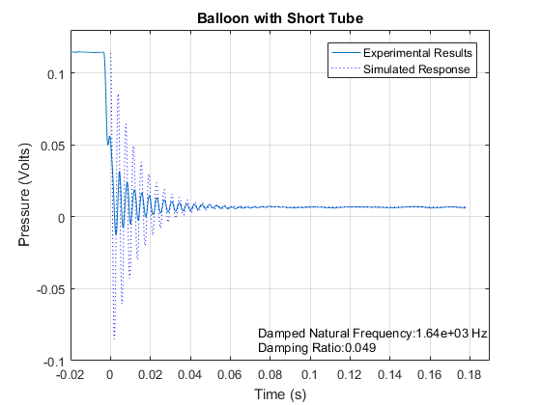

Figure – The balloon with the short tube (7.375”) uses a balloon to simulate a step response. The computer simulated response has a mediocre fit with the experimental results.

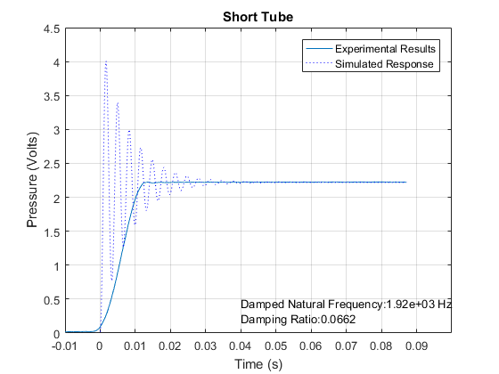

Figure – The sort tube without the balloon generated step function has poor data Only 2 peaks were found using the MATLAB peakdet function, so the results of this test cannot be taken as confident results. The simulated response did not match the experimental response well.

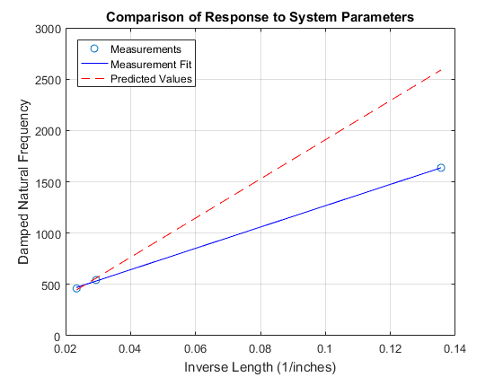

Figure – The comparison of natural frequency to the inverse of the tube length. The slope of the measured data best fit line was 10395 (Hz\*in). The slope of the predicted values was 19097 (Hz\*in). The error was 46%. The prediction was found using equation 1.

Line Data:   
measured data: ω=10395(Hz\*in) \* x(1/in) + 227.3705(Hz)  
predicted values: ω =19097(Hz\*in) \* x(1/in) -9.3124e-13(Hz)

Equation 1:

$$ω_{n}=\frac{a}{l\sqrt{.5}}$$

Equation 2:

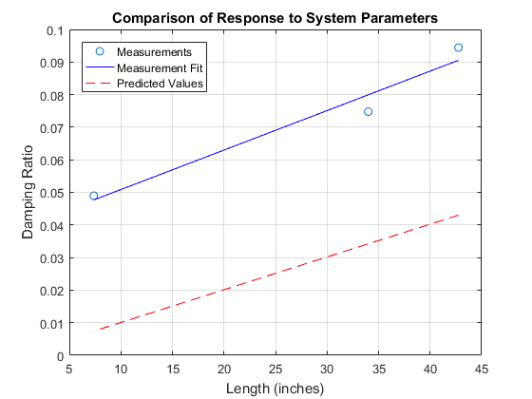

Figure – A comparison between damping ratio and tube length. The slope of the measurement best fit line was .0012 and the slope of the predicted values best fit line was .001. The error between the two was 16.7%. The predictions were found using equation 2. The blue line was found using the damping ratio function made for lab 3, the dashed line was made using Equation 2.

Line Data:  
measured data line equation: ζ=.0012(1/inches) \* x(inches) + .0388  
predicted values line equation: ζ =.001(1/inches) \* x(inches) + 1.0593e-18

$$ζ=\frac{16μl}{aρd^{2}}\sqrt{.5}$$