# MECHANICAL SYSTEM MODELLING

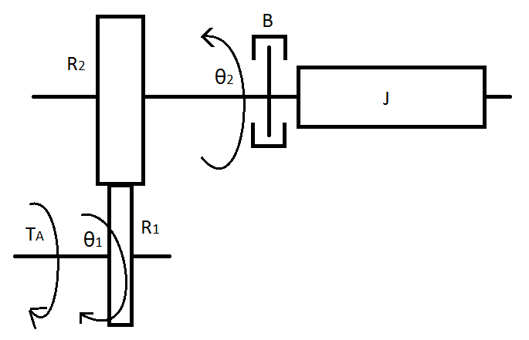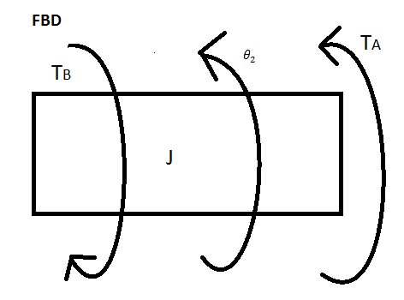

The system model above describes our rotational cylinder setup. The system has a mass, a spring, and a damper. However, the spring effect is negligible in comparison to the magnitudes of other factors, therefore it is not included in the equations below and diagram above.

The gear factors and the angle of our motor can be represented as:

$$R_{1}θ_{1}=R_{2}θ_{2}$$

Similarly, the angular velocity is given by:

$$R_{1}{\dot{θ}}_{1}=R_{2}{\dot{θ}}_{2}$$

From our free body diagram, the equation of motion for the system is:

$$J\ddot{θ_{2}}=-B{\dot{θ}}_{2}+T_{A}(t)$$

$$J\ddot{θ_{2}}+B{\dot{θ}}_{2}=T_{A}(t)$$

Substituting the known angle θ1 values gives:

$$J\frac{R_{1}}{R_{2}}{\ddot{θ}}_{1}+B\frac{R_{1}}{R_{2}}{\dot{θ}}_{1}=T_{A}(t)$$

Finding the Laplace transform:

$$J\frac{R_{1}}{R_{2}}s^{2}ϴ_{1}(S)+B\frac{R_{1}}{R_{2}}sϴ_{1}(S)=T_{A}(S)$$

$$(J\frac{R_{1}}{R_{2}}s^{2}+B\frac{R_{1}}{R_{2}}s)ϴ_{1}(S)=T_{A}(S)$$

Expressing in terms of angular velocity:

$$(J\frac{R_{1}}{R_{2}}s+B\frac{R_{1}}{R_{2}}){\dot{ϴ}}_{1}(S)=T_{A}(S)$$

The transfer function between the input torque TA and output angle is given by:

$$G\left(s\right)=\frac{{\dot{ϴ}}_{1}\left(S\right)}{T_{A}(s)}=\frac{1}{J\frac{R_{1}}{R_{2}}s+B\frac{R_{1}}{R_{2}}}$$