COMPUTER CONTROL OF MAGNUS EFFECT AIRFOIL  
ME 670

Simon Popecki  
James Skinner  
Jesse Feng

CONTENTS

EXPERIMENTAL SETUP 3

DESCRIPTION OF CODE 4

CODE 5

# EXPERIMENTAL SETUP

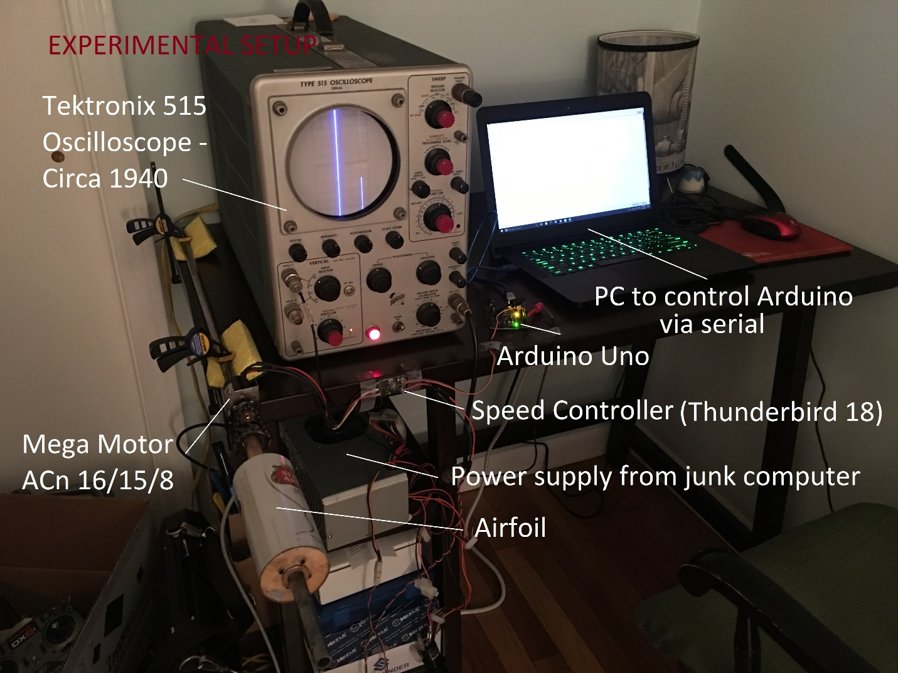Ink Drawings
Personal Computer
Ink Drawings
Arduino UNO
Ink Drawings
Ink Drawings
Ink Drawings
Tektronix 515
Oscilloscope
Ink Drawings
Thunderbird 18
ESC
Ink Drawings
DC Power Supply
(12 V)
Ink Drawings
Ink Drawings
MEGA ACn 16/15/8
Brushless Motor
Ink Drawings
Ink Drawings


# INTRODUCTION

Code was written in C++ and compiled using the Arduino IDE built in compiler. The program is stable on the Elegoo UNO (Arduino UNO clone) with ATmega16U2 processor architecture. This program features proportional control.

A human operator is able to communicate with the Arduino via serial over USB. An arbitrary input (in this case a desired power level in percentage) can be sent to the Arduino which will subsequently determine the difference between the current outputted pulse width, and the target pulse width to be sent to the electronic speed controller. The Thunderbird 18 will not accept conventional 490 Hz PWM from the Arduino’s built in PWM pins. Instead a 50 Hz pulse must be sent, with a duty cycle of 1-2 milliseconds on, and total period of 20 milliseconds. These values were found by copying the output of a Spektrum dx6i transmitter and BR6000 receiver by watching pulse width values on the Tektronix 515 oscilloscope. A 1 millisecond *on* pulse corresponds to zero throttle, and a 2 millisecond *on* pulse corresponds to full throttle.

# CODE

//MOTOR CONTROL PROGRAM FOR ME 670 FINAL PROJECT

//This program allows a user to input a motor power level with the serial monitor, and have the motor spin to that power

//This version allows for proportional control

//Simon Popecki

//James Skinner

//Jesse Feng

//Developed on Arduino UNO

//For: Thunderbird 18 ESC; MEGA Motor ACn 16/15/8

//This program is for temperamental electronic speed controllers that require the 50 Hz PWM signal given by hobby receivers (1-2 ms on, 18-19 ms off)

//A pulse width of 2 ms on represents full throttle, 1 ms

#include <**Servo**.h>

#include <stdint.h>

const uint8_t SIGNAL = 3; //this is the pin on the Arduino producing the signal for the ESC (does not need to be a PWM output pin)

const uint32_t BAUD = 9600; //rate of communication with the arduino

const uint8_t RESPONSETUNING = 4; //this is a proportional control parameter, it adjusts how fast the motor will reach the desired speed. Higher values decrease the response speed

const uint16_t TIMETUNING = 200; //this is another proportional control parameter, it adjusts how long the motor spins at a certain value during speed transient

uint16_t current = 1000; //the current pulse value - zero throttle to arm the ESC - this value must be 1000 microseconds during start up, but is changed later as the program runs when the variable is used for proportional control

Servo THUNDERBIRD; //Creating a servo object for the thunderbird 18 ESC (it is controlled the same way a servo would be)

void setup()

{

THUNDERBIRD.attach(SIGNAL); //this binds the servo object to a specific pin, the servo object is used instead of a pin number from here on out

**Serial**.begin(BAUD); //start a serial communication - make sure that the serial monitor is set to a BAUD of 9600, and no line endings!

**Serial**.println("Enter a motor speed (percentage of full throttle):");

THUNDERBIRD.writeMicroseconds(current); //initializing the ESC - it won't take any commands until it sees zero throttle (1000 microseconds). This is done in setup so the user doesn't have to do it in the terminal.

}

void loop()

{

while (**Serial**.available())

{

uint16_t target = **Serial**.parseInt(); //whatever number the user just typed in is the new motor pulse speed IN PERCENT!

**Serial**.print("New Speed: ");

**Serial**.print(target); //displaying the percentage value to the user before it is converted to a pulse width for the ESC to understand

**Serial**.print("%");

**Serial**.print('\n'); //new line for the next output

target = (target*10)+1000; //converting percentage to a pulse width for use with theThunderbird 18 ESC

int16_t difference = target-current; //finding the difference between the target speed (pulse length) and the current speed (pulse length) - the units are pulse width difference in microseconds

while (difference != 0)

{

int16_t response = difference/RESPONSETUNING; //response can be positive or negative, and uses a tuning factor to generate a value to be added or subtracted from the current pulse width to get closer to the target value

current = current+response; //updating the new speed of the motor by factoring in the response modifier

THUNDERBIRD.writeMicroseconds(current);

difference = target-current;

//Serial.println(difference); //the difference between the current speed setting and target speed setting can be displayed if desired

delay(TIMETUNING);

if ((difference <= 5) && (difference >= -5)) //if the difference is small enough then just ignore it and go straight to the target value

{

THUNDERBIRD.writeMicroseconds(target); //go straight to the target pulse width before terminating the while loop

current = target;

difference = 0; //terminates the while loop and resets the difference variable for further use

}

}

}

}