Objectives:

The characteristics of a mass-spring-damper system were determined through the use of a linear velocity transducer (LVT) that produces a voltage proportional to the velocity of a magnetic core. Next, the properties of a linear variable differential transformer were investigated by calibration through weights and beam deflection. The effects of modulation and filtering were also observed. Experimental frequency response of the system was then determined using Lab View Signal Express.

Theory:

2.3. LVDT Frequency Response

The break frequencies were found by extrapolating a linear fit for the horizontal line for usable bandwidth in the magnitude plot. Then the intersection points with the sloped filtered magnitude lines were found such that the error with the actual curve is about 3 dB. The frequencies at these two points are the break frequencies. See Figure #####



Figure : 1st Break Frequency Approximation. The larger time division data was used.



Figure : 2nd Break Frequency Approximation. The smaller time division data was used.

The LVDT system follows the following transfer function

From the spec sheet

The transfer function is in standard form, so time constant relationships can be used with the s coefficients in the denominator. is the input impedance, is the output impedance, and is the measuring impedance

Usable bandwidth is between the break frequencies, 308 Hz – 47.5 kHz

The theoretical sensitivity for any frequency within this bandwidth is determined by taking the magnitude of the transfer function for that range.

The sensitivity is defined from the bode plot as 0.0794 (-22 dB). Assuming x=0.1 in, the gain term is defined as follows

The total gain for the transfer function (numerator coefficient) can be found from

2.3 Discussion

Experimental Methods:

1. Linear Velocity Transducer

The LVT system was hooked up to the oscilloscope such that the trigger position could record a significant change in velocity of the shaft. The shaft was then dropped about an inch, which caused it to bounce off the foam. The first few oscillations left the foam and returned to freefall, however it soon became in constant contact with the foam and the signal quickly decayed.

2.1 LVDT Characteristics



The function generator was used to create an excitation voltage, which was a sin wave with an amplitude of 6V and a frequency of 2.5 kHz.

Next, both coil outputs were hooked up to the oscilloscope. The signals were investigated for a few different states: with the core at null, above null, and below null. The amplitude of the input voltage was then increased to 10 V, and a full wave demodulator was implemented. The signal was then “averaged” to get a single value that was proportional to displacement. This was made possible by a low-pass filter. Data was collected for the vibrating beam from both the demodulator and the filter output.

A FFT frequency plot was taken of the demodulated signal with the beam moving and not moving. The frequency scale was 4.9 – 5.1 kHz, with a time scale of 0.5 sec and 75K total data points.

2.2 LVDT System Calibration

The LVDT was calibrated first by weight. A plastic bucket of known weight was incrementally filled with various weights up to 500g. The corresponding filter output was recorded for each increment.

Next, the LVDT was calibrated using incrementing deflections from a micrometer set up on the free end of the beam. Each micrometer measurement corresponded to a filtered output. Finally, an under-damped 2nd order response was collected by flicking the beam and recording the signal.

2.3 LVDT Frequency Response

An experimental frequency response was collected from the LVDT system by using Lab View Signal Express and a DAQ. This was accomplished **by sending broadband noise through the input of the circuit to test the whole spectrum of frequency inputs. The input was connected to the NI DAQ (Figure 5) output terminals. Refer to “Using LabView for Frequency Responses” by M.H. deLeon [1] for a more in depth procedure.**

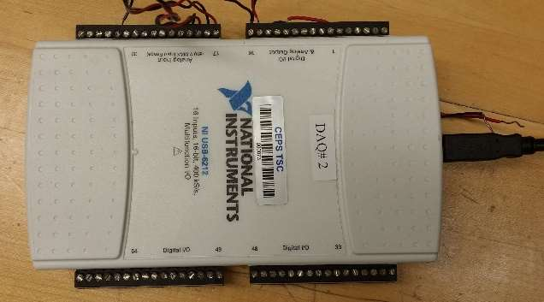

Appendix: