LAB 5 – VELOCITY CONTROL OF A DC BRUSHED MOTOR

University of New Hampshire

30. November 2017

Jesse Feng  
Simon Popecki  
Reilly Webb



***VELOCITY CONTROL OF A BRUSHED DC MOTOR***

|  |  |
| --- | --- |
| **Course Number and Name:**  ME 747 – Senior Lab | |
| **Semester and Year:**  2017 semester 2 | **Name of Lab Instructor:**  **Alireza Ebadi** |
| **Lab Section and Meeting Time:**  2b 14:00 | **Report Type:**  **External Group Report** |
| **Title of Experiment:**  **Velocity Control of a DC Brush Motor** | |
| **Date Experiment Performed:**  14. November 2017 | **Date Report Submitted:**  1 December 2017 |
| **Names of Group Members:**  Jesse Feng Simon Popecki Reilly Webb | **Grader's Comments:** |
| **Grade:** |

# Cover Letter

Jesse Feng  
Simon Popecki  
Reilly Webb  
33 Academic Way  
Durham, NH 03824

Alireza Ebadi  
33 Academic Way  
Durham, NH, 03824

Dr. Ebadi,

The following document contains an analysis of control systems for a DC brushed motor. DC motors are generally controlled via pulse width modulation and a microprocessor, however for the purpose of demonstration, we controlled DC motors with power op-amp driven proportion control, integral control, and proportional-integral control.

These control systems were compared against each other in terms of functionality- the motor parameters have been determined through experimentation.

The body of this report comprises of the results of inputs to the system and recorded system response.

Best Regards,

Jesse Feng

Simon Popecki

Reilly Webb

# Contents

Cover Letter 3

Contents 4

Objectives 5

Executive Summary 6

Theory and Experimental Methods 7

Results and Discussion 12

Conclusions 13

Appendix 14

# Objectives

The objective of this experiment was to compare different methods of control using a power operational amplifier. Proportional, Integral, and Proportional-Integral control systems controlled a motor under load to be measured by a second motor. The parameters of the motor were calculated, and the system response determined from experimental data. The motor back EMF, open-loop, and closed-loop response were analyzed in particular. Quantitative analysis was performed and interpreted. All relevant values are tabulated/listed. Gain values were confirmed by root locus analysis.

# Executive Summary

In this experiment, a DC brush motor under test (MUT) is coupled with a back-driving motor to determine the system parameters under step input and disturbance loading conditions. The system was also subjected to three types of power op-amp control systems: proportional control, Integral control, and proportional-integral control. Motors were controlled by voltage. The objective of the control systems was to maintain motor speed regardless of the load placed on the motor. Motor speed was measured by a tachometer and the output tachometer voltage was recorded.

The velocity constant, , was calculated to be by linearly fitting the velocity data (calculated from tachometer output) to the MUT’s voltage output. The MUT’s back-EMF constant, , was found to be using the assumption that in British units. These two values are within the range listed in the motor’s specification sheet.

The MUT’s step response time constant, , and motor gain, , were calculated to be and , respectively. Multiply the motor gain with the tachometer gain, , the overall system gain was found to be . The parameters calculated from the experimental data were: , . The two gains were close in value, but when used to calculate the mass-moment of inertia and damping coefficient of the motor, the small gain difference resulted in very large system parameter differences. Since the MUT was still connected to the back-drive motor the moment of inertia and damping coefficient were expected to be double the values listed in the specification sheet at and . However, the difference in the system gains resulted in a damping coefficient of . Using the experimental damping coefficient and time constant, the moment of inertia was found to be . If the expected damping coefficient was used instead, the moment inertia would be . The smaller gain is likely due to the motor being worn out, friction being neglected, and potentially additional damping from other factors such as the connecting coupler. Additionally, the setting time is found using four times the time constant: . The response time constant to a disturbance load of is found to be , which is about two third of the the motor’s system time constant, suggesting the motor responds to disturbance loads faster than step input.

Closed-loop motor response to a voltage step input and disturbance torque was recorded with a tachometer in the same way as the open-loop response. The power op-amps were controlled by a 741 op-amp – proportional, integral, and proportional-integral control were implemented and analyzed. The time constants of the step response for the P, I, and PI controller were found to be 5.4 ms, 20 ms, 10.8 ms respectively. The P controller has the fastest response, although it is the only controller that halves the voltage output. Also, it has the highest steady state error in response to disturbance at 18.9%. The I controller has less error with 7%, and the PI is the most effective at reducing error to .0007%. In a purpose-built closed-loop system the magnitude of each control element (P,I,D) is modified such that it has a larger or smaller role to fit the individual needs of the system. Generic control parameters were used for this experiment (non-optimized).

# Theory and Experimental Methods

The experimental setup for the open-loop response is shown in Figure 1 below.

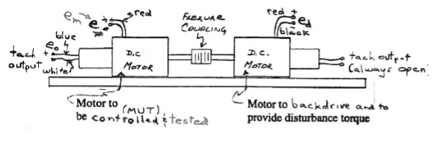

Figure 1: Experimental Setup and Physical Schematic

The motor left most is the MUT – the motor under test, and the motor on the right is the motor which is back driven and used to provide a load for the MUT. The two motors are coupled with a flex-coupling to allow for minor shaft misalignment. The MUT was supplied with power from a power op-amp. The MUT was connected to a tachometer, which outputted a voltage proportional to the rotational velocity.

Figure 2 below shows the schematic describing the power op-amp setup.

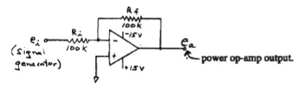

Figure 2: Power op-amp connection schematic

The gain of the power op-amp is -1, which means the motor spins the opposite direction (not relevant to the results). Voltages of +15 and -15 volts. The power op-amp was supplied by BK Precision, it provides the power for the motor. Both resistors are 100 kΩ.

The open-loop block diagram of the motor is shown below in Figure 3.

The time constant of the electrical system is much shorter than the time constant of the mechanical system, it is therefore neglected. In this case, the mechanical pole is dominant.

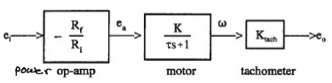

Figure 3: Open Loop Block diagram of the system

1.1 DC Motor Systems Modeling

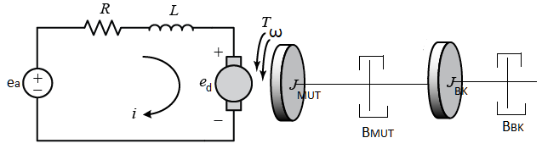

Figure 4: DC Brush Motor Electro-mechanical model

The electro-mechanical model of a DC brush motor is shown in figure4. The electrical circuit takes an input voltage and generates a voltage drop across the rotor. The electrical energy from the voltage drop can be related to the resulting angular velocity, , through the motor velocity constant, :

(Equation 1)

The current of the circuit, , can also be coupled to the resulting torque in the motor,, through the back-EMF constant, :

(Equation 2)

Performing electrical and mechanical analysis on the system using equations 1 and 2 leads to the following transfer function relating the output angular velocity to the input voltage:

(Equation 3)

Equation 3 is typically written in the following format for ease of identifying the system parameters, system gain, , and time constant, :

Therefore, the equations for the system gain and time constant of a motor are:

(Equation 5)

(Equation 4)

The detailed derivation steps for the motor transfer function are attached in Appendix A1.1 in this document.

1.2 Experimental Setup and Methods

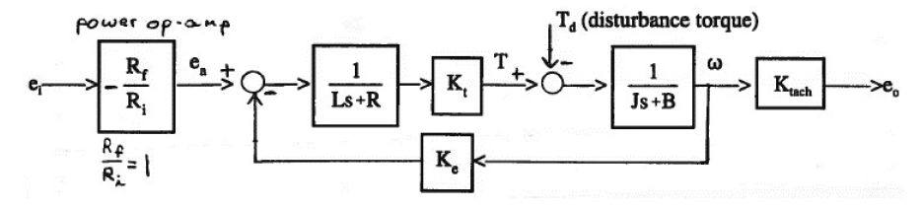

Figure 5: Experimental Setup Block Diagram

The full experimental setup is shown in the block diagram in figure 5. The generated input voltage is passed through a power op-amp with a gain of to produce the motor input voltage . The motor’s resulting angular velocity is fed back to complete a closed-loop feedback system through the motor velocity constant. The difference (error) between the input voltage and the output angular velocity controls the motor. The term represents the electrical system’s resulting voltage drop at the rotor, which converts the electrical energy into torque through the back-EMF constant. Potential disturbance loading is included in the schematic. The angular velocity is measured by a tachometer with a gain of and outputs a voltage measurable with a scope.

It is worth noting that when the disturbance load is equal to the generated torque from a given voltage, , the input into the mechanical model would be zero, resulting in zero angular velocity. But the motor is still generating a torque . This torque is the stall torque at the given voltage .

A back-drive motor is connected to the motor under test (MUT). In the first part, the back-drive motor delivers torque to the MUT, converting the motor into a generator, and the generated voltage and the tachometer output for the back-drive motor are measured. The data is used to determine the back-EMF constant, , of the MUT by linearly fitting the angular velocity with the MUT output, assuming the loss between the back-drive and MUT connection is negligible.

In the second part, after is determined, the MUT is directly connected to determine the motor’s time constant, gain, and response to disturbance load. The steady-state error of the disturbance response is the difference between the output before and after engaging the disturbance.

Finally, the system is then connected to proportional, integral, and proportional-integral controllers to form a closed-loop system. The three controllers’ circuit diagram is shown in figure 6 (next page). The P, I, and PI controllers’ transfer functions are shown in equations 6 to 8. The P controller’s gain is 1.5:

(Equation 8)

(Equation 6)

(Equation 7)

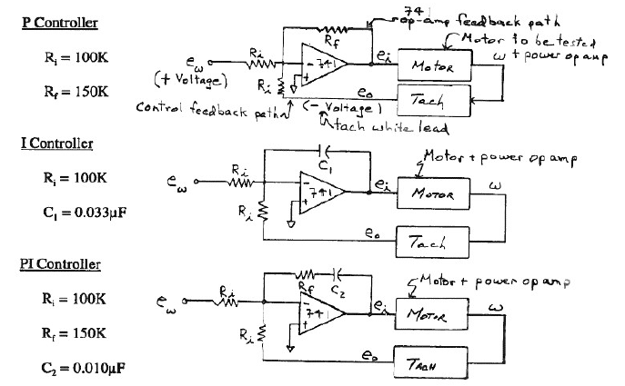

Figure 6: P, I, and PI Controller circuit diagrams showing connection to the rest of the system

# Results and Discussion

The back-EMF constant was found by driving the MUT with varying voltages, and measuring the resulting RPM. The resulting curve is a linear response, which is used to find the motor’s torque constant, Kt. The curve is shown in Figure 7 below.



Figure 7: MUT output voltage vs rotational speed

The motor voltage constant, , was found using the slope of the line in Figure 7, which was then used to find the motor torque constant, . was found to be . was calculated to be , using the relationship of . The calculation steps are included in Appendix A1.3. The motor voltage constant was specified to the range of , the experimental value is approximately the average of the range. The motor torque constant range was listed to be . The calculated value falls within 2% of the mean.

The input voltage was adjusted until a step response of amplitude ±4 V was observed (figure 8). The motor stall torque was calculated to be , see Appendix A1.4 for details. The system time constant was calculated to be and the motor gain was calculated to be using equations 4 and 5. Combining with the tachometer gain, the overall system gain is found to be .



Figure 8: Tachometer output voltage with respect to time.

The experimental data suggested a step input of resulted in of step response. The experimental gain is . Solving for and from equations 4 and 5 using the experimental time constant of 9 ms and the overall gain (tau point labelled in figure 9), the values are calculated to be:

The experimental damping coefficient is 8 times larger than the expected , the combined damping coefficient of two motors. However, the damping coefficient term is much less compared to the multiplied gain terms (), the experimental moment of inertia is close to the expected value of with 2.95% error.



Figure 9: Zoomed in step response output with tau point indicated

The settling time is calculated using 4 times the time constant:

The steady-state voltage error of the disturbance response is calculated by subtracting the steady-state voltage before and after engaging the disturbance load. The voltage difference is found to be 0.7931 V, which is equivalent to a speed change of 27.7 rad/s. These values are 27.7% of the voltage and speed before engaging the load, suggesting the disturbance from the back-drive motor as a result of engaging the resistor led to 28% drop of the output.

The disturbance load response time constant is found to be 6.7 ms (see figure 10 for the disturbance load response and labelled tau point), suggesting the motor responds quicker to disturbance loading than typical step inputs by about 33%.



Figure 10: Motor Disturbance Response with Tau Point Labelled

## Closed-Loop Response to a Voltage Step Input and a Disturbance Torque

Block Diagrams

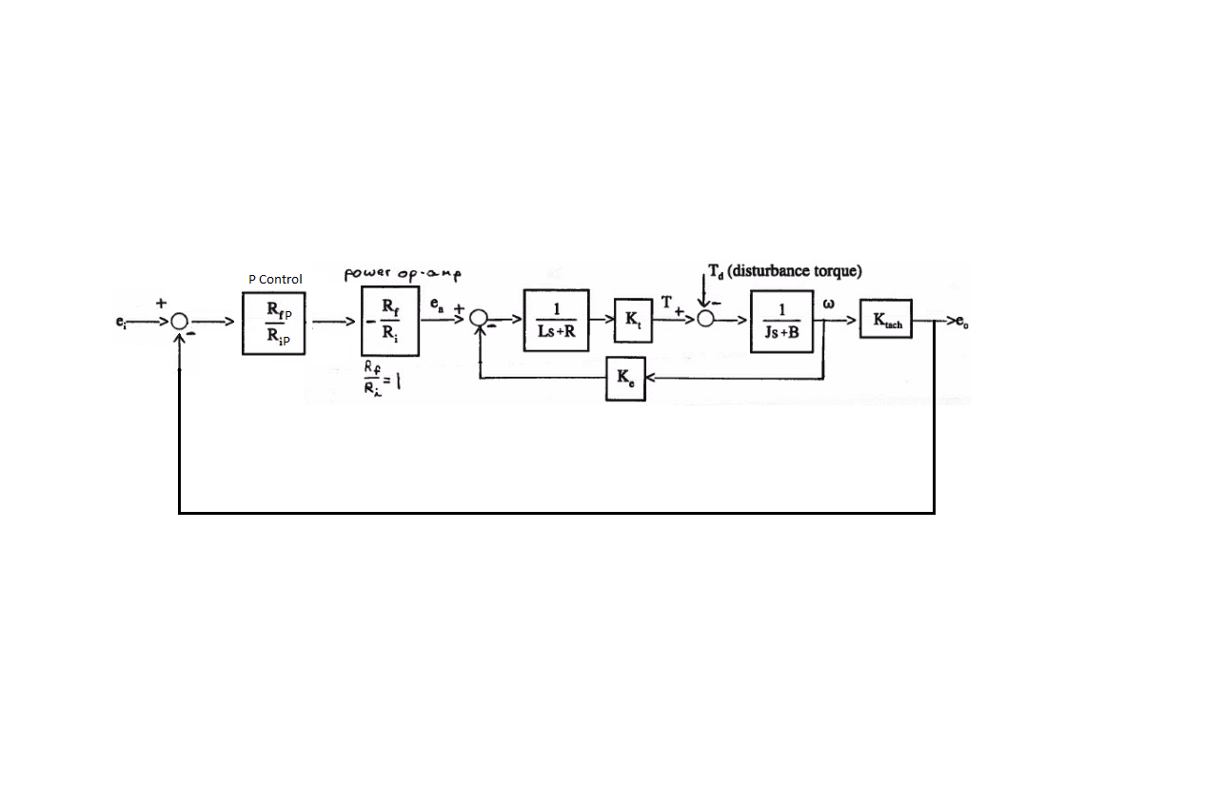

Figure 11: P Controller

**Figure 11**, **figure 12**, and **figure 13** show the closed loop system block diagrams for the P, I, and PI controllers respectively.

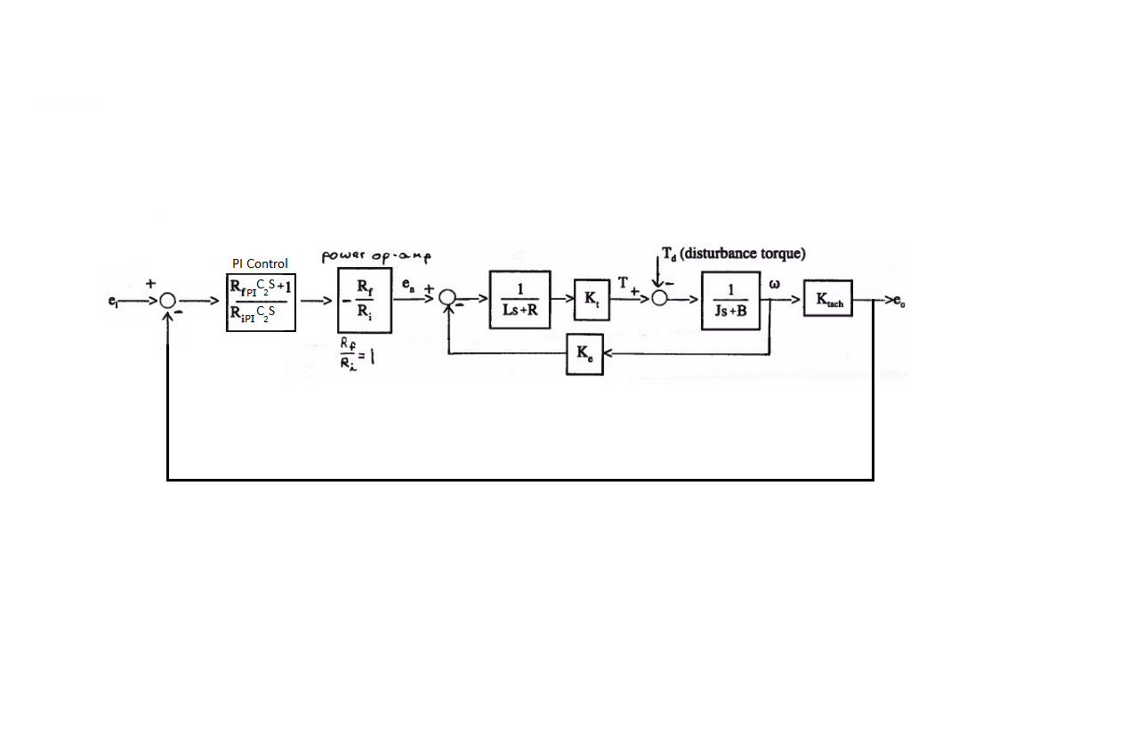

Figure 13: PI Controller

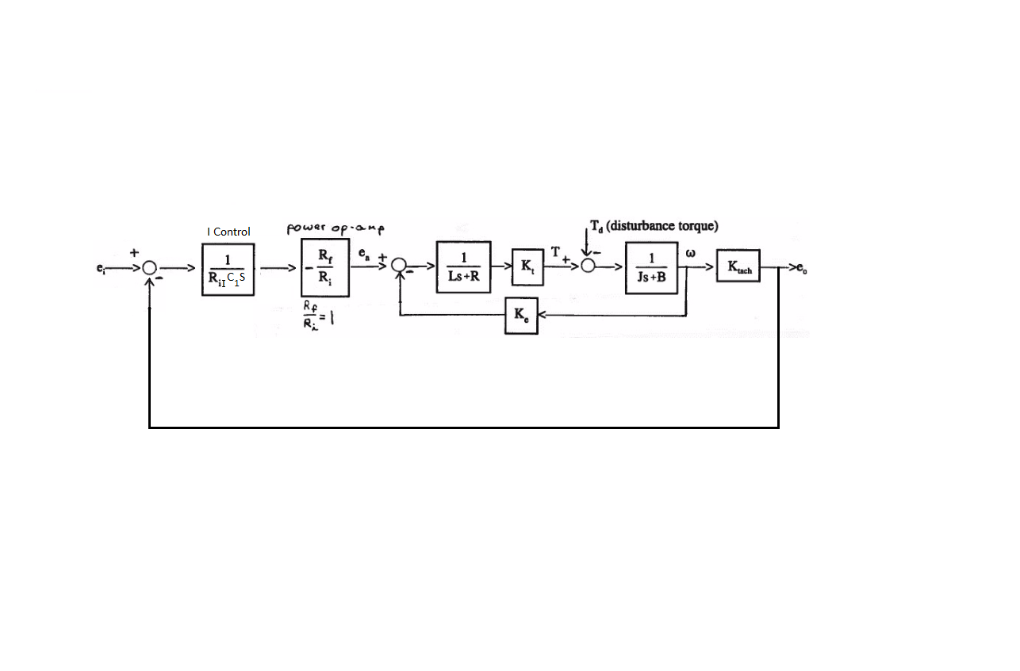

Figure 12: I Controller

**Root-locus Plots**

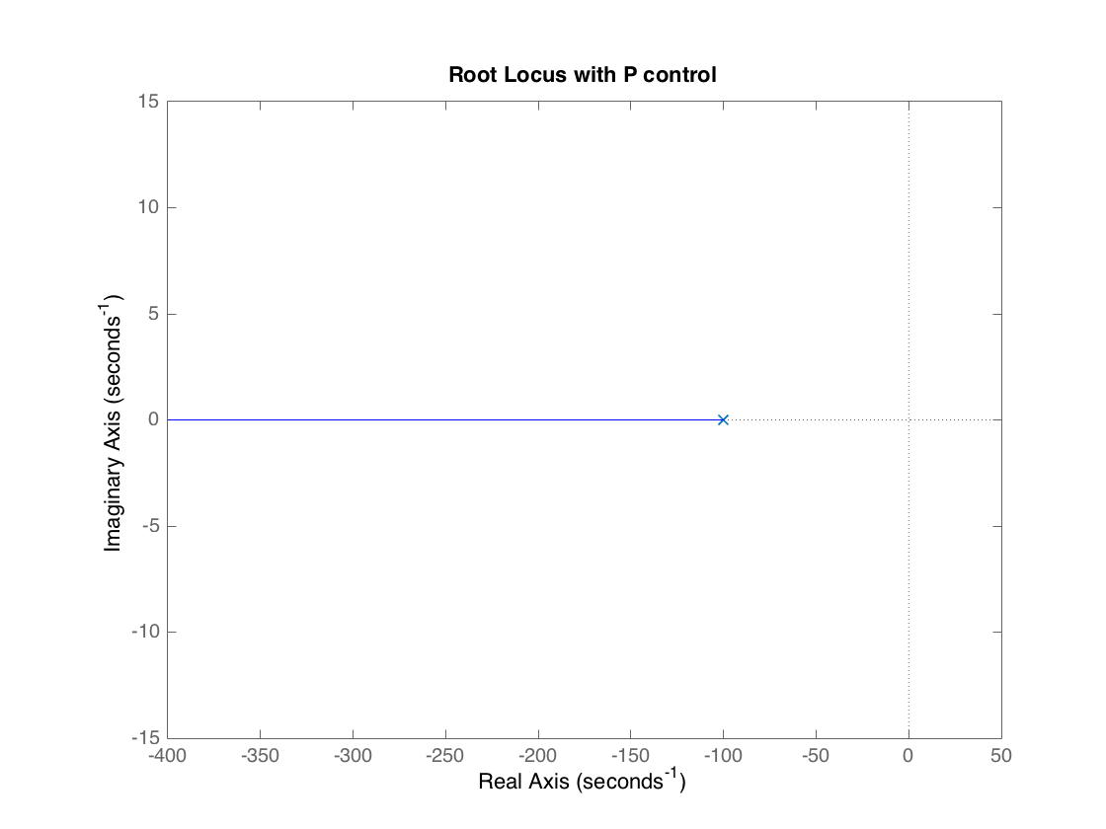

Figure 14: P Root Locus

Assuming an additional gain term of 1, the initial pole starts at -100 and continues along the real axis towards negative infinity. The root in **figure 14** was found to be .

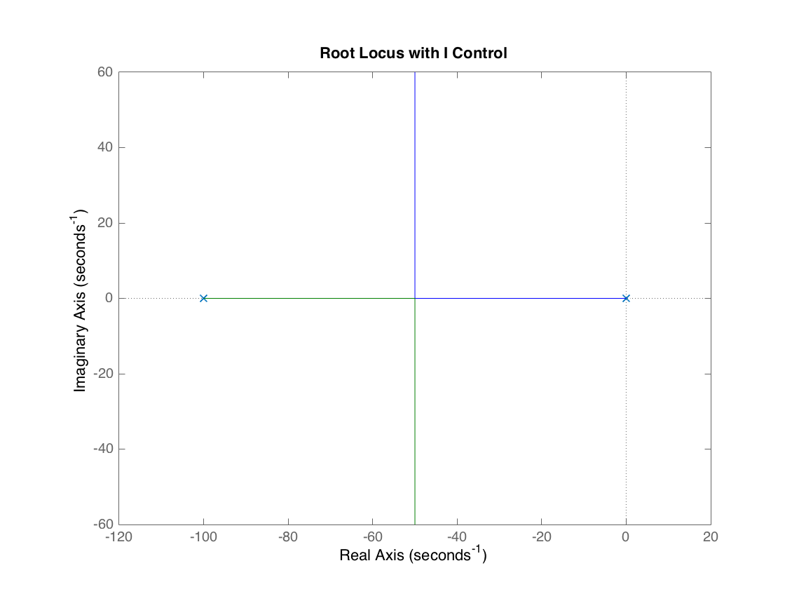

Figure 15: I Root Locus

Assuming an additional gain term of 1, the initial poles start at -100 and 0 and they both move toward the asymptote at -50. The roots in **figure 15** were found to be .

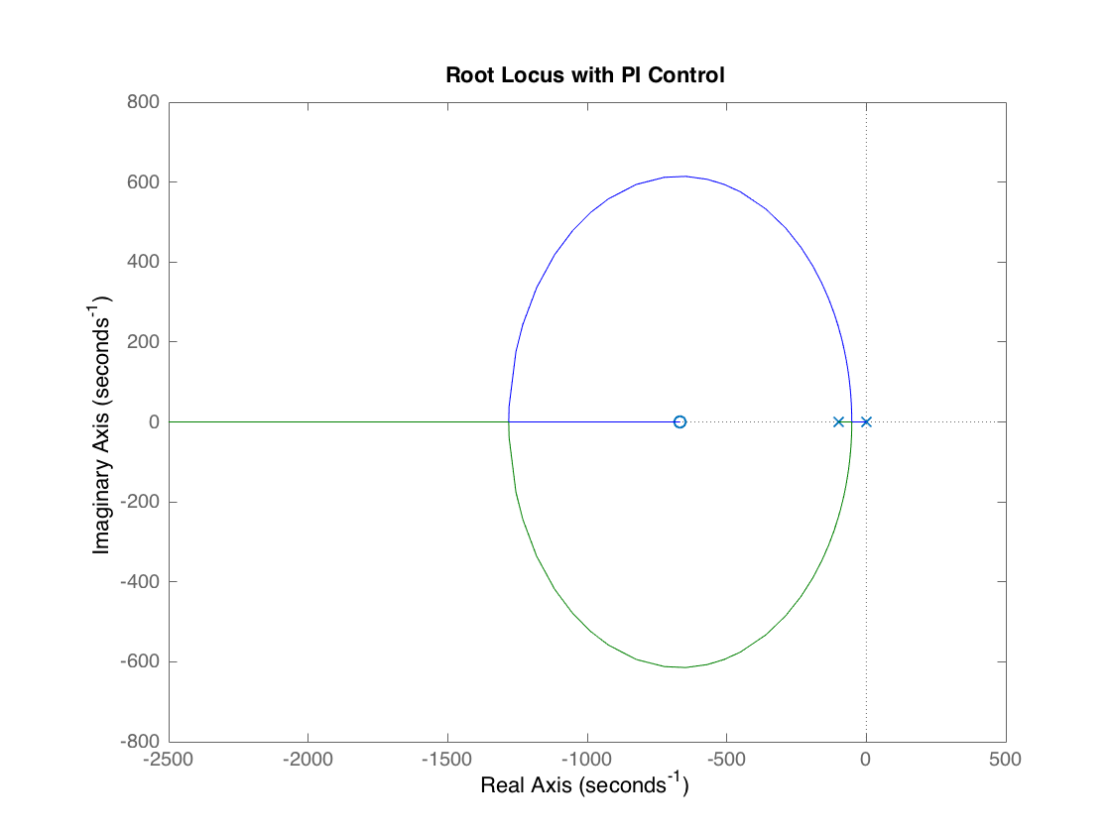

Figure 16: PI Root Locus

Assuming an additional gain term of 1, a zero occurs around -677 and extends to negative infinity. The poles start at -100 and 0. The roots in **figure 16** were found to be .

**Step Response**

**Figure 17** demonstrates the step response for an input voltage step change of -4 V to +4 V. The steady state prediction is slightly higher than the experimental data. This could be explained by unaccounted for friction in the motor. It is also important to note that the steady state output for the P controller is around 2 V instead of 4 V

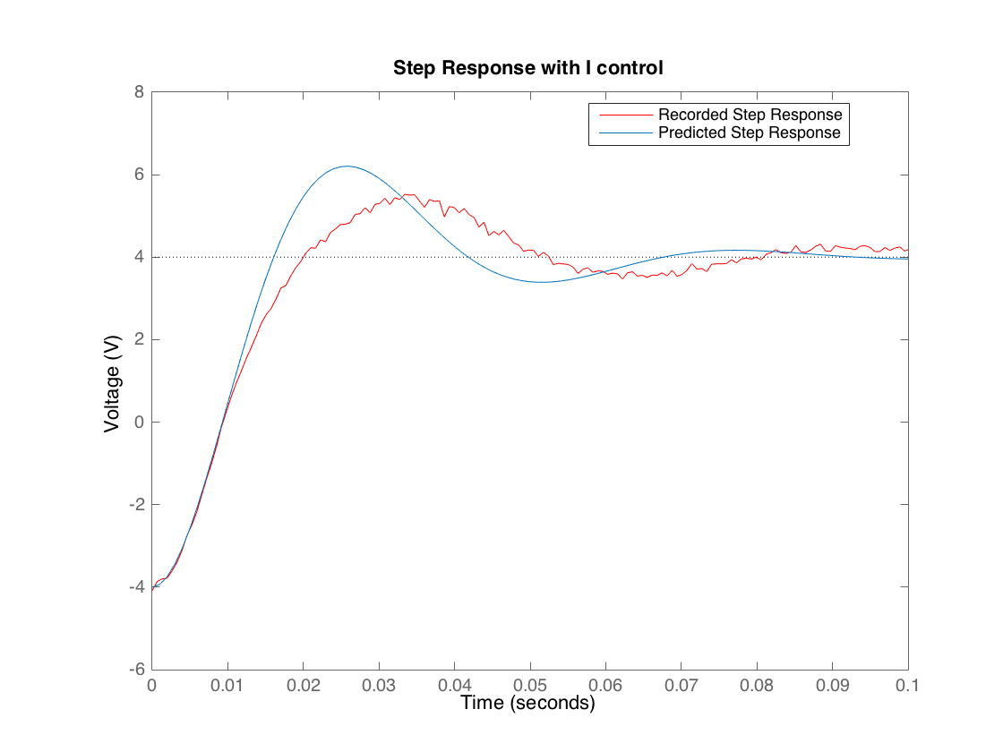

Figure 18: I Step Response

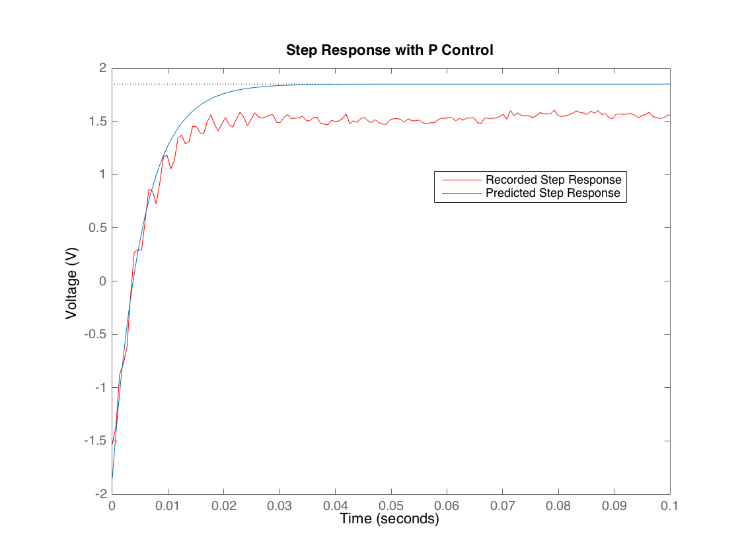

Figure 17: P Step Response

**Figure 18** shows that the I controller results in a 2nd order output. The experimental data for the I controller is a little slower than the predicted response. It also has higher damping, which can be explained by unaccounted for friction. Unlike the P controller, it reaches the steady state value of 4 V.

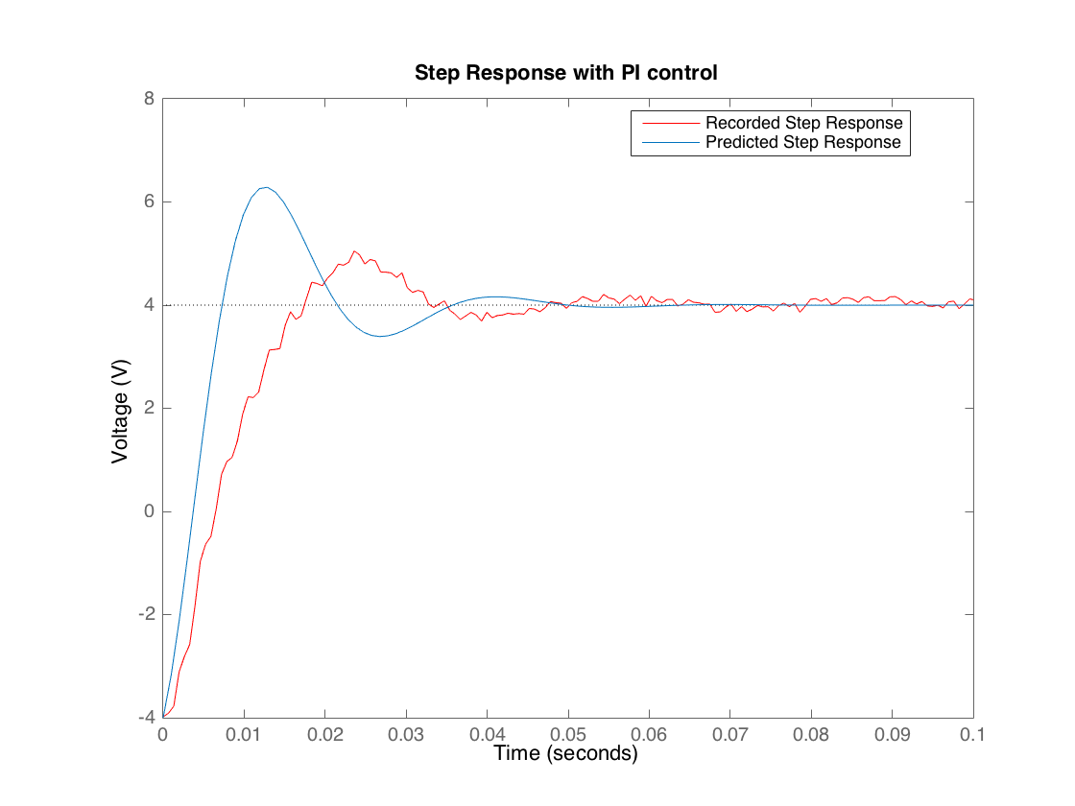

Figure 19: I Step Response

The PI predicted results drift even further from the experimental, as seen in **Figure 19.** PI also outputs a 2nd order system that reaches a stead state of 4 V.

**Speed of Step Responses and Steady State Error with a Disturbance**

Table 1 Controller Time Constants

|  |  |
| --- | --- |
| **Controller** | **Tau [ms]** |
| Open Loop | 10 |
| P | 5.4 |
| I | 20 |
| PI | 10.8 |

**Table 1** demonstrates that the P controller has the fastest response time, followed by Open Loop, PI, then I. Again, although P control is the fastest, it cuts the output voltage in half.

Table 2: Controller Steady State Error

|  |  |
| --- | --- |
| **Controller** | **Steady State Error** |
| P | 18.86 % |
| I | 7 % |
| PI | .000738 % |

The P controller has the largest error, and I has about half the error as P. PI has significantly less error than either P or I when subjected to a disturbance. This makes PI a desirable controller even though P has a quicker response time.

The primary factor for the difference between the theoretical and experimental results is friction that is unaccounted for in the transfer function.

Error can result from friction within the motors as well as wear to the structure from behaviors such as creep and fatigue. The controller that is chosen should be able to handle the expected error from disturbances over the lifetime of the design.

# Conclusions

Jesse:

Data collected from parts 2, 3, and 4 are well within manufacturer specification excluding the erroneous damping coefficient (or more accurately – the damping coefficient which included the higher frictional force within the motor).

The experimental damping coefficient has error caused by using an older motor, and friction within the system. The friction within the system was neglected, but it turned out that it plays a big role in the results of the analysis.

The experimental gain is less than expected, which actually makes sense because the damping ratio is higher. In this case, it makes sense that the PI controller has a slower response time compared to the proportional controller.

Our results stated that the proportional response was the fastest – at the cost of a higher error level. The integral response was slower, but had less steady state error than the proportional control. Where the proportional-integral control system provided the lowest error with the second highest speed.

For future research, the frictional forces and other motor properties should be looked at closer if a higher degree of accuracy in the results is required.

Simon:

Motor properties were analyzed using open-loop and closed-loop control systems. The open loop systems had an advantage in the sense that they are functionally more simple and easier to implement, however, the closed-loop systems provided superior control. The closed-loop response was able to maintain a set motor rotational velocity to a better degree than the open loop system.

In general, the proportional response was the fastest, but had a high error. The integral response had a lower error the proportional, but was the slowest of all three methods. Neither proportional nor integral response compared to the low error level of the proportional-integral control, and the proportional-integral response was faster than the integral response alone.

Regarding the calculated parameters, the calculated values, excluding the damping coefficient are all within the spec range of the motor – generally very close to the middle of the range. Incidentally, this (although not statistically significant in sample size) suggests that the motor company specifies their motors such that the entire standard deviation range they produce will fit within spec, rather than creating a tighter specification that only a few motors reach. This makes sense from a manufacturer’s point of view – to simply make the spec large enough to cover the deviation of their production is cheaper than changing manufacturing.

Major errors in this study were caused by excessive friction and motor age. A newer motor is recommended for applications where a tighter conformance to spec is required. An interesting experiment would be to replace the bearings on the motor to see whether or not the bearings were the major cause of friction, or if the difference in performance comes from motor brush wear or another unknown variable.

Reilly:

The parameters of a DC motor were found through back-driving with another DC motor. Data was recorded using a tachometer, and the open loop gain characteristics were found for the system. Proportional, Integral, and Proportional-Integral controllers were utilized to test the closed loop feedback system.

It was found that the P controlled step response was the fastest, however it had significant error in the event of a disturbance. The PI controller resulted in a negligible disturbance error, while still having a faster response than the I controller. Determining these characteristics is important for choosing the optimal controller for any given system. It is clear that each of these controllers has a use, and selecting one depends on which factors (i.e. response time and disturbance error) are important for the function of the system.

The results could have been improved by using newer and more efficient motors. This would improve the results of this experiment by decreasing the friction that was unaccounted for in the analysis, therefore lessening the deviation between expected and experimental system behavior.

# Appendix

A1.1 DC Motor Electromechanical Model Derivation

Given the following system for a DC motor:

From the circuit, perform Kirchhoff’s loop law:

The voltage drop is proportional to the resulting angular velocity of the mechanical system, and the current is proportional to the resulting torque by:

Using and , the mechanical system equation is:

Since the inductance is three magnitudes less than the resistance, the inductance term is neglected. Laplace transform and combine the equations:

The transfer function relating output angular velocity to input voltage is then:

A1.2 Controller transfer function derivations

Given the P controller setup shown in **figure 3**, assuming ideal op-amp, performing nodal analysis on the negative lead node gives:

Ideal op-amp means , and is grounded to zero. Therefore:

Rearranging:

Similarly, for I controller:

The PI controller is slightly more complicated. The resistor-capacitor in series need to be combined into one element:

The repeat the same steps:

A1.3 Deriving from

Appendix 1.5 Matlab Code

clear all;

close all;

%% Part 2 a) and b)

Part2_a_V = [1.7,2,3,4,5,6,7,8,9,10]; % [V]

Part2_a_Et = -[-0.40215,-0.55697,-1.11,-1.67,-2.25,-2.82,-3.38,-3.93,-4.49,-5.02]; % [V]

Part2_a_MUT = [0.6754,0.94198,1.87,2.83,3.77,4.71,5.63,6.53,7.49,8.36]; % [V]

KtachSens = 3; % V/kRPM

Part2_a_EtOmega = Part2_a_Et/KtachSens; % [kRPM]

Part2_a_fit = polyfit(Part2_a_EtOmega,Part2_a_MUT,1);

KeCalc = Part2_a_fit(1); % 4.9817 [V/kRPM] - right on the money

Part2_a_fitY = Part2_a_EtOmega*Part2_a_fit(1) + Part2_a_fit(2);

figure(1);

hold on;

plot(Part2_a_EtOmega,Part2_a_MUT,'O');

plot(Part2_a_EtOmega,Part2_a_fitY,'--');

xlabel('\omega (kRPM)','FontSize',12);

ylabel('MUT Voltage (V)','FontSize',12);

%% Part 2 c)

% Conversion factor Kt = 141.6 Ke in British units, in V/rad/s

Kt = 141.6*KeCalc/1000/(2*pi/60); % Kt = 6.7273 Oz-in/A, matches the spec sheet's +/- 10%

%% Part 3 b)

% ea - KeW -> 1/ (Ls+R) -> Kt -> 1/(2Js+2B) -> W

% To find stall torque, plot torque vs. omega. The region where omega

% increases but torque remains constant is the stall torque. Spec sheet

% says 12 oz-in

R = 4.2; % [ohm]

einput = 6;

torque_6V = einput*Kt/R;

%% Part 3 c)

J = 0.0004; % [oz-in-s^2]

B = 0.2; % [oz-in/kRPM]

K = Kt/(2*B*R + Kt*KeCalc); % [kRPM/V] velocity constant

tau_calc = 2*J*R/(2*B*R + Kt*KeCalc); % [s^2 kPRM]

tau = tau_calc*1000*(2*pi/60); % [s-rad]

%% Part 3 d)

% ch. 0: Tach output ch. 1: ei after op-amp

Part3_b_data = importdata('Data from Section 3 Step 7.lvm','\t',33);

Part3_b_data = Part3_b_data.data;

Part3_b_Time = Part3_b_data(:,1);

Part3_b_TachV = Part3_b_data(:,2);

Part3_b_InputV = Part3_b_data(:,3);

figure(2);

hold on;

plot(Part3_b_Time,Part3_b_TachV);

plot(Part3_b_Time,Part3_b_InputV);

xlabel('Time (s)','FontSize',12);

ylabel('Voltages (V)','FontSize',12);

legend('Location','best','Tachometer Output','Input Voltage e_a');

% data reconfiguration

Part3_b_Time = Part3_b_Time(501:2500);

Part3_b_TachV = Part3_b_TachV(501:2500);

Part3_b_InputV = Part3_b_InputV(501:2500);

Part3_b_TachV = smooth(smooth(Part3_b_TachV));

Part3_b_InputV = smooth(smooth(Part3_b_InputV));

Part3_b_TachV = Part3_b_TachV - mean(Part3_b_TachV(1:100));

Part3_b_FinalV = mean(Part3_b_TachV(1000:end));

% 63.2% tau point

Part3_b_TauV = 0.632*Part3_b_FinalV;

for i = 1:length(Part3_b_Time)

if (Part3_b_Time(i) > -0.006389)

Part3_b_Time = Part3_b_Time - Part3_b_Time(i);

break;

end

end

for i = 1:length(Part3_b_TachV)

if (Part3_b_TachV(i) > Part3_b_TauV)

Part3_b_tauInd = i;

Part3_b_tauTime = Part3_b_Time(i);

break;

end

end

figure(3);

hold on;

plot(Part3_b_Time,Part3_b_TachV);

plot(Part3_b_Time(Part3_b_tauInd),Part3_b_TachV(Part3_b_tauInd),'O');

xlabel('Time (s)','FontSize',12);

ylabel('Voltages (V)','FontSize',12);

legend('Location','best','Tachometer Output','Tau Point');

% tauTime = JR/(BR + KtKe) with Kt, Ke, R known

% gain = KtKtach/(BR + KtKe)

% Total step input amplitude: 16 V

% Total step response final value: 8 V

inputGain = Part3_b_InputV(1) - Part3_b_InputV(end);

stepGain = Part3_b_TachV(end);

totalGain = stepGain/inputGain;

Bcalc = 1/R*(Kt*KtachSens/totalGain - Kt*KeCalc);

Jcalc = Part3_b_tauTime*(Bcalc*R + Kt*KeCalc)/R/1000/(2*pi/60); % [Oz-in-s/kRPM] -> [oz-in-s^2/rad]

% using the B from spec sheet and tau from data

Jcalc_betterB = Part3_b_tauTime*(2*B*R + Kt*KeCalc)/R/1000/(2*pi/60);

%% Part 3 e)

% Import data for disturbance

Part3_e_data = importdata('Data from Section 3 Step 9.lvm','\t',33);

Part3_e_time = Part3_e_data.data(:,1);

Part3_e_tachV = Part3_e_data.data(:,2);

Part3_e_inputV = Part3_e_data.data(:,3);

Part3_e_tachV = smooth(smooth(Part3_e_tachV));

for i = 1:length(Part3_e_time)

if (Part3_e_time(i) > 0.0221)

Part3_e_time = Part3_e_time - Part3_e_time(i);

break;

end

end

Part3_e_stV = mean(Part3_e_tachV(1:500));

Part3_e_endV = mean(Part3_e_tachV(3000:end));

Part3_e_tauV = Part3_e_endV + (Part3_e_stV - Part3_e_endV)*0.368;

for i = 1:length(Part3_e_tachV)

if (Part3_e_tachV(i) < Part3_e_tauV)

Part3_e_tauInd = i;

break;

end

end

Part3_e_tauTime = Part3_e_time(Part3_e_tauInd);

Part3_e_tauVolt = Part3_e_tachV(Part3_e_tauInd);

Part3_e_SSE = Part3_e_stV - Part3_e_endV;

Part3_e_SSE_omega = Part3_e_SSE/KtachSens*1000*(2*pi/60);

figure(4);

hold on;

plot(Part3_e_time,Part3_e_tachV);

plot(Part3_e_time(Part3_e_tauInd),Part3_e_tachV(Part3_e_tauInd),'O');

xlabel('Time (s)','FontSize',12);

ylabel('Tachometer Voltage (V)','FontSize',12);

legend('Location','best','Tach Output','Tau Point');

clear all; close all;

%% 4b

Rf=150000;

Ri=100000;

C1=0.033e-6;

C2=0.01e-6;

tau=.01; %s

Kv=20.02; %Rad/(V*s)

Ktach=.003; %V/rpm

Ktach=(Ktach*60)/(2*pi); %V/rad/s

Kadj=1;

%P

KGcP=Rf/Ri;

sysP=tf([Kadj*KGcP*Kv*Ktach],[tau 1]);

figure(2)

rlocus(sysP);

title('Root Locus with P control')

%I

KGcI=1/(Ri*C1);

sysI=tf([Kadj*KGcI*Kv*Ktach],[tau 1 0]);

figure(3)

rlocus(sysI)

title('Root Locus with I Control')

%PI

sysPI=tf([Kadj*Rf*C2*Kv*Ktach Kadj*Kv*Ktach],[Ri*C2*tau Ri*C2 0]);

figure(4)

rlocus(sysPI)

title('Root Locus with PI Control')

%% 4c

%P

sP = (1/tau)+KGcP*Ktach*(Kv/tau);

tauP=1/sP;

modelP=feedback(sysP,1);

opt=stepDataOptions;

opt.InputOffset=-4;

opt.StepAmplitude=8;

lvtdata = importdata('Data from Section 4 Step 5 P Controller.lvm','\t',34);

Peo = lvtdata.data(:,2);

Ptime=(0:0.000655:0.000655*4998)';

Ptime=Ptime(1335:1488);

Peo=Peo(1335:1488);

Ptime=Ptime-Ptime(1);

figure(5)

plot(Ptime,Peo,'r')

hold on

step(modelP,opt,.1)

title('Step Response with P Control')

xlabel('Time')

ylabel('Voltage (V)')

legend('Recorded Step Response','Predicted Step Response','location','best')

hold off

%I

syms s

eqn=1+(KGcI*Kv*Ktach)/(tau*s^2+s);

sI=solve(eqn,s);

modelI=feedback(sysI,1);

lvtdata = importdata('Data from Section 4 Step 5 I Controller.lvm','\t',34);

Ieo = lvtdata.data(:,2);

Itime=(0:0.000655:0.000655*4998)';

Itime=Itime(1205:1358);

Ieo=Ieo(1205:1358);

Itime=Itime-Itime(1);

figure(6)

plot(Itime,Ieo,'r')

hold on

step(modelI,opt,.1)

title('Step Response with I control')

xlabel('Time')

ylabel('Voltage (V)')

legend('Recorded Step Response','Predicted Step Response','location','best')

hold off

%PI

syms s

eqn=1+((Rf*C2*s*Kv*Ktach)+(Kv*Ktach))/((tau*Ri*C2*(s^2))+(Ri*C2*s)) == 0;

sPI = solve(eqn,s);

modelPI=feedback(sysPI,1);

lvtdata = importdata('Data from Section 4 Step 5 PI Controller.lvm','\t',34);

PIeo = lvtdata.data(:,2);

PItime=(0:0.000655:0.000655*4998)';

PItime=PItime(1094:1247);

PIeo=PIeo(1094:1247);

PItime=PItime-PItime(1);

figure(7)

plot(PItime,PIeo,'r')

hold on

step(modelPI,opt,.1)

title('Step Response with PI control')

xlabel('Time')

ylabel('Voltage (V)')

legend('Recorded Step Response','Predicted Step Response','location','best')

hold off

%% 4d

tauOL=tau;

tauP=1/sP;

tauI=1/50;

tauPI=1/93.0148;

%P

lvtdata = importdata('Data from Section 4 Step 6 P Controller.lvm','\t',34);

Pdeo = lvtdata.data(:,2);

Pdtime=(0:0.000200:0.000200*4998)';

figure(8)

plot(Pdtime,Pdeo,'r')

title('Disturbance Load with P Control')

xlabel('Time')

ylabel('Voltage (V)')

errorP=abs((mean(Pdeo(1:997))-mean(Pdeo(1084:end)))/mean(Pdeo(1:997)));

%I

lvtdata = importdata('Data from Section 4 Step 6 I Controller.lvm','\t',34);

Ideo = lvtdata.data(:,2);

Idtime=(0:0.000655:0.000655*4998)';

figure(9)

plot(Idtime,Ideo,'r')

title('Disturbance Load with P Control')

xlabel('Time')

ylabel('Voltage (V)')

errorI=abs((mean(Pdeo(1:2522))-mean(Pdeo(2582:4168)))/mean(Pdeo(1:2522)));

%PI

lvtdata = importdata('Data from Section 4 Step 6 PI Controller.lvm','\t',34);

PIdeo = lvtdata.data(:,2);

PIdtime=(0:0.000655:0.000655*4998)';

figure(10)

plot(PIdtime,PIdeo,'r')

title('Disturbance Load with PI Control')

xlabel('Time')

ylabel('Voltage (V)')

errorPI=abs((mean(PIdeo(1:1006))-mean(PIdeo(1039:1416)))/mean(PIdeo(1:1006)));