**1.0 Introduction**

**2.0 Scope of Work**

The electro chemical lathe project started its development by first establishing its parameters. The overall dimensions of the system were estimated by elaborating a drawing of it in SolidWorks. These dimensions were established by the actual measurements of the main components of a Sherline lathe (e.g. lathe’s bed, spindle, and tool holder). Figure 2.1 is intended to represent a standard Sheriline lathe.

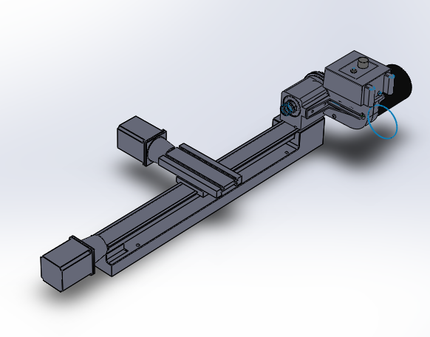

**Figure 2.1:** Combinational Lathe Obtained from Sherline Industries

A similar lathe as from the figure above was purchased and is now in the process of modification, so electro chemical technologies can be implemented.

The following diagram represents the system that is going to be elaborated at the project’s completion. It represents the deliverables that need to be satisfied, as well.

|  |
| --- |
| 7  6  1  2  3  4  5  **Figure 2.2**: ECM Lathe System Diagram |

From figure 2.2, the following deliverables can be concluded:

1. CNC- Machine Control Computer:

The ECM lathe will be operated using a G code format from a conventional computer. This is a deliverable that is still in progress.

1. ECM Lathe:

From figure 2.1, the lathe will be reengineered so the necessary appliances of an electro chemical machine can be incorporated into it.

1. Dirty Electrolyte Pump:

In a traditional machine, coolant is used for combinational cutting. This one diverges from different kinds of oils. For a conventional ECM the “coolant” that is use to accelerate the oxidation of the metal is known as electrolyte. This fluid will be transported from the cutting chamber to the filter by a pump. Due the nature of the electrolyte, which is mostly salt, a special pump is needed. In addition, a pressure measurement device will be needed to prevent overflowing.

1. Filter Press:

The contaminated electrolyte will travel from the ECM to the filter press where it will be filtered, so the residuals of metal can be extracted from the fluid.

1. Electrolyte Storage tank:

One of the many challenges of the project is to design a system that could be relatively easy to transport. This means that a storage tank needs to be designed capable to store enough amounts of electrolyte without jeopardizing the systems transportation.

1. Clean Electrolyte Pump:

This secondary pump will eject clean electrolyte to the electro chemical lathe. Just like he first pump, this one will need to provide enough electrolyte to the work enclosure, meaning that pressure and consistence are vital. It is worth to notice that from the figure 2.2, sections 3, 4, 5, and 6 will determine the drainage system which will be addressed after the completion of the ECM design.

1. Power Supply:

This deliverable remains to be determined.

As for now, the deliverable that has been prioritized is the elaboration of the actual lathe. Focusing on its design allowed a satisfactory and accurate motion of the lathe’s axis with a minimal error to be achieved. This achievement was made by installing two NEMA hybrids stepping motors on each axis.

In addition, the process of redesigning the lathe has initiated. The new design consists on adding an extension to the spindle. This extension increases the working area of the part. To take the most advantage of this idea, the lathe itself was tilted 90 degrees. With a now standing lathe, as shown in figure 2.3, it has been established that the tool would approach the part from above.

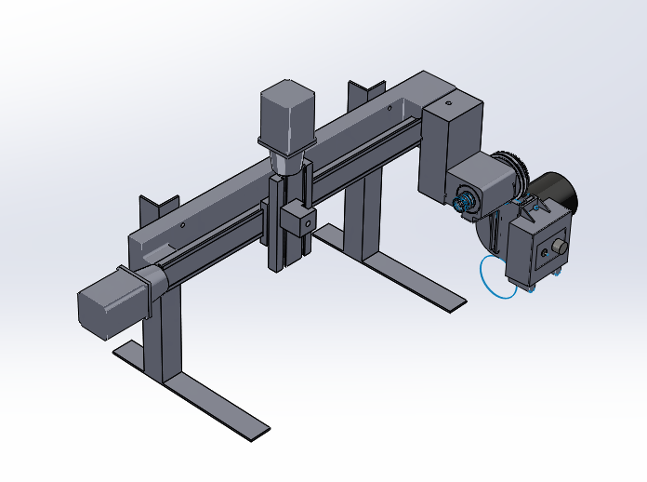

Extension

Tool Holder

**Figure 2.3:** Isometric view of the Electro Chemical Lathe.

**3.0 Schedule**

**Table 3.1:**  Schedule including major task for completion of project in a hierarchy order.



Table 3.1 shows the tasks that are vital for the project. The electro chemical lathe which was previously discussed will be completed by end of December. For this task, the motion of the lathe was implemented by Simon Popecki while the machining of the extension in the spindle was elaborated by Carlos Graniello. The drawings displayed throughout this report have been elaborated by a combined effort of both members of the team.

The most critical tasks of the project has been established to be the actual electro chemical lathe, since its design will determine the parameters of the system as all.

The working enclosure has been an ongoing process. It has been concluded that the material for this section would be mostly plastic, so the process of “cutting” can be visible. The final design of this task can be appreciated on later stages of this report.

The machine support is vital as well. It is worth to remember that the transportation of the system is important. This means that the design of this support needs to be elaborated to also account for any possible vibration at moments of operations. As previously stated, this task has not been completely determined. The drawings in any figure in this report show a provisional support. However, this provisional support is being used as a base for the final design.

The pump system is also vital for the report. Its efficiency will play an important role on the speeds and feed rate applied to the machine. This task has been postponed until the support is completed, so the space available can be used wisely.

Finally, the power supply will be tested in combination to the rest of the project to determine the better voltage of operation.

**4.0 Results**

There have been no real calculations made yet to show. However, for instance, the theory to determine the needed voltage has been studied, but not yet concluded.

The results can be resumed in basically three topics:

1. Axis Motion:

The motion of the axis was achieved by Simon Popecki who used the Bresenham’s Line Algorithm to calculate a line of motion.

This algorithm determinates the points of an n-dimensional plane to elaborate a best fitted line between two points. In practice, it is also known as an incremental error algorithm due the fact that the algorithm keeps an error bound at each point of the line as a function of the line’s slope.

To convert these Cartesian coordinates to digital motion, Simon used a G code converter. The converter outputted the coordinates in a G-code format making the movement applicable to any CNC machine. Finally, stepper motors enable and disable the movements of the received G-commands.

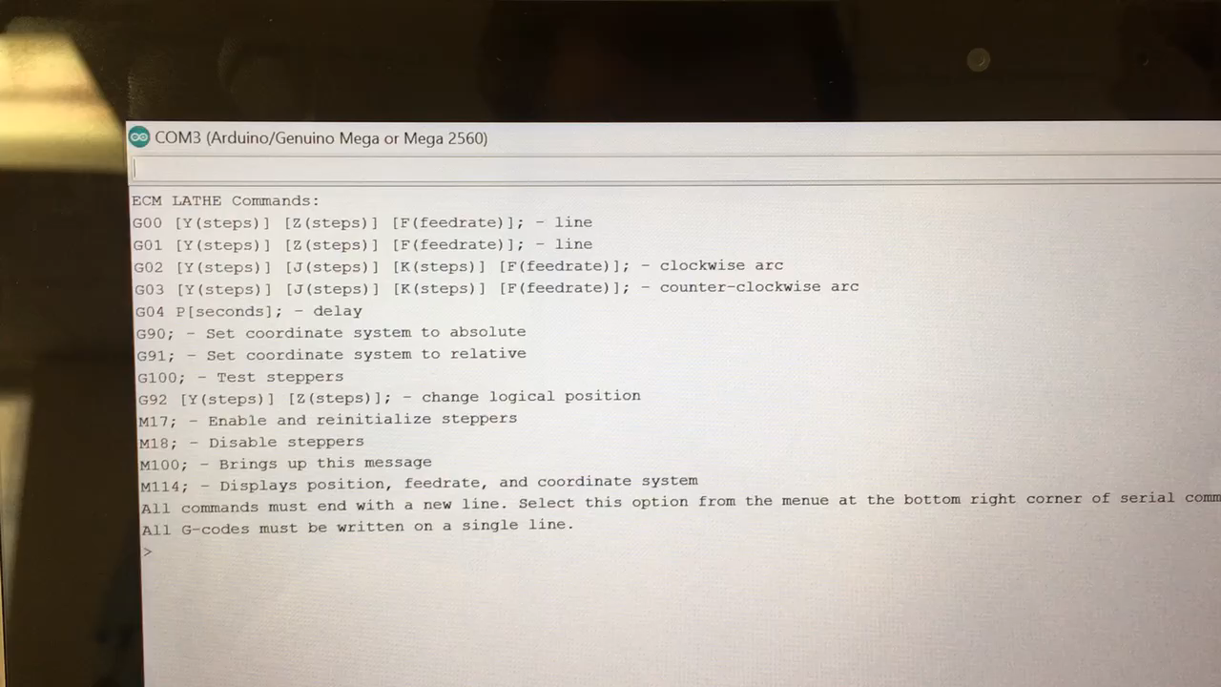

**Figure 4.1:** Example of the G-code responsible of movement

1. Spindle Extension:

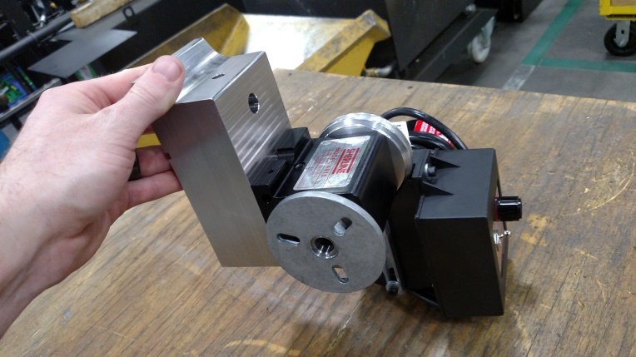

**Figure 4.2:**  Spindle extension for the ECM lathe

The extension was made out of stainless steel 304 to prevent oxidation of the part. It was machined in a 3-axis mill by Carlos Graniello.

1. Machine Drawings:

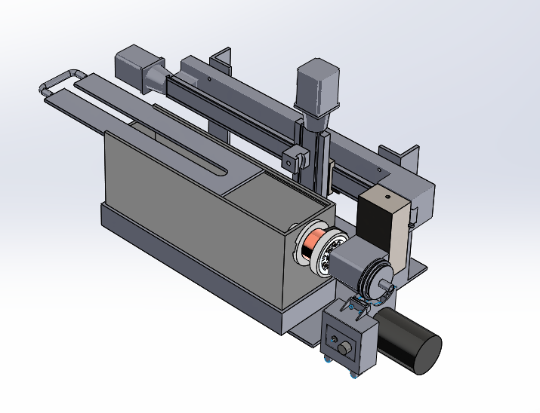

**Figure 4.3:** Detailed Electro Chemical Lathe Drawing

The conclusion of the drawings was a team effort from both students. These drawings were designed to constrain the design of the machine as a whole and to solve the challenges of design, for instance the transmission of the spindle, the work enclosure, and possible supporters.

As mentioned before, the support of the machine is still in process. It is being considered to bolt the lathe into two separate legs made out of 304 stainless steel angle stock. A finite element analysis is being use to decide on this design.

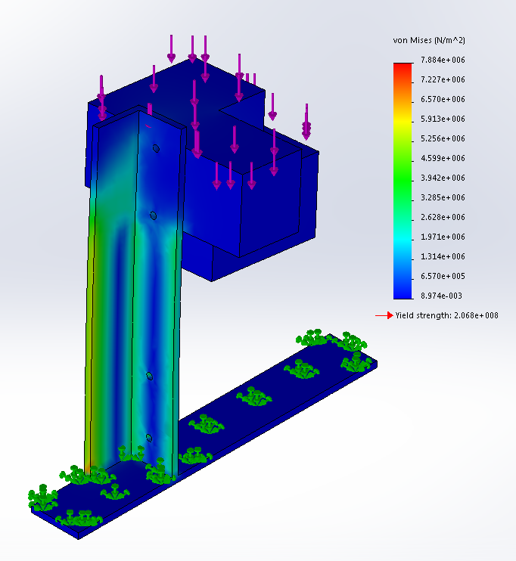

**Figure 4.4:** Stress analysis of a possible support design

The above figure shows a potential design that will support the lathe at 90 degrees. The block being held by the support is a representation of the weight of the extension with the addition of the spindle. A force of 10 pounds is applied to the upper block, representing the end of the lathe’s bed. The bottom block is being affected by a force of 20 pounds which is an over estimation of the weight generated by the spindle and the extension.

As it can be appreciated from figure (4.4) at an overestimation of the spindle’s weight, the material yield strength is of 206.8MPa and the maximum stress is witnessed to be 7.884 MPA. This means that using an angle stock to design the support of the system might be the right approach to take.

**5.0 Summary**

**6.0 References**

**7.0 Layout and Detailed Drawings**

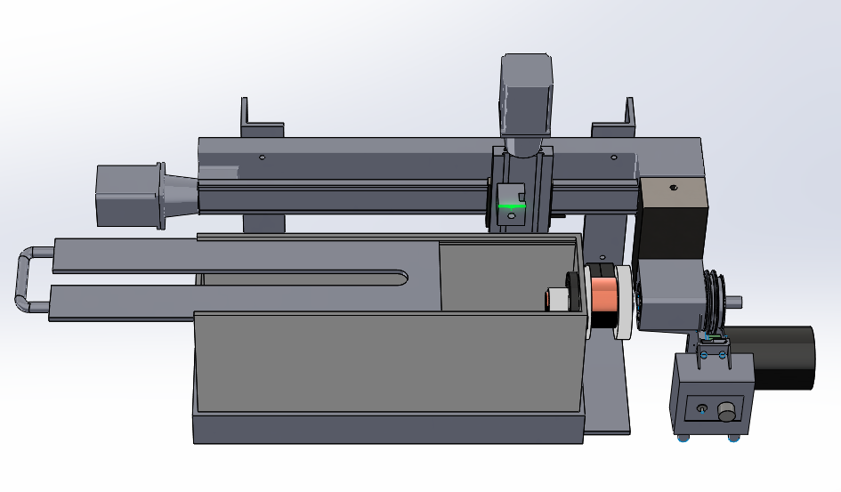

**Figure 7.1:**  General Layout Drawing of the Electro Chemical Lathe

|  |  |
| --- | --- |
|  |  |
|  |  |
|  |  |
|  |  |