

|  |  |
| --- | --- |
| **Course Number and Name:**  ME 747  Experimental Measurement and Modeling of Complex Systems | |
| **Semester and Year:**  Fall 2017 | **Name of Lab Instructor:**  Professor Fussell |
| **Lab Section and Meeting Time:**  Lab Section 3B  Wednesdays 2:00-5:00PM | **Report Type:**  Internal Group Report |
| **Title of Experiment:**  Velocity and Position Control of a Robot Vehicle and Auger Motor  -Final Laboratory- | |
| **Date Experiment Performed:**  15 November – 15 December 2017 | **Date Report Submitted:**  15 December 2017 |
| **Names of Group Members:**  Michael Locke  Matthew Westbrook  Simon Popecki  James Skinner  Zhangxi ‘Jesse’ Feng | **Grader's Comments:** |
| **Grade:** |



December 15, 2017

M. Locke, M. Westbrook, S. Popecki, J. Skinner, Z. Feng

Dept. of Mechanical Engineering

University of New Hampshire

33 Academic Way, Durham, NH 03824

Dear Professor Fussell and Dr. Ebadi,

With the anticipation of the UNH’s LunaCats competing at the NASA Robotics Mining Competition our team has decided to develop PID control for both the velocity of the Mars Bot and the Mars Cat’s auger velocity.

For the purpose of this experiment a theoretical model for a smaller robot called Another Brick in the Wall is developed to compare theoretical results qualitatively to experimental results for different control values. Another model is made for the Mars Cat’s auger to be controlled by a PID controller based on the robot’s position from a wall at 90° to simulate the Mars Bot’s approach to the mining area. Both system models are created in Simulink and MATLAB is used to for the analysis of their system constants and evaluating proper controller values.

Regards,

Michael Locke, Matthew Westbrook,

Simon Popecki, James Skinner, Zhangxi ‘Jesse’ Feng

Michael Locke, Matthew Westbrook, Simon Popecki, James Skinner, Zhangxi ‘Jesse’ Feng

Lead Project Engineers

**TABLE OF CONTENTS**

OBJECTIVES 5

EXECUTIVE SUMMARY 6

THEORY AND EXPERIMENTAL METHODS 7

RESULTS AND DISCUSSION 8

CONCLUSION – Michael Locke 9

CONCLUSION – Matthew Westbrook 10

CONCLUSION – Simon Popecki 11

CONCLUSION – James Skinner 12

CONCLUSION – Zhangxi ‘Jesse’ Feng 13

REFERENCES 14

APPENDICES 15

A. Data Tables 15

B. Sample Calculations 16

C. Equipment List 17

D. Lab Instructions 18

PEER EFFORT 19

**TABLE OF FIGURES AND TABLES**

No table of figures entries found.

**No table of figures entries found.**

# **OBJECTIVES**

***INSERT TEXT HERE***

# **EXECUTIVE SUMMARY**

***INSERT TEXT HERE***

# **THEORY AND EXPERIMENTAL METHODS**

The UNH LunaCats robotics team is creating a lunar mining robot that consists of many subsystems. The team’s goal is to have the robot autonomously approach the mining area from a designated starting location using a non-wall based positioning system (i.e. using sensor feedback such as ultrasonic). Upon reaching the mining area, the auger mining system will be deployed and begin the mining operation. The robot should reach the mining area as quickly as possible while not overextending past the designated mining area. The auger would then be deployed and feature velocity control to detect when the mining apparatus is digging at different depths. For this senior lab project, the drivetrain and auger subsystems were design and evaluated using simple experimental prototypes.

For the drivetrain subsystem… INSERT TEXT HERE

For the auger subsystem, proportional-integral-derivative (PID) velocity control was developed in this experiment and tested on a prototype platform to evaluate the control algorithm. The goal of this platform and algorithm is to develop an understanding of P, I, PI, and PID control using sensor feedback and a dedicated microcontroller to process the sensor inputs and motor outputs. To start, a basic process diagram was developed to understand the velocity control process, in which four main parts to this experiment were determined. First, a means of delivering a step input via user input was needed. Second, a microcontroller was needed to take this step input and control a motor accordingly. Third, a motor to be tested was needed that would provide sufficient output speed. Fourth, a sensor that could be used to provide velocity feedback from the motor to the microcontroller was needed to act as the basis for the control data. Figure 1 below demonstrates this process flow:

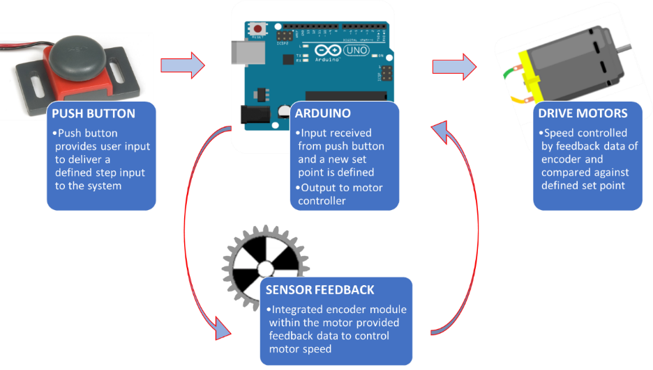

**Figure 1 – Velocity Control Process Diagram**

Knowing the overall process of the velocity control, components were selected that would satisfy each of the four components (seen in Figure 1) and that were easily accessible. An Arduino Uno served at the microcontroller that would process the inputs, outputs, and velocity control algorithm. A basic push button served as the means of user input to initiate a step input. A VEX robotics gearbox motor served as the tested motor for its desirable working speed of about 350RPM. Lastly, an encoder was chosen to provide feedback to the Arduino. Since the encoder measures position and not velocity, the position data was converted to velocity data by taking the difference in positional encoder ticks and dividing by the corresponding change in time measured using an internal timer on the microcontroller.

The next step was to combine all the components together. A wiring diagram was created to define how each component would be connected and to serve as a reference when creating the circuit. Figure 2 reveals the velocity control experimental circuit:

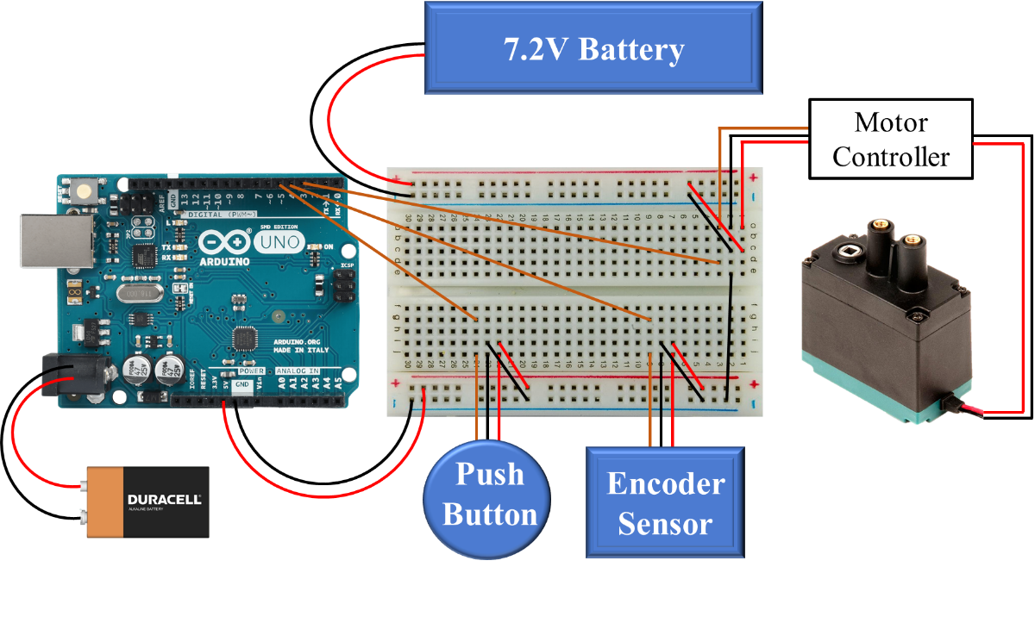

**Figure 2 – Wiring Diagram for Experimental Setup**

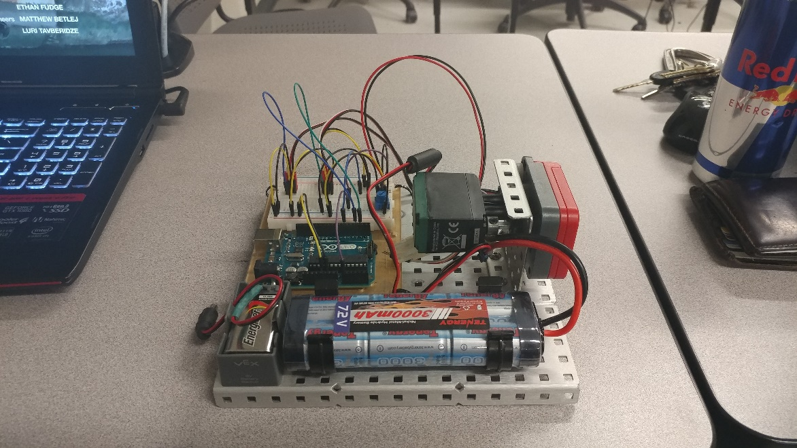 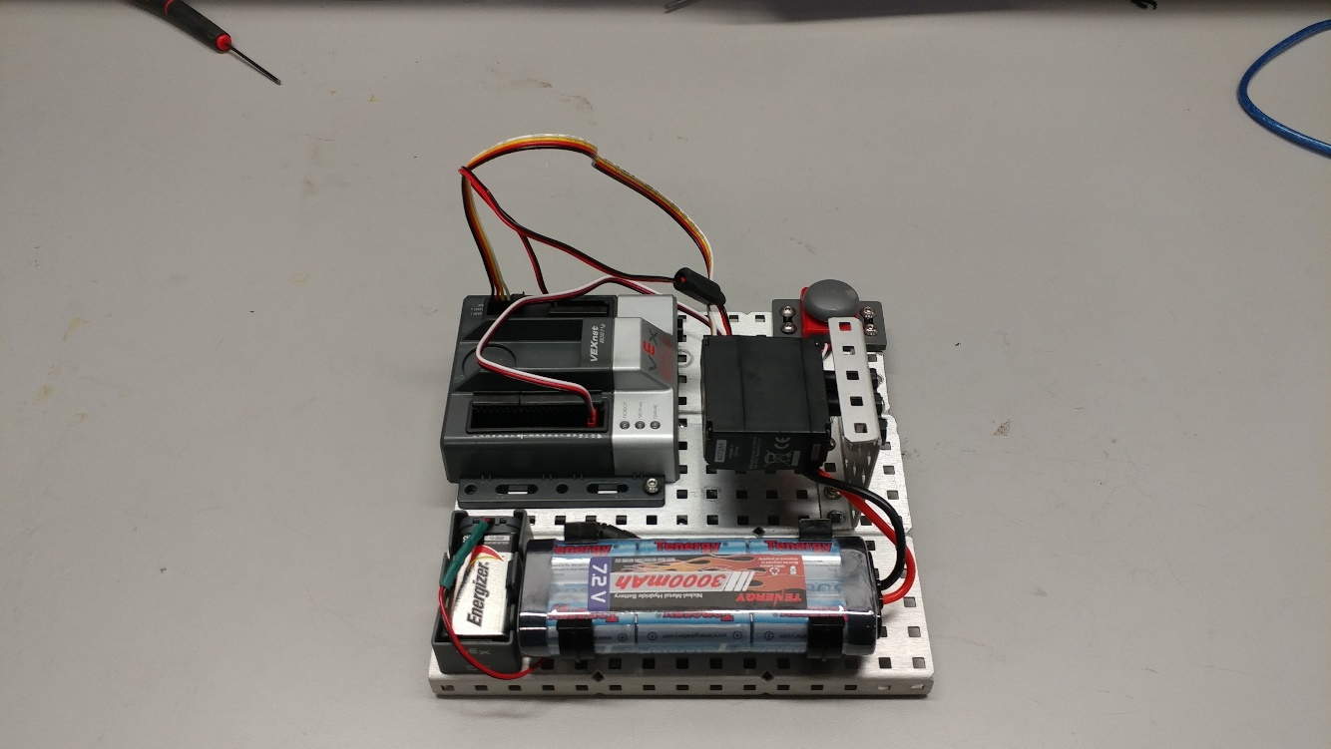

# **RESULTS AND DISCUSSION**

In order to determine the systems parameters of the Another Brick in the Wall robot the Arduino’s code was set to go to maximum speed, ignoring any obstacles sensed by the ultrasonic sensor. The figure below shows output voltage from the ESC PWM signal before it reaches the motors.



Figure 3- The resulting output voltage of the robot driving along the table

Using this response the time constant and gain of the system were calculated for the measured constant voltage from the DC battery source measured as 7.41 V and a steady state voltage of 7.20 V. The motor’s resistance was determined by tapping the motor leads with an ohmmeter. Using the specifications for the Beetle B16 Gearmotor 16:1 the stall torque is interpolated for the input voltage from the battery, which then allowed the torque constant to be calculated. By rearranging equation (INSERT EQ # HERE) the damping and moment of inertia for the system is calculated. The Another Brick in the Wall system parameters are tabulated below.

Table 1-Another Brick in the Wall system parameters

|  |  |
| --- | --- |
| **Time Constant, τ (sec)** | 0.0244 |
| **System Gain, K** | 0.9719 |
| **Motor Resistance, R (Ω)** | 4.0000 |
| **Stall Torque, Td (oz-in)** | 31.2300 |
| **Torque Constant, Kt (oz-in/A)** | 20.8200 |
| **Motor Voltage Constant, Ke (V/rad/s)** | 0.1470 |
| **Damping, B (oz-in/(rad/s))** | 4.5905 |
| **Moment of Inertia, J (oz-in-s2)** | 0.1306 |

The time constant was expected to be a small value from qualitative experimentation of the robot going to full speed

Using the system parameters above for the robot vehicle and MATLAB the system can be simulated with Simulink. The Simulink model is displayed in figure (INSERT FIGURE NUMBER OF SIMULINK MODEL HERE).

**CONCLUSION – Michael Locke**

***INSERT TEXT HERE***

# **CONCLUSION – Matthew Westbrook**

***INSERT TEXT HERE***

# **CONCLUSION – Simon Popecki**

***INSERT TEXT HERE***

# **CONCLUSION – James Skinner**

***INSERT TEXT HERE***

# **CONCLUSION – Zhangxi ‘Jesse’ Feng**

***INSERT TEXT HERE***

# **REFERENCES**

[1] Ogata, K., *System Dynamics,* 4th ed*.,* Upper Saddle River, NJ.: Person Prentice Hall, 2004.

[2] Figliola, R., and Beasley, D., *Theory and Design for Mechanical Measurements,*5th ed.,

Hoboken, NJ.: John Wiley & Sons, 2011.

# **APPENDICES**

## **A. Data Tables**

## 

## **B. Sample Calculations**

## 

## **C. Equipment List**

* Station #2 – Kingsbury S221
* Arduino Uno
* Arduino Mega
* Robot Chassis Platform with Motors
* Ultrasonic Sensor
* Vex Robotics Microcontroller
* VEX 393 Motor with Integrated Encoder Module
* NI Eight Slot Chassis (NI PXIe-1062Q)
* Control Board (NI PXIe-8360)
* Function Generator (NI PXI-5412)
* Digital Multimeter (NI PXI-4065)
* Digital Oscilloscope (NI PXI-5142)
* DC Power Supply (NI PXI-4110)
* DMM Soft Front Panel Software
* LabVIEW 2016
* MATLAB R2016B

## **D. Lab Instructions**

# 

# **PEER EFFORT**

Title of Project: Final Laboratory – Velocity and Position Control of a Robot Vehicle and Auger Motor

Group reports will be given a grade based on the report content and quality. Individual grades will be assigned according to the following formula:

Individual grade = Report grade X number of group members X percent contribution.

**Expectations:**

* All group members are expected to write part of the reports.
* All group members are expected to provide substantive/constructive edits to their partner’s first drafts.
* All group members are responsible to ensure that the report contains all of the deliverables.
* All group members to participate in a timely manner. This requires planning for enough time to respond to editing suggestions and final inspection of the report prior to submission.

|  |  |
| --- | --- |
| Names of Group Members (Signed/Printed) | Percent Contribution |
| Michael Locke | 20% |
| Matthew Westbrook | 20% |
| Simon Popecki | 20% |
| James Skinner | 20% |
| Zhangxi ‘Jesse’ Feng | 20% |
|  |  |
|  |  |