

|  |  |
| --- | --- |
| **Course Number and Name:**  ME 747  Experimental Measurement and Modeling of Complex Systems | |
| **Semester and Year:**  Fall 2017 | **Name of Lab Instructor:**  Professor Fussell |
| **Lab Section and Meeting Time:**  Lab Section 3B  Wednesdays 2:00-5:00PM | **Report Type:**  Internal Group Report |
| **Title of Experiment:**  Velocity and Position Control of a Robot Vehicle and Auger Motor  -Final Laboratory- | |
| **Date Experiment Performed:**  15 November – 15 December 2017 | **Date Report Submitted:**  15 December 2017 |
| **Names of Group Members:**  Michael Locke  Matthew Westbrook  Simon Popecki  James Skinner  Zhangxi ‘Jesse’ Feng | **Grader's Comments:** |
| **Grade:** |

December 15, 2017

M. Locke, M. Westbrook, S. Popecki, J. Skinner, Z. Feng

Dept. of Mechanical Engineering

University of New Hampshire

33 Academic Way, Durham, NH 03824

Dear Professor Fussell and Dr. Abadi,

Regards,

Michael Locke, Matthew Westbrook,

Simon Popecki, James Skinner, Zhangxi ‘Jesse’ Feng

Michael Locke, Matthew Westbrook, Simon Popecki, James Skinner, Zhangxi ‘Jesse’ Feng

Lead Project Engineers

**TABLE OF CONTENTS**

OBJECTIVES 5

EXECUTIVE SUMMARY 6

THEORY AND EXPERIMENTAL METHODS 7

RESULTS AND DISCUSSION 8

CONCLUSION – Michael Locke 9

CONCLUSION – Matthew Westbrook 10

CONCLUSION – Simon Popecki 11

CONCLUSION – James Skinner 12

CONCLUSION – Zhangxi ‘Jesse’ Feng 13

REFERENCES 14

APPENDICES 15

A. Data Tables 15

B. Sample Calculations 16

C. Equipment List 17

D. Lab Instructions 18

PEER EFFORT 19

**TABLE OF FIGURES AND TABLES**

No table of figures entries found.

**No table of figures entries found.**

# **OBJECTIVES**

***INSERT TEXT HERE***

# **EXECUTIVE SUMMARY**

***INSERT TEXT HERE***

# **THEORY AND EXPERIMENTAL METHODS**

The UNH LunaCats robotics team is creating a lunar mining robot that consists of many subsystems. The team’s goal is to have the robot autonomously approach the mining area from a designated starting location using a non-wall based positioning system (i.e. using sensor feedback such as ultrasonic). Upon reaching the mining area, the auger mining system will be deployed and begin the mining operation. The robot should reach the mining area as quickly as possible while not overextending past the designated mining area. The auger would then be deployed and feature velocity control to detect when the mining apparatus is digging at different depths. For this senior lab project, the drivetrain and auger subsystems were design and evaluated using simple experimental prototypes.

For the drivetrain subsystem… INSERT TEXT HERE

For the auger subsystem, proportional-integral-derivative (PID) velocity control was developed in this experiment and tested on a prototype platform to evaluate the control algorithm. The goal of this platform and algorithm is to develop an understanding of P, I, PI, and PID control using sensor feedback and a dedicated microcontroller to process the sensor inputs and motor outputs. To start, a basic process diagram was developed to understand the velocity control process, in which four main parts to this experiment were determined. First, a means of delivering a step input via user input was needed. Second, a microcontroller was needed to take this step input and control a motor accordingly. Third, a motor to be tested was needed that would provide sufficient output speed. Fourth, a sensor that could be used to provide velocity feedback from the motor to the microcontroller was needed to act as the basis for the control data. Figure 1 below demonstrates this process flow:

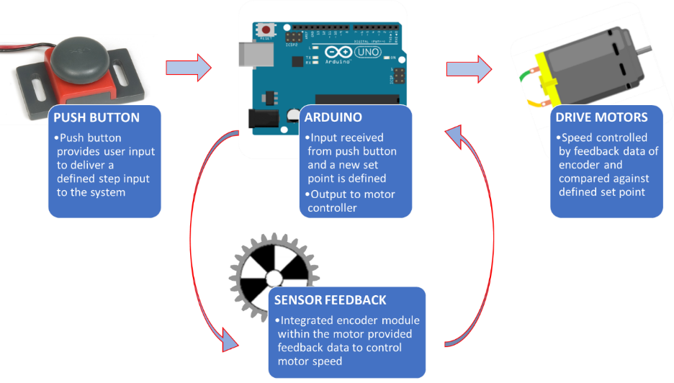

**Figure 1 – Velocity Control Process Diagram**

Knowing the overall process of the velocity control, components were selected that would satisfy each of the four components (seen in Figure 1) and that were easily accessible. An Arduino Uno served at the microcontroller that would process the inputs, outputs, and velocity control algorithm. A basic push button served as the means of user input to initiate a step input. A VEX robotics gearbox motor served as the tested motor for its desirable working speed of about 350RPM. Lastly, an encoder was chosen to provide feedback to the Arduino. The optical encoder sensor used works by having an array of optical sensors view a pattern on a gear within the motor gearbox (seen in Figure 1). The array of optical sensors then can detect when the specific goes from black to white (and vice versa) to then output that change to the microcontroller. The microcontroller then can count the number of time the optical sensors detect a change and convert that to a rotary position. Since the encoder measures position and not velocity, the position data was converted to velocity data by taking the difference in positional encoder ticks and dividing by the corresponding change in time measured using an internal timer on the microcontroller.

The next step was to combine all the components together. A wiring diagram was created to define how each component would be connected and to serve as a reference when creating the circuit. Numerous specification sheets and research was performed to ensure that each component received the correct amount of voltage/current and was configured correctly. Figure 2 reveals the velocity control experimental circuit:

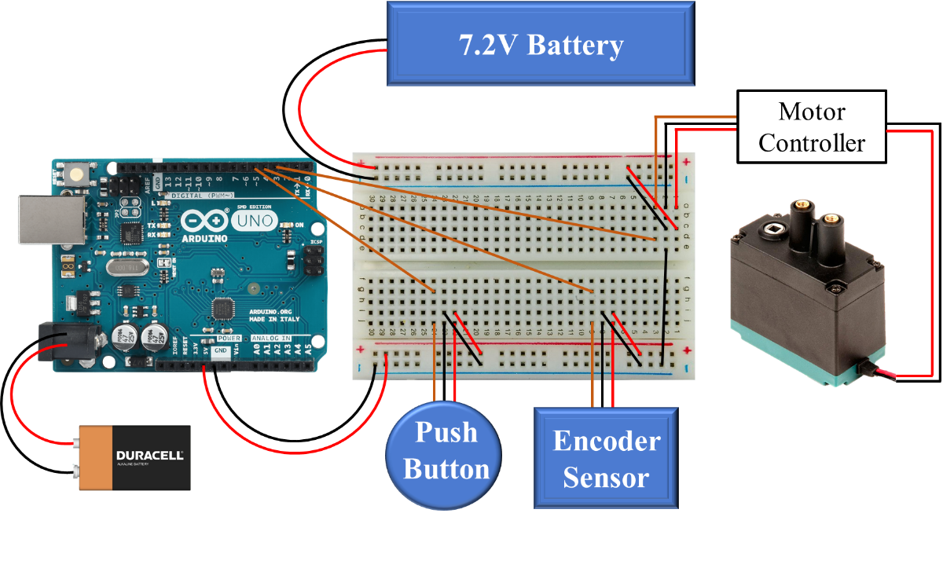

**Figure 2 – Wiring Diagram for Experimental Setup**

From the wiring diagram, note that an extra 7.2-volt battery was used to provide enough power to the motor controller and motor. Using this layout, the experimental setup could finally be constructed. The first experimental prototype and final experimental prototype can be seen below:

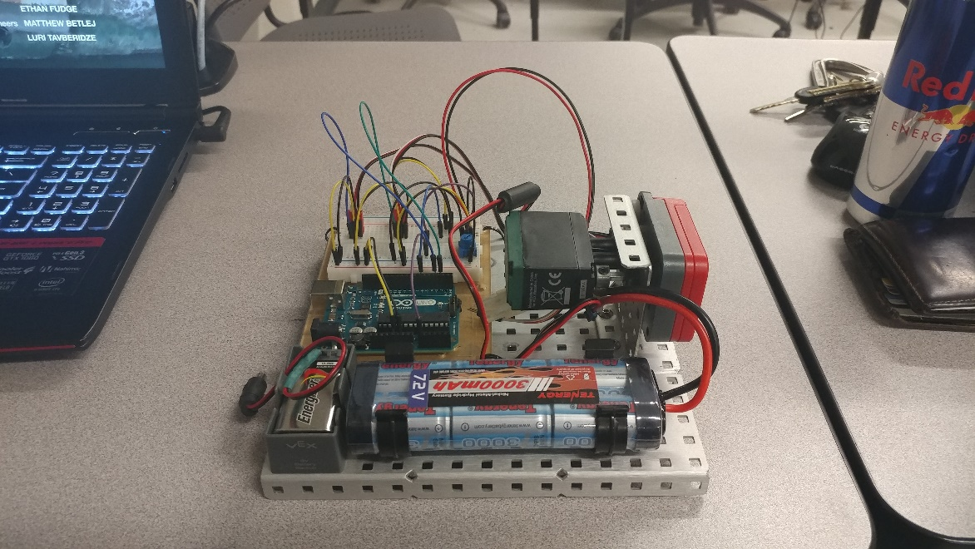 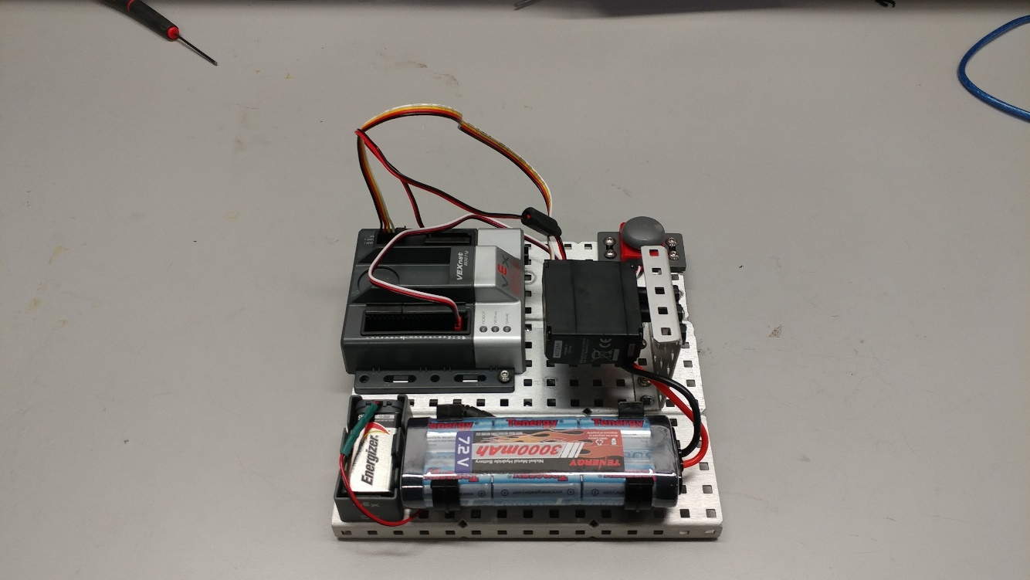

**Figure 3 – Experimental Prototypes (Left: Original, Right: Final)**

Seen in the figure above, multiple experimental setups transpired throughout this project. The first version contained an Arduino microcontroller, separate quadrature encoder, a motor, and push button. The final version contained a VEX Robotics microcontroller, integrated encoder module with the motor housing, a motor, and push button. The reason for this change in equipment was due to numerous issues with components burning out and the Arduino not sampling fast enough to accurately count the number of encoder ticks. The VEX Robotics microcontroller has built in encoder features to accurately track encoder position, so it was used in the final setup.

Now that the experimental setup has been built, the control algorithm needed to be created to control the motor velocity of the system. The three control methods investigated in this experiment were proportional, integral, and derivative control (and combinations of PI and PID). The basis for each control method can be seen in the equations below:

For proportional control, the difference between a desired set point velocity and the feedback velocity of the motor is considered. For integral control, the summation of error over a time period is considered, so the error will start to increase rapidly over time if the error is large. Finally, for derivative control, the rate at which the feedback velocity is approaching the setpoint velocity is considered. For a full PID control, the sum of these three errors controls the response of the motor. Below is the combined PID control algorithm:

Where , , and are the respective proportional, integral, and derivative gain values that tune the system response for different responses. Knowing these control algorithms, a block diagram of the system can be developed:

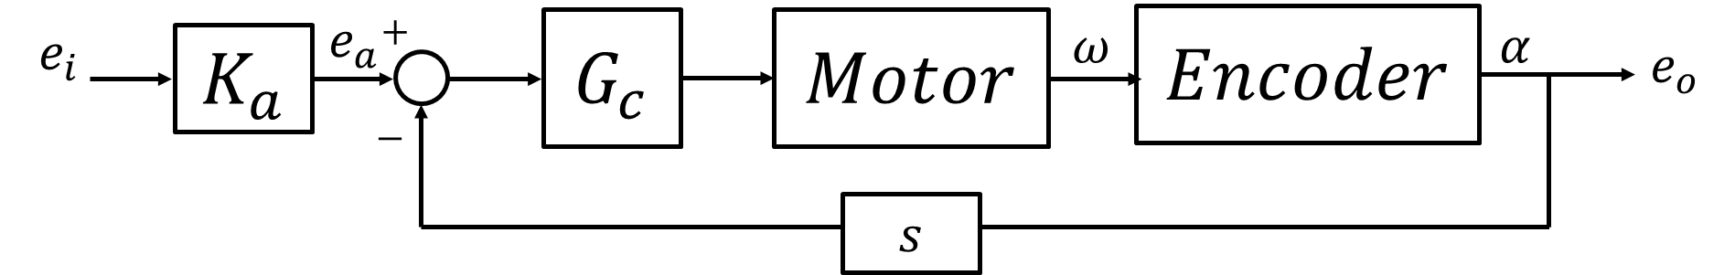

**Figure 4 – Experimental Prototypes (Left: Original, Right: Final)**

Where is the motor controller gain, and is the respective controller being used. Note that the encoder signal needed to be differentiated to obtain a velocity signal. Using this block diagram, a transfer function was derived that describes the complete PID control system:

Where and are the motor gain and motor system response, respectively. These values were going to be found experimentally. Once all values of the transfer function were determined, root loci of each control system were determined to better understand the range of system parameters and system responses.

The original setup was first tested, and the initial analysis started with the calibration of the pulse-width-modulation (PWM) input to the motor controller. The motor controller specification sheet called for an input PWM signal of 1.5-2.0ms pulse widths, so this band was tested to discover the optimal operating range. Once the best operating range was found, an initial proportional control step input was examined. The Arduino was not able to accurately sample the data, and lousy data was obtained. Due to this, the microcontroller was switch for a VEX Robotics microcontroller, and testing resumed. This new platform operated on sending a power signal of -127 to 127 to the motor (with -127 being full reverse, 0 being stop, and 127 being full forward). A desired starting velocity was calibrated to a corresponding motor power input, and a mapping equation was created to proportionally convert future velocities to the correct, corresponding motor power:

The different control algorithms were then implemented into the system and tested against a set step impulse of a desired set point. P, I, PI, and PID control were all examined and compared against theoretical step responses. Resulting settling times were used to evaluate each system.

# **RESULTS AND DISCUSSION**

# **CONCLUSION – Michael Locke**

***INSERT TEXT HERE***

# **CONCLUSION – Matthew Westbrook**

***INSERT TEXT HERE***

# **CONCLUSION – Simon Popecki**

***INSERT TEXT HERE***

# **CONCLUSION – James Skinner**

***INSERT TEXT HERE***

# **CONCLUSION – Zhangxi ‘Jesse’ Feng**

***INSERT TEXT HERE***

# **REFERENCES**

[1] Ogata, K., *System Dynamics,* 4th ed*.,* Upper Saddle River, NJ.: Person Prentice Hall, 2004.

[2] Figliola, R., and Beasley, D., *Theory and Design for Mechanical Measurements,*5th ed.,

Hoboken, NJ.: John Wiley & Sons, 2011.

# **APPENDICES**

## **A. Data Tables**

## 

## **B. Sample Calculations**

## 

## **C. Equipment List**

* Station #2 – Kingsbury S221
* Arduino Uno
* Arduino Mega
* Robot Chassis Platform with Motors
* Ultrasonic Sensor
* Vex Robotics Microcontroller
* VEX 393 Motor with Integrated Encoder Module
* NI Eight Slot Chassis (NI PXIe-1062Q)
* Control Board (NI PXIe-8360)
* Function Generator (NI PXI-5412)
* Digital Multimeter (NI PXI-4065)
* Digital Oscilloscope (NI PXI-5142)
* DC Power Supply (NI PXI-4110)
* DMM Soft Front Panel Software
* LabVIEW 2016
* MATLAB R2016B

## **D. Lab Instructions**

# 

# **PEER EFFORT**

Title of Project: Final Laboratory – Velocity and Position Control of a Robot Vehicle and Auger Motor

Group reports will be given a grade based on the report content and quality. Individual grades will be assigned according to the following formula:

Individual grade = Report grade X number of group members X percent contribution.

**Expectations:**

* All group members are expected to write part of the reports.
* All group members are expected to provide substantive/constructive edits to their partner’s first drafts.
* All group members are responsible to ensure that the report contains all of the deliverables.
* All group members to participate in a timely manner. This requires planning for enough time to respond to editing suggestions and final inspection of the report prior to submission.

|  |  |
| --- | --- |
| Names of Group Members (Signed/Printed) | Percent Contribution |
| Michael Locke | 20% |
| Matthew Westbrook | 20% |
| Simon Popecki | 20% |
| James Skinner | 20% |
| Zhangxi ‘Jesse’ Feng | 20% |
|  |  |
|  |  |