Statement of shared effort

All team members put in an appropriate amount of work and wish that the points will be split evenly.

Jesse Feng

C:\Users\Simon\AppData\Local\Packages\Microsoft.Office.OneNote_8wekyb3d8bbwe\TempState\msohtmlclip\clip_image001.png

Simon Popecki

C:\Users\Simon\AppData\Local\Packages\Microsoft.Office.OneNote_8wekyb3d8bbwe\TempState\msohtmlclip\clip_image001.png

Matt Westbrook

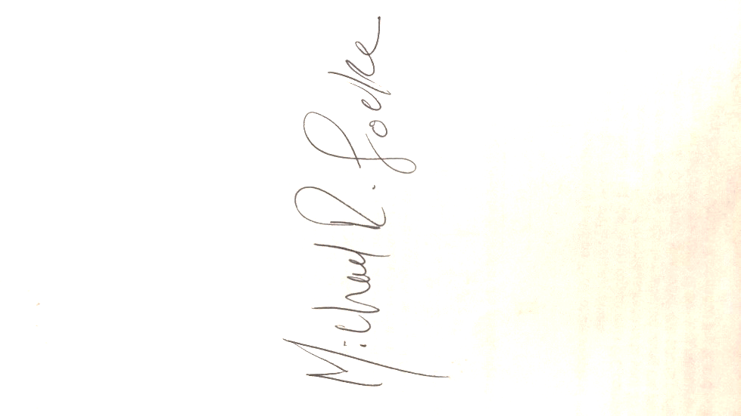cid:d7436e67-f070-47dd-9855-7f24f799c52b

Mike Locke

James Skinner