**Computer Network HW2**

工海三 柯哲邦 b05505053

* **Compile:**
* *make* :

compile the source code of sender.cpp and receiver.cpp

* **Run:**
* ./receiver <receiver IP> <receiver port> <new file name and path>

ex: ./receiver local 8889 result.txt

* ./agent <sender IP> <receiver IP> <sender port> <agent port> <receiver port> <loss rate>

ex: ./agent local local 8887 8888 8889 0.3

* ./sender <sender IP> <sender port> <agent IP> <agent port> <file name and path>

ex: ./sender local 8887 local 8888 test.txt

* Remember to run the sender after agent and receiver have run. Or else, sender will keep on timeouting.
* **Difficulties and Solutions**
* Timeout

At first, I didn’t know how to implement the timeout mechanism. I tried clock() and signal, but I kept facing a problem that the timeout will keep on timeout during the sending process. Moreover, sometimes it isn’t easy to implement from it.

Then, I found a useful function in socket.h, which is setsockopt(). It is really easy to implement and easy to understand, which really save me a lot of time.

* File Problem

At first, I used ifstream to read the text file in and fstream to write it. However, I found out that we also have to transfer media files and picture files, which means that I have to read it in binary form and do some process to it.

Thus, I changed to write it using only open, read, and write. In this way, I don’t have to handle the coding problem.

* **Flow Charts**
* Sender:

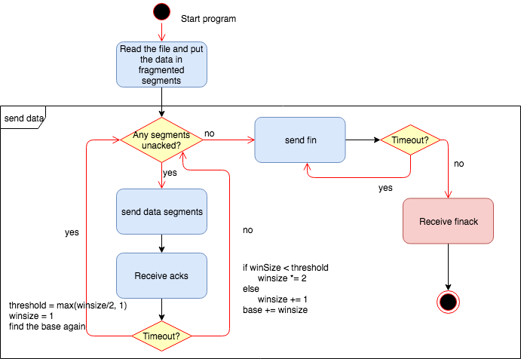

* Receiver:

