**3.1 For the beta density with parameters ↑ = 2 and ↓ = 7, do the following:**

**1. Referring to Table A.2, calculate the mean and mode as functions of the**

**parameters.**

**2. Use an R function to determine the median and a 90% central interval.**

**3. Plot the density.**

Solution:

1. The mean is alpha / (alpha + beta) = 2/9

2. The median is qbeta( 0.5, 2, 7)= 0.2011312

The 90% central interval is: qbeta( c(0.05,0.95), 2, 7)= (0.04638926,0.47067941)

3. The plot of density is:

x <- seq(0.00,1,length=100)

y <- dbeta(x, 2, 7)

plot(x,y,type="l",main="beta(2,7)")

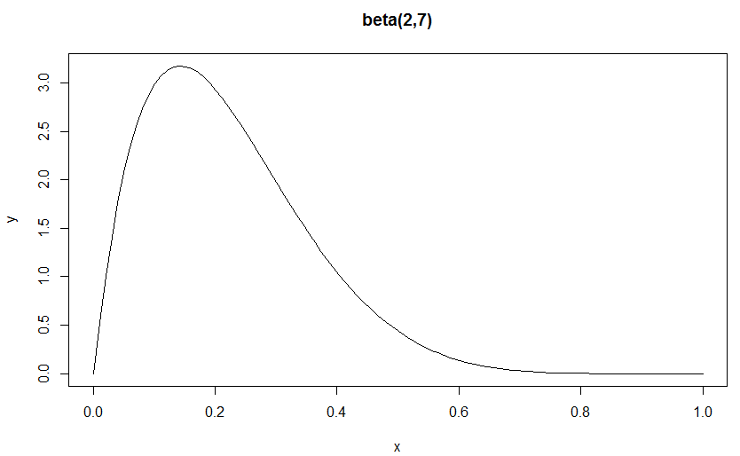

**3.2. To see some of the different shapes that beta densities may take on, plot each**

**of the following densities:**

**1. Beta(0.5, 0.5)**

**2. Beta(10.2, 1.5)**

**3. Beta(1.5, 10.2)**

**4. Beta(100, 62)**

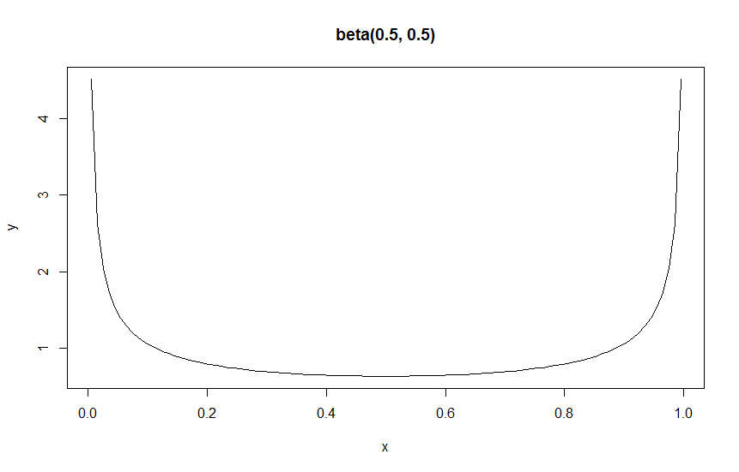

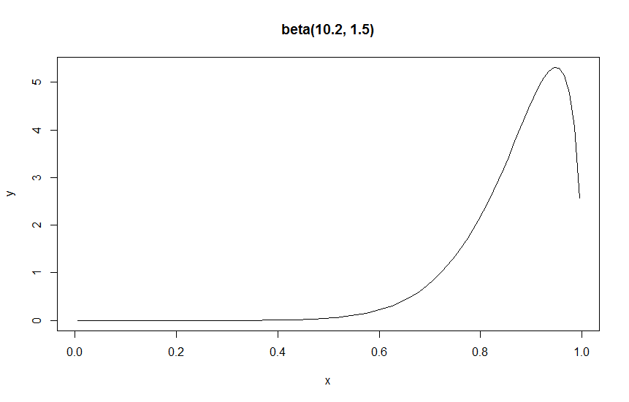

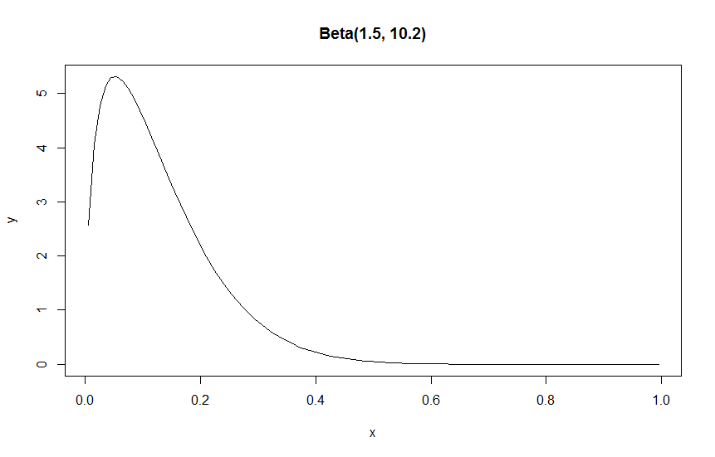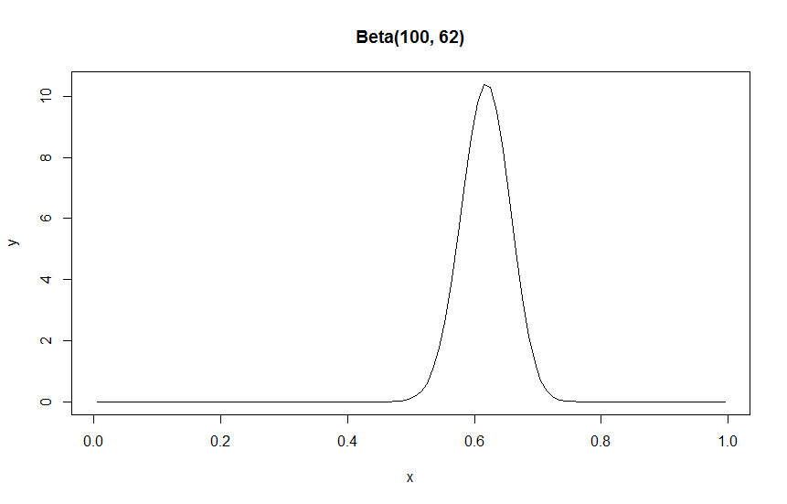

3.4.

1. and 2.

My prior is:

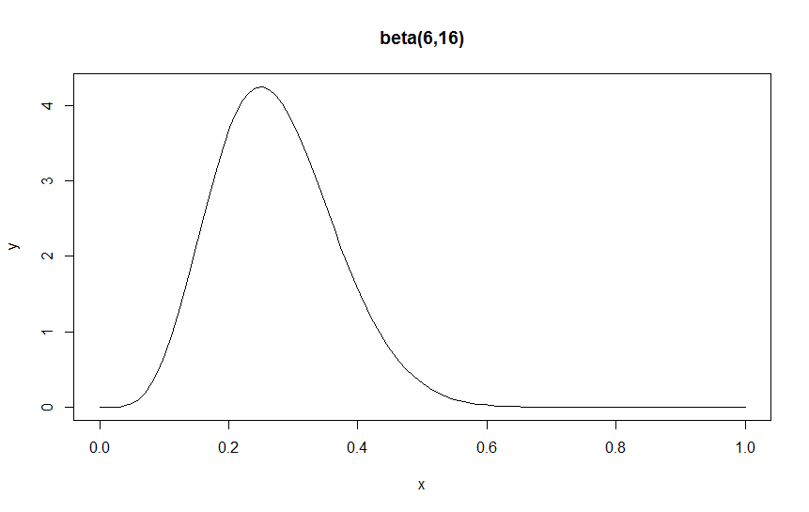

The prior of the women’s record is:

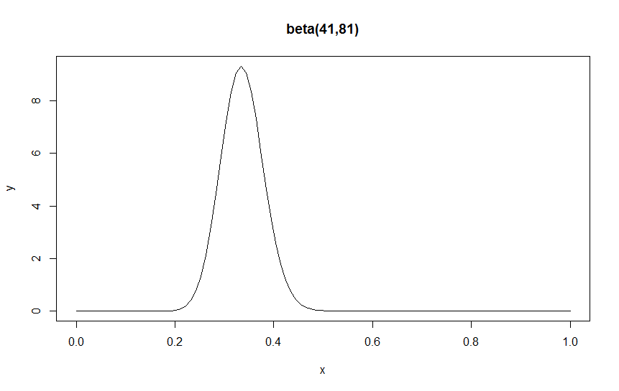

The prior of her mother’s beliefs is:

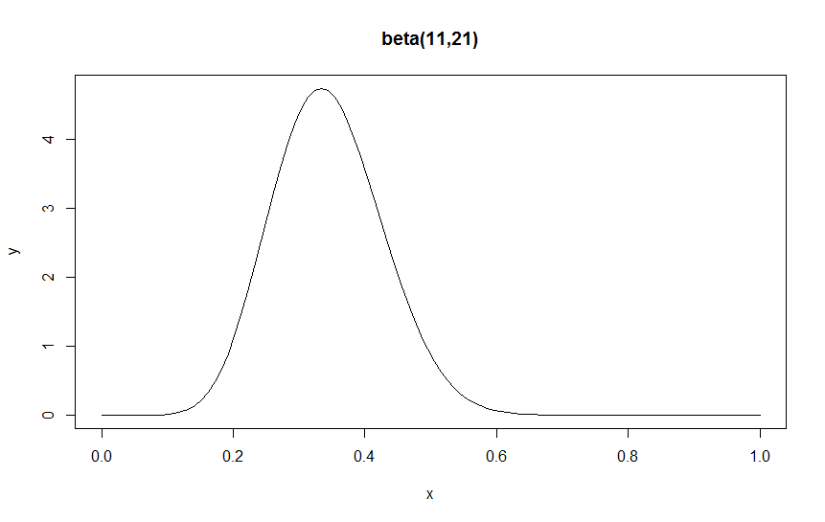

The prior of uniform is:

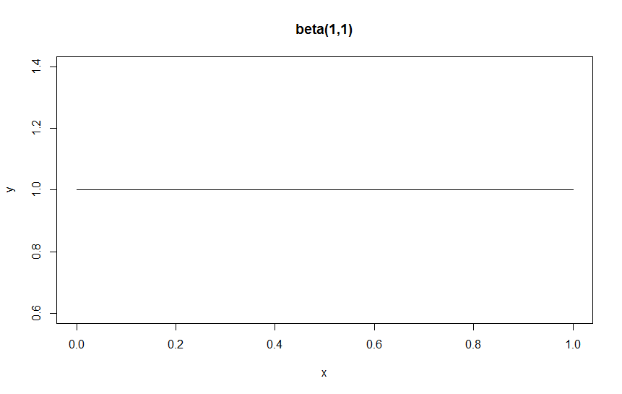

4.

The posterior of my prior is:

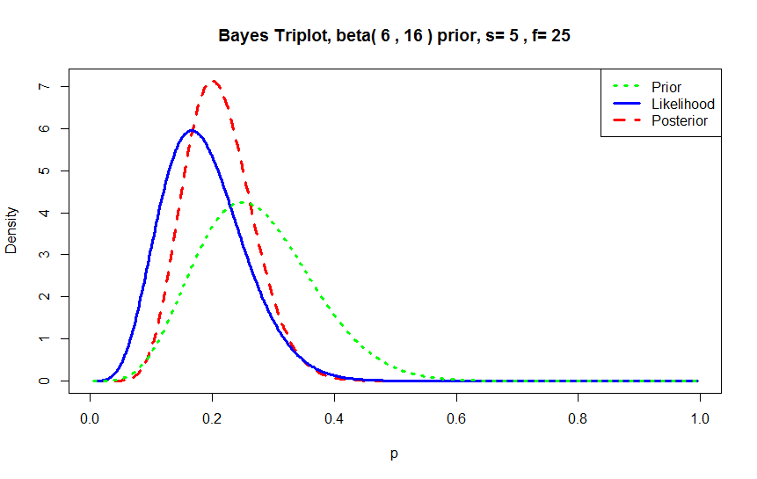

The posterior of women’s prior is:

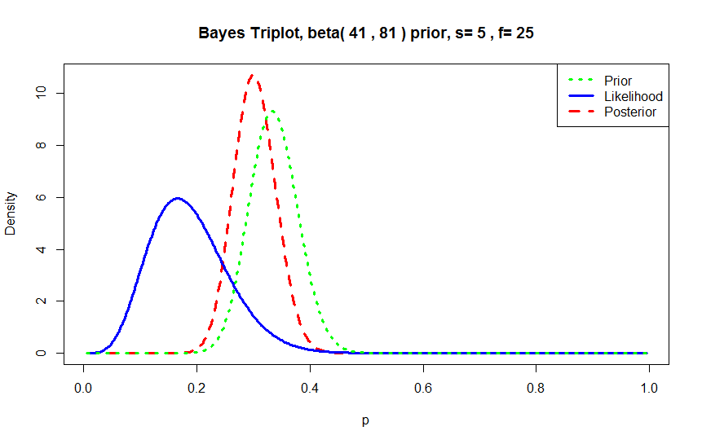

The posterior of her mother’s beliefs is:

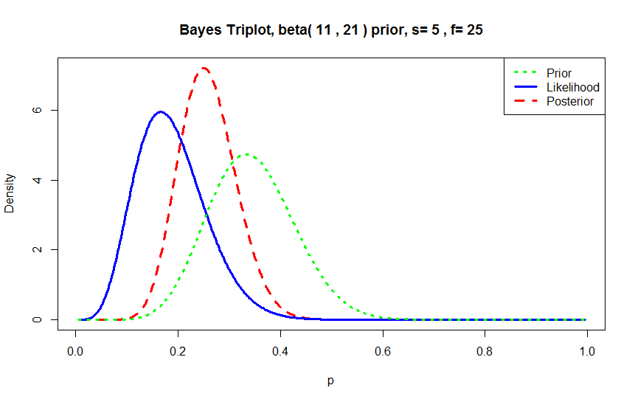

The posterior of uniform prior is:

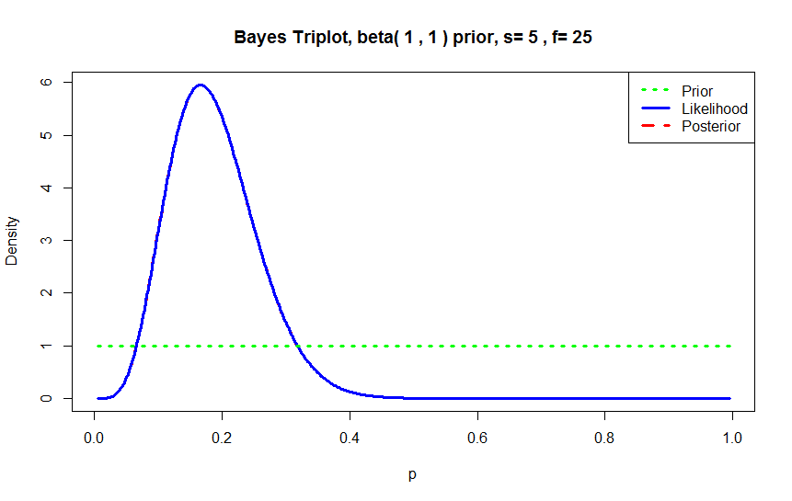

Problem 2.A

The 3D plot is:

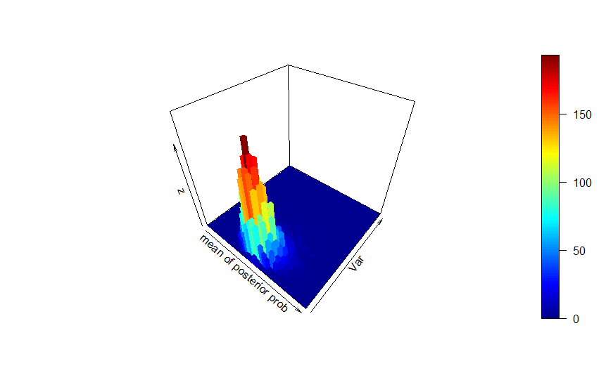

Problem 3.A

|  |  |  |  |  |  |  |  |  |
| --- | --- | --- | --- | --- | --- | --- | --- | --- |
| n | y | Post. Mean | s/sqrt(n) | Post. Std. Dev. | 95% Confidence Low. | 95% Confidence Upper. | 95% Credible Low. | 95% Credible Upper. |
| 5 | 9.7164 | 9.7141 | 0.4308 | 0.5993 | 8.052382 | 11.380593 | 9.224396 | 10.209662 |
| 15 | 9.8989 | 9.8999 | 0.1940 | 0.2122 | 9.482826 | 10.315153 | 9.503017 | 10.296098 |
| 30 | 10.0362 | 10.0385 | 0.1846 | 0.5766 | 9.658726 | 10.413844 | 9.576185 | 10.503511 |
| 100 | 10.0481 | 10.0500 | 0.0886 | 1.6974 | 9.872335 | 10.223946 | 9.613458 | 10.482523 |

3d histogram for n=5:

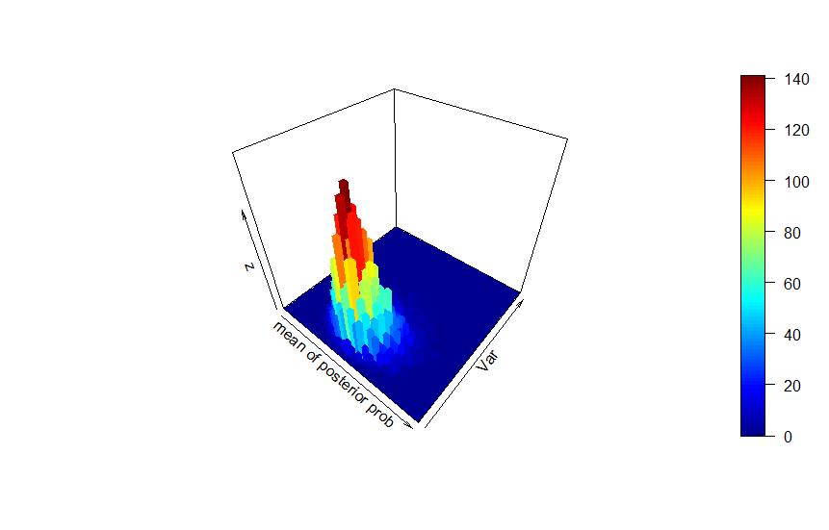3d histogram for n=15:

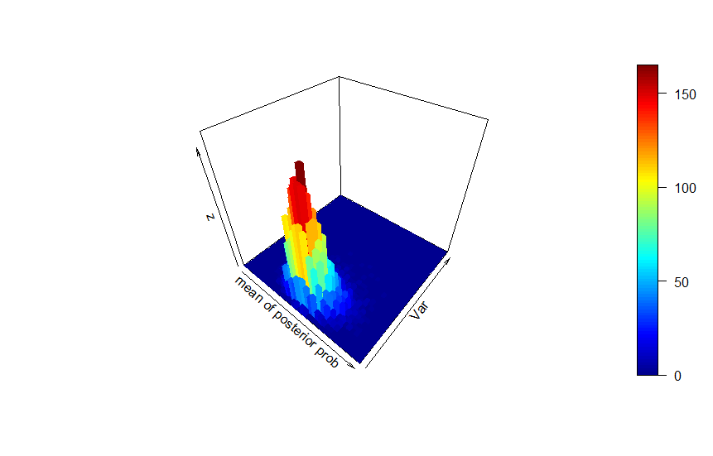

3d histogram for n=30:

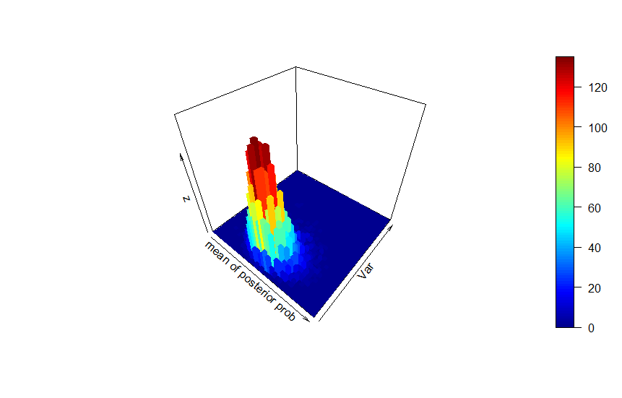

3d histogram for n=100:

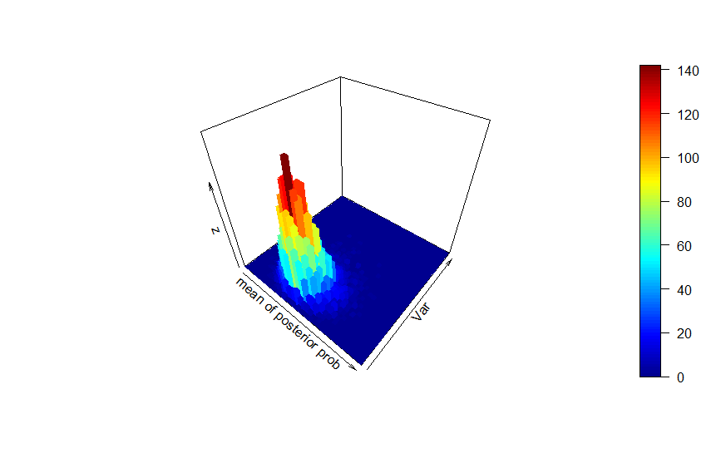

Appendix 2

R codes:

#STAT330 HOMEWORK

#Simon

#9/13/2017

#Problem 3.1

x <- seq(0.00,1,length=100)

y <- dbeta(x, 2, 7)

plot(x,y,type="l",main="beta(2,7)")

qbeta(0.5,2,7)

qbeta(c(0.05,0.95),2,7)

summary(y)

confint(y)

y

quantile(y,0.90)

qbeta( c(0.05,0.95), 2, 7)

qbeta( 0.5, 2, 7)

#Problem 3.4

y <- dbeta(x, 41, 81)

plot(x,y,type="l",main="beta(41,81)")

y <- dbeta(x, 11, 21)

plot(x,y,type="l",main="beta(11,21)")

y <- dbeta(x, 1, 1)

plot(x,y,type="l",main="beta(1,1)")

y <- dbeta(x, 6, 16)

plot(x,y,type="l",main="beta(6,16)")

install.packages("LearnBayes")

library("LearnBayes")

triplot(c(41,81),c(5,25))

triplot(c(11,21),c(5,25))

triplot(c(1,1),c(5,25))

triplot(c(6,16),c(5,25))

qbeta(c(0.025,0.975),11,36)

qbeta(c(0.025,0.975),46,106)

qbeta(c(0.025,0.975),16,46)

qbeta(c(0.025,0.975),6,26)

pbeta(0.25,11,36,lower.tail = F)

pbeta(0.25,46,106,lower.tail = F)

pbeta(0.25,16,46,lower.tail = F)

pbeta(0.25,6,26,lower.tail = F)

#Problem 2.A

#1.

sleep<-c(9.0,8.5,7.0,8.5,6.0,12.5,6.0,9.0,8.5,7.5,8.0,6.0,9.0,8.0,7.0,10.0,9.0,7.5,5.0,6.5)

mean(sleep)

ssy<-sd(sleep)*19

set.seed(2017)

sg<-1/rgamma(10000,mean(sleep),ssy/2)

rand<-rnorm(10000,mean(sleep),sqrt(sg/20))

#2.

install.packages("plot3D")

library("plot3D")

x_axis<-cut(rand,40)

y_axis<-cut(sg,40)

hi<-table(x_axis,y_axis)

hist3D(z=hi,xlab="mean of posterior prob",ylab="Var")

#3.

mean(rand)

quantile(rand,c(0.025,0.975))

#4.

t.test(rand)

t.test(sleep)

#5.

quantile(sg,c(0.025,0.975))

#6.

mean(rand+0.674*sg)

sd(rand+0.674*sg)

#Problem 3.A

#1.

rand5<-rnorm(5,10,1)

rand15<-rnorm(15,10,1)

rand30<-rnorm(30,10,1)

rand100<-rnorm(100,10,1)

#2.

mean(rand5)

ssy5<-sd(rand5)*4

sg5<-1/rgamma(10000,mean(rand5),ssy5/2)

rand5p<-rnorm(10000,mean(rand5),sqrt(sg5/5))

mean(rand5p)

sd(rand5)/sqrt(5)

sd(sg5)

t.test(rand5)

quantile(rand5p,c(0.025,0.975))

mean(rand15)

ssy15<-sd(rand15)*14

sg15<-1/rgamma(10000,mean(rand15),ssy15/2)

rand15p<-rnorm(10000,mean(rand15),sqrt(sg15/15))

mean(rand15p)

sd(rand15)/sqrt(15)

sd(sg15)

t.test(rand15)

quantile(rand15p,c(0.025,0.975))

mean(rand30)

ssy30<-sd(rand30)*29

sg30<-1/rgamma(10000,mean(rand30),ssy30/2)

rand30p<-rnorm(10000,mean(rand30),sqrt(sg30/30))

mean(rand30p)

sd(rand30)/sqrt(30)

sd(sg30)

t.test(rand30)

quantile(rand30p,c(0.025,0.975))

mean(rand100)

ssy100<-sd(rand100)*99

sg100<-1/rgamma(10000,mean(rand100),ssy100/2)

rand100p<-rnorm(10000,mean(rand100),sqrt(sg100/100))

mean(rand100p)

sd(rand100)/sqrt(100)

sd(sg100)

t.test(rand100)

quantile(rand100p,c(0.025,0.975))

x_axis<-cut(rand5p,40)

y_axis<-cut(sg5,40)

hi<-table(x_axis,y_axis)

hist3D(z=hi,xlab="mean of posterior prob",ylab="Var")

x_axis<-cut(rand15p,40)

y_axis<-cut(sg15,40)

hi<-table(x_axis,y_axis)

hist3D(z=hi,xlab="mean of posterior prob",ylab="Var")

x_axis<-cut(rand30p,40)

y_axis<-cut(sg30,40)

hi<-table(x_axis,y_axis)

hist3D(z=hi,xlab="mean of posterior prob",ylab="Var")

x_axis<-cut(rand100p,40)

y_axis<-cut(sg100,40)

hi<-table(x_axis,y_axis)

hist3D(z=hi,xlab="mean of posterior prob",ylab="Var")

#problem 4.A

fre<-0

for(i in 1:1000){

nor<-rnorm(5,10,1)

ssx<-sd(nor)/4

sgx<-1/rgamma(5,mean(nor),ssx/2)

rando<-rnorm(5,mean(nor),sqrt(sgx/4))

if(as.numeric(quantile(rando,0.025))<=mean(nor)){if(as.numeric(quantile(rando,0.975))>=mean(nor)){fre<-fre+1}}

ssx<-numeric(0)

sgx<-numeric(0)

}

fre