Problem 4.

First, we use R to generate the posterior.

Given that the sample following poisson, we know that the posterior follows gamma(a+sum of X, b+n), where n is the numbers of X.

Then, we have:

vix<-c(161,155,136,133,153,171,141,157,137,172)

#prior is gamma

pri.a<-0.001

pri.b<-0.001

#posterior

po.a<-pri.a+sum(vix)

n<-length(vix)

po.b<-pri.b+n

pos<-rgamma(10000,po.a,po.b)

mean(pos)

hist(pos, main="posterior histogram oflambda")

plot(density(pos),main="posterior distribution oflambda")

The result is:

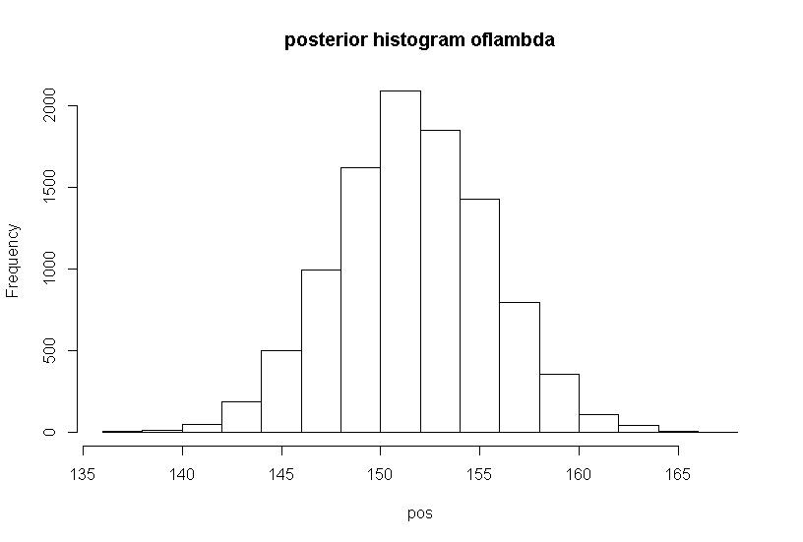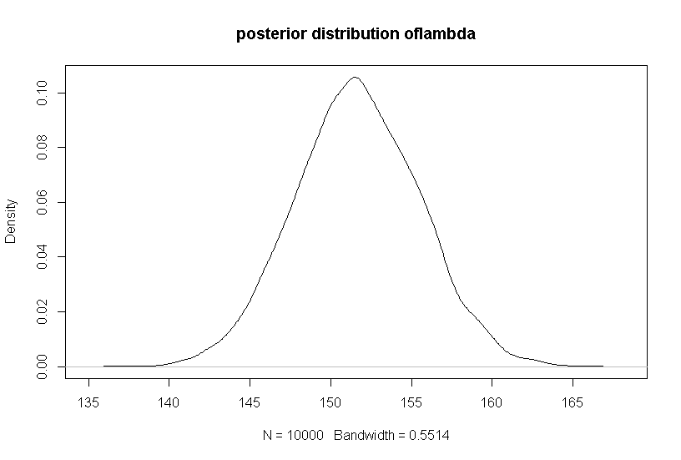

mean(vix) #the mean from samples

[1] 151.6

mean(pos) #the mean from posterior

[1] 151.6304

Next, we use Rstan to sample:

By using the codes:

library(rstan)

library(StanHeaders)

stancode<-"

data{

int<lower=1>n;

int vx[n];

}

parameters{

real<lower=0>mu;

}

model{

vx~poisson(mu);

}

"

fit <- stan(model_code=stancode)

fit

We have:

> fit

Inference for Stan model: a148b9fa62e8331ad5c9d1741cf63562.

4 chains, each with iter=2000; warmup=1000; thin=1;

post-warmup draws per chain=1000, total post-warmup draws=4000.

mean se_mean sd 2.5% 25% 50% 75% 97.5% n_eff Rhat

mu 151.86 0.11 3.94 144.29 149.12 151.88 154.52 159.54 1247 1.01

lp__ 6100.72 0.02 0.68 6098.85 6100.52 6100.99 6101.18 6101.23 1603 1.00

Samples were drawn using NUTS(diag_e) at Wed Sep 27 22:59:58 2017.

For each parameter, n_eff is a crude measure of effective sample size,

and Rhat is the potential scale reduction factor on split chains (at

convergence, Rhat=1).

Thus, we have mean of posterior is 151.86, which is quite similar to the mean of x(151.6).