b)

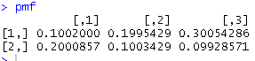

The result from R is:

|  |  |  |  |
| --- | --- | --- | --- |
|  | Theta2 = 1 | Theta2 = 2 | Theta2 = 3 |
| Theta1 = 1 | 0.1002000 | 0.1995429 | 0.30054286 |
| Theta1 = 2 | 0.2000857 | 0.1003429 | 0.09928571 |

(The codes will be shown at Appendix)

Conclusion: Comparing to calculation by hand, it is almost the same.

3.b

Summary for different values for (a, b)

Similarities: The estimations of lambda have the similar result

Differences: The Beta are influenced heavily by the (a, b), when a=b=1, it is close to 0; while a=b=0.001, which shows that beta follow the flat prior, that makes the beta much smaller.

1) When a=b=1,

The 95% credible intervals for beta are (0.002826432 0.378971191)

The 95% credible intervals for lambda are (6.562691 12.519106)

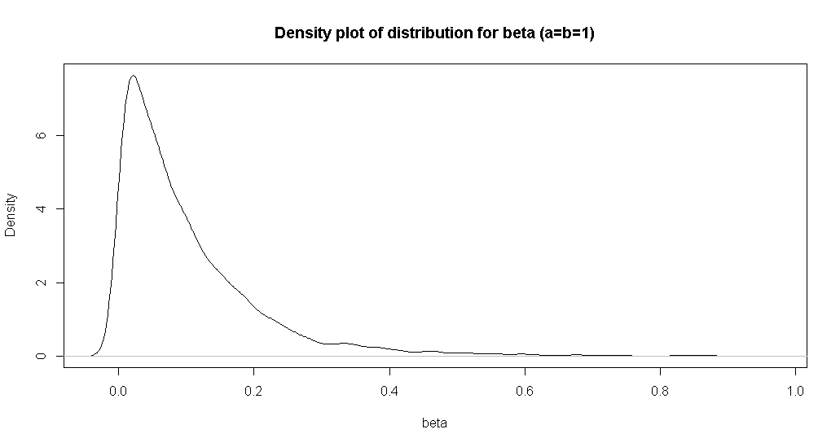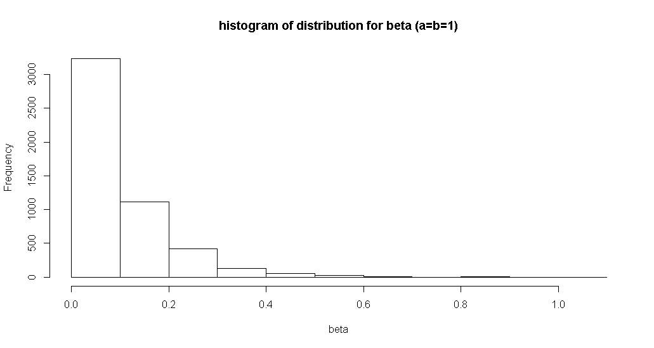

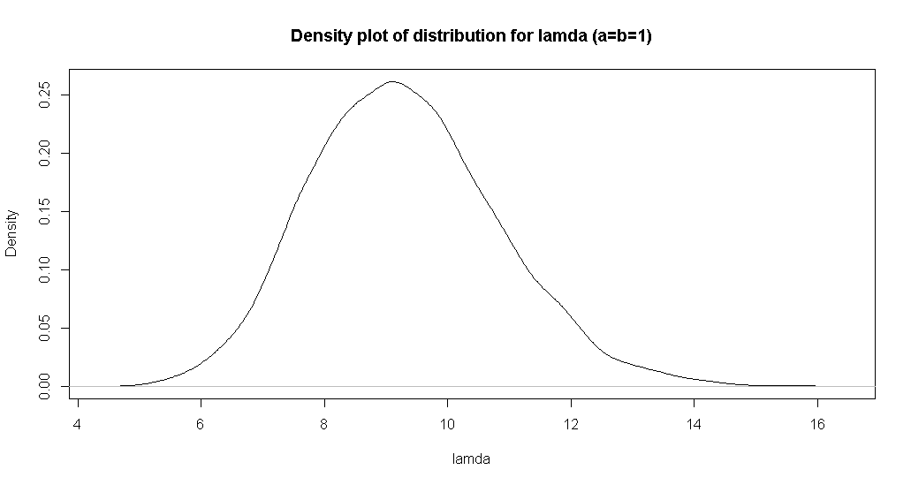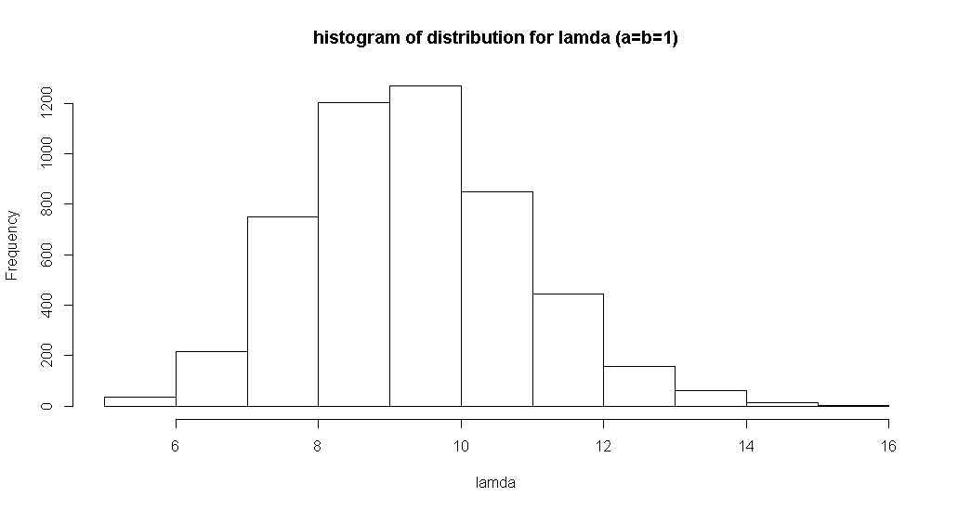

When a=b=0.001,

The 95% credible intervals for beta are (0.000000e+00 3.558335e-12)

The 95% credible intervals for lambda are (6.791233 12.839585)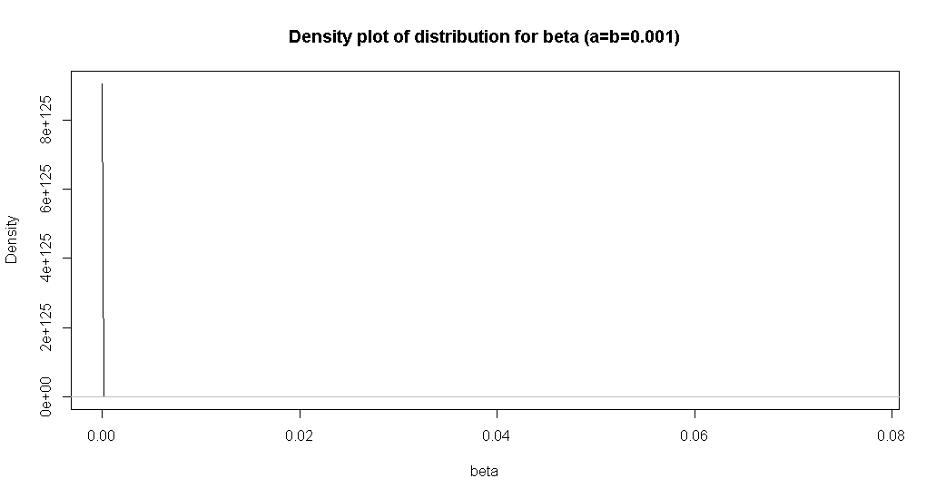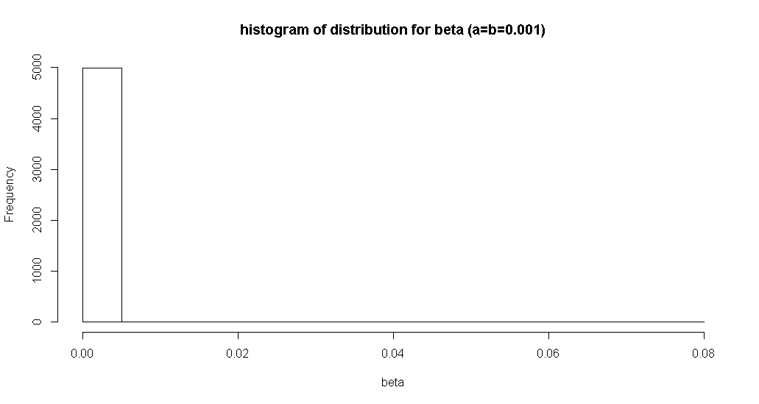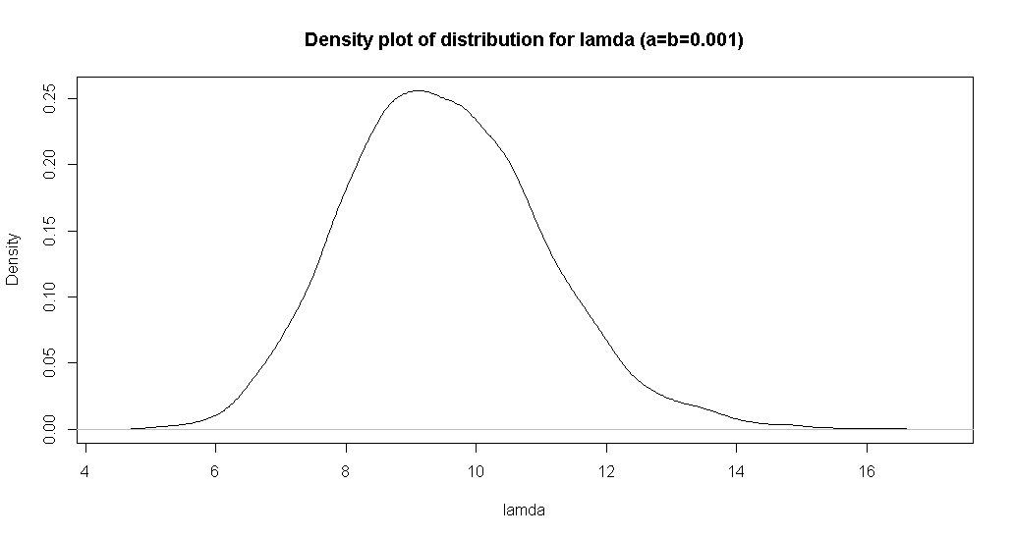 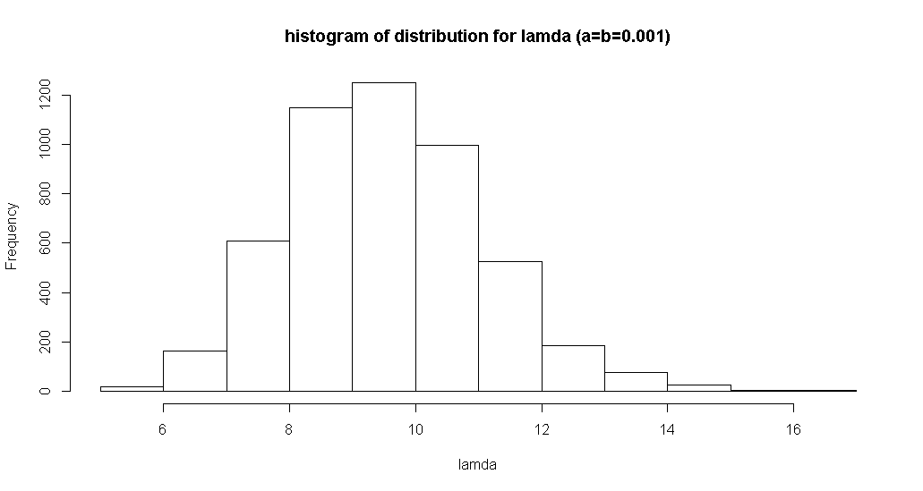

Appendix I

R codes:

#1.b.

p.theta12<-matrix(c(1/3,2/3,2/3,1/3,3/4,1/4),nrow=2,ncol=3)

p.theta21<-matrix(c(1/6,1/3,1/2,1/2,1/4,1/4),nrow=3,ncol=2)

p.theta12

theta1.star<-1

theta2.star<-1

i<-1

save.theta1<-c(1)

save.theta2<-c(1)

n<-80000

k<-10000

set.seed(2017)

for (i in 1:n){

u_theta1<-runif(1,0,1)

if (u_theta1<=p.theta12[1,theta2.star]){theta1.star<-1}

if (u_theta1>=p.theta12[1,theta2.star]){theta1.star<-2}

u_theta2<-runif(1,0,1)

if (u_theta2<=p.theta21[1,theta1.star]){theta2.star<-1}

if (u_theta2>p.theta21[1,theta1.star]){

if (u_theta2<=(p.theta21[1,theta1.star]+p.theta21[2,theta1.star])){theta2.star<-2}

}

if (u_theta2>p.theta21[1,theta1.star]+p.theta21[2,theta1.star]) {theta2.star<-3}

save.theta1<-c(save.theta1,theta1.star)

save.theta2<-c(save.theta2,theta2.star)

}

new.theta1<-data.frame(save.theta1[k+1:n])

new.theta2<-data.frame(save.theta2[k+1:n])

joint <- data.frame(cbind(save.theta1[(k+1):n], save.theta2[(k+1):n]))

j.11 <- length(joint[joint$X1==1&joint$X2==1,1])/(n-k)

j.21 <- length(joint[joint$X1==2&joint$X2==1,1])/(n-k)

j.12 <- length(joint[joint$X1==1&joint$X2==2,1])/(n-k)

j.22 <- length(joint[joint$X1==2&joint$X2==2,1])/(n-k)

j.13 <- length(joint[joint$X1==1&joint$X2==3,1])/(n-k)

j.23 <- length(joint[joint$X1==2&joint$X2==3,1])/(n-k)

pmf<-matrix(c(j.11,j.21,j.12,j.22,j.13,j.23),nrow=2)

pmf

# pmf is [theta2=1][theta2=2][theta2=3]

#[theta1=1] 0.1002000 0.1995429 0.30054286

#[theta1=2] 0.2000857 0.1003429 0.09928571

#3.b.

n<-10000

k<-5000

#a=b=1

a<-1

b<-1

y<-c(8,9,9,10)

sumy<-sum(y)

ny<-length(y)

beta.star<-rgamma(1,a,rate=b)

lamda.star<-rgamma(1,2,rate=beta.star)

save.beta<-c(beta.star)

save.lamda<-c(lamda.star)

for (i in 1:n){

beta.star<-rgamma(1,a,rate=b+lamda.star)

lamda.star<-rgamma(1,2+sumy,rate=beta.star+ny)

save.beta<-c(save.beta,beta.star)

save.lamda<-c(save.lamda,lamda.star)

}

post.3.1<-data.frame(cbind(new.beta<-save.beta[k+1:n],new.lamda<-save.lamda[k+1:n]))

hist(post.3.1$X1,main="histogram of distribution for beta (a=b=1)",xlab="beta")

g=density(post.3.1$X1,na.rm=TRUE)

plot(g,main="Density plot of distribution for beta (a=b=1)",xlab="beta")

hist(post.3.1$X2,main="histogram of distribution for lamda (a=b=1)",xlab="lamda")

f=density(post.3.1$X2,na.rm=TRUE)

plot(f,main="Density plot of distribution for lamda (a=b=1)",xlab="lamda")

quantile(post.3.1$X1,c(0.025,0.975),na.rm = TRUE)

#95% credible intervals for beta

quantile(post.3.1$X2,c(0.025,0.975),na.rm = TRUE)

#95% credible intervals for lamda

#a=b=0.001

a<-0.001

b<-0.001

y<-c(8,9,9,10)

sumy<-sum(y)

ny<-length(y)

beta.star<-rgamma(1,a,rate=b)

lamda.star<-rgamma(1,2,rate=beta.star)

save.beta<-c(beta.star)

save.lamda<-c(lamda.star)

for (i in 1:n){

beta.star<-rgamma(1,a,rate=b+lamda.star)

lamda.star<-rgamma(1,2+sumy,rate=beta.star+ny)

save.beta<-c(save.beta,beta.star)

save.lamda<-c(save.lamda,lamda.star)

}

post.3.2<-data.frame(cbind(new.beta<-save.beta[k+1:n],new.lamda<-save.lamda[k+1:n]))

hist(post.3.2$X1,main="histogram of distribution for beta (a=b=0.001)",xlab="beta")

h=density(post.3.2$X1,na.rm = TRUE)

plot(h,main="Density plot of distribution for beta (a=b=0.001)",xlab="beta")

hist(post.3.2$X2,main="histogram of distribution for lamda (a=b=0.001)",xlab="lamda")

o=density(post.3.2$X2,na.rm = TRUE)

plot(o,main="Density plot of distribution for lamda (a=b=0.001)",xlab="lamda")

quantile(post.3.2$X1,c(0.025,0.975),na.rm = TRUE)

#95% credible intervals for beta

quantile(post.3.2$X2,c(0.025,0.975),na.rm = TRUE)

#95% credible intervals for lamda