|  |  |
| --- | --- |
|  |  |

|  |  |
| --- | --- |
| EvanS Bandhan Gomes | Nawabgonj, Dhaka, Bangladesh  +8801840655929  bandhangomes@gmail.com |

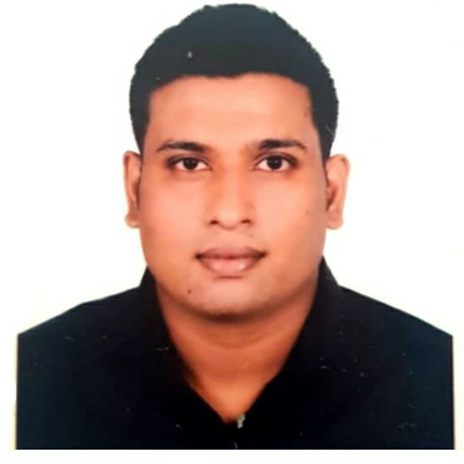To buildup dynamic career in the challenging field of business by having some of new experience, abilities, skills, and education in the in institution.

|  |  |
| --- | --- |
|  | Education |

## Degree Title | School

### sECONDARY sCHOOL CERTIFICATE (s.s.c)

School : Bandura Holly Cross High School.

G.P.A : 3.50

Group : Commerce/Business studies

Passing year : 2012

## Degree Title | Collage

### hIGHER SECONDARY CERTIFICATE (H.S.C)

Collage : Tejgaon Collage, Dhaka

G.P.A : 3.70

Group : Commerce/Business studies.

Passing year : 2014

## Degree Title | University

## Diploma

University : Ideal Institute Of Business & Science, Dhaka

C.G.P.A : N/A

Department : Major In Marketing.

Passing year : N/A

|  |  |
| --- | --- |
|  | Experience |

Worked in Forge Technology from 01 July 2014 to 28, February 2015 as a Data Entry operator.

Still working on Tuition Merit View as a student contactor.

|  |  |
| --- | --- |
|  | Skills |

|  |  |
| --- | --- |
| * I Can operate windows and others | * A data entry staff |

|  |  |
| --- | --- |
|  | Activities |

Basically I am a worker now in Tuition Merit View. My work in here is to search for student for teacher’s.

|  |  |
| --- | --- |
|  | Personal details |

Father’s Name : Eric Gomes

Father’s occupation : Teacher

Mother’s Name : Jhumur Gomes

Mother’s occupation : House wife / Teacher

Sex : Male

Blood Group : B+

Date of Barth : 7th  April 1996

Nationality : Bangladeshi

Religion : Christianity (Roman catholic)

Permanent Address : Village: Borogolla, Postoffice: Gobindapur, Distric: Dhaka1320, P.S:

Nawabgonj,

|  |  |
| --- | --- |
|  | Signature |

 Evans Bandhan Gomes

|  |  |
| --- | --- |
|  | References |