Contents
Notes 2
Static Site Generation (SSG) 2
Prisma 3
SQLite Manager 6
Startup command and script 7
TailWind 8
Next.JS Flow 13
General Setup 16
Phase 1 17
Phase 2 24
Phase 3 39

Notes

Static Site Generation (SSG)
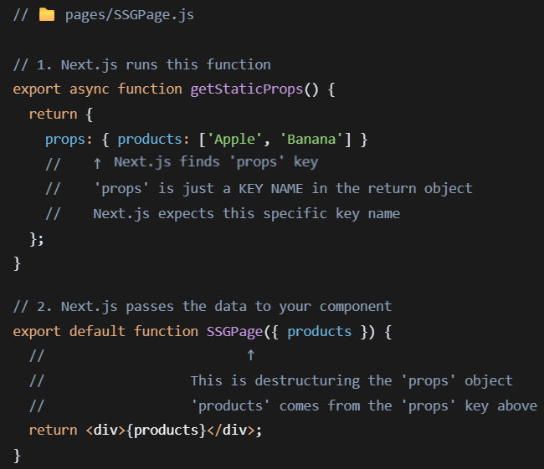
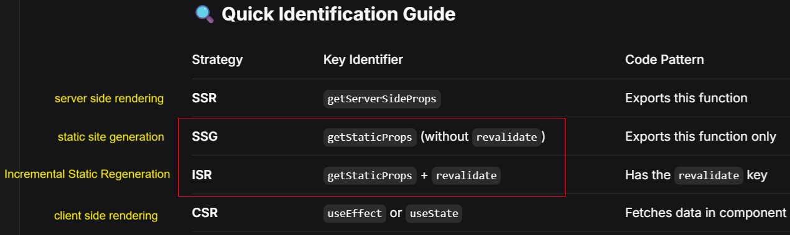

Prisma
Workflow
- Edit schema.prisma to define/update your models
- Run prisma migrate dev to generate SQL migrations and apply them
- Run prisma generate to update the Prisma Client
- Use the generated client in your application code

npx prisma migrate dev --name init create your first database migration and applies it to your database.
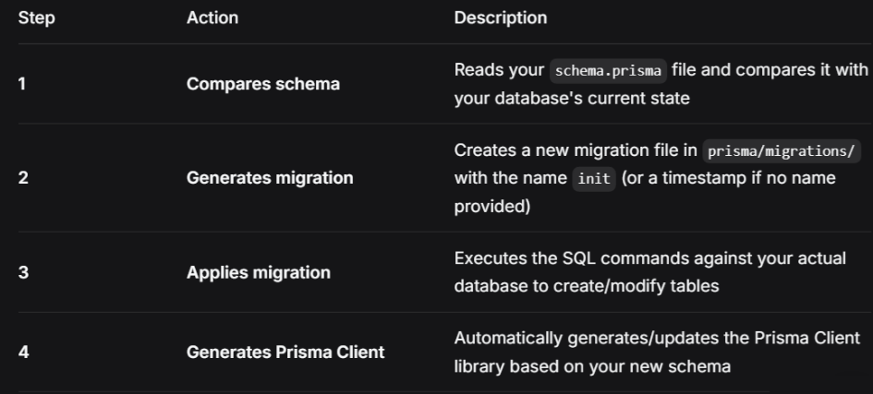
When you run any migration command, Prisma creates a table called _prisma_migrations in your database to track which migrations have been applied.
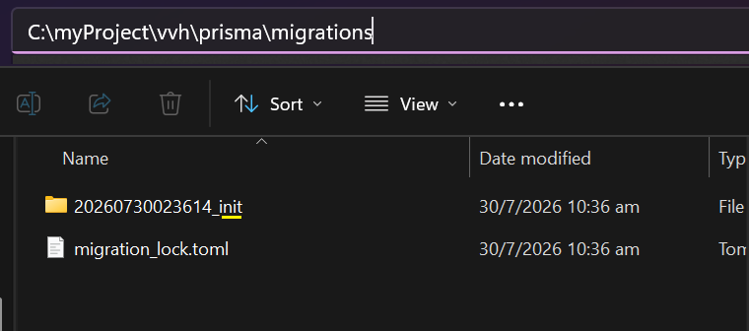
It also reads schema.prisma and outputs custom, tailor-made code for interacting with your database.

prisma.ts is not an official file required by Prisma but it is commonly used by developers to create and export a single, shared instance of PrismaClient.
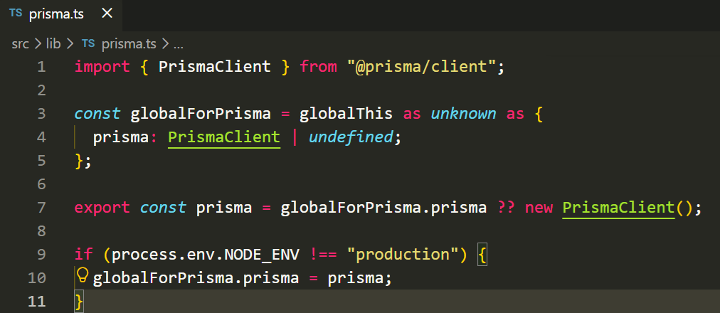
The globalForPrisma.prisma = prisma assignment only happens in development, but globalForPrisma.prisma being undefined in production means you get a clean, fresh Prisma Client instance when your app starts up.

Example
- Create different .env file
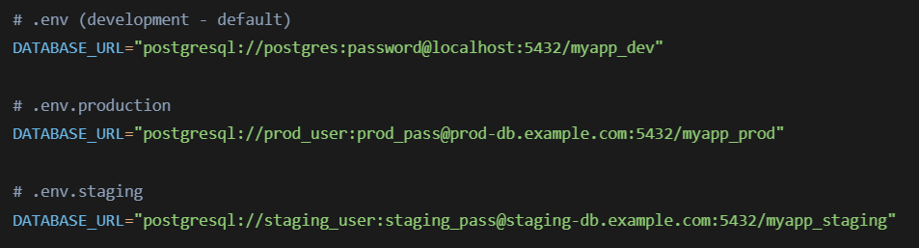
- Development WorkFlow
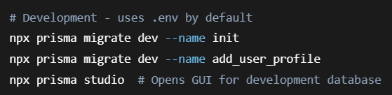
- Production Deployment
Connect to myapp_prod and check _prisma_migration. It then applies only pending migration and update _prisma_migrations after completion.
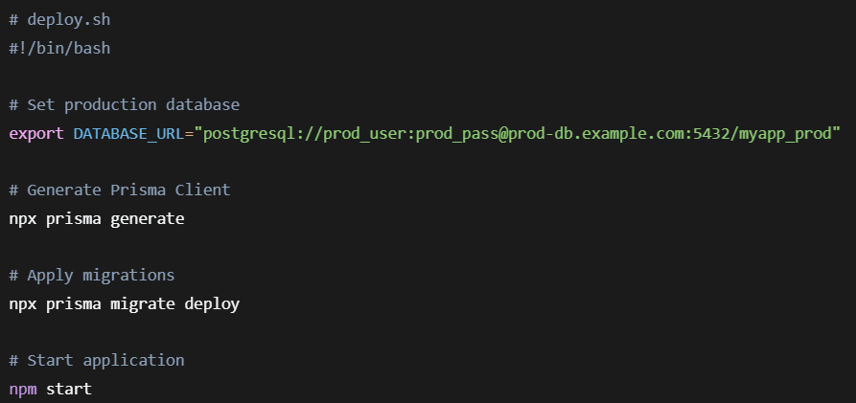
You can also use npm scripts (package.json)
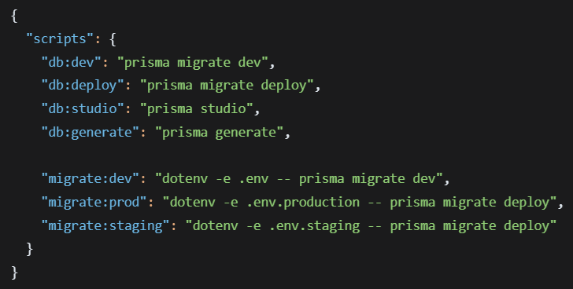

Usage :
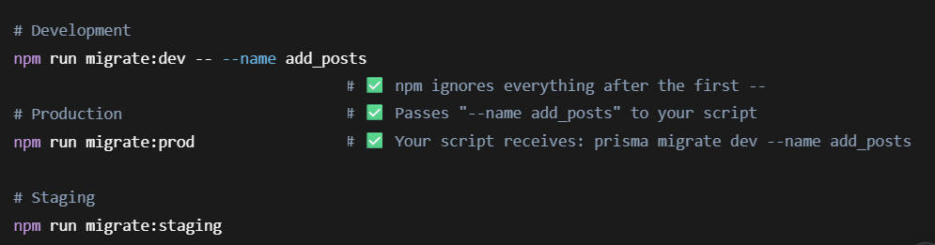
In Prisma ORM version 7, migrate dev command will no longer automatically trigger prisma generate. You will need to regenerate the client manually by running npx prisma generate after your migration

SQLite Manager
https://sqlitebrowser.org/dl/

Startup command and script
- npx next start is designed to run the production build of your application. It looks for a specific file (the BUILD_ID) inside the .next folder, which is only created after running npx next build. After the build finishes successfully, start the production server: npx next start
- To run on development server, run npx next dev.
- You can run custom script in package.json.
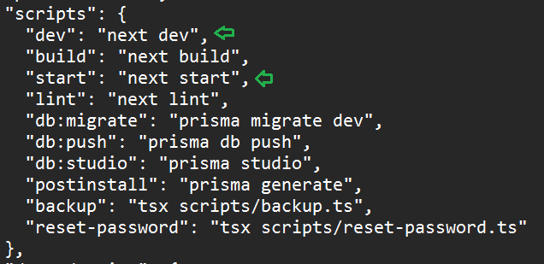
npm run dev -> npm next dev
npm run start -> npm next start

TailWind
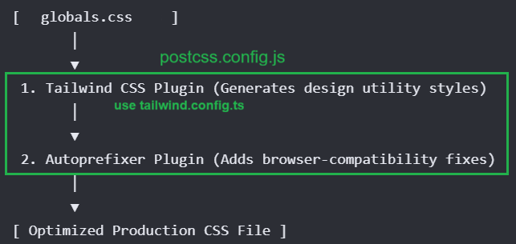
next.config.js sets up your Next.js application with internationalization (i18n) support.
postcss.config.js is a configuration file for PostCSS – a tool that transform CSS with JavaScript plugins to process and optimize your CSS.
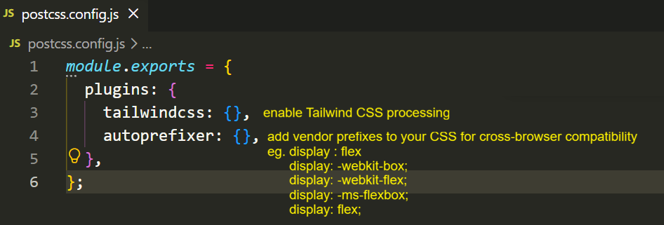

The content array in tailwind.confg.ts tell Tailwind which file to scan for class names. You can only generates CSS for those classes. That is what keeps your final CSS file small.

Files listed in content → Tailwind scans them → Finds class names like flex, p-4, text-center → Generates CSS for them.
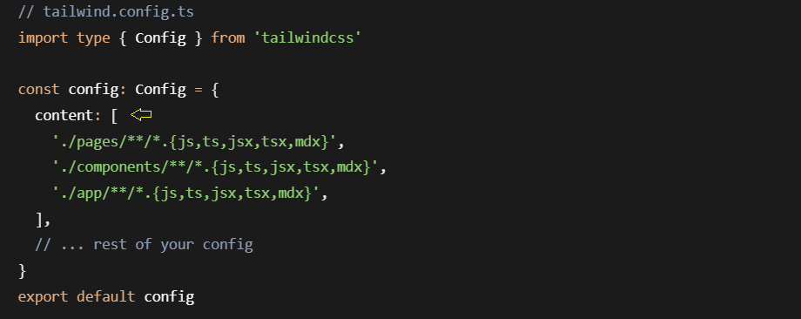
The theme section is where you extend or overrides Tailwind’s default design system. You add custom colors, fonts, spacing values or breakpoints that match your brand’s design.
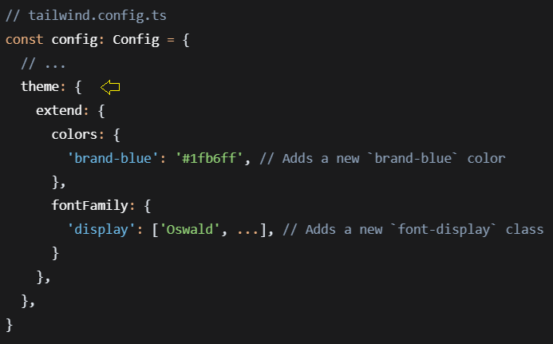
You can creates a full color palette with multiple shades.
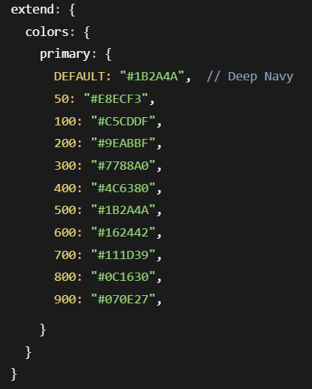

This follows a standard color scale pattern used in design system :
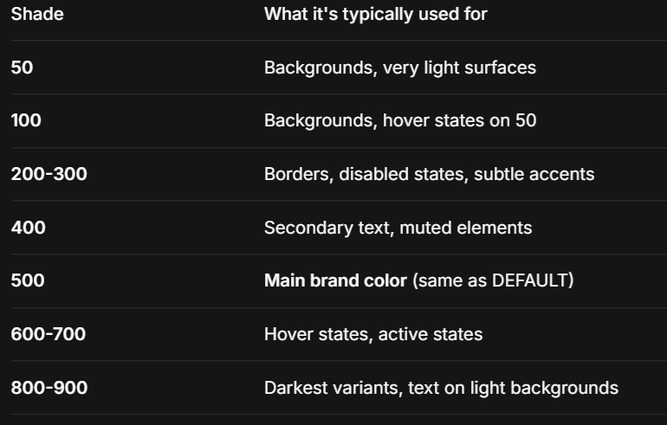

Utility prefix in TailWind
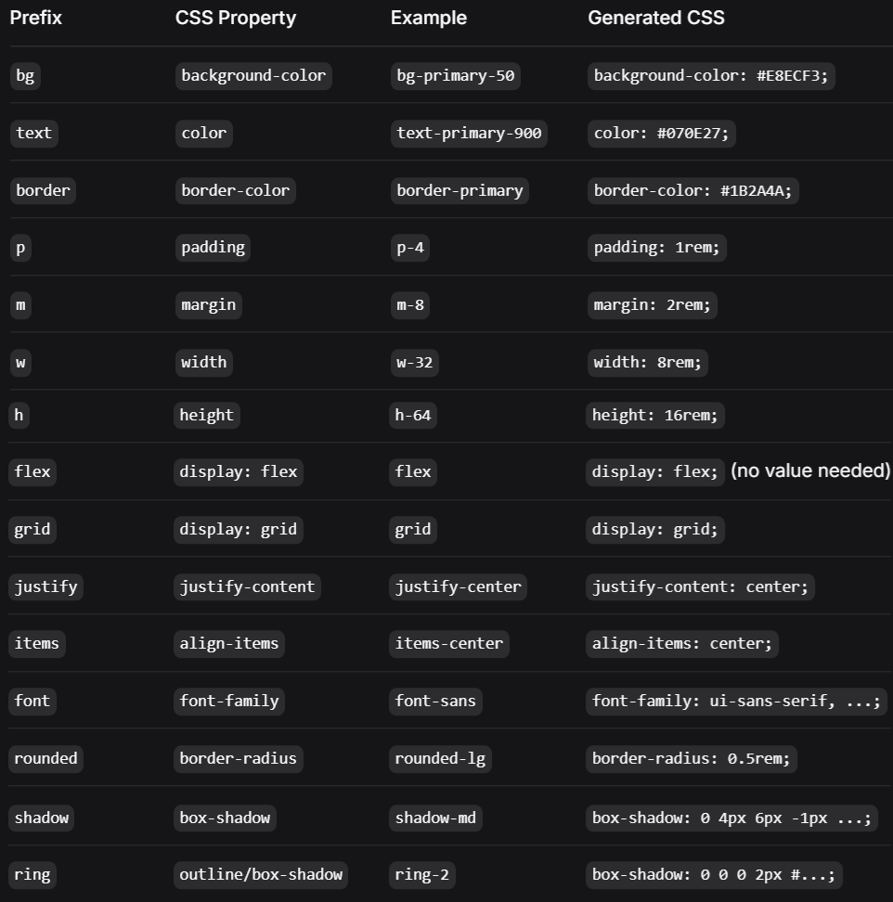
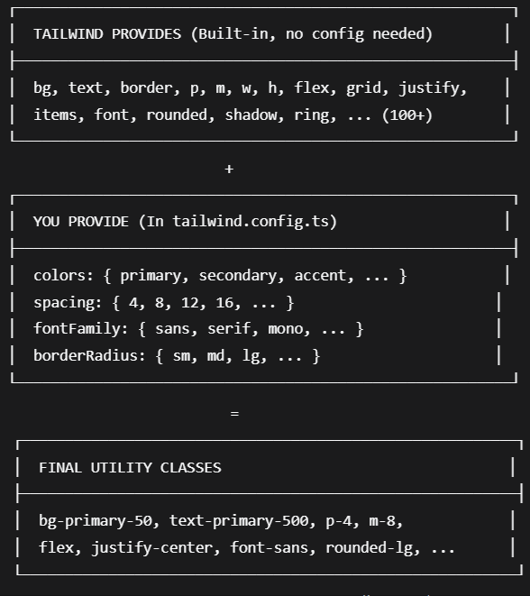

globals.css is a global stylesheet file commonly used in Next.js application that contains CSS rules applied across your entire website.
Tailwind organizes styles into three specific layers with priority order :
- base – Lowest priority (resets, element defaults)
- components – Medium priority (component classes)
- utilities – Highest priority (p-4, text-center)

@layer base tells Tailwind that these styles belong to the “base” layer I Tailwind’s layering system.
@apply is a Tailwind CSS feature that allows you to compose Tailwind utility classes into custom CSS rule.
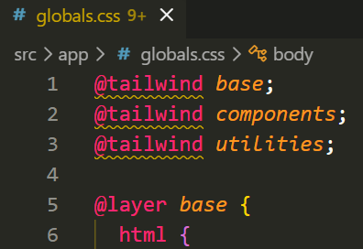

Next.JS Flow
- A route.ts can be placed inside any folder within the app directory, and its location determines the URL path for the API endpoint. eg. app/api/users/route.ts will handle requests to /api/users.
- You cannot have both a page.tsx and a route.ts in the exact same folder. One folder can either serve a page or an API endpoint, but not both.
- You cannot directly import or reference route.ts. Route Handlers are server-only API endpoitns, not reusable code modules.
- Next.js uses a specific priority order when matching routes :
- Exact static matches (e.g., api/pages/specific-page/route.ts)
- Dynamic routes (e.g., api/pages/[slug]/route.ts)
- Catch-all-routes (e.g., api/pages/[...slug]/route.ts)
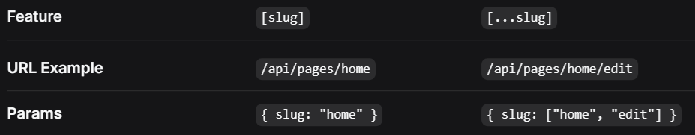
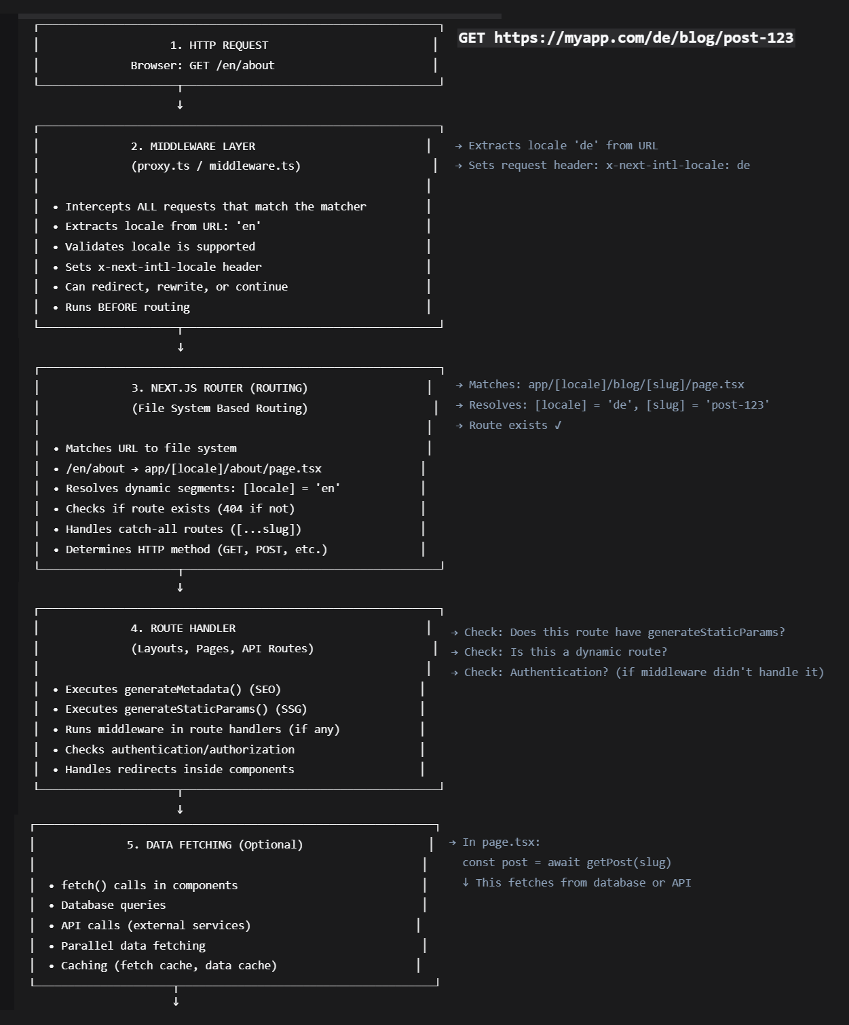

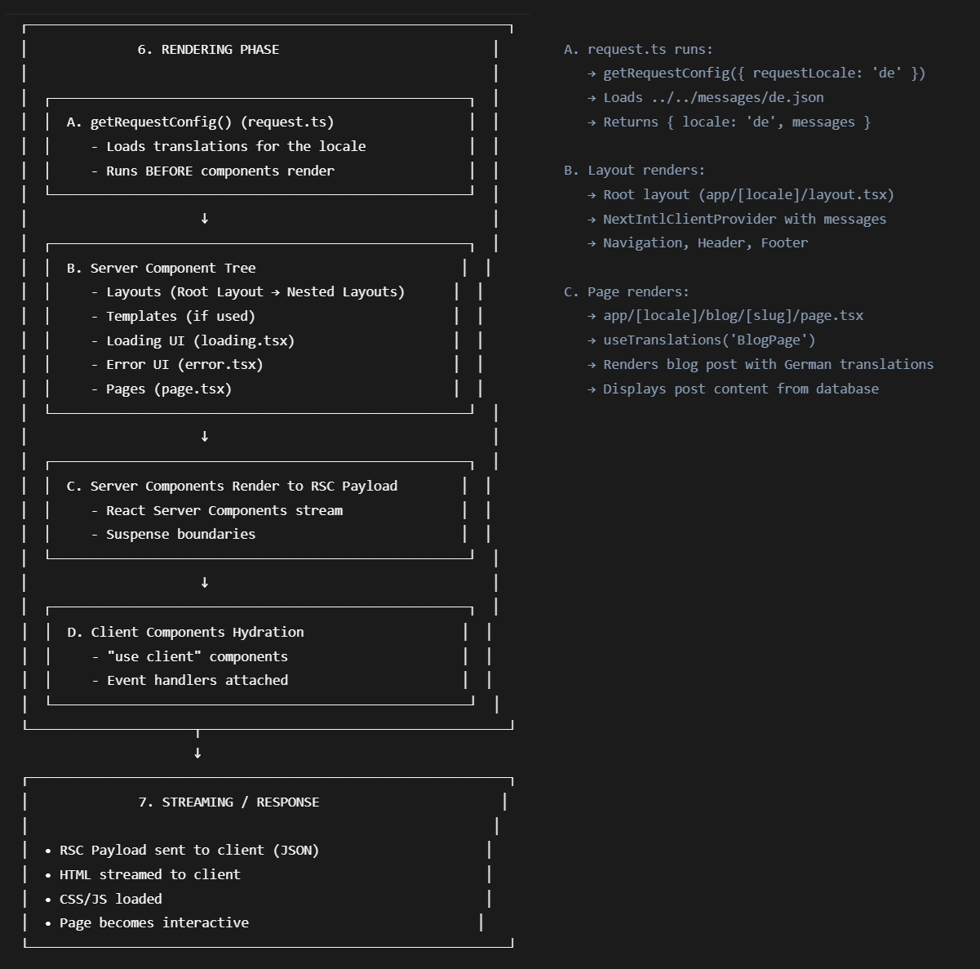
- layout.tsx defines user interface elements that are shared across multiple pages. The Root layout is app/layout.tsx.
You need to define global.d.ts for .css such that TypeScript module resolver can recognizes .css as a valid module type.
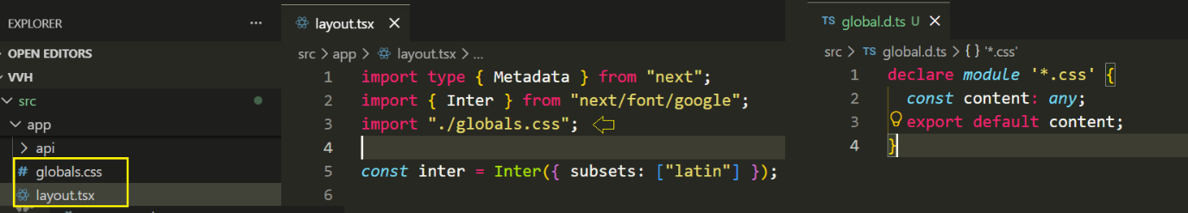
- i18n.ts is the gatekeeper for the app’s internationalization. It validates languages, load the right translations and ensures your app only serves content in the languages you support.
- When you have a folder named [locale], it’s a dynamic segment that matches any value.
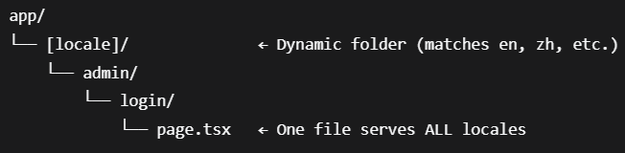

General Setup
- Source Control > Initialize Repository
- Create repository on GitHub
- install https://cli.github.com/ and authenticate GitHub through browser https
  - gh auth login
  - git remote -v
- Create a local file and click Commit to commit a file change locally
- Click Publish Branch button to create repo on GitHub

- Create .GitHub/skills/ and save different skills under this folder
Install Cline from Extensions. Afterwards, click Cline setting from left activity bar.

Phase 1
Work Flow /en/admin/setup
Program | Description
app/layout.tsx  (Root Layout) | defines the root HTML structure, global metadata (title/description), and international font for all pages in a company website.
[locale]/layout.tsx | provides internationalized page structure with a header, sidebar, and footer wrapper, using next-intl for translations and validating that the URL locale
[locale]/admin/layout.tsx | protects authenticated routes by checking user session, redirecting to login if unauthenticated (login/setup). If authenticated, render admin navigation bar (AdminNav).
[locale]/admin/setup/page.tsx | render an admin setup form. If admin already login, redirect to admin page. If admin already exists, redirect to login page.

[locale]/layout.tsx
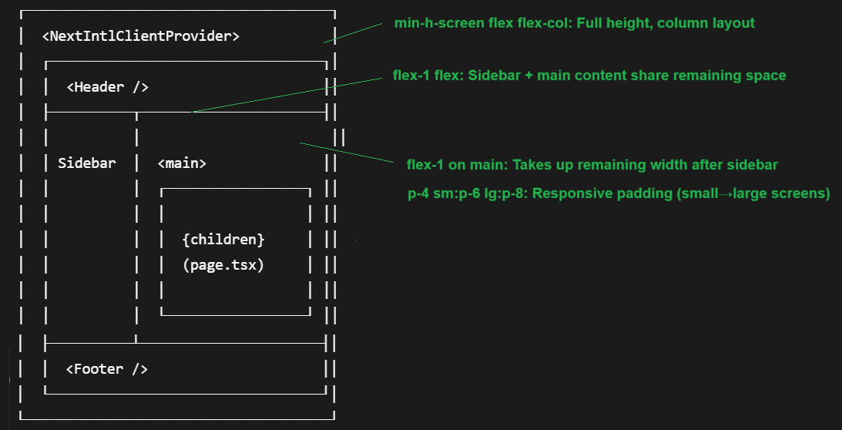
[locale]/admin/layout.tsx
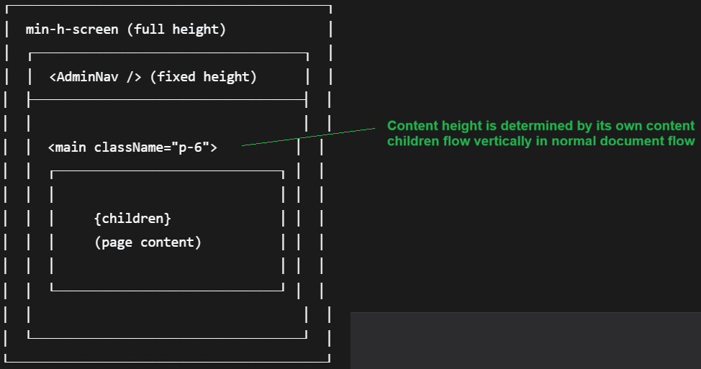

Header.tsx
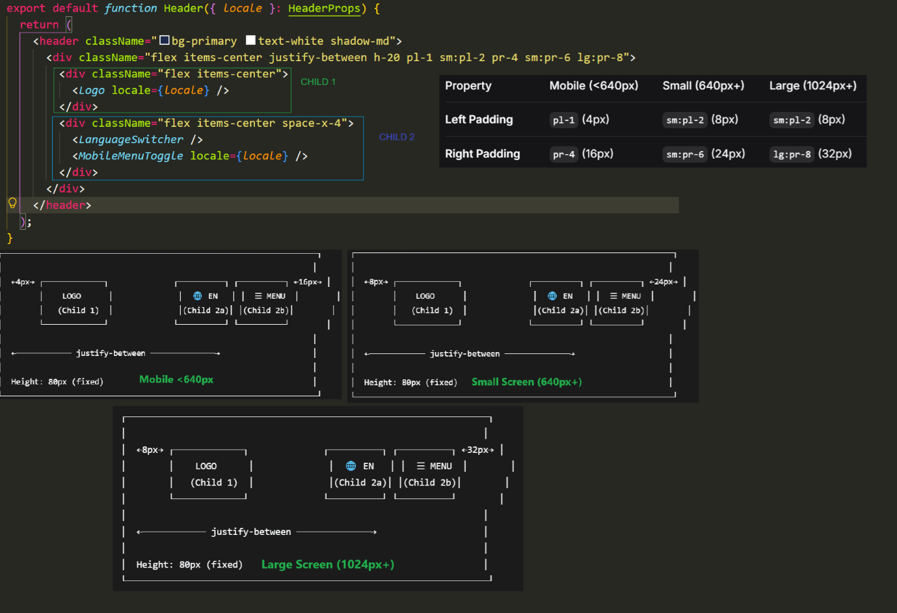
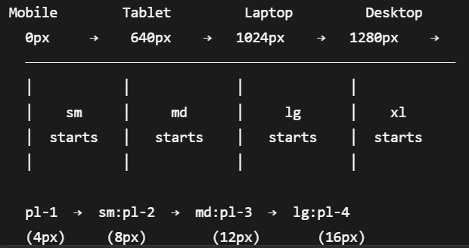

MobileMenuToggle.tsx
creates a mobile-only hamburger menu button that:
- only appears on mobile devices (md:hidden)
- has proper padding for touch targets (p-2)
- has rounded corners for modern design (rounded)
- shows a subtle hover effect (hover:bg-white/10)
- animates smoothly (transition-colors)
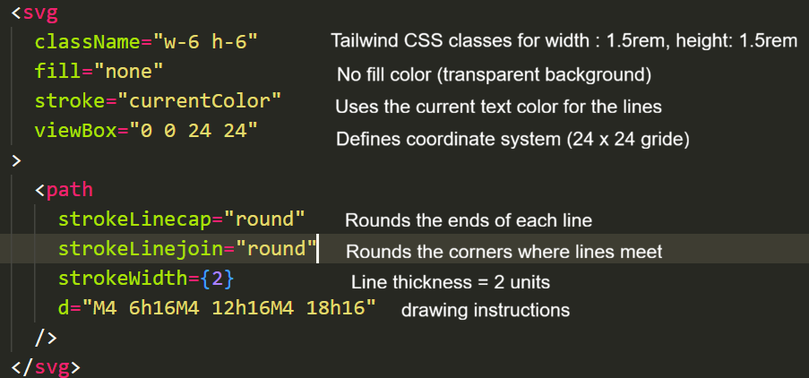
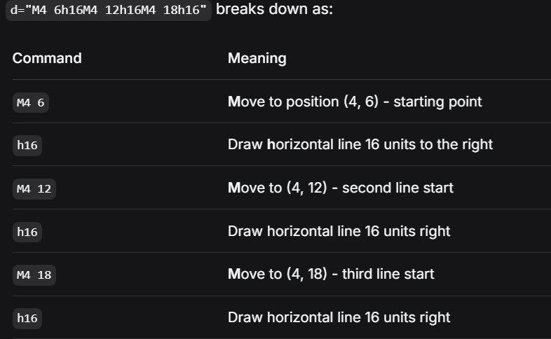
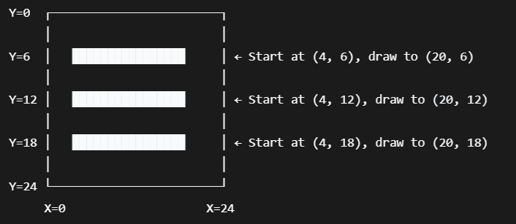

MobileMenu.tsx
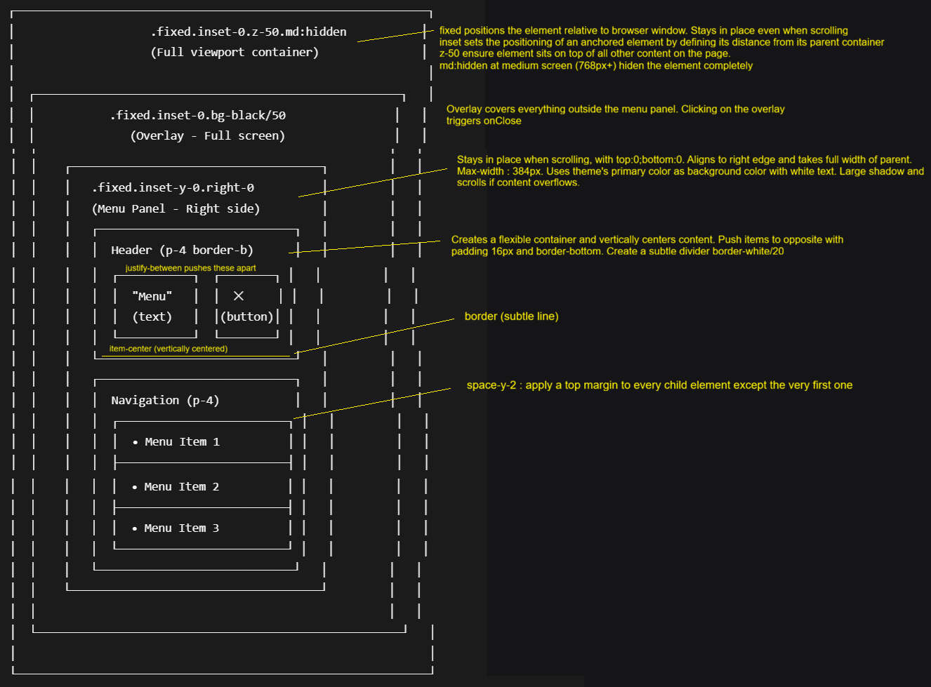
MobileMenu.tsx
- Detects the current language from the URL.
- Builds a link to the same page but in other language.
- The className style make the <Link> component look and feel like a clickable button
- Shows the appropriate translated button text

import Link from "next/link"
Import <Link> component for client-side navigation (no full page reload).

const pathname = usePathname()
Get current URL path (eg. /en/dashboard/settings)

const params = useParams()
Gets all dynamic route parameters from URL

Sidebar.tsx
The sidebar has a fixed width of 256px and won't shrink. When placed in a flex container with flex-1 (takes up ALL remaining space after the sidebar) on the main content, the sidebar occupies 256px on the left, and the remaining space goes to the other content.
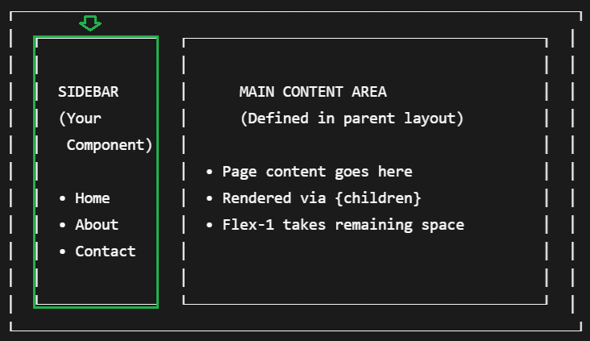
<aside className="hidden md:block w-64 shrink-0">
- <aside> HTML semantic element for sidebar/auxiliary content
- hidden md:block Hidden on mobile, becomes visible on medium screens and above
- w-64 Fixed width of 256px (16rem)
- shrink-0 Prevents the sidebar from shrinking in a flex container

<nav className="bg-white rounded-lg shadow-md p-4 sticky top-4">
- <nav> Navigation element
- bg-white White background
- rounded-lg Rounded corners (large radius)
- shadow-md Medium drop shadow for depth
- p-4 Padding of 16px on all sides
- sticky top-4 Sticky positioning, stays fixed 16px from top when scrolling

<ul className="space-y-1">
- <ul> Unordered list for navigation items
- space-y-1 4px vertical gap between list items (spacing utility)

className=”px-3 py-2 text-xs font-semibold text-sidebar uppercase tracking-wider mt-2 border-b border-sidebar/20”
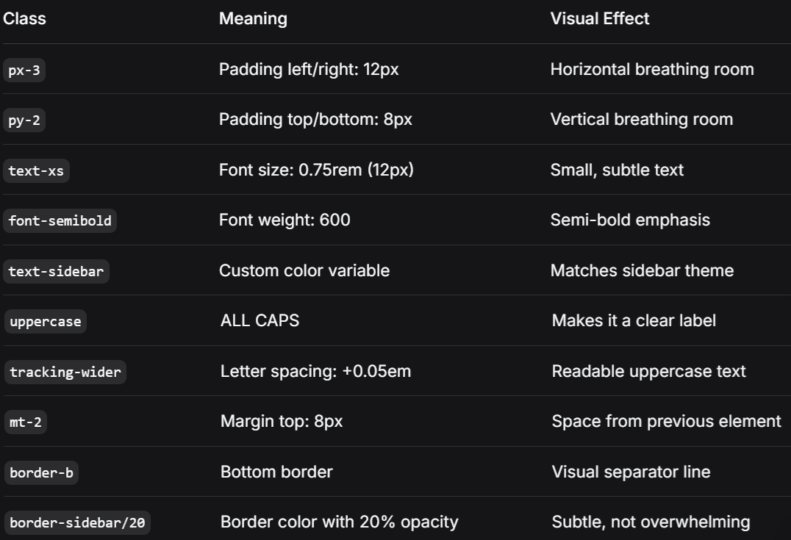

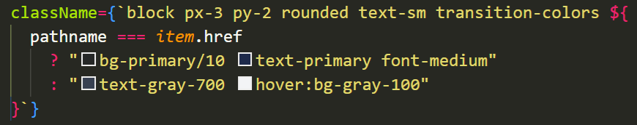
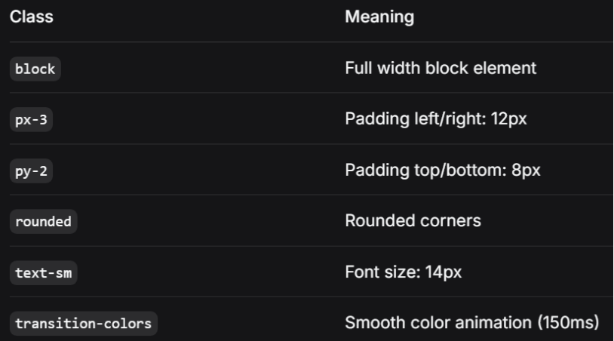
Active State (when pathname === item.href)
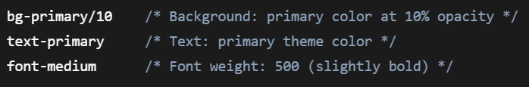
Inactive State (default):
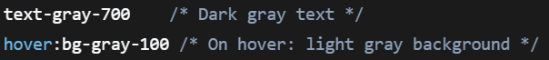
Footer.tsx
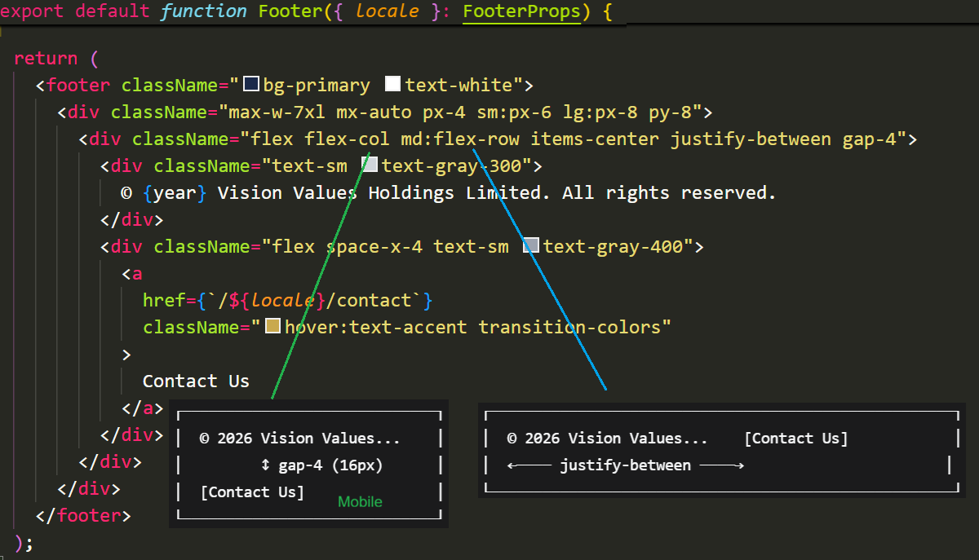

Dockerfile
- docker build : docker build -t myapp .
- docker run : docker run [-p 3000:3000] myapp
Anyone starts a container from the image, CMD ["node", "server.js"] will run (node server.js).

Phase 2
Setup Vitest
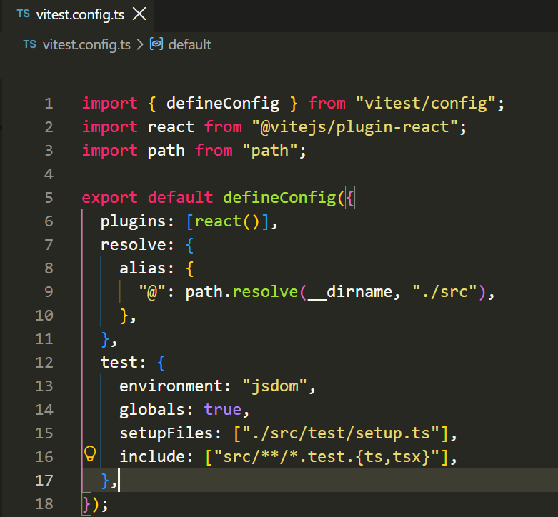
- environment: "jsdom": Simulates a browser environment for testing React components (DOM APIs)
- globals: true: Makes Vitest APIs (like describe, it, expect) globally available without importing them
- setupFiles: ["./src/test/setup.ts"]: Runs a setup file before tests to configure testing environment (e.g., extending expect, mocking APIs)
- include: ["src/**/*.test.{ts,tsx}"]: Specifies which files Vitest should treat as test files - any .test.ts or .test.tsx files inside the src folder
Running npm test will execute all test files under src/**/*.test.{ts, tsx}.
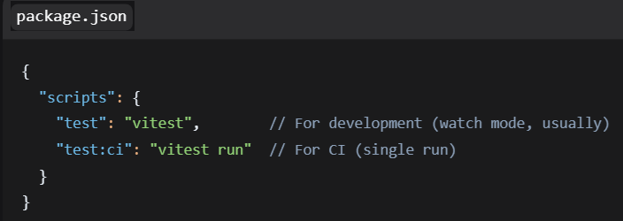
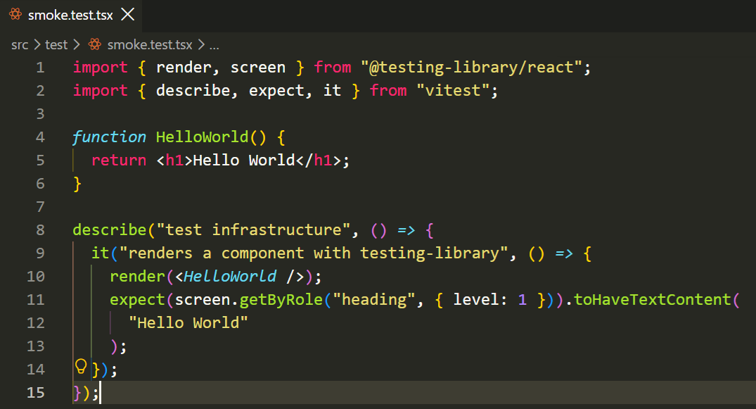
- render: Renders a React component into a virtual DOM for testing
- screen: Provides methods to query the rendered DOM (find elements by text, role, etc.)
- describe: Groups related tests together (creates a test suite)
- it: Defines an individual test case
- expect: Makes assertions about the test results

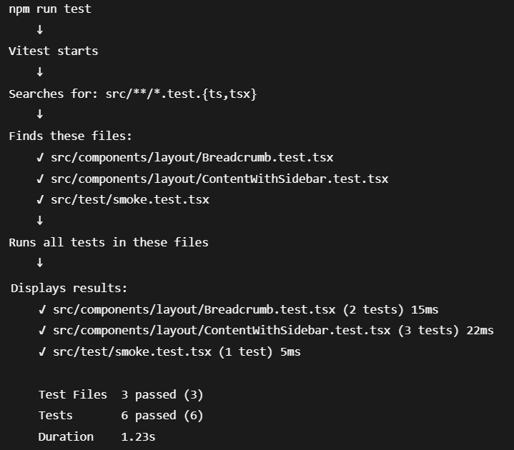

navigation.ts
NavSlug is a type that creates a union of all possible slug values (eg. “home” | “contract” |board-of-directors”…).
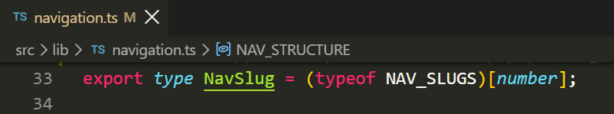
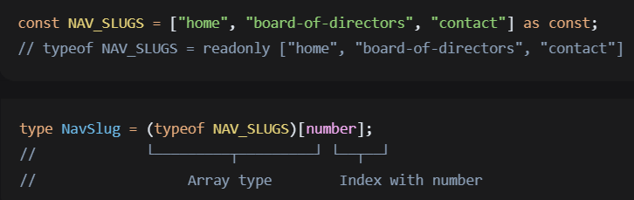
Visual Representation
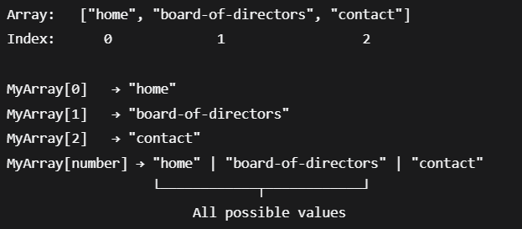

- This pattern is called "array to union type", a type that creates a union of all possible slug values. This allows type safety instead of simply passing any string.
- Why use This instead of an Enum
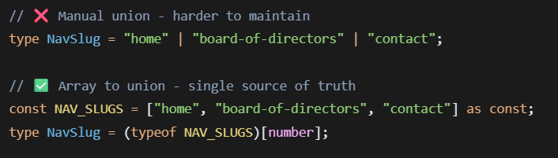

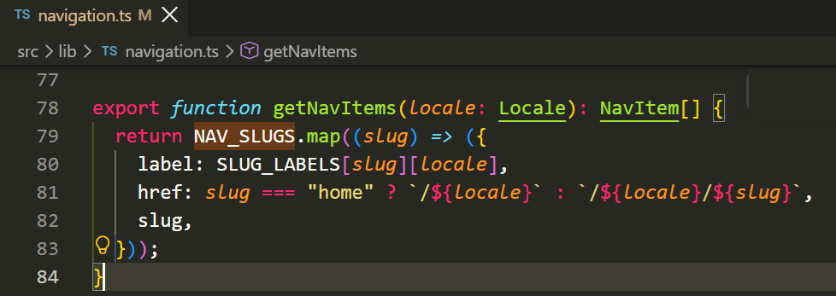
- getNavitems generates a flat list of navigation items based on the selected language.
- When you call getNavItems(“en”) :
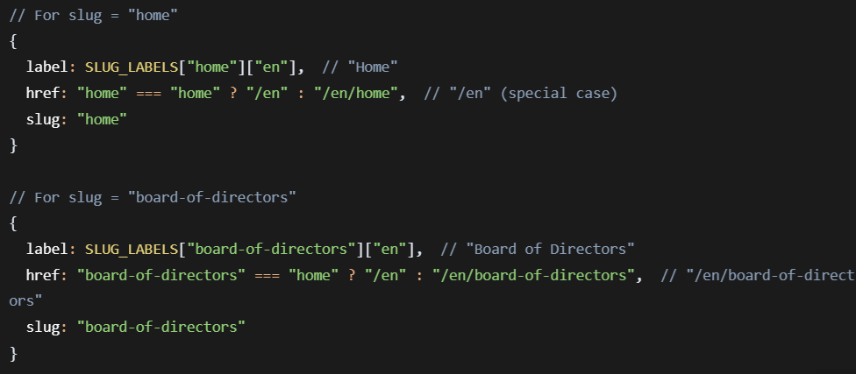
Final Output :
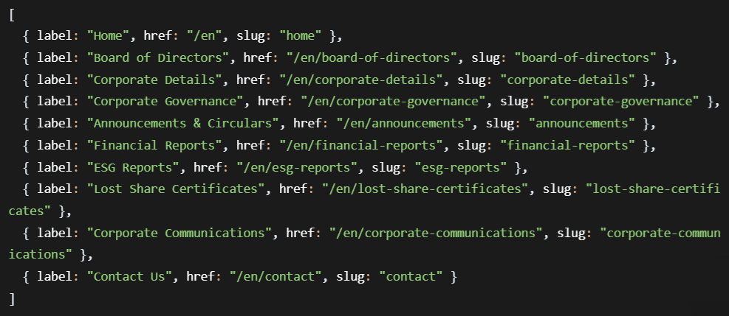

getNavGroups organized items according to NAV_STRUCTURE.
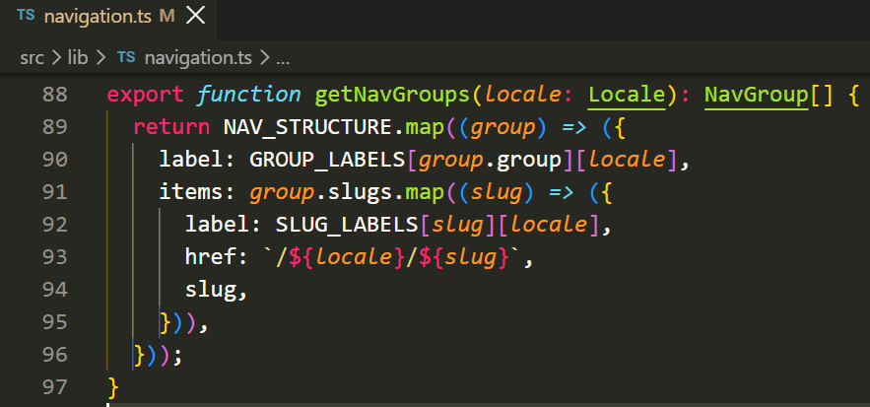
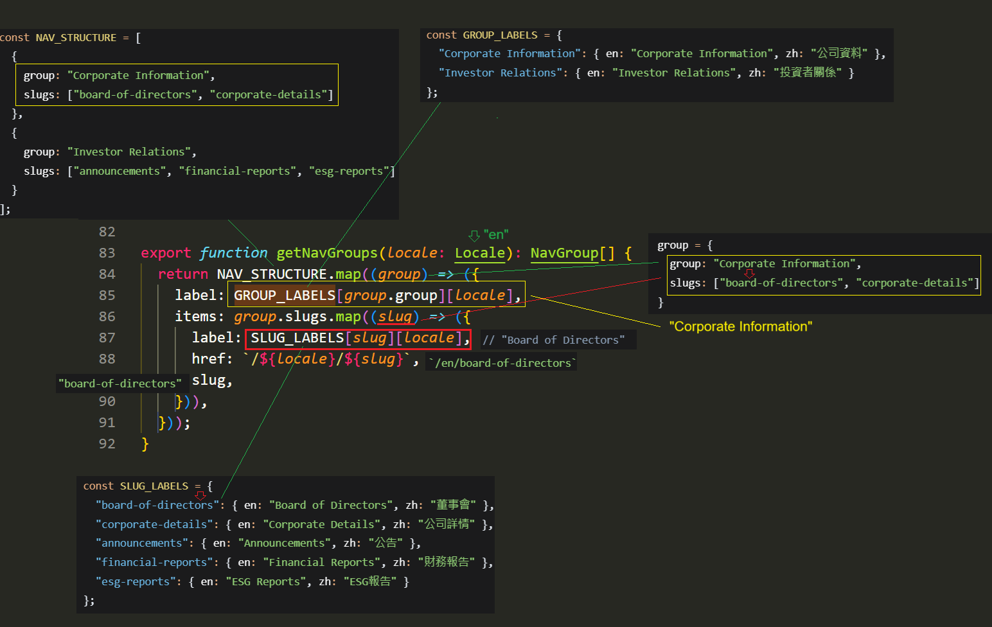

Result :
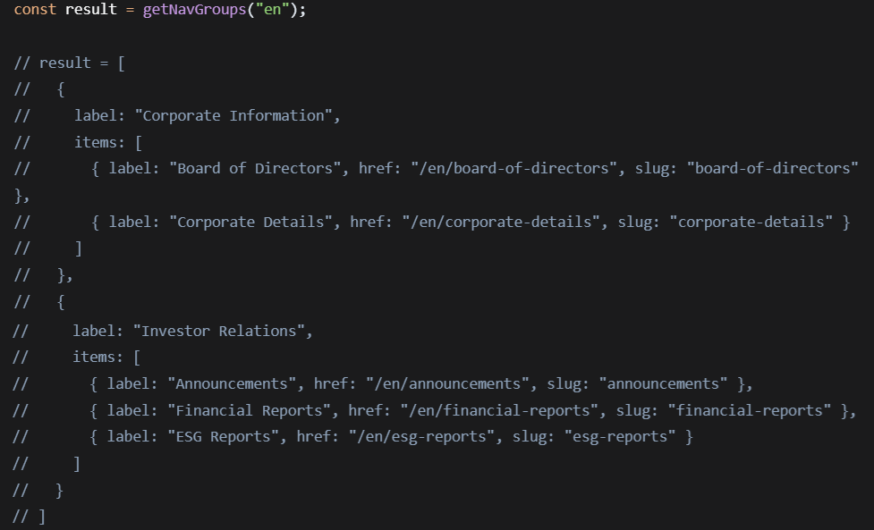
placeholders.ts
It defines static placeholder content for bilingual (English / Chinese) corporate website. It contains a complete set of pre-defined HTML content, metadata, and page information for every page on the company website.
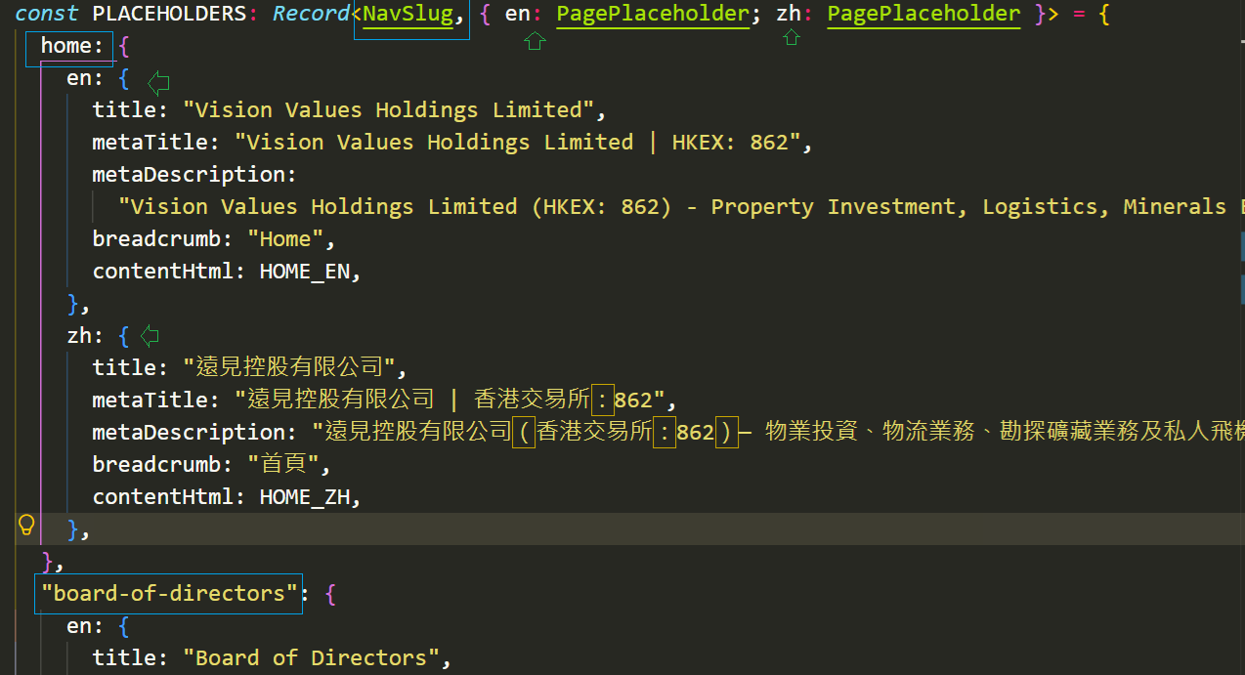

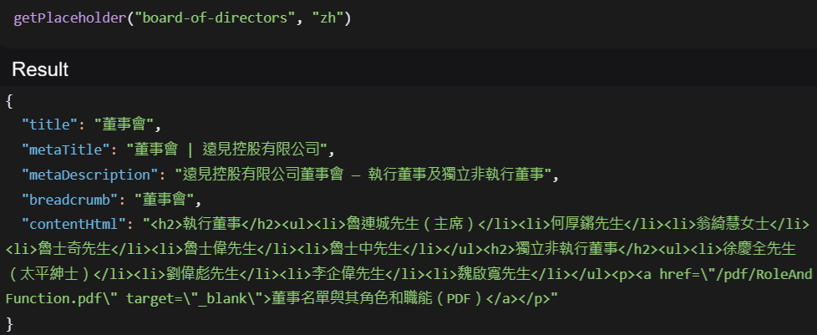

breadcrumbs.ts
Create a trail of navigation links showing the user’s current location within the site hierarchy.
- g.items – Each group (g) has an items array containing the navigation items.
- .some() – Tests whether any element in the array passes the condition
- (item) => item.slug == slug – test whether this item’s slug match the target slug

It returns true if at least one item in the array matches
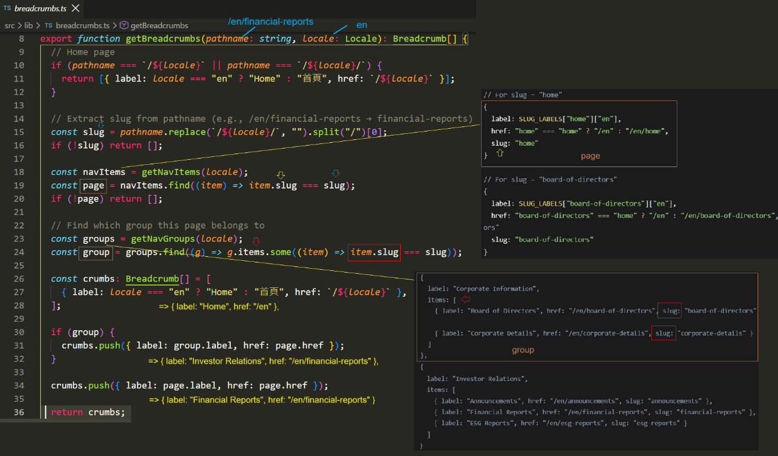

Breadcrumb.tsx
Renders a breadcrumb navigation component in React/Next.js. It creates a horizontal navigation trail showing the user’s current location.

pages.ts
It is a wrapper function that serves as a future-proof abstraction layer for fetching page data.
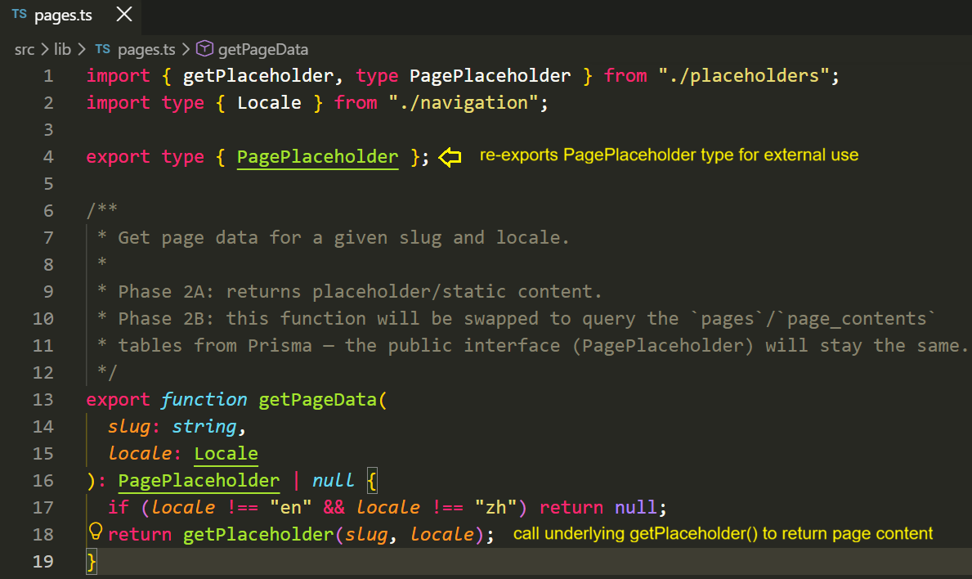
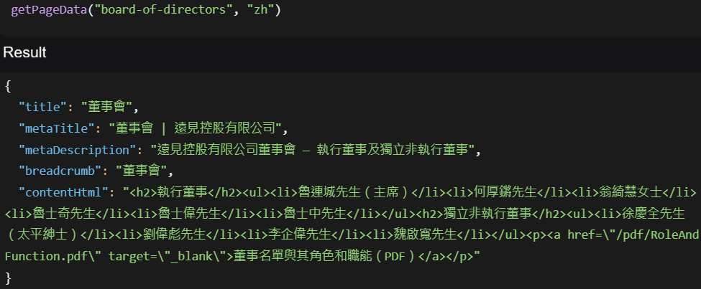

ContentWithSidebar.tsx
This component breakdown:
  - Receive props: slug (page identifier) and locale (language)
  - Fetches page data: Uses getPageData() to get content for given slug and locale
  - Renders
    - A hero section with gradient background and page title
    - A breadcrumb navigation component
    - The main content area with HTML rendered via dangerouslySetInnerHTML
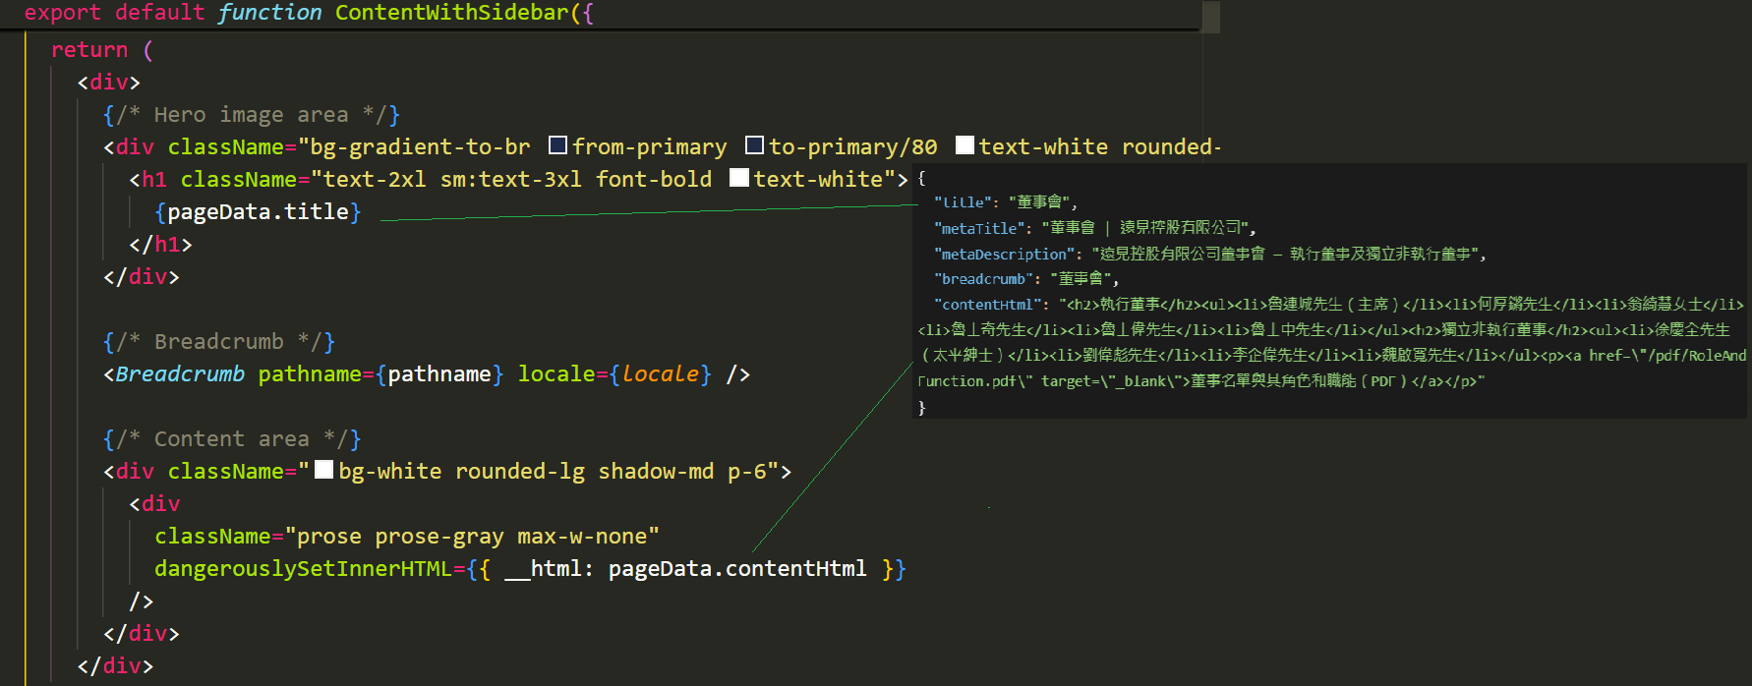
React normally protects against XSS attacks by automatically escape all content. When you , you’re bypassing that protection and telling React to rust the raw HTML.
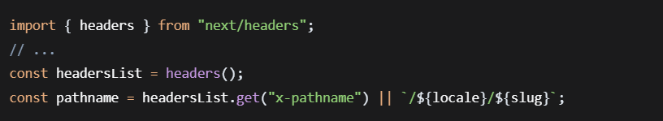
- header() is a Next.js Server Component function that allows reading incoming HTTP request headers
- It returns a Header Object that you can query with .get()
- If that header doesn’t exist, it falls back to /${locale}/${slug}

DirectorCards.tsx
Tells framework this component should be rendered on client side rather than server side.
    - Enables client-side interactivity – It marks this component as a Client Component in Next.js App router, allowing it to use React hooks like useState (ie expanded state) , Event handlers (onClick) and Browser DOM interactions.
    - Hydration boundary – The component will be pre-rendered on the server (SSR) but then hydrated on the client, making it interactive.
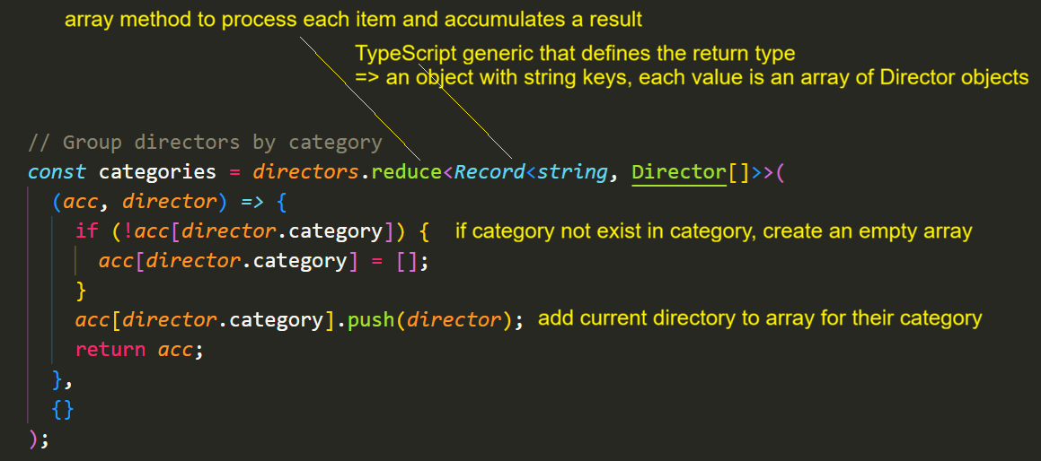
It transforms an array of directors into an object where each category (like “Board Members”, “Advisors”, etc) maps to an array of directors in that category.

ReportsTable.tsx
ReportsTable is a client-side React component that renders a sortable, paginated table of report data.
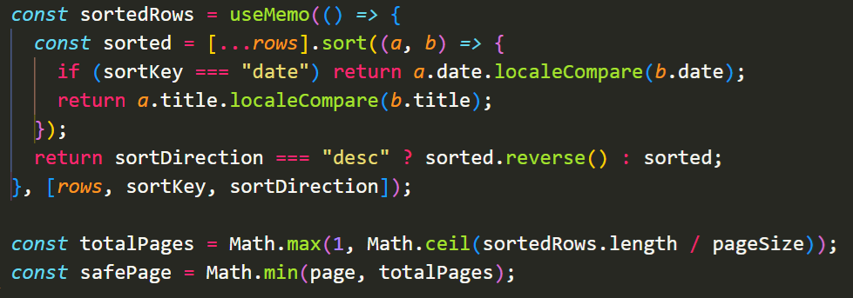
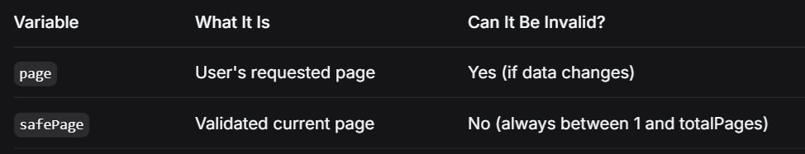
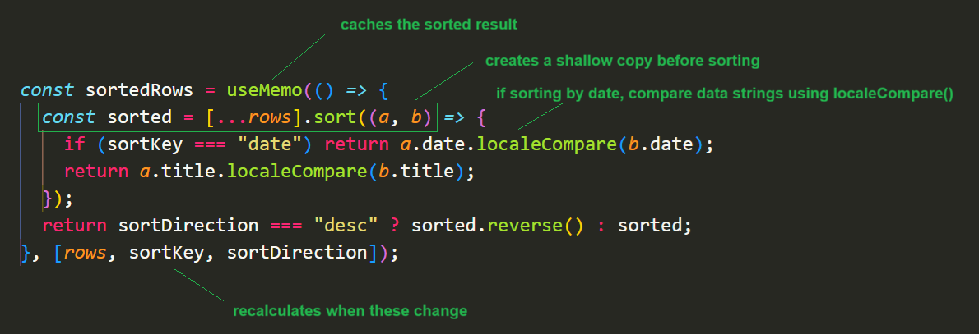
The following codes extract a slice of the sorted rows array based on the current page number and page size and caches the result for performance.
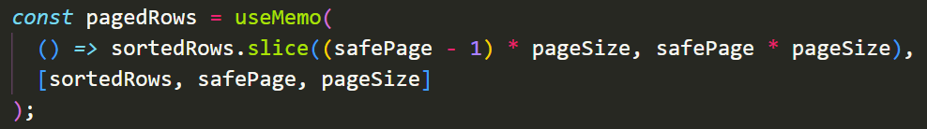
Example :
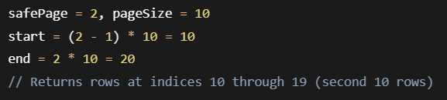
These 2 lines calculate the first and last record numbers displayed on the current page.
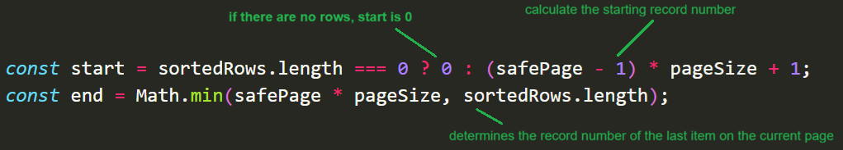

The code below generates a list of page number to display in the pagination control.
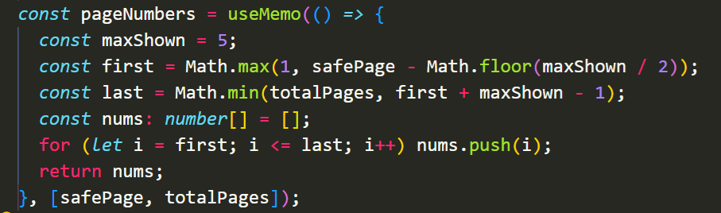
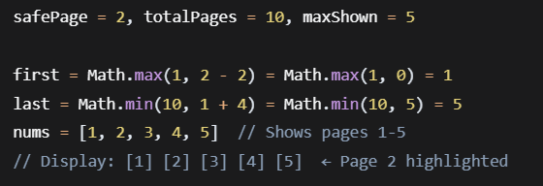

Rows-per-page + Summary
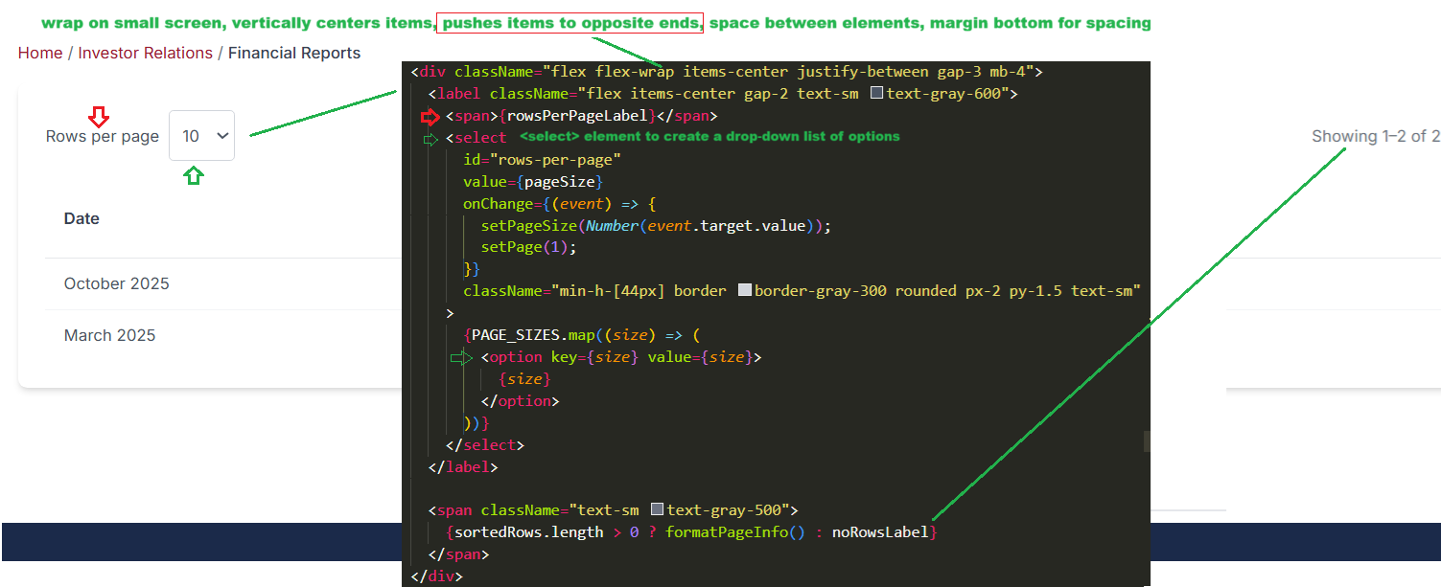
Table
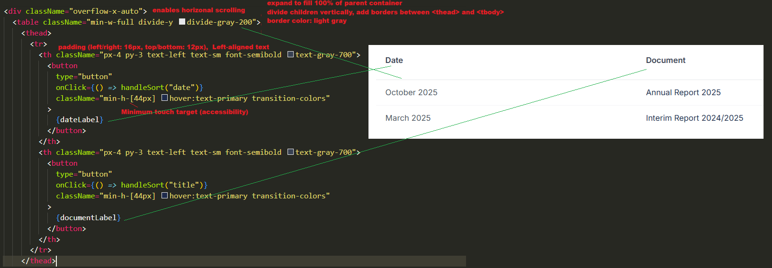
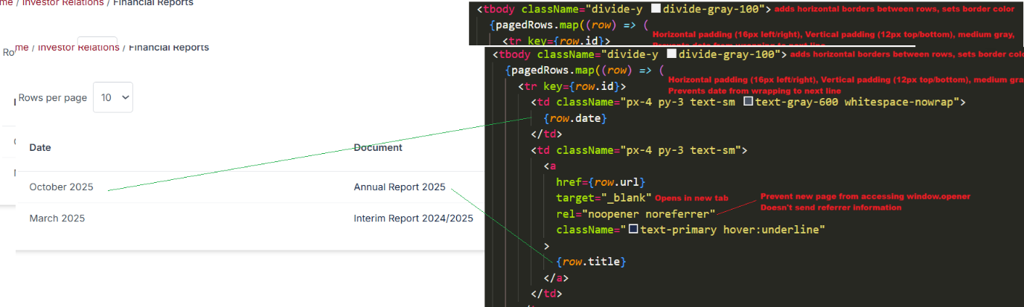

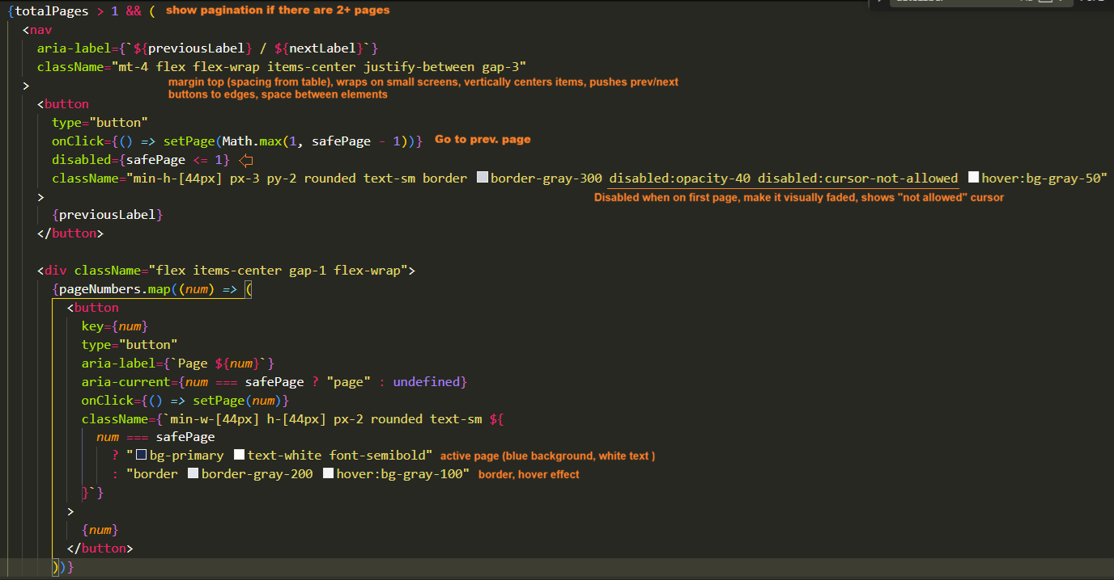
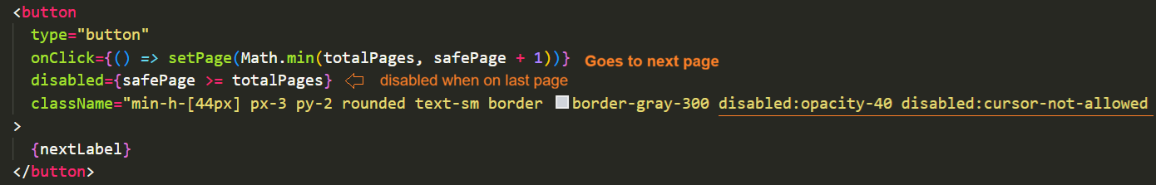
\app\[locale\esg-reports\page.tsx
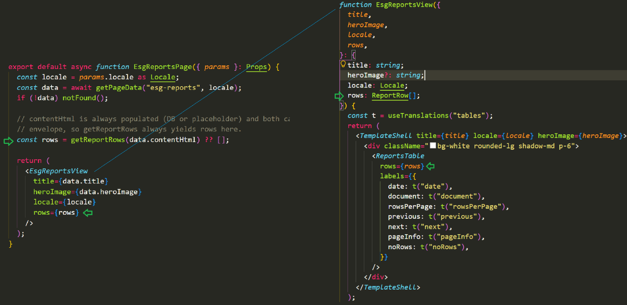
TemplateShell.tsx
This component provides a reusable page shell with :
- Consistent visual header across inner pages
- Automatic breadcrumb navigation based on the current path
- Content slot for page-specific content
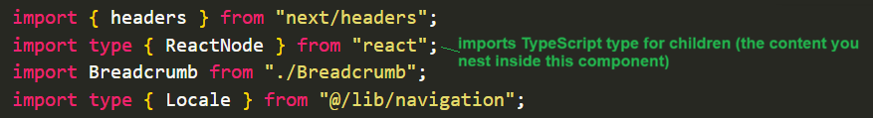
When another page or component uses TemplateShell, they pass content as children:
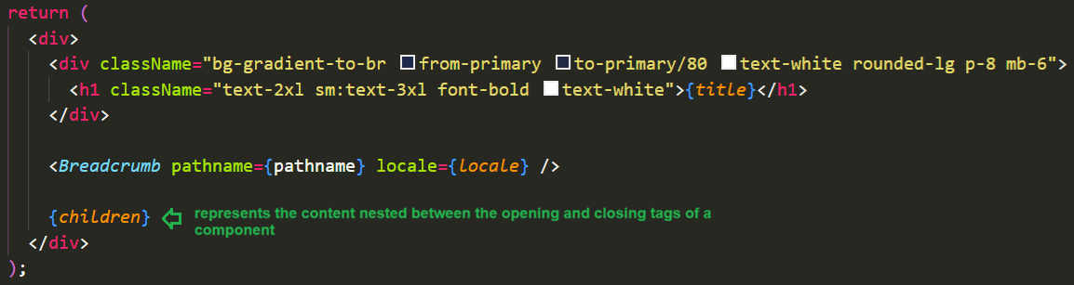
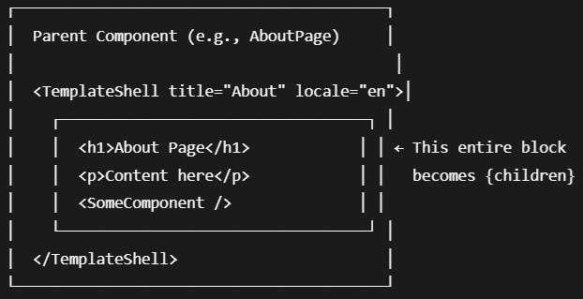
\corporate-communication\pages.tsx
When you use generateMetadata on a page with dynamic data, Next.js uses a technique called streaming metadata to improve performance. Here's how it works:
- For Regular Users: The page's visual content is sent to the browser first, and the metadata is injected into the HTML <head> a moment later when it's ready. This makes the page feel faster.
- For Search Engine Bots (and other crawlers): This streaming behavior is automatically disabled. Next.js detects bots like Googlebot, Bingbot, and Twitterbot by their user agent and waits for generateMetadata to fully finish before sending the complete HTML. This ensures that the metadata is correctly placed in the <head> tag when search engines index the page.
This behaviour means search engines will not see the metadata if it's streamed in late for a human user, but because Next.js specifically blocks streaming for known bots, the metadata is guaranteed to be in the correct place for SEO.
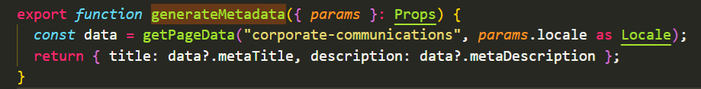
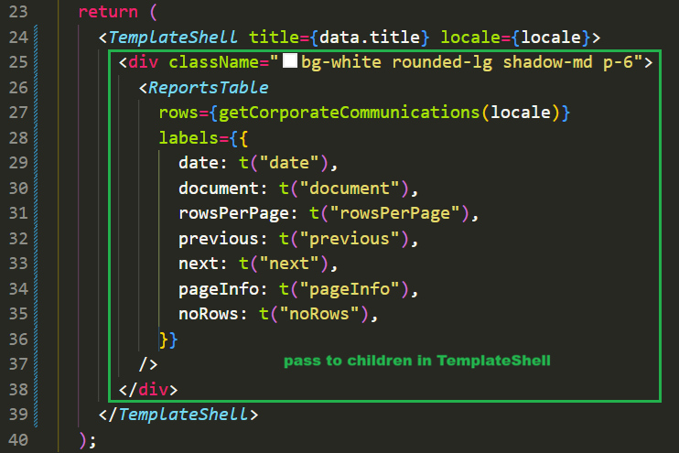

ContactForm.tsx
Render Contact form.
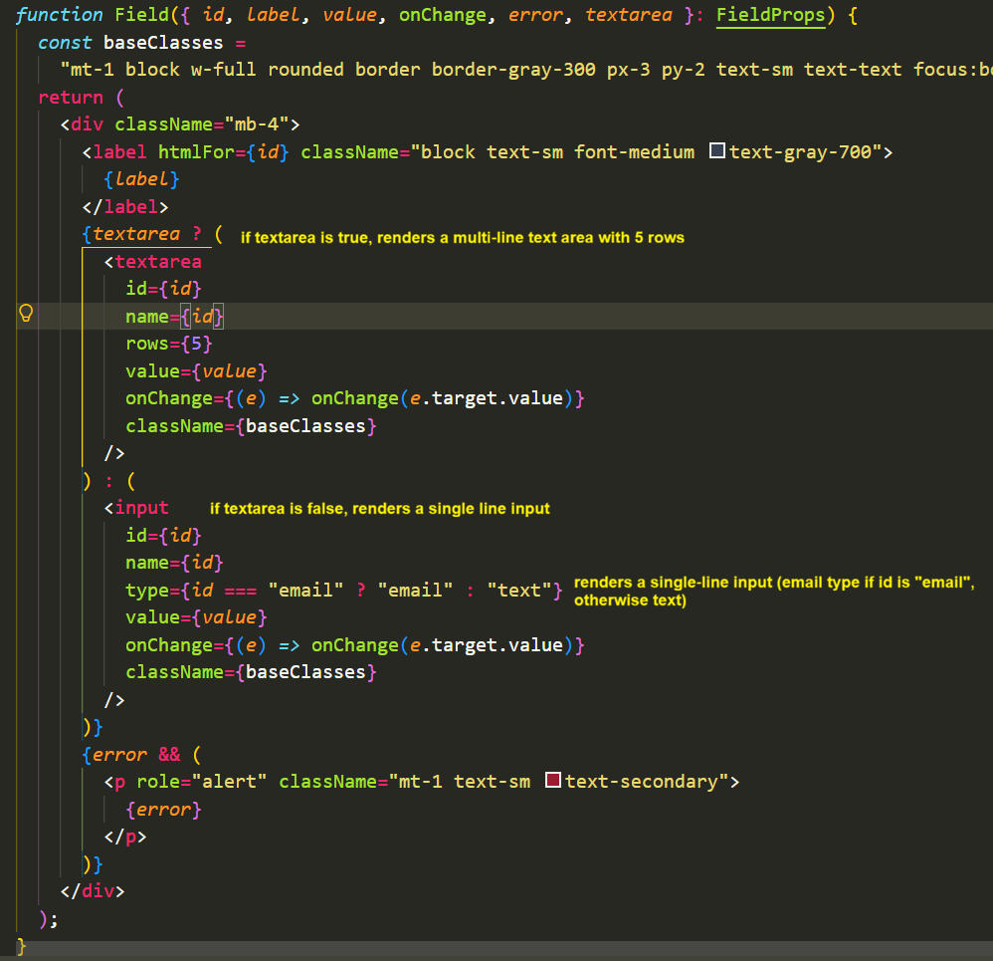
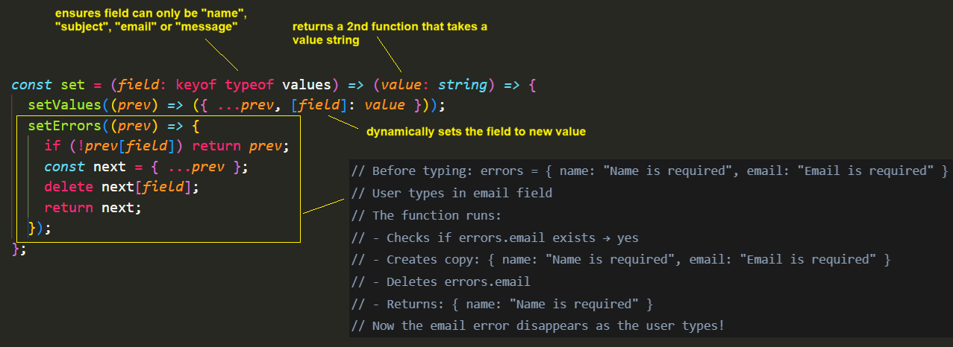
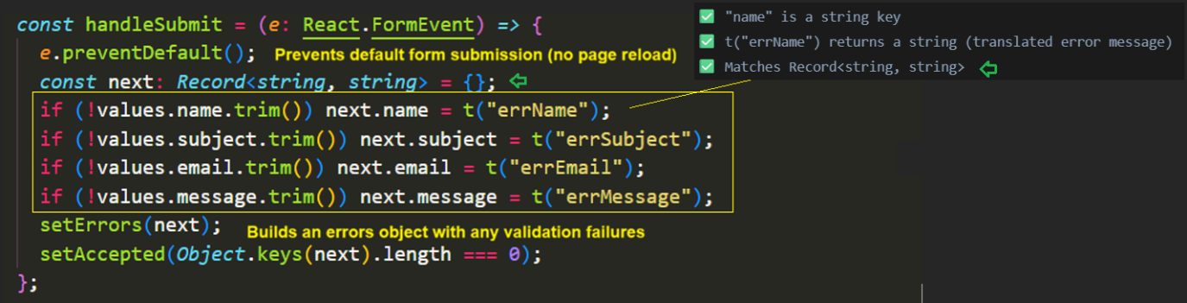

Phase 3
tailwind.config.ts
The plugins line adds the official Tailwind CSS Typography plugin to your Tailwind configuration. It automatically styles HTML elements when you wrap content in a prose class.
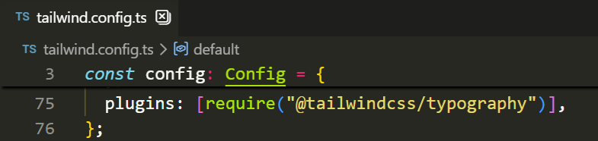

..\src\app\uploads\[...path]\route.ts
The […path] capture everything after /uploads/ as an array.
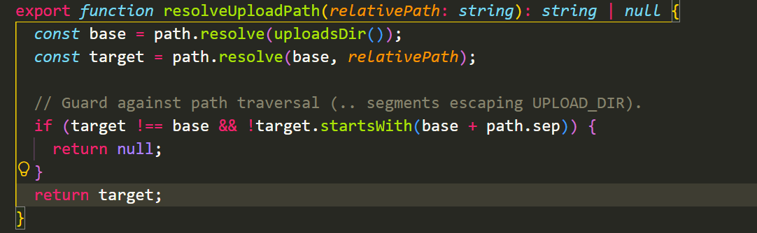
*This function move to /lib/uploads.ts in phase 2b
This function converts a relative path to an absolute path while preventing directory traversal attacks.
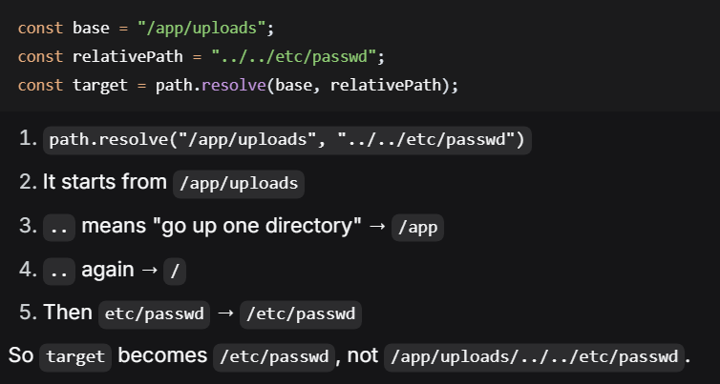
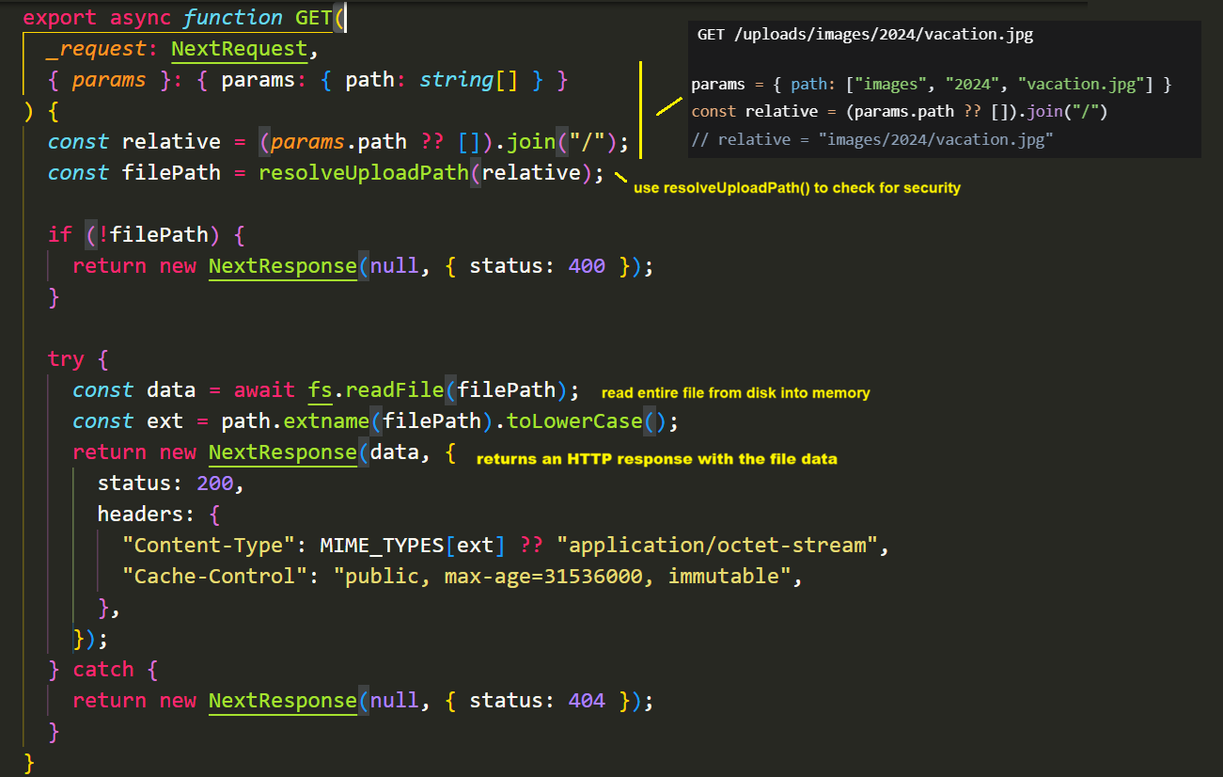

seed.ts
Prisma database seed script that ensures all required pages exist in the database.
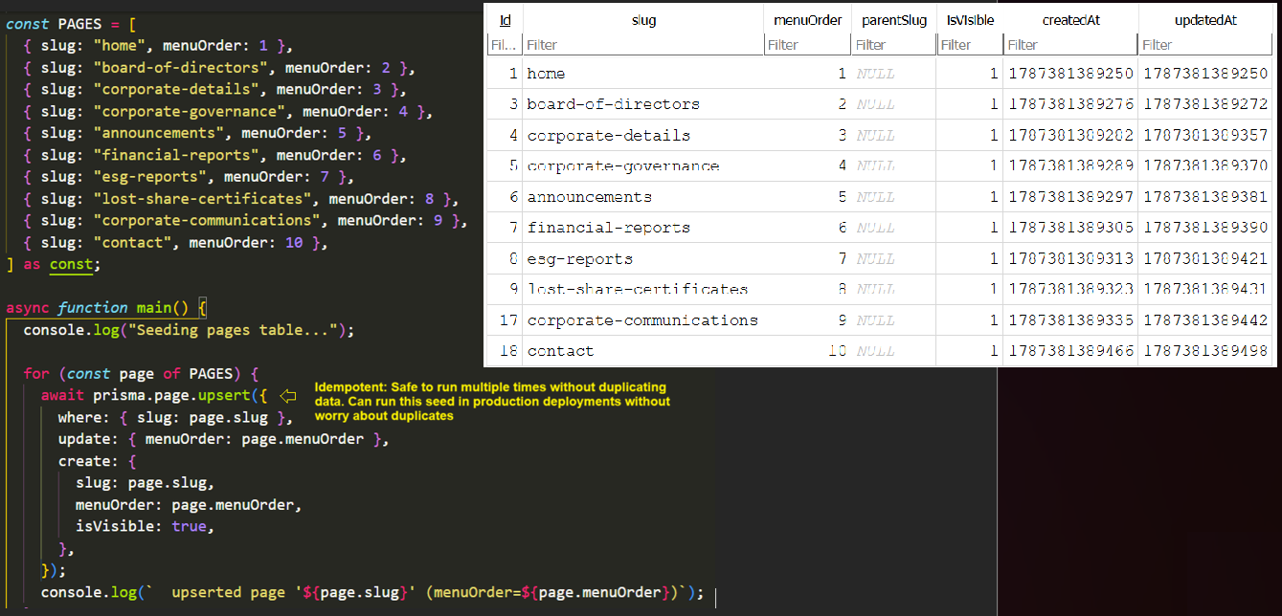
page-content.ts
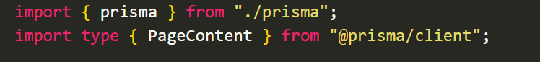
getPageContent() fetches a single page’s content for a specific language.
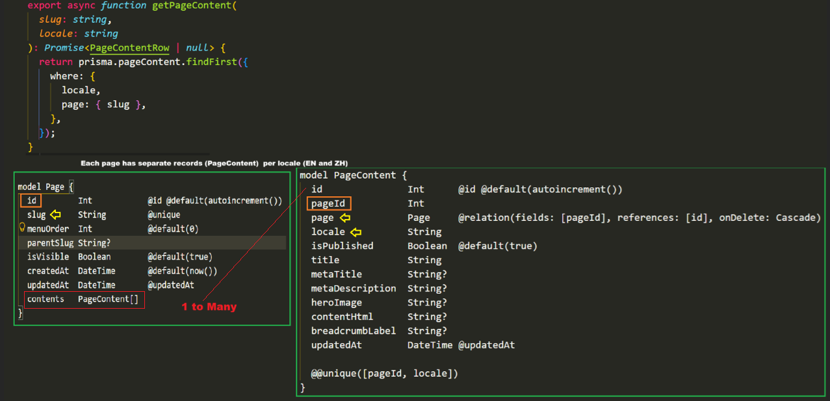

Create a new content record OR updates an existing one (UPSERT = UPDATE + INSERT)
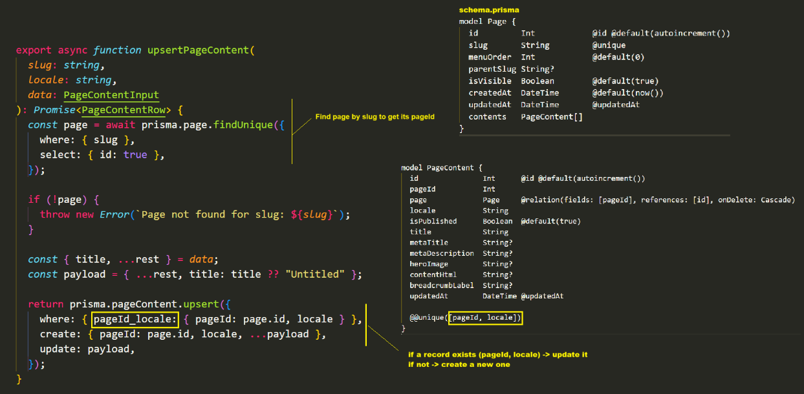
Get all pages with both language versions.
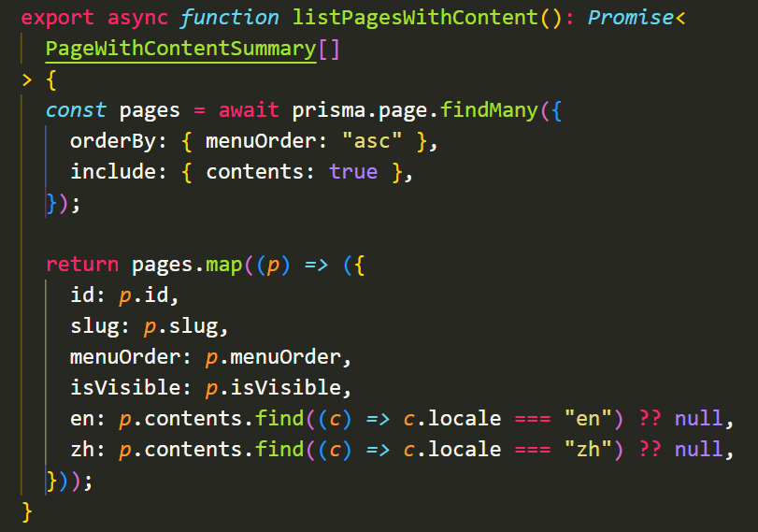
Gets the most recently edited page for the admin dashboard.
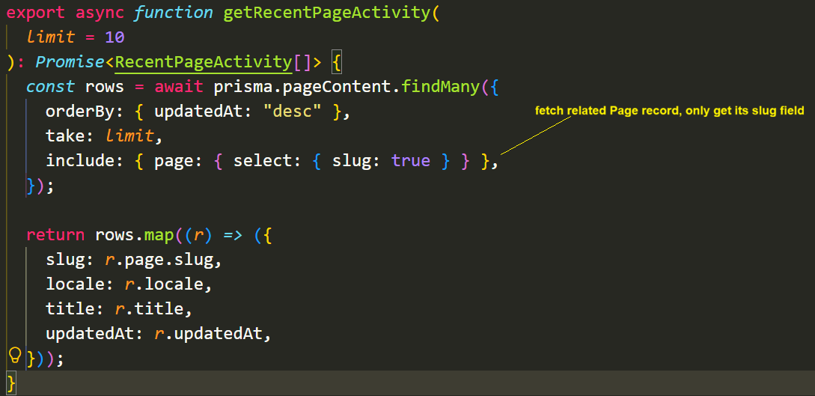

page-content.test.ts
- Mock Setup – creates mock objects that stimulate Prisma’s page and pageContent models. Each mock has spy functions vi.fn() to track if / how they ‘re called.
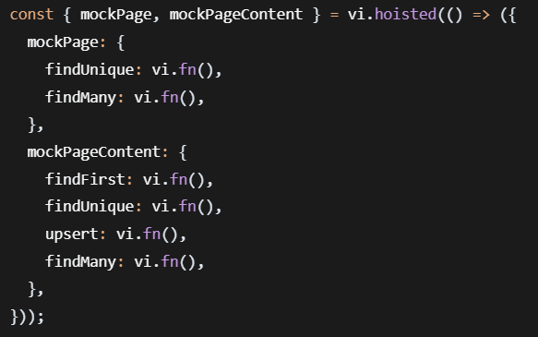
- Mocking Prisma – replaces the real Prisma import with our mock objects. Ensures test don’t hit the actual database.
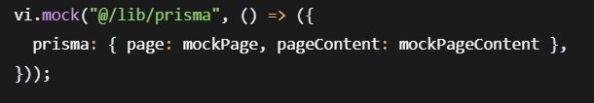
- Helper Function – creates a mock database row with default values.
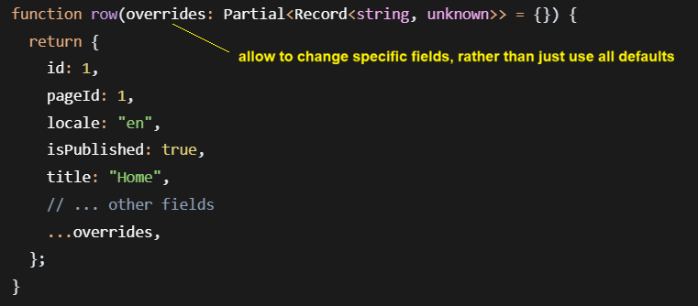
Partial<> makes all properties optional. You can pass { } empty object and don’t need to provide all fields. The overrides parameter with …overrides lets you create a base object with defaults, then easily customize specific fields for each test without repeating all the boilerplate code.
- Test
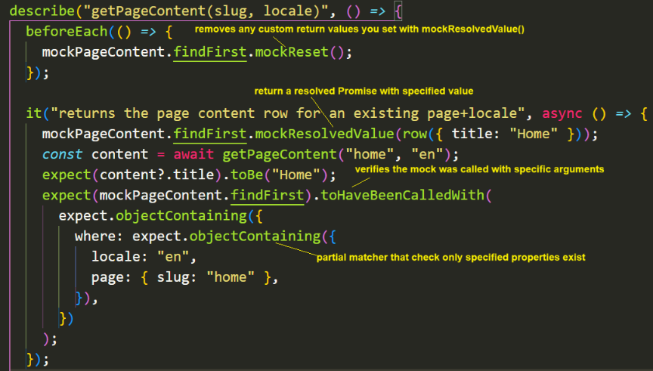
site-settings.ts
Function getSiteSetting() retrieve a single global setting value by its key.
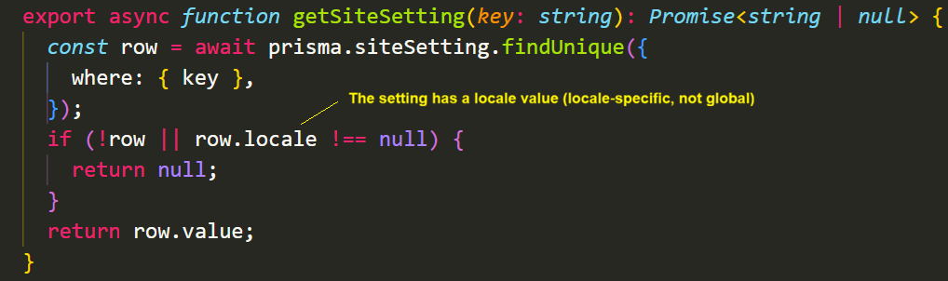
Function setSiteSetting() create or update a global setting. Always enforces locale: null to maintain global scope.
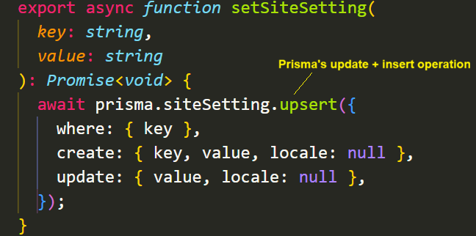

uploads.ts
Helper utilities for handling image (header images and logos) uploads in CMS.
resolveUploadPath() guard against path traversal
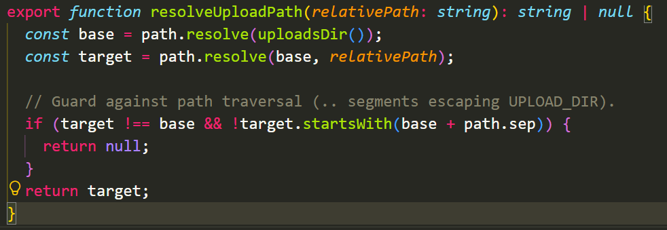
Normal Example
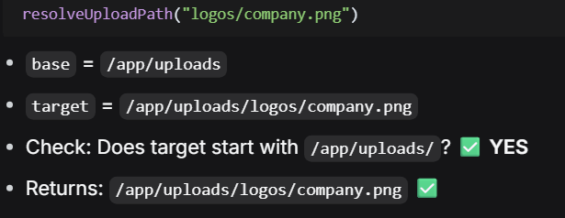

Dangerous Example
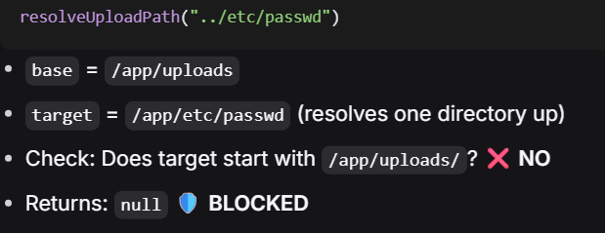
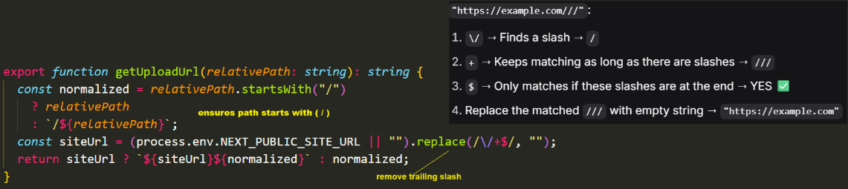
/api/pages/[slug]/route.ts
Two API endpoints (GET and PUT) that handle retrieving and updating page content for different locales (English and Chinese).
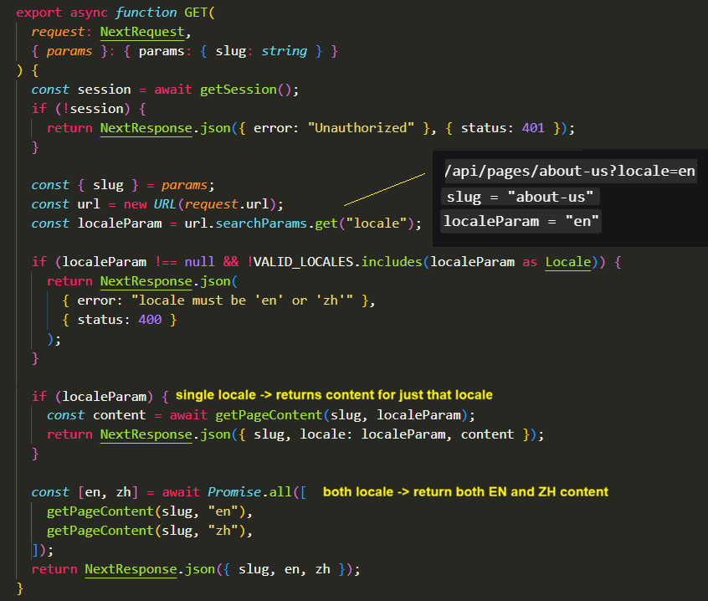

\api\upload\image\route.ts
Securely processes image uploads, validates and saves them ot the server, returns a URL for the uploaded image.
- Verify the user is authenticated before allowing uploads
- Extracts multipart form data from the request
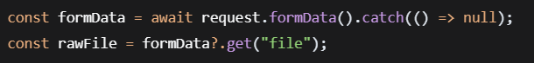
- File Type Validation
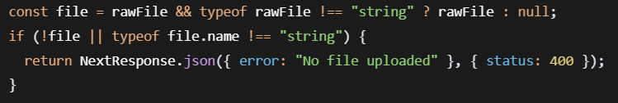
- Validates file extension, file size limits and MIME type
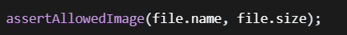
- File Storage Preparation
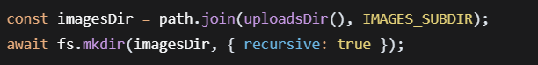
Create the images subdirectory under the uploads directory and use recursive: true to create parent directories if they don’t exist.
- Unique Filename generation
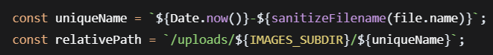
- Prevent filename collisions by adding a timestamp
- Sanitizes the filename to remove unsafe characters
- Generate the relative path for storing and serving the image
- File Writing
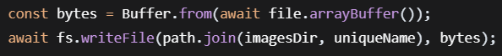
- Converts the file to a Buffer
- Writes the file to the filesystem
- Response Generation
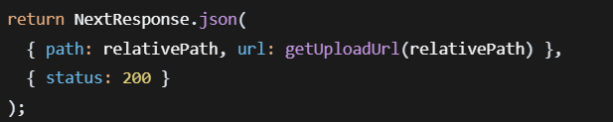
Returns the relative path and a full URL for accessing the uploaded image
The URL is generated using getUploadUrl() which constructs an absolute URL
/api/settings/route.ts
    - an API route to provide a RESTFUL endpoint for managing website settings.
- Defines which settings can be modified
- as const makes this a read-only tuple type for type safety

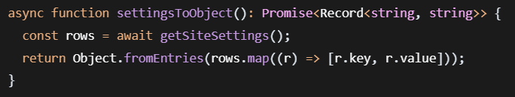
- Fetches al settings from the database
- Converts array of {key, value} pairs into a plain object
[{key: "site_name", value: "My Blog"}] → {site_name: "My Blog"}

GET Endpoint will fetch settings and PUT Endpoint will update settings.

/api/auth/route.ts
An api endpoint that allows logged-in admins to change their password securely.
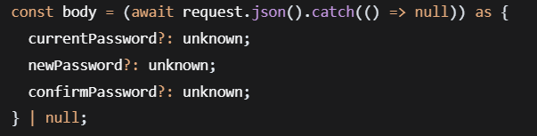
- Handles parsing errors gracefully.
- Expects three fields: currentPassword, newPassword, confirmPassword

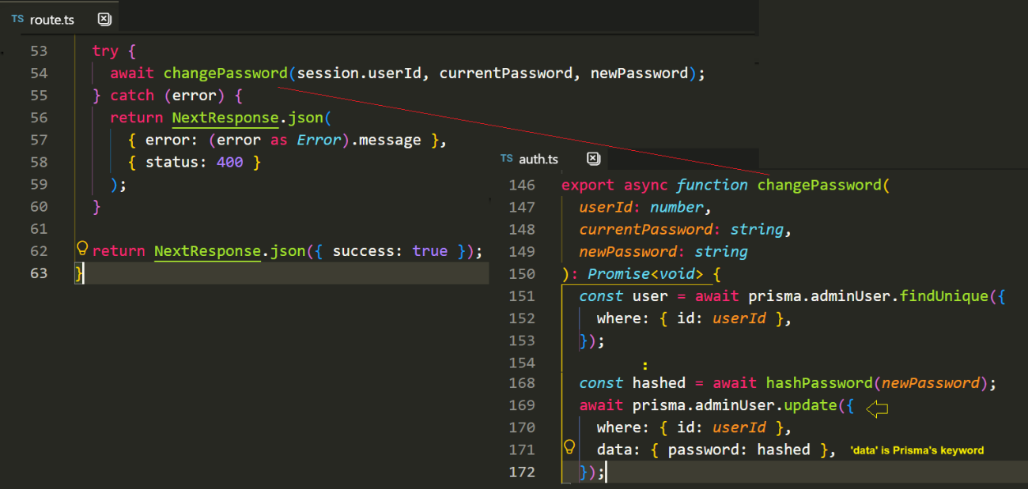
- Hashes new password and update it in the database

/app/[locale]/admin/AdminNav.tsx
Defines a navigation component for an admin dashboard in application
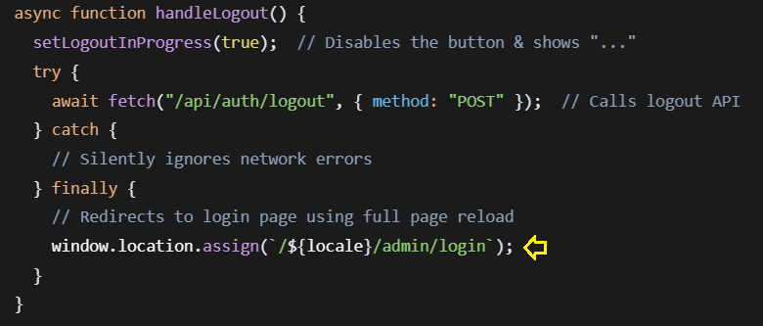
window.location.assign instead of router.push?
- Full page reload ensures the session cookie is completely cleared
- Prevents the admin layout from briefly appearing after logout
- Guarantees the login page renders fresh, without cached admin state

/components/admin/TipTapEditor.tsx
It provides a minimal WYSWYG editor with only bold, italic, paragraph, heading and link.

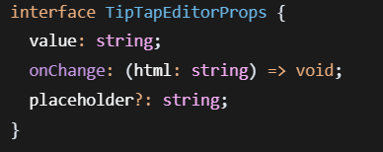
- value : current HTML content (from parent)
- onChange : callback that sends the updated HTML back to the parent
- placeholder – optional placeholder text

Editor Instantiation
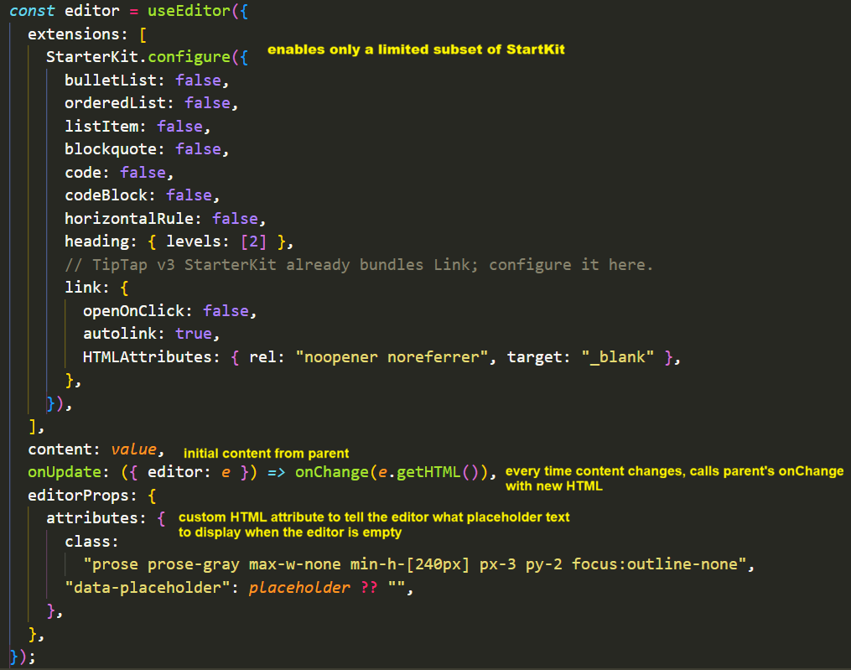
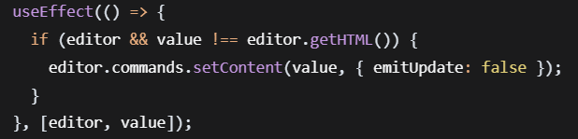
If the parent changes value (eg. switching language tabs) and it differs form the current editor content, update the editor without triggering another onChange (prevents an infinite loop).

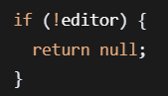
Early return if editor isn’t ready. The editor initializes asynchronously; return nothing until it is ready.

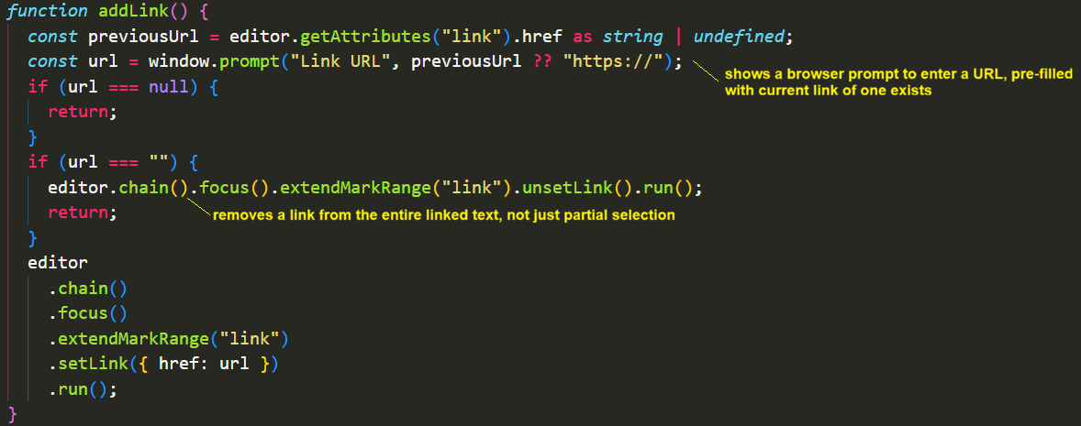
- show a browser prompt to enter a URL, pre-filled with current link if one exists.
- If user cancels (null), does nothing
- If the user enters an empty string, removes the lnik

For each button :
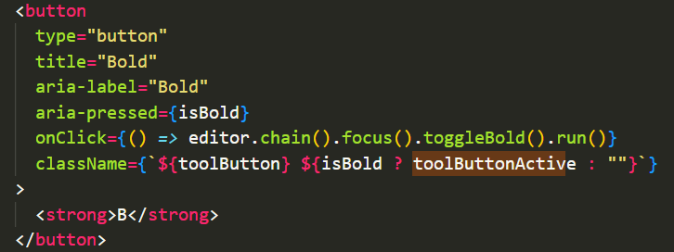
- focus() brings focus back to the editor.
- toggleBold() toggles bold formatting on the current selection
- run() executes the command
Bold, Italic, Paragraph, Heading, Link – each with appropriate titles, labels and active -state styling.

Editor area renders the actual editable content area.
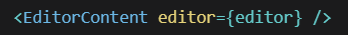

/components/admin/LocaleTabs.tsx
It is a locale/language tab switcher component built with App Router.

- Reads current locale from ?tab= URL parameter.
- Defaults to “en” if no parameter or parameter is not “zh”

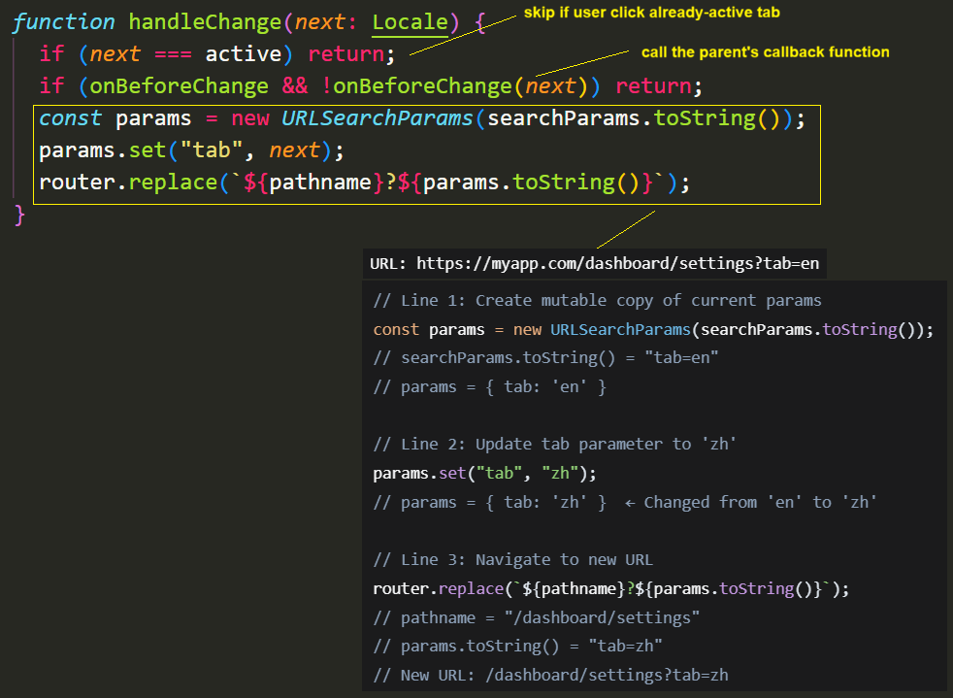
- Update URL using router.replace() - not push() to avoid history clutter
- Use onBeforeChange callback to prompt user when there is unsaved changes

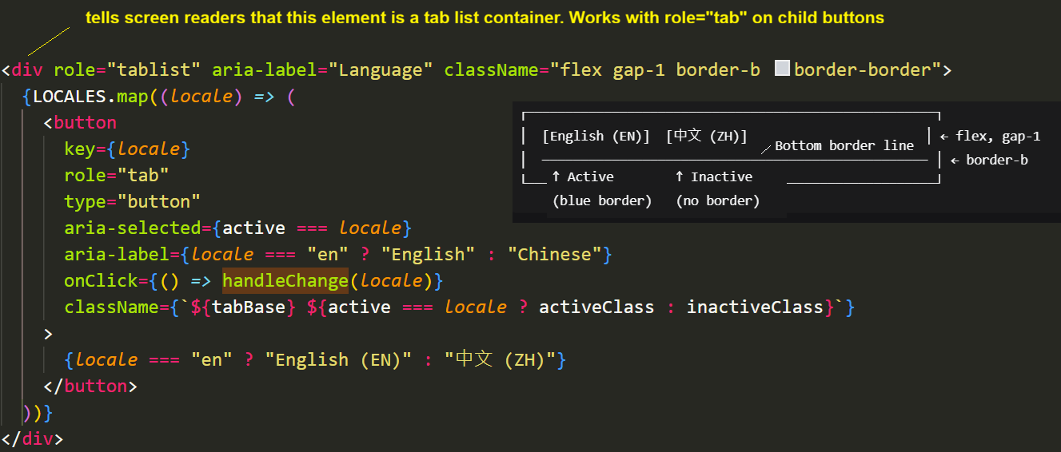
Creates a container for the tab buttons with accessibility and styling attributes.
ImageUploader.tsx
Type Definition
Validation Function
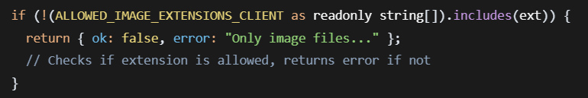

Component Props Interface
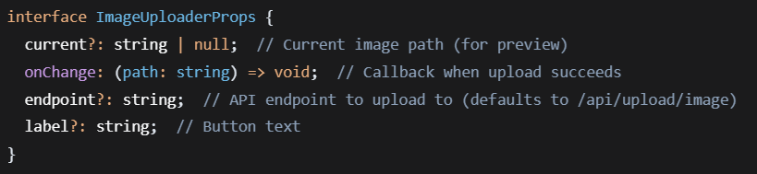
Component Hooks
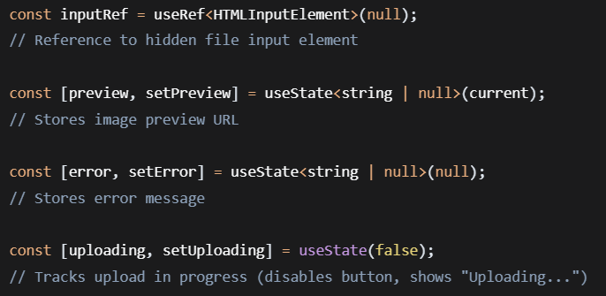
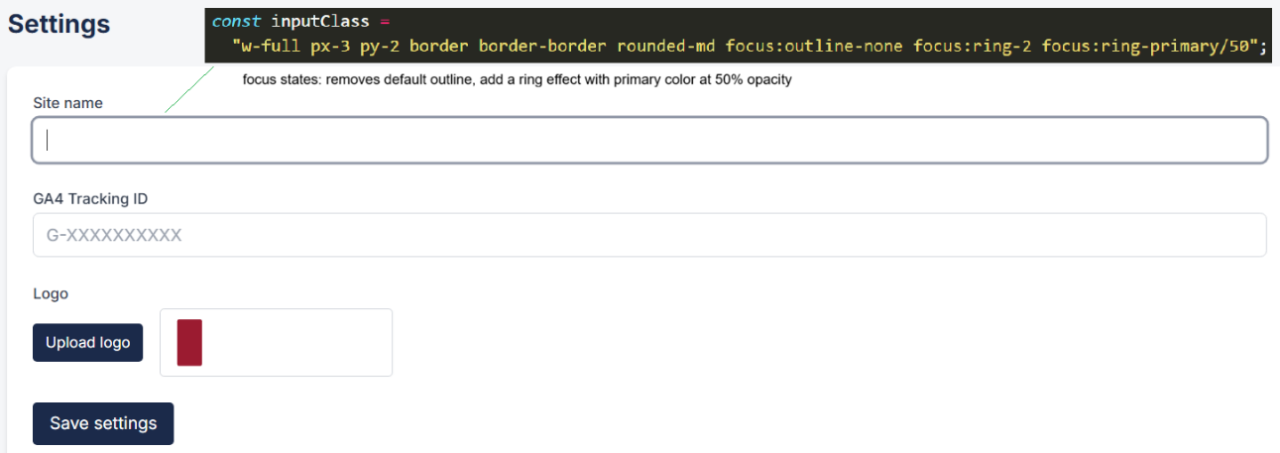

File Upload Handler
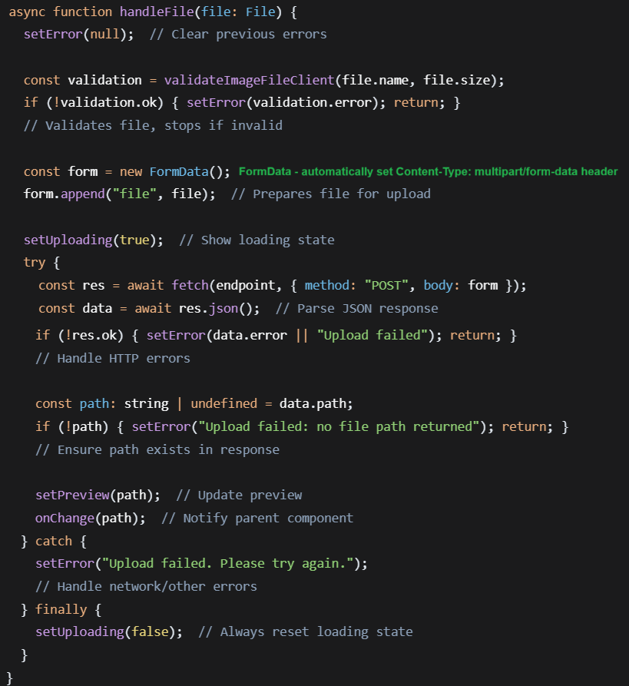
fetch () API for making HTTP requests. It returns a Promise that resolves to a Response object
await () Pauses the function execution until the fetch() Promise resolves.
endpint URL where the request is sent, default to /api/upload/image. This is the server endpoint that handles file uploads
method: “POST” HTTP POST method to submit data.
body: form The request payload (data being sent)

Rendering
- Hidden file input exists in the apge
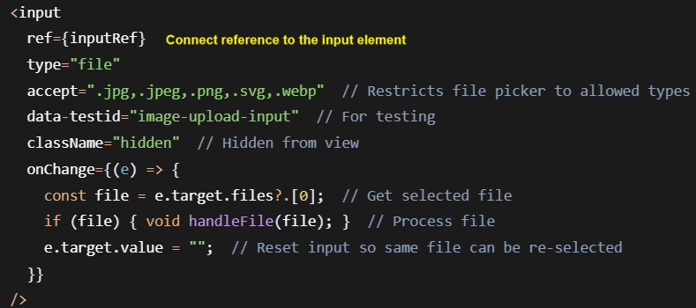

- Visible button triggers the hidden input
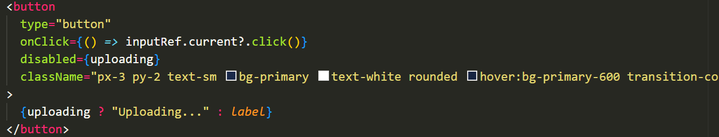

\app\[locale]\admin\pages\page.tsx
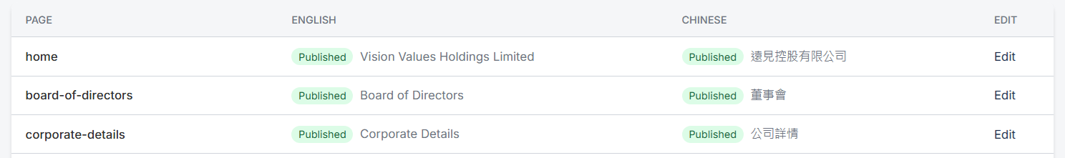
Table body with dividers between rows
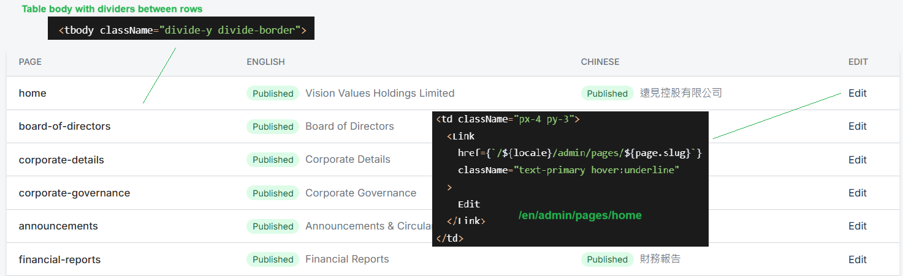

/app/[locale]/admin/pages/[slug]/page.tsx
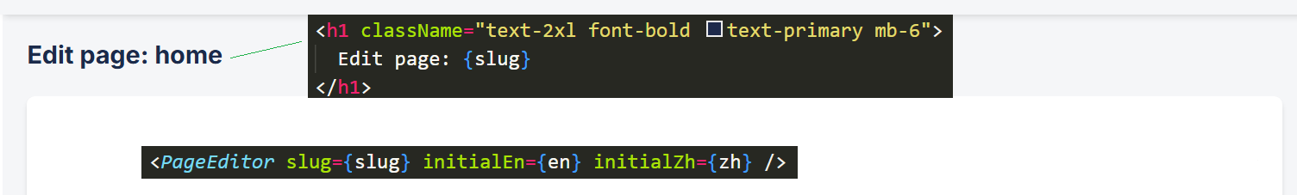

/components/admin/PageEditor.tsx
State Management
drafts contains two separate objects, one for each locale, each following the PageDraft format.
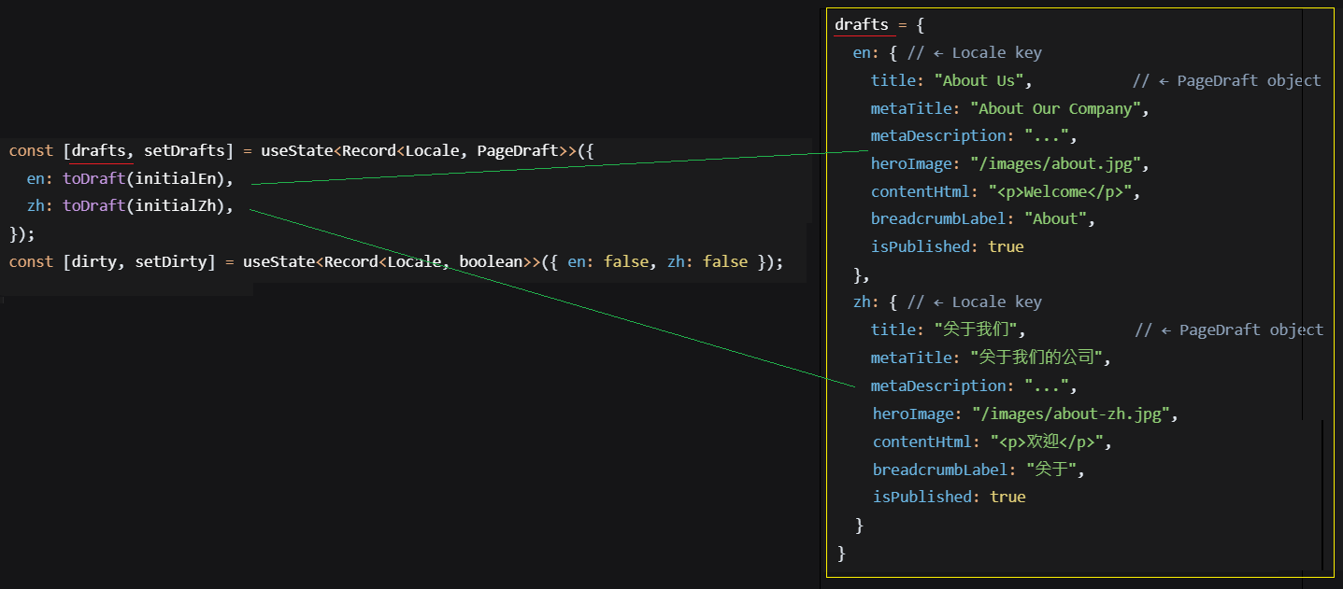

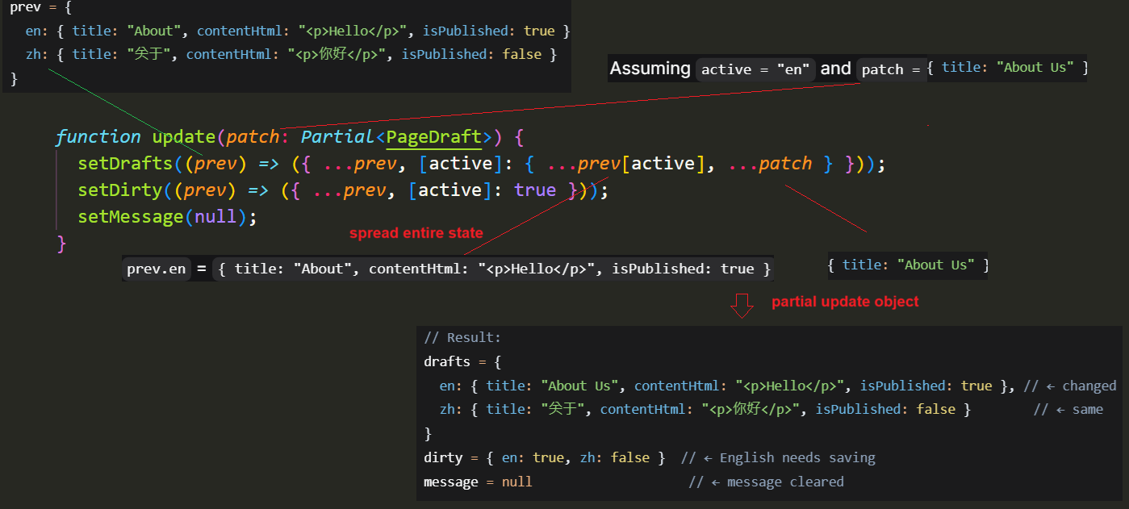
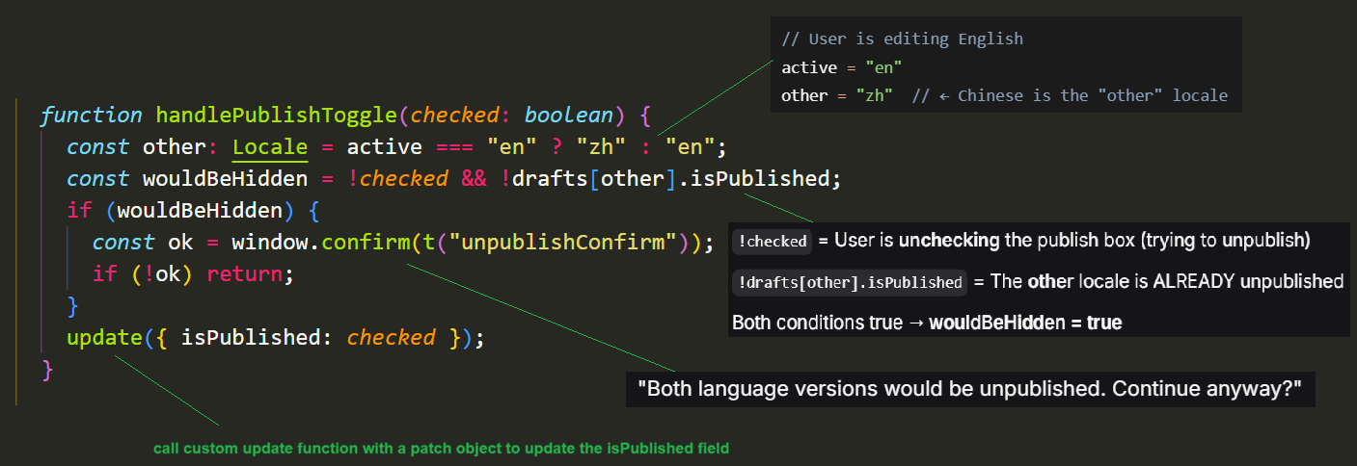

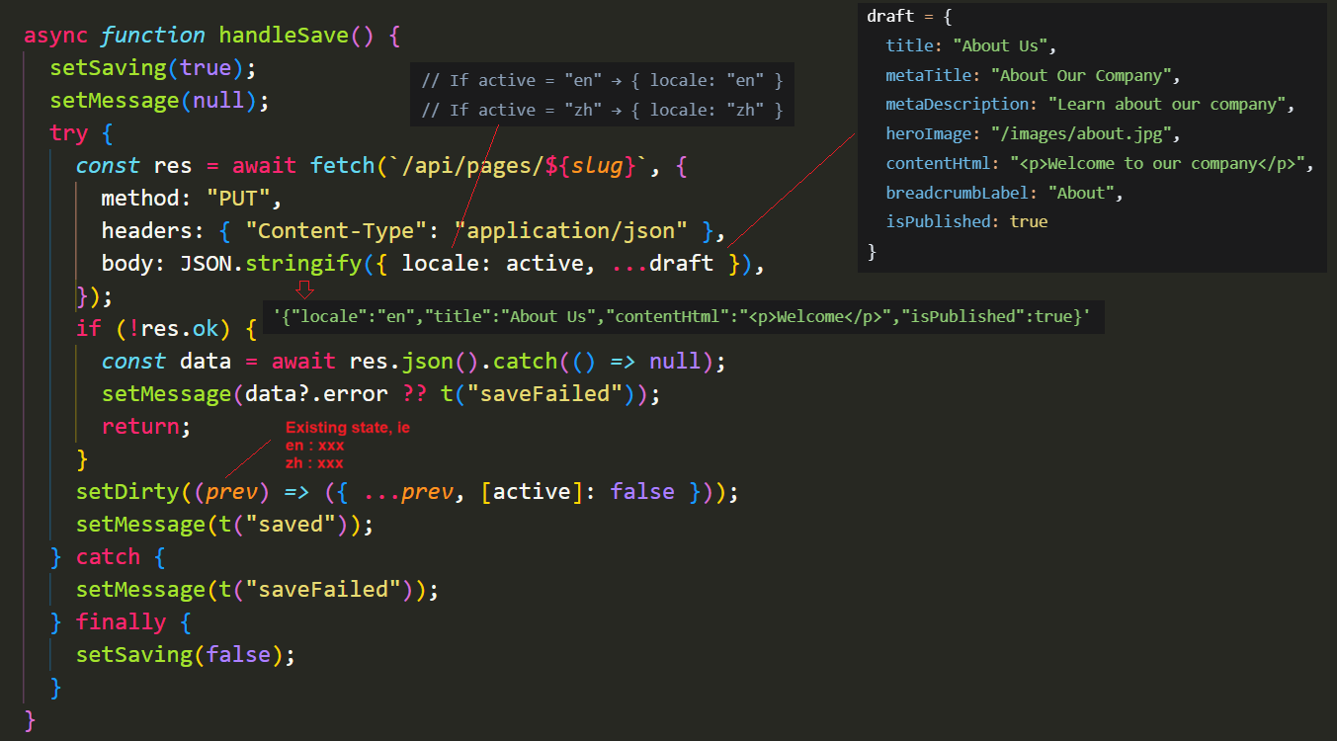

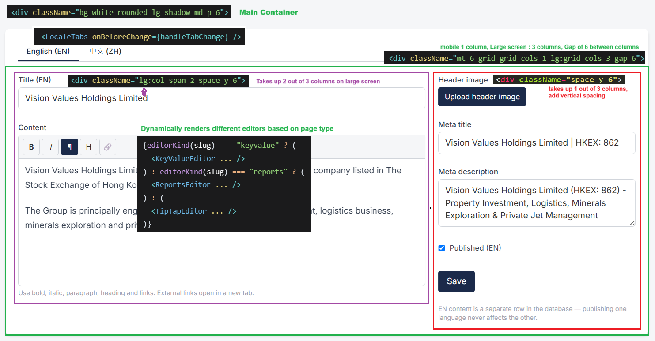

src/app/api/logo/route.ts
Handles site logo uploads.
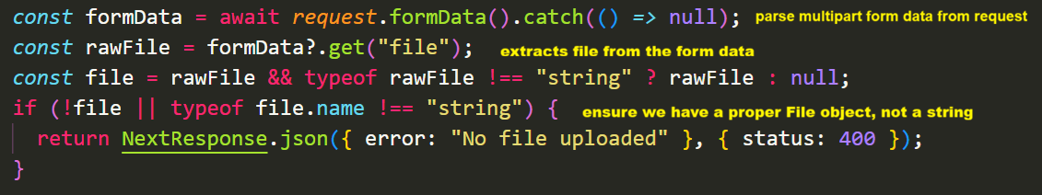

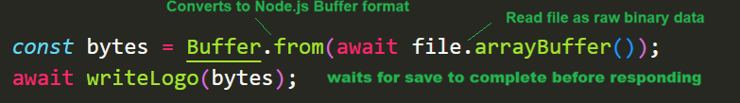

src/components/admin/SettingsForm.tsx
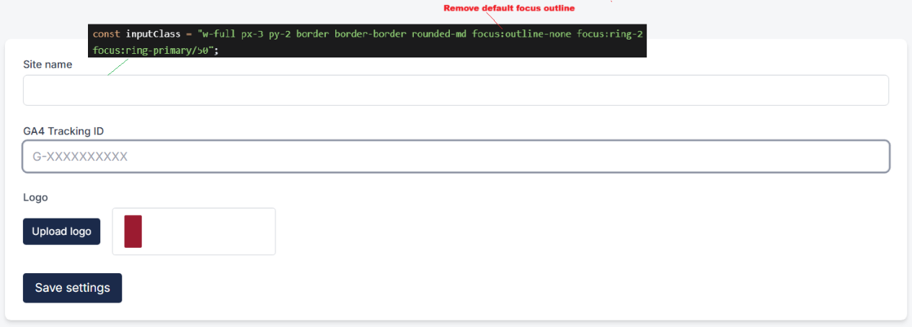

src/app/[locale]/admin/settings/page.tsx
_props is a common convention. If it were just props without underscore, linters would warn about unused parameters. AdminSettingsPageProps defines what props this component expects.

src/app/[locale]/admin/change-password/page.tsx
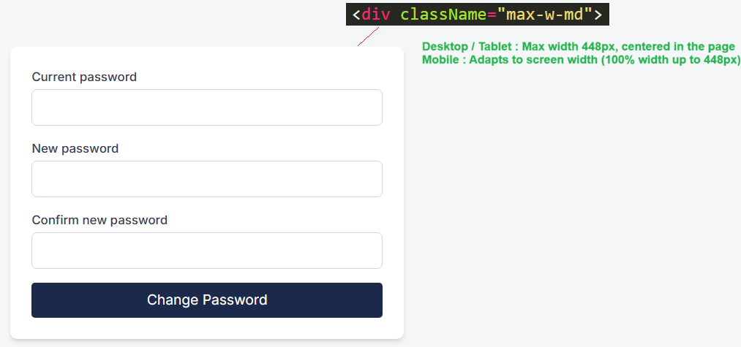

/src/lib/pages.ts
It defines a server-only function that fetches page data for a given slug and locale, with a smart fallback system.

getPageData() retrieves page content from a database, but gracefully fall back to static placeholder when needed – ensuring the site always renders something.
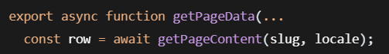
It’s an async function that await database operations and it must only be called on the server. If you need data in a Client component, fetch it via:
- A server component wrapper that passes data as props
- An API route called from useEffect or fetch
- A server Action invoked from the client

/lib/ typically contains server-side utilities. These files are usually not meant to be bunded for the client.

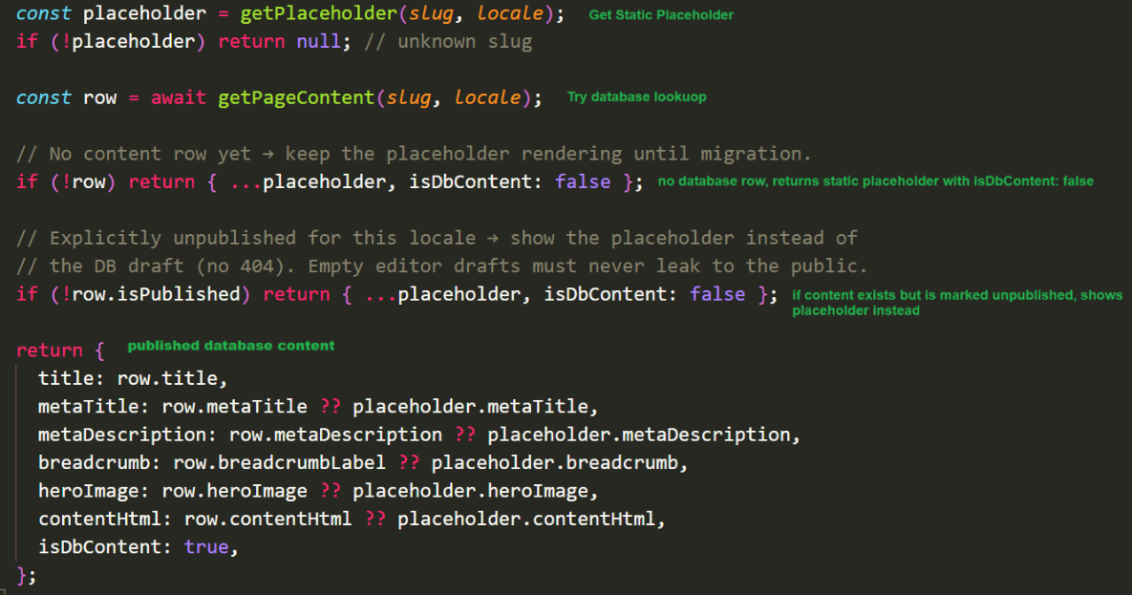
isDbContent is a flag not stored in database to indicate this row is coming from database.

/src/app/[locale]/admin/page.tsx
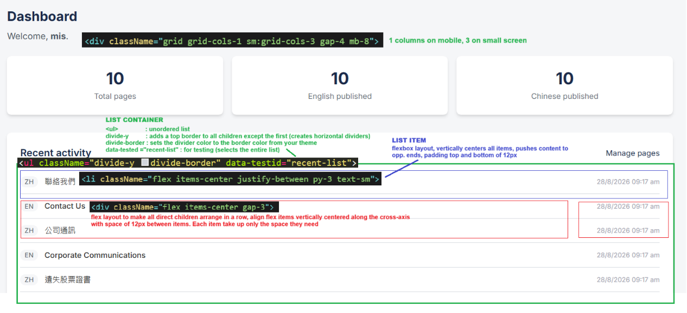

/src/app/[locale]/announcements/page.tsx
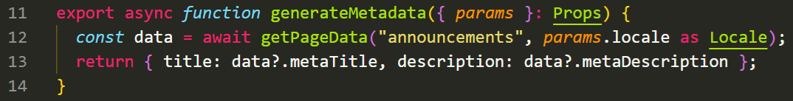
When you export generateMetadata from a page, Next.js’s framework automatically :
- Detects this export
- Calls it during the rendering process
- Injects the returned metadata into the HTML <head>

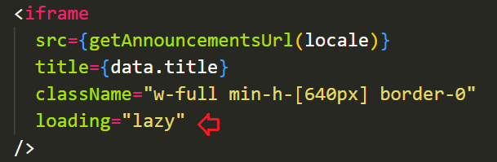
The iframe will not load until :
- The user scrolls and the iframe comes close to the visible area area of the screen (viewport)
- OR the user never scrolls to it – then it never loads at all

/src/app/[locale]/board-of-directors/page.tsx
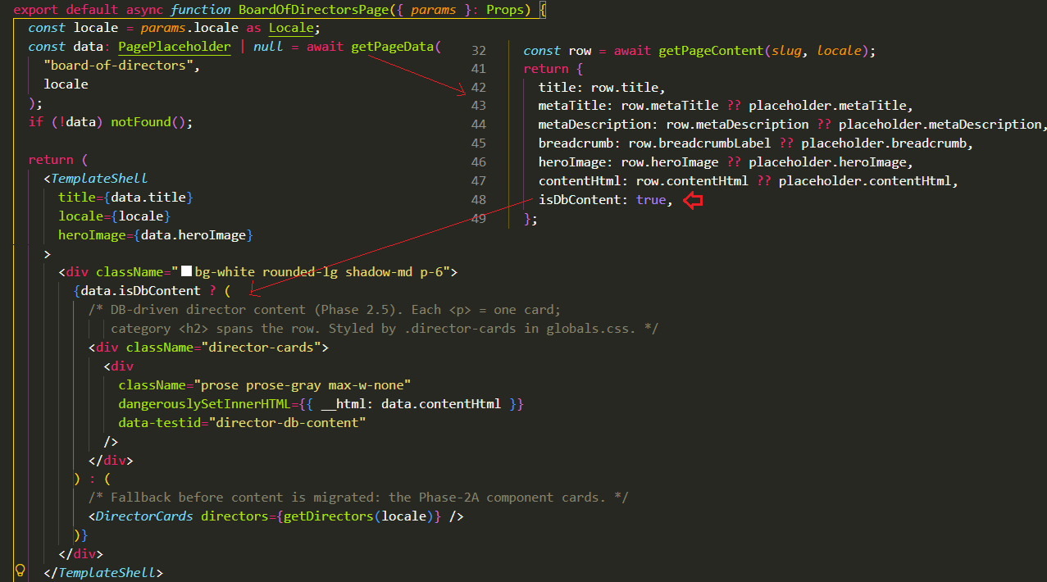

/src/lib/report-rows.ts
It provides utility function to manage structured report data that’s stored as JSON in a document’s HTML content.
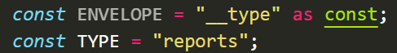
- ENVELOPE can only be the exact string “__type”
- TYPE : The value “reports” marks this as report data

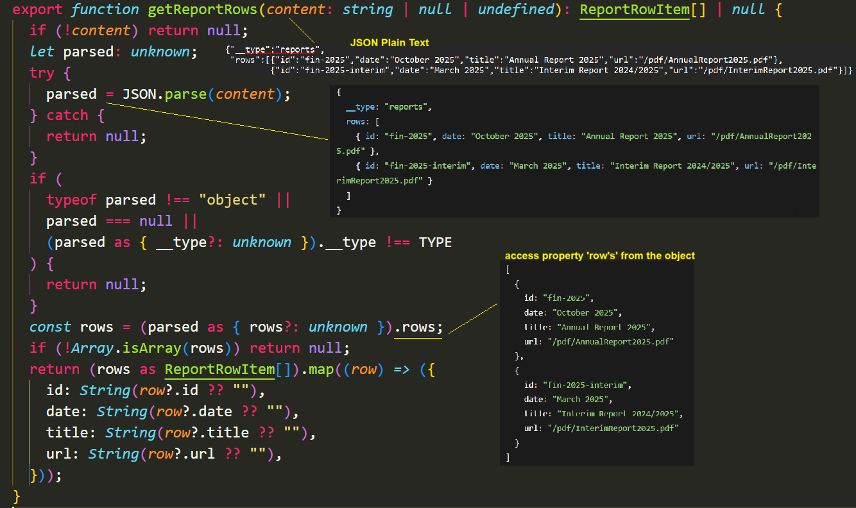

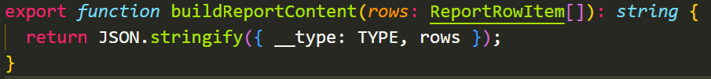
- Convert array of objects to JSON string

/src/app/[locale]/corporate-communications/page.tsx
Rows is always populated either through database or placeholder.
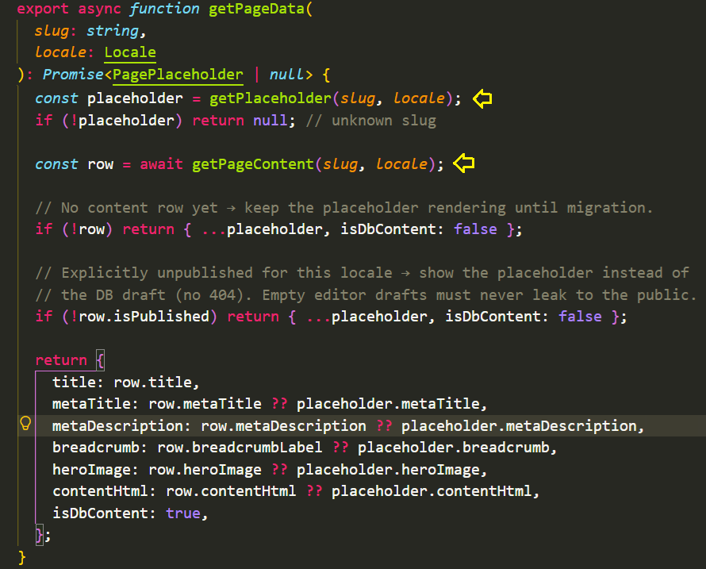

/src/app/[locale]/esg-reports/page.tsx
/src/lib/key-value.ts
The code finds all content inside <p> tags and converts it into key-value pairs.
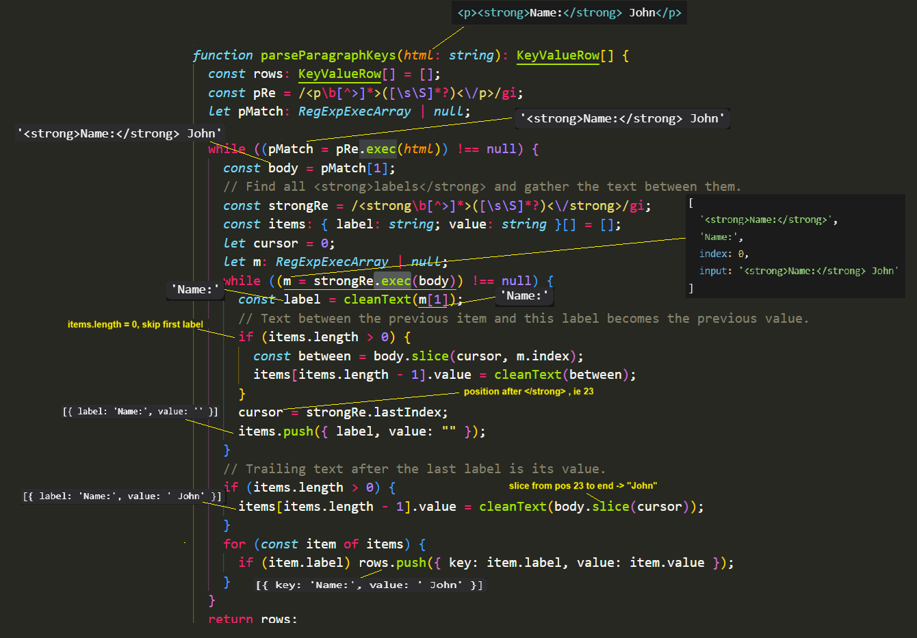

Parse table HTML into key/value rows.
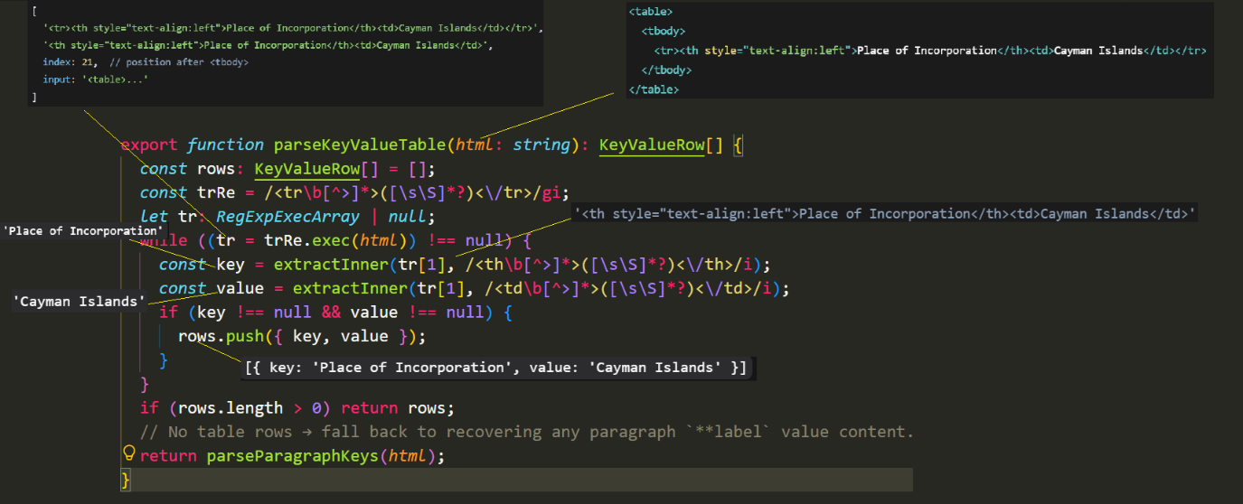
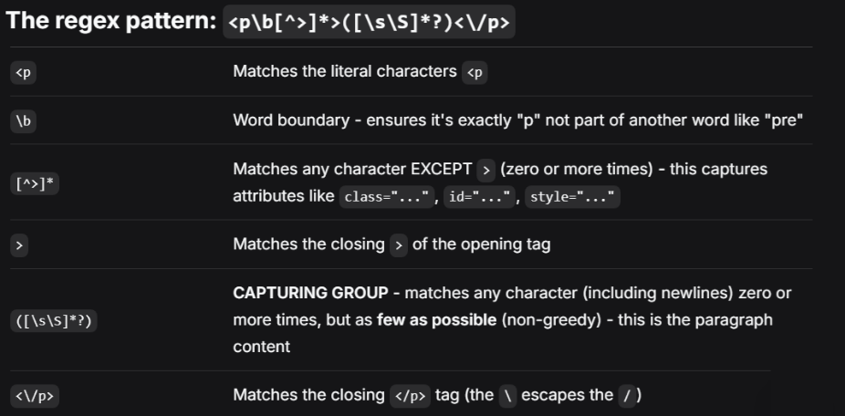

RegExpExecArray is the TypeScript for the result returned by exec() method of a regular expression. It’s an array-like object that contains information about the regex match.
pMatch[1] get the content inside the <p> tags (the first capture group)
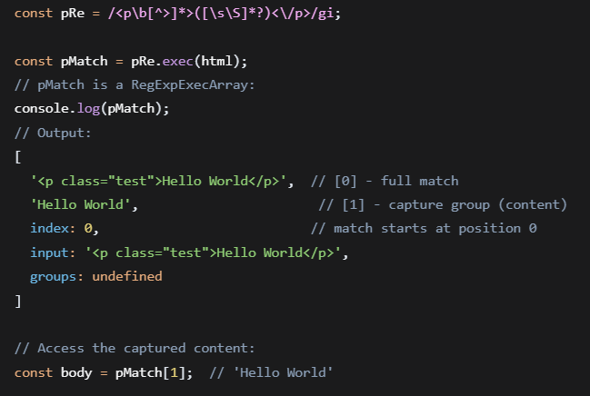
extractInner() extracts key-value pairs from HTML tables and falls back to paragraph parsing if no tables are found.
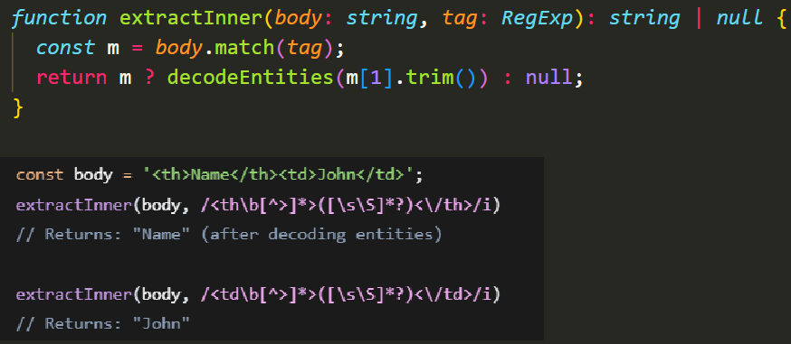

buildKeyValueTable converts key-value pairs back into an HTML table
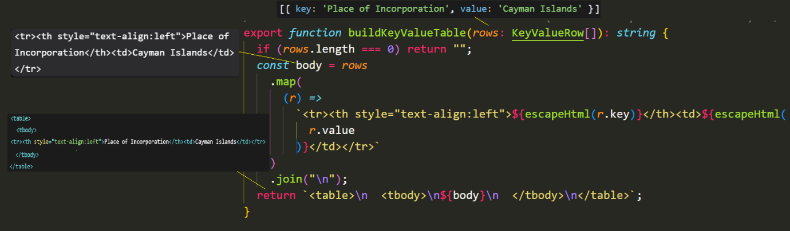
src/components/admin/KeyValueEditor.tsx
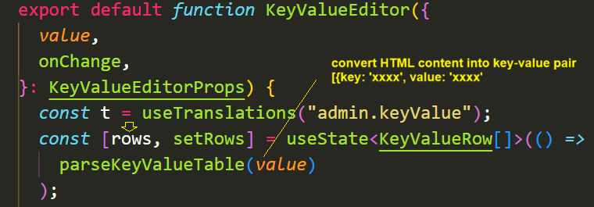

updateRow updates a specific row in an array of KeyVlaueRow objects.
