電通二乙微處理器實驗 實驗結報

實驗名稱 | Arduino入門
組別 | 14 | 組員 | 03050371葉竣皓

- 實驗目的 認識Arduino

- 實驗步驟 更改delay

- 程式碼
// Pin 13 has an LED connected on most Arduino boards.
// give it a name:
int led = 9;

// the setup routine runs once when you press reset:
void setup() {
// initialize the digital pin as an output.
pinMode(led, OUTPUT);
}

// the loop routine runs over and over again forever:
void loop() {
digitalWrite(led, HIGH); // turn the LED on (HIGH is the voltage level)
delay(1000); // wait for a second
digitalWrite(led, LOW); // turn the LED off by making the voltage LOW
delay(1000); // wait for a second
}

- 實驗結果及分析
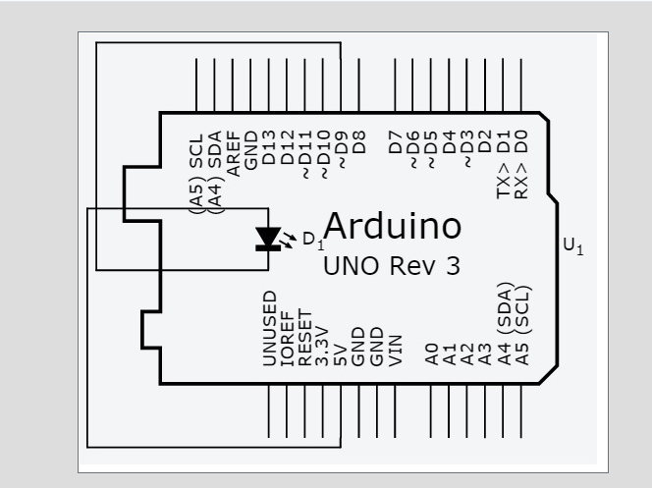

- 心得討論
交作業
很難
….
修正電路圖
- 修正程式碼

