Stage Model Derivation: From the α-Power Law to the Stage Law
October 1, 2026

II. Stage Model Derivation
This section derives the stage law used in this work from the α-power law MOSFET model [1]. Equations are numbered consecutively; each is obtained from those preceding it, and the approximations are isolated in Section II-M. Notation is collected in Table I.

A. Node dynamics
A predriver stage is a CMOS inverter whose output node, at voltage $V_{o}$, drives a lumped capacitance $C$. Kirchhoff’s current law at that node gives
$$C \frac{dV_{o}}{dt}=I_{P}−I_{N} \left(1\right)$$
where $I_{P}$ is the pull-up (PMOS) current into the node and $I_{N}$ is the pull-down (NMOS) current out of it. Equation (1) is the only physical law used; all remaining steps model $I_{P}$ and $I_{N}$ and change variables.

B. Device model
Each transistor is described by the α-power law [1]. For a device with gate–source voltage $V_{GS}$ and drain–source voltage $V_{DS}$ (magnitudes),
$$I_{D}=\left\{\begin{matrix}0, & D=0 \left(\text{cutoff}\right) \\ \frac{I′_{D0}}{V′_{D0}} V_{DS}, & V_{DS}<V′_{D0} \left(\text{triode}\right) \\ I′_{D0}, & V_{DS}≥V′_{D0} \left(\text{saturation}\right)\end{matrix}\right. \left(2\right)$$
with
$$I′_{D0}=I_{D0} D^{α} \left(3\right)$$
$$V′_{D0}=V_{D0} D^{α/2} \left(4\right)$$
$$D=clip\left(\frac{V_{GS}−V_{TH}}{V_{DD}−V_{TH}}, 0, 1\right) \left(5\right)$$
Here $I_{D0}$ and $V_{D0}$ are the saturation current and saturation voltage at $V_{GS}=V_{DD}$, $V_{TH}$ is the threshold, and $α∈\left[1,2\right]$ is the velocity-saturation index ($α=2$ recovers the long-channel square law; $α→1$ for strongly velocity-saturated devices). The lower clip in (5) encodes the cutoff row of (2); the upper clip expresses $V_{GS}≤V_{DD}$.
Because (2) is piecewise linear in $V_{DS}$ up to $V′_{D0}$ and constant beyond it, its two conducting rows collapse to a single expression:
$$I_{D}=I′_{D0} min\left(1, \frac{V_{DS}}{V′_{D0}}\right) \left(6\right)$$
Substituting (3) and (4) into (6),
$$I_{D}=I_{D0} D^{α} min\left(1, \frac{V_{DS}}{V_{D0} D^{α/2}}\right) \left(7\right)$$
Equation (7) is the device model in the form used below: a full-drive current, a gate factor $D^{α}$, and a drain factor that saturates at unity.
The device model (2)–(5) was checked against the transistors actually used in the predrivers of two test buffers, simulated in HSPICE from their model cards at their drawn dimensions. $V_{TH}$ and $α$ are extracted as in [1, App. A]: $V_{TH}$ is the value for which the saturation current is a straight line against $V_{GS}−V_{TH}$ on logarithmic axes, and $α$ is the slope of that line. Reference [1] gives no procedure for $V_{D0}$; it is taken here as the breakpoint that best fits the piecewise form (6) to the output curve at full gate drive. Fig. 1 shows the result and Table II lists the two normalized parameters. The measured $α$ is 1.10–1.63, between the short-channel limit of 1 and the long-channel value of 2 [2], and the saturation voltage is 0.34–0.57 of the supply, comparable to the 0.5–0.55 used in [1].
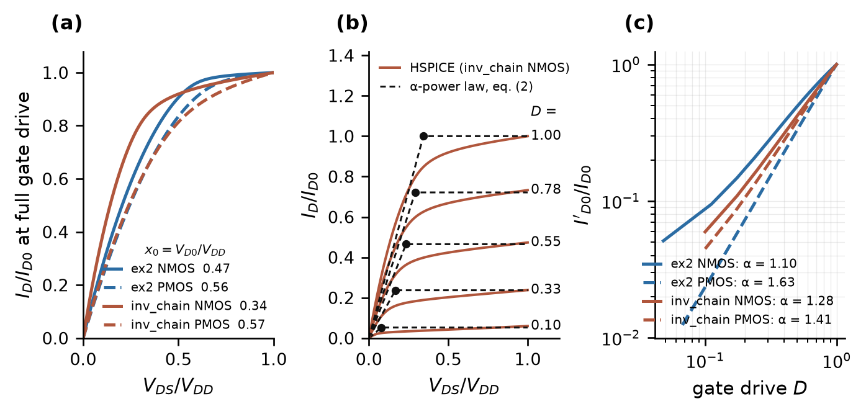
Fig. 1. HSPICE characteristics of the predriver devices of test buffers ex2 and inv_chain, at their drawn dimensions. (a) Output curves at full gate drive, normalized; the legend gives the fitted $x_{0}=V_{D0}/V_{DD}$. (b) Output curves of one device at five gate drives (solid) against the α-power law (2) with the extracted $α$ and $V_{D0}$ (dashed; dots mark the saturation voltage $V'_{D0}$ of (4)). (c) Saturation current against gate drive; the slope is $α$.
Table II: Device parameters of (2)–(5) extracted in HSPICE from the predriver transistors
Device | Model card | Drawn length | $V_{DD}$​ | $x_{0}=V_{D0}/V_{DD}$​ | $α$​
ex2 predriver NMOS | hspice.mod (BSIM3v3) | 600 nm | 3.3 V | 0.472 | 1.10
ex2 predriver PMOS | hspice.mod (BSIM3v3) | 600 nm | 3.3 V | 0.559 | 1.63
inv_chain NMOS | HL18G-S3.7S | 180 nm | 1.8 V | 0.343 | 1.28
inv_chain PMOS | HL18G-S3.7S | 180 nm | 1.8 V | 0.569 | 1.41

C. Normalization
Let the stage output move from its resting rail toward its destination rail, a distance $V_{DD}$. Define, for a rising output,
$$v≜\frac{V_{o}}{V_{DD}}, u≜\frac{V_{DD}−V_{in}}{V_{DD}} \left(8\right)$$
so that $v$ is the output’s progress toward its destination and $u$ is the input’s progress toward the level that fully turns on the working (pull-up) device. Both run from 0 to 1 during a transition. Define the normalized device constants
$$v_{t}≜\frac{V_{TH}}{V_{DD}}, x_{0}≜\frac{V_{D0}}{V_{DD}} \left(9\right)$$
With the PMOS source at $V_{DD}$ and the NMOS source at ground, the four terminal voltages follow from (8):
$$\left|V_{GS,P}\right|=u V_{DD}, \left|V_{DS,P}\right|=\left(1−v\right) V_{DD}, V_{GS,N}=\left(1−u\right) V_{DD}, V_{DS,N}=v V_{DD} \left(10\right)$$
Substituting (9) and (10) into (5), $V_{DD}$ cancels and the gate drives of the two devices become
$$D_{P}=g\left(u\right), D_{N}=g\left(1−u\right), g\left(x\right)≜clip\left(\frac{x−v_{t}}{1−v_{t}}, 0, 1\right) \left(11\right)$$
Substituting (9) and (10) into the drain ratios of (7),
$$\frac{\left|V_{DS,P}\right|}{V_{D0}}=\frac{1−v}{x_{0}}, \frac{V_{DS,N}}{V_{D0}}=\frac{v}{x_{0}} \left(12\right)$$
Applying (7) to each device with (11) and (12):
$$I_{P}=I_{D0,P} g{\left(u\right)}^{α} min\left(1, \frac{1−v}{x_{0} g{\left(u\right)}^{α/2}}\right) \left(13\right)$$
$$I_{N}=I_{D0,N} g{\left(1−u\right)}^{α} min\left(1, \frac{v}{x_{0} g{\left(1−u\right)}^{α/2}}\right) \left(14\right)$$
Equations (13)–(14) use one $v_{t}$, $α$ and $x_{0}$ for both devices; this is the same symmetric-device simplification adopted in [1, Sec. VI], where the two indices are averaged when they differ.

D. Normalized stage dynamics
From (8), $dV_{o}/dt=V_{DD} dv/dt$. Substituting this and (13)–(14) into (1) and dividing by $C V_{DD}$:
$$\frac{dv}{dt}=s_{up} g{\left(u\right)}^{α} min\left(1, \frac{1−v}{x_{0} g{\left(u\right)}^{α/2}}\right)−s_{dn} g{\left(1−u\right)}^{α} min\left(1, \frac{v}{x_{0} g{\left(1−u\right)}^{α/2}}\right) \left(15\right)$$
where
$$s_{up}≜\frac{I_{D0,P}}{C V_{DD}}, s_{dn}≜\frac{I_{D0,N}}{C V_{DD}} \left(16\right)$$
Equation (15) is exact with respect to (1)–(5). Its parameters are dimensionless except $s_{up}$ and $s_{dn}$, which have units of swings per second; $1/s_{up}$ is the time the stage would take to cross the full swing at its full-drive current. At $u=1$, (15) reduces to a constant-slope ramp for $1−v>x_{0}$ followed by an exponential approach with time constant $x_{0}/s_{up}=C V_{D0}/I_{D0,P}$, which is the $C_{L}R_{3}$ of [1, App. B].
Note that $α$ appears twice in each term of (15): in the gate factor $g^{α}$ and in the saturation boundary $x_{0} g^{α/2}$.

E. Reduction to the stage law
Two approximations reduce (15) to the form used in this work.
A1 (gate exponent). Replace $α$ in the gate factor by a model parameter $p$ and define
$$h\left(x\right)≜g{\left(x\right)}^{p}=clip{\left(\frac{x−v_{t}}{1−v_{t}}, 0, 1\right)}^{p} \left(17\right)$$
At full swing the stage input dwells near $g=1$, where (17) is independent of $p$; the full-swing waveform therefore cannot identify $p$, and $p=1$, the short-channel limit of [1], is adopted as the default.
A2 (fixed saturation boundary). Replace the drive-dependent boundary $x_{0} g^{α/2}$ in (15) by its full-drive value, a constant $x_{lin}$, and define
$$r\left(x\right)≜min\left(1, \frac{x}{x_{lin}}\right), x_{lin}=x_{0} \left(18\right)$$
At $g=1$, (18) coincides with the boundary in (15); the two differ only under partial drive.
Applying (17) and (18) to (15) yields the stage law:
$$\frac{dv}{dt}=s_{up} h\left(u\right) r\left(1−v\right)−s_{dn} h\left(1−u\right) r\left(v\right) \left(19\right)$$
Comparing (19) with (15) term by term: $s_{up}$ and $s_{dn}$ are unchanged; $h\left(u\right)$ replaces $g{\left(u\right)}^{α}$ (A1); $r\left(⋅\right)$ replaces the drive-dependent drain factor (A2). The second appearance of the gate drive in (15), inside the boundary, is the only structural element removed.
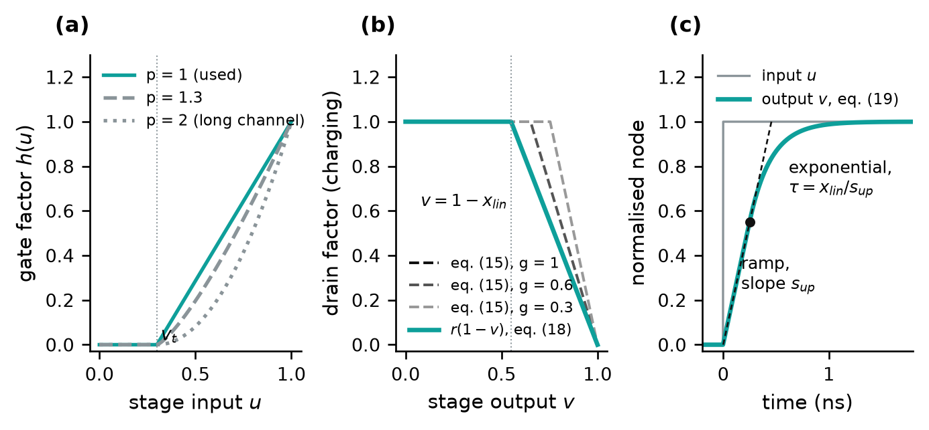
Fig. 2. The stage law (19). (a) Gate factor $h(u)$ of (17) for three exponents. (b) Drain factor of the charging term: the fixed boundary $r(1−v)$ of (18), against the drive-dependent boundary of (15) at three gate drives ($α=1$, $x_{0}=0.45$); the two coincide at full drive. (c) Response of one stage to an input step: a constant-slope ramp while $1−v>x_{lin}$, then an exponential approach to the rail.
The value used is $x_{lin}=0.45$. It is a built-in constant of the method, not a quantity read from the IBIS file. It was chosen during development from fits of (19) to the individual probed predriver stages of two test buffers, which gave 0.37–0.47 on ex2 and 0.52–0.63 on inv_chain. Later evidence agrees with it: fitted to the probed gate with $x_{lin}$ free, the chain gives 0.41 on ex2 and 0.48 on inv_chain; the measured $x_{0}$ of Table II is 0.34–0.57; and [1] uses 0.5–0.55. In the pad-level tests of Section II-L it is fixed at 0.45 on ten of the twelve buffers; on inv_chain and io_buf it was instead fitted to the file together with the other stage parameters. Section II-J shows why the file constrains it only weakly. The default $p=1$ is likewise a built-in constant; it is the lower limit of the measured $α$ (1.10–1.63).
As a check that (19) is the model of [1] and not merely similar to it, one stage with $p=α$ was driven by a linear input ramp and its delay compared with the closed-form delay of [1, eq. (5)]. The two agree within 4 ps for input ramps of 0.05 to 0.8 ns (stage delays of 0.24 to 0.35 ns), with the opposing device either present or switched off; they separate only for ramps slower than the range of validity stated in [1].
For a falling output, (8) becomes $v=\left(V_{DD}−V_{o}\right)/V_{DD}$ and $u=V_{in}/V_{DD}$; (10) exchanges the P and N rows, and (19) is unchanged.

F. From the stage law to a buffer model: overview
Equation (19) describes one predriver stage. Sections II-G to II-L turn it into a model of a complete output buffer and verify it. The argument has six steps, one per section:
(i) $K$ stages in cascade generate the trajectory of the output device's gate (Section II-G); (ii) a static map converts that gate trajectory into the conducting fractions $K_{u}$ and $K_{d}$, which scale the I–V tables of the IBIS file exactly as in the existing converter (Section II-H); (iii) the stage rates are fitted to the $K_{u}(t)$ that the file already contains (Section II-I); (iv) that fit is shown to leave the stage count, the stage threshold and the map shape undetermined (Section II-J); (v) one stressed pad measurement calibrates the threshold and selects among a small set of candidates (Section II-K); (vi) the model is verified at the internal gate node and at the pad (Section II-L). Fig. 3 shows the signal path and Table III the procedure.
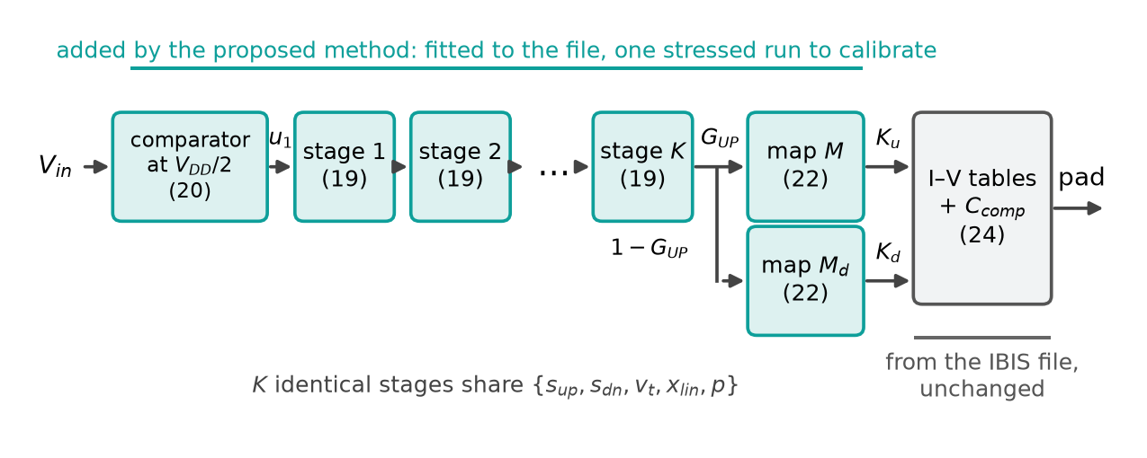
Fig. 3. Signal path of the model. The blocks added by the proposed method replace the way the conducting fractions $K_{u}(t)$ and $K_{d}(t)$ are generated; the I–V tables, $C_{comp}$ and the package elements are those of the IBIS file and are unchanged. Numbers in parentheses are equation numbers.
Table III: The procedure. $p=1$ is fixed; $x_{lin}=0.45$ is fixed on ten of the twelve test buffers and fitted in step 1 on the other two.
Step | What is determined | Data used | Eq.
0 | I–V tables, $C_{comp}$, full-swing $K_{u}(t)$ and $K_{d}(t)$ | IBIS file, existing converter | (24), (25)
1 | $s_{up}$, $s_{dn}$ and an initial $v_{t}$, for each candidate stage count and map shape | full-swing $K_{u}(t)$ of the file | (26)
2 | Candidate set: three stage counts × three map shapes | fit residuals of step 1 | (27)
3 | $v_{t}$, for each candidate | peak of one stressed pad waveform | (28)
4 | Stage count $K$ and map shape | the same stressed pad waveform, whole shape | (29)

Table IV: Inputs of the model and their origin
Input | Origin
I–V tables, $C_{comp}$, package elements, full-swing $K_{u}(t)$ and $K_{d}(t)$ | the IBIS file
$s_{up}$, $s_{dn}$, initial $v_{t}$​ | fitted to the file (step 1)
final $v_{t}$, stage count $K$, map shape | one stressed pad measurement (steps 3 and 4)
$x_{lin}=0.45$, $p=1$, the three candidate map shapes, the band rule (27) | built-in constants, chosen during development on the twelve test buffers with transistor-level information

Applying the method to a new buffer therefore needs no transistor-level information, but the method is not derived from the IBIS file alone: it uses one measurement, and four built-in constants whose values were chosen with knowledge of the test buffers' transistors. Whether those constants suit buffers outside the test set has not been tested.

G. The chain: from the input pin to the output gate
The predriver is modeled as $K$ stages, each obeying (19) with one shared parameter set $\{s_{up},s_{dn},v_{t},x_{lin},p\}$ (approximation A3, identical normalized stages). Because (8) expresses every node as its own progress from 0 to 1, an inverting stage needs no sign: each stage's output is simply the next stage's input. The first stage is driven by a comparator on the input pin at half the supply:
$$u_{1}(t)=1 \text{if} V_{in}(t)>V_{DD}/2, \text{else} 0; u_{k+1}(t)=v_{k}(t), k=1,…,K−1 (20)$$
The output of the last stage is the gate of the output pull-up device, normalized from off to on, and the pull-down gate is taken as its complement:
$$G_{UP}(t)≜v_{K}(t), G_{DN}(t)≜1−G_{UP}(t) (21)$$
The complement in (21) corresponds to an output stage whose two devices are driven from one predriver node, which is the case for ex2 and inv_chain and their variants. Where the netlist has separate pull-up and pull-down predriver paths, as in io_buf, a second chain with its own stage count and parameters is fitted for $G_{DN}$.
Fig. 4 shows what the chain does. For a full transition every stage completes its swing and the chain contributes only a delay and an edge shape. For a pulse shorter than the chain's own delay, the input reverses while the later stages are still rising: each stage turns back before reaching its rail, and the gate reaches only part of its swing (0.74 in Fig. 4(b)). Because a stage delivers no current until its input passes $v_{t}$, a pulse loses amplitude at every stage and, once its peak falls below $v_{t}$, it is not passed on at all. This is why the stage count is a first-order parameter of the model rather than a refinement. The abrupt cutoff is a property of the hard threshold in (17); in a transistor chain the loss is gradual.
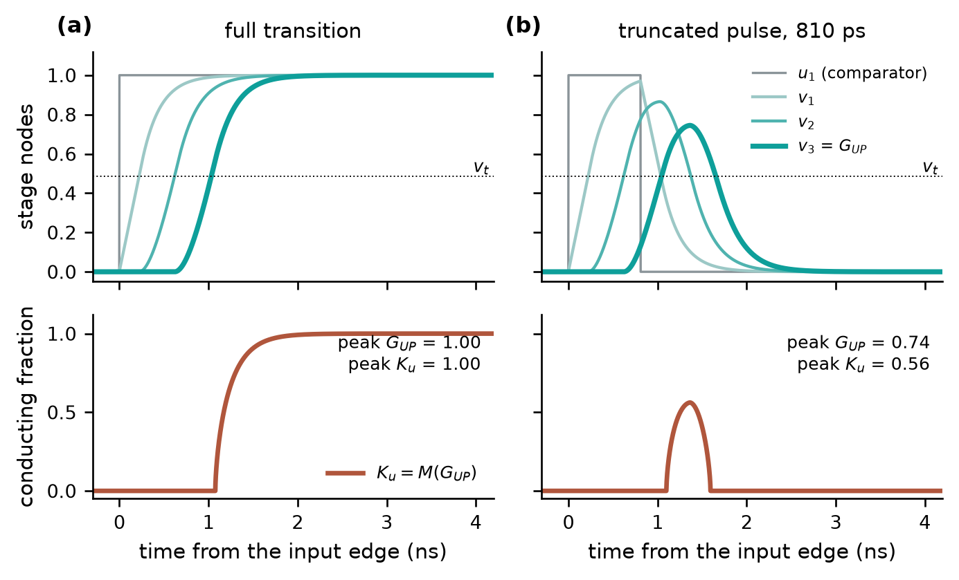
Fig. 4. One chain, two inputs (ex2: $K=3$, $s_{up}=2.19$/ns, $s_{dn}=2.12$/ns, $v_{t}=0.487$, $x_{lin}=0.45$). Top: the stage nodes of (19)–(21). Bottom: the conducting fraction obtained from the gate through the map (22), normalized. (a) Full transition. (b) An 810 ps input pulse: the gate turns back at 0.74 of its swing and $K_{u}$ reaches 0.56.
For the fits of Sections II-I and II-L, (19)–(21) are integrated with Heun's method (second-order Runge–Kutta) at 1 ps steps, each state limited to $[−0.05,1.05]$. Explicit Euler at 2 ps was found to be inadequate for the fastest stages (time constants near 20 ps): it passed a 119 ps pulse that the same chain extinguished in ngspice, whereas Heun agrees with ngspice. In the circuit model each stage is a behavioral current source charging an explicit capacitor $C_{g}$, so that $v_{k}$ is a circuit node:
$$C_{g}\frac{dv_{k}}{dt}=C_{g}⋅10^{9}\left[s_{up} h(v_{k−1}) r(1−v_{k})−s_{dn} h(1−v_{k−1}) r(v_{k})\right]$$
with the rates in swings per nanosecond; $C_{g}$ cancels and its value is immaterial.

H. From the gate to the conducting fraction and the pad
The stage law produces the gate trajectory $G_{UP}(t)$ and nothing else; it makes no statement about the output current. An IBIS-based driver model, on the other hand, needs at each instant the fraction $K_{u}$ of the pull-up I–V table that is conducting, and the fraction $K_{d}$ of the pull-down table. A second relation, separate from the stage law, connects the two.
The map. The pull-up table of the file is the current of the output transistor against pad voltage with its gate fully on. With the gate only partly on, the transistor delivers less, and the reduction is taken to be one multiplier at every pad voltage, which is the assumption any $K_{u}$-based IBIS model already makes:
$$I(V_{pad},g)=K_{u}(g) I_{PU}(V_{pad})$$
$K_{u}$ is therefore a property of the output transistor: how far it is turned on when its gate is at level $g$. It is modeled by a static curve of transistor shape, scaled between the settled off and on levels of the file's own $K_{u}$ and $K_{d}$:
$$K_{u}(t)=k_{off}+(k_{on}−k_{off}) M(G_{UP}(t)), M(g)≜clip{\left(\frac{g−v_{t,map}}{g_{s}−v_{t,map}},0,1\right)}^{a} (22)$$
$$K_{d}(t)=d_{off}+(d_{on}−d_{off}) M(G_{DN}(t)) (23)$$
Below $v_{t,map}$ the output device is off and $M=0$; above it $M$ rises with the gate drive, with curvature $a$, and reaches 1 at $g=g_{s}$ ($g_{s}=1$ in the two-parameter form used below). The levels $k_{off},k_{on},d_{off},d_{on}$ are close to 0 and 1 (0.0035 and 0.998 for $K_{u}$ on ex2). The map parameters describe the output device and are distinct from the stage parameters $v_{t}$ and $p$ of (17), which describe the predriver; the two have the same clip-and-power form because both are gate-drive factors of the kind (5), but they are different quantities.
That $K_{u}$ depends on the gate alone, without memory, was checked on the three buffers whose gate node can be probed: when the $K_{u}$ solved from the pad is plotted against the probed gate, the rising and falling branches coincide within 0.07–0.11. The shape of the curve, however, cannot be read from an IBIS file, because the file does not contain the gate. The shape parameters are therefore not fitted in step 1; they are taken from a small fixed set and selected in step 4 (Section II-K).
From the gate waveform to the conducting fraction. The model's $K_{u}(t)$ is obtained by evaluating the two relations one after the other: (19)–(21) give $G_{UP}(t)$, and (22) is applied to each of its values. Table V does this for a single stage after an input step; Fig. 5 does it for the fitted three-stage chain of ex2.
Table V: Worked example: one stage ($s_{up}=2$ per ns, $x_{lin}=0.45$) read through the map ($v_{t,map}=0.57$, $a=0.64$)
Time after the input step (ns) | Gate $g$, from the stage law (19) | $M(g)$, from the map (22)
0.10 | 0.20 | 0 (gate below $v_{t,map}$)
0.20 | 0.40 | 0 (gate below $v_{t,map}$)
0.30 | 0.60 | 0.19
0.40 | 0.74 | 0.56
0.60 | 0.89 | 0.84
1.00 | 0.98 | 0.97

The gate rises as a ramp of 2 per ns until it is within $x_{lin}$ of its rail and then approaches it exponentially. Nothing conducts until the gate passes 0.57, 0.29 ns after the step; the conducting fraction then rises quickly, because the map is steep just above its threshold.
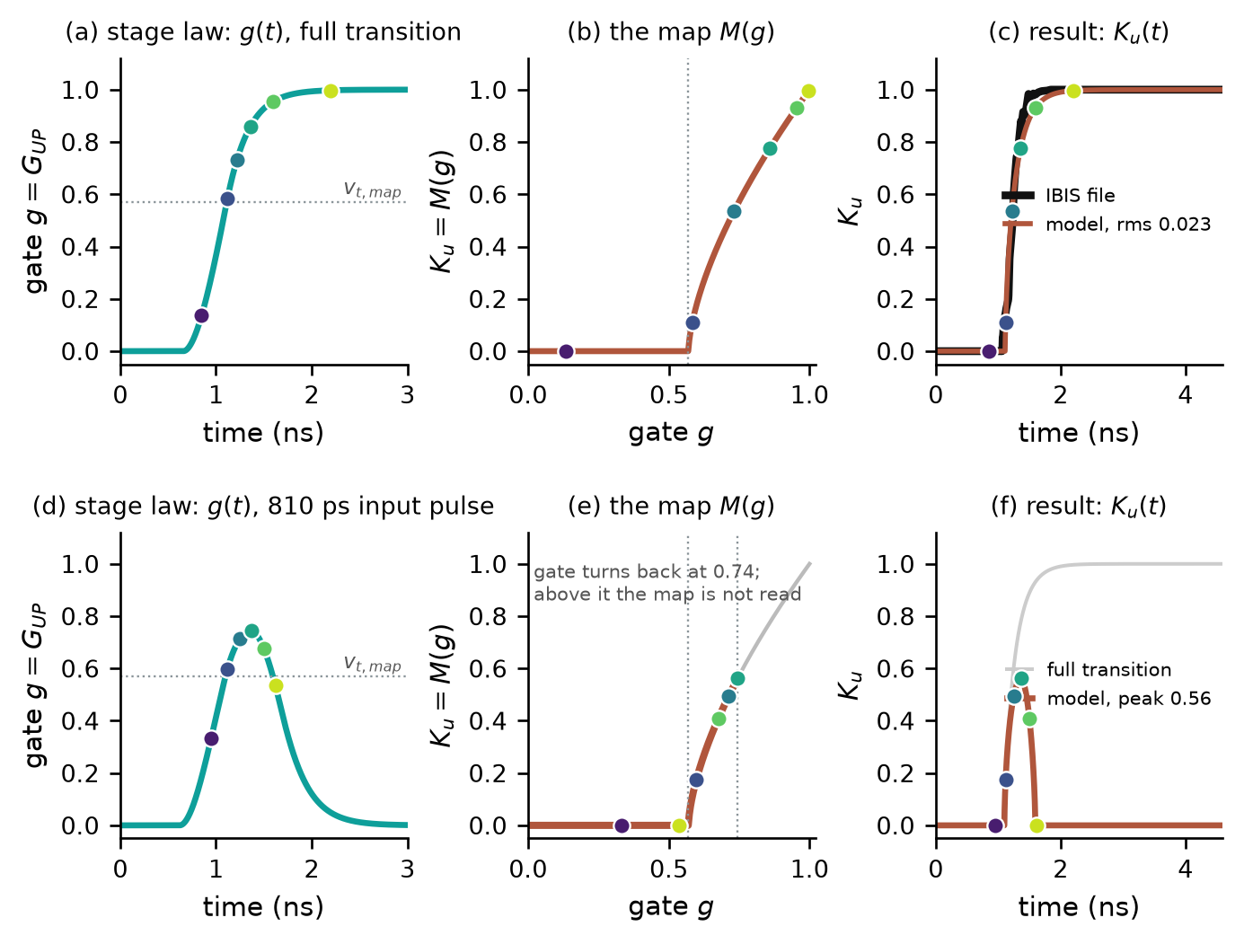
Fig. 5. Construction of the conducting fraction on ex2 ($K=3$, map shape (0.57, 0.64)). Left: the gate trajectory given by the stage law. Middle: the map (22); the dots are the gate values of the left panel at six instants. Right: the resulting $K_{u}(t)$, normalized, with the same instants marked. (a)–(c) Full transition, with the parameters of the fit (26); in (c) the model is compared with the $K_{u}(t)$ of the IBIS file, and this comparison is the fit of Section II-I. (d)–(f) An 810 ps input pulse, after calibration: the gate turns back at 0.74, the map is read only up to that level, and $K_{u}$ reaches 0.56.
The top row of Fig. 5 is the situation the file records. The gate sweeps its full range, the whole map is read, and the result in (c) can be compared with the file. The stage parameters are adjusted until the two curves in (c) agree; the map is not changed in that process. The bottom row is the situation the file does not record. The input is cut short, the gate turns back before reaching its rail, and only the lower part of the map is read. The conducting fraction in (f) rises to 0.56 and returns to zero: a waveform that no table of the file contains, produced by the same two relations with no additional parameter.
From the conducting fraction to the pad. The current delivered to the die node is that of the existing converter:
$$I_{die}(t)=K_{u}(t) I_{PU}(V_{die})+K_{d}(t) I_{PD}(V_{die})+I_{PC}(V_{die})+I_{GC}(V_{die}) (24)$$
where $I_{PU}$ and $I_{PD}$ are the pull-up and pull-down I–V tables of the file, held at their end values outside the tabulated range, and $I_{PC}$, $I_{GC}$ are the power- and ground-clamp tables, present only when the file contains them (io_buf does; ex2 and inv_chain do not). $C_{comp}$ loads the die node and the package $R$, $L$, $C$ of the file connect it to the pad. Equation (24) was checked against the generated subcircuits and is unchanged by the proposed method, which replaces only the source of $K_{u}(t)$ and $K_{d}(t)$; the converter's short first-order lag on the fractions (5 ps) and its residual correction term are also retained as they are.
The ambiguity this creates. In Fig. 5(c) only the composition of the two relations is tested. For any monotone trajectory $G(t)$, the map $K_{u}∘G^{−1}$ reproduces the same full-swing $K_{u}(t)$ exactly, so a faster gate with a later-starting map, or a slower gate with an earlier one, fits the file equally well. The two differ under a truncated pulse, because where the gate turns back depends on how fast it was moving. The stage law restricts the admissible trajectories to those a cascade of current-limited stages can produce, and the map shape is held fixed while the stage parameters are fitted, otherwise (19) and (22) trade off against each other. What remains undetermined is the subject of Section II-J.

I. Step 1: fitting the stage parameters to the IBIS file
The fitting target is the gate-driven part of the file's own $K_{u}(t)$. It is obtained by simulating the existing IBIS-derived subcircuit of the buffer through one full transition and recording its internal conducting fraction, without the converter's residual term. Target and model are both normalized from the settled off level to the settled on level:
$${\hat{K}}_{u}(t)=clip\left(\frac{K_{u}(t)−K_{u}(t_{rest})}{K_{u}(t_{on})−K_{u}(t_{rest})},0,1\right), t_{rest}=4.5 \text{ns}, t_{on}=12 \text{ns} (25)$$
(the input edge is at 5 ns). For a given stage count $K$ and map shape $(v_{t,map},a)$, the stage parameters minimize the root-mean-square mismatch over 4–21 ns, sampled every 2 ps:
$$\{s_{up},s_{dn},v_{t}\}^{⋆}=argmin {rms}_{t}\left[M(v_{K}(t))−{\hat{K}}_{u}^{file}(t)\right], x_{lin}, p \text{fixed} (26)$$
During the fit the chain input is an ideal 10 ns pulse starting at the mid-point of the input edge. The minimization is Nelder–Mead from three starting points ($s_{up}=s_{dn}=2$, 8 and 30 per ns; 800 iterations each) with $0≤v_{t}≤0.7$, and it is repeated for every candidate $K$ and map shape. The comparison is made in the $K_{u}$ domain because the gate is not observable from the file: the model gate is passed through the map and only then compared. For a buffer with a separate pull-down path, the pull-down chain is fitted in the same way to $K_{d}(t)$ through its own map; fitting it through the $K_{u}$ target leaves its onset unconstrained, because that target is zero wherever $K_{d}$ turns on (an onset 250 ps early was observed on an open-drain test buffer).
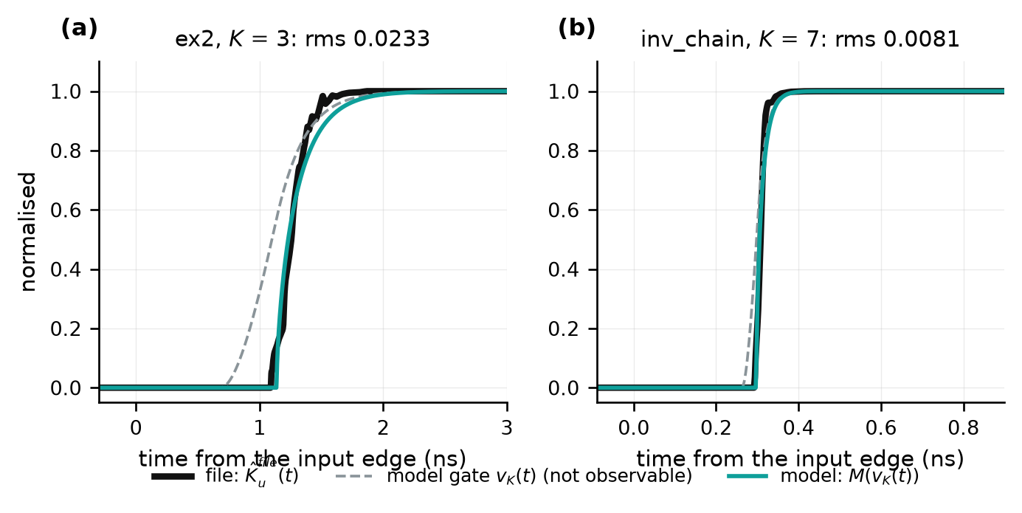
Fig. 6. Result of the fit (26) with $x_{lin}=0.45$: the file's normalized $K_{u}(t)$, the fitted model, and the model's gate trajectory, which the file does not contain. (a) ex2, $K=3$, map shape (0.57, 0.64). (b) inv_chain, $K=7$, map shape (0.49, 0.60).
Example. For ex2 with $K=3$, map shape (0.57, 0.64) and $x_{lin}=0.45$, (26) gives $s_{up}=2.190$/ns, $s_{dn}=2.124$/ns and $v_{t}=0.528$ at a residual of 0.023 (Fig. 6(a)). Three numbers are fitted, to a curve that the file already contains; no stressed data is used in this step.

J. What the file cannot determine
The fit (26) determines the rates well and the structure poorly. Table VI and Fig. 7 give its residual as a function of the stage count for three of the twelve test buffers, each $K$ fitted independently. The transistor netlists of the test buffers are available, so the true stage count is known.
Table VI: Residual of the fit (26) in the $K_{u}$ domain against the stage count $K$
Buffer | $K$ = 1 | 2 | 3 | 4 | 5 | 6 | 7 | 8 | 9 | 10 | Netlist
ex2 | .0829 | .0292 | .0233 | .0224 | .0215 | .0222 | .0235 | .0255 | .0274 | .0294 | 3
inv_chain | .0468 | .0216 | .0141 | .0108 | .0076 | .0071 | .0070 | .0072 | .0072 | .0074 | 7
io_buf (pull-up) | .0176 | .0264 | .0500 | .0639 | .0724 | .0783 | .0825 | .0858 | .0883 | .0904 | 1

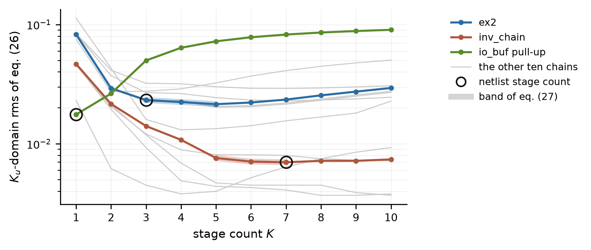
Fig. 7. Residual of (26) against stage count for the thirteen predriver chains of the twelve test buffers (io_buf has two). Circles mark the netlist stage count; the thick segments mark the band (27).
Two features are evident. First, $K=1$ fails on ex2 and inv_chain: a single stage cannot produce the required delay together with the required edge rate, so the full swing does constrain the rate. Second, beyond that the residual is flat: on ex2, $K=3$ to 6 lie within 0.002 of each other and the minimum is at $K=5$ although the netlist has three stages; on inv_chain, $K=6$ to 9 differ in the fourth decimal. The margin between the best and the second-best $K$ is at most 0.0007 on twelve of the thirteen chains. Only io_buf's pull-up, which is a single stage, has a distinct minimum (margin 0.0088). This is the composition degeneracy of Section II-H in numbers.
The same holds for the other quantities that act only under partial drive. The threshold: the fitted $v_{t}$ of ex2 is 0.029 in one fitting pass ($K=6$) and 0.528 in another ($K=3$) that differs in $C_{comp}$ and map shape, at residuals of 0.0202 and 0.0233. The exponent: at full swing each stage input dwells at the rail, where (17) does not depend on $p$; in fits of the individual probed stages every $p$ between 1 and 2 reaches a residual of 0.002–0.007. The saturation boundary: if $x_{lin}$ is left free in (26) it settles at 0.206 on ex2 and 0.135 on inv_chain, less than half the measured $x_{0}$ of Table II, and replacing (18) by the drive-dependent boundary of (15) changes the residual by about 1 % on ex2 and not at all on inv_chain. The file cannot distinguish these alternatives, which is why $x_{lin}$ and $p$ are normally held fixed (Table IV) rather than fitted.
A fit with every stage free is worse than uninformative. On ex2 with $K=2$ and all eight parameters free, the full-swing residual against the probed gate falls to 0.0046, below the 0.0066 of the identical-stage fit with the correct $K=3$; it achieves this with one very slow stage and one fast one, and such a chain extinguishes short pulses: it predicts a stressed gate peak of 0.228 where 0.758 is measured. Sharing one parameter set among the stages (A3) removes this solution and leaves $K$ as the single structural unknown.
The procedure therefore keeps a band of stage counts instead of a point estimate:
$$\text{band}=\text{the three smallest} K \text{with} rms(K)≤1.25 \min_{K'} rms(K') (27)$$
On the twelve test buffers the band contains the netlist stage count in every case. The tolerance of 25 % and the band width of three were chosen on these same buffers, so this is a property of the rule as tuned and not an independent validation.

K. Steps 2–4: the single stressed measurement
What the file cannot determine is settled by one measurement that the file does not contain: the pad voltage for a single short pulse into a known load. In the tests below the pulse is the one that reaches about 50 % of the buffer's settled swing into a 50 Ω, 2 pF load, and the measurement is a transistor-level simulation of the buffer. The measurement is used twice.
Candidates (step 2). The band (27) supplies three stage counts. The map shape, the other factor of the composition, is taken from three shapes, $(v_{t,map},a)∈$ {(0.50, 0.70), (0.40, 0.60), (0.40, 0.90)}. Each of the nine candidates has its own fit (26).
Calibration of the threshold (step 3). For each candidate, with $\hat{V}$ the measured peak of the pad voltage, define the peak error
$$e(v_{t})≜\frac{\max_{t}V_{pad}^{model}(t;v_{t})−\hat{V}}{\hat{V}}, e(v_{t}^{cal})=0 (28)$$
and solve $e=0$ for $v_{t}$ by bisection on $[0,0.7]$, all other parameters held at their values from (26). Each evaluation is one circuit simulation of the complete model; three bracket the interval and seven bisect it. If the threshold cannot bracket the peak, $s_{up}$ and $s_{dn}$ are scaled together within $[0.5,2]$ instead. The threshold is used, and not the rates, because the rates were fitted to reproduce the full swing and moving them degrades it, whereas $v_{t}$ changes when each stage hands over without changing how fast it runs. For ex2 the calibration moves $v_{t}$ from 0.528 to 0.487 (Fig. 8(b)).
Selection of the stage count and map shape (step 4). After calibration all nine candidates reproduce the measured peak, so the peak carries no further information; they differ in the rest of the waveform (Fig. 8(c)). The candidate is chosen by the waveform error over the pulse and its return,
$$(K,v_{t,map},a)^{⋆}=argmin {rms}_{t∈[t_{f}−0.3 \text{ns}, t_{f}+1.5 \text{ns}]}\left[V_{pad}^{model}(t)−V_{pad}^{meas}(t)\right] (29)$$
where $t_{f}$ is the falling edge of the input pulse. The window was chosen once and was not tuned.
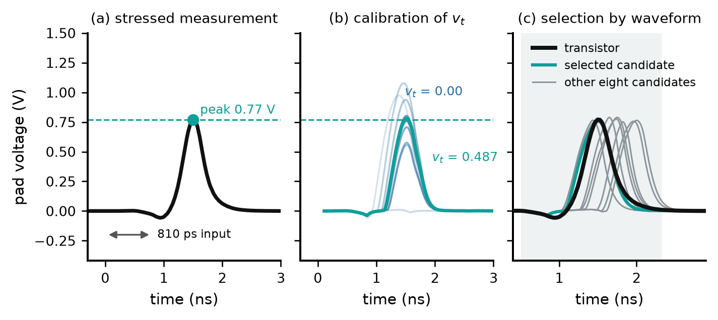
Fig. 8. Use of the stressed measurement on ex2 (810 ps input pulse). (a) The measurement and its peak. (b) Calibration (28): pad waveform of the model as $v_{t}$ is bisected; the final curve meets the measured peak (dashed). (c) Selection (29): the nine calibrated candidates all reach the measured peak and differ elsewhere; the shaded interval is the window of (29). Time is measured from the input edge.
The stage count and the threshold are thus both taken from one waveform, but from different features of it: the threshold from its height, the stage count and map shape from its shape. Selecting on the peak instead of the waveform is markedly worse. Averaged over the twelve buffers, the pad-waveform error at all five stressed widths (the rms of (29) evaluated at each width) is 52.3 mV for the candidates chosen by (29), against 51.7 mV for the best candidate available in each grid and 217.3 mV for the candidates that minimize the worst peak error, which achieve their peak by arriving 155–300 ps late.

L. Verification
Two claims are verified separately. The first concerns the stage law itself: fitted to a full transition only, a cascade of (19) predicts how the gate responds to a truncated pulse. The second concerns the complete method: built from the IBIS file and one stressed measurement, the model reproduces the pad voltage of stressed pulses.

1) Gate level: the stage law extrapolates from full swing to truncated pulses
This test uses the internal gate node of the transistor netlist (node n4 of ex2, vout7 of inv_chain) and therefore is not available to a user of the method; its purpose is to test (19). $K$ identical stages are fitted in the gate domain to the probed full-swing gate; the chain is then driven by the stressed input and compared with the probed stressed gate at five pulse widths, which correspond to pad amplitudes of about 50, 60, 70, 80 and 90 % of the settled swing. No stressed data enters the fit. The comparison is linear superposition of the node's own full-swing rise and fall responses, which is what any linear model of the predriver (an RC cascade, a delay followed by an RC) reduces to.
Table VII: Peak of the stressed gate, ex2 (fitted at full swing only)
Pulse width (ps) | 810 | 830 | 858 | 895 | 975
Measured | 0.758 | 0.797 | 0.838 | 0.880 | 0.936
Stage law, $K$ = 3 | 0.756 | 0.782 | 0.813 | 0.847 | 0.898
Stage law, $K$ = 2 | 0.303 | 0.332 | 0.372 | 0.426 | 0.538
Linear superposition | 0.926 | 0.932 | 0.940 | 0.951 | 0.968

On ex2 the stage law with the netlist stage count is within 0.04 of the measured peak at every width, where linear superposition is off by 0.17 at the narrowest pulse (Table VII, Fig. 9(a)). The waveform error at the narrowest pulse is 0.012 for the stage law, from a full-swing fit residual of 0.0066. The stage count matters as Section II-J predicts: $K=2$ gives 0.30–0.54, far below the measurement.
Table VIII: Peak of the stressed gate, inv_chain (fitted at full swing only)
Pulse width (ps) | 104 | 106 | 111 | 119 | 135 | Full-swing residual
Measured | 0.879 | 0.935 | 0.972 | 0.992 | 1.003
Stage law, $K$ = 7 | 0.701 | 0.832 | 0.913 | 0.961 | 0.987 | 0.0032
Stage law, $K$ = 5 | 0.000 | 0.000 | 0.000 | 0.000 | 0.810 | 0.0037
Stage law, $K$ = 3 | 0.000 | 0.000 | 0.000 | 0.000 | 0.000 | 0.0141
Stage law, $K$ = 9 | 0.942 | 0.954 | 0.967 | 0.981 | 0.992 | 0.0032
Linear superposition | 0.999 | 1.000 | 1.002 | 1.005 | 1.008

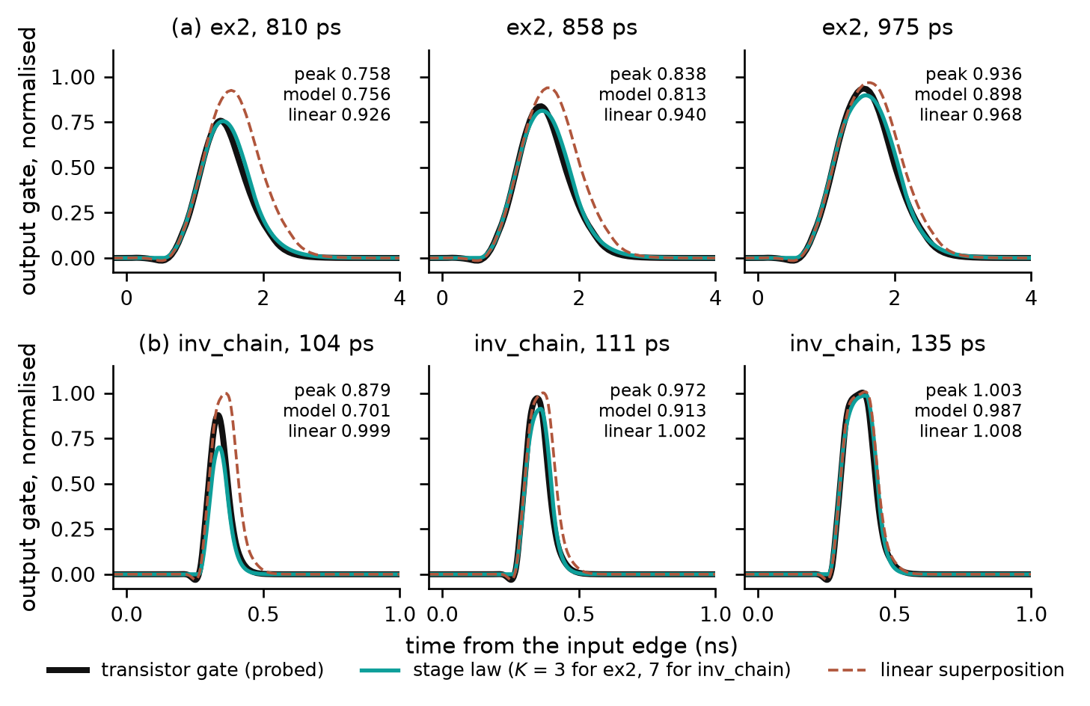
Fig. 9. Stressed gate of the transistor netlist against the stage law fitted at full swing only, and against linear superposition, at the narrowest, middle and widest of the five pulse widths. (a) ex2. (b) inv_chain.
On inv_chain (Table VIII, Fig. 9(b)) the stage law with the netlist stage count follows the measurement at the three widest pulses (within 0.06) and undershoots at the two narrowest, by 0.18 at 104 ps. This is the partial-drive regime in which approximation A2 is active (Section II-M). The other rows show the consequence of the flat residual of Section II-J. The full-swing residuals of $K=7$, 5 and 3 are 0.0032, 0.0037 and 0.0141; with $K=5$ the chain extinguishes 4 of the five stressed pulses and with $K=3$ it extinguishes 5. (Both of those fits end with $v_{t}$ at its upper bound of 0.7, so they are constrained fits, not free ones.) With $K=9$, at the same residual as $K=7$, the pulse passes almost unattenuated. The file supplies the band (27); only the stressed measurement can choose within it.
A control establishes that the nonlinearity captured by (19) is a property of the buffers and not of the fit. On io_buf, for input pulses of 1505–2354 ps, every probed predriver node and the pad follow linear superposition (pad peak 0.373 measured against 0.371 predicted at 1505 ps), whereas the same test fails on the output gate of ex2 (0.758 against 0.926) and at the pad of inv_chain (0.490 against 0.853). This statement covers high-going pulses of those widths; the pull-down path of io_buf under much shorter low-going pulses (163–322 ps) is not linear.

2) Pad level: the complete method on twelve buffers
The complete procedure of Table III was applied to twelve test buffers: ex2, inv_chain and io_buf, and nine variants of the first two. For each buffer the model was built from its IBIS file and from one transistor-level pad waveform at the pulse width giving about 50 % of the settled swing; $C_{comp}$ was taken from the file, reduced where the declared value implied a conducting fraction above unity. The model was then simulated at five pulse widths (about 50 to 90 % of the settled swing) into the same load and compared with transistor-level simulation of the same buffer. The score is the worst peak error over the five widths, with the peak error defined as in (28). The calibration width is one of the five, so the score is not entirely held out. HSPICE's native IBIS element with the same file is given for comparison.
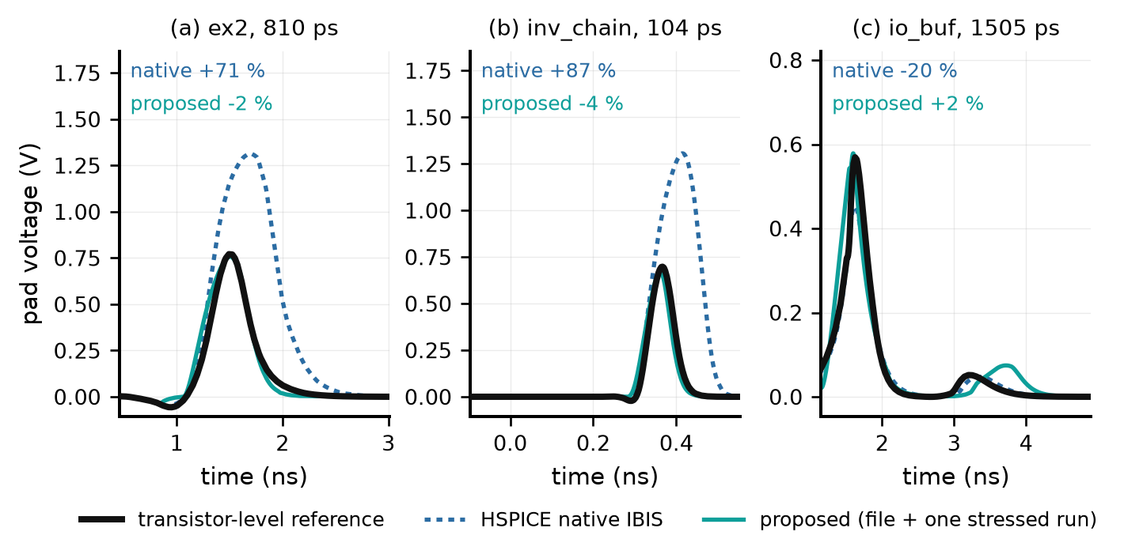
Fig. 10. Pad voltage for the narrowest stressed pulse of three buffers: transistor-level reference, HSPICE native IBIS, and the proposed model built from the IBIS file and one stressed measurement. The percentages are peak errors against the reference. Time is measured from the input edge.
Table IX: Pad-level result on the twelve test buffers (worst of five stressed pulse widths)
Buffer | Netlist $K$ | Selected $K$ | Selected map shape | Proposed: worst peak error (%) | Native IBIS: worst peak error (%)
ex2 | 3 | 3 | (0.5, 0.7) | 8.3 | 70.7
ex2_base | 3 | 3 | (0.5, 0.7) | 7.0 | no valid run
ex2_slowpre | 3 | 3 | (0.5, 0.7) | 5.4 | no valid run
ex2_skewp | 3 | 3 | (0.5, 0.7) | 10.0 | no valid run
ex2_weak | 3 | 3 | (0.5, 0.7) | 8.7 | no valid run
ex2_nomiller | 3 | 3 | (0.5, 0.7) | 7.2 | no valid run
inv_chain | 7 | 6 | (0.4, 0.9) | 5.1 | 87.2
inv_base8 | 7 | 7 | (0.4, 0.6) | 8.4 | 66.8
inv_stage4 | 3 | 3 | (0.4, 0.9) | 3.2 | 99.8
inv_skewp | 7 | 7 | (0.4, 0.6) | 8.1 | 37.3
inv_weak | 7 | 7 | (0.4, 0.6) | 4.1 | 35.8
io_buf | 1 | 1 | (0.5, 0.7) | 7.7 | 20.4

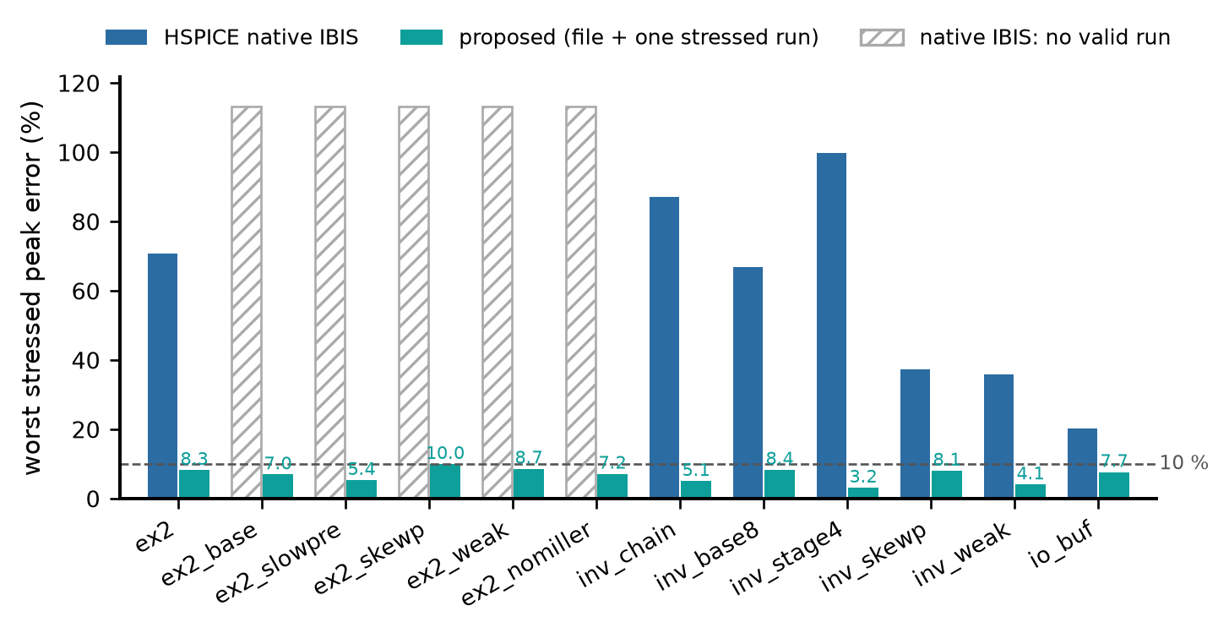
Fig. 11. Worst stressed peak error at the pad for the twelve test buffers.
The proposed model is within 10 % on all twelve buffers (range 3.2–10.0 %, mean 6.9 %). On the seven buffers for which the native IBIS element produced a valid run, its worst peak error is 20–100 %; on the five ex2 variants it did not produce a valid waveform at any pulse width with the simulation settings used, and no number is reported. The selected stage count equals the netlist count on eleven buffers (inv_chain selects 6 against 7).

3) Limits of the evidence
The gate-level test establishes that the structure of (19) extrapolates from full swing to truncated pulses when it is fitted to the true gate; it does not by itself establish the accuracy of the file-only procedure, in which the gate is never observed. That is what the pad-level test addresses, and the two are complementary. Both have a narrow statistical base: the five pulse widths of a buffer sample one stressed trajectory and are strongly correlated, so the evidence rests on the number of buffers. The pad-level test covers single high-going pulses, one load and the typical corner; trains of pulses, low-going pulses (examined so far only on io_buf), other loads and other corners are outside it. The map-shape grid and the band rule (27) were chosen on these same twelve buffers.
One limit is inherited from the device model. Reference [1] states that the α-power law does not reproduce the region near and below threshold, and its delay analysis neglects the opposing device, which is justified for fast inputs [3]. A truncated pulse holds the stages near $v_{t}$ with both devices conducting, which is outside the regime for which [1] validated the model. Equation (19) keeps both devices, but its accuracy there rests on the tests of this section and not on [1].

M. Summary of approximations
Table X: Approximations of the model
Label | Approximation | Introduced at | What it removes | Evidence
A0 | One $V_{TH}$, $α$, $V_{D0}$ for both devices of a stage | (13)–(14) | Per-device parameters | As in [1, Sec. VI]. Table II: the N and P devices differ ($x_{0}$ 0.34 against 0.57 on inv_chain)
A1 | $p$ in place of $α$, with $p=1$​ | (17) | The measured $α$ (Table II) | Not identifiable from the file (Section II-J)
A2 | $x_{0}g^{α/2}→x_{lin}$, with $x_{lin}=0.45$​ | (18) | Drive dependence of the saturation boundary | Not identifiable from the file (Section II-J); candidate cause of the inv_chain undershoot in Table VIII
A3 | $K$ identical normalized stages | (20) | $4(K−1)$ free parameters | Free fit fails (Section II-J); $K$ selected by (29)
A4 | Map shape taken from a grid of three | (22), (26) | Trade-off between gate and map | Selected by (29); grid chosen on the test buffers

Everything else in (19) is inherited from (1) and (2)–(5): the threshold, the constant-current ramp, the straight-line resistive tail and the two-device structure. Equation (24) is the existing converter's and is unchanged.

Table I: Notation
Symbol | Definition | Origin
$u$, $v$​ | Normalized stage input and output, 0 → 1 | (8)
$v_{t}$​ | $V_{TH}/V_{DD}$; in the fitted model, the effective stage threshold | (9)
$x_{0}$​ | $V_{D0}/V_{DD}$, saturation boundary at full drive | (9)
$x_{lin}$​ | Fixed value replacing $x_{0}g^{α/2}$ | (18)
$g(x)$​ | Normalized gate drive with cutoff | (11)
$h(x)$​ | Gate factor, $g^{p}$ | (17)
$r(x)$​ | Drain factor, $min(1,x/x_{lin})$ | (18)
$s_{up}$, $s_{dn}$​ | $I_{D0}/(CV_{DD})$ per device, swings per unit time | (16)
$p$​ | Gate exponent, model counterpart of $α$ | (17)
$K$​ | Number of stages | (20)
$G_{UP}$, $G_{DN}$​ | Normalized gate trajectories of the output pull-up and pull-down devices | (21)
$M$, $(v_{t,map},a,g_{s})$​ | Static gate-to-fraction map and its shape parameters | (22)
$K_{u}$, $K_{d}$​ | Conducting fractions of the output pull-up and pull-down devices | (22), (23)
${\hat{K}}_{u}$​ | $K_{u}$ normalized from its settled off level to its settled on level | (25)
$e(v_{t})$​ | Relative error of the model's pad peak against the measured peak | (28)

References
[1] T. Sakurai and A. R. Newton, “Alpha-power law MOSFET model and its applications to CMOS inverter delay and other formulas,” IEEE J. Solid-State Circuits, vol. 25, no. 2, pp. 584–594, Apr. 1990.
[2] H. Shichman and D. A. Hodges, “Modeling and simulation of insulated-gate field-effect transistor switching circuits,” IEEE J. Solid-State Circuits, vol. SC-3, 1968.
[3] N. Hedenstierna and K. O. Jeppson, “CMOS circuit speed and buffer optimization,” IEEE Trans. Computer-Aided Design, vol. CAD-6, no. 2, pp. 270–280, Mar. 1987.

Remarks for the manuscript
Sources. Every statement in Sections II-F to II-M was checked against the code and result files of the project; the builder script of this document lists the file behind each. Reference [1] was read in full: equations (2)–(5) here are its (2)–(4), the straight-line triode region of (6) is its own, the single-stage response of Fig. 2(c) is its Appendix B, and approximation A0 is its Section VI. Reference [3] is given as it appears in the reference list of [1]. Reference [2] is given as it appears in the bibliography of Leventhal and Green, Semiconductor Modeling (Springer, 2006); its issue and page numbers were not available for checking and are omitted.
Regenerated numbers. Table VIII was regenerated for this document. The earlier committed table had been produced with an explicit-Euler integrator that was later replaced (Section II-G); ex2 (Table VII) is unaffected to the third decimal for $K=3$.
Open points. (1) A drive-dependent boundary (15) in place of A2 reduces the inv_chain undershoot at the gate (mean peak error 0.077 to 0.016) but is neutral on ex2 and cannot be identified in the $K_{u}$ domain, so it has not been adopted; fixing $x_{lin}$ per buffer from a measured $x_{0}$ (Table II) is untested at the pad. (2) The pad-level score includes the calibration width. (3) Pulse trains, low-going pulses and other loads and corners are not covered by Table IX.

