APPLE STOCKS PRICE PREDICTION.

NON-TECHNICAL PRESENTATION.

BUSINESS UNDERSTANDING.

**1.1 Overview**

Britam Asset Managers is a leading asset management firm in Kenya, offering a range of investment solutions, including portfolio management, equity investments, and financial advisory services. As they manage various investment portfolios with the goal of optimizing client returns, they are seeking to enhance their investment strategies by incorporating accurate forecasts of Apple Inc.’s stock prices. By integrating these forecasts into their portfolio management processes, Britam aims to optimize asset allocation, make more informed trading decisions, and provide improved financial advisory services to their clients.

There are, however, several challenges that need to be addressed in this endeavor. Firstly, ensuring the accuracy of the forecasting model is crucial for providing reliable predictions of Apple stock prices. Additionally, the model must be adaptable to varying market conditions and economic events that influence stock prices. To tackle these issues, a time series forecasting model will be developed using historical Apple stock price data from the Alpha Vantage API. This model will provide Britam Asset Managers with valuable insights into future stock prices, thereby facilitating more informed investment decisions and improved portfolio management. The project's success will be evaluated based on the accuracy of its predictions.

In conclusion, by incorporating accurate forecasts of Apple Inc.’s stock prices into Britam Asset Managers' investment strategies represents a significant opportunity for enhancing portfolio management and financial advisory services. By addressing these challenges and focusing on the accuracy of predictions, Britam aims to optimize asset allocation, improve investment decisions, and ultimately enhance client satisfaction.

**Metrics of Success:**

* RMSE
* Accuracy

**1.2 Problem Statement**

Britam Asset Managers requires a reliable time series forecasting model to accurately predict Apple Inc. stock prices. Such a model is essential for enhancing the firm's investment strategies by enabling more precise decision-making, optimizing portfolio performance, and delivering valuable insights to clients. By achieving accurate forecasts, Britam aims to not only improve investment outcomes but also strengthen its competitive edge in the asset management industry, ensuring better alignment with market trends and client expectations.

**1.3 Objectives**

The **MAIN** objective is to develop a Time Series forecasting model to predict Apple stocks prices using historical data.

The specific objectives are:

1. To analyze stock price trends on a weekly, monthly, and yearly basis to identify patterns and seasonal effects that influence Apple stock prices.
2. To investigate how significant events, such as earnings reports, product launches, or macroeconomic changes, affect Apple stock prices and incorporate these insights into the forecasting model.

DATA UNDERSTANDING.

This project analysis uses the Historical stock price data for Apple Inc., which contains information on Apple products and their Stocks and Interest rates.

The dataset is a folder with csv files (apple_stock_and_interest_rates.csv and competition.csv) and excel files(apple_products_2009_to_2024.xslx) from Alpha Vantage API.

The major dataset(apple_stock_and_interest_rates.csv) was created between January 02, 2009 and August 02, 2024.

1. apple_products_2009_to_2024.xslx

Products information is contained in this file. Each line of this file after the header row represents release date entries, and the corresponding apple products.

It contains 26 rows and 2 columns.

1. apple_stock_and_interest_rates.csv

Stocks and Interest Rates information is contained in this file. Each line of this file after the header row represents date entries, and has the following format: 'Open', 'High', 'Low', 'Close', 'Adj Close', 'Volume', 'Interest_Rate'

It contains 3921 rows and 8 columns.

Each column represents:

* Open - the daily opening prices
* High - the daily highest points
* Low - the daily lowest points
* Close - the daily closing prices
* Adj Close - the daily adjusted closing prices
* Volume - the total number of shares traded in daily
* Interest_Rate - the daily interest rates

1. competition.csv

Competitions (other companies) information is contained in this file. Each line of this file after the header row represents release date entries, and the corresponding products from other companies.

It contains 26 rows and 2 columns.

DATA PREPARATION.

For the “apple_stock_and_interest_rates.csv”:

The shape; 3922 rows and 8 columns.

The info; Date has 3922 non-null integers (typically strings).

Open, High, Low, Close, Adj Close, Interest_Rate have 3922 non-null floats.

Volume has 3922 non-null integers.

This dataset contains no duplicates and no missing values.

For each of the datasets, we converted the date columns to index using the function **DateIndexConverter.**

EXPLORATORY DATA ANALYSIS.

We performed EDA (univariate and bivariate analysis) to explore Apple stock price data along with related datasets such as product release dates and competitor events.

1. Univariate analysis

* We plotted Apple Stock Closing Prices over time. Apple’s stock exhibits a long-term upward trend, with significant growth phases after 2018 showing rapid increases in price.
* We plotted Interest Rates over time. Despite fluctuations in interest rates, Apple’s stock price grows consistently, indicating that Apple’s performance is not heavily influenced by interest rates.

1. Bivariate analysis

We plotted:

* A scatter plot of Apple Stock Closing Prices vs. Interest Rates. There is no strong correlation between Apple’s stock price and interest rates, suggesting that other factors, such as product success, drive Apple’s stock performance.
* Apple Stock Closing Prices with Product Release Dates. Apple's stock price consistently trended upward despite frequent product launches, showing that while these releases contribute to success, they do not cause immediate or drastic price changes.
* Apple Stock Closing Prices with Samsung Product Release Dates. Samsung's product releases did not significantly affect Apple's stock, which maintained its upward trend, indicating Apple's resilience to competitor actions.
* Apple Stock Closing Prices with Google Product Release Dates. Google’s product launches had little impact on Apple’s stock, which continued its upward trajectory, demonstrating Apple’s strong, independent market performance.
* Apple Stock Closing Prices with Microsoft Product Release Dates. Microsoft’s product launches did not noticeably affect Apple’s stock, which continued to trend upward.
* Apple Stock Closing Prices with Steve Jobs Retirement Date. Despite Steve Jobs' resignation, Apple's stock continued to rise, reflecting strong investor confidence and smooth leadership transition. Significant growth occurred, particularly after 2018.

MODELLING.

1. **Baseline Model (Random Forest)**

We used Random Forest as a strong baseline model for stock price prediction due to its ensemble approach, ability to handle non-linearity, robustness to noise, and flexibility. It provides a good starting point for comparison with more sophisticated models and helps identify important features influencing stock prices. The initial Random Forest model's performance was suboptimal, as indicated by the low accuracy (48%). To improve performance, we opted to use Random Forest with GridSearchCV to optimize hyper parameters and enhance the model's predictive capabilities.

1. **Random Forest with GridsearchCV**

The Random Forest model with GridSearchCV has not demonstrated an improvement in accuracy compared to the initial model, indicating that the model’s performance is still insufficient for effective stock price prediction. The use of time-based cross-validation was essential to ensure realistic model evaluation, but it also highlights the need for further optimization and exploration of alternative approaches to enhance predictive accuracy.

1. **Facebook Prophet**

Prophet is specifically designed for time series forecasting, making it well-suited for handling temporal data with trends and seasonality. It was developed to handle common time series challenges, including missing data, outliers, and strong seasonal effects. Setting up the model involves defining the target variable (y) as the series we want to forecast and the datetime column (ds) to ensure proper ordering of data. Prophet can model multiple seasonal effects (e.g., daily, weekly, yearly) with flexibility, making it effective for capturing regular patterns in the data. It includes components to model linear or logistic growth trends, which can adapt to changes in the time series over time. The RMSE of 7.496051447151834 indicates that the model's predictions are, on average, about 7.50 units away from the actual values. To potentially improve the model's performance, we will consider adding regressors, which might provide additional relevant information and enhance predictive accuracy.

1. **Facebook Prophet with regressors**

Incorporating regressors into a Facebook Prophet model is essential for enhancing forecast accuracy and capturing the impact of external factors on the target variable. By adding relevant regressors, the model's ability to understand and predict complex patterns in the time series data improves, leading to more reliable and insightful forecasts. The new RMSE of 7.490949400727919 is slightly lower than the previous RMSE of 7.496051447151834. This indicates a small improvement in the model’s performance, as the predictions are now, on average, 7.49 units away from the actual values compared to 7.50 units before. While the improvement is little, it suggests that adding regressors has had a positive effect on the model's accuracy.

1. **LSTM Model**

Long Short-Term Memory (LSTM) networks are a specialized type of Recurrent Neural Network (RNN) designed to capture temporal dependencies in time series data. They are specifically designed to work with sequences of data, making them well-suited for time series forecasting where past values influence future ones. LSTMs can model complex relationships in time series data, including non-linear trends and seasonal patterns, which traditional models might struggle to capture. The LSTM model, which has an RMSE of 2.2216, shows excellent performance in predicting the target variable. This comparatively low RMSE reflects that the model's predictions are quite close to the actual values. Given its superior accuracy, the LSTM stands out as the most effective model in the analysis.

DEPLOYMENT

The Apple Stock Price Prediction model was deployed using Streamlit, a popular open-source Python library for creating custom web applications for machine learning and data science projects. The deployment process involved the following key steps:

**Streamlit Application Development**

1. **User Interface (UI) Design**:
   * **Home Page:**

Introduces the project, explaining its purpose, methodology, and significance to Britam Asset Managers.



* + **Prediction Page:**

Allows users to input a date and select a prediction period (e.g., one day, one week, one month, etc.) to receive predictions for Apple stock prices.

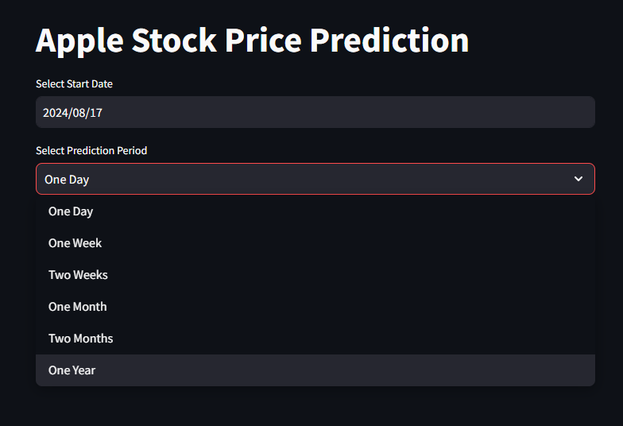

* + **About Page:**

Provides details about the development team.

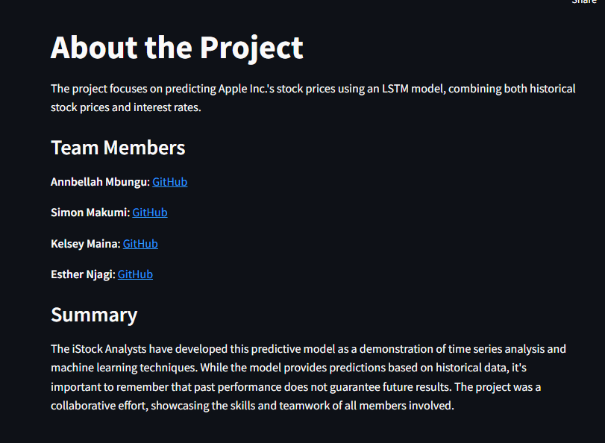

1. **Model Integration**:

* The trained LSTM model was integrated into the Streamlit app. The app loads the pre-trained models to generate real-time predictions based on user inputs.
* For longer prediction periods (more than one week), the app only displays the last predicted value to avoid overwhelming users with excessive data.

1. **Error Handling**:

* The app was designed to handle common issues like incorrect date inputs or missing data gracefully. Users receive informative error messages to guide them in correcting their input.

1. **Performance Optimization**:

* To ensure smooth operation, the app was optimized for fast loading times and efficient memory usage. This involved fine-tuning the model loading process and reducing the size of the deployed model where possible.

1. **Deployment to Streamlit Cloud**:

* The application was deployed on Streamlit Cloud, making it accessible to Britam Asset Managers and everyone else. This platform was chosen for its ease of use, scalability, and seamless integration with Python environments.

CONCLUSION

The Apple Stock Price Prediction project successfully developed a robust time series forecasting model to predict the future prices of Apple Inc.'s stock. The deployment of this model via a Streamlit application enables Britam Asset Managers to incorporate accurate stock price predictions into their investment strategies, optimizing portfolio management and improving financial advisory services.

Key takeaways from this project include:

* **Model Accuracy**: The LSTM model demonstrated superior accuracy with an RMSE of 2.2216, making it the most effective model in the analysis. Its ability to capture temporal dependencies in stock price data led to highly accurate predictions.
* **Incorporating External Factors**: The inclusion of regressors in the Facebook Prophet model slightly improved its performance, highlighting the importance of considering external factors like product launches and competitor actions in stock price forecasting.
* **Practical Application**: The deployed Streamlit app provides an intuitive interface for predicting Apple stock prices, making it a valuable tool for financial analysts and decision-makers at Britam Asset Managers.

RECOMMENDATIONS

Based on the results and experiences from this project, several recommendations can be made:

1. **Model Enhancement**:
   * Continue exploring additional features and external factors that could further improve the model’s predictive accuracy. This may include incorporating sentiment analysis from financial news or social media data, which could provide insights into market sentiment and investor behavior.
2. **Regular Model Updates**:
   * As financial markets are dynamic, it's crucial to regularly update the model with the latest data. Implementing an automated pipeline for model retraining and deployment would ensure that the predictions remain accurate and relevant over time.
3. **Expanding to Other Stocks**:
   * While this project focused on Apple Inc., the methodology and models developed here could be extended to other stocks in Britam Asset Managers’ portfolio. A multi-stock forecasting tool could be developed to provide a comprehensive view of the market.
4. **User Training**:
   * Provide training sessions for the financial analysts at Britam Asset Managers to familiarize them with the Streamlit app and the underlying models. Understanding the strengths and limitations of the predictions will help in making more informed decisions.
5. **Further Research**:
   * Explore alternative deep learning architectures such as Transformer models, which have shown promise in time series forecasting. Comparative studies with the LSTM model could identify potential areas for improvement.

By following these recommendations, Britam Asset Managers can continue to enhance their investment strategies, leveraging cutting-edge machine learning techniques to stay ahead in the competitive financial landscape.