**IT Technology**

**Assignment 2** **VMnets8, network diagram, static IP and traffic monitoring**



Author

Romulus Virgiliu Prundis

[rvpr37603@edu.ucl.dk](mailto:rvpr37603@edu.ucl.dk)

Wednesday 15 September 2021

**Table of Contents**

1 Introduction 1

2 Tasks 1

3 Audience 1

4 Inventory 1

5 Tasks **Error! Bookmark not defined.**

6 CLI commands text style has to be Courier New 2

7 How to install a Xubuntu Linux computer Virtual Machine (VM) in VMWW and setting internet **Error! Bookmark not defined.**

8 Sources 6

9 Conclusion 6

# Introduction

In the next chapters it will be presented this week (37) assignment, documenting how to set up a network with two Linux Xubuntu hosts and internet access in VM ware Workstation (VMWW) using the previous internet configuration VMnet8, we worked on week 36. After that we will present a network diagram. Next we will configurate the ethernet interface on Xubuntu Linux computers. We will intall Wireshark on our Xubuntu for ethernet traffic moanitoring.

# Tasks

1.An introduction.

2. A network diagram with IP addresses. (Layer 3 network diagram.)

3. How to set up VMnet8 in the Virtual Network Editor.

4. How to set static IP addresses on Xubuntu Linux hosts.

5. How to use PING to check connectivity between two hosts

6.What the ping program is.

7. What a networking interface is.

8. How to use Wireshark to monitor traffic between two hosts.

9. How to update and upgrade a Linux OS.

10. What a Linux repository is and how to pull and install software from it.

11. Challenge: What a broadcast ping is and who will reply to it.

12. Conclusion on the learning goals.

# Audience

The main audience for this report is students or self-learners without advanced knowledge about VM (virtual machines) and other OS (operating system) such as Xubuntu and how to set up networks and how to draw network diagrams.. The wide audience can be formed of students, employees or people interested in networks and virtual machines.

# Inventory

In order to proceed to the next step, which is downloading, and installing the VM (virtual machine) the next components and software are required:

A laptop

Internet connection

Software

-Vmware workstation

-An xubuntu (and the following networking software from linux repositories)

-wireshark

-tcpdump

-putty

-net-tools

-brctl

-bridge-utils

-iproute2

-curl

-ufw

# Comands in the terminal emulator

Enter the terminal emulator for updating the Operating system:

sudo update

clear (for cleaning the information in the terminal)

sudo apt upgrde (for upgrading the OS)

Connection-specific DNS Suffix . :

Link-local IPv6 Address . . . . . : fe80::38bb:b001:a201:656f%15

sudo apt install wireshark (for installing the networking software form linux repositories)

sudo wireshark (for opening wireshark)

sudo apt install tcpdump (for installing the network software from linux repositories and so on for the others).

Ctrl +c (to stop the tcpdump from running)

Sudo apy install putty (same procedure for installing the next networking software)

# VMnets8, network diagram, static IP and traffic monitoring

After the opened our Xubuntu on our VM we enter the terminal emunator and we follow the steps explained in the previous chapter in order to upgrade the OS and to install the networking software.

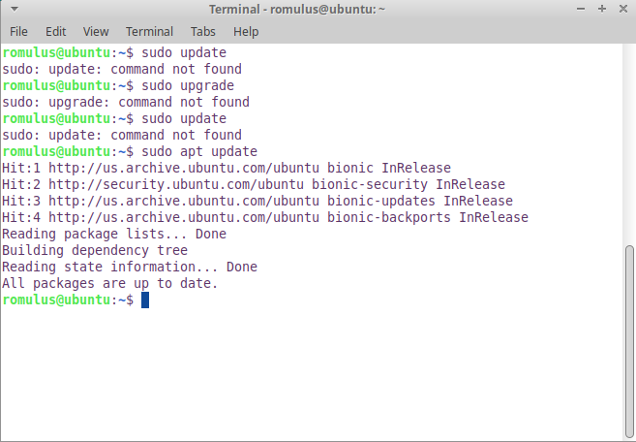

Picture 1 –Xubuntu upgrade from the terminal

As we can see in the Picture 1, the Xubuntu have been successfully updated. Also in the Picture 2, we can see that wireshark has been successfully installed as we can pin Google’s IP address. To enter wireshark we enter the terminal and press sudo wireshark and enter the ens33.

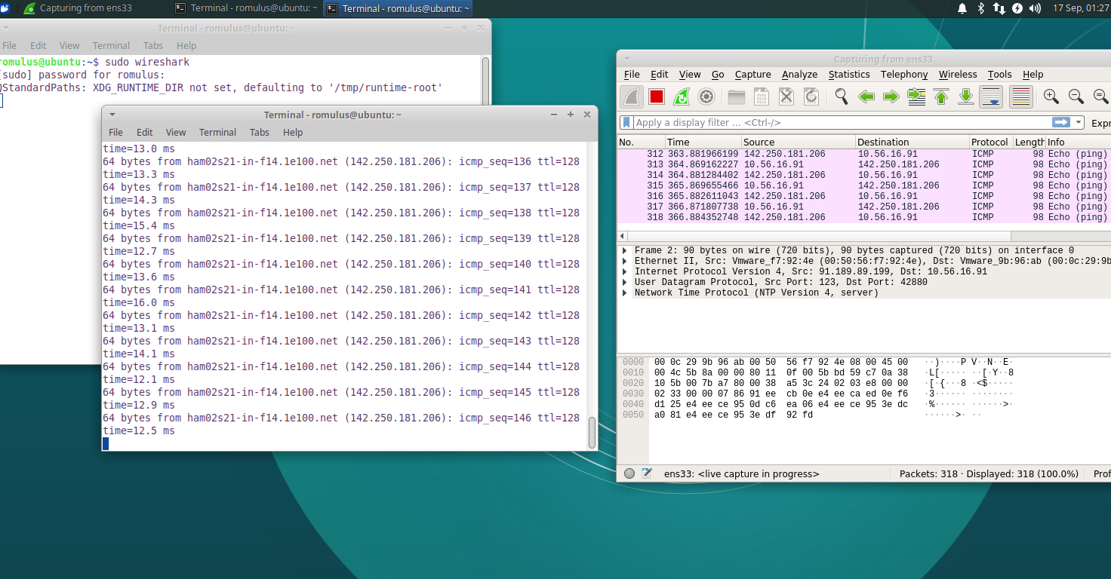

Picture 2 – testing wireshark by trying to pin the Google IP.

To test if the tcpdump was successfully installed e open a new terminal and press sudo tcpdump and we soould be able to see the ens33 interface as in the picture 3 below.

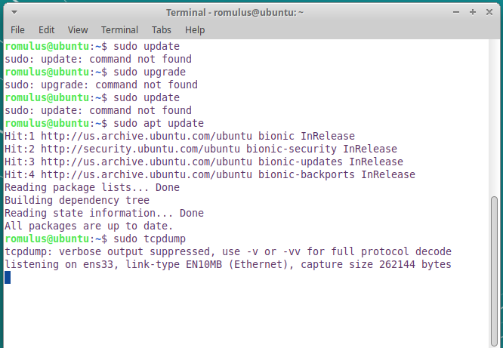

Picture 3 – testing tcdump installation

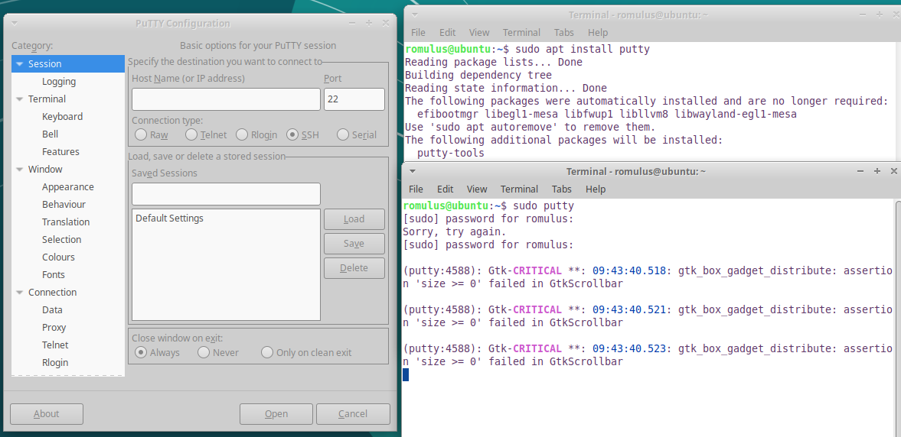

Picture 4 – installing and testing putty

For installing and testing putty we follow the steps in picture 4, the same one from picture 3.

Following the same instructions in the terminal we will install the remaining networking software from Linux: net-tools, brctl, bridge-utils, iproute2, curl, ufw.

In the picture 5 we can see how we can copy our virtual machine. W turn of our Xubuntu base machine.

After we look under the Favourites bar on the left of the screen, left clicking on our name Xubuntu machine (Xubuntu_base) -> Manage -> and we press Clone. After we should see the “welcome to the Clone virtul Mahcine Wizard” icon and we press NEXT and we chose to clone from “The current state in the virtual machine”. After pressing NEXT we chose to create a full clone, and the next step will be to select where to install it. After we installed it we should see our cloned Xubuntu machine, if it is not under favourites search it using the name you gave it.

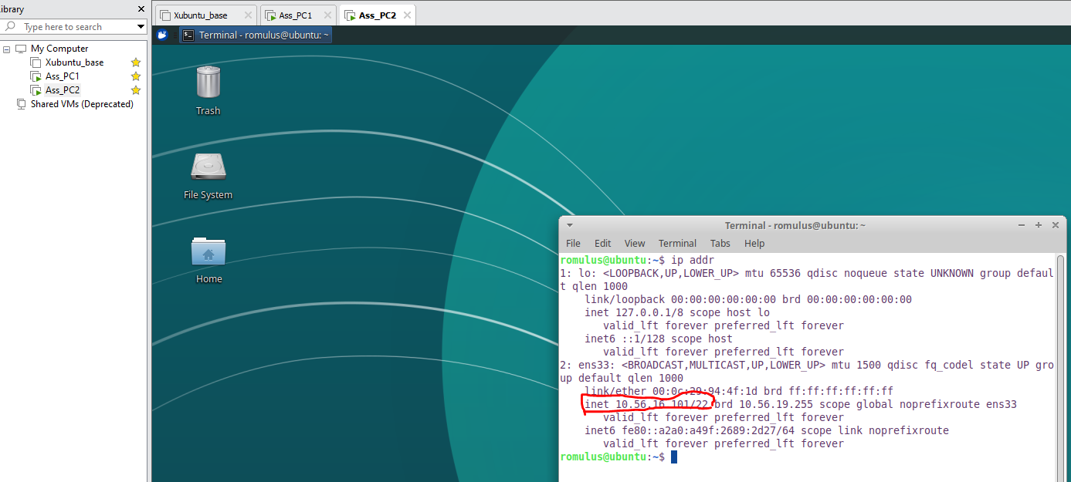

Picture 5 – cloned VM and connecting the VMnet static 8

After we have cloned the two Xubuntu into Ass_PC1 and Ass PC2 we need to configurate the internet. First we need to eneable the internet. We press the internet sign in the top bar on the left, and we press Edit connections and we chose the pluss sign under the Ethernet. The connection name can be a symbolic one, and the Method needs to be switched to Manual the Adress is the one from the cloud connection we created and the numbers for the two Xubuntu.101 and 100.To check if it worked we open the terminal as in picture 5 and picture 6.

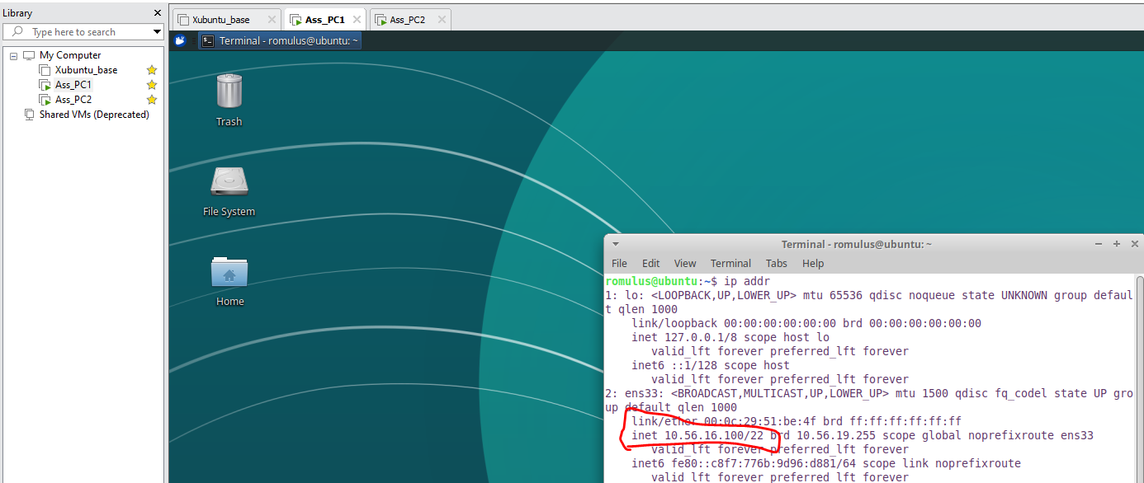

Picture 6 – Second cloned VM connected to the internet

In order to check if the connection between the two cloned VM is functional we enter the terminal and press ping 10.56.16.101 -c 5 just like in picture 7.

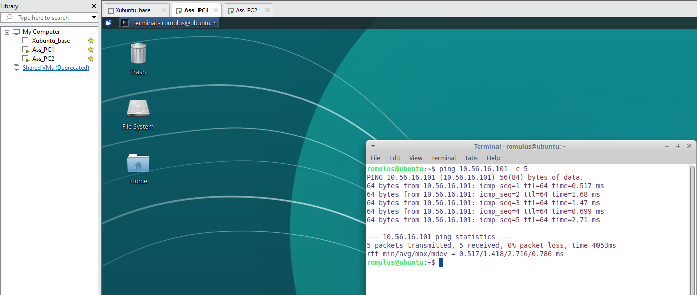

Picture 7 – the two VM clones connected

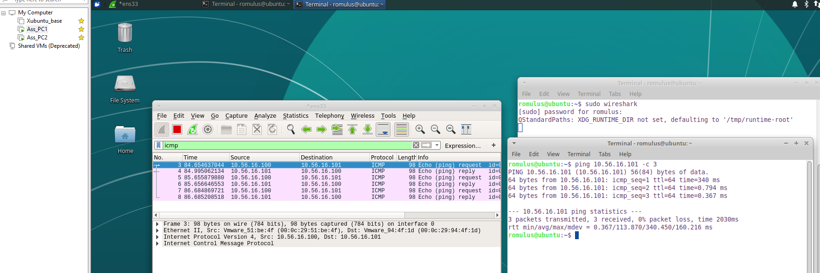

Picture 8 – testing connectivity by pinning the traffic between the two Vm clones

For pinning the two Vm, we use the command and sudo wireshark in the terminal, and enter ens33 For testing connectivity we will search in the display filter: icmp (underlay protocop used by the pin protocop) just like in picture 8. We open a new terminal to generate some traffic, we write the pin of the Ass_pc2 and we should see 3 pin requests and 3 replies, depending the number written in the terminal.

# Sources

The sources are from the software VM and the two cloned Xubuntu OS:

*VM workstation software*

Xubuntu software

QXWHJ-NFDRH-W7BMG-HTC3G-YG9Y7

# Conclusion

If you manage so far, you have successfully installed two VM by cloning from the original one and you ping them to a VMnet 8 internet.