**IT Technology**

**Assignment 3 - VMware Workstation and VM installation**



Author

Romulus Virgiliu Prundis

[rvpr37603@edu.ucl.dk](mailto:rvpr37603@edu.ucl.dk)

Wednesday 08 September 2021

**Table of Contents**

1 Introduction 1

2 Tasks 1

3 Audience 1

4 Inventory 1

5 Tasks 1

6 CLI commands text style has to be Courier New 2

7 How to install a Xubuntu Linux computer Virtual Machine (VM) in VMWW and setting internet 2

8 Sources 10

9 Conclusion 10

# Introduction

In the next chapters it will be presented this week (36) assignment, documenting how to install Vmware work station (Virtual Machine Work station) and the OS Ubuntu. In the new OS (Operating system) it will be presented also how to install it and set up the internet connection.

# Tasks

1. Draw a network diagram with IP addresses and MAC addresses listed. Please note that as MAC addresses will only be learned later in this assignment, these will have to be added to the drawing when they have been learned.

2. Install a Raspberry Pi Buster Operating system on a Virtual Machine VM in VMWW. Connect it to VMnet8 set to NAT to give the Raspberry Pi Buster VM internet access.

3. Name the VM in VMWW: Raspberry_Buster_Base.

4. Install the networking software:

o Before installing software on Linux do:

▪ update (sudo apt update)

▪ upgrade (sudo apt upgrade)

Install networking software from Linux repositories:

▪ wireshark (Ethernet capturing and monitoring GUI software.)

▪ tcpdump (app to capture live TCP/IP packets on a network interface)

▪ putty (Terminal program.)

▪ net-tools arp, hostname, ifconfig, netstat, route).

▪ bridge-utils (Utility to create and manage bridge devices.)

▪ iproute2 (ip commands like: ip route)

▪ curl (curl is a command line tool to transfer data to or from a server.)

▪ ufw (Uncomplicated Firewall is a program for managing a netfilter firewall)

Install nmcli Network Manager and uninstall dhcpcd on the the Raspberry_Buster_Base.

6. Clone the Raspberry_Buster_Base to create PC1 and PC2 and configure PC1 and PC2 with static IPs as shown in the illustration above.

7. Use ping to verify connectivity between network devices PC1 and PC2. Run Wireshark on PC1. Ping PC2 and the router in turn. Use the filter icmp as Wireshark Display filter. Find the source and destination IP addresses in the request packets and find the corresponding source and destination MAC addresses. Find the source and destination IP addresses in the reply packets and find the corresponding source and destination MAC addresses.

8. Compare the IP and MAC addresses found in Wireshark with the IP and MAC addresses found by the command **$ ip addr**

Note that “inet” means IPV4 in the output from the ip addr command.

9. Draw up manually he ARP table from the findings in the items above. The ARP table maps IP addresses to MAC addresses, i.e. ARP resolves IPs to MAC addresses on a networking device. Here on the Raspberry Pi as a networking device.

10. Use the ip neigh Linux command to inspect the ARP table on the Linux box PC1 and then on PC2. I.e. use the command:

Comment on the output from these commands compared to the “hand written“ ARP table

$ ip neigh

or the old command:

$ arp

# Audience

The main audience for this report is people without advanced knowledge about installing VM (virtual machines) and another OS (operating system) such as Ubuntu inside the VM. The wide audience can be formed of students, employees or people that have to install another OS on their computer.

# Inventory

In order to proceed to the next step, which is downloading, and installing the VM (virtual machine) the next components and software are required:

Vmware workstation

A laptop

Internet connection

An xubuntu-20.04.3-desktop-amd64.iso

# Tasks

• Install VM Ware Workstation (VMWW) on a Lap Top host computer.

• Install a Xubuntu Linux Virtual Machine (VM) in VMWW.

• Connect the Linux VM to VMnet8 in VMWW.

o VMnet8 will share the Lab Top hosts internet connection which means that the Linux VM should now have internet access via VMnet8.

• Run the default internet browser on Xubuntu to verify that this Xubuntu

# CLI commands text style has to be Courier New

Text copy pasted from CLI´s I.e. Command Line Interfaces, has to be formatted as bold Courier New font size 10. Smaller font sizes can be defended if the text has long lines and the structure is more important that the legibility.

The style is predefined in this document as “CLI” alongside the standard styles “Heading 1” and so on.

Ethernet adapter Ethernet:

Connection-specific DNS Suffix . :

Link-local IPv6 Address . . . . . : fe80::38bb:b001:a201:656f%15

# How to install a Xubuntu Linux computer Virtual Machine (VM) in VMWW and setting internet

The first step is downloading the Virtual Machine (VM), which can be found on VMware.com [website](https://www.vmware.com/products/workstation-pro/workstation-pro-evaluation.html) as seen in picture number 1. Depending on your operating system (OS) download the Workstation 16 Pro for Windows or Linux.

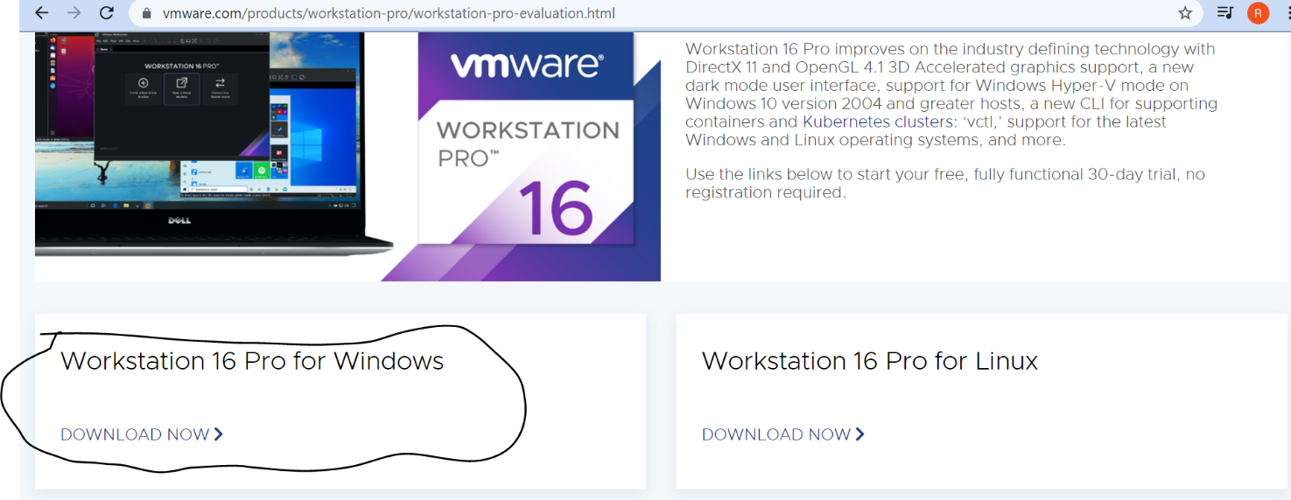

*Picture 1; Source(vmware.com/products/workstation-pro)*

After the download is complete, we can double click on the file and start installing the Vmware Workstation following the classical steps as seen in picture 2 and 3, setting up the wizard, selecting the directory, etc.

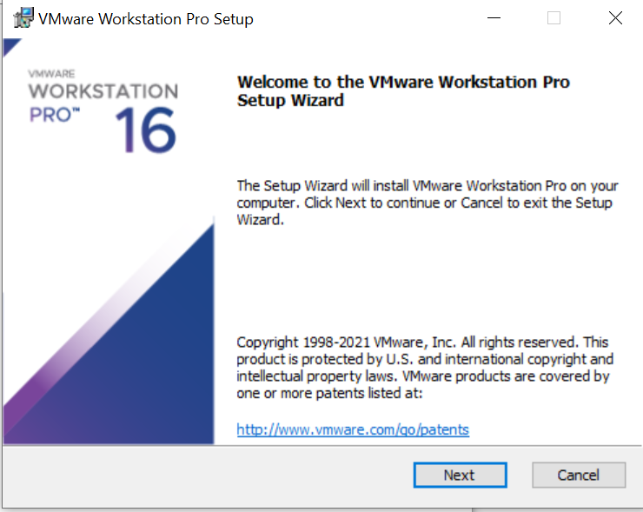

*Picture 2; Source (VM workstation software)*

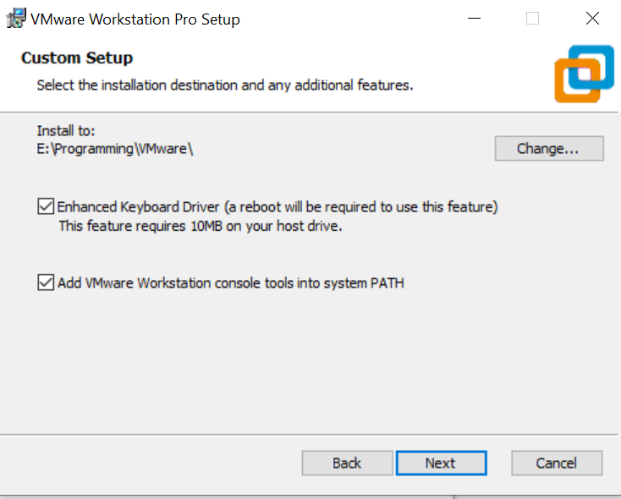

*Picture 3; Source (VM workstation software)*

After we have installed the VM Workstation we can proceed with installing Ubuntu. By downloading it from the website [Xubuntu.org](https://xubuntu.org/download) and selecting the xubuntu 20,04.3 the iso version as seen in the picture 4 below.

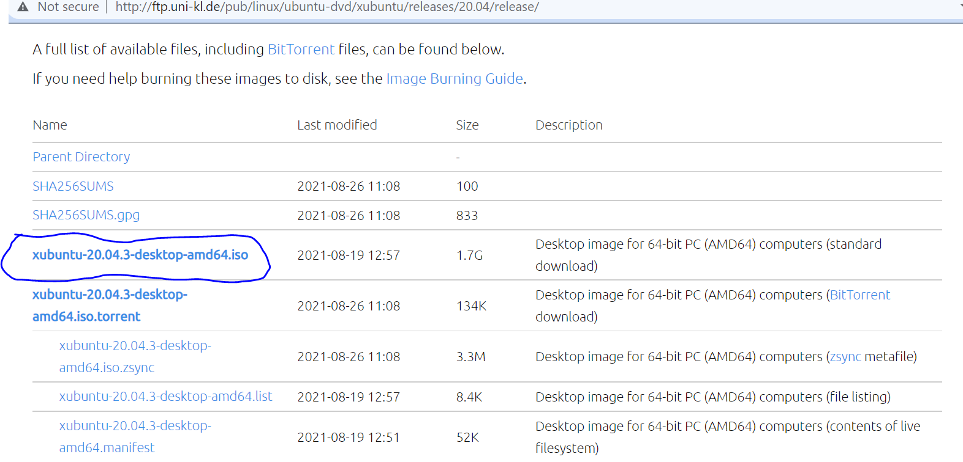

Picture 4, Source( <https://xubuntu.org/download>)

After we have downloaded the xubuntu we need to upload it in the VM by inserting the image (iso). Clicking in the upper part File -> new virtual machine-> it is recommended to use the *Typical* configuration, but if we want to make specific changes such as the disk type, we select *Custom.* After pressing next we need to chose the directory where we have the iso with the Xubuntu.

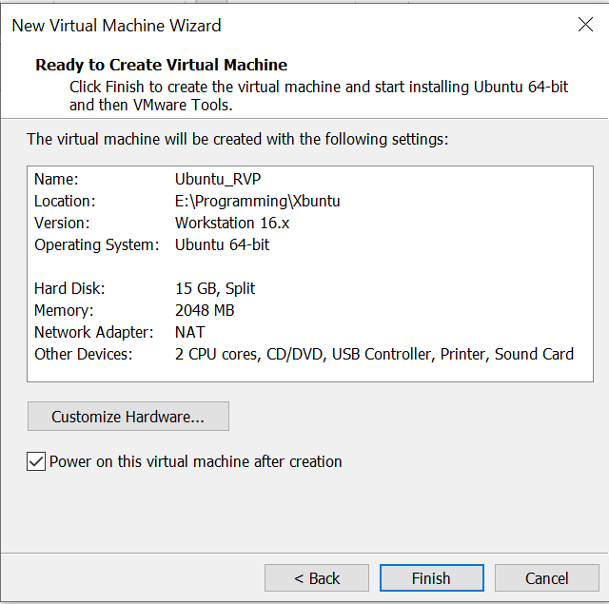

*Picture 6*

IT will take a couple of minutes to have it installed. After we have successfully installed it we open it by pressing the play button (green one) as seen in the picture 7.

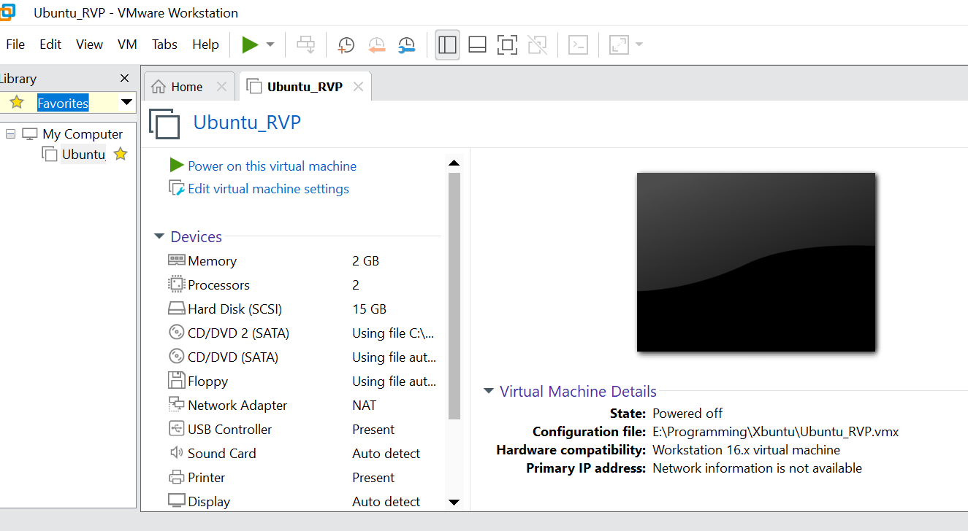

*Picture 7; Source (VM software)*

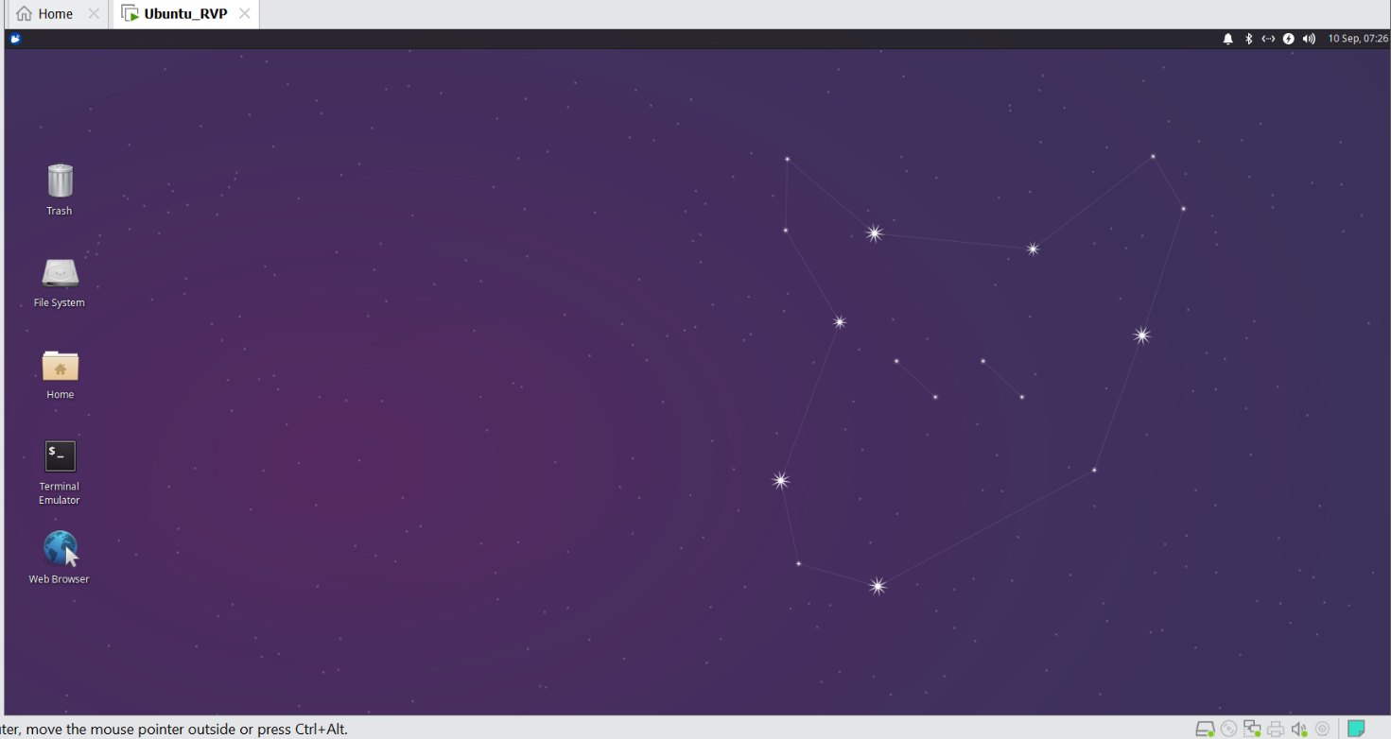

Picture 8 (own source)

As seen in the picture 8, we were successfully and we should have the same desktop image after installing Ubuntu. Also, as python is included in the Ubuntu OS, we have it already installed as we can see in picture 9.

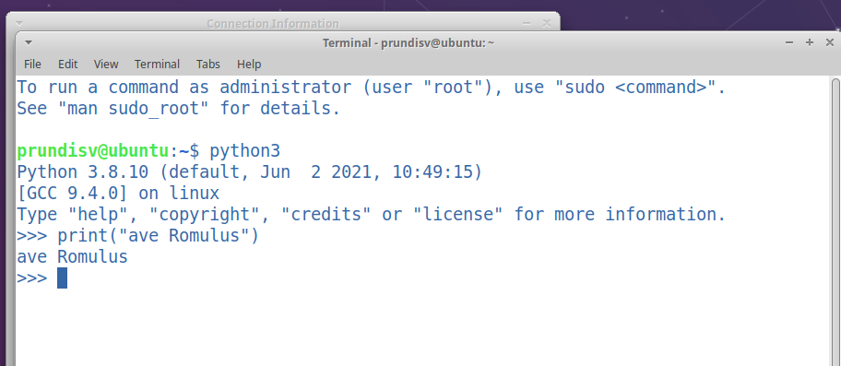

Picture 9 (Own source from python)

Now that our new OS is working there is only one problem, we don’t have internet. We need to set it.

First we need check if the Subuntu base machine is connected VMnet8. We left click our Ubuntu machine => enter Settings => and we search for Network adaptor and we modify in the left to Custom Specific virtual Network and we select VMnet8 (NAT) and we press OK. As in picture 12 we can see where our Ubuntu is connected now.

After we enter at the top bar and press in the Eddit => Virtual Network Editor

We need to set the name number in the settings as in picture 10 or 12 in the Subnet IP and mask.

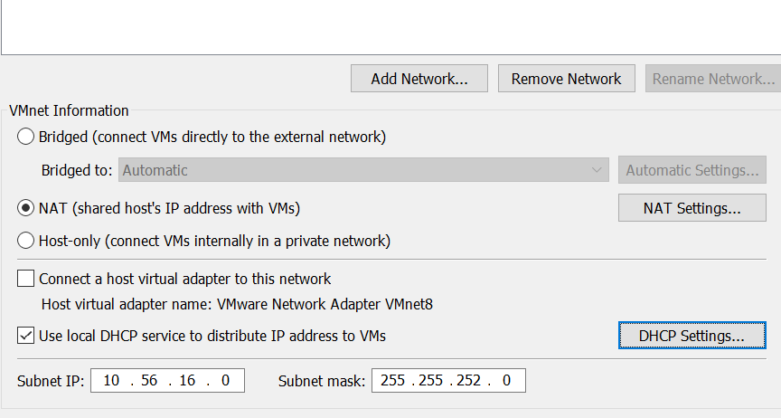

Picture 10

After we set the NAT settings copying the same number and after we click apply. Now we should have configured VMnat 8 to have internet access. After we just need to close and turn on our internet connection and we can test if we can internet.

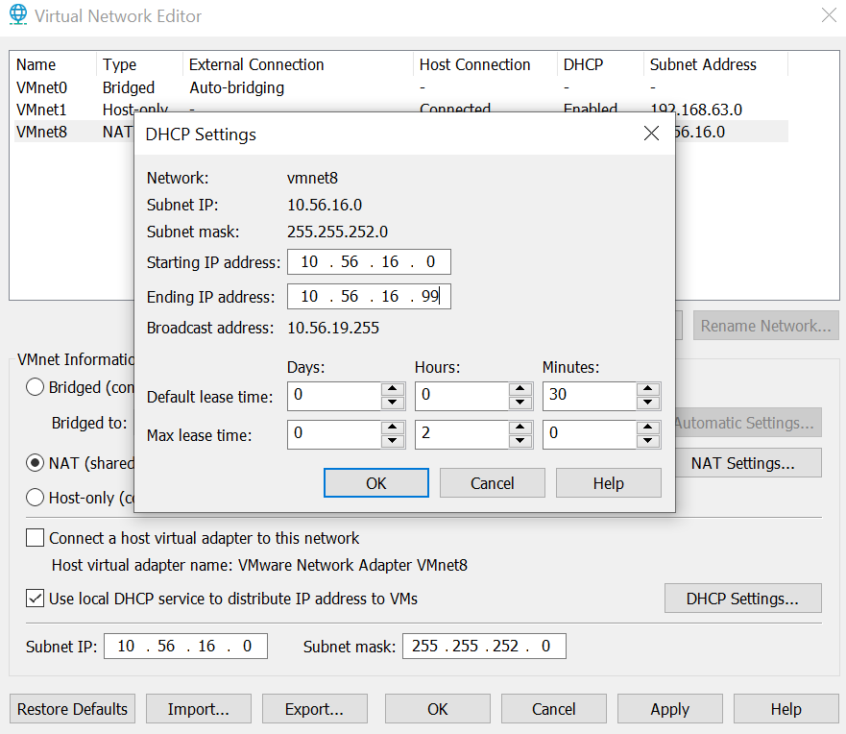

Picture 11

To understand how to VM is connected to the internet we need to follow the picture underneath that describes how our VM is connected to the internet (Wifi).

Picture 12 (Per source)

We have to set the internet in the Ubuntu to the VMnet8.VMnet8 = gives as access to the laptop network interface. VMnet8 is the Ubuntu – where our ubuntu internet interface is connected to.

As we can see in picture 13, we have internet access.

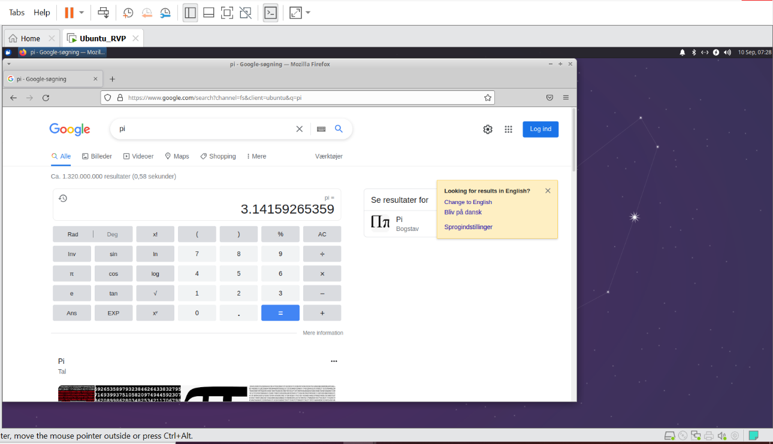

Picture 13

# Sources

The sources are from the software and webpages we used to install the VM and the new OS:

*vmware.com/products/workstation-pro*

<https://xubuntu.org/download>

*VM workstation software*

# Conclusion