**IT Technology**

**Assignment 16 - Linux routing table. Default gateway DGW or just Gateway GW.**



Author

Romulus Virgiliu Prundis

[rvpr37603@edu.ucl.dk](mailto:rvpr37603@edu.ucl.dk)

Wednesday 29 September 2021

**Table of Contents**

1 Introduction 1

2 Tasks 1

*2.1.1* *-Draw the network diagram and configure the PCs* 1

*2.1.2* *- Verify the Linux routing table configuration.* 1

*2.1.3* *-Change the DGW address on PC1 and PC2 to be different from the R1 IP address.* 1

*2.1.4* *- Change i.e. correct the R1 IP address to the DGW address set on PC1 dn PC2* 1

*2.1.5* *- Delete the DGW on PC1 and PC2* 1

*2.1.6* *- Reestablish manually the DGWs on PC1 and PC2* 1

*2.1.7* *- Misconfigure the routing table on PC1* 1

*2.1.8* *- Ping program outputs* 1

**3. Solution** 1

**2. Draw the network diagram and configure the PCs** 1

**Verify the Linux routing table configuration.** 4

**3. Change the DGW address on PC1 and PC2 to be different from the R1 IP address.** 5

**Change i.e. correct the R1 IP address to the DGW address set on PC1 dn PC2** 8

**Misconfigure the routing table on PC1** 10

**8. Ping program outputs** 12

3 Audience 12

4 Inventory 13

5 Installing a Raspberry Pi Buster Operating system on a Virtual Machine VM in VMWW and connecting it to the internet VMnet8. 14

6 Sources 15

7 Conclusion 15

# Introduction

In the next chapters it will be presented this week (39) assignment, documenting how to set the internet connection between two virtual machines one on Xubuntu and one on Raspberry Pi using the VNnet8. This assignment is using the VM Ware Workstation VMWW hardware and network virtualisation management tool.

# Tasks

### -Draw the network diagram and configure the PCs

### - Verify the Linux routing table configuration.

### -Change the DGW address on PC1 and PC2 to be different from the R1 IP address.

### - Change i.e. correct the R1 IP address to the DGW address set on PC1 dn PC2

### - Delete the DGW on PC1 and PC2

### - Reestablish manually the DGWs on PC1 and PC2

### - Misconfigure the routing table on PC1

### - Ping program outputs

**3. Solution**

**2. Draw the network diagram and configure the PCs**

* Draw the network design or network diagram.
* Configure the PCs network interfaces settings according to the network diagram.

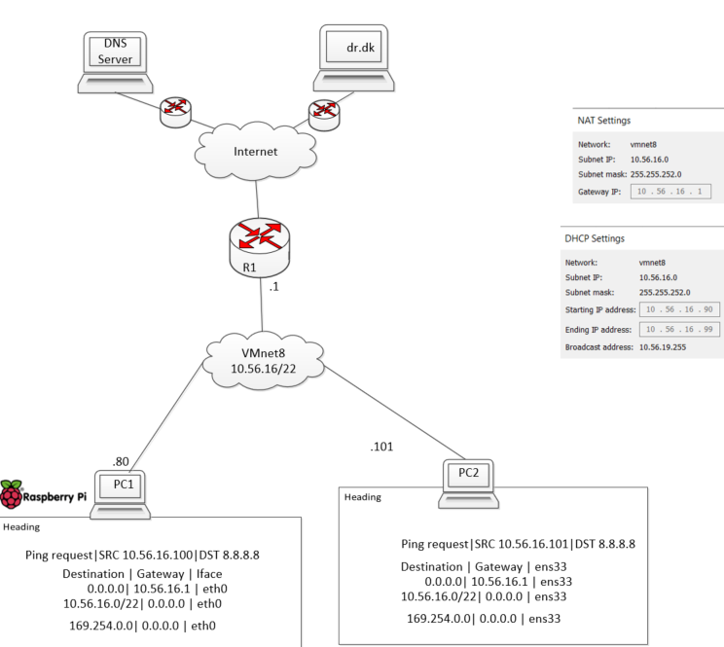

Figure 1 - Network diagram

In the figure 1 is presented the network diagram between to virtual machines Raspberry Pi and Xubuntu OS. For configurating according to the diagram, we enter settings, preferances and advanced network configuration. We need to follow picture 1 and add the configuration from the diagram. For Xubuntu OS we need to follow the same instruction just from picture 2, and don’t forget the internet settings can find found in the upper toolbar, the two arrow in opposition, and select Edit connection.

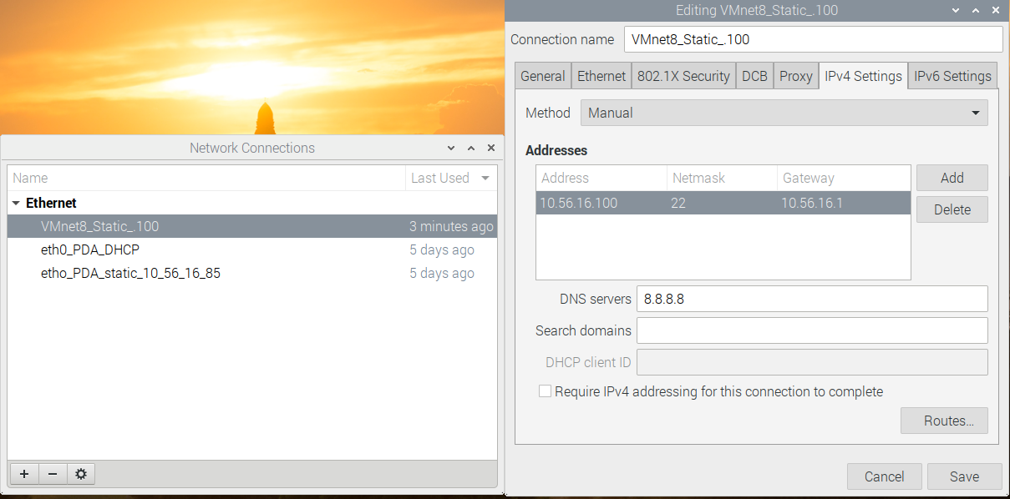

Picture 1 – Setting the internet connection on the Raspberry Pi

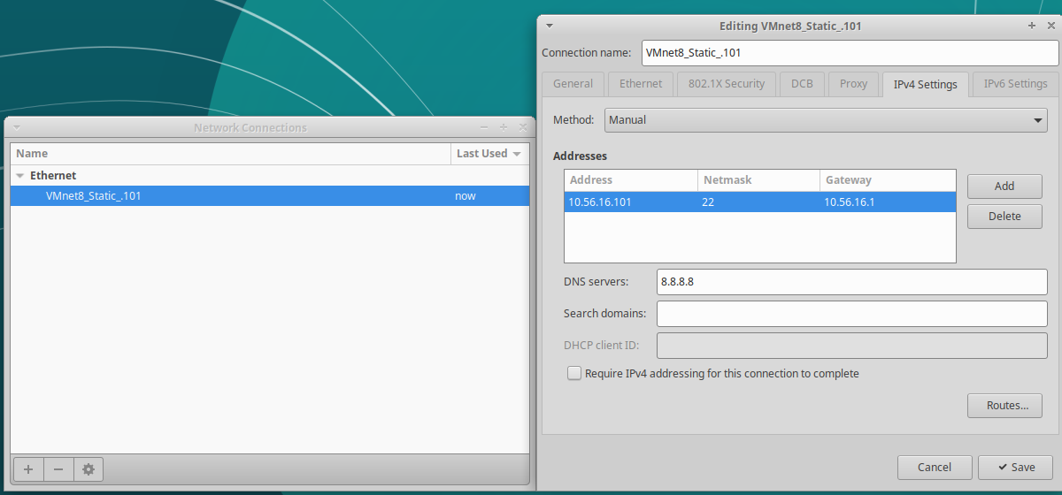

Picture 2 – Setting the internet connection on the Xubuntu

As we can see in Picture 3 we were able to ping the PC2 from PC1 (Raspberry). Seeing the receiver IP address (.101).

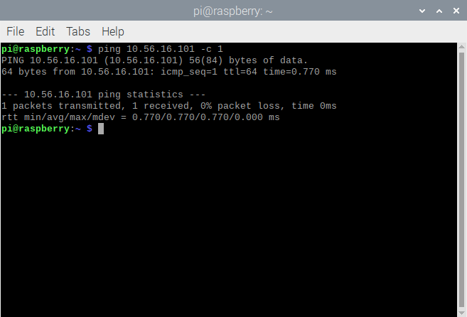

Picture 3 – Ping form Raspberry vm(pc1) to Xubuntu vm(pc2)

**Verify the Linux routing table configuration.**

* List the routing table on PC1 and PC2 and compare to the design.  
  Explain: What is the Default Gateway DGW in the table?

The default configurate address is 10.56.16.1 address on router .1, from picture 1/ diagram.

* + What is the route to the directly connected network?

The route to the directly connected internet is R1 (router) and then the internet.

* + Any other route listed in the table.

Yes, the 169.254.0.0

* Verify that the routing table works:
  + Ping e,g, 8.8.8.8. Explain if it works.

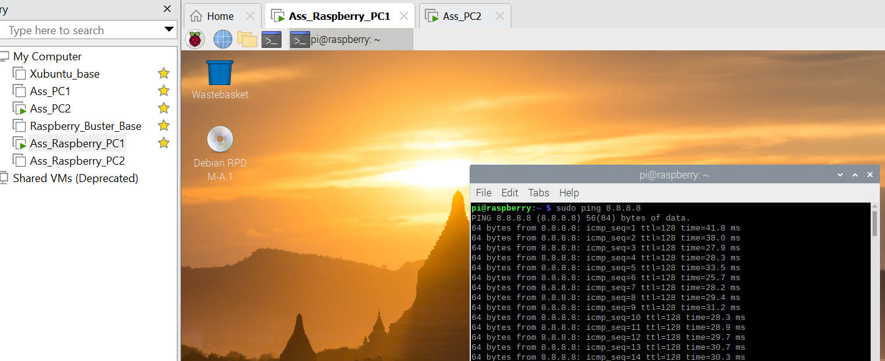

Picture 4 – Pinning 8.8.8.8

When we settled the ethernet setting for VNnet8 on the Raspberry PC1 we chose the DNS servers 8.8.8.8 (like in picture 4). It means that it works and direct match between the destination 0.0.0.0 as no other direct match in the destination column in the Picture 1.

**3. Change the DGW address on PC1 and PC2 to be different from the R1 IP address.**

* On both PCs configure the DGWs to a new IP address that is not 10.56.16.1. It has to be the same address i.e. DGW on both PCs. The address has to be between 2 and 254 and should not be between 90 and 99.
* Draw a new network diagram to match this error prone network.

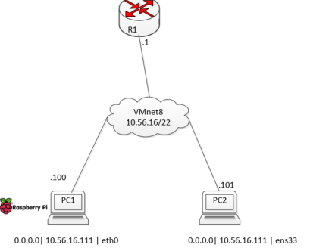

Figure 2 – The error diagram with the wrong DGW

The new default gateway (DGW) is 10.56.16.111 as we can see in figure 2 and picture 5.

* List the routing tables and compare to the design.  
  Explain:
  + What is the R1 address, in the network diagram?

The default gateway is on router one. That now is not matching with the new gateway we selected (.111), like in picture 4. We can look now how the routing table looks like in Picture 5(pc1) and 6(pc2). By inserting the commands:

ip route

route

route -n

(in this order).

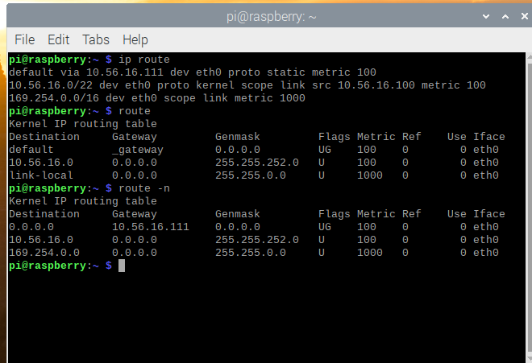

Picture 5 - new default gateway route on pc1

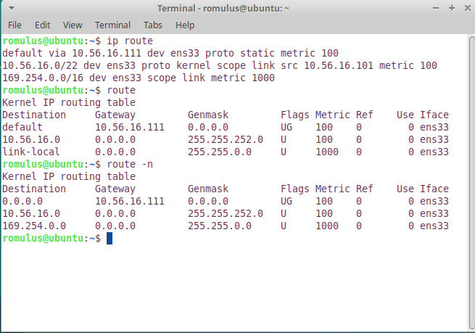

Picture 6 – new default gateway route on pc2

* + What is the Default Gateway in the table on PC1 and PC2?

In PC1 we have 10.56.16.111 and for PC2 we have 10.56.16.111 as we can see in picture 5 and 6. Although, it needs to be the same with the router.

* + Is this a problem?

We will not be able to sync with the router which has .1if our default gateway ends with .100

* + Does a wrong gateway prevent PC1 and PC2 from pinging each other?
    - Why/Why not?

The R1 is the one establishing a connection between the two PC’s, without it they can’t pin, communicate with each other.

As we can see in picture 7 and 8 we can’t ping from both PC1 and PC2 to send a pin request to 8.8..8 a routing process will take place, the IP package will not be able to get to the default gateway as the router R1 (.1) has a different address.

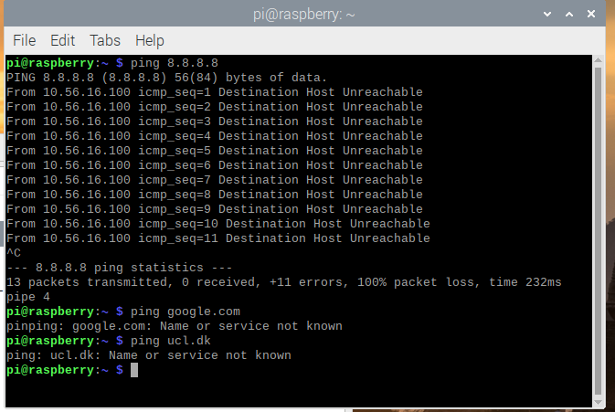Picture 7 – Ping 8.8.8.8 from pc1

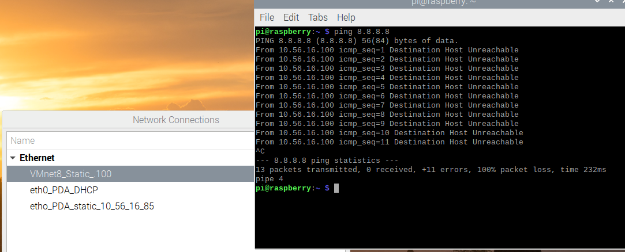

Picture 8 – Ping 8.8.8.8 form pc2

* + - Show what the output from the ping program says and explain what it means.
      * Output example for PC1:  
        From 10.56.16.100 icmp_seq=1 Destination Host Unreachable
  + Run Wireshark with Display Filter icmp
    - Why does Wireshark not show any ping/icmp ip packets when pinging to the internet , e.g. ping 8.8.8.8?
    - List the PC1s ARP or MAC table. $ ip neigh
    - Why is the Gateway entry ... dev eth0 INCOMPLETE?

**Change i.e. correct the R1 IP address to the DGW address set on PC1 dn PC2**

* Change the router R1 IP address in VMWW Virtual Network Editor NAT settings for VMNet8 to the address set as the DGW the PC1 dn PC2 above. In Virtual Network Editor the R1 address is called: Gateway IP:

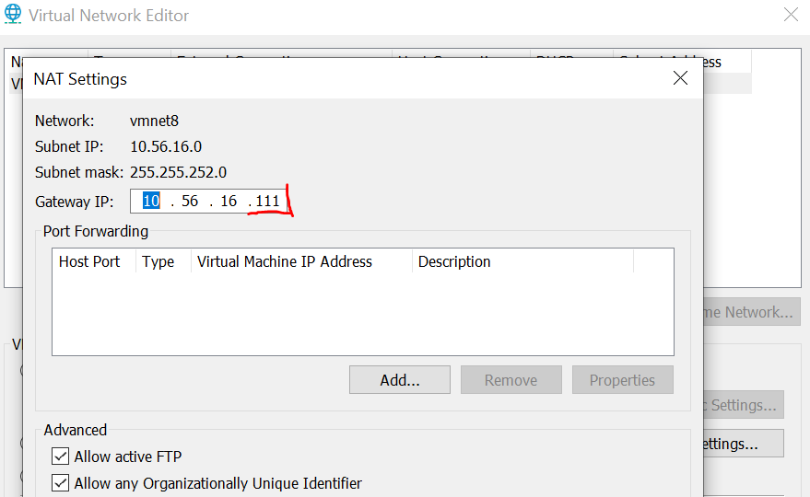

Picture 9 – Changing the NAT setting with the PC1 and PC2 default gateway.

* Draw or correct the network design or diagram accordingly by correcting the R1 IP address.
* Explain/show:

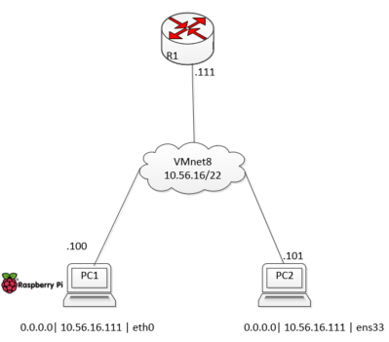

Figure 3 – The new network diagram with the R1(router) with the same address as the PC1 AND PC2 dafualt fateway.

* + What is the R1 address, in the network diagram?

The new R1 address is .111

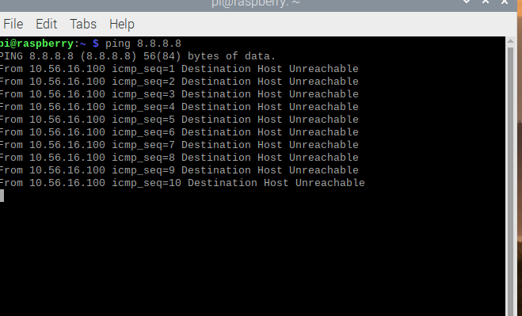

Picture 10 – R1 and DGA changes

As we can see in the picture 10, we can’t ping 8.8.8.8 even though now we have the same R1 (router address) with the efault gateway on PC1 and PC2.

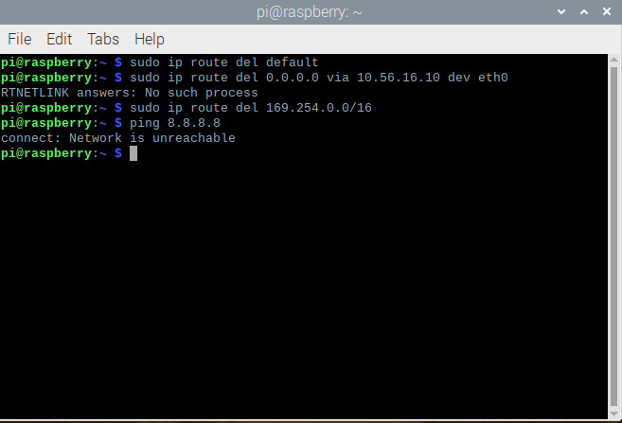

Picture 11 – more changes

As we can see we can’t ping 8.8.8.8 as the virtual network editor is not working, since we changed to the default gateway address on pc1 and 2pi

**Misconfigure the routing table on PC1**

Misconfigure the routing table on PC1 by deleting the route to the 10.56.16.0/22 network and flushing the ARP table:

* $ sudo ip route del 10.56.16.0/22
* $ sudo ip -s -s neigh flush all

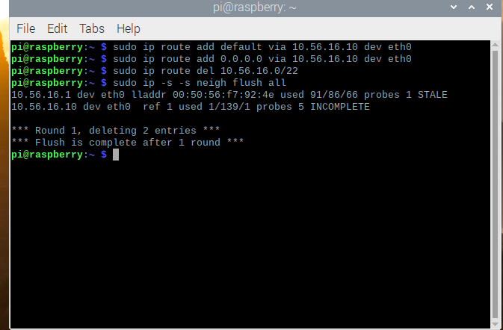

Picture 12 - Misconfigure the routing table on PC1

* Does ping to an address on a network on the internet work?  
  * Why/Why not? Ping e.g. 8.8.8.8.  
  * Show what the output from the ping program says and explain what it means.

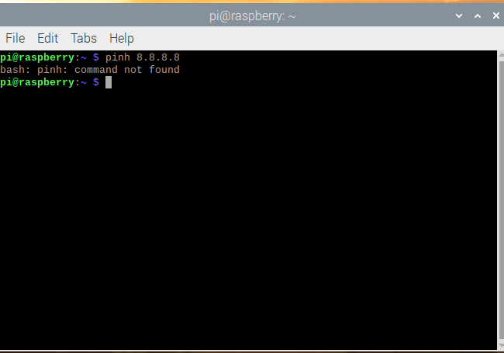

Picture 13 – Ping 8.8.8.8 after we deleted the ARP

Without the ARP table and the route destination Xubuntu can’t find the command as the network table is empty.

* Does ping to PC2 work?
* 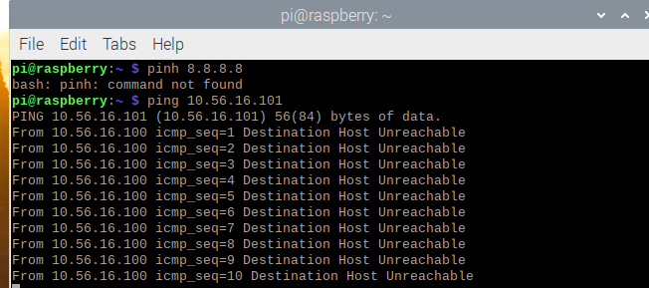

Picture 13 – ping PC2

By ping 10.56.16.101 which is pc2, without the address pc1 can’t connect, like in picture 13.

**8. Ping program outputs**

* From the above "experiments", compile a debugging list that in oneliners explains what misconfiguration(s) will generate the folowing icmp or ping messages:
  + Destination Host Unreachable (Misconfigure the routing table, different address between default gateway and R1 (router))
  + connect: Network is unreachable (When the computer can’t pin an address, either because of our network connection, network setting, default gateway)
* Go online and investigate how these outputs from the ping program occur:
  + No route to host {Will be a reply from a router firewall.}

Check that the server that you’re trying to connect to is even online. We may be trying to connect on the incorrect port. Iptables Is Blocking the Connection. The DNS is not configured properly

Check that the server that you’re trying to connect to is even online.

* + Request Timed Out

problem is with your ssh configuration

# Audience

The main audience for this report is people without advanced knowledge about installing VM (virtual machines) and another OS (operating system) such as Ubuntu inside the VM. The wide audience can be formed of students, employees or people that have to install another OS on their computer.

# Inventory

In order to proceed to the next step, which is downloading, and installing the VM (virtual machine) the next components and software are required:

Vmware workstation

A laptop

Internet connection

An xubuntu-20.04.3-desktop-amd64.iso

Raspberry Pi Buster Operating system

Visio (Microsoft)

# Installing a Raspberry Pi Buster Operating system on a Virtual Machine VM in VMWW and connecting it to the internet VMnet8.

First we need to download the Raspberry Pi Linux Debian OS from their website (just like in the picture below): [https://www.raspberrypi.org/software/operating-systems/#raspberry-pi-os-32-bit](https://www.raspberrypi.org/software/operating-systems/%23raspberry-pi-os-32-bit)

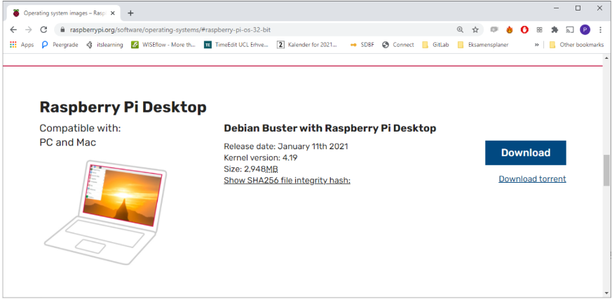

After we have downloaded and saved on our computer the iso image of the Raspberry Pi OS we open the VMware we select it and run it.

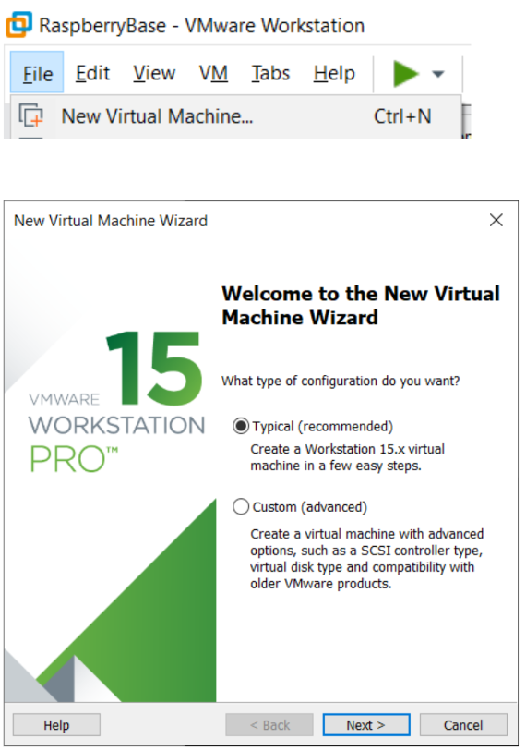

The rest of the instructions are usual, with the file directory, , maximum disk size it is advised for 10 GB.

For setting up the internet we right click on Raspberry_Buster_Base and click on Settings and we select Netowrk Adapter.

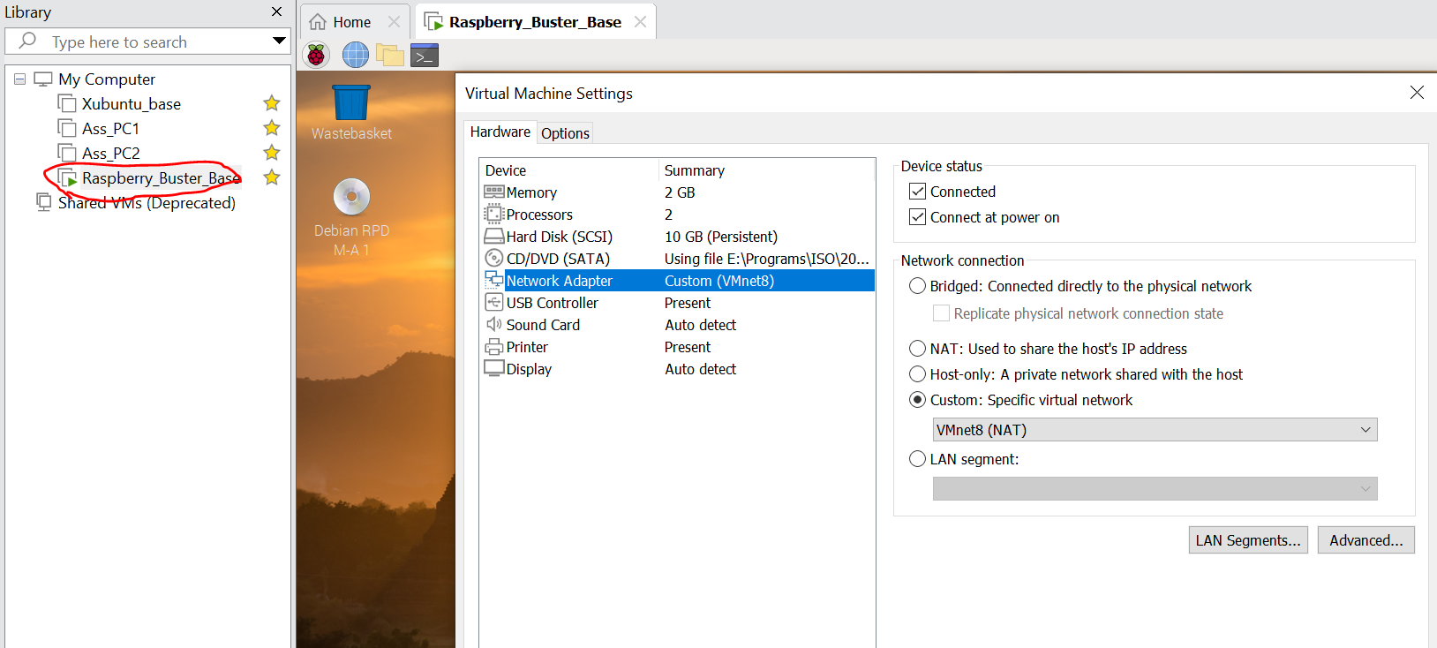

And we make sure we have the VMnet8 settings just like in the picture below.

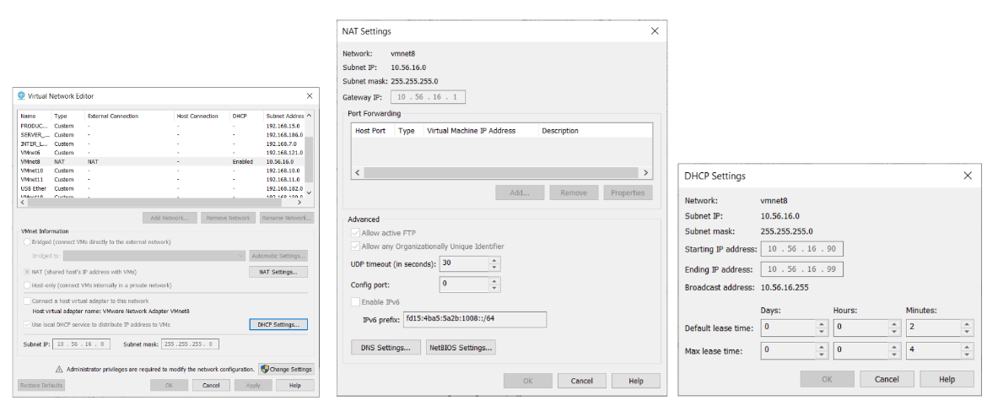

# Sources

The sources are from the software and webpages we used to install the VM and the new OS:

*vmware.com/products/workstation-pro*

<https://xubuntu.org/download>

*VM workstation software*

# Conclusion