**IT Technology**

**Networking**

**Assignment 3**



**Author**

Simon Slamka

Class 212

sisl37451@edu.ucl.dk

8 Sept. 2021

Table of Contents

2 Introduction 1

3 Audience 1

4 Definitions 1

5 Inventory 1

5.1 Software: 1

6 Tasks 1

7 Answers 2

7.1 Download & install 2

7.2 Add a guest system 2

7.3 Configure networking in a guest system 4

7.4 Boot the guest system and test network connection 4

7.5 What next? 5

8 Conclusion 5

# Introduction

This assignment documents how to install a hypervisor and then run a GNU/Linux distribution within. In the case of this hand-in, *Debian* is used as a distribution and *Parallels* is used as a hypervisor. Parallels has the same basic capabilities as VMWare Workstation.

*Note: the steps described in this document are applicable to all guest systems installed through Parallels.*

# Audience

This report is intended for individuals interested in virtualization and/or networking basics running macOS. It is an ideal entry point for students without any experience with virtualization and/or networking.

# Definitions

The term “*hypervisor*” means a program that can create and operate virtual operating systems within an already running operating system, also called the *host* operating system.

Operating systems run by a hypervisor are called *guests* or *guest machines*.

In general, all systems running under a hypervisor are called *virtual machines*, or *VMs*.

A hypervisor usually dedicates a portion of the host’s resources for the virtual machines to use. For storage, a virtual hard drive of fixed size is usually created for the virtual machine. The hard drive can also be of a dynamic size, resizing based on the guest system’s needs on the fly.

*Parallels*, *VMWare*, and *VirtualBox* are all hypervisors.

# Inventory

## Software:

* Parallels Desktop 17
* Debian GNU/Linux aarch64 on kernel 4.19

# Tasks

1. Install *Parallels* on a host computer.
2. Install a *Debian Linux* Virtual Machine (VM) in *Parallels*.
3. Connect the Linux VM to the “*Shared Network*” network
4. *Shared Network* will share the host’s internet connection, which means that the Linux VM should now have internet access via *Shared Network*.
5. Run the default internet browser on Debian to verify that the guest system really is Debian (run “**uname -a**” in *Terminal* to find this information).

# Answers

## Download & install

To install *Parallels* for *macOS*, navigate to the [download page](https://www.parallels.com/products/desktop/download/)[1] and press the download button.

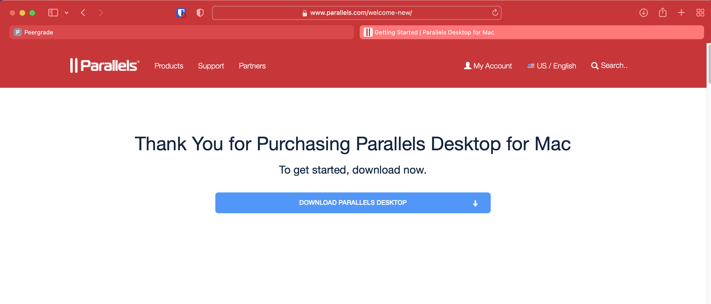

Figure 1 - the official download page of Parallels for macOS

As soon as the download is complete, open the *.dmg* file. *Parallels* will then install automatically.

## Add a guest system

To install a guest system to Parallels, open it up and click the “+” button, as shown.

Figure 2 - the main interface of Parallels

After pressing the “+” button, a window with a choice of *GNU/Linux* distros will appear. Select “*Debian GNU/Linux*” and click continue.

Figure 3 - a selection of GNU distros to choose from. You can also choose your own image

On the next screen, *Parallels* will display basic details about *Debian* and prompt you to download its image. Click *Download* to begin. After the process is finished, you will be ready to launch your new *GNU/Linux* guest.

Figure 4 - the information screen about the distro selected and a prompt to download its image

## Configure networking in a guest system

To configure networking in *Parallels*, head to the *Configure* window of your VM by right-clicking on it and click on *Hardware* within the newly opened window.



Figure 5 - the network config menu in Parallels settings - the Shared Network mode will be selected by default

By default, the *Shared Network* mode will already be selected – this is all you need to connect to the Internet, which means that the machine can now be launched.

## Boot the guest system and test network connection

The machine can now be booted. After logging in, we will automatically be connected to the host’s network.

Figure 6 - the ping command pinging a remote location successfully, proving that we're connected to the Internet

Figure 7 - firefox-esr successfully opening DuckDuckGo, further proving that we're indeed online

## What next?

We have now proven that we’re online. From here, we can move on to updating the system using sudo apt update && sudo apt upgrade -y and installing the packages we need.

# Conclusion

We have successfully installed the *Parallels* hypervisor on macOS, installed *GNU/Linux Debian* to it as a virtual machine, made sure that the virtual machine is configured to use the network connection of our host (*Shared Network*), and proven that we’re online by pinging a remote location and opening a live site in a browser.



1. <https://www.parallels.com/products/desktop/download/>