**IT Technology**

**Networking**



Author

Per Dahlstrøm

[pda@eal.dk](mailto:pfl@eal.dk)

Friday 13 March 2022

**Table of Contents**

1 Introduction 1

2 Technical document writing style recommendation 2

3 Sources 3

4 Foot Notes 4

5 Conclusion 5

6 Landscape page 6

# Introduction

This assignment documents how to install a hypervisor and then run a GNU/Linux distribution within. In the case of this hand-in, *Debian* is used as a distribution and *Parallels* is used as a hypervisor. As far as I know, Parallels has more or less the same basic capabilities as VMWare Workstation.

# Audience

This report is intended for individuals interested in virtualization and/or networking basics running macOS. It is an ideal entry point for students without any experience with virtualization and/or networking.

# Inventory

Software:

* Parallels Desktop 17
* Debian GNU/Linux aarch64 on kernel 4.19

# Tasks

1. Install *Parallels* on a host computer.
2. Install a *Debian Linux* Virtual Machine (VM) in *Parallels*.
3. Connect the Linux VM to “*Shared Network*” network
4. *Shared Network* will share the host’s internet connection, which means that the Linux VM should now have internet access via *Shared Network*.
5. Run the default internet browser on Debian to verify that the guest system really is Debian (run “**uname -a**” in *Terminal* to find this information).

# Answers

1. To install *Parallels* for *macOS*, navigate to <https://www.parallels.com/welcome-new/> and press the download button.

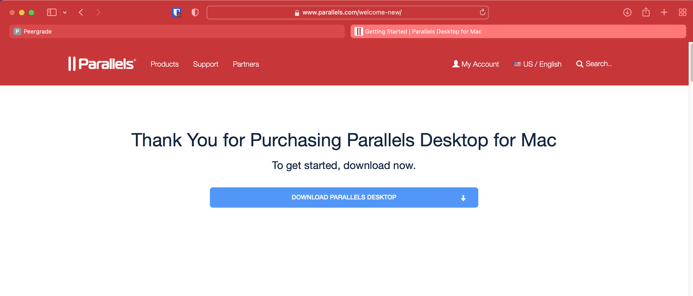

Figure 1 - the official download page of Parallels for macOS

As soon as the download is complete, open the *.dmg* file. *Parallels* will then install automatically.

1. To install a guest system to Parallels, open it up and click on the + button, as shown.

Figure - the main interface of Parallels

# Sources

Remember that sources must be set as foot notes where they are relevant. See the last chapter in this document, which explains how to insert foot notes.[1]

It is not allowed to copy text into any student document for hand in, without explicitly stating that it is a citation and what the source is.

# Foot Notes

A section on how to insert foot notes in your document. [2]

Note that all links must be clickable and placed in footnotes.

1. Place the cursor where the footnote mark should be located
2. In the Word REFERENCES tab menu, click Insert Footnote.

The footnote mark will appear at the selected location. Word will take you to the footnote section at the bottom of the page.

1. Enter or paste the footnote text. Add formatting if desired.

Footnotes can be added in any order. Word automatically updates the numbering.

# Conclusion

Reports must have a conclusion that matches the introduction. I.e. the conclusion will describe to what extend the descriptions in the introduction have been treated in practice and in the report and what the development stage and success has been.

# Landscape page

A section break can be inserted to e.g. make the next sections pages in landscape orientation. This is useful to e.g. show program source code without having long lines accidentally auto wrapped by Word.

In order to remove this page. First, make it Portrait Orientation and then delete it including the section separator.

To see page separators and section separators and new line and so on, click the paragraph symbol ¶ in the HOME tab menu.



1. Place a relevant link to the used source here.
2. <http://wordprocessing.about.com/od/wordprocessingsoftware/a/footnotes.htm>