**IT Technology**

**Networking**

**Assignment 3**



Author

Simon Christiansen

Ssch38571@edu.ucl.dk

Wednesday September 8, 2021

**Table of Contents**

1 Introduction 2

2 Audience 2

3 Inventory 2

4 Definitions 2

5 Tasks 2

6 Installation 3

6.1 Installing VMWare Workstation 16 PRO 3

6.2 Installing Xubuntu in VMware 4

7 Conclusion 8

# Introduction

This report covers how to download and install VMWare Workstation 16 PRO, installing Xubuntu and setting up internet connecting.

# Audience

This report is intended for individuals that is new to VMWare Workstation 16 PRO and have a need for installing Xubuntu and setting up an internet connection through VMWare.

# Inventory

1. VMWare Workstation 16 PRO capable computer with WIN10. Go to VMWare website[1] for minimum requirements.
2. Working internet connection

# Definitions

VMWare Workstation 19 PRO is a *hypervisor* installed on the *host* system. The hypervisor enables the opportunity to create virtual machines, and on these install and control other operation systems. These systems are known as *guest* operation systems. Typically, the hypervisor dedicates a pre-defined amount of the host systems resources to each virtual machine.

# Tasks

1. Install VM Ware Workstation (VMWW) on a Lap Top host computer.
2. Install a Xubuntu Linux Virtual Machine (VM) in VMWW.
3. Connect the Linux VM to VMnet8 in VMWW.

* VMnet8 will share the Lab Top hosts internet connection which means that the Linux VM should now have internet access via VMnet8.

1. Run the default internet browser on Xubuntu to verify that this Xubuntu

# Installation

## Installing VMWare Workstation 16 PRO

Go to the VMWare Workstation website to download VMWare Workstation 16 PRO.[2]

Click “Download Now” for you appropriate operating system.

When VMWare is downloaded, click the file to install and then click “Yes” to allow installation to continue.

Click “Next” to continue.

Check the “Accept” box and “Next” to continue.

Click the “Next” button without editing anything, and then “Install” button to start installation.

Click “Finish” to complete the last steps in the installation.

VMWare Workstation 16 PRO is now successfully installed.

Open VMWare Workstation 16 PRO for final step.

Click “I want to try VMWare Workstation 16 for 30 days”, to continue to open VMWare Workstation 16 PRO until a license can be acquired. Once VMWare Workstation 16 PRO has started, the start screen of the program will be shown. *(Figure 1)*

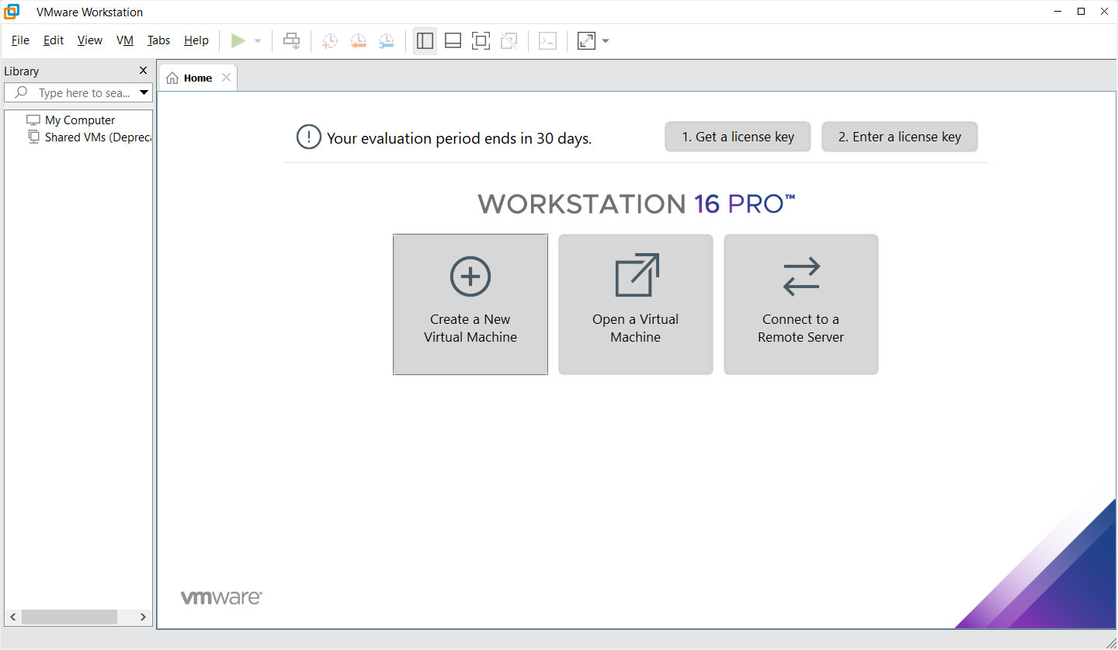

Figure

## Installing Xubuntu in VMware

Download Xubuntu from a trusted website.[3]

Once downloaded, open VMWare Workstation and click the “Create a New Virtual Machine” button. *(Figure 2)*



Figure 2

In the wizard tick the box “Install disk Image file (iso):”, and then the “Browse…” button. Navigate to the newly downloaded Xubuntu iso file and click the “Next >” button. *(Figure 3)*

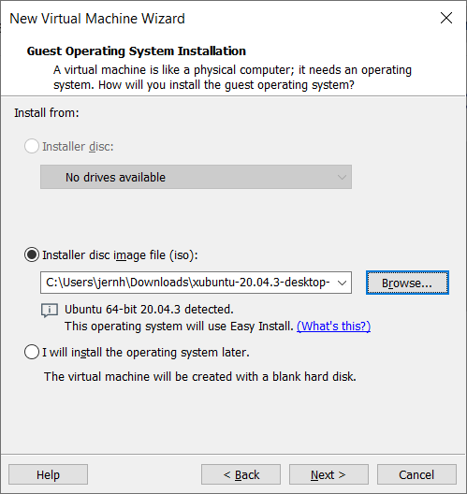

Figure

Fill in the desired information and then click “Next >”. *(Figure 4)*

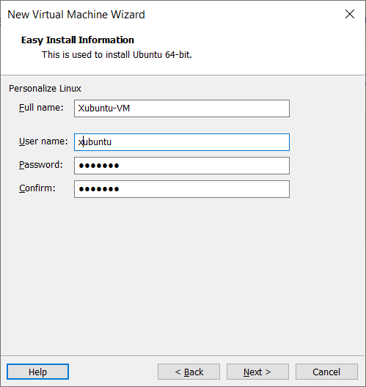

Figure 4

Enter the desired name and location of the Virtual Machine and click “Next >”. *(Figure 5)*

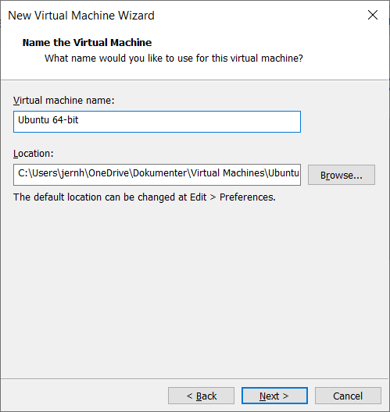

Figure 5

Enter the desired amount of maximum disk size and click “Next >”. *(Figure 6)*

For this installation 15GB of space is sufficient.

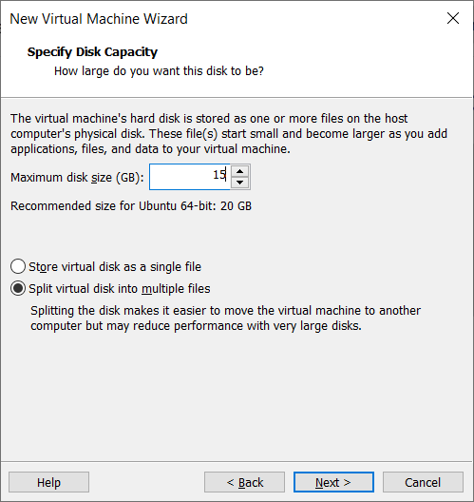

Figure 6

Check the applied settings and click “Finish” to start the Xubuntu installation. *(Figure 7)*

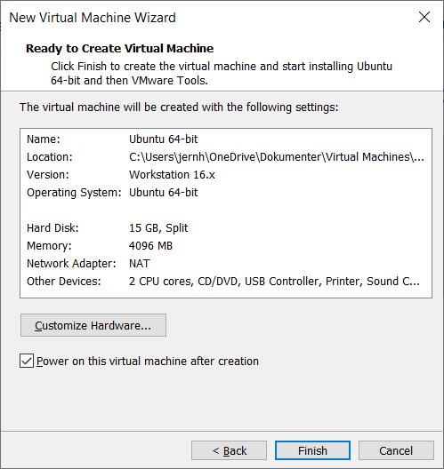

Figure 7

Once installation is finished, you can login to the newly created virtual machine and start setting up the internet connection.

Here it is shown that VMWare is set up for VMnet8 and the connection is working. *(Figure 8)*

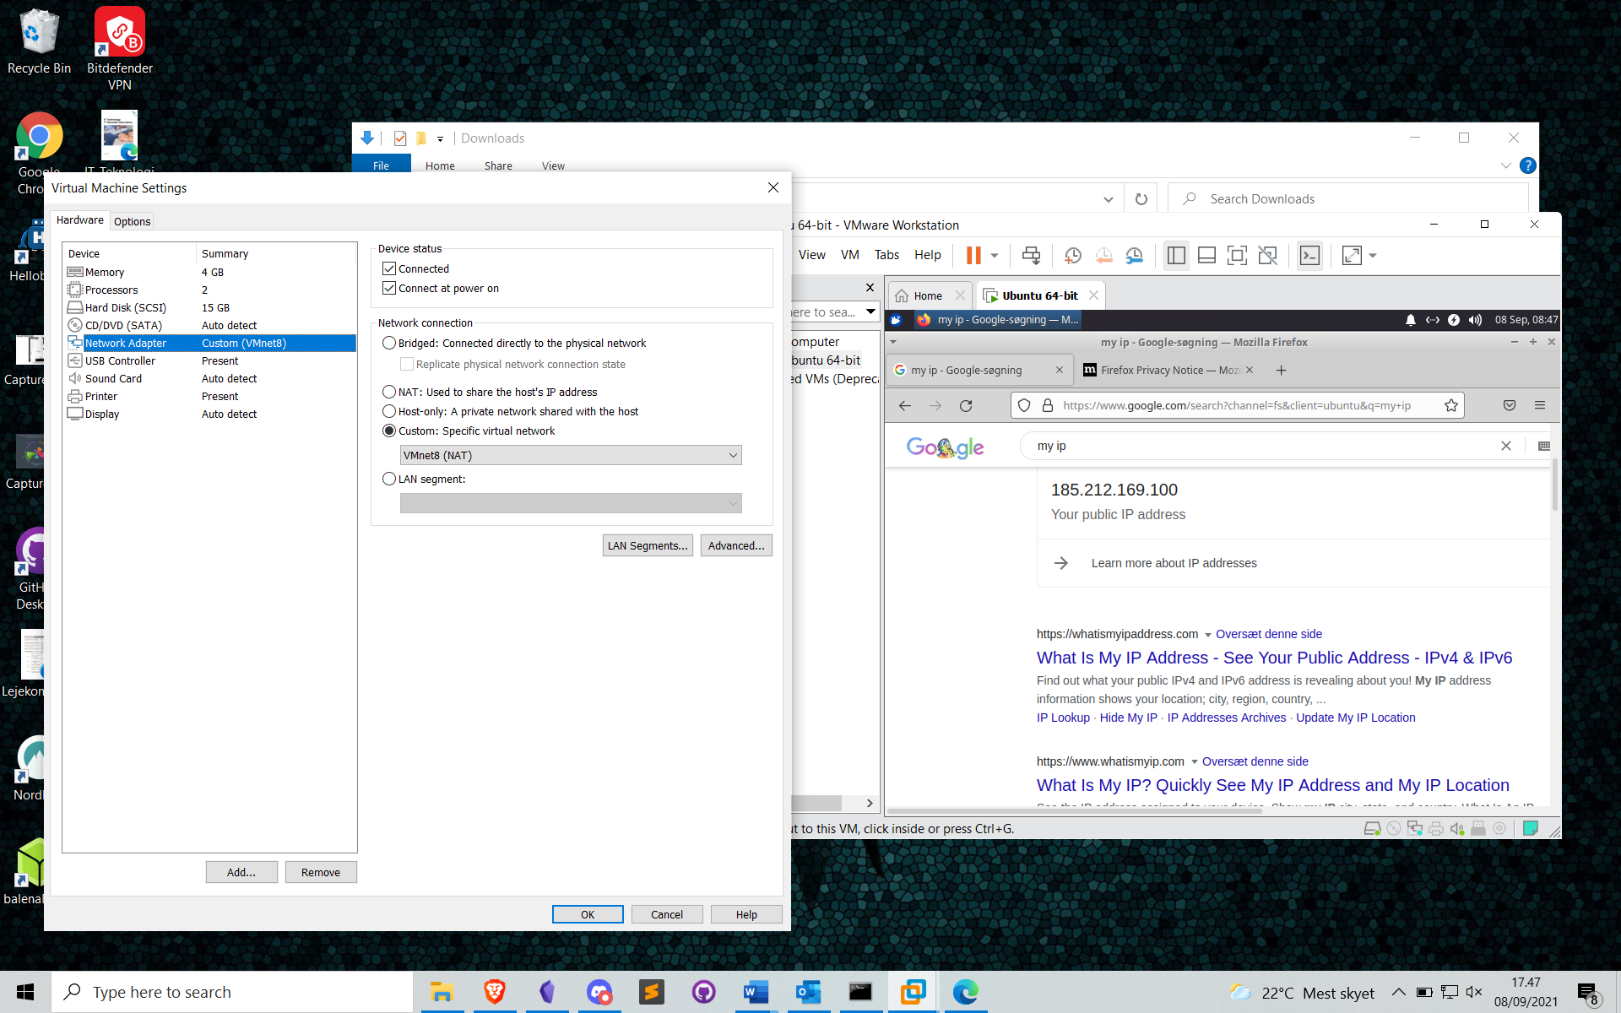

Figure

# Conclusion

VMWare Workstation 16 PRO and guest operating system(Xubuntu) are now successfully installed on the host system. After initial setup of the network through the VMWare hypervisor, it is concluded and proven, that the guest operating system has established connection to the internet via VMnet8.



1. <https://docs.vmware.com/en/VMware-Workstation-Pro/16.0/com.vmware.ws.using.doc/GUID-47896F7A-2C4F-457E-8ED1-6E5AEFDDD64A.html>
2. <https://www.vmware.com/products/workstation-pro/workstation-pro-evaluation.html>
3. <http://ftp.lysator.liu.se/ubuntu-dvd/xubuntu/releases/20.04/release/>