FINAL PORTFOLIO
OF
“INVO-6”

Simona kattel (24030159)
Sachin Maharjan(24036543)
Aayushma Dhakal(24030146)
Abhinav Sitaula(23085179)
Bardan Thapa(23085198)
Pradeep Yadav(24036544)
Submitted by- (GROUP 5):




The British college| University of West of England
Department of BSc hons. AI
Under the guidance of Rohit Raj Pandey

Abstract

There are many difficulties in managing various processes such as stock control, bill payments, customers' service, and record management faced by retailers while doing their regular activities. Most of the mid-sized stores till date rely on archaic methods which cause huge wastage of time, mistakes, and difficulties in controlling all processes involved in the business. To overcome all those issues, our team has designed a unique Enterprise Retail and Strategic Inventory Management system known as INVO-6 that will make it easy for retail operations because of automation and smart features.

In the process of designing INVO-6, we have adopted appropriate software development methodologies like planning, requirement gathering, system designing, testing, and documentation. We have used agile approach based sprint planning along with project management tools such as Trello, Jira, GitHub, and Discord. We did a lot of testing like unit testing and integration testing and functional testing to make the system work better and be more stable and not break at last.

INVO-6 shows that we can also use technologies like artificial intelligence and IoT and web development to make a system for managing retail stores. A true full stack retail system. The main goal of this system was to make things easier for people who own stores so they can get their work done in lesser time and make fewer mistakes and have a really good experience for both the stores and the customers, with building trust for customer. However, there are some things that can be made better in INVO-6, like making more intelligent model and deploying it.
Keywords
Enterprise Retail System, Inventory Management, Smart Billing, FastAPI, React, React Native, MySQL, IoT, ESP32, Barcode Reader, Artificial Intelligence, Sales Predictions, Retail Automation, Web App, Mobile App, Scikit-learn, Modular Monolith Architecture, Real-time Inventory Management, Retail Management System, Automation.

Table of content

Contents
Abstract 2
List of Images 4
List of Tables 5
Introduction 5
1.1Project aim 5
1.2 Title and its components 6
1.3 Summarization of all chapters 7
Literature Review 7
2.1 Title emergence, and benefits 7
2.2 Title and its advantage 8
2.3 Existing product 8
2.4 Related works 9
PROJECT PLANNING, TEAM ROLES AND REQUIREMENTS 10
3.1 Initiation 10
3.2- Planning 13
Executing- DESIGN AND TEST PLAN 22
4.1Design 22
4.2- requirements 25
IMPLEMENTATION AND TESTING 29
5.1- Monitoing and controlling 33
Individual Reflective Evaluation 35
6.1 Introduction 35
6.2 Contribution 35
6.3- Reflection on what when well 36
6.4 Challenges 36
6.5- Problem solving 36
6.6 learnings 37
Conclusion 38
FUTURE RECOMMENDATIONS 41
Refrences 43

List of Images
Figure 1. Project Title Document
Figure 2. Project Charter
Figure 3. Team Contract
Figure 4. Belbin Team Role Analysis
Figure 5. Skill Audit Analysis
Figure 6. Trello Project Management Board
Figure 7. Jira Sprint Management Dashboard
Figure 8. Functional and Non-Functional Requirements Diagram
Figure 9. System Architecture Diagram
Figure 10. Use Case Diagram
Figure 11. ESP32 IoT Workflow Diagram
Figure 12. Database Entity Relationship Diagram (ERD)
Figure 13. Figma UI Wireframe Design
Figure 14. Discord Communication Screenshot
Figure 15. Mobile Application Final Output
Figure 16. Web Application Final Output

List of Tables
Table 1. Team Members and Roles
Table 2. Software and Technology Stack
Table 3. Test Case Scenarios
Table 4. Advantages of INVO-6 System
Table 5. Risk Register
Table 6. Project Timeline and Milestones

Introduction

1.1Project aim
The project Invo-6 is an Enterprise Retail and Strategic Inventory Management System. This system is Store-customer faced, where we realize that “billing only, is not the ideal system a medium scale store business needs.” While researching, our team found out that the main problem of a business market especially in stores, for store owner, is time, for customer, is trust, and for cashier, it is lack of automation. The statements just made is backed with these statements “It’s clear that building customer loyalty and trust is a worthy goal for any business [1]”, “Valuing time is a foundational principle for successful business owners, treating it as their most valuable, non-renewable asset rather than an optional resource [2]”, and “Should the cashiers be machines or should be humans? [3]” released by “freshworks”, “Karalambert”, and “BBC” articles. Invo-6 was not only just made for cashiers of the store, it was also made for shopkeepers and customers. In the era of artificial intelligence, we aim to remove workload of inventory and stock management, sales predictions, supplier chain, order recommendations and more from shopkeepers or admins, and also aim to build trust, compatibility, while delivering a sense of hospitality to all the users or customers of the store. Invo-6 was developed to modernize the inventory system through automation. The main goal of the project is to help save time for business owner either by making predictions or helping to their own store in a better way, help cashier personalize their way of working and give then a healthy work environment and customer to value and trust the store. Today, time is the most important factor than anything, it is what every business person craves for, and INVO-6 is here to provide exactly that.

1.2 Title and its components
To achieve our goal, we used React, React native, for frontend app and website FastAPI for backend, and MYSQL for database. We also did API integrations for chatbot and used Sckit learn to train and test forecasting model. For IOT we used ESP32 Microcontroller, Barcode Scanner, as main products. The decision to use these models, language, and devise was discussed upon and researched, if it could or could not give the desired result. The Project name INVO-6 comes from invoice six meaning a system that helps you generate invoice or a bill, which is made by the team of six people. INVO-6 contains several integrated components for different user. For Admin it contains, inventory tracking, Order management, Transaction tracking, supplier management, product management, Customer tracking, Staff Management, Discount Management, AI for casting, Report tracking, Billing security and more. In the case of cashier some components are revenue tracing, stock tracking, transaction management, billing, product tracking. And for customer components like deal tracking, history tracking and offer/deals tracking is available. These modules work together to create a centralized retail management platform. INVO-6 has centralized monolithic architecture meaning, Fast API acts like the central hub to all the other components. To develop INVO-6 a series of documentation was released, 1st was project title, followed by project charter, and team contract this is the initiation phase, after initiation planning phase was done in this phase Belbin analysis, communication and project management tool used and, skill audit was released, then only execution phase was performed where all the designs and coding part took place, with this, monitoring and controlling phase took place where testing, and guidelines(user manual, guideline to use the product) were documented, and then for the closing phase, where final presentation and final documentation will be released which will the end of the 1st draft of INVO-6.

1.3 Summarization of all chapters
In this report there are seven chapters, and each chapter carries a specific significance, Chapter One introduces the project background and objectives where what the project is, how it is done and what is the aim of the project where the problem of current market and its solution is explained. Chapter Two presents the literature review and related research, where similar projects are identified and researched. Here emergence of invo-6, advantages and research gaps are mentioned. Chapter Three explains project planning, team roles, and requirements analysis. Here team contact, project charter, Belbin analysis, Jira, trello, functional, non-functional requirements, risk analysis, is discussed. Chapter Four discusses the system design and testing plans, in this chapter, system architecture, Usecase, database design, user interface, testing, and test cases are explored. Chapter Five explains implementation and testing procedures here tech stack, frontend, backend, Database, API, and challenges with solution is mentioned, while the 6 chapter’s present reflective evaluation which is an individual evaluation done by each member of the group here contribution of each individual, achievements, problem solving, learning outcome, self-evaluation and future improvements is analyzed and written, at last conclusion and future improvements, and then the references. This is how each chapter signifies the project and help understand what INVO-6 is.

Literature Review

2.1 Title emergence, and benefits
Smart retail means automation. Smart retail systems now-a-days, is on the trend which is no surprise. The world is moving towards automation so is retail system, an article named “Smart Retail: What is IoT Retail and what are its benefits”, published by “Tektelic” states “the IoT-enabled retail sector would be valued at 94$ billion by 2025. Retail, like many other businesses, is adopting the Internet of Things (IoT). By 2020, IoT in retail was anticipated to be worth more than $35 billion. IoT technology is being used by retailers to improve customer experience, cut labor costs, promote growth, and boost the overall performance of infrastructure and network components in the retail business. [4]”. This article talks about IOT in retail however, in today’s world this is very common. We need AI integration to stay up to date. Which is also stated by an article published by IMB, that states “For retail brands both large and small, AI tools can have a significant business impact, though organizations still sometimes struggle to deploy the technology in a large-scale and cost-effective way [5].” And this is where INVO-6 makes its way through.

2.2 Title and its advantage
The advantages of Smart retail system include, Reduced human error, AI is known to do its work with little to no mistakes whether that be writing essays, code, or handling mathematics calculation, it is growing day by day, with good prompt AI does exactly what you wanted to be done. Saves time, time saving is our one of the objective and also one of the biggest advantages, it is what draws the business person toward INVO-6. Better stock management, stock gets counted and updated with every order received and every transaction done, if any products stock count is low admin is notified It removes the burden of managing and counting stock levels. Real time monitoring, monitor your store in real time. Improved forecasting instead of manually forecasting customers for the next week to update the inventory AI analyses your data, customer transactions to predict what will be the amount of customer buying form the store for next week which is far more reliable than doing the same things manually. Builds trust it helps customer to build trust to the store.

2.3 Existing product
While researching we came across few existing retail systems. The first one is Open Source Point of Sale (OSPOS)[6], https://opensourcepos.org/, OSPOS is a web-based point-of-sale system that is used by retail shop owner to manage daily sales, product stock, customer details, and sales reports. It helps store owners record transactions in one place and keep track of what items are available and what item are not available in the store, so it mainly focuses on stocks and is useful for basic retail operations which is close to INVO-6 in terms of billing and inventory tracking. Limitation of OSPOS is that it mainly focuses on core retail functions only. It does not include IoT-based devices such as barcode scanners connected to microcontrollers, which are part of INVO-6. It also does not provide chatbot integration for customer, cashier, admin support, or any AI forecasting system for predicting future sales or stock demand. Because of this, it is less advanced than INVO-6 in terms of automation and smart features and also billing. The second System that is similar to INVO-6 is ODOO POS, which can be assessed by the URL https://opensource.com/tools/point-of-sale [7]. Odoo POS is a retail module, that is inside larger business management system. It supports selling products, managing stock, and handling retail transactions. This system technically was designed to make shop operations smoother and more organized, and in that sense it is similar to INVO-6 because of the sales and inventory management idea, however it has its differences or limitation from INVO-6 as it works as part of enterprise system rather than as a custom retail system with separate roles or users. It does not specifically provide admin, cashier, and customer dashboards like INVO-6 does. It also does not include the chatbot for admin casher customer support, forecasting model for better prediction, and IoT device integration that INVO-6 aims to offer.

2.4 Related works
There also are some of the related projects that we came through done by developers in GitHub, the first being Retail IQ System assessable through “github.com/thevirajtyagi/retail-iq-system” link [8]. This project is a basic retail management app for billing, stock, and sales tracking which is similar to INVO-6, but not exactly as the project has its own drawback which serves as a limitation for a billing software unlike INVO-6 this project is Console-based and much simpler also there is no full modern web/mobile stack or advanced AI/IO. The Second is named, Product Inventory Management System, assessable through “github.com/JuanNovas/Product-Inventory-Management-System” link [9]. This project is a backend system for product inventory using FastAPI and PostgreSQL which is similar to INVO-6 in the way it manages products, but it is not the same because it is only backend-based. Its limitation is that it is not a complete retail platform, and it does not include cashier or customer modules. The third is AI Retail Management System, assessable through the “github.com/Vijju-15/AI-Retail-Management-System” link [10]. This project is an AI-powered retail platform for forecasting, pricing, and customer segmentation, and it is similar to INVO-6 because it also uses AI features. However, its limitation is that it focuses more on AI and it does not clearly provide a full retail billing system with hardware and mobile app support. The fourth is Smart Billing Management System, assessable through the ‘github.com/aMan404deep/smart-billing-management-system ‘link [11]. This project is a React-based billing app for invoices, inventory, and dashboards, and it is similar to INVO-6 in billing and inventory handling. However, the limitation is that it is frontend-focused and does not include the full backend, IoT, and forecasting scope of INVO-6. The fifth is E-commerce FastAPI React, assessable through the ‘github.com/renaldyhidayatt/ecomfastapireact’ link [12]. This project is a simple online shop using FastAPI and React with payments, and it is similar to INVO-6 in using the same kind of web technologies. However, it is more like e-commerce than retail operations, and it does not deeply match the admin, cashier, and customer flow.

As all these researches were made for INVO-6, similar systems, and project we also came across a huge research gap on the following things. Existing systems mostly handle billing, stock, customers, and reports, but they do not really combine all functions in one system. Most systems are only backend, or only frontend, or only POS, they are not fully integrated like INVO-6. Some systems have AI, and are admin facing but do not support IoT barcode scanning, chatbot support, forecasting, or mobile access. Some systems even do not separate users into admin, cashier, and customer roles properly. With that being said yes every project, system researched might have their own aim, objective, goal but the lack of a system that provides everything as one single product was missing. Therefore, there is a need for a centralized retail system like INVO-6 that combines all these functions in one application.
To summarize all the points been made, a lot of projects was done before us, a lot of systems were made before us, but most of them did not fully integrate advanced features such as AI forecasting, chatbot support, IoT-based scanning, and separate user roles. Therefore, there is still a need for a centralized and more intelligent retail management system like INVO-6 that can handle all these functions in one place.

PROJECT PLANNING, TEAM ROLES AND REQUIREMENTS
This chapter explains the project planning, Team Roles and Requirements part of the INVO-6 project. It includes the project charter, team contract, team role analysis also known as Belbin analysis where we analyze ourselves individually, project schedule, and system requirements. Planning is the most important stage because it helps the team to understand what the project is about, who is responsible for each task. It also helps the team manage work properly and complete the project in an organized way, and complete it in a particular desired time period to develop this system successfully, the team first, needed to decide everything the project needed to acquire, assign roles based on the person’s ability, and define the features that the system should include.

3.1 Initiation

To make planning phase successful our team 1st started from project charter. project charter is a short introduction to the project. It has all information on project title, objectives, scope, stakeholders, and timeline. It is the first formal document created during the initiation phase. However, before project charter a project title was released as well.
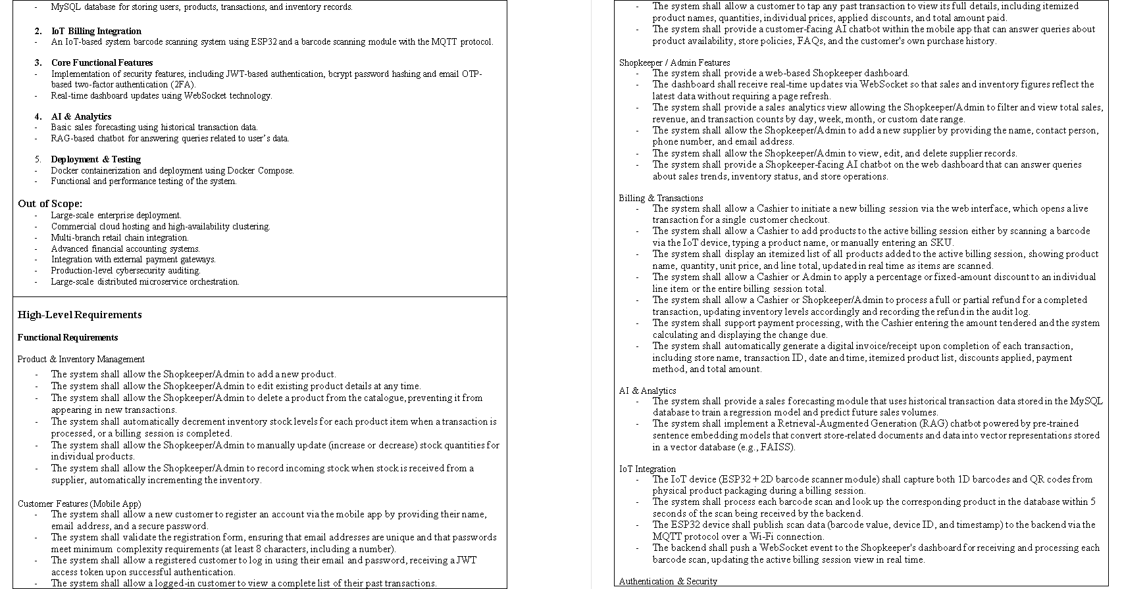
Fig. Project charter
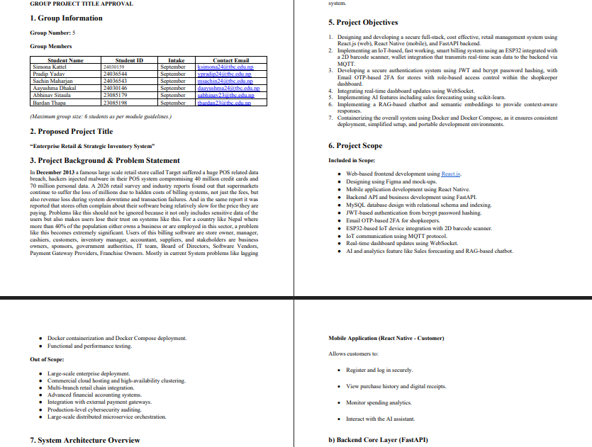
Fig. Project title
After that the team contract was released, this was carefully crafted and agreed upon by all the team members officially. The team contract is a type of document that explains how the team are going to work together. It states the roles of each member, communication rules, meeting schedules, and responsibilities. In this document also the consequences of not meeting the expectation form any team member was clarified, which helps the team to stay organized, avoid confusion and work with trust during the project.
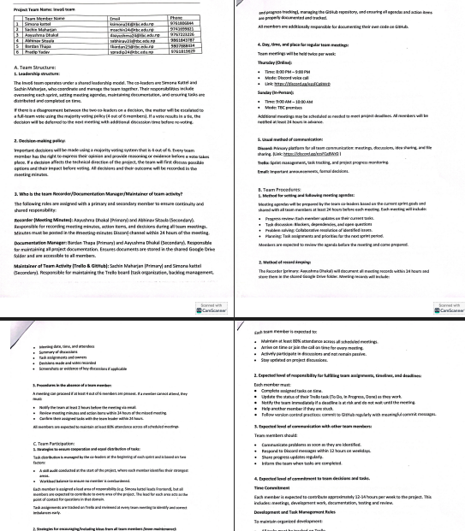
Fig. Team contract.

3.2- Planning
Right after team contract we moved on to the planning phase, in this phase team sat down and planned upon what should be done and how should be done, to do this 1st of all the team individually and personally analysed themselves to understand what category listed under Belbin analysis do they most relate to. Belbin analysis helps identify the strengths of each team member, however we did not just stop at the strengths we focus on the weakness too, team divided this analysis in 3 part, primary role main strength, secondary roles- extra strength and least likely role weakness, which we aimed to work on in the project duration. It shows how each person has contributed to the project based on their own working style.
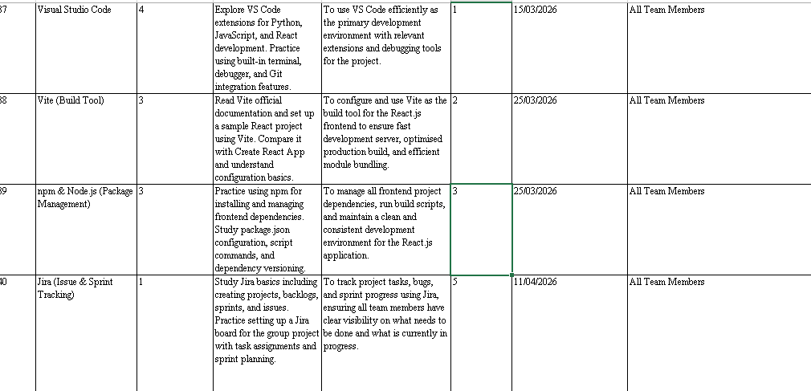
Fig: Skill audit

Coordinator:
The coordinator is the person who communicates, organizes the team also ensures that everyone focused on the main goal of the project. This member assigns tasks and makes sure the project moves in the right direction. In INVO-6, the coordinator Simona kattel, helped to manage the overall progress, and supported communication between every member.

Shaper:
The shaper is the person who pushes the team forward to solve any problem quickly. This member is important to keep the motivation of the team up when things go wrong. In INVO-6, the shaper Pradeep Yadav, helped maintain energy and also encouraged the team to finish all tasks on time.

Completer-Finisher:
The completer-finisher is the person who checks all the details carefully and makes sure the final work is correct and does not break down. This member looks for mistakes and helps improve the quality of the project. In INVO-6, the complete-finisher Sachin Maharjan, helped maintain the quality of the report and made sure everything goes well.
Specialist:
The specialist is the person who has a good amount of knowledge in one specific area and gives professional help when the team needs on that particular topic. This member focuses on the technical side rather than social or creative and brings specific skills that are important for the project. In INVO-6, Aayusma Dhakal helped by contributing her knowledge and support in the area where she was best at.

Plant:
The plant is the creative member of the group who comes up with new ideas and unique ideas for problem that rises. This member is known to think differently and helps the team when fresh ideas are needed. In INVO-6, Bardan Thapa, as a plant shared his unique and creative thoughts that helped the team improve the project.

Resource Investigator:
The resource investigator is the person who explores outside information, finds useful resources, and brings new opportunities to the team. This member is extroverted, fun and helps the team by collecting ideas, references, and support from different sources or different teams in the class. In INVO-6, Abhinav Sitaula worked as a resource investigator, finding useful information and resources that supported the development of the project.
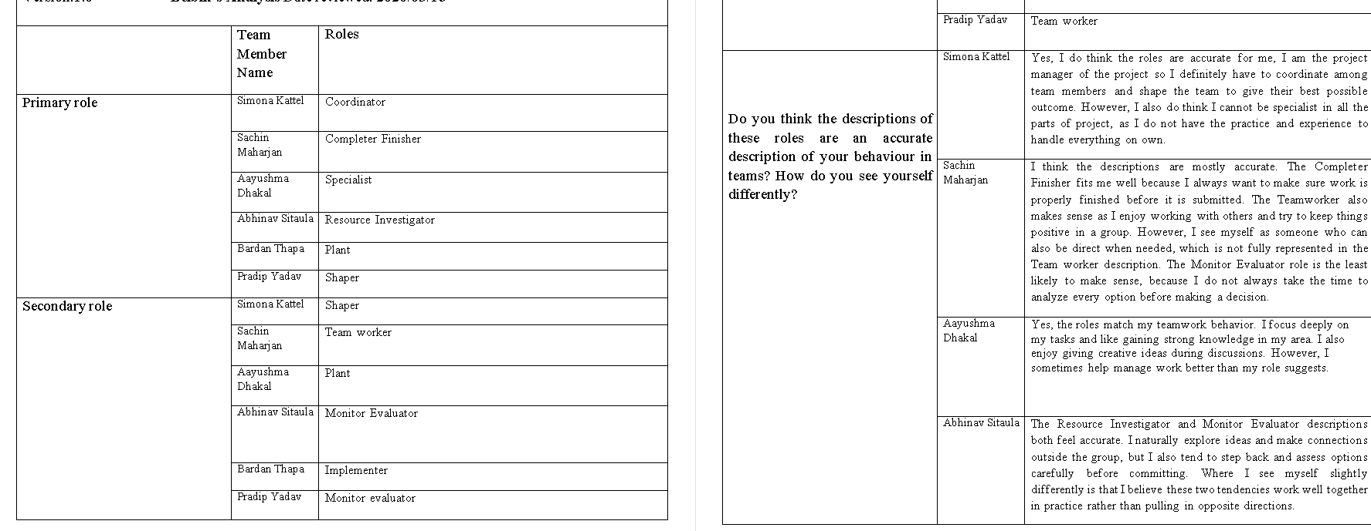
Fig. Belbin analysis

The project timeline was divided into four phases or sprit which was later integrated to trello and Jira like project management software from where the team combine contributed and tracked their progress on, the commination method was clear and respectful which was done in both native language and English language. Important updates were shared through group chat, meetings, and direct messages, which was done via. Discord.
Sprint metric 1
- Setup React project (Vite, Tailwind, routing)
- Create basic components (Navbar, Sidebar, Forms)
- Prepare frontend folder structure
- Setup pages (Login, Dashboard, Inventory, Billing - basic layout only)
- Wireframe design

Sprint metric 2
- improve styling (colors, spacing, responsiveness)
- Make dashboard visually structured (charts, cards, layout fixes)
- Add animations and better UX (hover, transitions)
- Ensure all pages are fully responsive

Sprint metric 3:
- Connect frontend with backend APIs.
- Implement login system (JWT + authentication)
- Setup backend server
- Connect backend with MySQL database
- Create API endpoints (products, users)
- Implement full CRUD operations
- Store and retrieve product & user data
- Data validation and consistency
Sprint metric 4:
- Implement forecasting model
- Build chatbot (RAG-based)
- Integrate AI APIs with backend
- Complete IoT billing workflow, ESP32 and MQTT communication
- Full system testing (frontend + backend + AI + IoT)
- Final deployment (Docker)
- Documentation and report writing
- Prepare dataset for sales forecasting

Table.project timeline/sprint
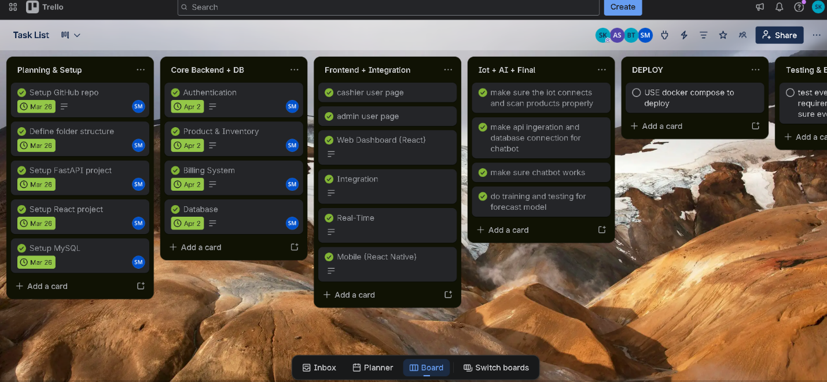
Fig-trello
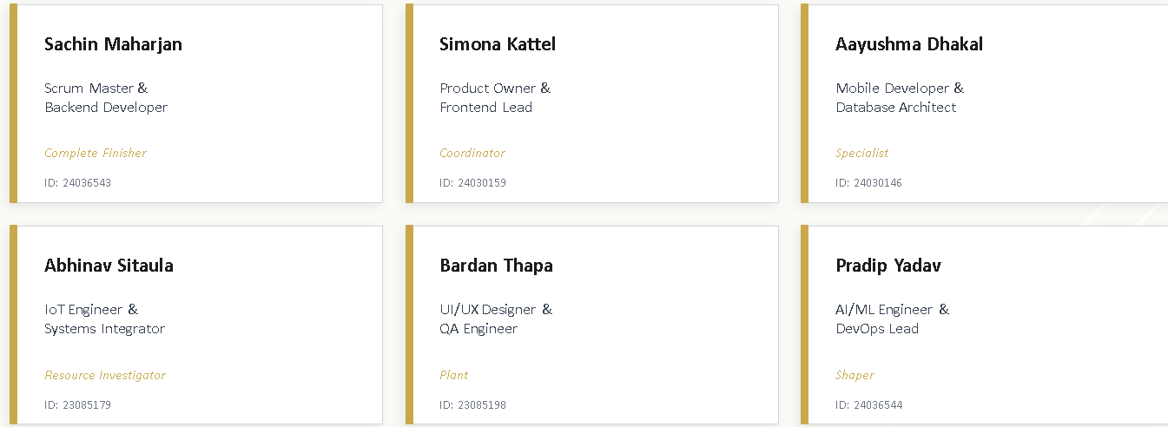
Table. Team member – with roles
Functional requirements are a file that describes what the system does. What are the main feature that is done by the system or aims to achieve by the system? Some functional feature of The INVO-6 system is “should allow users to log in securely”, “should allow the admin to add, edit, and delete products.”, “should track inventory and show stock level” “must allow billing and invoice generation.”, “would manage customer records and supplier records.” And “could support order tracking”. As we see from these example that fictional requirement is following Moscow rule, Moscow rule basically is must, should, could, would. If it is essential for the system to achy that particular goal it comes under must. If it is necessary for the system to achy something it comes under should. And could is when we are uncertain but if all the should and must are finished and we have time then we do it, and then at last would can be for future improvements.

Non-functional requirements focus on how the system should perform. It is different from fictional as functional is about what and nonfunctional is about how, functional requirements focus on quality, speed, safety, and usability. Some of the nonfunctional requirement of INVO-6 includes “The system should be secure so that only authorized users can access It”. “It should be fast and respond quickly during billing and product search.” “The system should be easy to use so that cashiers and admins can work without difficulty.” “It should also be scalable so it can handle more products, users, and transactions in the future.” “It should have 90 percent uptime.” All these full requirements are kept in the pictures section.
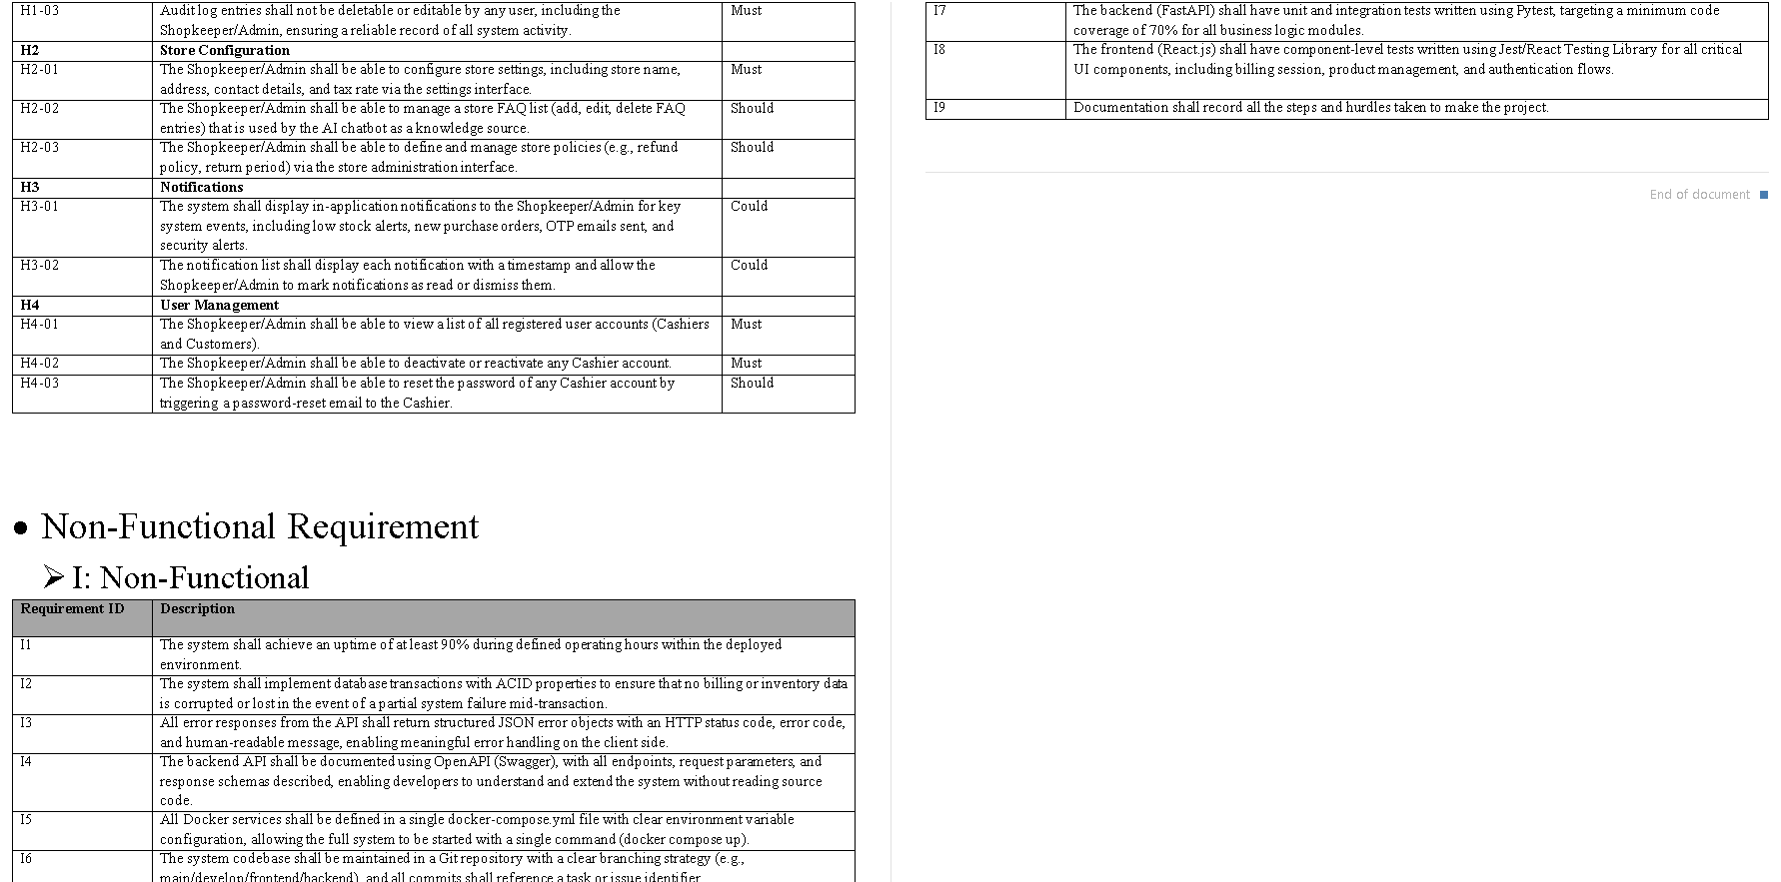
Fig. Functional and Non-functional requirements
Every project has some risks, and so does INVO-6. Risk factor is something that must be thought upon and analyzed upon, before the project start it gives it greater view and prepares us in a level if something wrong happens later. Risks our team analyzed and thought upon before the execution of the project is given below:
ID | Risk | Risk Description | L | I | Sev | Owner | Mitigation Strategy | Status
R1 | Team Member Unavailability | A group member may become unavailable due to illness or other personal issues, causing delays to assigned modules and placing undue burden on remaining members. | 3 | 3 | 9 | Project Manager | Maintain a shared task tracker like GitHub or Trello. Ensure all code is reviewed and documented so any member can pick up another’s work. | Open
R2 | Stakeholder Disagreement | Differences in expectations between group members or simulated stakeholders regarding system features, design, or scope may result in rework and late deliveries. | 2 | 3 | 6 | Project Manager | Conduct regular reviews meeting with the project supervisor. Maintain clear documentation of agreed requirements in a shared repository. Use Figma prototypes to validate UI decisions early before development. | Open
R3 | IoT Hardware Failure | The ESP32 microcontroller or barcode scanner module may malfunction, fail to initialize or become damaged during development and live use, stopping the billing process completely. | 3 | 4 | 12 | IoT Lead | Purchase at least two backup ESP32 units and scanner modules. Implement a software backup that allows manual backup entry through the web interface if the IoT system is unavailable. | Open
R4 | AI Forecast Inaccuracy | The scikit-learn forecasting model may produce unreliable predictions if trained on insufficient data, failing to meet the target error rate below 15% | 3 | 3 | 9 | AI/ML Lead | Create or look for a valid transaction dataset from Kaggle that reflects seasonal trends. Test multiple regression models. Monitor performance using RMSE and MAE and retrain the model if performance thresholds are exceeded. | Open
R5 | Database Data Loss | Accidental deletion, schema migration errors, or container volume misconfiguration in Docker could result in permanent loss of transaction records, inventory data and audit logs. | 2 | 5 | 10 | Backend Lead | Set up automated daily MySQL backups using Docker volume mounts to a persistent host path. Tests restore procedures monthly and implement transaction rollback mechanisms in FastAPI. | Open
R6 | RAG Chatbot Irrelevant Responses | The RAG-based chatbot may generate inaccurate or hallucinated responses if the vector store is poorly populated, embeddings are mismatched or the LLM API returns incorrect context. | 3 | 3 | 9 | AI/ML Lead | Build a comprehensive knowledge base of store-related FAQs. Apply semantic similarity thresholds to filter out low-confidence results and provide a default response when necessary. Conduct user testing to validate effectiveness. | Open
R7 | Poor Version Control Practices | Merge conflicts, accidental commits to the main branch, or a lack of a structured branching strategy may corrupt the codebase, particularly when several developers are working on interconnected modules simultaneously. | 3 | 3 | 9 | Project Manager | Implement a Git branching strategy like Git Flow. Protect the main branch with mandatory pull request reviews. Conduct weekly merge sessions to resolve conflicts before they build up. | Open
R8 | Copyright and licensing issues | The use of third-party libraries, open-source models, or LLM APIs with restrictive licenses may unintentionally violate their terms, especially in commercial applications or public demonstration purpose. | 2 | 3 | 6 | Project Manager | Audit all dependencies for license compatibility using tools like “pip-licenses” and “license-checker”. Prefer libraries with MIT or Apache 2.0 licenses. Document all third-party components in the project report. | Open
R9 | Cybersecurity Attack (SQL Injection / XSS) | The FastAPI backend may be vulnerable to SQL Injection, XSS, or API abuse if validation is weak. | 3 | 5 | 15 | Backend Lead | Use parameterized queries (ORM), input validation (Pydantic), rate limiting, JWT expiry, HTTPS. Immediate patch, revoking tokens, restoring clean DB backup | Open
R10 | MQTT Communication  Failure | MQTT broker downtime may stop barcode scan transmission from ESP32. | 3 | 4 | 12 | IoT Lead | Use persistent sessions, QoS level 1, broker monitoring. Manual billing fallback via web interface. | Open
R11 | WebSocket Real-Time Sync Failure | WebSocket disconnection may prevent real-time dashboard updates. | 3 | 3 | 9 | Backend Lead | Auto-reconnecting logic, fallback polling API. We can use Temporary refresh-based dashboard updates. | Open
R12 | Email OTP Delivery Failure | Email OTP may fail due to SMTP restrictions or spam filtering. | 2 | 4 | 8 | Backend Lead | Use reliable SMTP, retry mechanism. Temporary admin manual activation. | Open
R13 | Docker Misconfiguration | Incorrect Docker Compose setup may break environment consistency. | 3 | 3 | 9 | Backend Lead | Using environment variables and test staging container builds. We can also roll back to last stable image. | Open
R14 | Data Privacy Compliance Issue | Mishandling customer transaction data may violate data protection laws in Nepal. | 2 | 5 | 10 | Project Manager | Encrypting sensitive fields, role-based access control. | Open
R15 | Incomplete Testing Coverage | Lack of proper unit/integration testing may allow hidden bugs. | 3 | 4 | 12 | QA Lead | Using Jest for frontend and Pytest for backend, code coverage tracking. Allocating final sprint exclusively for bug fixing. | Open

Table. Risk Register

This chapter explained the planning part of the INVO-6 project. It included the project charter, team contract, Belbin team role analysis, project schedule, functional requirements, non-functional requirements, and risk analysis. All the screenshot, tables, is given in the 1st part of the project. This chapter is to show how the team members worked together as a team. Overall, this chapter is the base for the design and development of the INVO-6 retail management system.

Executing- DESIGN AND TEST PLAN

This part explains, how our system was designed and how it was tested. The design part shows the main structural design of the system, and the tools and that was used to build all the interface for the project or the UI, the database is used to store all the information, and the overall architecture. The testing part explains how the system will be checked to make sure it works correctly and gives the expected result. The purpose of this chapter is to show that the system is not only has a planning phase but also solid, practical, reliable, design pattern and diagrams to pre understand how the coding will structure. Therefore, in simple words, design is to tell how the system is built, and testing tells us whether it works properly or not.

4.1Design
The system architecture means how the application is built, or a bigger picture of system working. The system architecture of this project is based on a modular monolithic architecture. Which means the whole application has one central system as the main system, then it is divided into different modules such as product management, supplier management, billing, inventory, authentication, AI features, customer app, and Iot integration. We used this architecture because it was easier to develop, manage, and test rather than a large distributed type architecture system. Although each module has its own task, all of them work together in one application. Which means, when the cashier scans a product, processes of transaction is done and also the inventory module is updated for the stock. This structure makes the any system easier to comprehend, faster to maintain, and suitable for a project like INVO-6 considering it has many connected features.
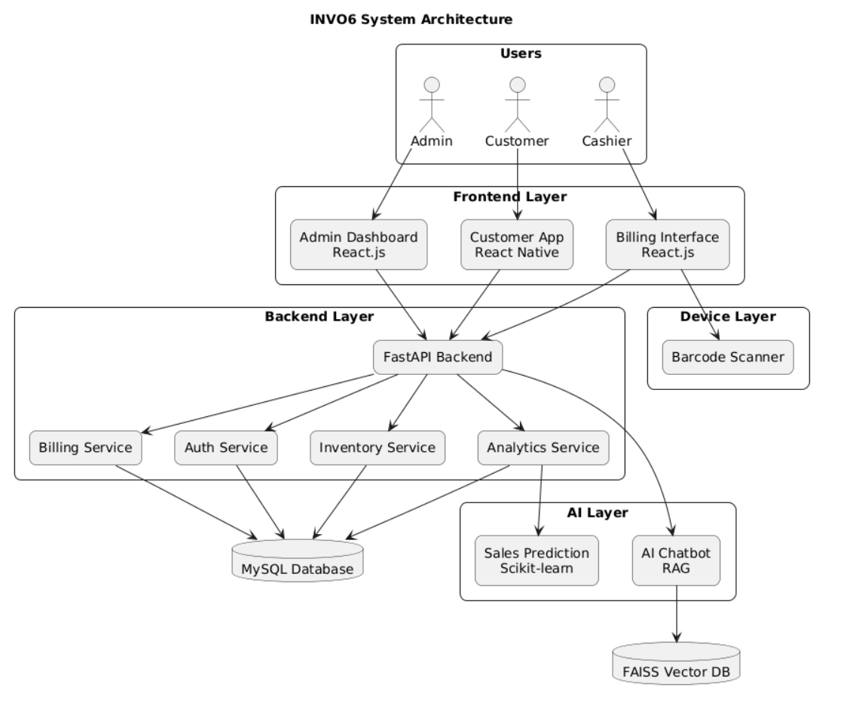
Fig . System Architecture
First of all, use case was made. Use case is a simple way to show who are the user or the actors in the system and what do they do in the system, it basically is defining the work of user and introducing the feature of the system. It explains what each user can do, why they do it, and how the system responds. We use use case diagram because they help us to understand the system from a particular user’s point of view instead of only viewing the system from the technical side. In the use case diagram, of INVO-6 the main actors are Admin, Cashier, Customer, and ESP32. The Admin can manage products, suppliers, roles, stores, inventory, and view audit logs. The Cashier can scan products, apply discounts, process transactions, and handle payments. The Customer can view purchase history, receipts, and spending analytics. The ESP32 device is used for Iota functions like publishing scan data and receiving dashboard updates. In usecase there is also include and extend function which basically means, if a task can be done optionally it is extend if it must be done than that is include.
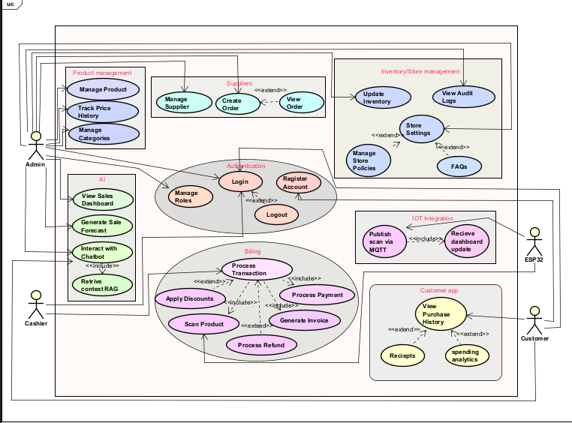
Fig. Usecase diagram

The user interface is designed in Figma before actual the development. Figma is a design tool that helps us to visualize how the frontend might look with the design we have in our mind in a clear and organized way. It is simple, easy and a professional tool for UI designing. A good UI is a very important factor when it comes to product because admin, cashier and customer all the actors are working in the frontend its elves. We used figma because it allows us to plan the layout, buttons, menus, forms, and pages easily. It also helps us check whether the interface is simple, attractive, and easy to use for admin, cashier, and customer. In this project, we focused on having easy navigation UI with and quick access to important features like product management, billing, and customer purchase history. Even a powerful and well-made system sometime can become difficult to use if the design is confusing. So, Figma helped us reduce any mistakes and improve INVO-6s user experience in the design stage.
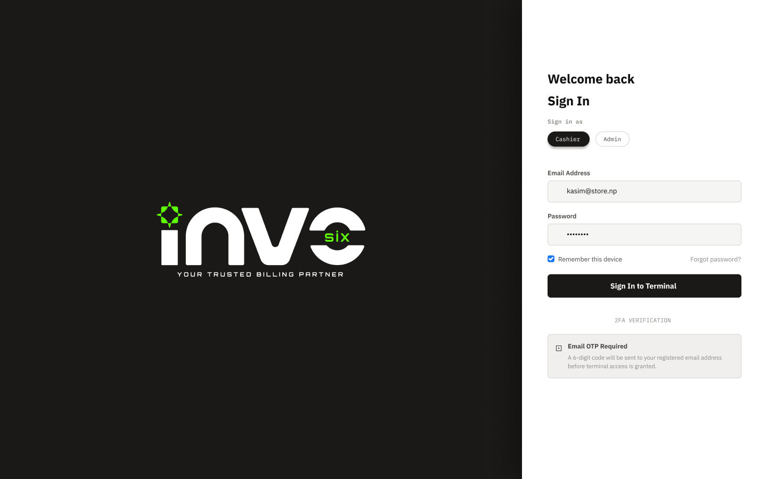
Fig. Login page – wireframe

4.2- requirements
The database we used for the system is MySQL. A database is used to store, organize and add all the important information so that the system works properly. In this project, MySQL stores product details, supplier information, user accounts, billing records, inventory updates, customer purchase history, and audit logs. We used MySQL because it is reliable, widely used, suitable for handling structured data, simple, and fast. It also supports fast searching, updating, and reporting, which is important for a retail or store management system like INVO-6 as the transaction keeps increasing so does the stock decreases and we need updates in real time.
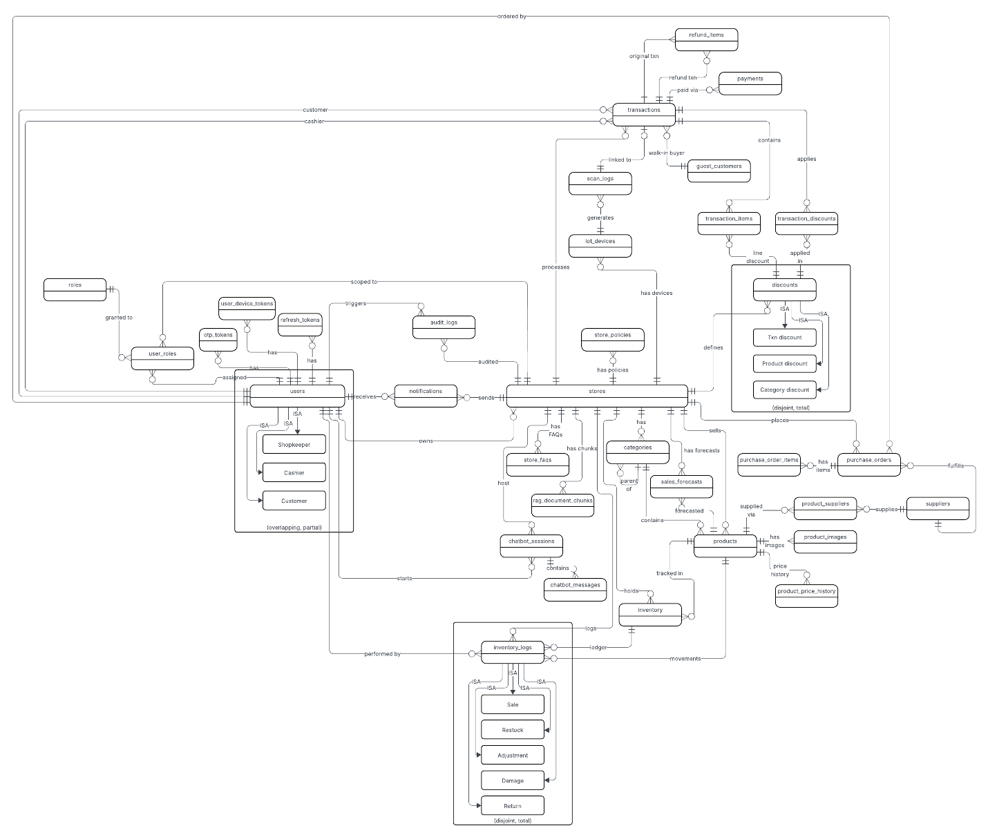
Fig. EERD
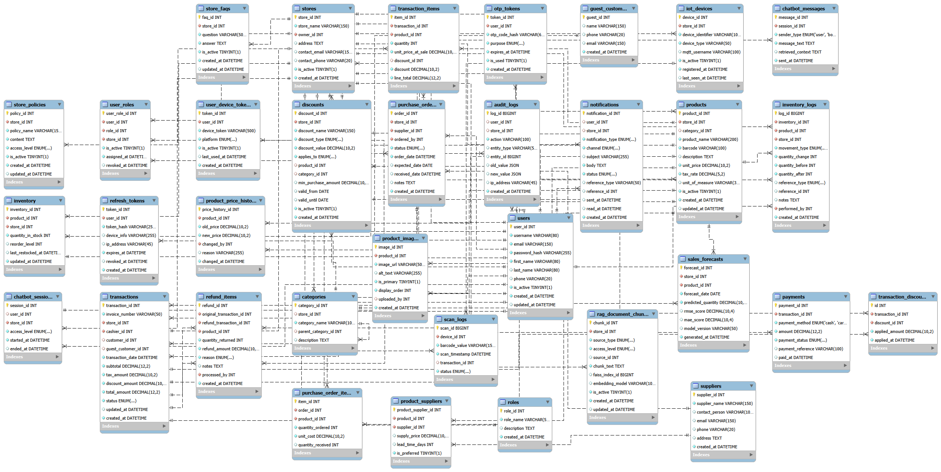

Fig- Decomposite diagram

Testing is used to check whether the system works as expected. This part is where you check and try your best to break the system to find the loopholes and breaking point if any in your system. We use testing to find errors, improve performance, and make sure every feature is working correctly before the system is fully integrated, deploying or handed over. The testing strategy for this project includes unit testing, which means testing each part step by step and one by one, integration testing, and user acceptance testing and fictional requirement testing. Unit testing checks small parts like login, product update, or invoice generation. Integration testing checks whether different modules work together, such as billing updating inventory at the same time. User acceptance testing checks whether the system is easy and useful for real users like admin and cashier, which is done by giving to a random person and asked to use it and then questioned if he would use the system or what changes would he make or understanding if there was any point where the system broke. Test cases are made function with expected results, such as “if a valid login is entered, the user should enter the dashboard” This testing plan helps ensure that the system is stable, safe, and ready for real-world use.
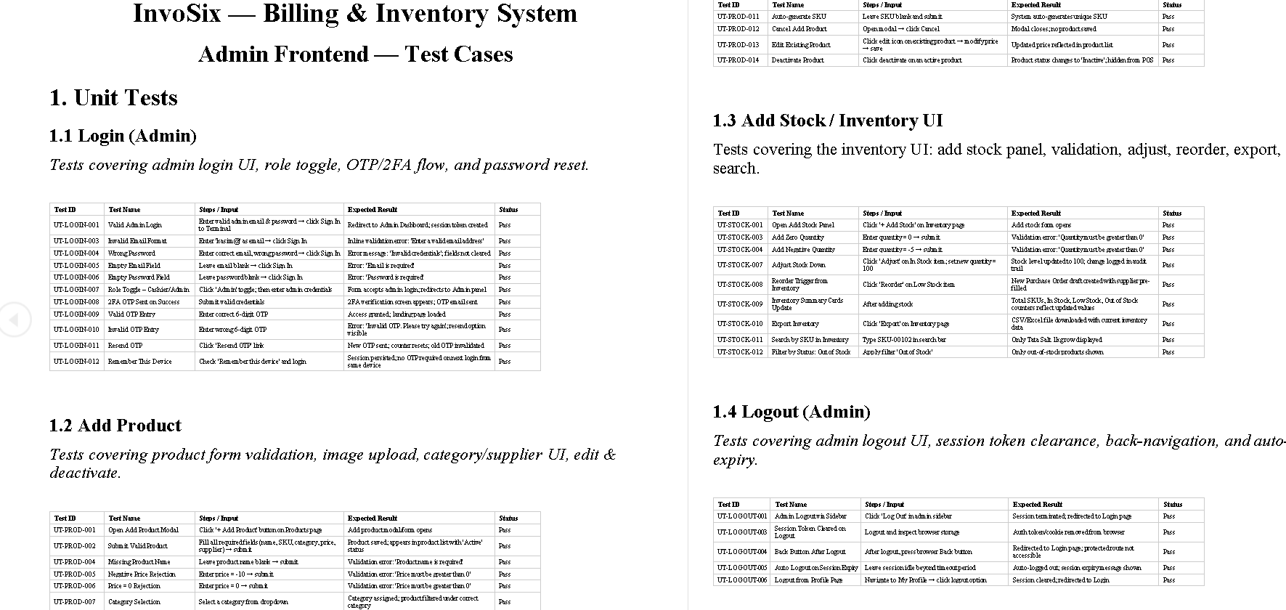
Fig.testing
This chapter explains how the INVO-6 system was designed and tested in a simple and clear way. To summarize everything that has been mentioned previously, the system structure, the use case diagram, the UI design made in Figma, and the MySQL database used to store all data have been mentioned. The modular monolithic architecture helps to keep the system organized, it divides the whole system into small parts like billing, inventory, suppliers, and authentication. The use case diagram makes it easy to understand what each user does, and testing helps to check whether the system works correctly or not. Overall, this chapter shows that the system was planning to building it logically.

IMPLEMENTATION AND TESTING
This part of the report talks about how the INVO-6 system was actually built and checked upon in real development environment with real people. Implementation means taking all the designs we made and turning it into a working system, while testing means making sure each part works properly and gives the wanted result. In this stage, all the part frontend, backend, database, APIs, and system integration were developed step by step. After that, the system was tested using different test cases, and different test case strategy to to find problems and fix them before the final use. This chapter is an evidence that the project is not only planned well, but also developed in a reliable and professional way.

First is the frontend part here all the users and actors can see and interact with it directly. In frontend some of the pages are, like buttons, forms, menus, dashboards, and other visual elements used by the admin, cashier, and customer. This is the page which is responsible to give first impression. In INVO-6, the frontend was built to be simple, clean, and easy to use so that users and all actors can complete quickly without confusion, and also have simple navigation. We in the development always focused on making the interface user-friendly because one thing a store system needs is fast navigation and also clear actions, especially during billing and inventory work. A well-designed and planned frontend like IVO-6 helps to reduce mistakes and improves the overall experience of any system.

The backend is the hidden part of the system done in FASTAPI that handles the main logic and processing. It manages things like login, transaction handling, stock updates, supplier records, role management, and report generation. In this project, the backend was also built to make sure all operations happen correctly when the user performs an action on the frontend. As the system solely works on frontend and all the backend and database is also updated works internally from the frontend it selves a for example, when a cashier processes a payment, the backend calculates the total, saves the transaction, and updates the inventory. This part is important because it connects the user actions with the actual business process of the system.
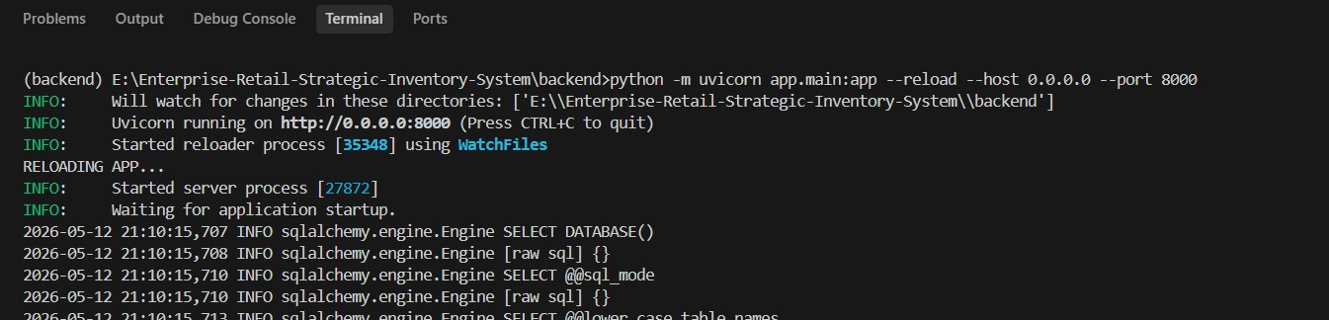
Fig. backend running
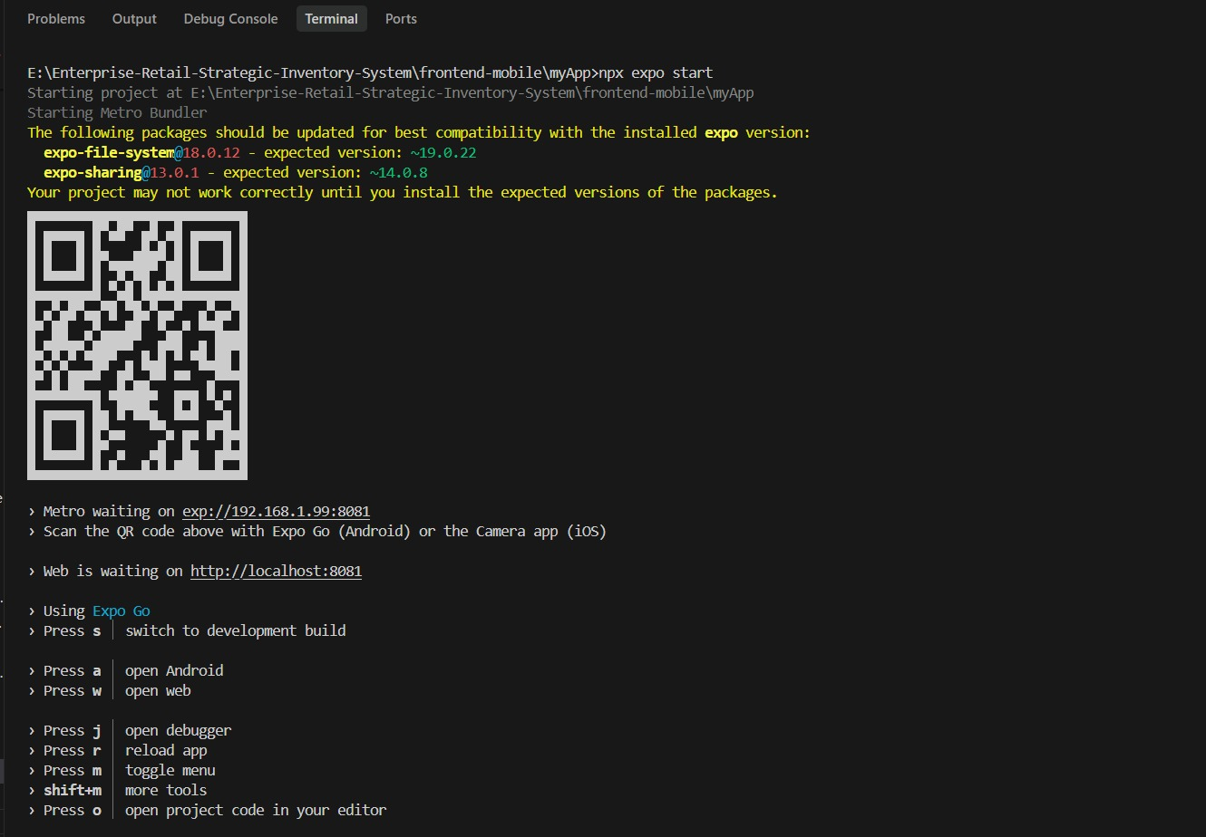
Fig. frontend running
The database stores all the important information used by the system. INVO-6 uses MySQL to save data such as products, suppliers, users, invoices, customer history, stock records, and audit logs. The database was designed to keep the information organized, secure, and easy to retrieve whenever needed. Not only that, it also supports real-time updates, which is very useful especially for retail management as it needs fast updates also when stock changes after a sale or when new product details are added. Without the database, the system would not even be able to either remember or manage its data properly.

APIs were one of the important factor it is used to connect different parts of the system and make all the communication smooth. An API allows the frontend, backend, database, and external devices or services to exchange data properly. In INVO-6, APIs help send and receive information such as product details, sales data, dashboard updates, and IoT scan results. We have used APIs because they are well-known to make the system more flexible, organized, and easier to expand later. For example, in our system when the ESP32 device sends scan data, the API transfers that information to the system database so it can be processed immediately.
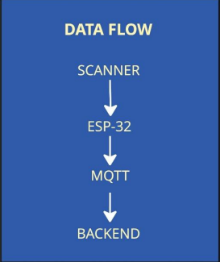
FIG. IOT Flow
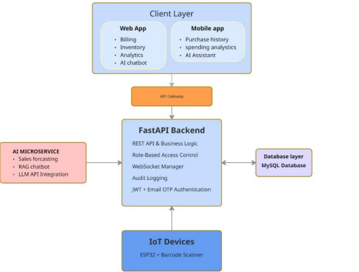
Fig.AI layer
System integration means combining all the separate parts of the system into one working application. This is the point where all the components of frontend, backend, database, and API integration have been done and tests have been conducted to check whether all the components are working as expected. It should be noted here that it is equally essential to integrate these components since they can create difficulties during the process. For example, the billing module must correctly update the inventory module after a sale, and both must store data in the database properly. Good integration makes the system stable and ensures smooth operation in real use.

The technology stack of INVO-6 includes the tools and technologies used to build the system. We used React, React native, for frontend app and website FastAPI for backend, and MYSQL for database. We also did API integrations for chatbot and used Sckit learn to train and test forecasting model. For IOT we used ESP32 Microcontroller, Barcode Scanner, as main products. This stack covers the frontend framework, backend language, database, design tools, and API support used in the project. We cho0se these technologies because they are practical, efficient, and suitable for a modular monolithic system which we aimed to follow. If a stack is good it helps development become faster, easier to maintain, and more reliable. It also makes sure that all the part of the system works well with each other.
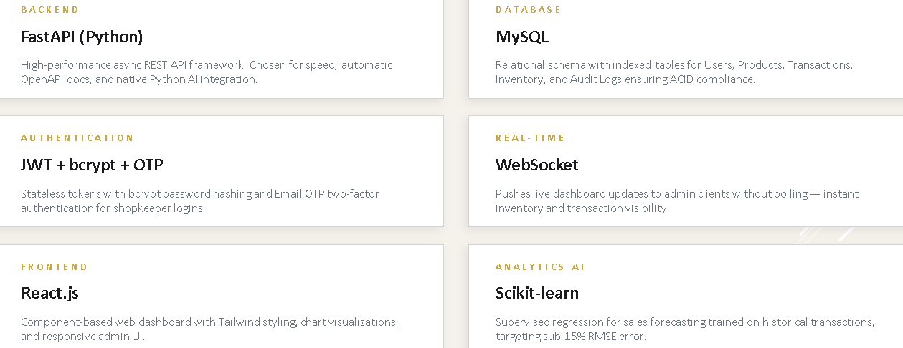
Table. Tech stack

5.1- Monitoring and controlling
For the system testing process, we verified whether the application satisfies our expectations. Various kinds of tests have been carried out; for example, unit test, integration test, functional test, and user acceptance test. In the case of unit testing, we performed tests on individual components one at a time, whereas for the integration test, we checked whether the system modules work in coordination. The functional test ensures that all functionalities operate as expected, whereas the user acceptance test determines the satisfaction level of users from the system.

Test cases were created simply to check a specific situation and for an expected result. For example, one test case was to enter valid login details and confirm that the user reaches the dashboard successfully. Another test case was to process a sale and check whether the invoice is generated and the stock is reduced correctly. We also tested error and situations, such as entering wrong credentials in login part or trying to access a feature without permission for example cashier changing the pin. These test cases helped the confirm that the system behaves correctly in both normal and unexpected or in an anomaly conditions.
Test ID | Test Name | Steps / Input | Expected Result | Status
UT-LOGIN-001 | Valid Admin Login | Enter valid admin email & password → click Sign In to Terminal | Redirect to Admin Dashboard; session token created | Pass
UT-LOGIN-003 | Invalid Email Format | Enter 'kasim@' as email → click Sign In | Inline validation error: 'Enter a valid email address' | Pass
UT-LOGIN-004 | Wrong Password | Enter correct email, wrong password → click Sign In | Error message: 'Invalid credentials'; fields not cleared | Pass
UT-LOGIN-005 | Empty Email Field | Leave email blank → click Sign In | Error: 'Email is required' | Pass
UT-LOGIN-006 | Empty Password Field | Leave password blank → click Sign In | Error: 'Password is required' | Pass
UT-LOGIN-007 | Role Toggle – Cashier/Admin | Click 'Admin' toggle; then enter admin credentials | Form accepts admin login; redirects to Admin panel | Pass
UT-LOGIN-008 | 2FA OTP Sent on Success | Submit valid credentials | 2FA verification screen appears; OTP email sent | Pass
UT-LOGIN-009 | Valid OTP Entry | Enter correct 6-digit OTP | Access granted; landing page loaded | Pass
UT-LOGIN-010 | Invalid OTP Entry | Enter wrong 6-digit OTP | Error: 'Invalid OTP. Please try again'; resend option visible | Pass

Table. testing
Although problems occurred when implementing and testing the software, there was always a solution to the problem. For instance, where the module did not provide the instantaneous update of information, the matter was sorted out by the improved connectivity between the API and database. Where the user interface had some limitations, changes were introduced to make the interface more user-friendly. If a particular test was unsuccessful, adjustments were made to make the program deliver the desired output.
Consequently, summing up, it can be stated that the stage of development and testing transformed our idea into a functioning software application. That is, all components from frontend and backend to databases, APIs, and many others were successfully implemented into a working application. Due to testing, possible risks associated with our application in the future could be recognized and dealt with. Ultimately, we obtained a functioning application ready for deployment.

Individual Reflective Evaluation

6.1 Introduction
I could not find a way to solve these problems, except to try to look up the system before writing code and try to figure out what each component does before working on it. It helped me to minimize error because I had a good idea of what I was working with. When errors occurred, I did not simply guess and check a solution - but examined the code, checked structure once more and looked for similar solutions on GitHub and elsewhere. This was a great way to develop a more careful and logical debugging process. On the frontend, I primarily just cleaned up the look and did it a little at a time until it was working correctly. I communicated with members of the team more effectively so that our work is consistent. I also spent my time more effectively, breaking down the tasks into smaller parts, which helped to make the development, documentation, and presentation more manageable. I was able to solve most of the problems and continue and progress by using research, communication, patience.

6.2 Contribution
This project has taught me a lot of valuable skills, technical and otherwise. On a technical level, I got a better understanding of frontend tools, project structure and the value of using GitHub for code research and project understanding. I also gained an understanding of the way that real software projects are structured and the interactions between different files and modules. In terms of the project skills I learned, I felt I knew more about how to set up a real environment project, how to plan it, how to allocate the work, how to work within the timeframe and how to merge various features into a final product. Very useful, as it helped me gain insights into software teams in action. As far as teamwork is concerned, I got to know how to work with others, share the load, listen to suggestions, and go to bat for one another when there are issues. I also gained personal skills, as I would have to co-ordinate, communicate and be responsible for my own work, to keep in touch with the group. One of my biggest learning experiences as part of this project has been these learning experiences.

6.3- Reflection on what when well
When I look back on myself honestly, I would say I did a decent job and participated in the project, but still would like to think that I could have done even better in a couple of areas. For instance, maybe I could have done a better job of managing myself and the time so certain things wouldn't have been as rushed as they were near the end. I believe that I could've gone into more ideas for the front end and tried more design iterations before settling on the interface. In some instances, I over-relied on solving problems AFTER they occurred rather than preventing them earlier by more thorough planning. Nonetheless, I'm pleased I could fulfill my duties and help the team through the various phases of the project. This project made me realize that good work is not just about getting the job done, but excelling in the quality, consistency and attention to detail.

6.4 Challenges
Finally, I think this project was a whole learning experience for me and I've gained a lot of experience in Research, Frontend development, testing, documentation and presentation. I had the opportunity to make a contribution in many different ways, and each one of them was different in helping me to grow. This project helped me to learn that working with groups, planning, problem-solving and perseverance are the key skills for successful work. Despite the difficulties, I could clear the hurdles, by researching, questioning, and staying focused. I am planning to learn more technical skills, make good use of time and participate in similar projects more confidently in the future. The overall project experience was useful to me and to the team because I learned new concepts and acquired new skills.

6.5- Problem solving
So, to overcome these issues, I attempted to find out what each component should do ahead of time and investigate the system prior to coding. This really helped me to make fewer mistakes as I had a better idea of what I was creating. If errors came up, I didn't simply take a guess at a solution, but rather I read the code and re-looked at the structure and looked for similar solutions on GitHub and other places. Such a method made me realize how to debug more carefully and in a logical manner. I looked at them for frontend issues, went through simplifying the layout and tested it after each change, until I got it to work right. When working with teammates, I communicated better in order to ensure a consistent work flow. Also I was better able to plan my time by breaking things into smaller parts to make it easier to develop, document and present together. With research, communication and patiently I could solve most of the problems and continue to move forward.

6.6 learnings
I learned a lot in this project – it's been a great learning experience technically and personally. Technically, I learned more about frontend tools and how to use them, project structure, and the significance of GitHub for doing research on code and understand the project. I also became more familiar with the organization of real software projects, modules, and files, and how the various parts relate to one another. As a project skills perspective, I knew more about the structure of a real environment project with regards to planning, the allocation of tasks, dealing with deadlines and capturing various features into a single final product. This was of tremendous value, as it helped me to gain some insight into a software team's workings in reality. As a team player, I developed a better sense of team work and collaboration with others, learning to share, listen to someone's ideas, and help others out when difficulties arose. I also acquired personal abilities like coordination, communication and responsibility as I had to work with the group and coordinate my work. One of my greatest learning opportunities of the project were these learning experiences.

When I look back at myself, I'm happy that I did well and was active on the project but in some areas, I feel I could have done better. For instance, I could have planned my time more effectively to have some tasks done less hurriedly towards the end. I believe that I might have tried more interface variations and ideas, and tested more designs in front-end before the interface was finalized. In some areas, I've allowed myself to fall into a reactive stance and would only solve a problem after it was in my face, rather than address it at a deeper level early in the planning process. Despite this, I am very pleased that I was able to fulfill my duties and help the group in several phases of the project. This project gave me a good idea of the importance of doing the work well, consistently and paying attention to detail.

Finally, this project was a learning experience for me and provided me with valuable experience in research, frontend development, testing, documentation and presentation. I did have a lot of opportunities to make contributions in different ways, in different areas; and each way I was able to contribute helped me grow in a different way. The project taught me that good work is achieved by working collaboratively, planning ahead, problem solving, and perseverance. Though it was difficult, I managed to face the difficulties by doing research and asking questions and focusing. I want to further enhance myself technically, organize my time more effectively and be able to be a more active, confident participant in comparable projects in the future. In general, this project was a great experience for me and has enabled me to learn and become a better member of a team.

Conclusion

Out of reach for many shop owners across Nepal, proper record keeping once meant scribbles on notebooks. Then came something different - Invo6 Enterprise Retail filled that space quietly. Running small stores used to mean tangled routines until this system stepped in. Not everything changed overnight, yet progress showed up piece by piece. Old habits gave way when screens replaced dusty ledgers slowly. Now tasks flow better even where internet stays weak. Moving ahead felt hard before tools like this existed. Without shouting about innovation, daily operations began shifting anyway. Things feel easier once tech learns to move like we do. Weight lifts when gadgets slide right into the day.

Out of nowhere, once done, Invo6 reveals an entire system made fresh with different parts - web gadgets here, phone app bits there, linked by clever data storage that talks in real time thanks to online gadgets whispering back and forth, while quiet learning software hums beneath. It runs. Actually runs. Shows how split technologies can line up neatly, solving actual business problems without clutter or detours. Straight off, the goal set the pace - replacing clunky paper-driven bilingual processes with a leaner digital flow. Right there, errors dropped because tasks ran quicker and numbers turned sharper. Not stuck waiting anymore; changes appear right away, not days later. Hand-scribbled lists used to disappear - now nothing slips through cracks so easily. Past customer orders? They’re visible at last. Old tools choked on tangled entries and slow updates, yet INVO6 links each piece in real time. When pieces talk fast, guesswork about stock vanishes. Lost invoices bother nobody now that all moves line up together.

One thing grabs attention here: the pieces fit neatly into a single frame, no longer scattered. Not isolated bits anymore, but tied together by a main hub that supports each part. Running on FastAPI and MYSQL, the back end manages info handling, sign-ins, and key actions - no doubling up. When users log in, safety leads; scrambled code shields private data constantly. Purchase records and inventory amounts settle into clear patterns, so changes later feel easier. Most jobs it handles are tricky, yet the design follows REST principles - making future updates fit without chaos. This way of building means scaling up isn’t tearing apart old parts but simply reaching further from where things already stand.

React powers the web dashboard, offering managers and staff a straightforward path through daily duties. Alongside checkout functions sit inventory tracking, history logs, yet settings for people using the system - all gathered neatly. Clear visuals guide every step, built so anyone, regardless of experience, finds their way without pause. It mirrors real shop workflows, each view matching the pace of actual shifts. Flow emerges not by force but how pieces fit together when you start moving through them.

Straight off, using React Native means the app works smoothly on phones. This lets customers look up old purchases without going near a physical shop. Since all records live online, each transaction becomes visible, slowly creating confidence. Paper receipts fade out when digital trails sit neatly within the software. Suddenly, keeping tabs on shopping trips shifts from pockets to displays. Instant updates kick in each time a scan hits - no lag, just live bill changes. Out goes the old way of manual entry, replaced by seamless links between scanner and central brain. These gadgets rely on ESP32 units, whispering data via MQTT signals. Mistakes fade when hardware feeds info directly into the loop. Checkout lanes breathe easier, handling more with less friction. Devices connect, talk, act - not magic, just smart wiring at work.

Inside the device, a clever component combines forecasting features with a chat assistant based on clear reasoning steps. Thanks to learning from old sales data, the system detects patterns, helping vendors plan stock smarter. Questions about items bring quick replies via the messaging robot, skipping delays. Getting information becomes simpler, keeping workflow moving steady. Everything runs in the background, easing everyday jobs without drawing attention. From the start, thoughtfulness guided every part of its creation. Not a single line appeared without first drawing out ideas - maps showing tasks, roughs linking pieces, frames shaping screens - all pinned down ahead of time. Because those drawings existed, confusion during coding dropped sharply. Information moved smoother since the data store obeyed clear logic, cutting duplicates before they started. When space and retrieval matched that order, speed followed without force. Built right, it ran light.

From day one, building with safety in mind set the tone. The system relies on a strong login process, using JWT tokens for active sessions while securing passwords through bcrypt hashing. Instead of links, emails deliver temporary codes to verify who you are. This approach wraps sensitive data - personal records and internal business information - in protection that blocks outside access.

Halfway in, things began flowing more smoothly thanks to a structure inspired by Agile methods. Not everything piled up at once - tasks were broken apart, managed in Jira for easier watching. Step after step, movement became clear, shared across the team. As updates moved forward, visibility grew naturally. Consistency held firm since GitHub tracked every version, isolating edits through branches. Now and then, folks gathered - less about status reports, more about lining up efforts around servers, screens, gadgets you carry, and networked sensors. One piece might sprint ahead while another took its time, though everything somehow stayed in step.

Inside the system lives the database, storing essentials - product names, how much is in stock, user accounts, records of every purchase. Strong links between parts make sure data stays correct, yet still quick to pull up during busy moments. Built this way, what you see on screen connects smoothly to background tasks, so updates flow steady, never stuck. Halfway in, things started flowing more smoothly thanks to a structure inspired by Agile methods. Not everything piled up at once anymore - tasks broke apart into tiny pieces using Jira, helping track what was happening without confusion. Each small move forward showed up clearly, seen by whoever needed to see it. The code remained steady as GitHub managed updates, with branches acting like lanes on a road, keeping each change distinct and tidy. Now and then, folks gathered - less about status reports, more about lining up efforts around servers, screens, gadgets you carry, and networked detectors. Every piece kept its rhythm while somehow staying in step with the whole.

Inside the system lives a database managing product info, inventory levels, user accounts, and purchase records. Built-in links between parts make sure data stays correct yet quick to find during active use. Structure matters here - it lets front-end displays connect smoothly with background tasks. Information flows steady, no interruptions.Here, the completed system reveals how digital tools unite to solve real business challenges. When theory meets practice, a reliable result emerges - crafted carefully, performing when needed most.

FUTURE RECOMMENDATIONS

One step ahead today doesn’t mean standing still tomorrow. The Invo6 Enterprise Retail system hits its targets just fine right now. Still, small gaps linger beneath the surface. Tweaking tools further might help sharpen daily moves. Staff interactions could feel lighter with slight refinements. When busy times hit, breathing room matters more than ever. Performance that holds firm during chaos? That kind of reliability tends to matter most when things get noisy. One step ahead, digital payment options may matter a lot soon. For now, the system just records what you owe and what gets paid - no extra features. Later on, mobile wallets could join in, perhaps along with scanning squares or moving money straight from banks. Shifting this way might allow stores to handle all tasks in a single place rather than switching between tools. Less passing around often leads to cleaner work behind the scenes.

Some stores might find better results by improving how they handle data. Today’s setup includes just basic forecasts along with a tool that runs tasks automatically - yet each has room to grow. Smarter math behind decisions can reveal things like customer habits when picking goods, changes in demand across seasons, or which items slowly rise in interest. These clues help shape decisions about inventory levels, timing for price moves, even testing discounts. Real insight shows up once you look past the obvious stats. Still decent, though a touch more polish wouldn’t hurt. Right now it runs fine, yet tidier visuals tend to help users relax while navigating. Rather than holding back, testing fresh arrangements can reveal simpler paths to common tasks. A dimmer display suits some, just like larger icons or spoken prompts assist others. Real skippers giving it a go would highlight what flows - and what trips them up. Start anywhere, and someone new might see it first. Over time, small shifts sparked by actual moments outshine the rest. Most hidden gains come not from grand plans but quiet fixes noticed late.

These days, looking at how fast the system scales, testing a cloud option might be worth it. Rather than relying on in-house machines, running the app through distant services often lifts reliability, space to expand, along with simpler access. So multiple locations can use identical features together, skipping lag issues entirely. Beyond that, storing data by default and bouncing back when glitches hit feels more seamless, locking down information safely.

Past a barcode, things start shifting. Devices chat through air, tracking items solo. When stock dips, sensors murmur alerts. Store movements glide better, seen by unseen eyes. Quiet machines step in, doing more without a word. Growth comes through calm attention, not loud effort.

Even now, weak signals plague countless locations, making offline functionality a quiet win. Should reception vanish - likely outside city edges - the system carries on, unruffled. Information sits patient, biding its time till connection returns, sliding home once online. Strength grows not by demanding perfect conditions, but by working anyway, right where people actually are. Tools sitting outside - say, invoicing software or tax services - could link up directly. This kind of tie-in may pull separate pieces into one flow, reducing app hopping during routine tasks. Right away, push notifications help apps stay in people’s pockets by sharing purchase confirmations or offers tuned to personal choices. That connection grows stronger - shops shift from simply selling items to building ongoing exchanges. Technology slips out of silence and begins acting almost human.

Later performance lives off present care. Routine stress tests, security sweeps, or usability runs reveal quiet flaws early. Because adjustments stack quietly, smooth operation sticks around. Upgrades handled steadily prevent slow fade into irrelevance. Future strength grows from current habits. What survives time leans on today's choices. Tomorrow might come easier because the system already stands on solid ground. Built the way it is now, growth doesn’t mean rebuilding from nothing. Small shifts, added one after another, open doors wider than mere expansion - flexibility across shops begins to take shape. Though right now it hits current targets fine, more lies waiting underneath. Smoother handling of heavier loads emerges when updates stick over time, adjusting as demands stretch further.

Refrences
[1] Freshworks. (n.d.). Customer loyalty and trust in business. Freshworks.
[2] Kara Lambert. (n.d.). The importance of valuing time in business. Kara Lambert.
[3] BBC. (n.d.). Should cashiers be replaced by machines? BBC.
[4] TEKTELIC Communications. (n.d.). Smart retail: What is IoT retail and what are its benefits? TEKTELIC Communications.
[5] IBM. (n.d.). AI in retail. IBM.
[6] Open Source Point of Sale (OSPOS). (n.d.). Open Source Point of Sale.
[7] OpenSource.com. (n.d.). Point of sale tools and systems. OpenSource.com.
[8] Retail IQ System GitHub Repository. (n.d.). Retail IQ System. GitHub.
[9] Product Inventory Management System GitHub Repository. (n.d.). Product Inventory Management System. GitHub.
[10] AI Retail Management System GitHub Repository. (n.d.). AI Retail Management System. GitHub.
[11] Smart Billing Management System GitHub Repository. (n.d.). Smart Billing Management System. GitHub.
[12] E-commerce FastAPI React GitHub Repository. (n.d.). E-commerce FastAPI React. GitHub.

