Admin user manual

STEP-1: Go to the website
- Open your browser.
- Type this url ‘ ’ .
- You will see two terminals, admin terminal and cashier terminal, click admin dashboard.
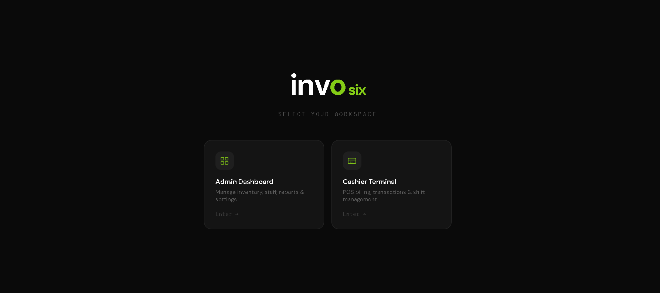
STEP-2: LOGIN
•Type the credential (Email – sim@gmail.com Password – simonana1) or make your own cashier from admin page and enter login, once the credential is correct you will be rendered to verification page, look at your email (sim@gmail.com) you will be given 6-digit verification code enter the code and enter into the system.
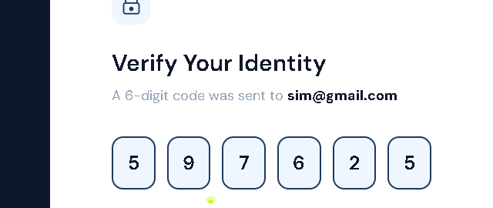

- After completion of these 2 steps you will be rendered to cashier dashboard page here you can see all the transactions, sales, top product, low stock items. You can also export this data by clicking on export button on the top right side.

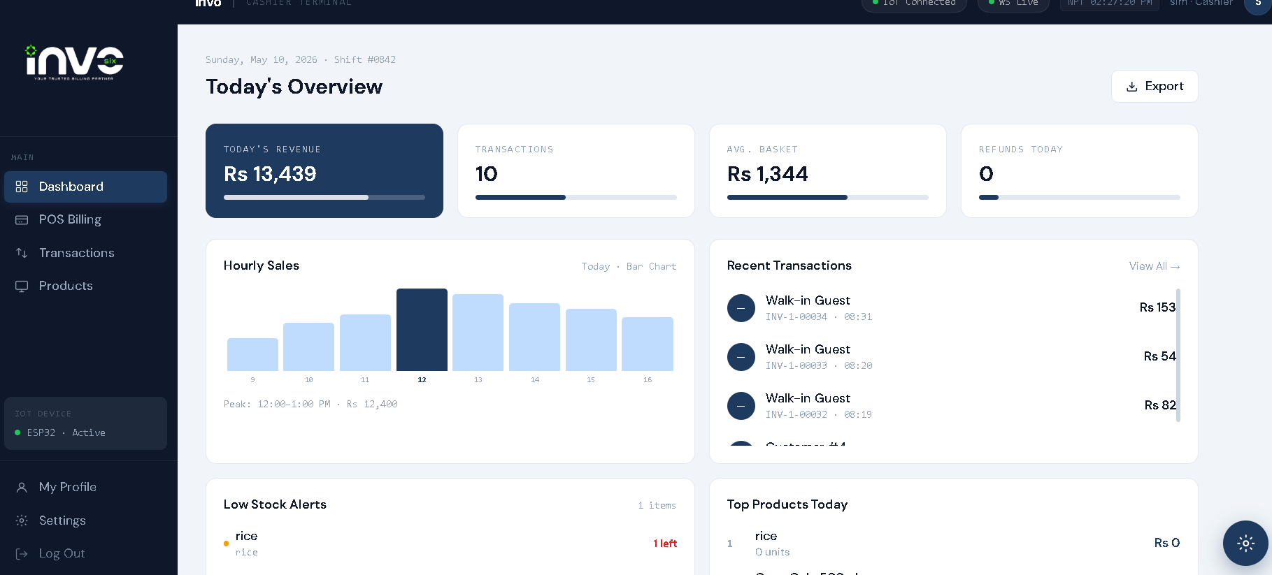
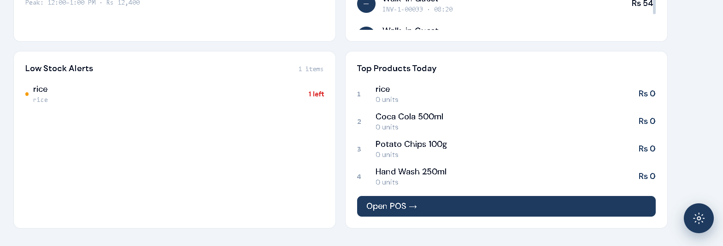

- POS BILLING
- This page satisfies the main use of cashier, here all the POS billing and transaction is being done, navigate to the page.
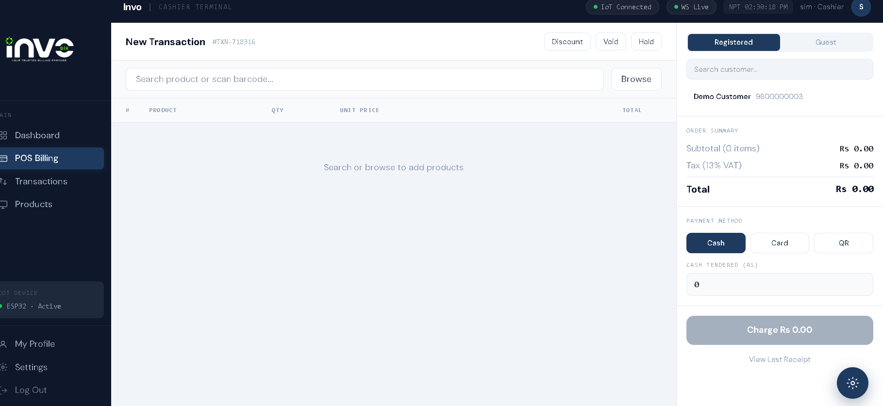

- Make a new transaction by browsing and selecting the product, adding discount to it and select if it is a registered demo user of unregistered customer, also select the payment method.
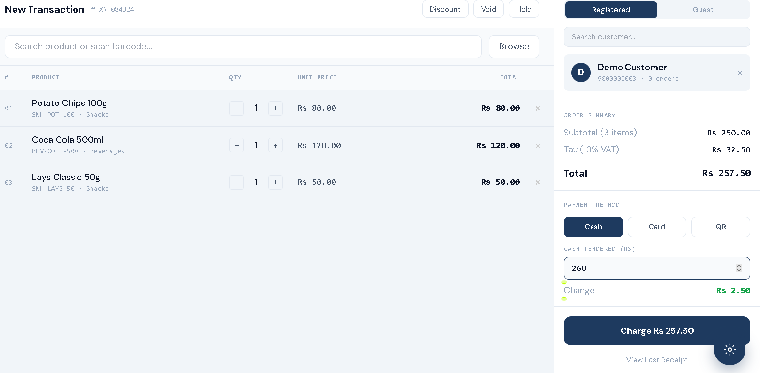

- After this scan every item from IOT device and then get receipt.
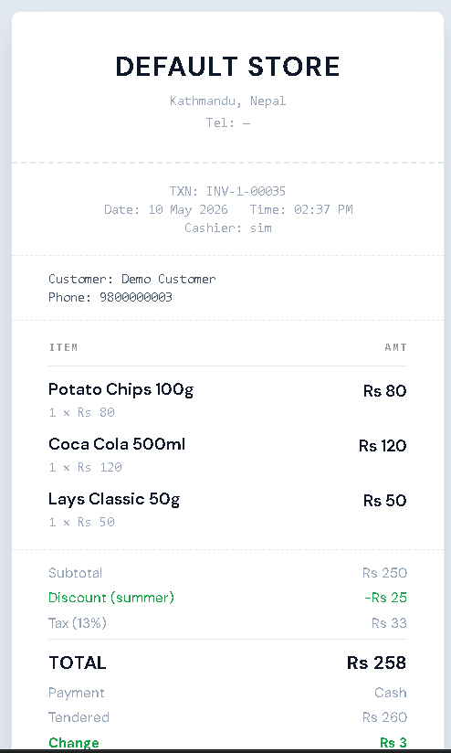
- In POS billing you can also use void to cancel and hold to wait the transaction.

- Transaction page
- In this page you can view and search all the transaction- paid, refunded, hold and these types too.
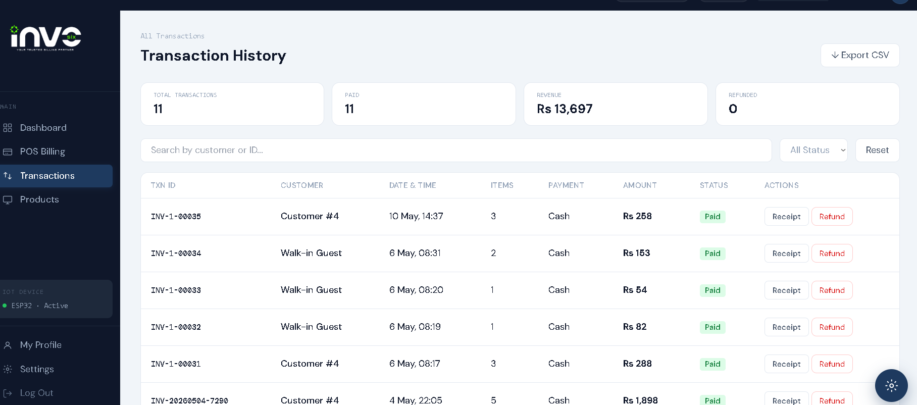
- You can also refund the transaction from here , by clicking refund you will be shown with a transaction pin you can change this pin from admin dashboard for now it is (1111) 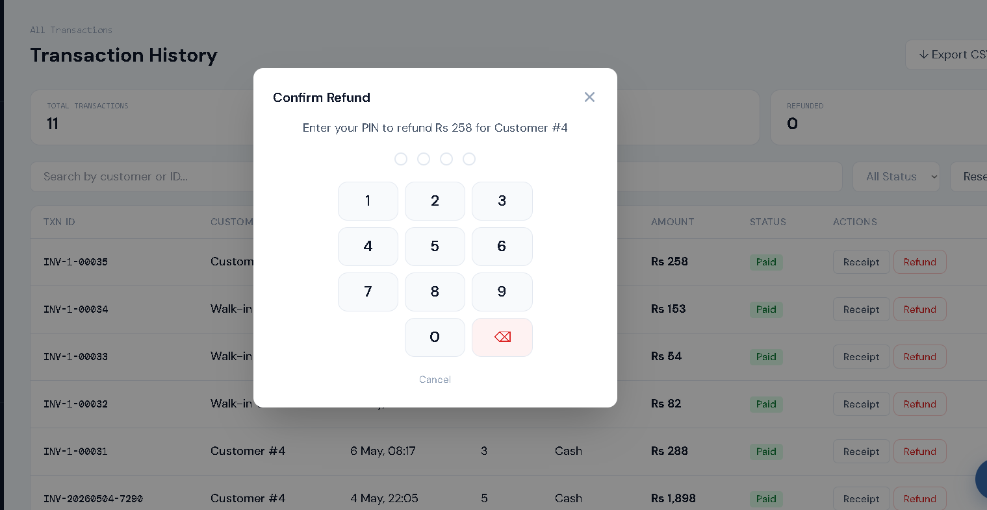

- Then it will be refunded as shown in the picture

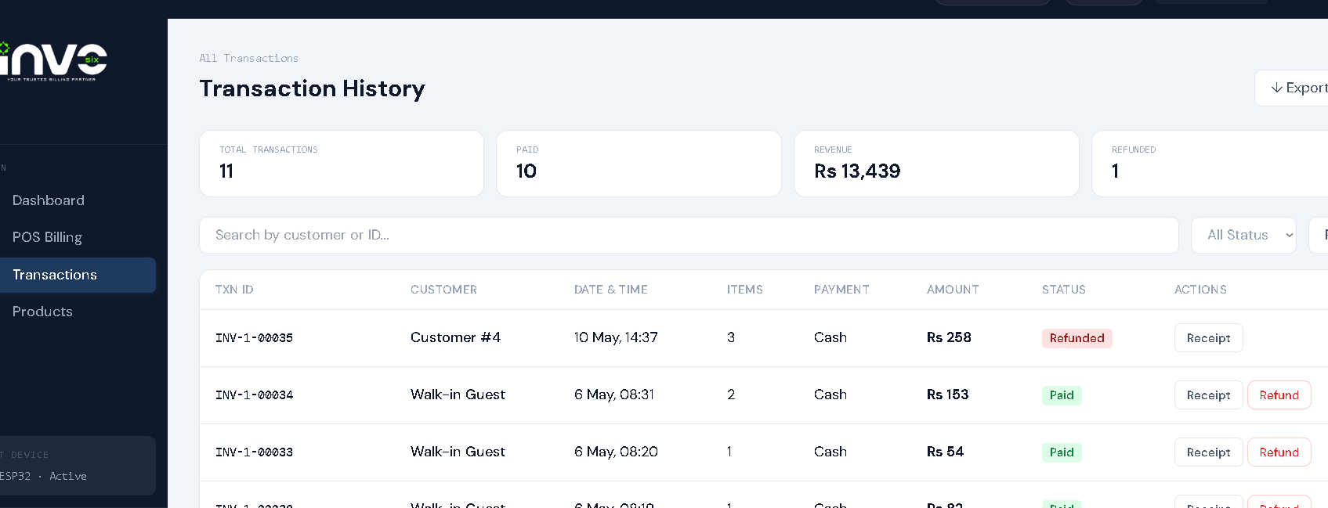
- You can also make view the receipt from here by clicking in receipt
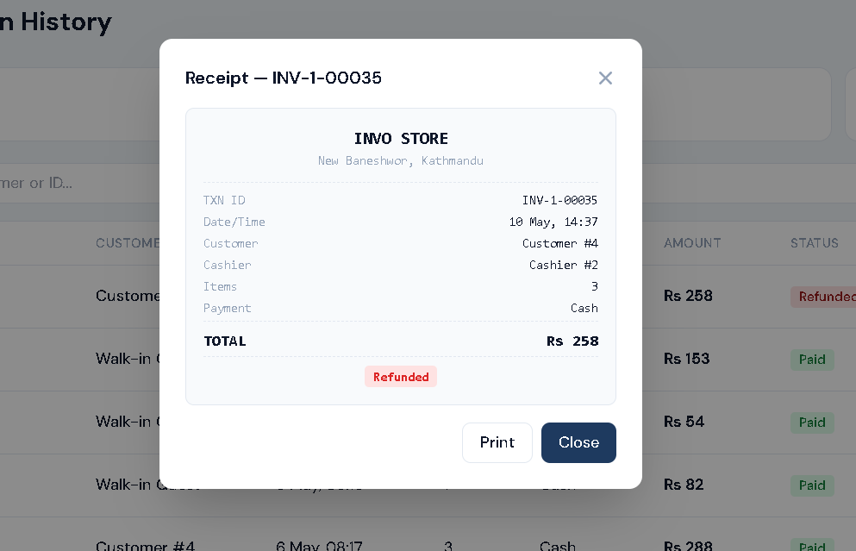

- Product page

- This page is to show all the product in the database with picture if we have added it. We can also add to cart the product from here and then do the POS billing.

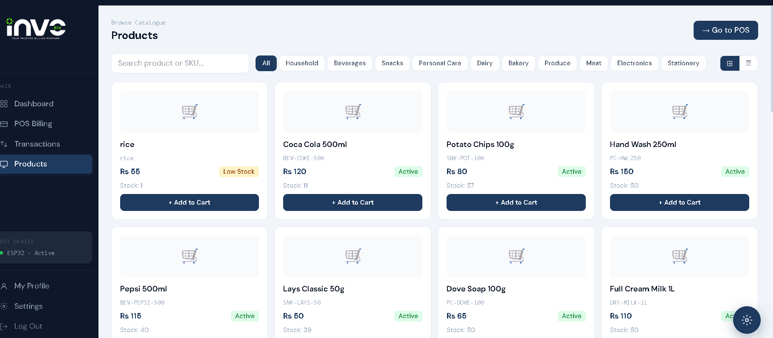

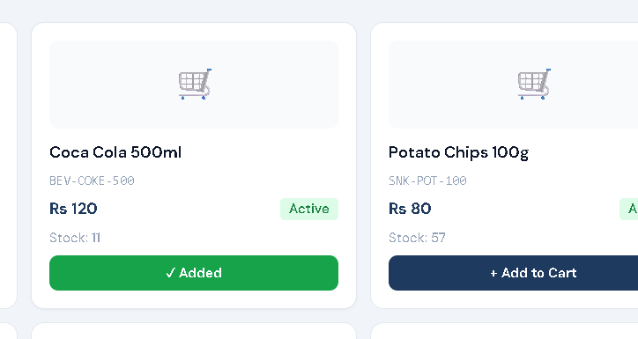
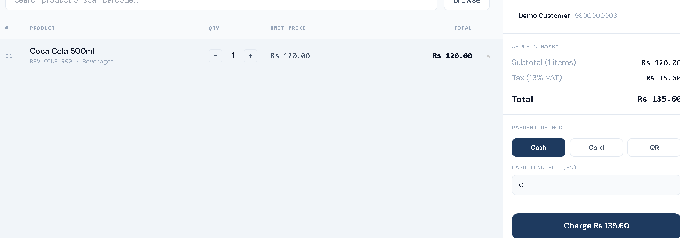

- Profile page

- In this page you can see your personal information and to choose among your preference.
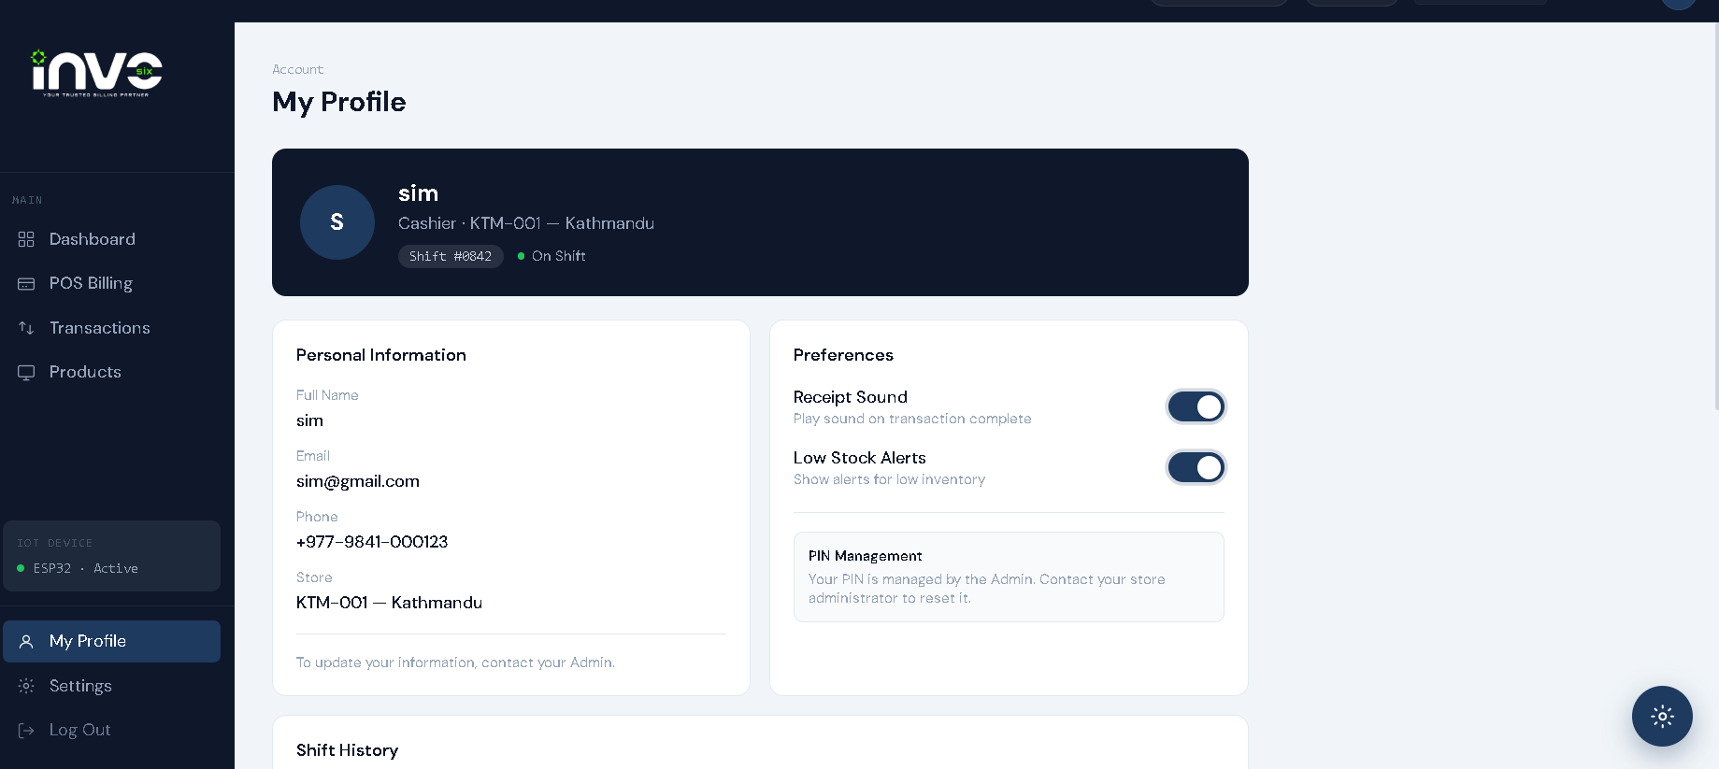

- Settings page

- In this page you can see the information of store and adjust according to your liking, it is a good way to understand the product what has been used and working according to preference.
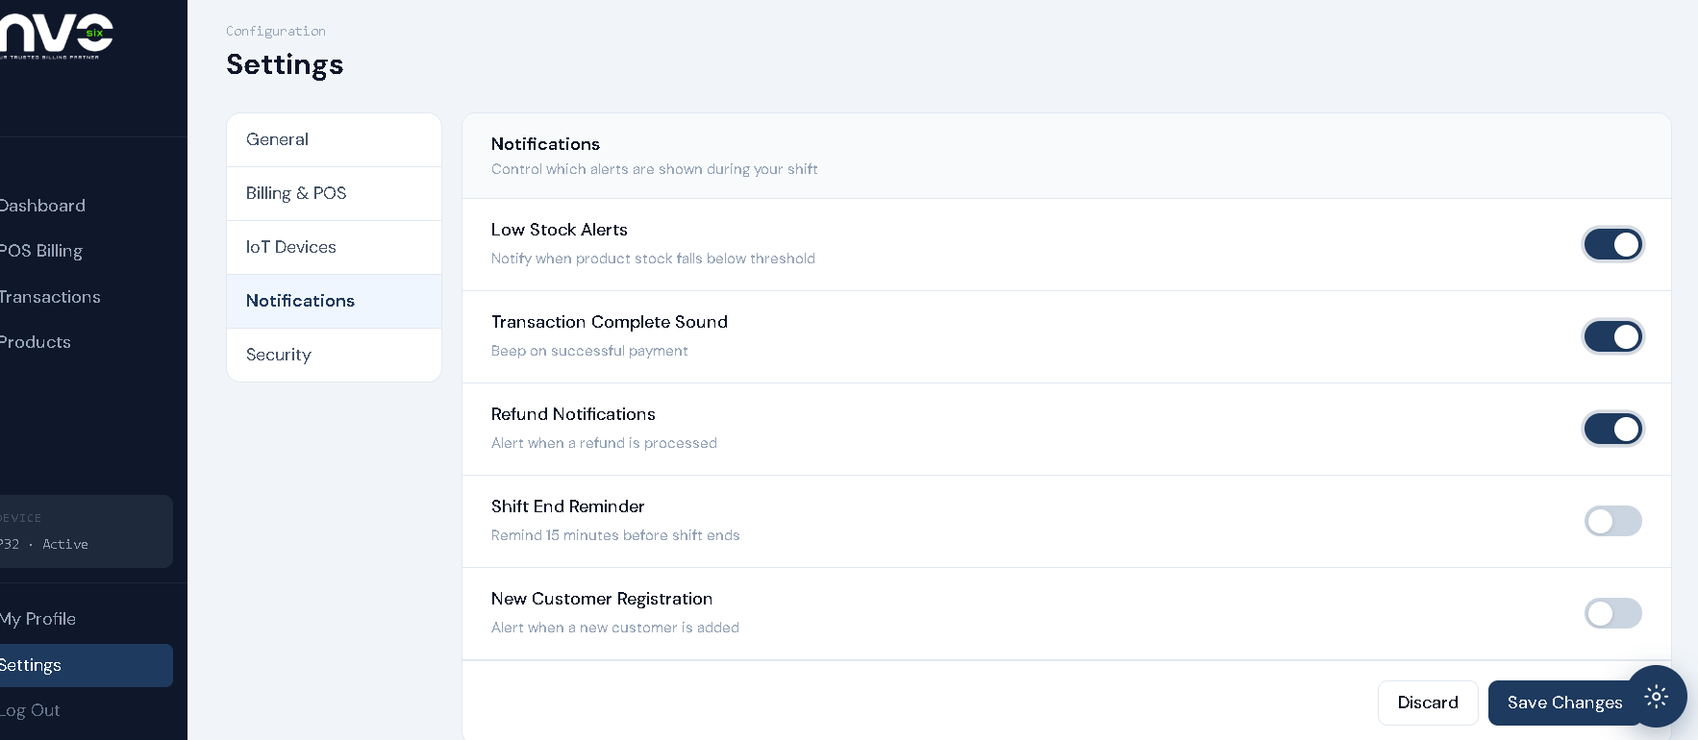
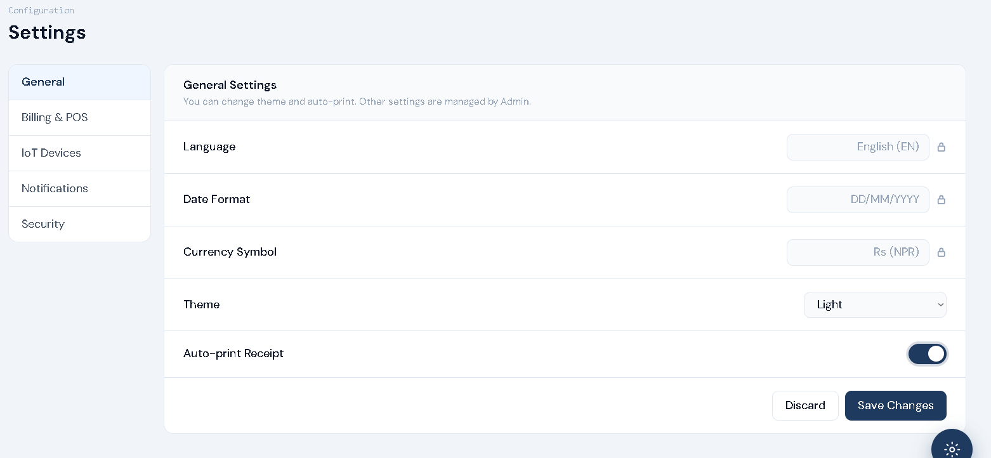

- Ai chatbot

- This is AI Chatbot it answers all the queries on transaction, sale, cashier and more, it is your intelligent billing friend.
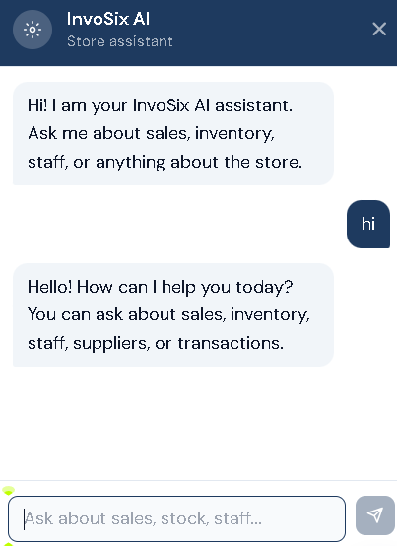

So, this is how you use Cahier Dashboard of INVO6

