CUSTOMER USER MANUAL
STEP 1-Open the app invo-6
Step 2- Register/ login
- Click register button and put your information and login to the system with same credential.

Home page – In this page you can see the transactions, history, and other information this is an informative page.
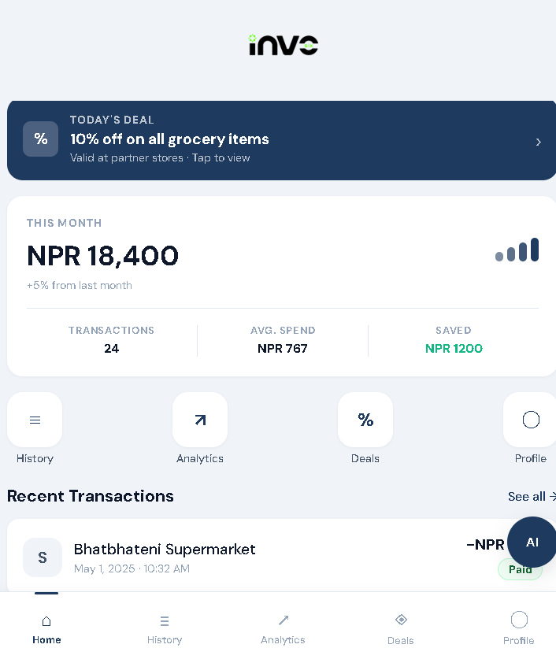

Notification page – Here deals, offers and other notifications pops.
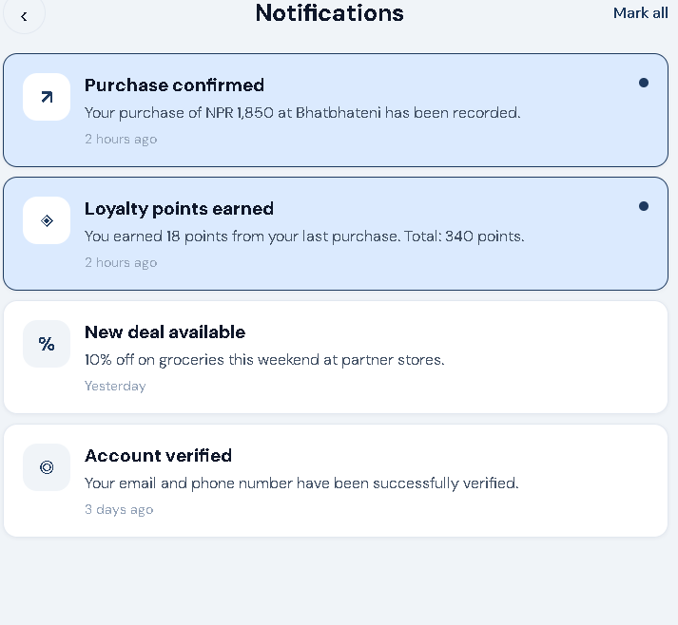

Offer page – In this page user can see the deals and offers offered by the store in current moment.
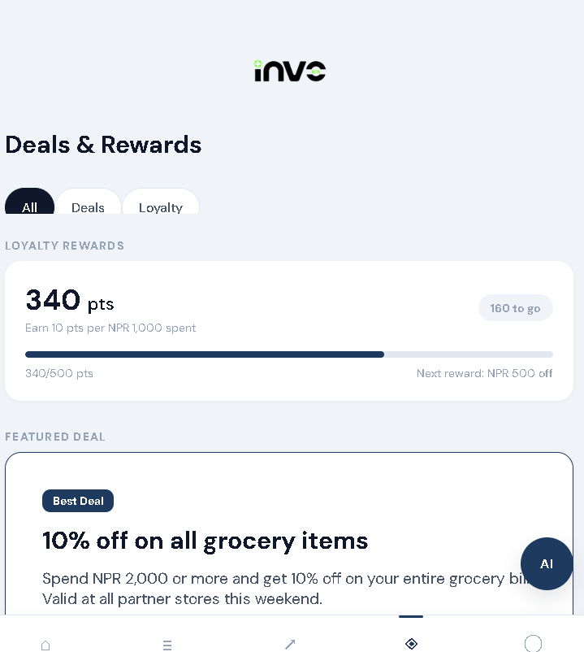

History page – All the transaction done by the uses in weekly, monthly basis is shown here. We can also view the receipt
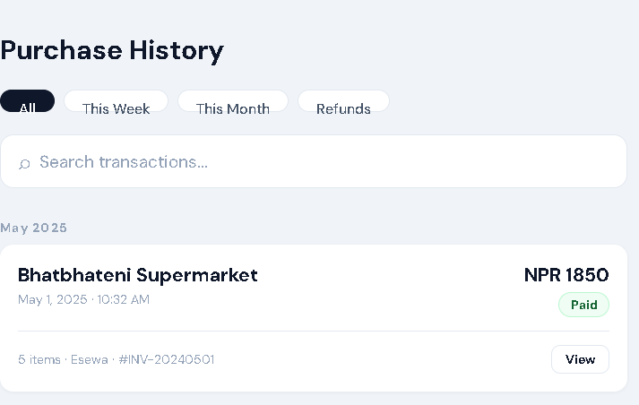
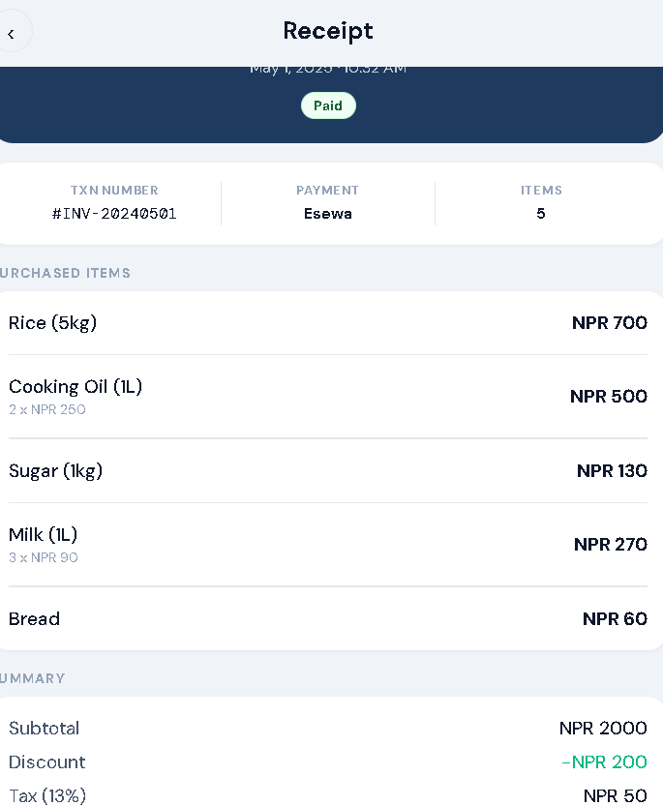

Analytics page – This page tracks your purchase, total purchased and total saved in weekly, monthly and yearly basis.
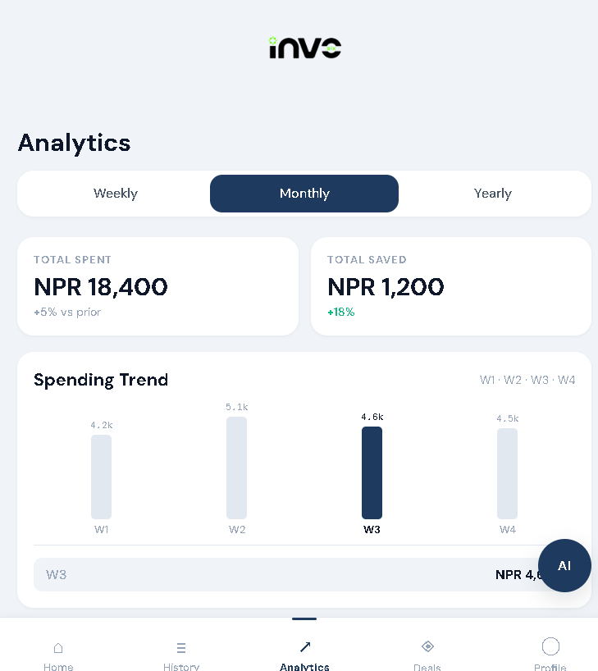

Profile page – Here we can view out information, change passwords, change preferences and more.
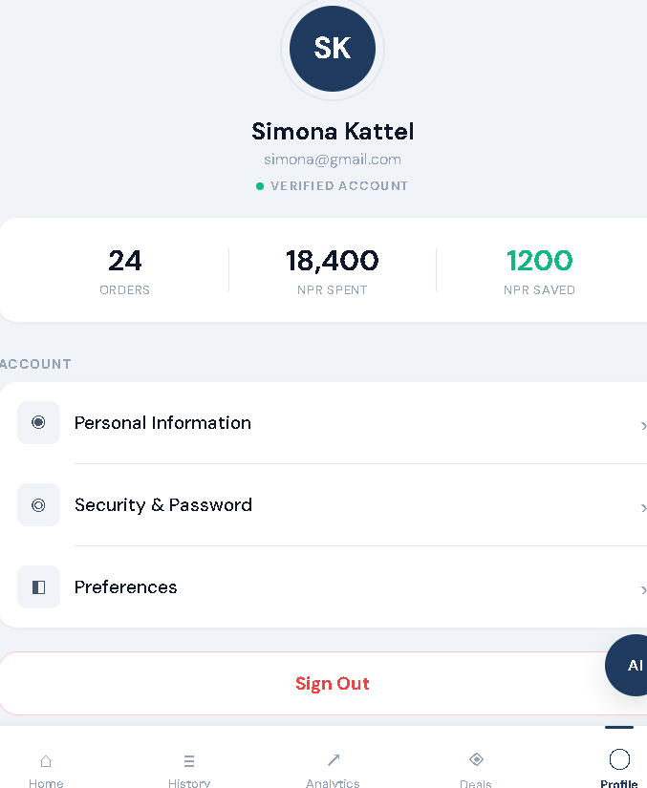
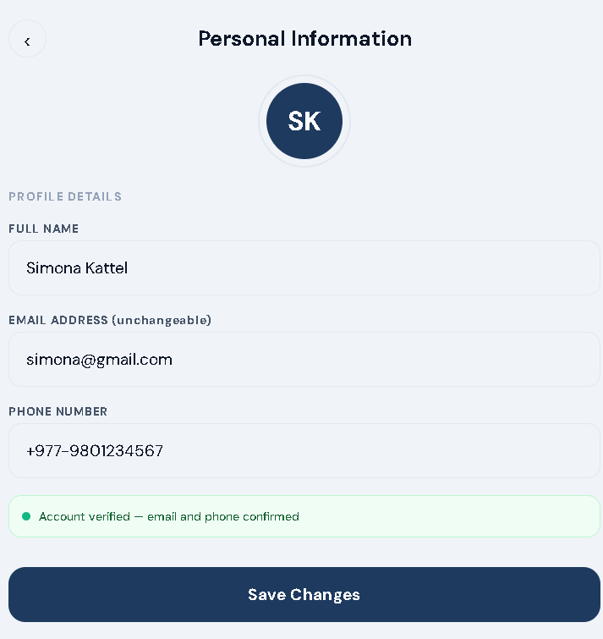

- We can also change passwords by going in security and passwords
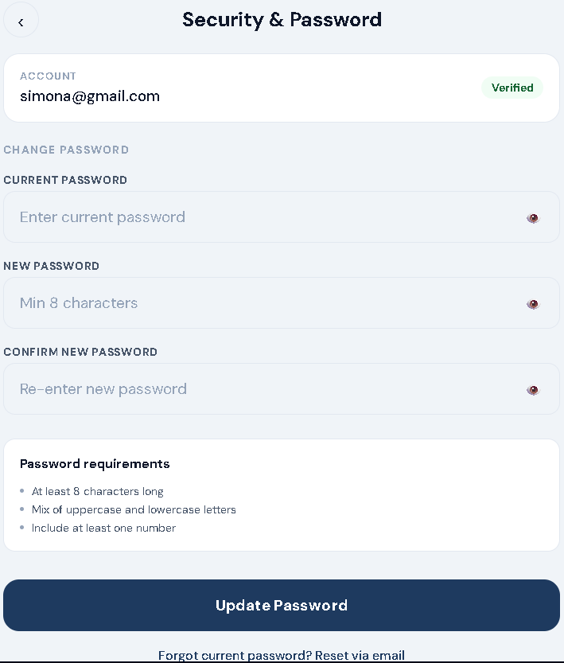
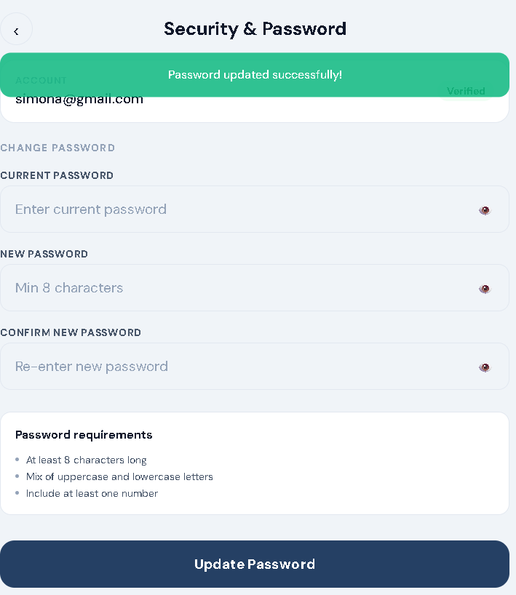

- Change the preferences according to your liking.
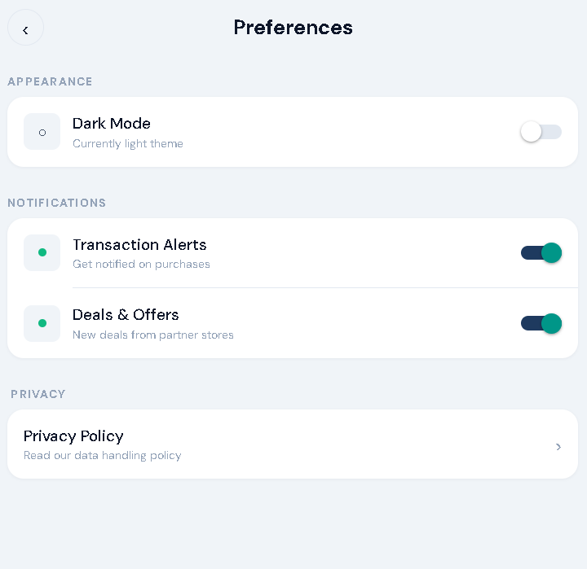
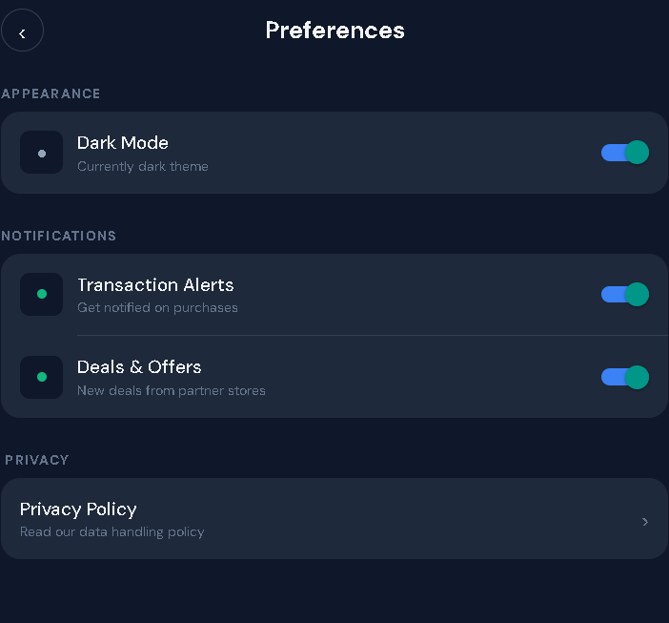

AI chatbot page – chatbot page opens when you click at the circular button places at bottom right corner, you can chat about your purchase, deals and more with the bot.
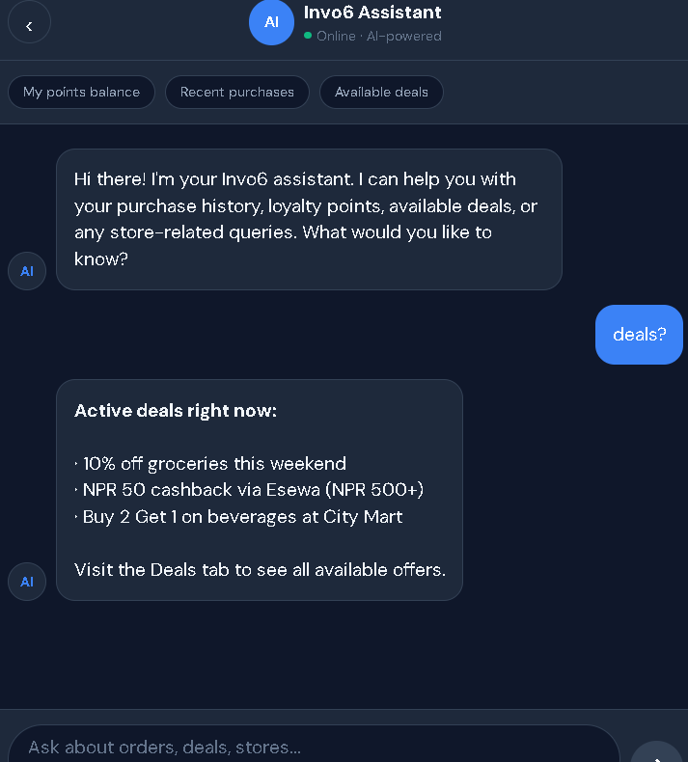

This is how you can use the customer app of INVO6

