Bugs

1.**[Email field validation] Email validation referred as username;**

**Description:** When entering the email, the field validation referred to user as “Username” which may be confusing.

**Steps to reproduce:**

1.Navigate to <https://betterqa.co/the-registration-page/>;

2.Go to email field and type a valid email address;

3.Email referred as “username”;

**Actual result:**

Email field validation referred as “Username”;

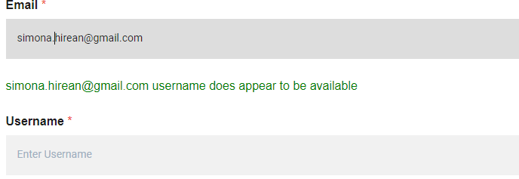

**Expected result:**

The email field validation should be referred as “Email does appear to be available”;

**2. [Repeat password] “Repeat password” content not hidden;**

**Description:** Based on the requirements, the “Repeat password” content should be hidden.

**Steps to reproduce:**

1.Navigate to <https://betterqa.co/the-registration-page/>;

2.Fill the input fields with valid data;

**Actual results:**

“Repeat password” content should be hidden;

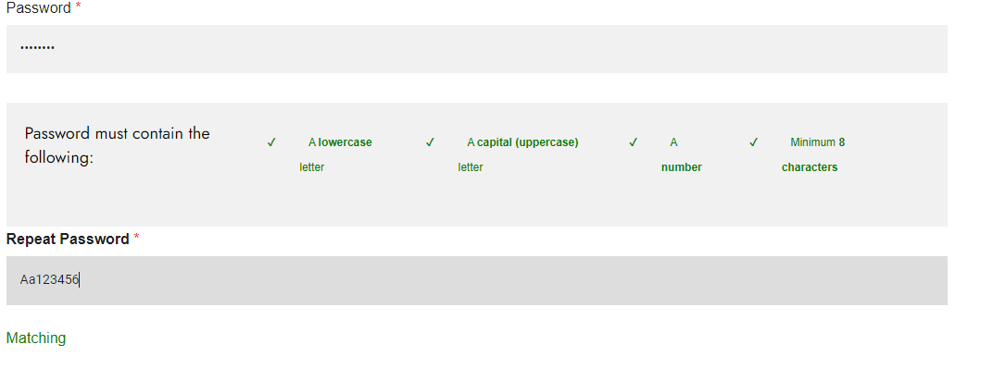

**Expected results:**

“Repeat password” content is being prompted;