Nanyang Technological University
MH6822 Assignment 2 | Regulatory Technology

OTC Derivatives Trade Reporting
Compliance Engine and Prediction
Market Classification Frontier
A rule-based RegTech pipeline for UPI, UTI, LEI, and CFTC/EMIR validation
with EventContract classification analysis
UPI / UTI / LEI validation · CFTC / EMIR reporting logic · T026–T028 EventContract frontier
Data quality · Reporting scope · Regulatory conclusion · Rule-based engine · Dashboard · Final report
Prepared by
Student ID | Name
G2505246J | LIU YISHAN
G2505431H | GONG PENG XIANG
G2506255B | GUO YIHAN
G2505266E | ZHANG JUNYI

Regulatory Technology | May 2026

Table of Contents
1. Thesis and Data Lineage 3
2. Regulatory Framing 4
3. Engine Architecture 4
4. UPI Lookup and Codeset Validation 5
5. Compliance, Scope, and Conclusions 7
6. Prediction Market Classification Frontier 10
7. Proposed EventContract UPI Schema 12
8. Regulatory Arbitrage Analysis—Two Elements from Brandes (2026) 13
9. Dashboard and Deliverables 14
10. Engine Limits and CFTC Recommendations 15
11. Conclusion 17
References 18
Appendix 19
List of Figures
Figure 1. Pipeline Architecture Diagram 5
Figure 2. Three-Dimensional Compliance Result 8
Figure 3. EventContract Classification Frontier Matrix 11
Figure 4a. Dashboard KPI Cards and Executive Interpretation 15
Figure 4b. Compliance Heatmap 15
List of Tables
Table 1. Auditable Data Chain 3
Table 2. Portfolio Asset-Class Distribution 3
Table 3. Engine Parse Status Summary 5
Table 4. Three-Dimensional Compliance Result Summary 7
Table 5. Legacy Overall Status 8
Table 6. Compliance Finding Frequency by Validation Rule 8
Table 7. Event-Contract Scope Assessment Rules 9
Table 8. Key Trade-Level Findings 9
Table 9. Event-Contract Classification Frontier Summary 10
Table 10. Economic Function Test for Event Contracts 11

Thesis and Data Lineage
The engine finds that conventional OTC products can be mapped and checked through existing UPI, UTI, and LEI infrastructure, but prediction market contracts expose a taxonomy and visibility gap: they may transfer real economic risk without producing standard trade-reporting identifiers. This report is therefore not only a JSON validation exercise. It is a data-driven regulatory analysis of where current reporting infrastructure works, where it flags bad data, and where it runs out of product-classification vocabulary.
Table 1: Auditable Data Chain
Layer | File | SHA-256 / version
Raw source facts | data/raw/trades.json | 3c19ed405809
Processed normalized trades | data/processed/trades.json | 3742984216e5
Product definitions | data/product_definitions | 8ddc6fc57e2a3f02
data/raw/trades.json is treated as the immutable case-file input. data/processed/trades.json is the normalized runtime file. The normalizer renames the raw parse_status to declared_parse_status and moves event-contract conclusion-like fields into case_file_ source facts. The engine then produces its own parse result, compliance findings, scope assessments, and regulatory conclusions. This avoids blindly trusting labels in the raw data while preserving the original case-file facts for audit.
Table 2: Portfolio Asset-Class Distribution
Asset class | Trades
Rates | 10
Credit | 4
FX | 5
Equity | 4
Commodities | 2
EventContract | 3

The data audit found:
- Event contracts: T026, T027, T028
- Null margin records: T017, T026, T027, T028
- Missing or placeholder LEI records: T021, T027
- Non-UTC or invalid timestamps: T013 (2025-09-01), T025 (NOT_A_DATE)
- Invalid or non-ISO currency candidates: T018 (INVALID_CCY), T019 (CNH), T027 (USDC)
- Legacy LIBOR reference-rate candidate: T005 (GBP-LIBOR-BBA)
The codeset checks are important. XAU is present in the DSB ISO currency codeset and must not be failed. GBP-LIBOR-BBA is present in the rates codeset, but it is a legacy LIBOR benchmark and should be a warning rather than a hard failure. USDC and CNH are not in the DSB ISO currency codeset used by this homework data.

Regulatory Framing
The assignment is about post-crisis OTC derivatives transparency. The engine is therefore organized around the three identifier pillars: UPI for product identity, UTI for transaction identity, and LEI for party identity. CFTC is treated as the baseline reporting regime, while EMIR is used as the selected second regime. MAS is retained as an alternative Singapore-focused run because the portfolio includes Singapore booking/trading fields.
The stronger framing is:
A rule-based RegTech engine for OTC derivatives trade reporting, with a classification analysis showing how prediction market contracts expose the boundary of current derivatives reporting taxonomy.
This framing matches the homework modules: parse all 28 trades, match ANNA-DSB product definitions, check CFTC/EMIR rules, and then analyze whether event contracts should be brought into reporting infrastructure.

Engine Architecture
The pipeline is:
python run_compliance_check.py --input data/processed/trades.json --regimes CFTC,EMIR
The implementation uses only the Python standard library. LEI check digits are validated directly using ISO 7064 MOD 97-10 logic. UPI lookup reads DSB JSON schema files from:
PROD/OTC-Products/UPI/{AssetClass}/{AssetClass}.{InstrumentType}.{UseCase}.UPI.V1.json
The architecture separates ingestion, normalization, validation, regime-specific checks, event-contract classification, and reporting outputs. Raw fields are preserved for auditability, while parse status, UPI status, compliance findings, scope assessments, and classification conclusions are generated by the pipeline. Product-label aliases are stored in config/product_aliases.json, and regime requirements are exposed through a REGIME_RULES mapping so additional jurisdictions can be added without rewriting the core analysis loop. src/engine.py is kept as the stable shared implementation layer, while the Module 1-4 wrapper files expose the homework architecture without duplicating logic.
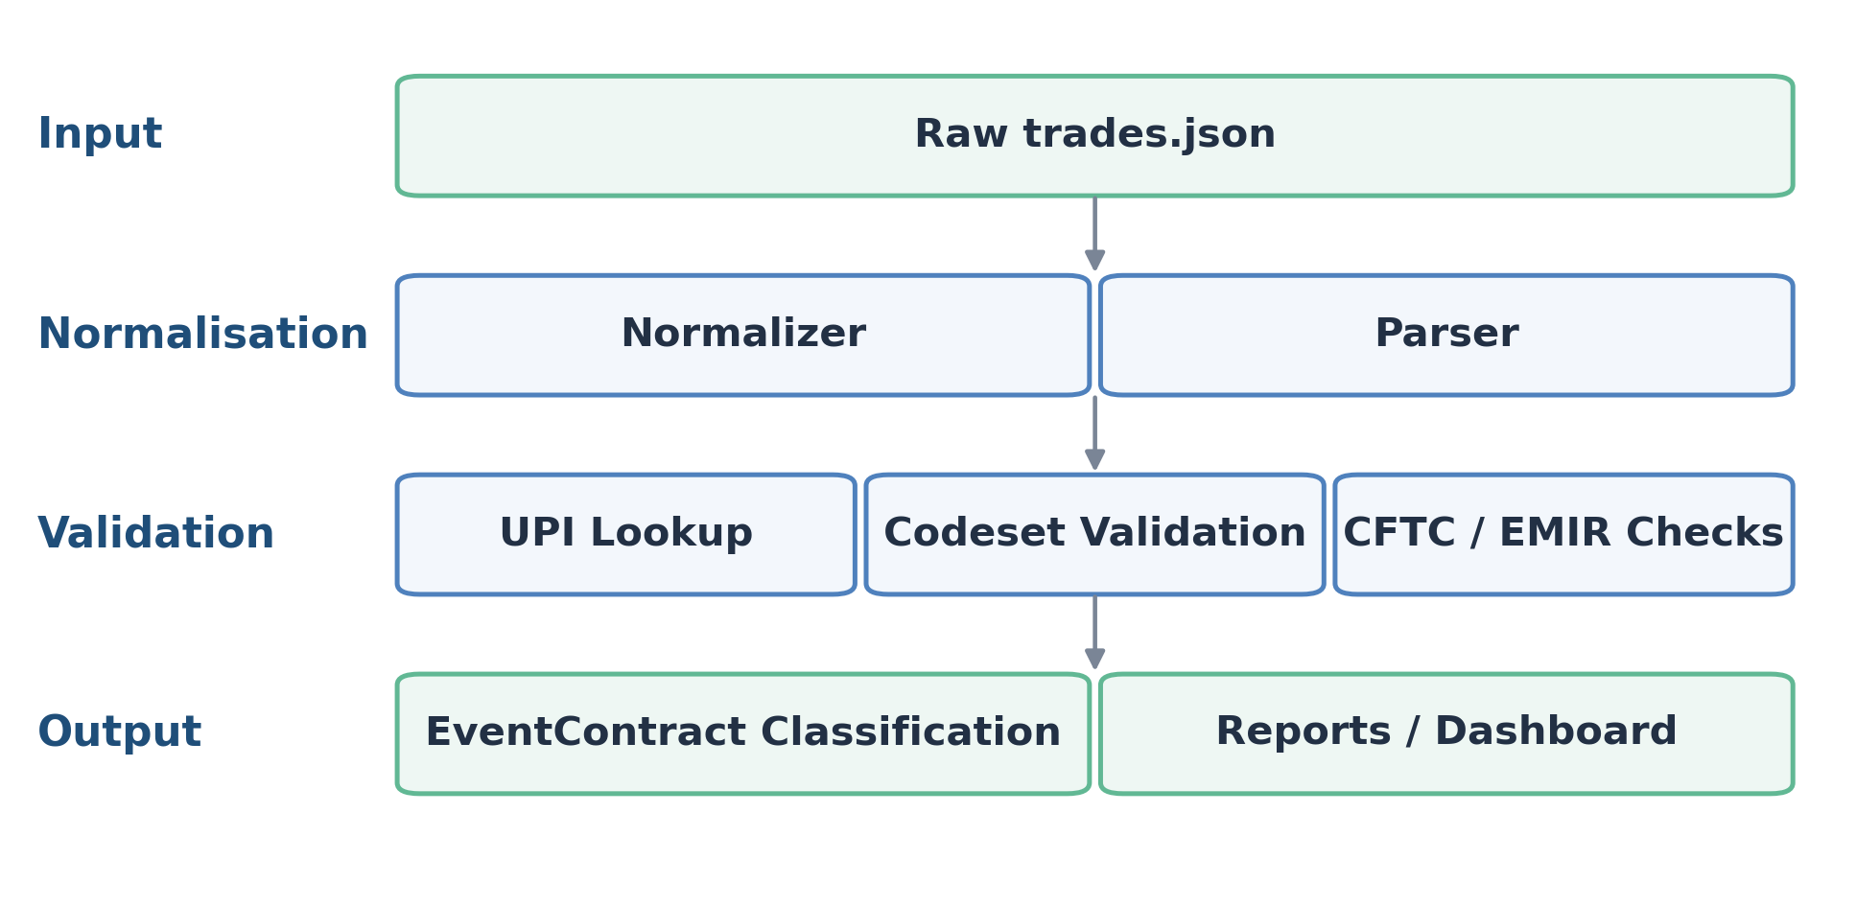
Figure 1: Pipeline Architecture Diagram
The pipeline shows the full validation flow from raw trade ingestion to reporting outputs.
Table 3: Engine Parse Status Summary
Engine parse status | Count
PASSED | 25
PARTIAL | 2
FAILED | 1
Note: Parse status (PASSED / PARTIAL / FAILED) reflects data quality at ingestion. The Module 1 classification flag — CONVENTIONAL_DERIVATIVE for all 25 conventional trades, NOVEL_INSTRUMENT_NO_TAXONOMY for T026–T028, and CLASSIFICATION_AMBIGUOUS for none in this portfolio — is a separate output field recorded in each trade's classification_flag attribute of the compliance report.
The parser deliberately distinguishes declared source labels from engine results. T013 has a date-only timestamp, so the record is identifiable but not fully ISO 8601 UTC compliant. T022 has an invalid maturity date (99999-12-31), so it is also partial even though the raw case file declared it as OK. T025 is failed because its timestamp is NOT_A_DATE.
The validation stack now includes business-consistency checks in addition to field presence: date order, timestamp versus trade date, positive notional amount, non-negative margin, boolean cleared, and allowed action_type values. This is closer to production trade-reporting validation than a simple null check.

UPI Lookup and Codeset Validation
The UPI module performs template lookup against ANNA-DSB. Some teaching-data product labels are not identical to production taxonomy labels, so the engine normalizes them through a transparent alias layer and records the mapping as a normalization note rather than a substantive compliance failure. For example, VanillaOption maps to Vanilla_Option, OIS maps to Fixed_Float_OIS, and CommoditySwap maps to the DSB commodity swap template.
Important Module 2 findings:
- T008 passes currency validation because XAU is a valid code in ISOCurrencyCode.json.
- T005 receives LIBOR_WARNING because GBP-LIBOR-BBA remains in the codeset but is a legacy rate after LIBOR cessation.
- T018 receives INVALID_CURRENCY for INVALID_CCY.
- T019 receives INVALID_CURRENCY because CNH is not in the DSB ISO currency codeset used here.
- T026-T028 receive NO_PRODUCT_DEFINITION because EventContract is absent from the ANNA-DSB OTC UPI taxonomy.
The engine extracts required field names from each matched DSB template and compares the mapped fields that exist in the homework record. This is not a full production ANNA-DSB submission validator: the source portfolio does not contain a complete DSB request payload, and the solution deliberately avoids pretending that a sparse homework record can satisfy every nested schema property. Instead, the engine separates three levels of Module 2 evidence: template coverage, codeset validation, and required-attribute coverage.
Representative template-level coverage results are:
- T001: Rates swap; required status CHECKED; checked 7, missing mapped 0, unmapped 4.
- T005: Rates swap; required status CHECKED; checked 7, missing mapped 0, unmapped 4.
- T015: FX Swap; required status PARTIAL; checked 6, missing mapped 1, unmapped 2.
- T024: Commodity swap; required status PARTIAL; checked 7, missing mapped 1, unmapped 2.
- T026: No OTC template; required status NO TEMPLATE; checked 0, missing mapped 0, unmapped 0.
The distinction matters. NO_PRODUCT_DEFINITION is not the same as a parser crash. It is evidence that prediction market event contracts sit outside the current OTC product-definition library. For conventional products, missing mapped attributes are reported as schema-coverage gaps rather than legal non-compliance, because a production system would first construct a full DSB request object and then run complete JSON-schema and enum validation.

Compliance, Scope, and Conclusions
The engine separates the legacy overall_status into three analytical dimensions: data quality, reporting scope, and regulatory conclusion. This avoids treating jurisdictional scope issues as ordinary data-quality failures.
Table 4: Three-Dimensional Compliance Result Summary
Data quality status | Count
Pass | 5
Warning | 9
Non-compliant | 14
Reporting scope status | Count
In scope | 25
Conditional | 2
Out of scope | 1
Regulatory conclusion | Count
Conventional | 25
Conditional event contract | 2
Not-reportable event contract | 1
The regulatory conclusion layer therefore translates the technical and scope findings into supervisory meaning. The 25 conventional trades can be assessed through existing UPI, UTI, LEI, and regime-field infrastructure. T026 and T028 are classified as conditional event contracts because they expose the boundary between regulated prediction markets and OTC derivatives reporting. T027 is classified as a not-reportable event contract under the case facts: it may be economically hedge-like, but it lacks the identifier, venue, settlement, and product-taxonomy infrastructure required for ordinary OTC trade reporting.

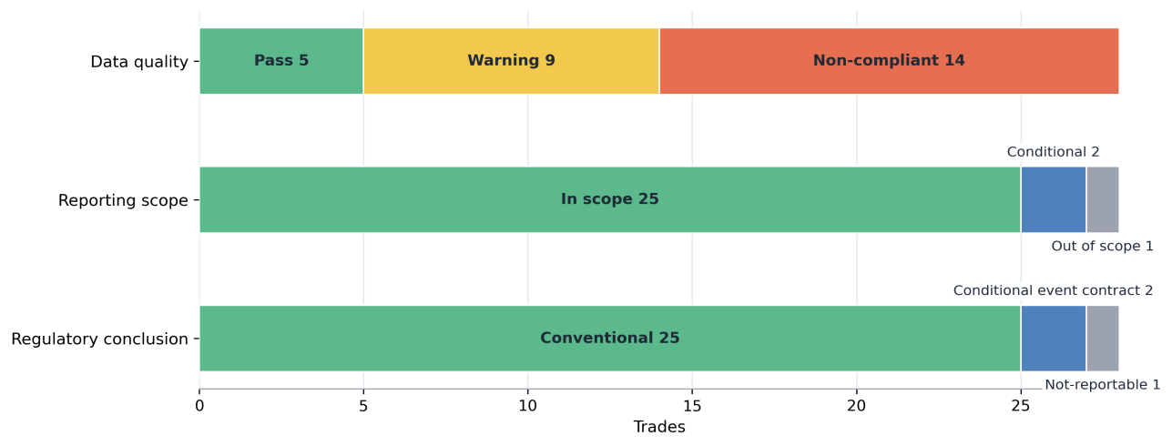
Figure 2: Three-Dimensional Compliance Result
The figure shows why the report separates field-level data quality from reporting scope and regulatory conclusion.
Table 5: Legacy Overall Status
Overall status | Count
Compliant | 5
Warning | 7
Non-compliant | 13
Regulatory ambiguous | 2
Not reportable | 1
The difference between 14 data-quality non-compliant records and 13 legacy non-compliant trades is caused by T027. T027 remains data-quality non-compliant because it has missing LEIs, missing UTI, non-ISO USDC settlement, and no product definition, but it is separated as NOT_REPORTABLE under the legacy overall_status for compatibility. The retained overall_status supports dashboard compatibility, while the three-dimensional view above provides a more precise interpretation of the portfolio.
Table 6: Compliance Finding Frequency by Validation Rule
Compliance rule | Count
LEI_CHECK_DIGIT | 6
EMIR_NULL_MARGIN | 3
INVALID_CURRENCY | 3
LEI_MISSING | 3
NO_PRODUCT_DEFINITION | 3
EMIR_REQUIRED_FIELD | 2
UTI_NAMESPACE | 2
UTI_NAMESPACE_FORMAT | 2
LIBOR_WARNING | 1
ACTION_TYPE_ENUM | 1
TIMESTAMP_PARTIAL | 1
CFTC_REQUIRED_FIELD | 1
The finding distribution shows that the main hard failures are concentrated in party identifiers, margin reporting, currency validation, and missing product definitions.
Scope assessments are tracked separately:
Table 7: Event-Contract Scope Assessment Rules
Scope rule | Count
EMIR_EVENT_SCOPE | 3
CFTC_EVENT_CONDITIONAL | 2
CFTC_EVENT_NOT_APPLICABLE | 1
These scope flags relate to T026–T028 and are kept separate because jurisdictional scope is not the same as field-level compliance.
T027 is the clearest split. It remains data-quality non-compliant because it has missing LEIs, missing UTI, USDC settlement, and no product definition, but it is out of scope and not reportable through the ordinary CFTC/EMIR OTC reporting path. T017 illustrates a different hard failure: under the assignment brief, null margin is not equivalent to zero.
Table 8: Key Trade-Level Findings
Trade | Status | Scope | Key finding | Interpretation
T005 | Warning / Conventional | In scope | LIBOR warning | Legacy benchmark warning, not a hard failure.
T008 | Non-compliant / Conventional | In scope | Invalid LEI | LEI check digit failure.
T013 | Warning / Conventional | In scope | Partial timestamp | Date-only timestamp; identifiable but not fully ISO 8601 UTC compliant.
T017 | Non-compliant / Conventional | In scope | Null margin | Null is not equivalent to zero under EMIR margin fields.
T018 | Non-compliant / Conventional | In scope | Invalid currency | Invalid currency candidate.
T019 | Non-compliant / Conventional | In scope | CNH codeset gap | CNH is not in the DSB ISO currency codeset used by this project.
T021 | Non-compliant / Conventional | In scope | LEI / UTI / required-field failure | Identifier and required-field failure.
T022 | Warning / Conventional | In scope | Invalid maturity date | Parser classifies the record as partial.
T023 | Non-compliant / Conventional | In scope | UTI namespace / suffix defect | UTI namespace and suffix do not satisfy validation rules.
T025 | Non-compliant / Conventional | In scope | Invalid timestamp | Timestamp is unparseable.
T026 | Warning / Conditional EventContract | Conditional | No EventContract UPI taxonomy | EventContract outside ANNA-DSB OTC taxonomy; conditional scope.
T027 | Non-compliant / Not-reportable EventContract | Out of scope | No UPI, missing LEIs/UTI, USDC settlement | Economically hedge-like but not visible through the ordinary CFTC/EMIR OTC reporting path.
T028 | Warning / Conditional EventContract | Conditional | No EventContract UPI taxonomy | Regulatory-event contract outside ordinary OTC taxonomy; conditional scope.

Prediction Market Classification Frontier
The final three trades are the most important part of the written analysis. They are not ordinary bad records; they test whether an economically meaningful hedge still fits the existing OTC reporting perimeter.
Table 9: Event-Contract Classification Frontier Summary
Trade | Platform | Economic function | Legal/reporting issue | Engine conclusion
T026 | Kalshi / CFTC DCM | Election subsidy hedge | EU gambling/public-policy issue; no OTC UPI | Ambiguous
T027 | Polymarket / offshore | CPI/USD bond exposure hedge | No LEI, USDC settlement, no CFTC DCM | Not reportable
T028 | Kalshi / CFTC DCM | AI Act compliance-cost hedge | Regulatory decision event; no OTC UPI | Ambiguous
Note: "Ambiguous" in this table corresponds to CONDITIONAL_EVENT_CONTRACT in the engine output (compliance_report.json). The label reflects regulatory uncertainty pending CFTC ANPR resolution.
The event-contract case-file fields are treated as source facts supplied by the homework scenario. The engine separately evaluates taxonomy coverage, identifier availability, settlement-currency visibility, platform type, and reporting scope so that a source label does not become the engine’s only reasoning path.
T026 and T028 are Kalshi-style EventContracts on a CFTC DCM. They can perform an economic hedging function, but they remain CONDITIONAL_EVENT_CONTRACT records because the ordinary OTC UPI taxonomy does not yet provide a clean product-definition route for them.
T027 is different: it is a Polymarket / offshore EventContract with no LEIs, no UTI, USDC settlement, and no CFTC DCM status. It is economically hedge-like, yet the engine classifies it as NOT_REPORTABLE_EVENT_CONTRACT because it is not visible through the ordinary CFTC/EMIR OTC reporting path.
The economic function test is necessary but not sufficient. A contract can transfer real economic risk and still fall outside the reporting infrastructure because of platform type, jurisdiction, legal classification, and settlement rail.
The broader regulatory-arbitrage point is that economically similar risk-transfer contracts can move across venue, settlement rail, and legal classification. A licensed DCM EventContract, an offshore crypto-settled market, and a bilateral OTC derivative may hedge related exposures, but only some generate the UPI, UTI, LEI, and trade-repository visibility used by ordinary OTC reporting infrastructure.
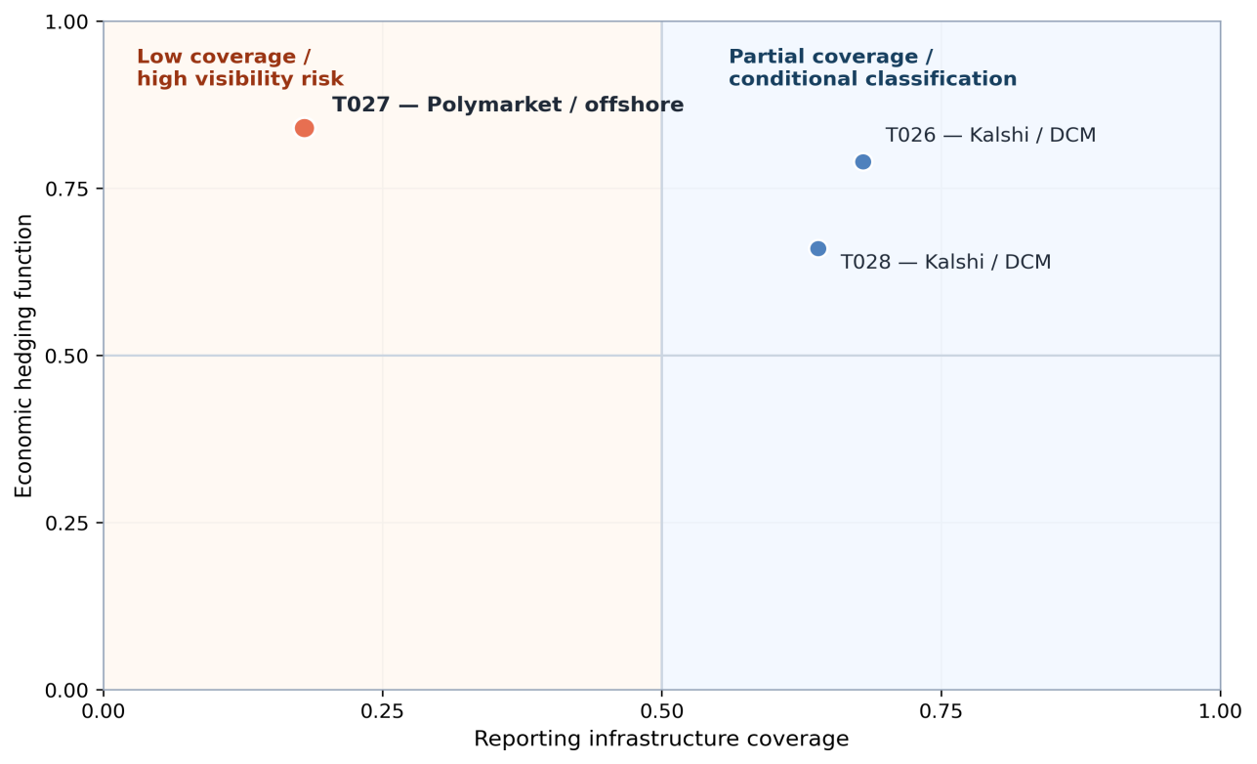
Figure 3: EventContract Classification Frontier Matrix
Key interpretation: T027 is the clearest visibility-risk case because it has plausible economic hedge value but weak UPI / UTI / LEI reporting coverage.
The three-question economic function test provides a structured basis for distinguishing genuine hedging instruments from speculative contracts or products that fall outside the OTC reporting perimeter. A "Yes" answer to all three questions is necessary but not sufficient for OTC reporting obligations; platform type, legal entity identifier coverage, and taxonomy availability must also be satisfied.
Table 10: Economic Function Test for Event Contracts
Trade | Test item | Assessment
T026 Kalshi / German election | Q1: Quantifiable exposure? | YES — A renewable-energy firm with German government feed-in tariffs faces quantifiable revenue exposure if the winning coalition cuts subsidies.
 | Q2: Viable hedge substitute? | PARTIAL — Conventional EUR interest-rate or FX hedges partially cover policy-linked cash flows but do not target the binary election trigger directly.
 | Q3: Price discovery beyond public data? | YES — Real-money prediction markets consistently dominate polling averages in forecast accuracy (Wolfers and Zitzewitz 2004); Kalshi prices provide continuously updated probability signals.
 | Engine conclusion | CONDITIONAL_EVENT_CONTRACT
T027 Polymarket / CPI, offshore | Q1: Quantifiable exposure? | YES — A fixed-income portfolio manager holding USD Treasuries faces quantifiable mark-to-market losses if CPI exceeds threshold and the Fed tightens.
 | Q2: Viable hedge substitute? | YES (functional, not legal) — Economically analogous to a CPI cap or inflation swaption; however, T027 settles in USDC, has no LEIs, is offshore, and cannot be cleared or novated under CFTC or EMIR rules.
 | Q3: Price discovery beyond public data? | YES — Polymarket CPI prices track CPI swap breakevens and provide binary probability signals not directly observable in fixed-income markets (Diercks, Katz and Wright 2026).
 | Engine conclusion | NOT_REPORTABLE_EVENT_CONTRACT
T028 Kalshi / ESMA AI Act | Q1: Quantifiable exposure? | YES — A fintech firm subject to the ESMA AI Act has budgeted EUR capital for compliance; if the deadline extends the cost defers, making the regulatory event a quantifiable binary exposure.
 | Q2: Viable hedge substitute? | NO — No standard OTC instrument references the ESMA AI Act deadline as its underlier; EUR/FX hedges address the financing cost but not the regulatory binary directly.
 | Q3: Price discovery beyond public data? | PARTIAL — Volume on this contract is thin; non-public information asymmetries (ESMA internal deliberations) reduce informational efficiency relative to election or macro contracts.
 | Engine conclusion | CONDITIONAL_EVENT_CONTRACT
The key insight from this analysis is that T027 satisfies all three economic function criteria yet is classified NOT_REPORTABLE_EVENT_CONTRACT because the regulatory infrastructure requirements — LEI, UTI, ISO currency, regulated venue — are entirely absent. Economic hedging intent does not create reporting infrastructure.

Proposed EventContract UPI Schema
If event contracts were brought into the reporting taxonomy, the schema should not simply copy rates, FX, or equity templates. The defining attributes should be event-specific:
- EventCategory: political outcome, economic indicator, regulatory decision, weather, litigation, or similar.
- ReferenceEntity: election, regulator, index, official source, court, or other body defining the event.
- EventJurisdiction and EventDate: where and when the event is determined.
- ResolutionSource: official source used to settle the contract.
- PayoutType: binary, scalar, capped, floor, or multi-outcome.
- SettlementCurrency: fiat or crypto/stablecoin settlement asset.
- PlatformType: CFTC DCM, offshore exchange, decentralized protocol, bilateral OTC, or other.
- RegulatoryStatus: approved, gambling/prohibited, not applicable, conditional, or uncertain.
The ANNA-DSB OTC UPI taxonomy currently covers five conventional asset classes: Rates, Credit, FX, Equity, and Commodities. EventContracts are absent, so the main body keeps the schema discussion concise.
Three design decisions matter. PlatformType separates CFTC DCM contracts from offshore or decentralized venues. RegulatoryStatus captures gambling or public-policy restrictions. SettlementCurrency captures fiat and stablecoin settlement while flagging non-ISO codes.
Together, those attributes help distinguish a licensed exchange-traded political EventContract from an offshore crypto-settled contract even when both have similar economic payoff structures.
Appendix C provides the proposed schema fields and the full implementation JSON template in compact technical form.

Regulatory Arbitrage Analysis—Two Elements from Brandes (2026)
Drawing on Brandes (2026), this section uses the project scenario to discuss two issues that are operationally relevant for a RegTech compliance engine: operator neutrality and market-integrity supervision.
  - Operator Neutrality
Brandes (2026) frames operator neutrality as a concern when an event-contract operator could hold positions in its own markets or have incentives linked to outcomes. In this project framing, that concern motivates a data-design question: whether supervisory reporting should make operator-linked exposure easier to detect.
The cross-border dimension is relevant in the project scenario. If an EU-resident firm accessed a non-EU event-contract venue, local supervisory visibility and available protections could differ from those associated with EU-regulated instruments, creating a plausible monitoring gap rather than a definitive legal conclusion.
A RegTech compliance engine could address this partially by cross-referencing the reporting counterparty LEI against the platform operator LEI. If they match or are affiliates based on GLEIF parent-child relationship data, the engine flags OPERATOR_CONFLICT. For EU-resident firms, comparing the platform LEI against the ESMA register of authorised venues could raise UNLICENSED_VENUE if absent. Neither check is possible for T027 (Polymarket), which has no operator LEI at all; the CFTC_EVENT_NOT_APPLICABLE finding therefore records a visibility gap in the project scenario. Under the EMIR regime run, T026 additionally receives EMIR_EVENT_SCOPE because the engine cannot resolve cross-jurisdictional scope from the available data. If the contract were treated as an OTC derivative, further analysis would be needed to determine the applicable EMIR consequences for the EU-resident counterparty. An SDR-style reporting extension or equivalent supervisory filing would be needed before this validation becomes operationally feasible.
  - Market Integrity Supervision
Brandes (2026) highlights market-integrity risks such as concentration, privileged information, and uneven surveillance in prediction markets. For this project, those concerns motivate additional monitoring fields and event-timestamp checks rather than a claim that every venue lacks equivalent controls.
Under the project framing, EU market-abuse analysis may differ depending on how a contract is legally classified and where it trades. The report therefore treats T026 as a useful supervisory-design case, not as a definitive statement on whether a particular legal regime applies.
A RegTech compliance engine could implement two checks once trade-repository data exists. First, a concentration flag: if a single counterparty LEI holds more than 20 percent of open interest in a contract, raise POSITION_CONCENTRATION. Second, a timestamp cross-reference: compare event-contract execution times against known political or regulatory announcement schedules to flag POTENTIAL_INSIDER_TRADING. T026 and T028 are classified CONDITIONAL_EVENT_CONTRACT because Kalshi is represented in the project as a CFTC DCM, while the ordinary OTC reporting route remains incomplete for the engine. The CONDITIONAL classification is therefore the prudent project outcome while reporting treatment remains uncertain in this scenario.

Dashboard and Deliverables
The dashboard supports the report rather than replacing it. It contains four views:
- Compliance heatmap by trade and rule family.
- Compliance Finding Frequency by Validation Rule, with scope assessments separated from data-quality errors.
- Asset-class compliance breakdown.
- Classification frontier panel for T026–T028 with data quality and scope status.
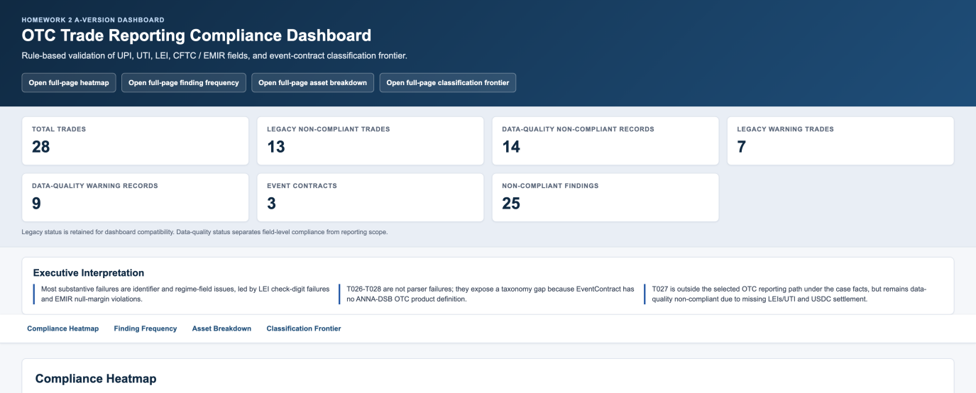
Figure 4a: Dashboard KPI Cards and Executive Interpretation
The KPI panel separates legacy compatibility metrics from field-level data-quality metrics before the dashboard moves into trade-level detail.
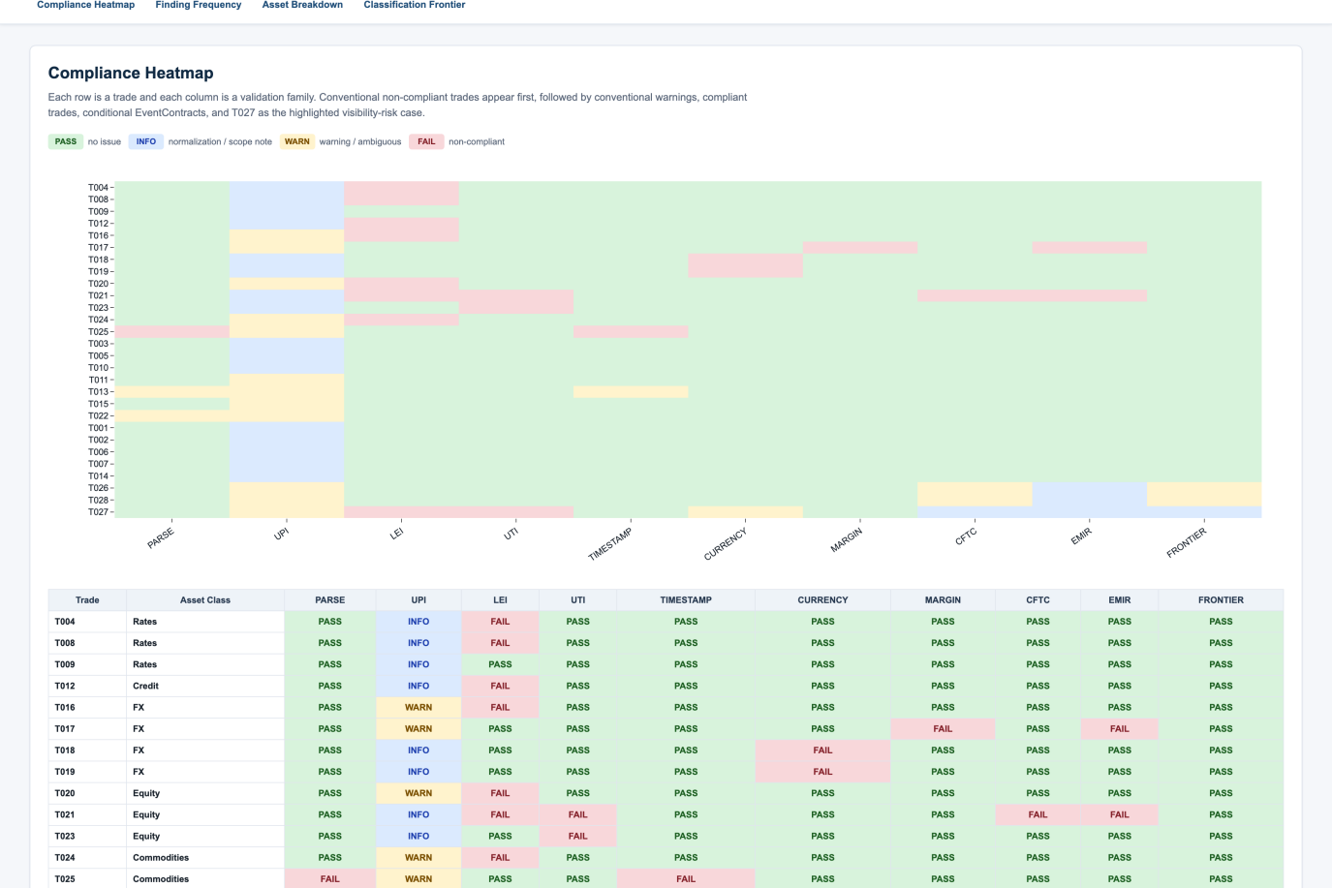
Figure 4b: Compliance Heatmap
The heatmap makes the portfolio pattern visible: conventional failures cluster in identifier and regime-field checks, while T027 remains the highlighted visibility-risk case.

Engine Limits and CFTC Recommendations
The engine can validate structured fields, match taxonomy files, detect missing identifiers, separate zero from null, and flag business-consistency defects. It cannot determine true hedging intent, gambling classification, exchange authorization, or cross-border enforcement consequences. Those issues require legal and supervisory judgment.
This is exactly why prediction market contracts are useful in the assignment. They show the difference between field-level compliance, jurisdictional scope, and product-level classification. The engine can prove that T026-T028 do not fit the existing ANNA-DSB OTC product taxonomy, but whether and how they should be reported is a regulatory design question.
  - The Scale of the Supervisory Blind Spot
Diercks, Katz and Wright (2026) cite substantial Kalshi trading volume in March 2026. Under the project framing, that activity is not represented in the engine’s ordinary UPI / UTI / LEI workflow, which illustrates why concentration and cross-market exposure can be difficult to aggregate when event products sit outside conventional OTC reporting infrastructure.
  - Is UPI Absence a Systemic Risk Indicator?
For conventional OTC derivatives, a missing or placeholder UPI is a data-quality defect that can be remediated through resubmission. For EventContracts, UPI absence signals a qualitatively different problem: the instrument category has no agreed taxonomy, no product definition, and no reference data infrastructure. This creates three distinct systemic risk channels. First, aggregation impossibility: regulators cannot net exposures across participants in the same event contract because there is no common product identifier. Second, cross-market risk invisibility: a CPI event contract (T027) is economically correlated with inflation swaps and Treasury futures, yet without a UPI no automated surveillance system can detect build-up of related exposure across asset classes. Third, collateral chain opacity: USDC-settled contracts have no standard margin-reporting pathway, making collateral calls and default waterfalls invisible to central counterparties and resolution authorities. CFTC could consider treating the absence of a registered UPI for material EventContract exposures as a trigger for a novel-instrument notification or supervisory review.
  - Two Technical Modifications to CFTC ANPR 91 FR 12516
The following recommendations are illustrative technical designs for the project scenario rather than statements of current legal obligations.
Modification 1 — Extend Part 45 SDR Reporting to CFTC-Licensed DCM Event Contracts.
Under the project framing, conventional Part 45 swap reporting is treated as the benchmark for OTC transparency. DCM-listed event contracts do not currently map cleanly into the same UPI / UTI / LEI reporting workflow used by the engine. An illustrative technical modification could extend SDR-style reporting to CFTC-licensed DCM event contracts above a materiality threshold.
Required fields would follow the EventContract UPI schema proposed in Section 7 and summarised in Appendix C, including EventCategory, ReferenceEntity, EventDate, PayoutType, SettlementCurrency, and counterparty LEI pairs. The RegTech impact is direct: T026 and T028 would move from CFTC_EVENT_CONDITIONAL to CFTC_EVENT_IN_SCOPE and the compliance engine would gain a validated data pipeline.
Modification 2 — Novel Instrument Notification for Non-ISO Settlement Assets.
An illustrative policy design could introduce a Form EC-1 style notification mechanism for offshore or stablecoin-settled event contracts above a materiality threshold. Such a notification could collect platform name and jurisdiction, event reference, settlement asset information, notional amount, and available counterparty identifiers. For the compliance engine, the combined appearance of INVALID_CURRENCY, LEI_MISSING, and CFTC_EVENT_NOT_APPLICABLE on a single trade would trigger a supervisory review flag rather than an automatic reporting conclusion.

Conclusion
This project builds and tests a rule-based RegTech engine on 28 OTC-derivative and event-contract records. For conventional OTC products, the engine is able to map products through the existing UPI structure, validate UTI and LEI identifiers, and flag common reporting problems such as invalid currencies, null margin fields, timestamp defects, and missing product definitions.
The main lesson from the implementation is that not all failures mean the same thing. Some records have ordinary data-quality problems, such as bad LEIs or incomplete timestamps. Others raise scope or classification problems that cannot be solved by a stricter parser. For this reason, the final output separates data quality, reporting scope, and regulatory conclusion instead of relying only on one overall compliance label.
The event-contract cases show this distinction most clearly. T026 and T028 are treated as conditional EventContracts because they are linked to regulated prediction-market venues but do not fit the current ANNA-DSB OTC product taxonomy. T027 is the strongest visibility-gap case: it has missing LEIs, no UTI, USDC settlement, and no ordinary CFTC / EMIR reporting path, even though it may still perform an economically hedge-like function.
Overall, the project shows that existing reporting infrastructure works reasonably well for known OTC product classes, but it is less effective when economic risk transfer moves into event-based or prediction-market instruments. The proposed EventContract schema, dashboard, and CFTC-style technical recommendations are intended to show how such exposures could be made more visible without treating every jurisdictional gap as a simple data error.

References
- Brandes, A. (2026). The Unhedgeable State: Political Risk, Prediction Markets,and the Gap in Europe's Risk Management Architecture. SSRN 6571938.
- ANNA-DSB. (n.d.). UPI & ISIN Product Definitions. Derivatives Service Bureau.
- International Organization for Standardization. (2020). ISO 23897: Financial services — Unique transaction identifier.
- Global Legal Entity Identifier Foundation. (n.d.). Introducing the Legal Entity Identifier (LEI).
- Commodity Futures Trading Commission. (n.d.). 17 CFR Part 45 — Swap Data Recordkeeping and Reporting Requirements.
- European Securities and Markets Authority. (2023). Guidelines for reporting under EMIR REFIT.
- Monetary Authority of Singapore. (2013). Securities and Futures (Reporting of Derivatives Contracts) Regulations 2013.
- Diercks, A. M., Katz, J. D., & Wright, J. H. (2026). Kalshi and the Rise of Macro Markets (NBER Working Paper No. 34702). National Bureau of Economic Research.
- Wolfers, J., & Zitzewitz, E. (2004). Prediction markets. Journal of Economic Perspectives, 18(2), 107–126.
- Taylor Wessing. (2026). Prediction markets in Germany and Europe: Legal status, challenges and risks.

Appendix
Appendix A: Team Contribution Statement
Student ID | Name | Responsibility | Main Deliverables | Related Module
G2505246J | LIU YISHAN | Data pipeline and trade parser | Raw/processed data review; parser handling; nulls, bad dates, partial timestamps. | M1 / Integration
G2505431H | GONG PENG XIANG | UPI lookup and ANNA-DSB taxonomy validation | ANNA-DSB template lookup; product alias mapping; currency/reference-rate codesets; EventContract no-product-definition. | M2 / UPI Lookup Engine
G2506255B | GUO YIHAN | Compliance checker and regime validation | LEI/UTI checks; CFTC/EMIR field validation; null-versus-zero margin logic; tests. | M3 / Testing
G2505266E | ZHANG JUNYI | Classification analysis, report, and dashboard integration | Prediction-market analysis; economic function test; EventContract schema; regulatory arbitrage; report/dashboard integration. | M4 / Dashboard / Final Report
All members participated in final integration, validation, and consistency review across the code outputs, written report, and dashboard. The final project was validated using the primary CFTC/EMIR run, with CFTC/MAS retained as an alternative Singapore-focused validation run.
Appendix B: Additional Test Trades
Trade ID | Asset Class | Instrument | Deliberate Error | Expected Rule Triggered
AT001 | Credit | CDS/SingleName | None | —
AT002 | FX | VanillaOption | None | —
AT003 | Equity | Option (MAS) | None | MAS_SG_NEXUS
AT004 | Rates | IRS | LEI check digit wrong | LEI_CHECK_DIGIT NONCOMPLIANT
AT005 | Credit | Index (MAS) | 3x null margin | EMIR_NULL_MARGIN NONCOMPLIANT
AT004 and AT005 are deliberately constructed to test LEI check-digit validation and second-regime null-margin detection respectively.

Appendix C: Proposed EventContract Schema
C1. Schema field overview
Field | Purpose
EventCategory | Classifies political, macro, regulatory, weather, litigation, or other event types.
ReferenceEntity | Identifies the official body, index, court, regulator, or source resolving the event.
EventJurisdiction | Records the jurisdiction where the event is determined.
EventDate | Records the event determination date.
ResolutionSource | Defines the authoritative source used for settlement.
PayoutType | Captures binary, scalar, capped, floored, or multi-outcome payoff.
SettlementCurrency | Captures fiat or stablecoin settlement and flags non-ISO identifiers.
PlatformType | Distinguishes CFTC DCM, offshore exchange, decentralised protocol, bilateral OTC, or other venues.
RegulatoryStatus | Records approved, conditional, prohibited, not applicable, or uncertain status.

C2. Full JSON schema
{
"TemplateVersion": "1.0",
"Header": {
"AssetClass": "EventContract",
"InstrumentType": "BinaryContract",
"UseCase": "PoliticalOutcome",
"Level": "Unique Product Identifier (UPI)",
"Identifier": {
"UPI": "PENDING_ISSUANCE"
},
"Status": "PROPOSED",
"LastUpdateDateTime": "2026-05-11T00:00:00Z"
},
"Attributes": {
"EventCategory": {
"Description": "Category of the reference event that determines settlement",
"AllowedValues": [
"PoliticalOutcome",
"MacroeconomicIndicator",
"RegulatoryDecision",
"WeatherOrClimate",
"CorporateAction",
"LitigationOutcome",
"Other"
],
"Required": true
},
"ReferenceEntity": {
"Description": "Body or index whose decision or outcome defines the event",
"Example": "German Federal Election Commission | US Bureau of Labor Statistics | ESMA",
"Required": true
},
"EventJurisdiction": {
"Description": "ISO 3166-1 alpha-2 country code of the primary jurisdiction",
"Example": "DE | US | EU",
"Required": true
},

C2. Full JSON schema (continued)
"EventDate": {
"Description": "Expected event determination date in ISO 8601 format",
"Example": "2025-09-28",
"Required": true
},
"ResolutionSource": {
"Description": "Official authoritative source used to determine final settlement outcome",
"Example": "Official federal election results | BLS CPI release | ESMA register",
"Required": true
},
"PayoutType": {
"Description": "Payout structure at settlement",
"AllowedValues": [
"Binary",
"Scalar",
"Capped",
"Floored",
"MultiOutcome"
],
"Required": true
},
"SettlementCurrency": {
"Description": "Settlement currency: ISO 4217 fiat or stablecoin identifier",
"Note": "Stablecoin codes such as USDC are not ISO 4217 and require a supplemental identifier scheme",
"Required": true
},
"PlatformType": {
"Description": "Legal and operational classification of the trading venue",
"AllowedValues": [
"CFTC_DCM",
"CFTC_SEF",
"OffshoreExchange",
"DecentralisedProtocol",
"BilateralOTC",
"Other"
],
"Required": true
},
"RegulatoryStatus": {
"Description": "Regulatory classification in the applicable jurisdiction",
"AllowedValues": [
"Approved",
"Conditional",
"GamblingProhibited",
"PublicPolicyProhibited",
"NotApplicable",
"Uncertain"
],
"Required": true
}
},
"Derived": {
"ClassificationType": "EventContract",
"ShortName": "EventContract.Binary.PoliticalOutcome",
"UnderlierName": "{ReferenceEntity} {EventDate}",
"UnderlyingAssetType": "Event"
}
}

