Simon Anger
Analysis and Design Unit

A.D 1 – Use a case diagram
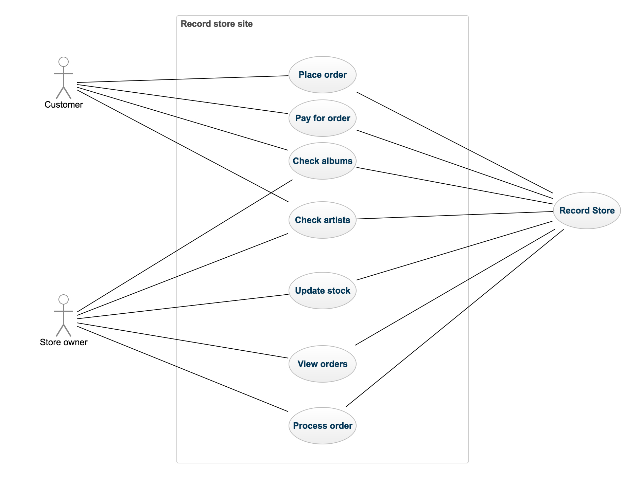
A.D 2 – Use a class diagram
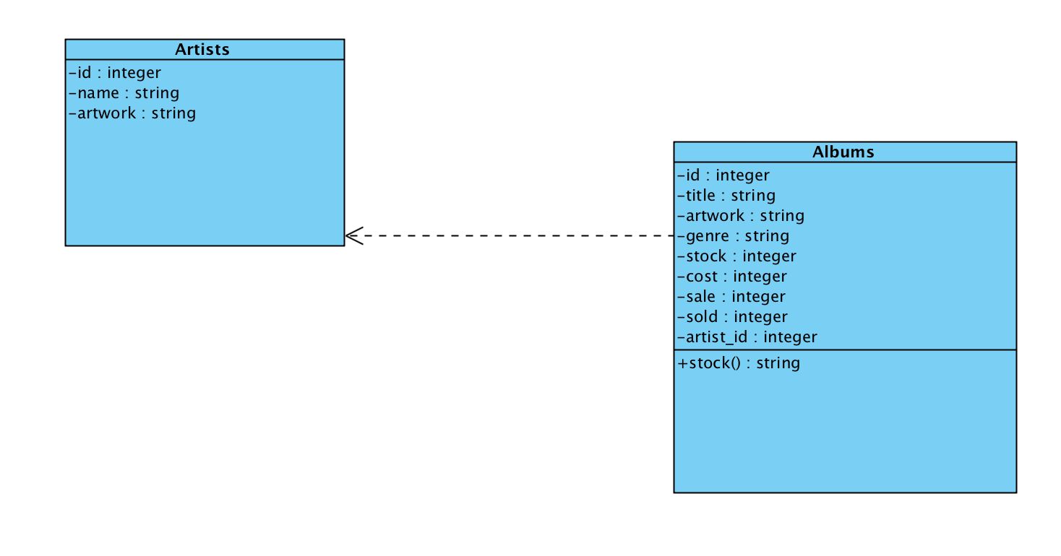
A.D 3 – Use an object diagram

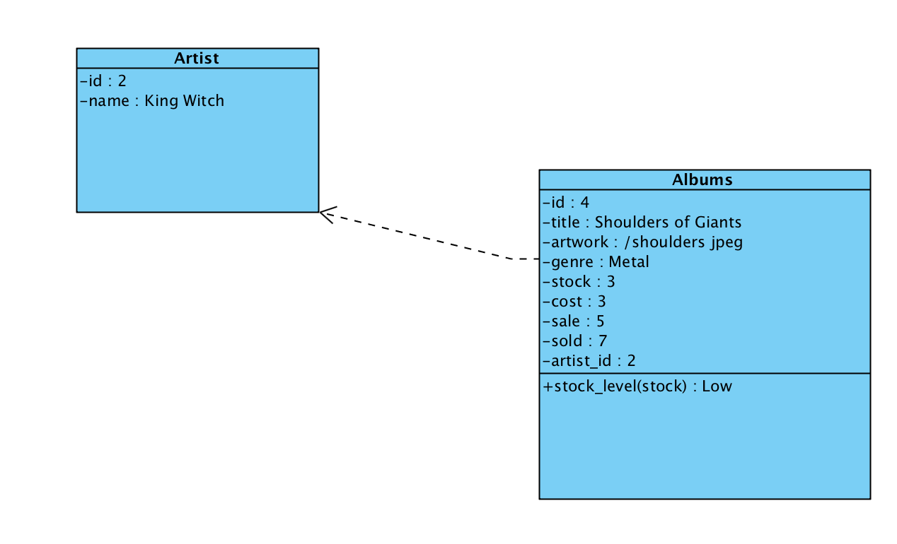
A.D 4 – Use an activity diagram
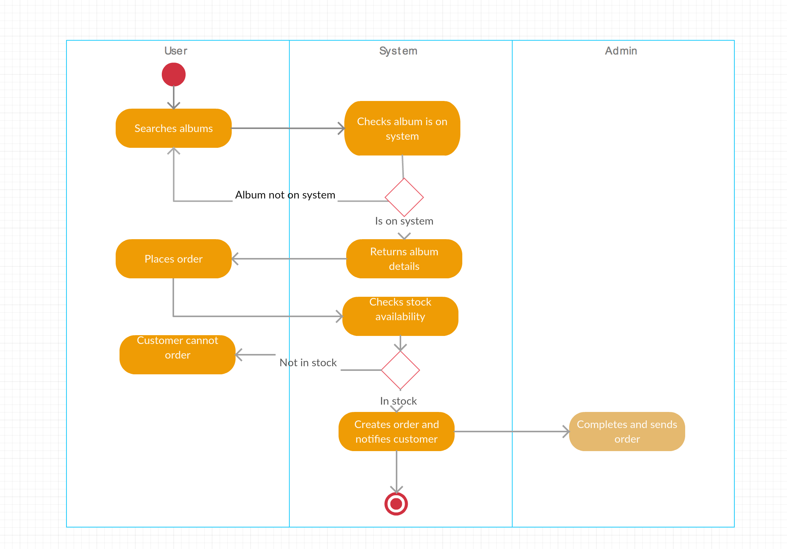

A.D 5 – An Inheritance Diagram

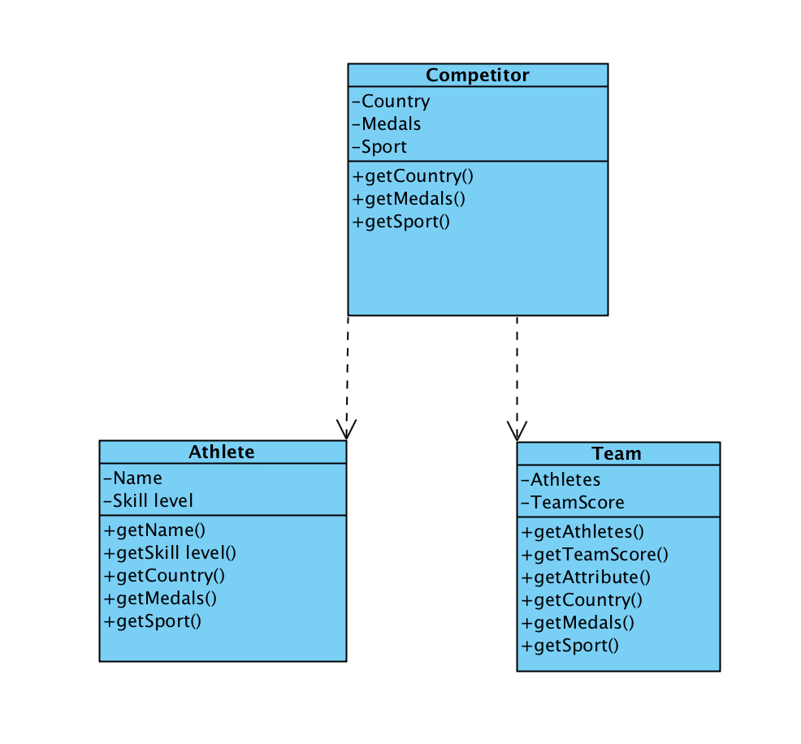

A.D 6 – Produce an implementations constraints plan

