Simon Anger
Implementation and Testing Unit

I.T 1 – Show encapsulation in a program
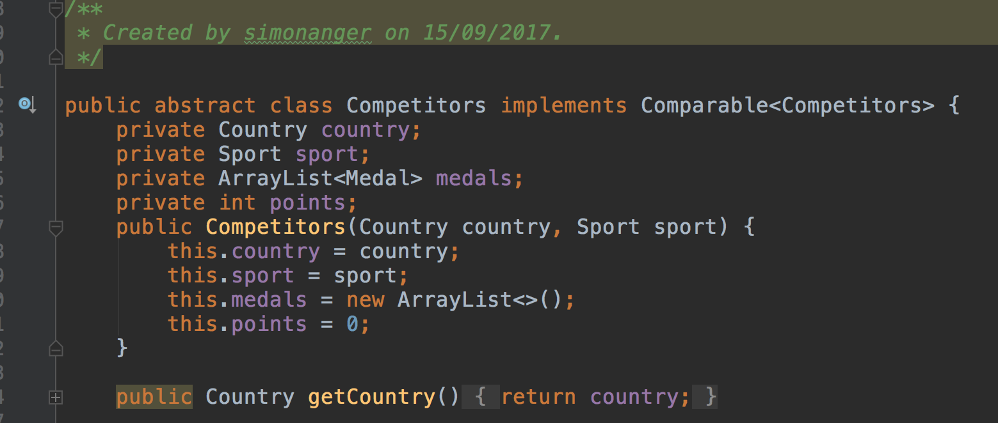
I.T 2 – Use of inheritance in a program

A class
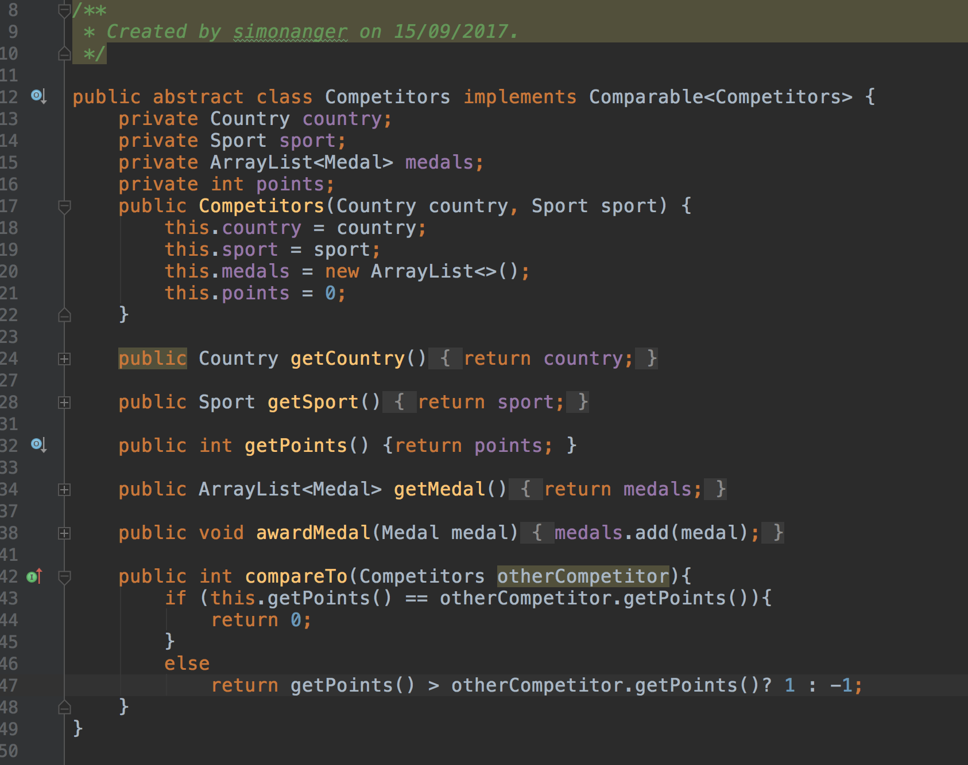
A class that inherits from previous class, object in the inherited class (ArrayList) & method that uses information inherited from another class (addAthlete uses athlete.getSport() & athlete.getCountry()).
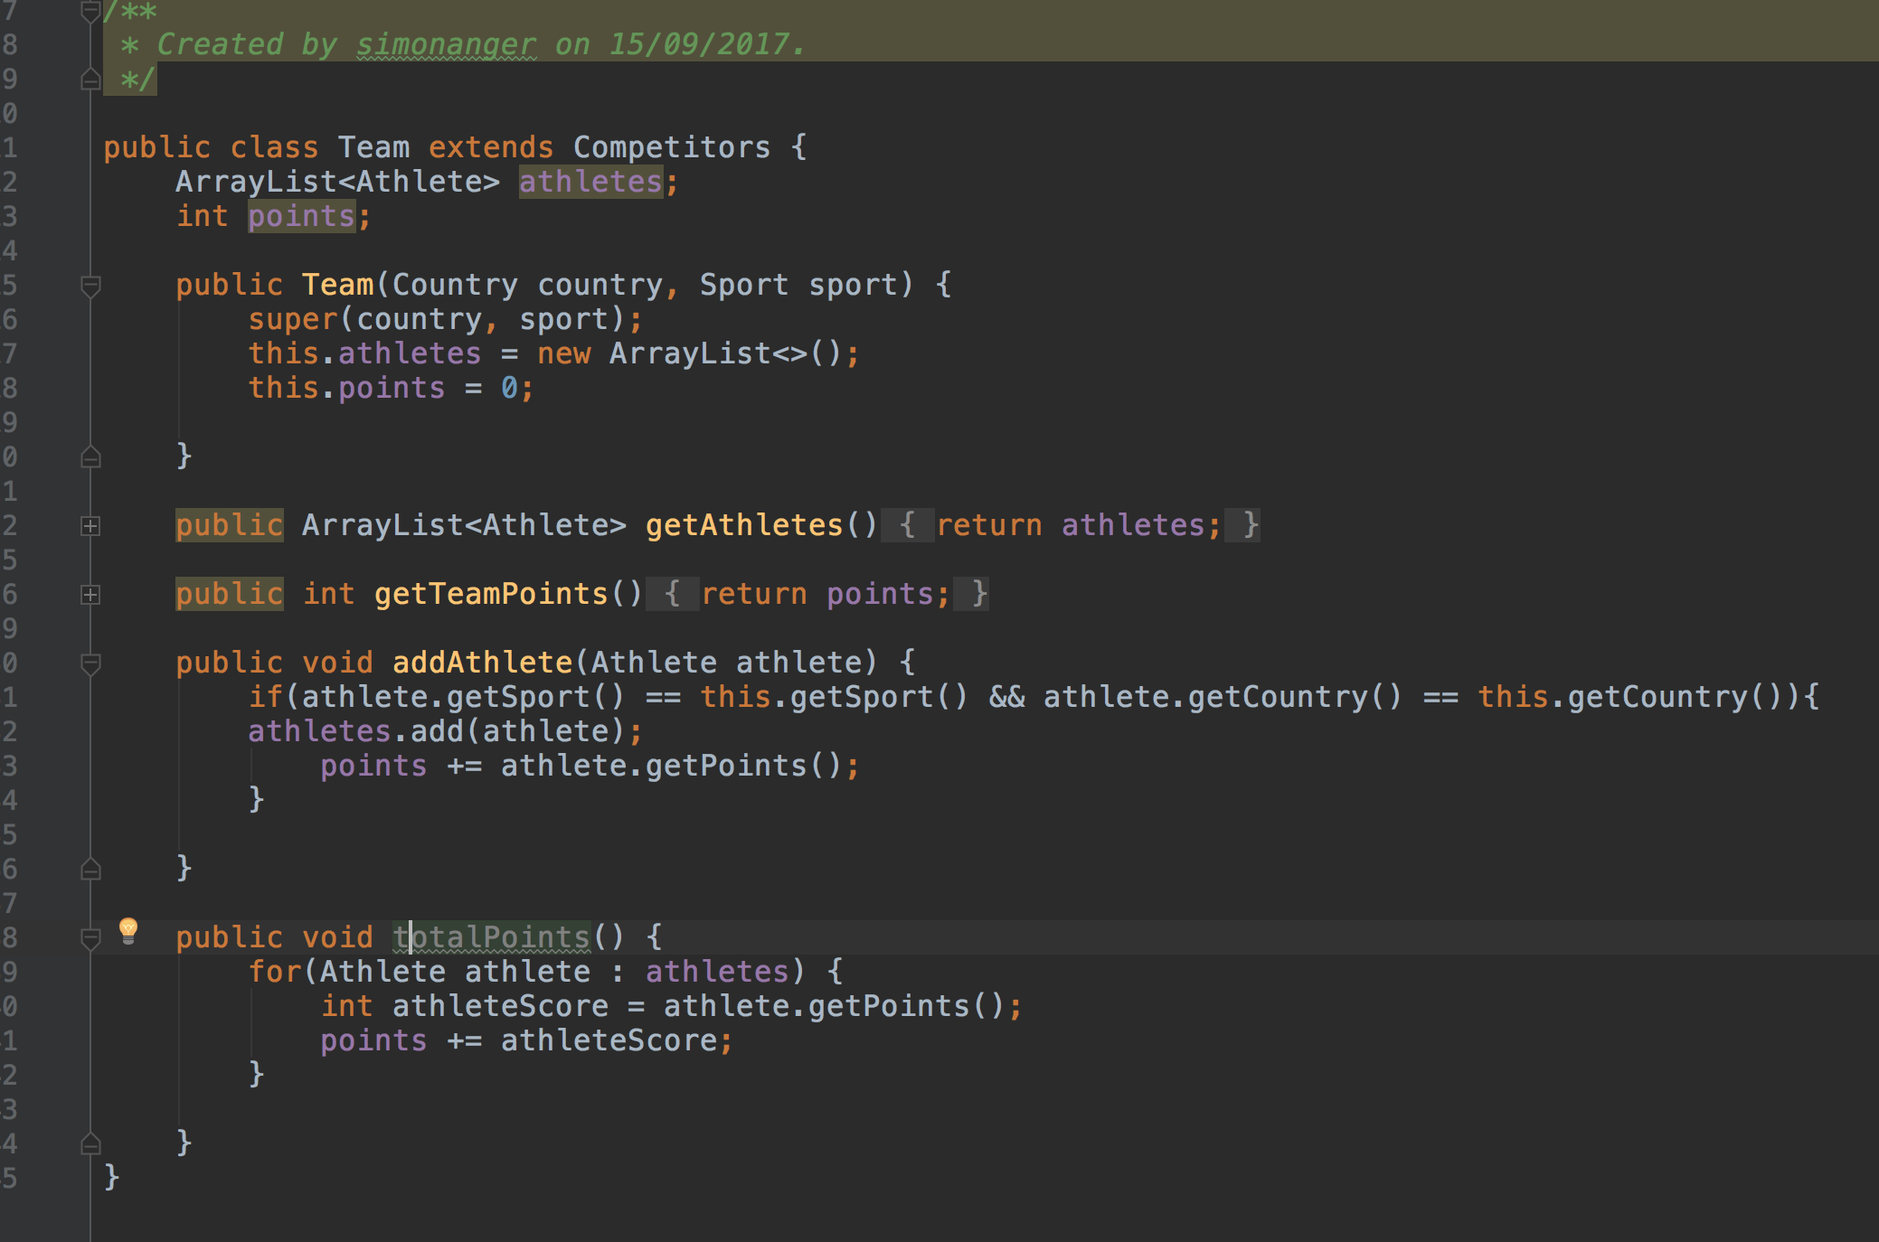
I.T 3 – Demonstrate searching data in a program

Function
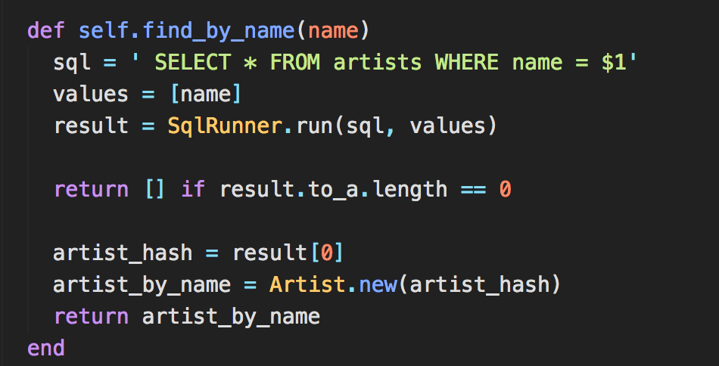

Result
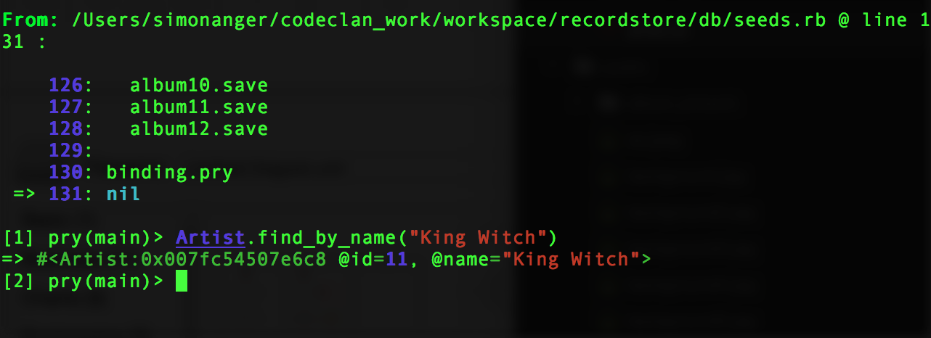
I.T 4 – Demonstrate sorting in a function

Function
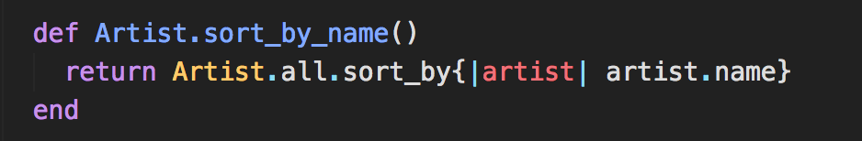
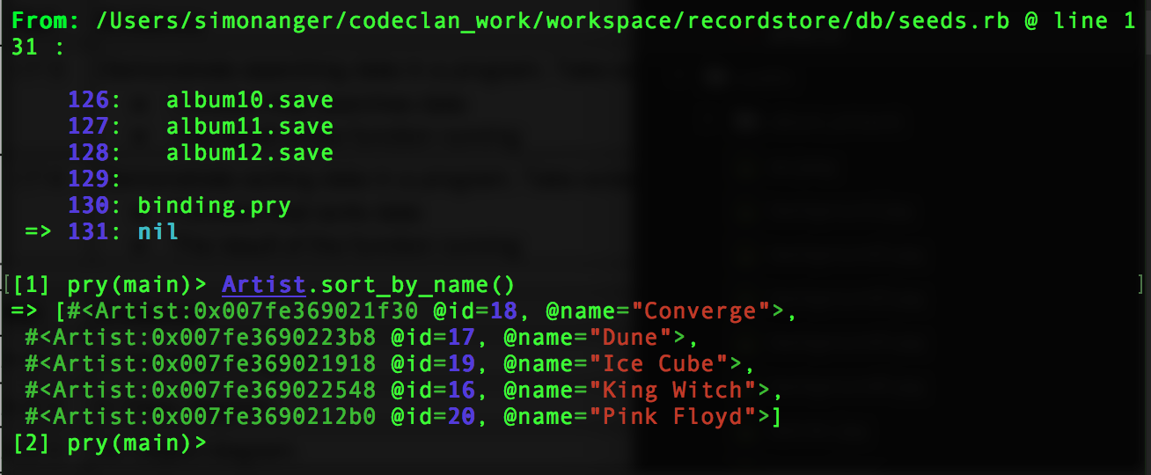
Result

I.T 5 – Demonstrate the use of an array in a program

Empty Array (guestlist) & function that uses it.

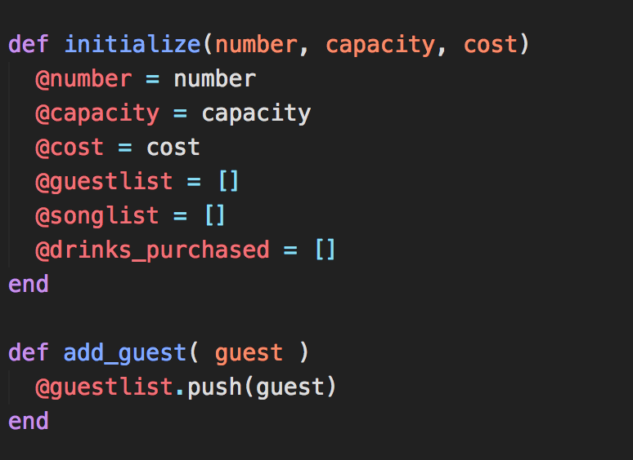
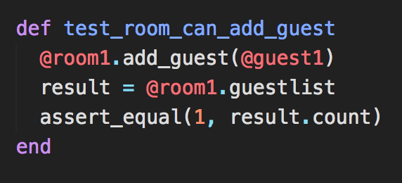
Test for function

Passing test
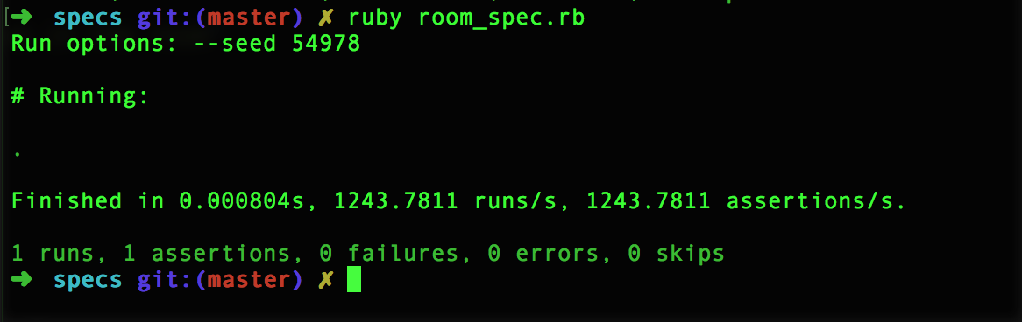

I.T 6 – Demonstrate the use of a hash in a program

Hash in program & function that uses it

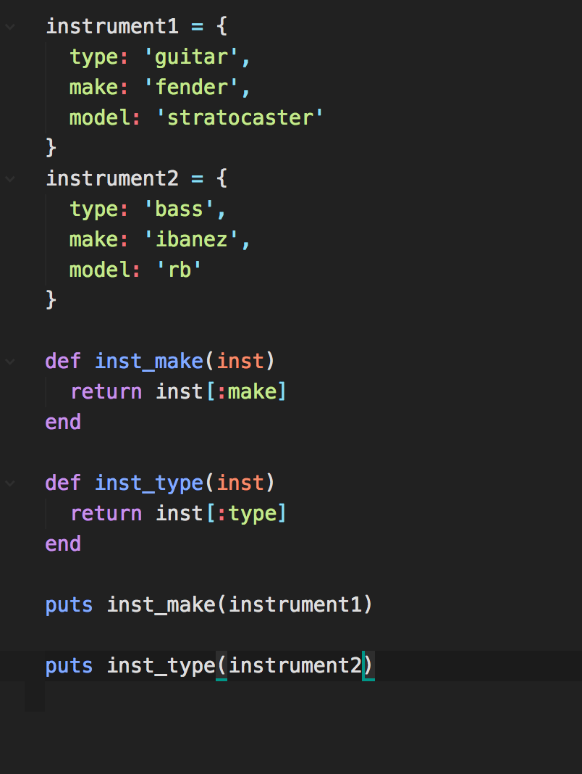
Result

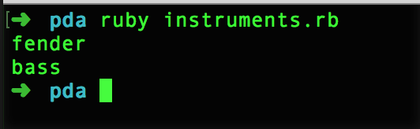

I.T 7 – Demonstrate the use of Polymorphism in a program

