Phishing Playbook

Version 1.0

Purpose 2
Using this playbook 2
Step 1: Receive phishing alert 2
Step 2: Evaluate the alert 2
Step 3.0: Does the email contain any links or attachments? 3
Step 3.1: Are the links or attachments malicious? 3
Step 3.2: Update the alert ticket and escalate 3
Step 4: Close the alert ticket 3
Phishing Flowchart (Version 1.0) 4

Purpose
To help level-one SOC analysts provide an appropriate and timely response to a phishing incident

Using this playbook
Follow the steps in this playbook in the order in which they are listed. Note that steps may overlap.

Step 1: Receive phishing alert
The process begins when you receive an alert ticket indicating that a phishing attempt has been detected.

Step 2: Evaluate the alert
Upon receiving the alert, investigate the alert details and any relevant log information. Here is a list of some of the information you should be evaluating:

- Alert severity
  - Low: Does not require escalation
  - Medium: May require escalation
High: Requires immediate escalation to the appropriate security personnel
- Receiver details
  - The receiver’s email address
  - The receiver’s IP address
- Sender details
  - The sender's email address
  - The sender's IP address
- Subject line
- Message body
- Attachments or links.

Note: Do not open links or attachments on your device unless you are using an authorized and isolated environment.

Step 3.0: Does the email contain any links or attachments?
Phishing emails can contain malicious attachments or links that are attempting to gain access to systems. After examining the details of the alert, determine whether the email contains any links or attachments. If it does, do not open the attachments or links and proceed to Step 3.1. If the email does not contain any links or attachments, proceed to Step 4.

Step 3.1: Are the links or attachments malicious?
Once you've identified that the email contains attachments or links, determine whether the links or attachments are malicious. Check the reputation of the link or file attachment through its hash values using threat intelligence tools such as VirusTotal. If you've confirmed that the link or attachment is not malicious, proceed to Step 4.

Step 3.2: Update the alert ticket and escalate
If you've confirmed that the link or attachment is malicious, provide a summary of your findings and the reason you are escalating the ticket. Update the ticket status to Escalated and notify a level-two SOC analyst of the ticket escalation.

Step 4: Close the alert ticket
Update the ticket status to Closed if:
- You've confirmed that the email does not contain any links or attachments
or
- You've confirmed that the link or attachment is not malicious.

Include a brief summary of your investigation findings and the reason why you’ve closed the ticket.

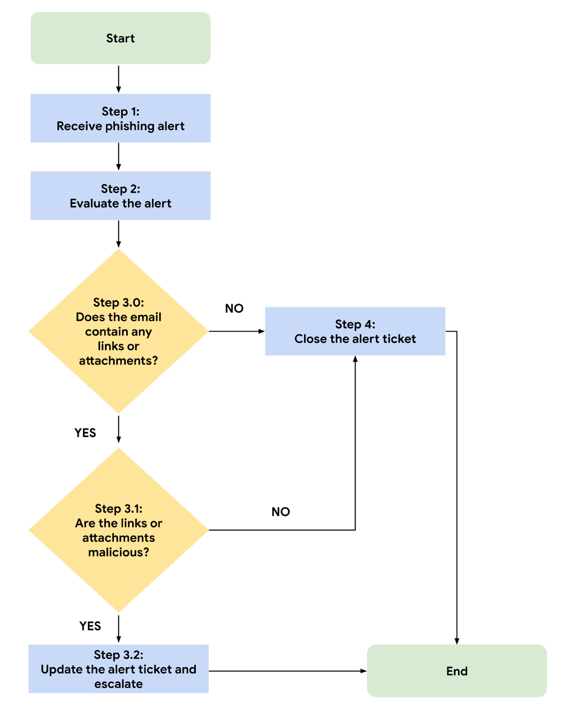
Phishing Flowchart (Version 1.0)

