Article
A Reproducible Machine-Learning Framework for Shot Quality and Attacking Profile Stability in Professional Football
Šimon Salaj 1,*, Michal Hrubý 1 and Jan Cacek 1
1 Faculty of Sports Studies, Masaryk University, Brno, Czech Republic; salaj@mail.muni.cz (Š.S.); michal.hruby@fsps.muni.cz (M.H.); cacek@fsps.muni.cz (J.C.)
* Correspondence: salaj@mail.muni.cz
Featured Application
A reproducible workflow for football analysts to temporally validate shot-quality models, test whether apparent team-profile clusters are stable, and prioritise repeatable continuous process indicators over unstable categorical team labels.
Abstract
Football analytics workflows often combine expected-goals modelling with multivariate team profiling, yet predictive discrimination alone does not establish that derived team representations are temporally reliable. This study developed a reproducible workflow that integrates temporal shot-quality validation, clusterability testing, continuous profile extraction, reliability analysis, and out-of-season prediction. Public shot-map data comprised 21,311 shots from 826 Czech First League matches across 2022/23–2024/25. A preselected CatBoost model achieved an AUC of 0.775, precision–recall AUC of 0.383, Brier score of 0.078, and calibration slope of 0.981 on the 2024/25 temporal holdout, although its negative calibration intercept indicated systematic overprediction. Gap statistics supported one cluster and two-cluster solutions were only moderately stable, favouring continuous dimensions. The dominant chance-creation axis was repeatable between seasons (r = 0.764; ICC = 0.780), whereas finishing was substantially less stable (r = 0.232; ICC = 0.205). Early xG retained useful ranking information, but absolute prediction of profile axes and finishing was poor. A separate outcome-free process axis was concurrently associated with points and goal difference. The workflow demonstrates that deployment of football analytics should evaluate calibration, clusterability, and temporal stability before converting model outputs into operational team categories.
Keywords: football analytics; expected goals; machine learning; performance profiling; temporal validation; reliability; principal component analysis

1. Introduction
Football performance analysis increasingly relies on computational models that transform event data into indicators of attacking quality, efficiency, and tactical behaviour. Traditional match statistics such as goals, shots, shots on target, possession, and passing volume remain informative, but their interpretation depends on situational context and does not directly quantify the quality of scoring opportunities [1–4]. Expected-goals (xG) models address part of this limitation by estimating the scoring probability of individual shots from spatial, technical, and contextual information [5–9]. This provides a process-oriented representation of attacking performance that is less dependent on realized scoring outcomes than goals alone.
The practical value of xG-based analysis, however, depends on more than discrimination. A model may rank shots correctly while producing systematically biased probabilities, and such bias can accumulate when shot probabilities are aggregated to the team level. Calibration therefore matters whenever xG is interpreted as an absolute quantity rather than only a ranking score [15,16]. Machine-learning methods such as gradient boosting can capture nonlinear interactions between shot characteristics [17,18], but their outputs require temporally separated validation because football data are non-stationary and provider taxonomies can change over time. Explainable and reproducible implementations are particularly important when model outputs are used by analysts rather than treated as purely predictive benchmarks [19,20].
A second challenge arises after shot-level predictions are aggregated into team profiles. Multivariate profiling can combine shot volume, shot quality, spatial selection, body-part use, chance source, and finishing into a lower-dimensional representation. Such representations are often converted into discrete team types through clustering, even when the underlying structure may be continuous. If clusterability is weak or cluster membership is unstable, categorical labels can create an impression of tactical separation that is not supported by the data [25,26]. The same issue applies to continuous profile dimensions: a mathematically dominant principal component is only operationally useful if it is sufficiently repeatable across time and can be estimated with tolerable uncertainty from partial-season data.
Recent football analytics research has demonstrated the utility of advanced event-based valuation, xG modelling, and data-driven performance parameterisation [11–14,21,22]. Applied Sciences has also published computational approaches for soccer performance analysis and the evolution of performance indicators, highlighting the role of reproducible data processing and multivariate analytics in applied sport settings [21,22]. Nevertheless, relatively few studies combine four checks in one workflow: temporal validation of shot probabilities, explicit testing of whether profile clusters are supported, longitudinal reliability of the resulting dimensions, and leakage-safe evaluation of early-season generalisation. This gap is relevant for smaller professional leagues, where public event data may be the most accessible source for applied analytics and where sample sizes at the team-season level are limited [23,24].
Accordingly, this study develops and evaluates a reproducible analytical workflow using three complete seasons of Czech First League data. The objectives were to: (1) temporally validate a league-specific shot-quality model; (2) determine whether multivariate attacking profiles are better represented by stable clusters or continuous dimensions; (3) quantify between- and within-season reliability of process and finishing indicators; (4) assess how well early-season information generalises to the remainder of a future season; and (5) test whether an outcome-free process axis retains applied relevance after season adjustment and opponent-strength correction. The central expectation was that process-oriented chance creation would be more temporally reliable than finishing and that explicit clusterability tests would favour continuous monitoring over fixed team typologies.

2. Materials and Methods

2.1. Study Design, Data Source, and Sample
This observational longitudinal study combined shot-quality modelling, team-season aggregation, clusterability assessment, principal component analysis (PCA), reliability analysis, temporal prediction, and opponent-adjusted validation. Analyses were descriptive or predictive and are interpreted as associational. Reporting was informed by STROBE principles for observational research and TRIPOD principles for predictive modelling.
The analytical dataset was closed on 28 July 2026 and covered Czech First League matches from 2022/23, 2023/24, and 2024/25. This three-season window was specified before final model fitting. Shot-level information was collected from publicly accessible SofaScore match-centre and shot-map pages; use of publicly accessible information was confirmed in written communication with the provider. Raw provider-derived records were not redistributed.
Extraction identified 866 match records. After postponed or cancelled fixtures were removed, 841 finished matches remained, with shot maps available for 836 matches (21,644 shots). Ten promotion/relegation play-offs against second-tier opponents were excluded from the primary analytical sample. Removing 62 own goals resulted in 21,311 shots from 826 matches (Table 1).
Table 1. Construction of the analytical sample.
Step | Matches | Shots
Scraped match records, 2022/23–2024/25 | 866 | 21,644
Finished matches | 841 | 21,644
Matches with shot-map data | 836 | 21,644
Czech First League matches retained | 826 | 21,373
Final sample after excluding own goals | 826 | 21,311
Ten promotion/relegation play-offs against second-tier opposition and 62 own goals were excluded from the final analytical shot sample.

2.2. Shot Variables, Preprocessing, and Data-Quality Audit
Candidate shot-level predictors comprised horizontal and vertical location, distance and angle proxies, lateral offset, centrality, penalty-area, six-yard-area and central-corridor indicators, body part, situation, match minute, added time, match half, late-game status, score difference, score state, and home status. Blocked-shot status, team identity, and opponent identity were not used as shot-quality predictors. Variables directly encoding the outcome were excluded. Spatial values were audited, categorical variables were harmonised where possible, and team-profile indicators were standardised within season.
A specific data-quality audit examined the provider-defined shot-situation taxonomy. Fast-break and throw-in labels increased sharply at the 2024/25 boundary, with non-overlapping monthly ranges relative to earlier seasons. Because such taxonomy shifts can create spurious longitudinal structure, the shot-quality and profile workflows were repeated without situation-derived information. This audit was treated as part of the modelling workflow rather than as a post hoc data-cleaning step.

2.3. Shot-Quality Model Development and Temporal Validation
The target was whether a shot resulted in a goal. CatBoost was the primary nonlinear model because it can model nonlinear interactions and mixed predictor types while limiting manual feature engineering [18]. For benchmarking, the analysis also included an overall goal-rate baseline, spatial logistic regression, contextual logistic regression, regularised logistic regression, random forest, and XGBoost [17]. Model configurations were selected using 2023/24 inner-validation log loss after training on 2022/23. The selected CatBoost configuration was then refitted on 2022/23 and 2023/24 together, and 2024/25 was used once as the final temporal holdout. The earlier 2022/23-to-2023/24 transition was also retained as a development-transition check.
Evaluation metrics were receiver operating characteristic area under the curve (AUC), precision–recall AUC (PR-AUC), log loss, Brier score, Brier skill score (BSS), expected calibration error (ECE), calibration slope, and calibration intercept. Predictions used for downstream team profiles were generated out of fold using five folds grouped by match, ensuring that no shot was scored by a model trained on shots from the same match.
After the final holdout evaluation, an exploratory intercept-only logistic recalibration was fitted to the 2024/25 predictions with the slope fixed at one. This same-holdout procedure was not used for model selection and is not interpreted as independent validation of the recalibrated model. It was used only to test whether the main downstream conclusions were sensitive to the observed aggregate probability shift. The fitted logit-intercept shift was also applied uniformly to out-of-fold predictions from all seasons, after which selected team-level reliability analyses were recomputed.

2.4. Team-Season Profiles and Clusterability
Team-season profiles combined 17 indicators describing shot quantity, modelled quality, distance, angle, centrality, body-part distribution, chance source, blocks, goals, and finishing relative to modelled quality. Indicators were aggregated by team-season and standardised within season. Because goal rate, on-target rate, and goals minus xG were part of the 17-feature matrix, the resulting profile PCA was descriptive rather than outcome-free.
Before assigning teams to discrete types, clusterability and stability were evaluated explicitly. K-means, Ward hierarchical clustering, and Gaussian mixture models were examined for k = 2–7. For each solution, 400 bootstrap samples of team-season profiles were drawn with replacement, the clustering algorithm was refitted, and each original cluster was matched to the resampled cluster with the largest Jaccard overlap. Jaccard values of at least 0.75 were treated as stable, whereas values from 0.60 to below 0.75 were interpreted as pattern-level rather than stable evidence. Gap statistics evaluated k = 1–7 against 200 uniform reference datasets drawn within the PCA-aligned bounding box and used the one-standard-error rule. Covariance-matched null data and reduced-feature matrices were used as additional robustness checks [25,26].
PCA summarised the standardised profiles. Five components explaining more than 80% of total variance were retained for clustering and robustness checks. Component signs were oriented for interpretability, and the first components were labelled from their dominant loading patterns.

2.5. Temporal Reliability and Early-Season Generalisation
Between-season reliability was assessed using consecutive-season Pearson correlations and team-level ICC(1,1) coefficients from a one-way random-effects model, interpreted as single-measure absolute agreement. A negative ICC indicates that within-team variation exceeded between-team variation. Pearson confidence intervals used the Fisher z transformation.
Within-season temporal stability compared first-half and second-half values. Individual correlation intervals used 2,000 percentile bootstrap resamples of team-season rows. Direct differences between the chance-creation and finishing correlations, and between xG per match and goals minus xG per match, used 2,000 paired club-cluster bootstrap draws. Clubs were sampled with replacement, all seasons for a sampled club were retained, and both correlations were recomputed within the same draw. Stabilisation curves used the same club-cluster resampling scheme.
Early-season prediction used the first five matches, first ten matches, and first 30% of the season as non-overlapping early windows. Models were trained on 2022/23–2023/24 and evaluated on the 16 team-seasons in 2024/25. The primary comparison was between a naive early-value baseline and regularised linear regression; random forest was retained as a sensitivity model. Performance was summarised by out-of-sample R², mean absolute error (MAE), and Spearman correlation. To prevent temporal leakage, 2024/25 shot-quality aggregates used only chronologically held-out predictions, and all profile scaling and PCA transformations were fitted on the two training seasons before application to 2024/25.

2.6. Outcome-Free Process Axis and Opponent Adjustment
To evaluate applied relevance without mechanically incorporating realised scoring outcomes into the predictor, a separate process-based chance-creation axis was constructed from 11 indicators: shots per match, xG per match, mean and median shot quality, high- and low-quality-shot shares, mean shot distance, mean centrality, set-piece share, header share, and close-range share. Indicators were standardised within season and the first principal component was oriented so that higher values represented greater xG. Goal rate, on-target rate, goals minus xG, and other realised conversion outcomes were excluded.
Exploratory season-adjusted models related the process axis and the original finishing axis to points per match, goal difference per match, and non-penalty goal difference per match. Uncertainty used team-clustered standard errors and a 2,000-draw club-cluster percentile bootstrap. Sensitivity models omitted the finishing axis. These analyses are interpreted as concurrent associations, not as prospective predictions or causal effects.
As a separate robustness check, xG, shot volume, and mean shot quality were adjusted for opponent strength using cross-fitted ridge models with team, opponent, venue, and season information. Rank correspondence between opponent-adjusted xG and the original chance-creation axis was assessed with Spearman correlation.

2.7. Robustness and Reproducibility
Robustness analyses excluded penalties, added time, and set pieces; used metric-corrected geometry; removed situation-derived predictors; and used reduced profile matrices. Analyses were conducted in Python using pandas, NumPy, scikit-learn, CatBoost, statsmodels, SciPy, and related open-source packages. Analysis code and derived analytical outputs are archived on Zenodo at https://zenodo.org/records/ 22876916.

3. Results

3.1. Sample Characteristics and Data-Quality Audit
The final sample contained 21,311 shots from 826 matches: 6,948 shots from 275 matches in 2022/23, 7,261 from 276 matches in 2023/24, and 7,102 from 275 matches in 2024/25. Across seasons, matches contained 25.8 shots and 2.75 goals on average; conversion was 10.67%, 33.9% of shots were on target, and 25.9% were blocked (Table 2).
Table 2. Seasonal sample characteristics and selected taxonomy-continuity checks.
Panel A. Seasonal shot characteristics.
Metric | 2022/23 | 2023/24 | 2024/25 | All seasons
Matches | 275 | 276 | 275 | 826
Teams | 16 | 16 | 16 | 18 distinct
Shots | 6,948 | 7,261 | 7,102 | 21,311
Shots/match | 25.27 | 26.31 | 25.83 | 25.80
Goals/match | 2.88 | 2.77 | 2.61 | 2.75
Conversion (%) | 11.40 | 10.52 | 10.11 | 10.67
On target (%) | 35.10 | 33.70 | 32.80 | 33.90
Blocked (%) | 24.60 | 26.00 | 27.10 | 25.90
Set-piece (%) | 26.80 | 27.60 | 32.70 | 29.10
Panel B. Selected annotation and spatial-continuity checks.
Variable | Type | 2022/23 | 2023/24 | 2024/25 | Ratio 2024/25: earlier
situation = assisted | Technical annotation | 0.5574 | 0.5452 | 0.4678 | 0.85
situation = corner | Technical annotation | 0.155 | 0.1592 | 0.165 | 1.05
situation = open_play | Technical annotation | 0.1586 | 0.149 | 0.1349 | 0.88
situation = set_piece | Technical annotation | 0.0635 | 0.0694 | 0.0684 | 1.03
situation = throw_in | Technical annotation | 0.0112 | 0.0139 | 0.0651 | 5.18
situation = free_kick | Technical annotation | 0.0278 | 0.0227 | 0.0189 | 0.75
situation = fast_break | Technical annotation | 0.0158 | 0.0295 | 0.0703 | 3.10
situation = penalty | Technical annotation | 0.0107 | 0.0110 | 0.0097 | 0.90
mean_distance_m | Spatial/derived | 18.1188 | 18.0029 | 17.0413 | 0.94
close_range_share | Spatial/derived | 0.1982 | 0.2125 | 0.2620 | 1.28
inside_box_share | Spatial/derived | 0.6186 | 0.6063 | 0.6322 | 1.03
header_share | Spatial/derived | 0.1966 | 0.1840 | 0.1867 | 0.98
Panel B values are proportions (0–1), except mean distance, which is reported in metres. The ratio compares 2024/25 with the mean of the earlier seasons.
The taxonomy audit identified a marked discontinuity at the 2024/25 boundary. Fast-break labels increased from 1.6% and 2.9% to 7.0%, whereas throw-in situations increased from 1.1% and 1.4% to 6.5%. Spatial variables were more stable, although mean shot distance decreased and close-range share increased. The spatial distribution of the analytical sample is shown in Figure 1.
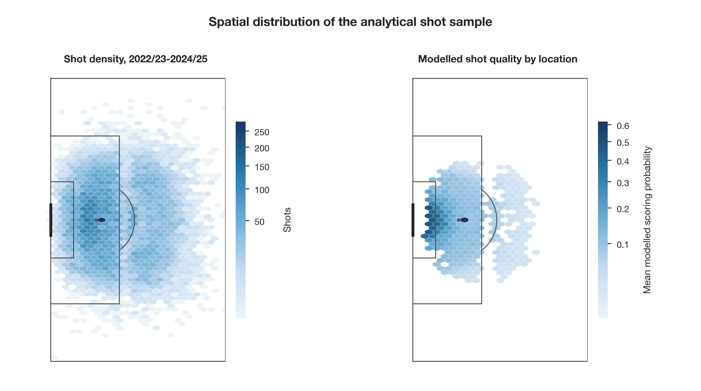
Figure 1. Spatial distribution of the analytical shot sample. The left panel shows shot density for observations with valid coordinates (n = 21,255); its darkest penalty-area hexagon contains 283 shots. The right panel shows mean modelled scoring probability by location; its darkest displayed cell contains 294 shots, and cells are shown only when they contain at least 30 shots. Local cell means are descriptive and should not be interpreted as precise estimates for an individual location.

3.2. Temporal Shot-Quality Model Performance
The selected CatBoost configuration achieved AUC 0.775, PR-AUC 0.383, log loss 0.276, Brier score 0.078, BSS 0.146, calibration slope 0.981, calibration intercept −0.320, and ECE 0.027 on the held-out 2024/25 season (Table 3). The negative calibration intercept indicates systematic overprediction even though the calibration slope was close to one. Performance was similar on the earlier 2022/23-to-2023/24 transition (AUC 0.788). Figure 2 shows the holdout calibration curve.
Table 3. Shot-quality model performance and temporal validation.
Panel A. Held-out 2024/25 model comparison.
Model | AUC | PR-AUC | Log loss | Brier | BSS | Slope | Intercept | ECE
Goal-rate baseline | — | — | 0.328 | 0.091 | 0.000 | — | — | 0.008
Spatial logistic | 0.733 | 0.277 | 0.298 | 0.085 | 0.071 | 0.966 | −0.234 | 0.023
Contextual logistic | 0.772 | 0.358 | 0.280 | 0.079 | 0.135 | 0.958 | −0.296 | 0.028
Regularised logistic | 0.772 | 0.379 | 0.279 | 0.078 | 0.140 | 0.939 | −0.323 | 0.028
Random forest | 0.770 | 0.368 | 0.278 | 0.078 | 0.147 | 1.062 | −0.279 | 0.024
XGBoost | 0.775 | 0.382 | 0.277 | 0.078 | 0.145 | 1.014 | −0.328 | 0.028
CatBoost | 0.775 | 0.383 | 0.276 | 0.078 | 0.146 | 0.981 | −0.320 | 0.027
Panel B. Temporal validation of the selected CatBoost model.
Transition | N | AUC | PR-AUC | Brier | BSS | Slope | Intercept | ECE
2022/23 → 2023/24 | 7261 | 0.788 | 0.4133 | 0.0773 | 0.1797 | 1.0602 | −0.1884 | 0.0158
2022/23 + 2023/24 → 2024/25 | 7102 | 0.7747 | 0.3830 | 0.0777 | 0.1461 | 0.9805 | −0.3199 | 0.0269
Panel C. Situation-taxonomy robustness.
Specification | AUC | Calibration intercept
Primary CatBoost | 0.775 | −0.320
CatBoost without situation | 0.775 | −0.276
BSS = Brier skill score; ECE = expected calibration error. Model selection used 2023/24 inner-validation log loss before final 2024/25 evaluation.
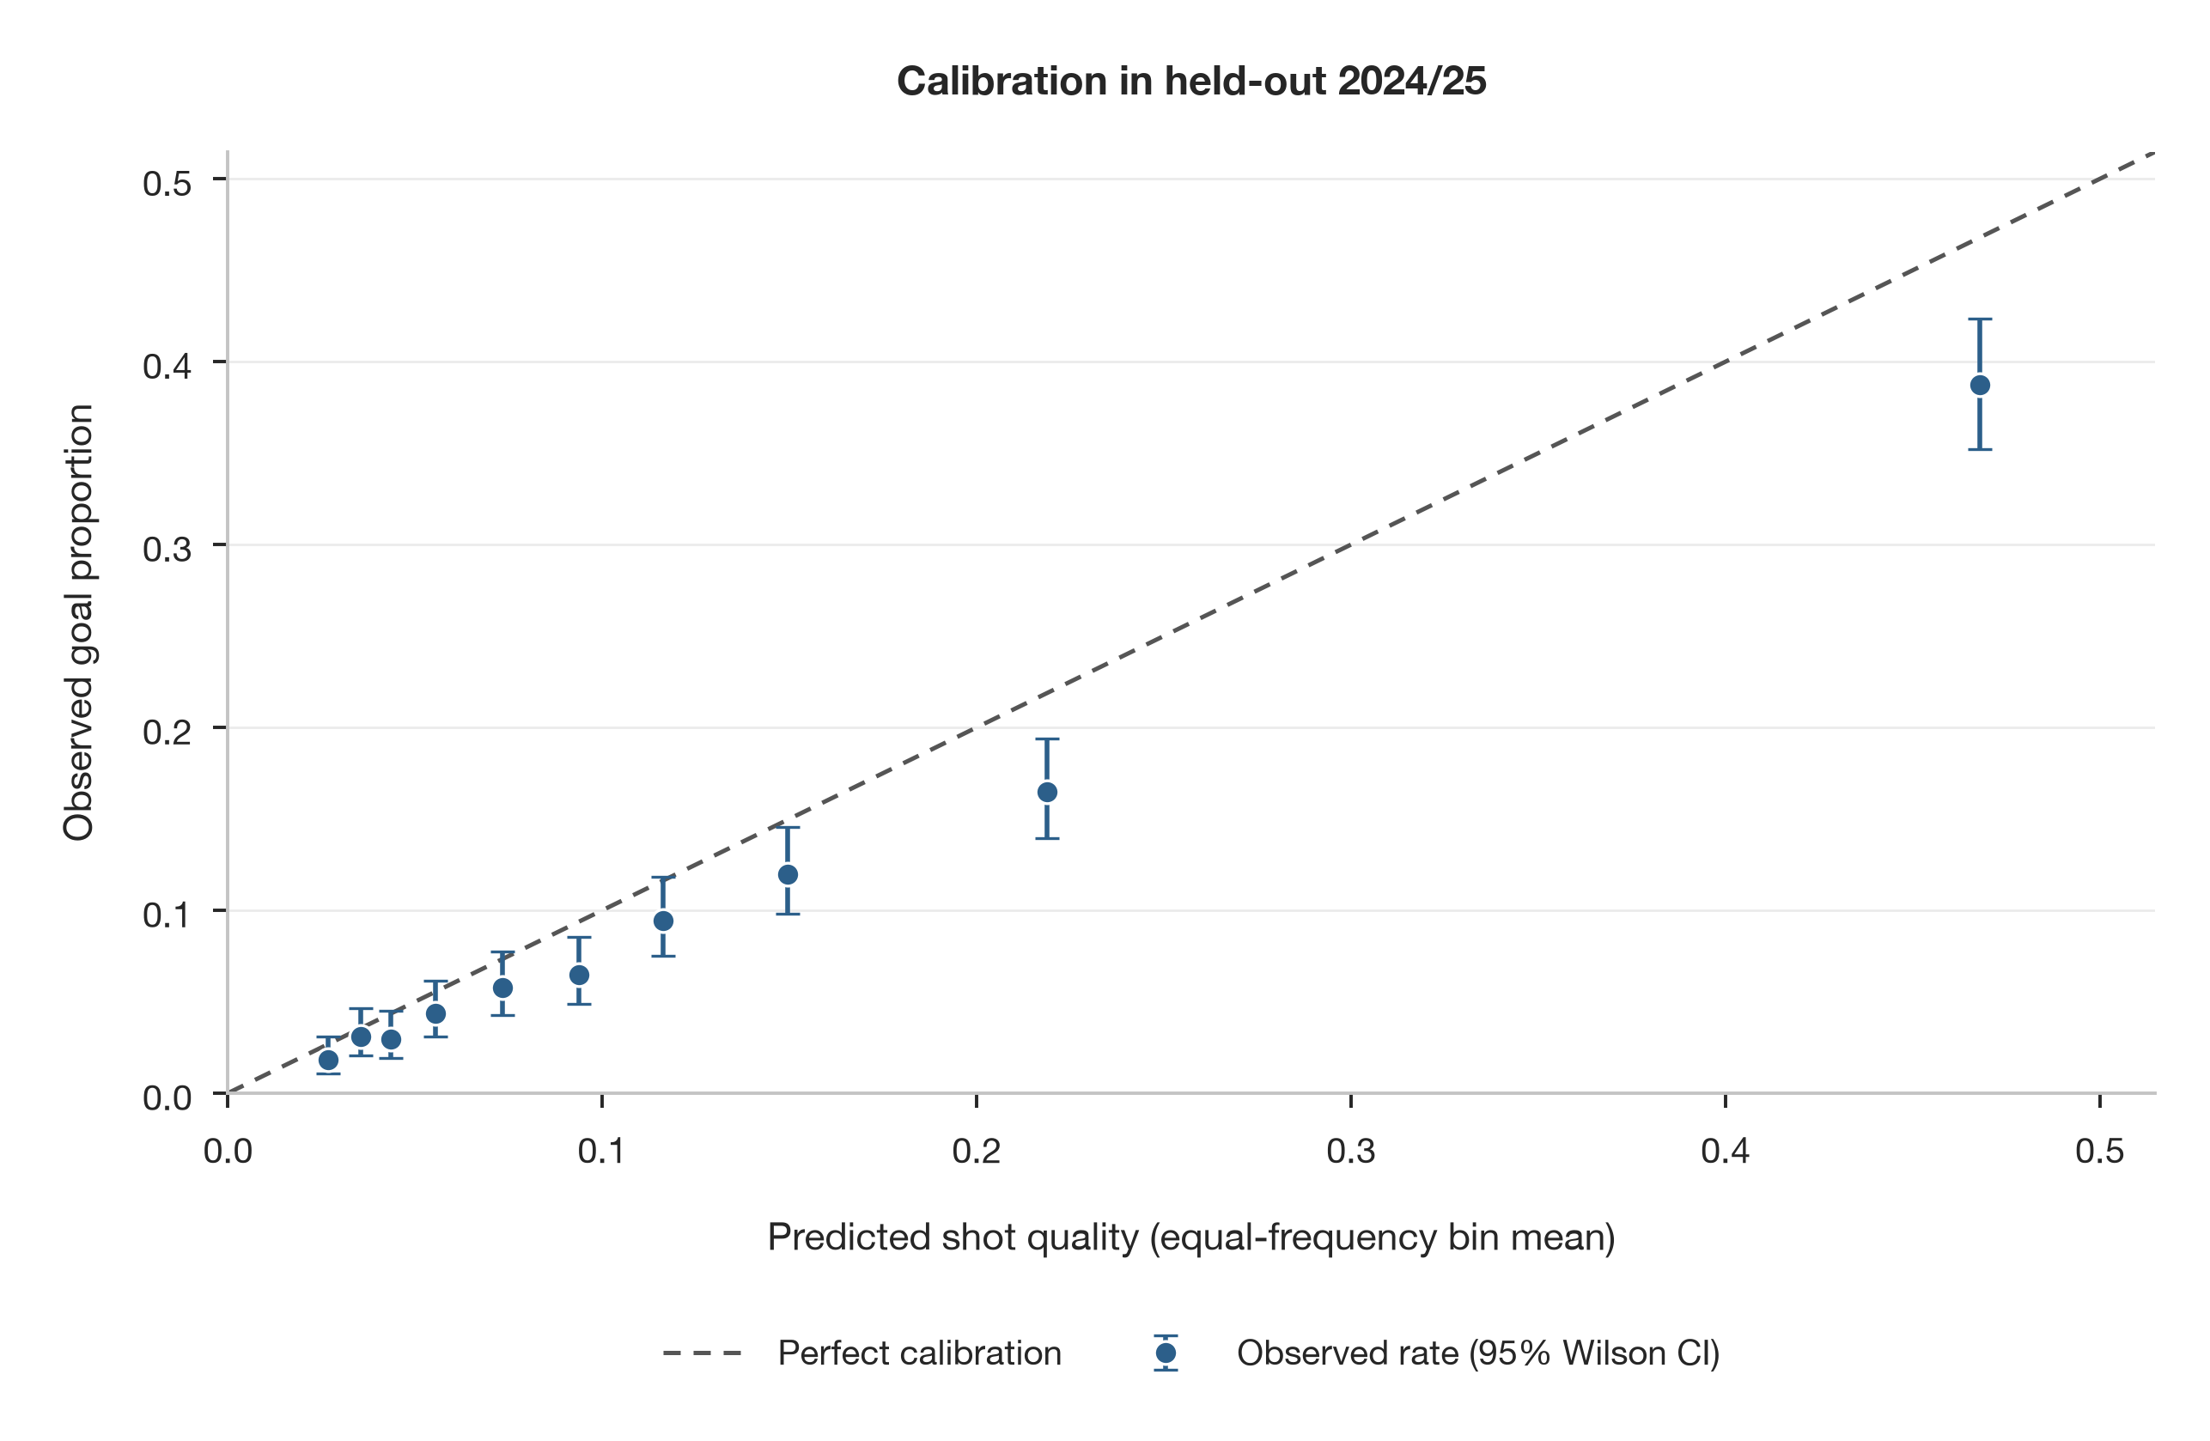
Figure 2. Calibration of the shot-quality model in the held-out 2024/25 season. Points show observed goal proportions within ten equal-frequency bins of predicted shot quality. Vertical error bars are 95% Wilson binomial confidence intervals; the dashed diagonal represents perfect calibration.
The post-evaluation same-holdout sensitivity analysis showed 909.2 summed xG compared with 718 observed goals. The intercept-only adjustment reduced summed xG to 718.0. Team xG ranks were almost unchanged (Spearman ρ = 0.997), and goals-minus-xG ranks were broadly preserved (ρ = 0.929). Applying the same intercept shift as a downstream stress test changed year-to-year correlations from 0.380 to 0.462 for goals minus xG and from 0.232 to 0.273 for the finishing axis; split-half correlations changed from 0.452 to 0.445 and from 0.552 to 0.576, respectively. Thus, the main stability interpretation was not dependent on the aggregate calibration shift.

3.3. Clusterability and Continuous Profile Structure
Profiles were constructed for 48 team-seasons. The full 17-feature matrix produced only moderately stable two-cluster solutions: minimum bootstrap Jaccard values were approximately 0.60–0.62. Three-cluster solutions were less stable. The gap statistic selected one cluster for both the full and reduced feature matrices, indicating that the data did not provide clear evidence for multiple separated team types (Table 4). The descriptive two-cluster partition was unchanged across two to four retained components, but reduced features did not improve stability. Consequently, subsequent interpretation focused on continuous PCA dimensions rather than categorical cluster labels.
Table 4. Clusterability evidence and continuous profile dimensions.
Panel A. Selected clusterability metrics.
Feature set | Algorithm | k | Silhouette | Mean Jaccard | Minimum Jaccard | Smallest n
Full 17-feature | k-means | 2 | 0.418 | 0.602 | 0.600 | 8
Full 17-feature | k-means | 3 | 0.216 | 0.510 | 0.450 | 8
Full 17-feature | Ward | 2 | 0.418 | 0.626 | 0.621 | 8
Reduced 9-feature | k-means | 2 | 0.198 | 0.503 | 0.493 | 22
Reduced 9-feature | Ward | 2 | 0.193 | 0.438 | 0.409 | 19
Panel B. Gap-statistic summary.
Feature set | Selected k | Gap | s_k | Interpretation
Full 17-feature | 1 | 0.463 | 0.065 | k = 1 selected
Reduced 9-feature | 1 | 0.532 | 0.060 | k = 1 selected
Panel C. PCA variance.
Component | Interpretation | Variance explained (%) | Cumulative (%) | Eigenvalue
PC1 | Chance creation | 42.9 | 42.9 | 7.44
PC2 | Finishing and shot outcome | 16.5 | 59.4 | 2.87
PC3 | Chance source/set-piece orientation | 11.1 | 70.5 | 1.92
PC4 | Additional profile variation | 8.3 | 78.7 | 1.44
PC5 | Additional profile variation | 5.3 | 84.1 | 0.92
Bootstrap Jaccard values below 0.75 were not interpreted as stable clusters. Component labels reflect dominant loading patterns; indicators may cross-load.
PC1 explained 42.9% of variance and was chance-creation dominant: mean and median shot quality, xG per match, high-quality-shot share, and shot volume loaded positively, whereas shot distance and low-quality-shot share loaded negatively. PC2 explained 16.5% and primarily represented finishing and shot outcome. PC3 explained 11.1% and contrasted set-piece with assisted creation. Figure 3 visualises the continuous team-season space; cluster labels are intentionally omitted because the clusterability diagnostics did not support stable discrete types.
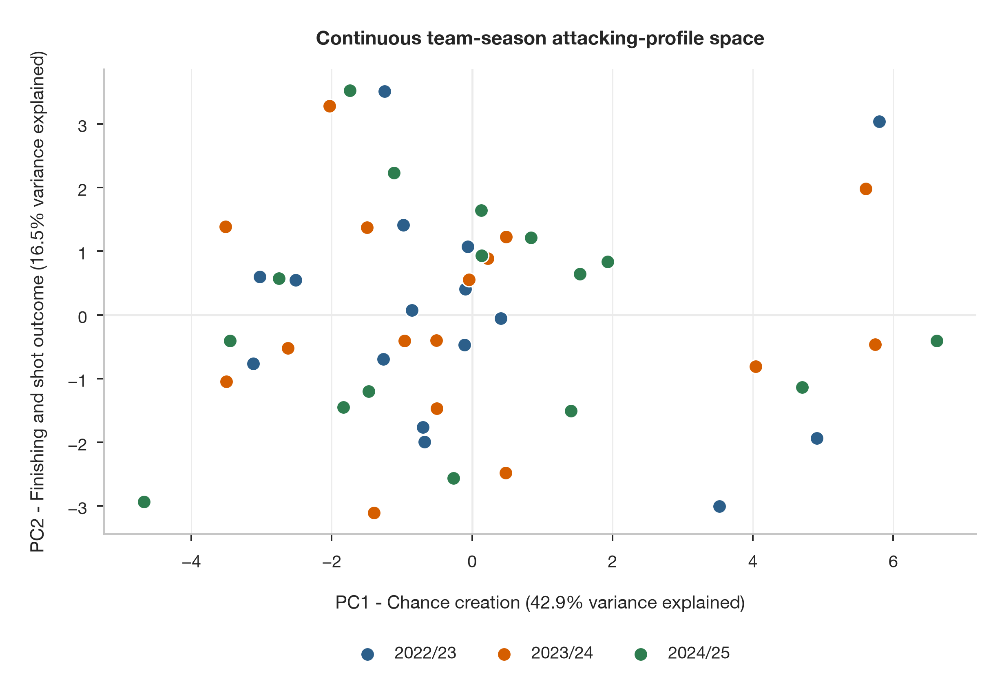
Figure 3. Continuous team-season attacking-profile space. Points show 48 team-seasons in the PCA space. PC1 is interpreted as a chance-creation-dominant dimension and PC2 as finishing and shot outcome. Colours distinguish seasons only; cluster labels are not shown because clusterability tests supported continuous variation rather than stable discrete types.
Table 5. Loadings for the three interpreted profile components.
Feature | PC1: chance creation | PC2: finishing/outcome | PC3: chance source
Mean shot quality | 0.348 | 0.017 | 0.011
Median shot quality | 0.336 | −0.058 | −0.075
xG per match | 0.333 | 0.015 | −0.147
Goals minus xG per match | 0.124 | 0.352 | 0.341
Mean distance | −0.311 | 0.251 | −0.069
Mean angle proxy | 0.075 | 0.260 | 0.300
High-quality shot share | 0.340 | 0.026 | −0.066
Low-quality shot share | −0.330 | 0.103 | 0.028
Shots per match | 0.271 | 0.025 | −0.231
On-target rate | 0.211 | 0.358 | 0.214
Blocked rate | −0.140 | −0.082 | −0.035
Goal rate | 0.294 | 0.256 | 0.217
Header share | 0.131 | −0.450 | −0.002
Assisted share | 0.041 | 0.341 | −0.520
Set-piece share | −0.006 | −0.318 | 0.552
Close-range share | 0.251 | −0.325 | −0.095
Fast-break share | 0.084 | 0.055 | 0.157

3.4. Temporal Reliability and Early-Season Generalisation
Between seasons, the chance-creation axis was highly repeatable (r = 0.764, 95% CI 0.56–0.88; ICC = 0.780), whereas the finishing axis was not (r = 0.232, 95% CI −0.14 to 0.55; ICC = 0.205). xG per match (r = 0.885) and shots per match (r = 0.776) were the most repeatable underlying indicators. Goals minus xG was less reliable in absolute level, with r = 0.380 and ICC = −0.243 (Table 6, Panel A).
Within seasons, first-half versus second-half correlations were 0.751 for xG per match and 0.452 for goals minus xG per match. Corresponding profile-axis correlations were 0.628 and 0.552. The observed differences favoured process indicators, but paired club-cluster bootstrap tests were not conclusive: the xG-minus-goals-minus-xG correlation difference was 0.299 (95% CI −0.039 to 0.618, p = 0.067), and the chance-minus-finishing axis difference was 0.076 (95% CI −0.354 to 0.282, p = 0.663). Figure 4 illustrates the stabilisation curves without imposing a prespecified threshold.
Table 6. Between-season and within-season reliability.
Panel A. Season-to-season repeatability.
Feature | Pairs | Year-to-year r | 95% CI | p | ICC
Chance-creation axis | 30 | 0.764 | 0.56 to 0.88 | <0.001 | 0.780
Finishing axis | 30 | 0.232 | −0.14 to 0.55 | 0.218 | 0.205
Chance-source axis | 30 | 0.383 | 0.03 to 0.65 | 0.037 | 0.331
Mean shot quality | 30 | 0.673 | 0.41 to 0.83 | <0.001 | 0.273
xG per match | 30 | 0.885 | 0.77 to 0.94 | <0.001 | 0.726
Goals minus xG per match | 30 | 0.380 | 0.02 to 0.65 | 0.039 | −0.243
High-quality shot share | 30 | 0.707 | 0.47 to 0.85 | <0.001 | 0.248
Shots per match | 30 | 0.776 | 0.58 to 0.89 | <0.001 | 0.759
On-target rate | 30 | 0.294 | −0.07 to 0.59 | 0.115 | 0.247
Goal rate | 30 | 0.407 | 0.05 to 0.67 | 0.026 | 0.306
Panel B. First-half versus second-half stability.
Indicator | Pearson r | 95% CI | Spearman ρ | MAE | n
Shots/match | 0.637 | [0.430, 0.775] | 0.541 | 1.651 | 48
xG/match | 0.751 | [0.572, 0.868] | 0.676 | 0.243 | 48
Mean shot quality | 0.593 | [0.355, 0.757] | 0.571 | 0.013 | 48
Chance-creation axis | 0.628 | [0.418, 0.773] | 0.506 | 2.209 | 48
Goals − xG/match | 0.452 | [0.124, 0.665] | 0.322 | 0.278 | 48
On-target rate | 0.381 | [0.143, 0.594] | 0.375 | 0.035 | 48
Finishing axis | 0.552 | [0.341, 0.711] | 0.557 | 1.641 | 48
Panel C. Paired differences in first-half versus second-half Pearson correlations.
Comparison | Difference | 95% paired bootstrap CI | p
Chance axis − finishing axis | 0.076 | [−0.354, 0.282] | 0.663
xG/match − goals − xG/match | 0.299 | [−0.039, 0.618] | 0.067
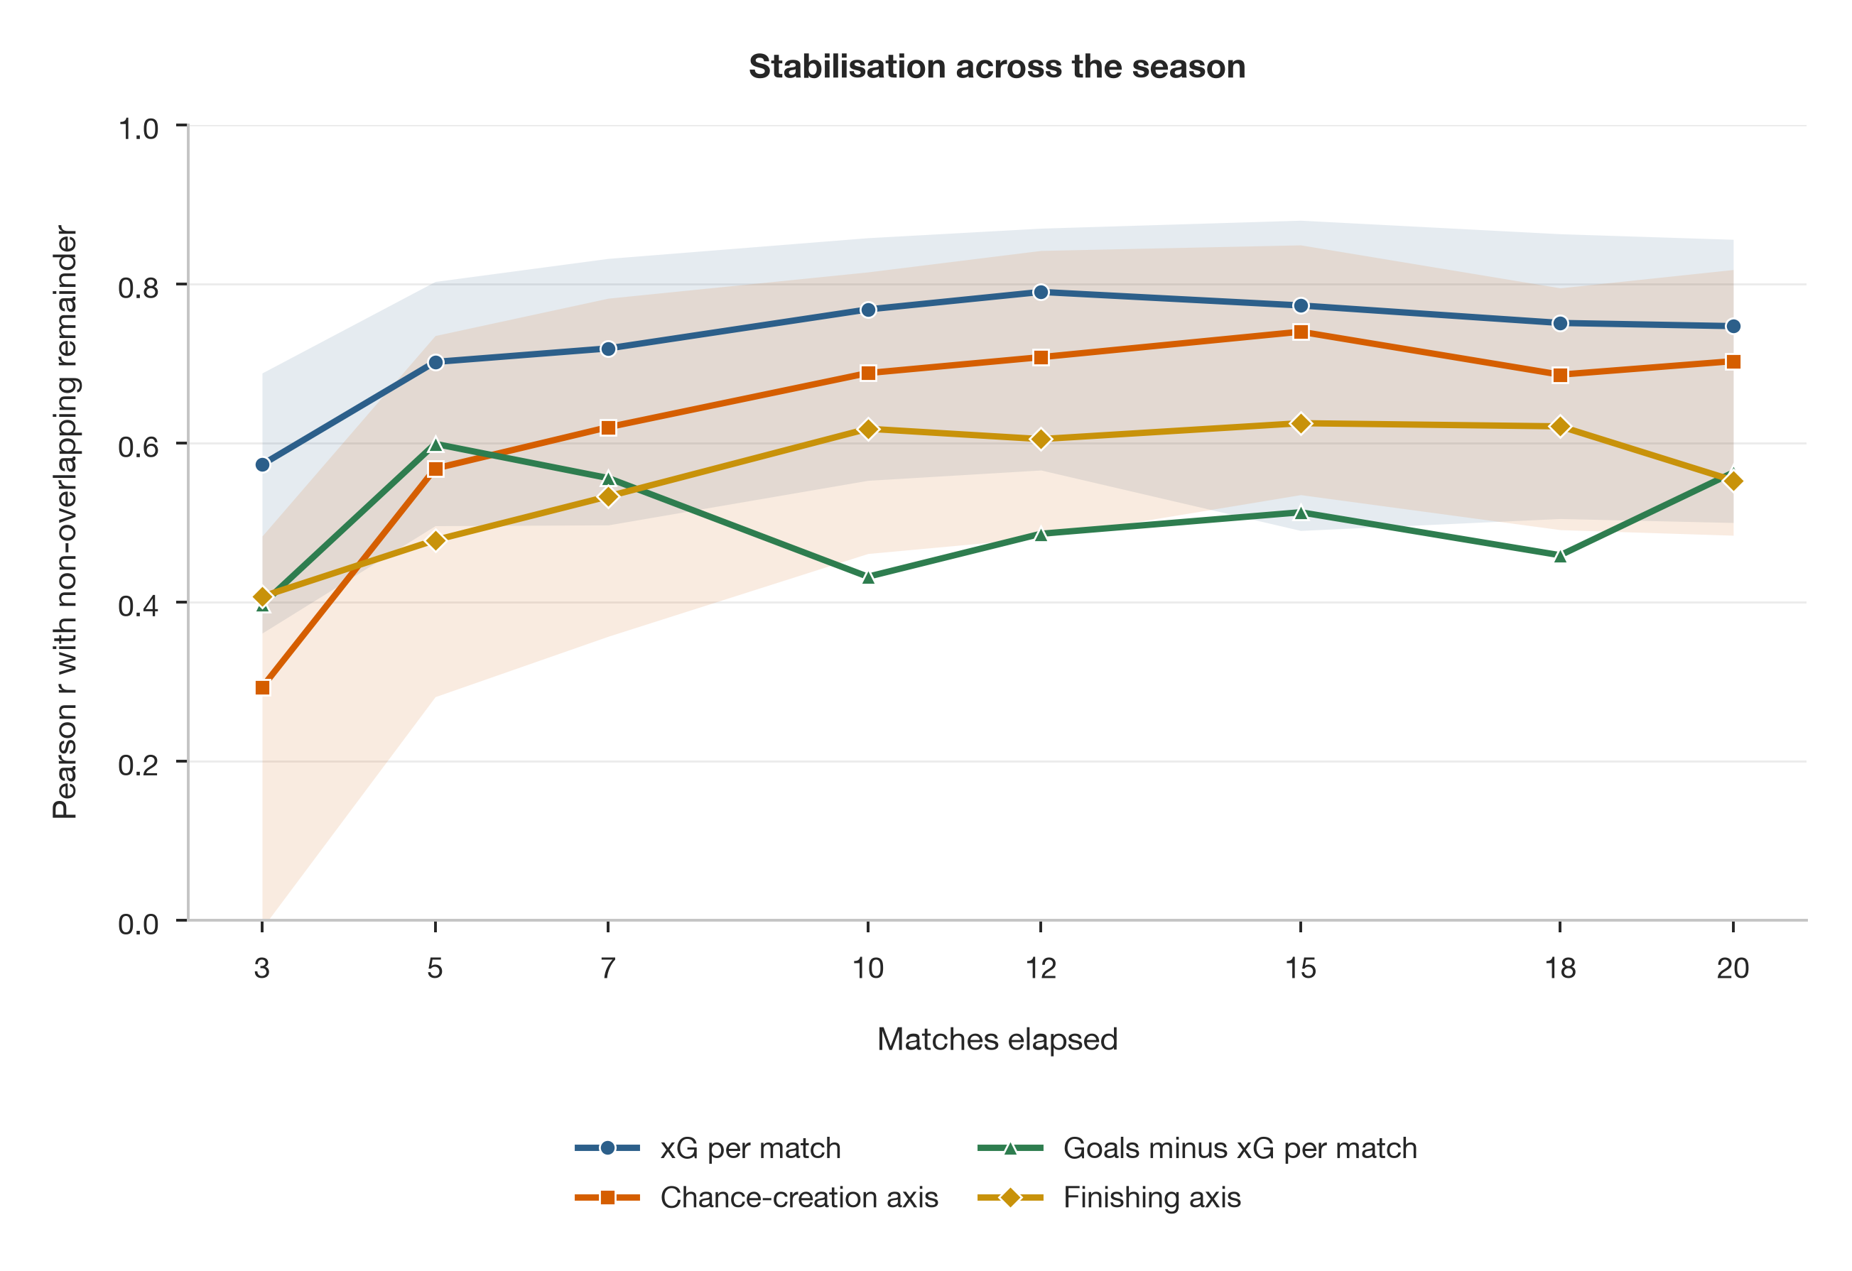
Figure 4. Stabilisation across the season. Curves show Pearson correlations between each early-season window and the remaining non-overlapping season. Shaded bands are 95% club-cluster bootstrap intervals for xG per match and the original 17-feature PCA chance-creation axis; the other curves show point estimates. No stability threshold was prespecified.
In the leakage-safe future-season evaluation, early xG retained useful information about remainder-of-season xG. After ten matches, the naive early-value baseline achieved R² = 0.377 (95% bootstrap CI −1.223 to 0.679), MAE = 0.303, and Spearman ρ = 0.726. Ridge regression achieved R² = 0.321, MAE = 0.282, and ρ = 0.600. With the first 30% of the season, the baseline R² was 0.429 and ρ was 0.726. By contrast, absolute prediction of the PCA profile axes and goals minus xG was poor, with negative held-out R² values across the reported ten-match specifications (Table 7).
Table 7. Selected early-season prediction results for the 2024/25 remainder.
Window | Target | Model | R² | R² 95% CI | MAE | ρ | ρ 95% CI
10 matches | Chance axis | Naive | −0.103 | [−3.044, 0.588] | 2.417 | 0.612 | [0.205, 0.839]
10 matches | Chance axis | Ridge | −0.540 | [−2.581, −0.011] | 3.021 | 0.553 | [0.076, 0.841]
10 matches | Finishing axis | Naive | −1.152 | [−5.819, 0.084] | 1.877 | 0.594 | [0.211, 0.827]
10 matches | Finishing axis | Ridge | −1.040 | [−4.319, −0.120] | 1.873 | 0.676 | [0.293, 0.888]
10 matches | xG/match | Naive | 0.377 | [−1.223, 0.679] | 0.303 | 0.726 | [0.358, 0.911]
10 matches | xG/match | Ridge | 0.321 | [−0.095, 0.507] | 0.282 | 0.600 | [0.161, 0.840]
10 matches | Goals − xG/match | Naive | −0.961 | [−2.849, −0.338] | 0.273 | 0.003 | [−0.540, 0.534]
10 matches | Goals − xG/match | Ridge | −2.209 | [−4.815, −1.315] | 0.356 | 0.356 | [−0.237, 0.839]
30% season | xG/match | Naive | 0.429 | [−0.820, 0.693] | 0.299 | 0.726 | [0.324, 0.911]
Training n = 32 team-seasons; holdout n = 16. Negative R² indicates worse absolute prediction than the holdout-mean benchmark. Targets cover only the remainder after the early window.

3.5. Outcome-Free Process Axis and Opponent Adjustment
The separately fitted 11-indicator process axis was positively associated with team outcomes without using realised conversion outcomes in its construction. Spearman correlations were 0.666 with points per match and 0.712 with goal difference per match; the original finishing-axis correlations were 0.102 and 0.097, respectively. In season-adjusted models containing both process and finishing axes, a one-unit increase in the process axis was associated with 0.173 points per match (club-cluster bootstrap 95% CI 0.132–0.201) and 0.275 goals of goal difference per match (95% CI 0.212–0.317). Sensitivity models excluding the finishing axis yielded coefficients of 0.155 (95% CI 0.103–0.189) and 0.243 (95% CI 0.168–0.300), respectively. These concurrent associations therefore did not depend on conditioning on the finishing axis.
Opponent adjustment produced a Spearman correlation of 0.721 between opponent-adjusted xG per match and the original chance-creation axis. This indicates that the continuous process ranking was not merely a reflection of the unadjusted opponent schedule. Figure 5 shows the unadjusted descriptive relationships for the outcome-free process axis; the plotted confidence bands are distinct from the season-adjusted inference reported above.
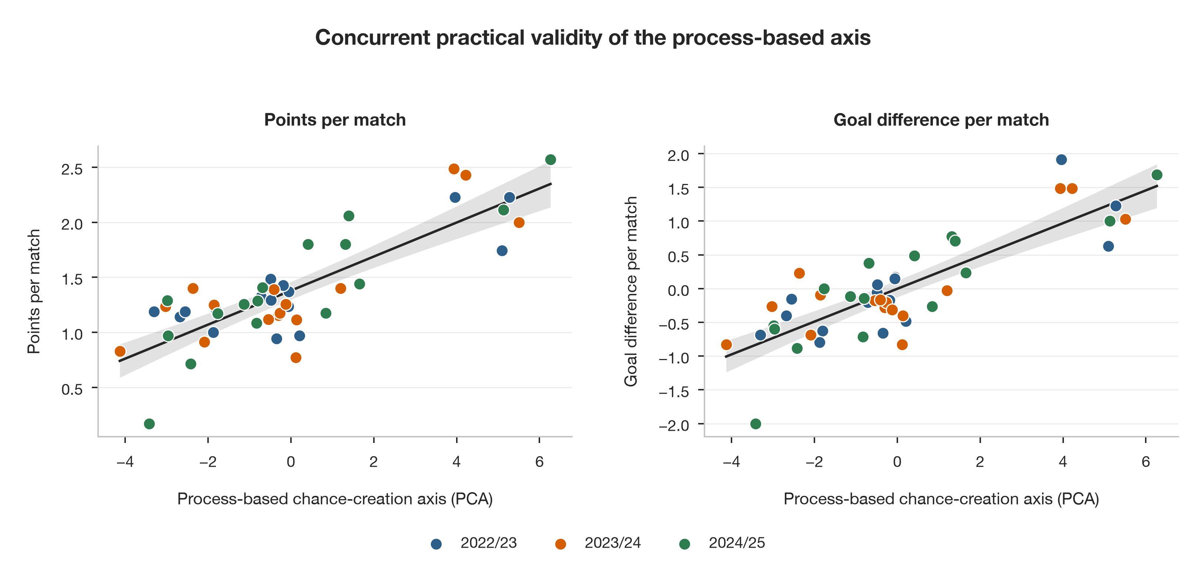
Figure 5. Concurrent applied validity of the outcome-free process-based chance-creation axis. The left panel shows points per match and the right panel shows goal difference per match against the separate PCA axis constructed from 11 process indicators. Points denote team-seasons and colours denote seasons. Black lines are unadjusted ordinary least-squares fits; grey bands are their 95% confidence intervals. The inferential models reported in the text additionally adjusted for season and used club-clustered uncertainty.

3.6. Robustness Checks
The principal conclusions were robust to several perturbations of the analytical workflow. Removing the provider-defined situation variable left AUC unchanged at 0.775 and improved the calibration intercept from −0.320 to −0.276. Excluding penalties produced AUC 0.759, and restricting the model to open-play shots produced AUC 0.756. In the no-situation profile workflow, correlations with the primary profile values were 0.998 for xG per match and 0.981 for high-quality-shot share. The full-profile cluster solution remained below the prespecified Jaccard stability threshold and the gap statistic continued to select k = 1. These checks support the interpretation that the core results are not driven by the identified taxonomy discontinuity or a single modelling specification.

4. Discussion
This study evaluated a football analytics workflow at three levels that are often examined separately: shot-level predictive validity, team-level structural validity, and temporal reliability. The main finding is that a technically competitive shot-quality model does not automatically justify stable categorical team profiles. In this dataset, CatBoost provided useful temporal discrimination, but the holdout calibration intercept revealed systematic probability overestimation. After aggregation, clusterability tests did not support distinct and stable team types, whereas a continuous chance-creation dimension was highly repeatable between seasons. The practical implication is methodological: model deployment should include explicit checks of calibration, clusterability, and temporal stability before team labels are operationalised.
The shot-quality results illustrate why discrimination and calibration should be interpreted jointly. AUC and PR-AUC indicated useful ranking performance, and the calibration slope was close to one, yet the negative intercept showed a systematic level shift in the 2024/25 holdout. This distinction is important because xG is commonly aggregated across shots and interpreted as an absolute attacking quantity. The same-holdout intercept correction was therefore used only as a sensitivity analysis, not as evidence of independently validated recalibration. The fact that team xG ranks and the qualitative reliability conclusions were preserved after the shift suggests that the main structural findings were not created by aggregate miscalibration, while still demonstrating that absolute xG values require caution [15,16].
The clusterability results provide a second applied lesson. Clustering is attractive because it compresses multivariate information into intuitive team types, but such labels are only defensible when the data contain stable separation. Here, gap statistics selected a single cluster and bootstrap Jaccard values for two-cluster solutions remained below the prespecified stability threshold. Treating these solutions as substantive tactical classes would therefore overstate the evidence. The continuous PCA representation retained the information without imposing unsupported boundaries. This aligns with the broader methodological principle that clustering should be preceded by explicit assessment of whether stable groups are present [25,26].
The dominant continuous dimension was interpretable and temporally repeatable. Higher values reflected greater xG, better mean and median shot quality, more high-quality attempts, greater shot volume, shorter average distance, and fewer low-quality shots. Its year-to-year correlation of 0.764 and ICC of 0.780 suggest that the dimension captured a persistent component of team attacking process. In contrast, finishing was much less repeatable between seasons. This distinction is consistent with the logic of process-based performance analysis: opportunity creation accumulates through repeated tactical and technical behaviours, whereas realised conversion is more exposed to short-run variance, goalkeeper performance, and stochastic effects [7–10].
The leakage-safe early-season analysis further separated ranking utility from absolute predictability. Early xG provided moderate information about future xG ordering, but multivariable regression did not consistently improve on carrying the early value forward. Profile axes and goals minus xG produced negative held-out R² values despite occasional moderate rank correlations. For applied use, this means that early-season analytics may support provisional ranking and monitoring before they support precise reconstruction of full-season profile values. The broad bootstrap intervals and small future-season holdout of 16 teams reinforce the need to communicate uncertainty rather than present early estimates as stable labels.
The outcome-free process axis was included to avoid a circular interpretation of practical validity. Because the original 17-feature profile included realised outcomes, associating that axis with points or goal difference could partly reflect shared outcome information. The separate 11-indicator axis excluded goal rate, on-target rate, and goals minus xG, yet remained associated with points and goal difference after season adjustment. The estimates also remained similar when the finishing axis was omitted. These analyses remain concurrent and cannot establish causality, but they show that the process representation has applied relevance beyond mechanical inclusion of realised scoring outcomes.
For analysts, the workflow can be implemented as a sequence of deployment gates. First, a shot-quality model should be evaluated on a temporally later season and assessed for both discrimination and calibration. Second, provider-taxonomy continuity should be audited before longitudinal aggregation. Third, clusterability should be tested before team categories are named. Fourth, any continuous profile dimension should be evaluated for between- and within-season reliability. Finally, early-season predictions should be benchmarked against simple carry-forward baselines on a future season. This sequence converts a collection of statistical procedures into an operational validation protocol rather than treating each method as an end in itself.
The study has several limitations. It used one professional league and three seasons, public shot-map data without pressure, goalkeeper position, passing sequences, or off-ball movement, and a small number of team-seasons for clustering and future-season prediction. The xG model was league-specific, and the 2024/25 holdout contained only 16 team-seasons for team-level prediction. Opponent adjustment cannot remove all tactical or schedule confounding. The identified provider-taxonomy change also demonstrates the dependence of public-data analytics on upstream annotation practices. Replication in other leagues and with richer event or tracking data is therefore needed before the numerical reliability estimates are generalised broadly.

5. Conclusions
A temporally validated football analytics pipeline should evaluate more than predictive discrimination. In three seasons of Czech professional football, a CatBoost shot-quality model provided useful discrimination but showed systematic holdout overprediction; multivariate attacking profiles did not form stable discrete clusters; and a continuous chance-creation dimension was substantially more repeatable than finishing. Early xG retained useful ranking information, whereas absolute prediction of profile axes and finishing was weak. An outcome-free process axis remained concurrently associated with team results and broadly aligned after opponent adjustment. For applied deployment, the evidence favours continuous, reliability-tested process indicators over fixed team typologies and supports a validation sequence that combines temporal calibration, data-taxonomy auditing, clusterability assessment, longitudinal reliability, and future-season benchmarking.
Author Contributions: Conceptualization, Š.S.; methodology, Š.S.; validation, M.H. and J.C.; formal analysis, Š.S.; investigation, Š.S.; data curation, Š.S.; writing—original draft preparation, Š.S.; writing—review and editing, Š.S., M.H. and J.C.; visualization, Š.S.; supervision, M.H. and J.C. All authors have read and agreed to the published version of the manuscript.
Funding: This research received no external funding.
Institutional Review Board Statement: Ethical review and approval were not required because the study used publicly available professional match-event information, involved no intervention or participant contact, and processed no private personal or individual-level health data.
Informed Consent Statement: Not applicable.
Data Availability Statement: Analysis code and derived analytical outputs are publicly available on Zenodo at https://zenodo.org/records/22535919. Raw provider-derived match-centre and shot-map records are not redistributed.
Acknowledgments: During the preparation of this manuscript, the authors used ChatGPT (GPT-5.6 Sol, OpenAI) for language editing, manuscript organisation, and code review and debugging. The authors have reviewed and edited the output and take full responsibility for the content of this publication.
Conflicts of Interest: The authors declare no conflicts of interest.

Abbreviations
AUC, area under the receiver operating characteristic curve; BSS, Brier skill score; ECE, expected calibration error; ICC, intraclass correlation coefficient; MAE, mean absolute error; PCA, principal component analysis; PR-AUC, precision–recall area under the curve; xG, expected goals.

References
- 1. Lago-Peñas, C.; Lago-Ballesteros, J.; Dellal, A.; Gómez, M. Game-related statistics that discriminated winning, drawing and losing teams from the Spanish soccer league. J. Sports Sci. Med. 2010, 9, 288–293.
- 2. Lago-Peñas, C.; Lago-Ballesteros, J. Game location and team quality effects on performance profiles in professional soccer. J. Sports Sci. Med. 2011, 10, 465–471.
- 3. Mackenzie, R.; Cushion, C. Performance analysis in football: A critical review and implications for future research. J. Sports Sci. 2013, 31, 639–676.
- 4. Carling, C. Interpreting physical performance in professional soccer match-play: Should we be more pragmatic in our approach? Sports Med. 2013, 43, 655–663.
- 5. Rathke, A. An examination of expected goals and shot efficiency in soccer. J. Hum. Sport Exerc. 2017, 12, 514–529.
- 6. Lucey, P.; Bialkowski, A.; Monfort, M.; Carr, P.; Matthews, I. Quality vs quantity: Improved shot prediction in soccer using strategic features from spatiotemporal data. In Proceedings of the MIT Sloan Sports Analytics Conference, Boston, MA, USA, 27–28 February 2015.
- 7. Anzer, G.; Bauer, P. A goal scoring probability model for shots based on synchronized positional and event data in football (soccer). Front. Sports Act. Living 2021, 3, 624475. https://doi.org/10.3389/fspor.2021.624475.
- 8. Mead, J.; O’Hare, A.; McMenemy, P. Expected goals in football: Improving model performance and demonstrating value. PLoS ONE 2023, 18, e0282295. https://doi.org/10.1371/journal.pone.0282295.
- 9. Wheatcroft, E.; Sienkiewicz, E. A probabilistic model for predicting shot success in football. arXiv 2021, arXiv:2101.02104. https://doi.org/10.48550/arXiv.2101.02104.
- 10. Hewitt, J.H.; Karakuş, O. A machine learning approach for player and position adjusted expected goals in football (soccer). Franklin Open 2023, 4, 100034.
- 11. Belloso, J.; Gómez-Ruano, M.-Á.; Lago-Peñas, C. Unveiling the xG metric in soccer: How the adjusted xG improves match predictions. Int. J. Perform. Anal. Sport 2026, advance online publication. https://doi.org/10.1080/24748668.2026.2633828.
- 12. Decroos, T.; Bransen, L.; Van Haaren, J.; Davis, J. Actions speak louder than goals: Valuing player actions in soccer. In Proceedings of the 25th ACM SIGKDD International Conference on Knowledge Discovery & Data Mining, Anchorage, AK, USA, 4–8 August 2019; pp. 1851–1861.
- 13. Fernández, J.; Bornn, L.; Cervone, D. Decomposing the immeasurable sport: A deep learning expected possession value framework for soccer. In Proceedings of the MIT Sloan Sports Analytics Conference, Boston, MA, USA, 1–2 March 2019.
- 14. Spearman, W. Beyond expected goals. In Proceedings of the MIT Sloan Sports Analytics Conference, Boston, MA, USA, 23–24 February 2018.
- 15. Steyerberg, E.W.; Vickers, A.J.; Cook, N.R.; Gerds, T.; Gonen, M.; Obuchowski, N.; Pencina, M.J.; Kattan, M.W. Assessing the performance of prediction models: A framework for traditional and novel measures. Epidemiology 2010, 21, 128–138.
- 16. Van Calster, B.; McLernon, D.J.; van Smeden, M.; Wynants, L.; Steyerberg, E.W. Calibration: The Achilles heel of predictive analytics. BMC Med. 2019, 17, 230. https://doi.org/10.1186/s12916-019-1466-7.
- 17. Chen, T.; Guestrin, C. XGBoost: A scalable tree boosting system. In Proceedings of the 22nd ACM SIGKDD International Conference on Knowledge Discovery and Data Mining, San Francisco, CA, USA, 13–17 August 2016; pp. 785–794.
- 18. Prokhorenkova, L.; Gusev, G.; Vorobev, A.; Dorogush, A.V.; Gulin, A. CatBoost: Unbiased boosting with categorical features. Adv. Neural Inf. Process. Syst. 2018, 31.
- 19. Cavus, M.; Biecek, P. Explainable expected goal models for performance analysis in football analytics. arXiv 2022, arXiv:2206.07212.
- 20. Cavus, M.; Stando, A.; Biecek, P. Glocal explanations of expected goal models in soccer. arXiv 2023, arXiv:2308.15559. https://doi.org/10.48550/arXiv.2308.15559.
- 21. Román-Gallego, J.-Á.; Pérez-Delgado, M.-L.; Cofiño-Gavito, F.-J.; Conde, M.Á.; Rodríguez-Rodrigo, R. Analysis and parameterization of sports performance: A case study of soccer. Appl. Sci. 2023, 13, 12767. https://doi.org/10.3390/app132312767.
- 22. Fernández-Cortés, J.; Gómez-Ruano, M.A.; Mancha-Triguero, D.; Ibáñez, S.J.; García-Rubio, J. Evolution of performance indicators in soccer during the last decade. Appl. Sci. 2022, 12, 12834. https://doi.org/10.3390/app122412834.
- 23. Memmert, D.; Lemmink, K.A.P.M.; Sampaio, J. Current approaches to tactical performance analyses in soccer using position data. Sports Med. 2017, 47, 1–10.
- 24. Gudmundsson, J.; Horton, M. Spatio-temporal analysis of team sports. ACM Comput. Surv. 2017, 50, 22.
- 25. Jain, A.K. Data clustering: 50 years beyond K-means. Pattern Recognit. Lett. 2010, 31, 651–666.
- 26. Diquigiovanni, J.; Scarpa, B. Analysis of association football playing styles: An innovative method to cluster networks. Stat. Model. 2019, 19, 28–54.

