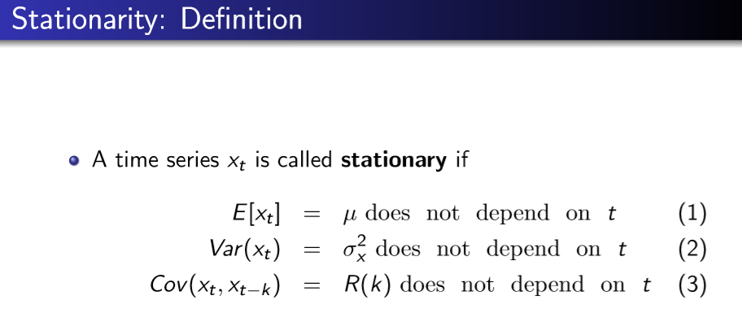

**Moving Average MA(q) Process**

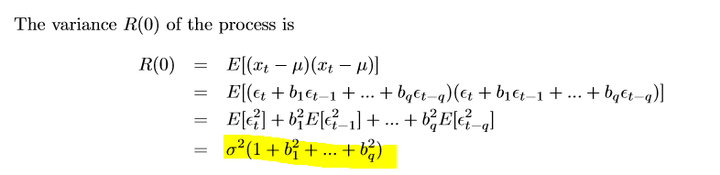

**ACF at lag k**

$$acf_{k}= \frac{b_{k}}{1+b_{k}^{2}}$$

Ex. MA(1):

$$X_{t}=ε_{t}+0.9ε_{t-1}$$

$$acf=\frac{0.9}{1+{0.9}^{2}}$$

**AR(1)-Process**

**Mean AR(p): $\frac{c}{1-a_{1}-_{…}-a_{p}}$**

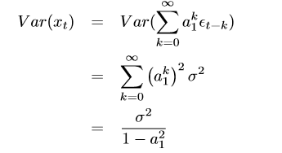

**MA-Inversion**

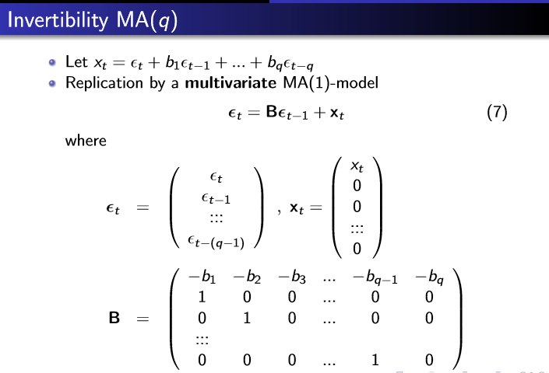

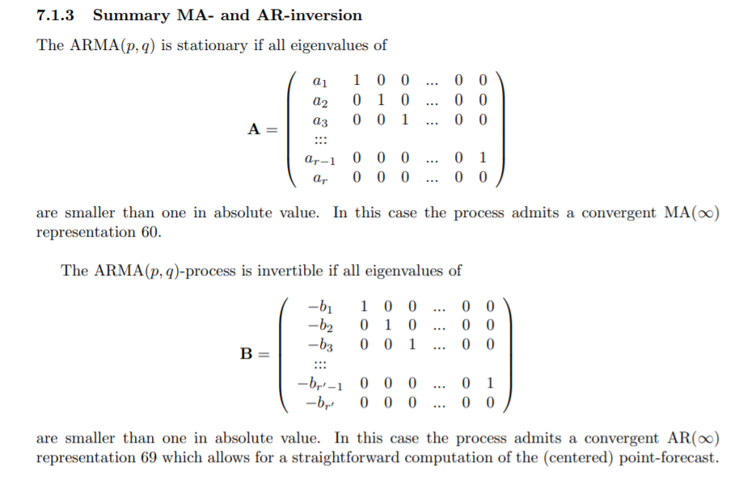

all eigenvalues of A are smaller than one in absolute value: this restriction ensures stationarity of the ARMA(p, q)-process

all eigenvalues of B are smaller than one in absolute value: this restriction ensures invertibility of the ARMA(p, q)-process