Computer science meets evolutionary biology: pure possible processes and the issue of gradualism.

Philippe Huneman
IHPST (CNRS / Université Paris I Sorbonne) .
huneman@wanadoo.fr

It seems that in many cases biology has to rely on simulation, because some of the most simple systems exhibit already features of non-linear causal relationships that preclude any analytical approach (Wagner 1999). On the other hand since a decade we witness an increase of studies in computer sciences that borrow terms and topics from evolutionary biology (Holland 1995, Mitchell & Forest 1993; Forrest 1996, Ray, 1992, Langton, 1996, Hedrich 1999). A whole branch of computer science, mostly devoted to optimization algorithms but not exclusively, developed on the basis of insights from evolutionary biology: genetic algorithms scientists speak in terms of genes, crossing over and mutation, and evolutionary computation (Koza 1992, Mitchell 1998) is a proliferating branch of computer sciences. Recent journals like Bioinformatics or Biocomputation exemplify this trend at an institutional level. The most biologically-oriented of those scientists, the Artificial Life practitioners, sometimes see their field as the investigation of life as it would be in any possible world – providing that we have a minimal set of criteria of life in terms of heredity and variation, which eventually resolves in a general susceptibility to Darwinian processes (Langton 1996, Bedau 1993, Lange 1996). In this radical sense, evolutionary biology becomes a part of computer science as science of general evolution, or, curiously, a kind of applied computer science – “applied” in the same sense than mechanics is somehow applied mathematics because a formal concept, namely differentiation, is therein physically interpreted. DNA here would be to pure evolutionary theory as computer science what speed is to mathematics. As implausible as it sounds, this claim has the virtue of being thought-provoking.
Whereas computer scientists often clearly refer to biology, biologists are less willing to consider computer science as such as relevant to evolutionary biology. An exception in the philosophy of biology is the famous work by Dennett (1996), which explicitly takes Darwinian selection as an algorithm, and evolutionary theory as the study of such Darwinian algorithm – a theory in fact mostly focusing on the genetic implementation of such algorithm, but not in principle wedded to this level. Another interesting occurrence of a serious consideration for algorithms is to be found in Maynard-Smith’s paper on the specificity of genetic information (Maynard-Smith 2000); in this paper, he argues for the legitimacy of the informational talk in genetics, provided that information is taken in the sense of semantic information. Interestingly, his argument mainly relies on a parallel between biological evolution by natural selection and genetic algorithms.
In this paper I want to assess the validity of those hints towards an affinity between evolution by selection and algorithms, by investigating the relationships between computer science and evolutionary biology, in order to uncover what underlies the unity of their approaches. Shall we accept that algorithmic models are a generalised biology that deals with “possible” organisms as they would exist in any possible world? In this case, are the digital entities representations of those organisms (Langton 1996, Ray 1996, Forrest and Jones, 1994), or are they themselves living entities (Adami 2002)? Or shall we only claim that computer science is an experimental extension of evolutionary biology, a tool for solving some of its issues – so that in this case we could not say that computer science and biology are two connected areas in a general science of Darwinian processes?
I will claim that one interest of the computational viewpoint for evolutionary biology, is its ability to clarify null hypotheses in terms of outcomes of pure processes clearly defined in abstraction from other processes, through which as a consequence it provides new models or paradigms of non-gradual evolution, thus bypassing the classical assimilation of evolution to gradual evolution through cumulative natural selection. Thus the first section will sketch some general distinctions relevant to the domain of computer modelling that will be useful to address the relations between evolutionary theory and computer sciences. For the moment I am rather vague on the term “computer science”, given that it encompasses several kinds of algorithms studies: optimisation algorithms, evolutionary computation, and in general evolutionary algorithms, and then the more specific field of Artificial Life. The specification of those fields, as well as some of their articulations, and the extent to which they are concerned by this study of their relationships with evolutionary biology, will become clearer in the course of the paper. The second and third sections will formulate the idea that computational modelling devises a range of what I’ll call pure possible processes that play the role of null hypotheses for evolutionary biology, and enunciate on this ground the validation problem regarding simulations. On this basis the fourth section will show that computer sciences provide evolutionary theory with a way to address the issue of gradualism, which is left unsolved in Neo-Darwinism.

1. Typology of evolutionary algorithm studies
. Addressing the wide domain of biologically-oriented computational models, two major distinctions have to be stated. The first one concerns the context of simulation, the second one deals with the uses of simulations.
The first kind of context of simulation is what I call the “Formal selection context”. Here, we assume that selection is a process unbound to its terrestrial realisation by nucleotides, amino acids and so on, but occurs as soon as we have replicating entities and variation among them. Simulation provides thus a context to watch the effectiveness of selection, but a selection with no living matter, hence a formal selection. This is in many ways relevant to life sciences, above all because such studies show the bearings and strength of selection in faster time given that evolutionary timescales encompass several decades, except for bacteria whose generation time is very short. Maley’s study on biodiversity (2001), showing that emergence of new species is more conditioned by geographical barriers between populations than by adaptive potential, is a good example: several species are modelled, their members reproduce very quickly on screen, and then the researcher assess the respective importance of the geographic specificities, and of some proper characteristics supposed to be related to adaptability (e.g. polymorphism, size, etc.): it appears after lots of generations that the first parameter is more explanatory – whereas in real time such studies would have required huge amounts of time. The simplest example in this category could be Maron’s modelling of the oldest paradigmatic case of natural selection, Kettlewell’s industrial melanism (Kettlewell, 1956). He rebuilt moths on his computer, and the effects of selection by darkening (e.g. pollution) of environment occurred, in the short time of several hundreds of generation of those digital entities. Each moth is a 18 bits string. The first 8 bits encode a 2D cellular automata rule, while the 10 other encode the initial state. Ruling the cellular automata gives a wing pattern. Reproduction copies the entity near its location. Each predator and each prey has a given probability of feeding, death, birth. Those probabilities define a genetic algorithm on the cellular automata – namely, the moths. In a way similar to Mitchell / Crutchfield‘s results (1994), establishing that CAs can be evolved by a GA to the best rule for a given optimum, Maron’s algorithm will evolve cellular automata towards fittest moths, namely the best at reproducing. It happens that their genotypes will match the environment in a way similar to Kettlewell’s view of melanism.

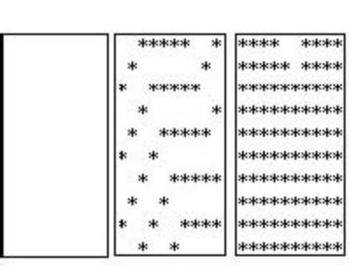Maron 2004. 3 wing patterns.

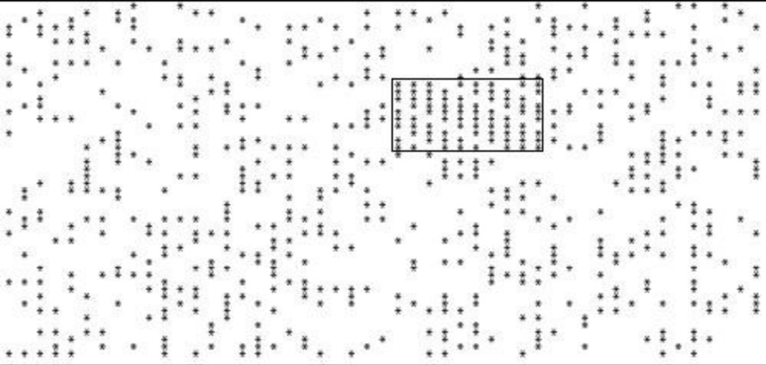

Maron 2004. A sample moth highlighted on a background with .25 density

Given that natural selection qua selection increases the mean fitness of the population of elements it operates upon, the whole discipline of optimisation algorithms extensively relies on forms of selection, and hence provides cases of “formal selection context”. However, the other context in simulation could be in opposite called the “no selection context”. Kauffmann’s work on “order for free” seems to be the best known example, since his models exemplify cases of the emergence of hereditary properties by physical process of self organisation, with no selection. Fontana and Buss (1994) conclude their enquiry on replicating macromolecules with those words: “our exploration of an abstract chemistry not only provides a route to generate such entities, but illustrates that different organization grades can arise in the absence of selection.” All those investigations have been phrased by the term “self-organization”. But some could be better understood as investigations of the prior conditions of a natural selection process, since, like models in Kauffmann’s (1993), they investigate the articulation between selection and selforganisation.
Reynolds’s boids are another interesting example. They are digital entities in an agent-based model simulating the flight of herds of birds, through three simple rules implemented in each agent, concerning basically relationship to the distance and position of the other agents. Here the “building blocks” are simulating the birds themselves. There is no selection at stake, the point is to see whether with very simple rules that one can formulate by observing the flocking birds (for example: maintain a minimal distance with neighbours, tend to the centre of the group…) a flocking behaviour can emerge (which happens to be the case). However, those simulations are also accurate for school of fish – whereas since the nervous systems of birds and fish are not similar, one can not assume that the individual rules which really explain the behaviour will be the same across those two lineages. In another context, Mc Shea (1996, 2005) designed simulations of increasing complexity trends with no selection (see below) – that could match patterns of punctuated equilibria in phylogenetics. Also about evolutionary patterns (rather than processes), Chu and Adami (2000) designed simulations of phylogenies whose parameter is the mean number of same-order daughter families of a family; they have shown that for some plausible values of this parameter, and independently of what are the processes of evolution (be they primarily natural selection or not), power laws distributions for taxa of a same rank are expectable – e.g., clades with lots of species will be ten times less numerous than clades with ten times less species, clades with 100 times less species less numerous than…, etc. This justifies that sandpile distributions can be expected in evolutionary processes.
In those cases we must therefore trace a distinction between the optimisation algorithms, which will embody formal selection context, and some other cases of evolutionary algorithms and allow “no selection context” simulations. Orthogonal to this distinction, we have to draw another line, between uses of simulation. Humphreys (2004) initiated the methodical investigation of computational devices as ways of enlarging our epistemic capacities; he emphasised the fact that the usual categories of philosophy of science (experience vs. theory, laws vs. facts, observables vs. theoretical entities...) are not appropriate to account for the kind of knowledge delivered by those new devices. He made a useful distinction between simulations relying on previous theories about the field modelled, and simulations based on phenomenological rules that are grossly noticed as pertaining to some phenomena, and then implemented within the rules of the computational devices. Thus I will draw here a very close distinction, intended to capture features of the most biologically oriented computational devices.
Concerning natural selection there is a strong use, and a weak use of them. This distinction between strong and weak simulation is akin to Pattee’s difference between realization and simulation (Pattee 1989), or Sober’s distinction between weak and strong AL (Sober 1992), or even to the distinction that Bedau draws between models that “strive for maximal fidelity to the details” and “unrealistic models” in biology (Bedau 1999, 20).
The weak use consists in testing some hypothesis on selection. Todd and Miller (1995) modelled the sexual selection in this manner, demonstrating the numerous and often neglected effects of sexual selection on diversification, adaptation, exploration of adaptive possibilities : they assume that mate choice makes female internalize natural selection (they pick up males that are fit to environmental demands) so that what distinguishes sexual selection from natural selection as such is an advantage given to “exploration” behaviour by males – hence males and females are not playing the same role vis à vis natural selection, males are more exploratory and females devoted to “exploitation” of environment. The hypothesis predicts different roles in diversification and adaptive radiation, roles that the simulation displays. In the field of population genetics Maley’s work, or Todd / Miller’s work are good examples; simulations provide an extension of the testing capacities of models regarding hypotheses about dynamics. This could be called a weak use of simulations, since they are subordinated to the hypotheses and theories they are intended to test . On the other hand, the strong use assumes that “digital organisms” as “defined by the sequence of instructions that constitute their genome, are not simulated: they are physically present in the computer and live there” (Adami, 2002), it is the world to which they adapt that is simulated. So here, we do not simulate in order to test a hypothesis found when dealing with real populations, but we have a new kind of population (“new” in the sense that it has not to be understood in reference to a reality it is supposed to model), about which we can forge new hypotheses. Entities in those simulations are not supposed to simulate anything (e.g. cells, genes, etc.) in the real world. Those hypotheses made about them are capable of being more general claims about natural selection, because the peculiar, terrestrial, domain of its application is neglected. Strong simulations are not a mere way of testing claims, they are in the same time the domain of hypotheses and the field of testing. Ray’s Tierra, Tim Taylor’s Cosmos or Channon’s Geb are good examples of this, and so are Conway’s Game of Life and the extended rules of cellular automata in the Brain, Margolus or Life mode (see Margolus & Toffoli, 1987). Of course one of the most famous is Holland’s Echo, intended to be a simulation of ecosystems, with “organisms” that meet, fight or not, then lose or acquire resources in function of which they can reproduce at the next generation (Holland 1995, Forrest 1996, Forrest & Jones 1994).
In strong simulations, unlike weak simulations, the parameters included in the hypotheses are not given and can vary. For example, Langton’s (1996) loop is a 2D cellular automaton in which emerges a loop which self replicates (Fig.2), whereas the rules code only for the dots composing the loop. Thus we may not have in advance building block entities which by hypothesis are capable to replicate, but the self-replicating feature is itself constituted in the course of the automata. Recently, Mc Caskill and Füchslin (2001) devised a simulation of molecules that evolve replicating templates and then a robust code, so that the simulation exhibits a robust origin of “genetic” coding. The oldest and classical example of emerging entity is the “glider gun” in Conway’s Game of life. Thus, when we simulate we do not test assertions about self-replicating entities (such as in the Fontana-Buss example), but self-replication is an immanent property of the simulation (and does not by itself simulate anything). Furthermore, Sayama’s (2001) SDSR loop, an improvement on Langton’s loop, exhibits differential reproduction – since some loops die while other reproduces - , so it defines a fitness function of its own, within the simulation itself.

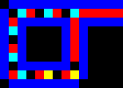
Fig. 2. The loop in Langton’s loop CA.

John Holland’s Echo has been used both in modelling natural phenomena such as host-parasite relationships, or mimicry. However the unrealistic assertions concerning reproduction and (in the case of mimicry) the absence of isolative reproduction between species, make those simulations poor in teachings for evolutionary biology (Crubelier et al. 1997). Therefore a richer use of Echo, - indeed, coherent with the notion of “strong” simulation – is to let it run in order to get ideas about potential evolutions of ecosystem, mainly about their stability, the patterns of associations, etc. To this extent Echo is a clear case of strong simulation

2. Natural selection and the pure possible processes.
If we consider computer simulations as such and abstract them from what they simulate – id est, biological evolutionary processes – but consider them in themselves, as pure digital devices like genetic algorithms and cellular automata, I will argue that they are often experiments on the modes of selection. In this sense, although weak and strong simulatiosn are different uses of them, they share some properties about the way they contribute to our knowledge of evolution.
First, in some sense, computer simulations as such involve causal relationships and processes. Let’s establish briefly this point, in order to understand what those simulations can bring to the study of causal processes in evolutionary biology. Suppose a cellular automaton with cells a_{i} at step n. To show it, let’s call a₁^{n+1} the state of the first cell on line n+1. Let’s call A₁ ^{n} a set of states a_{1+m, n}, m varying from 1 to p (p is defined by the rules) such that their outcome at level n+1 is a₁^{n+1.} Now, there is j other sets of states like A₁ ^{n} such that the outcome is still a₁^{n+1.} So we can indiciate those sets of states : A₁ ^{n, k .} The property P is then defined : a CA is said to have property P ^{n,1} at step n iff it exists k, 0<k<j+1, such that it is in a set of states A₁ ^{n, k}.
Now for any i , and the state of a_{i} at step n+1 we can define a set of states A_{i} ^{n, j} that all result in a_{i} ^{n+1} and thus define the property P ^{n,i} . And let’s define Q the property of being in the state {a_{1…} a_{i…} am}, the property instantiated by the CA at step n+1. Finally, we can say that the CA at step n has the property P iff it has all the { P ^{n,i} }. Then, if the CA had not been in a state P at step n it would not have been in state Q at time n+1 : counterfactual dependence, hence causation. So the only causal explanation of “being in state Q at n+1” is “being in state P at n”. In computer simulations like cellular automata there are causal relations between sets of states at various steps.
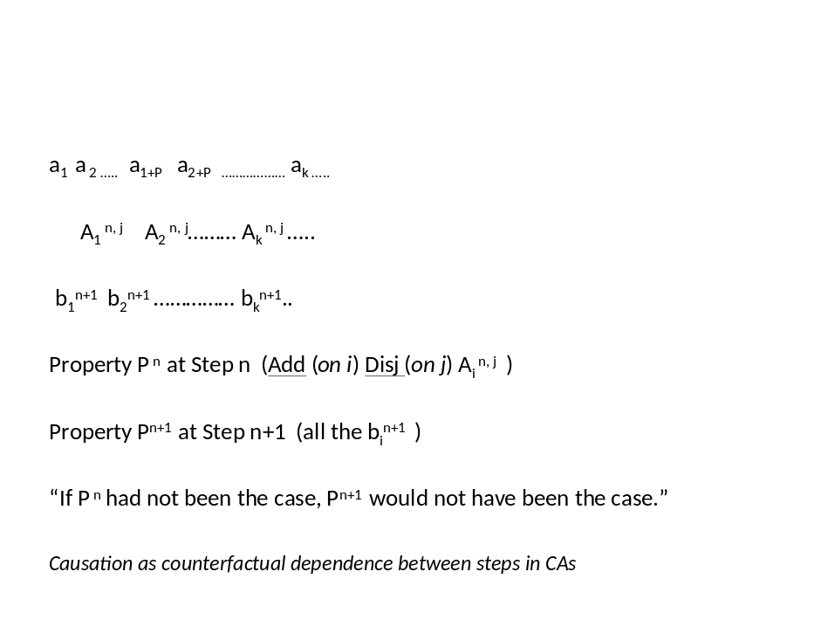
Fig. 3 Causation in CAs.

Therefore, in a computer simulation like cellular automata there are not only formal but also counterfactual dependencies between some states of cells, i.e. causal relationships. This establishes that computer simulations will be likely to provide tests for causal hypotheses in biology; as I will elaborate it from now on.
Since in formal selection contexts models deal with natural selection, states are compared in terms of their differential reproduction and persistence. The causal processes, here, are of selective nature, and those models embody rather than simulate natural selection. Finally, strong simulations appear to be a general investigation of some causal processes, of which natural selection is a prominent part. This investigation can be said “experimental”, when no equations can be designed – experiments here in the sense of computer experiments (see Winsberg 2003, see also Humphreys 2004 on non-theory-based computational devices) – but may be theoretic when analytic treatments of the dependencies within the algorithm can be provided. Weak simulations are testing hypotheses because they equally produce causal processes – selective processes in the case of formal selection models – to check whether they are indeed likely to produce the outcome which is our explanandum.
Those selective processes – present in the two uses of simulation - however are of various kinds, that computer scientists intended to characterize. They drew a distinction important for our purposes. Channon and Damper (2000) termed “artificial selection driven” the GA systems where evaluation of the fitness function is fixed in advance, and “natural selection driven”, the systems where one can not make a finite specification of what it is to be fit. Note that this second case is what occurs in natural ecosystems, where the same fitness value could be realized by (for example) either a high race speed or a perspicuous sight – so the labels “natural vs. artificial selection” here are not simply metaphorical.
Some systems, in simulations, are designed to undertake Channon’s “natural selection”. Ray’s Tierra (1994), Hillis’s coevolution (see Hillis 1998) are well-known examples. Here, the fitness function is not determined in advance; and we see that a population can evolve some new features, since they can be conceived as new classes of entities, and then behave in a specific manner in the simulation. Hillis improved an optimizing GA for sorting networks by creating another population, anti-networks, namely “sorting problems”… Those problems are intended to minimize the fitness of the sorting networks, because they randomly display difficulties for which those algorithms have not been designed for by selection; hence the fitness function itself evolves according to the arising of sorting problems. A dynamical coevolution analogous or identical to host-parasites coevolution occurs. Similarly, in his population of Tierra programs, Ray has found arising “parasites”, “hosts”, “hyper parasites” and so on… “Ecological” adaptations were therefore going on. Later, Channon designed a system called Geb, able to perform emergence of innovations. Nevertheless, he recognizes that a limit of those simulations is that “specifying the available actions constrains organisms around these actions and so limits evolution” (1998). Even if the fitness function is likely to be left open, the class of actions of which building blocks are capable is finite.
Holland (1995) has shown that in the Echo model, parasitism and some other features of the ecological settings are likely to appear, for example instantiations of the competitive exclusion principle. However an important difficulty, for one who would consider those Echo experiments as parts of ecology, is that they don’t provide univocal definitions and criteria to single out the genuine species in the Echo simulations (Jones and Forrest, 1994): depending upon the choice we make of considering a genotype (i.e. one agent), or a set of agents with various genotypes (collected under some principle), as constituting a species, the interpretations of an Echo round will strongly differ.
In this perspective, I state two remark that stem from the above considerations. (a) it is clear that when we get to the open-fitness computational systems, the relationship between computer science and evolutionary biology becomes much more than the analogy that was supposed to hold in the case of weak simulation. What occurs among the entities, be they cells in a CA, programs in a GA or “agents” in an agent-based models, is indeed a genuine causal process, the kinds of which are also the instances of natural selection in biology. Strong simulations are indeed likely to embody the same processes than biological evolutionary phenomena. Of course, in one case the underlying realities are physicochemistry, whereas it is digital entities in the other cases, but the processes undergone by, on one side chemical entities, on the other side digital entities, can be equated. The vocabulary of crossing-over, mutations, genes, etc. in Genetic Algorithms, for example, is not metaphorical, those processes are really occurring here, but are undergone by another kind of entities (non carbon-based genetics, if you want). From this viewpoint, evolutionary theory is not something imported in computer sciences, but those investigations in algorithmic modelling that we are addressing here (formal selection strong simulation, above all, because they abstract away from contingencies of this-wordly evolutionary entities) are part of a generalised evolutionary theory. Computer sciences and biology then appear as two branches of the same tree, like dense-matter physics and physics of liquids (and even closer, I would say).
However, (b) the entities engaged in those computer processes – unlike the processes themselves – are not easily mapped onto biological entities. This is obvious in the case of strong simulations : species are difficult to be isolated in Echo, lineages are not easily seen in Tierra, etc. Besides, unrealistic assertions (Bedau 1999) are often at the basis of computer simulations (absence of epistasis, of linkage disequilibrium, etc.), which compels one to be greatly cautious while interpreting their results in biological terms. More generally, even if some computation systems are designed to correspond to one set of entities - let’s say the species, in order to study phylogenetic patterns (Adami & Chu 2000, Mc Shea 2005) – the other levels of biological reality (organisms, chromosomes, etc.) are not in the same time given and identifiable in the systems.
This fact exemplifies something general about computer simulations, that is crucial to their epistemological status, and that I explicate now. Only in real biology one can trace in a same biological setting (within a population of one or various species) connections between species, organisms, chromosomes lineages, or generally microevolution and macroevolution; only in real biology are the whole evolutionary hierarchies, together ecological (genes, cells, organisms, populations, species) and genealogical (genes, organisms, species, genera etc.) (Eldredge, 1985), really given in the same time, in the sense that when you have cells you have both genes (the level below) and organisms and species. Yet if one system is designed to study some level of biological reality, the other levels are not ipso facto given (whereas if you have organisms you have genes and species).
A major consequence of this is: while phenomena in biology might resort to various processes involving several of those entities, and sometimes entities not taken into account in the biological models, within the computer simulations one can’t meet processes that would involve types of entities that are not capable of being defined in this simulation on the basis of the explicitly designed entities, i.e. on a simple, univocal and determined relation to the building blocks (for example, cells in a CA). Causal processes in computer simulations can’t involve entities that don’t algorithmically exist, while the entities undefined in biological models still biologically exist and biologically interact with the ones we have modelled. A paradigmatic case is multilevel selection: scholars increasingly account the fact that natural selection plays at several levels (genes, organisms, possibly species or clades), and in possibly opposite directions; this multilevel process is then responsible of many aspects of biology (cooperation, mutualism, plausibly the emergence of organisms multicellular and societies, etc. (Michod 2005, Damuth and Heisler 1988, Okasha 2006, etc.)) However, suppose that I devise a simulation with “genes” as entities : nothing guarantees that there will be the possibility to define species or cells in this simulation, so if selection acts here, it’s likely that there will be only selection at the level of genes. This fact is crucial to understand the epistemological value of compute simulations, as I will explain it in the next section. And obviously, this might account for the limits met by the computer systems when one wants to directly simulate ecological phenomena in Echo (Crubelier et al.), or to model long-term trends in evolution (Bedau 1999 vs. Mc Shea 2005). Notice that I do not contend that in a simulation there is only one class of entity, because I won’t preclude the possibility that some higher level entity can emerge (in fact lots of those simulations are intended to cast a light of this phenomenon of emergence); but my point is that nothing guarantees that all the levels are definable in one given simulation, unlike biological reality where all the levels of the hierarchies coexist, so that the causal process proper to all those levels do play in the same time.
Whereas (a) supports arguments of those who claim that evolution is an algorithmic process, or that evolutionary biology is a branch of a general evolutionary computational theory, (b) implies structural differences between processes in evolutionary biology and processes in simulations, a fortiori in strong simulations, differences that undermine the strong thesis of identity held for example by lots of AL practitioners.
The next section draws the consequences of those facts as to the validation of computer simulations.

3. Facing the validation problem: the variety of selective processes in computer sciences and their impinging on evolutionary biology.

In this sense, the value of algorithmic research for evolutionary biology is that they provide pure versions of some classes of processes, and an idea about what they are capable of producing. “Pure” here means that they are unmixed with other processes that could go unnoticed in genuine biological cases, because the entities involved in those parasitic processes, which in biology are accompanying the focal entities, would make radically no sense in the algorithmic realities considered. The epistemological fact here underlying the notion of pure processes is the “transparency” of computer algorithms, taken in two senses: the mechanisms involved being defined by us, nothing else than them is responsible for the outcome (Bedau, 1999); if something new emerges, we know what it emerges from. Now, in the case of formal selection simulation, where the processes pertain to natural selection, those models display pure selective processes concerning the entities modelled (e.g., pure species selection).

The question of whether those classes of processes match actual biological processes has to be raised in a second step. It arises, precisely, when one compares the patterns of evolution found in nature, in the fossil records, to the outcomes of such classes of processes, and notices that one of them maps into a computational outcome. This is not as such an evidence for the occurring of such a process, but it is a suggestion that this kind of process is likely to be the genuine explanation. However, this assertion further requires that the simplifying assumptions made in order to design the simulation – the definition of the agents, the ranges of their actions, the way they combine and replicate – are not too unrealistic. It requires also thinking about which processes might have occurred simultaneously in nature, since in simulations we have only the single process that we intended to simulate. So if, for example, a phylogenetic pattern exactly matches the result of the simulation of species selection acting on a set of species realistically defined, this does not prove that such pattern results from species selection since other processes were acting in nature
Hence simulation experiments inform about what classes of processes are likely to be found out there – exactly in the same way than logics informs us about what can be (and be said) – given which phylogenic patterns we have found in nature. Hence what might be the proper input of computer sciences in evolutionary theory is the connections made between patterns of evolution and classes of processes (mainly selective processes). They can not prove that a process with such and such parameter accounts for this or that feature of evolution, but they allow us to figure out candidate explanations. Their epistemic value consists only in pointing out what kind of evolutionary process can be at stake, even if the selective pressures are not identified – which should be the proper study of ecology. The idea is : if pattern X is met, then process x is likely to have produced it.
In a paper on complexity in the genome, Adami, Pennock, Ofria and Lenski (2003) show that evolution is likely to have favoured complexity through episodes of decreasing mean fitness. Their point is that, if there is complexity increase (in the sense of complexity chosen in the paper), then deleterious mutations might have been selected; thus a decrease in fitness might have been involved in the stabilisation of more functionally complex genomes: the simulation displays that rearranging the genome after a functional innovation is shown to involve a temporary less-functioning episode, hence a decrease in fitness. Thus, the general modes of getting increasing complexity are illuminated by the simulation, while no teaching is provided concerning what actually happened. Similarily, in Chu and Adami’s (2000) investigation of the patterns of abundance of taxa (cited above), the power-law distributions that they got as outcomes provide ideas about what would be the causes of a phylogenetic pattern: if the distribution of taxa resembles a certain power-law scheme X, it is likely that the parameter m (mean number of same order daughter families of a family) has been in nature close to the value of m involved in X when X issues in a simulation with such value of m.
In those examples we face a classic epistemological puzzle about computer simulations, that one could call the validity paradox : what tells us a simulation whose outcomes match reality ? Epstein (1996) famously takes the example of the historical expansion and decrease of the settlements of Anasazi Indians. Simulations have been made, in terms of agent-based models whose agents are Indians and whose actions are resources foraging, resources sharing, neighbours fighting etc. When you run the simulation, with some initial distribution, you get in the end a geographic pattern quite identical to the real pattern described by archaeologists. Epstein claims that this confirms the simulation’s rules as hypotheses about the causes of this situation: the Anasazi acted in such and such way, implementing the rules enacted by the simulation. However, as Yuele Granoff (*) emphasises, this does not prove that some alternative explanation, ascribing very different major actions and motives to Indians, would not yield the same outcome, so it does not rule out all alternative explanations, hence it does not prove the genuine motives. Moreover, Kuppers and Lehmann (2005) argued that the epistemological validity of simulations is rather the efficient matching of the outcome with real pattern, and hence the possibility of predicting patterns, than the correspondence between the rules of the agents in the models and the real-life agents’ rules. Their argument referred to Arakawa’s meteorological simulations, which reached a very successful matching with genuine weather patterns, much better than previous simulations, but at the price of making even more unrealistic the agents’ rules and the boundary assumptions.
To this extent, computer simulations in evolutionary biology can not be said to prove anything concerning real evolution and the genuine causes of evolution. I will briefly here mention two examples.
Think about Reynolds’s flocking Boids. For sure, the final outcomes match the real flight pattern of a flock of birds, or even a school of fish; yet this does not prove that the rules implemented in the nervous systems of the birds – and of all birds, irrespective of their species – are the three rules to which the agents obey in the model. So what does it prove ? It proves that the pattern of group flight does not need any central control to be realized – so it somehow excludes any social organisation process as an explanation of the group flight. But note that it truly circumscribes the set of plausible hypotheses only if one subscribes to a value of parsimony that is implicit here, and that entails that central-organisation explanations are less parsimonious than agent based explanations.
My second example – which is more relevant to the science of evolution as such - is Mc Shea’s work on complexity (1996, 1994, 2005). In a series of papers, this author designed models of what a complexity trend would be in evolution. At stake is the question of the nature of any trend in evolution: passive or driven, and caused by what ? Mc Shea distinguishes those two questions in terms of mechanisms (passive vs. driven) and causes (natural selection ? diffusion ? etc.) of the trend (Fig.4) . He builds computer simulations where basic entities are the species, which have a fixed probability to speciate, increase in complexity or go extinct. Simulations model either cases with boundaries (e.g. a lowest level of complexity) or no boundary. Computer simulations here allow us to find out that the mere fact of variation (the variance of the value of a character increases generation after generation even if a mean value is stable) produces a trend toward increasing complexity, even in the absence of natural selection (Mc Shea 2005). In the simulations, we also state what would be either a driven trend or a passive trend in evolution, so that we can confront the phylogenetic data in order to test which kind of trend (if any) is to be met (Mc Shea 1996) – the answer being a driven trend. The first result decouples issues of increase in complexity from the process of natural selection, allowing thus biologists to overcome the schema of complexity increasing with size through natural selection that Bonner (1988) explored; the second result shows what evolution would be like if some kinds of trends (namely, driven trends with no selection as a cause) were present within it.
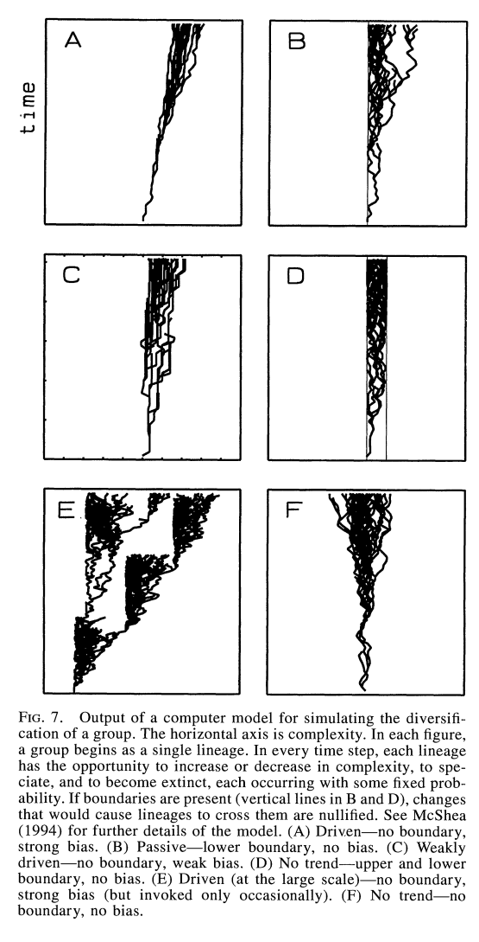
Fig. 4. Mc Shea’s trends in complexity in evolution.

In those cases, algorithmic investigations set the ground for explanations of trends in evolution – and above all, complexity trends – so that one knows what are the minimum conditions that make increasing complexity expectable, and also knows how to recognize various kinds of trends (passive vs. driven), which eventually permits a choice between the possible causes of trends. Interestingly, the simulation shows something about the phylogenetic pattern of complexity distributed across species, namely that some trend may have been at work here. It suggests that this trend is as such explanatory, with no reason to enter into more fine grained analysis. A parallel situation occurs in ecology with the so called ecological neutral theory initiated by Hubbell (2001). In those models a fixed probability of death and birth is ascribed to individuals of each species; yet the occurring distribution of species in modelled communities, as well as their succession, match pattern of distribution within real communities. This suggests that whatever the processes are at the level of individual organisms, species distributions within communities, and their succession rules, depend upon general facts about species. In Hubbell’s model actually the assumptions about birth and death rates are wholly unrealistic about individuals since they amount to denying natural selection (i.e. differential reproduction). The simulation here does not provide the explanation but indicates that some processes (here, species level interactions disregarding what happens at the organisms’ level) are likely to produce by themselves the actual pattern of species distribution.
In this sense, as we can see from those three examples, the simulations, even when their outcome match the empirically detected trends, do not explain them, but forge candidate explanations and compare their likelihoods. This latter term is taken in the technical sense of the probability of data conditional upon the hypothesis, or here the probability of a phylogenetic or ecological pattern conditional upon some hypothetical causal process. Moreover, in many cases they provide some kinds of null hypotheses: for example in Mc Shea (2005) for phylogenies, or in Hubbell (2001) for ecological communities, they sketch “what would occur with no selection”, In this respect, the epistemological value of algorithmic devices for evolutionary biology consists in providing null hypotheses that help to classify and isolate the various outcomes of the hypothesised processes likely to be at stake in the evolutionary reality.
This value is nowhere more obvious perhaps than when it comes to the issue of gradualism in evolution, onto which recent advances in bioinformatics or evolutionary computation have cast a new light.

4. The issue of gradualism and computer simulations.
4.1. Neodarwinism and innovations: a longstanding concern.
There is an implicit equation in neo-Darwinism between natural selection and cumulative selection. Darwin insisted on the fact that variation are small, so that natural selection is slowly shaping the adaptations, and later Fisher and the neo-Darwinian refuted objections according to which small variations could not give birth to big novelties (Mayr 1976, Gayon 1998). However, this made novelty – as the emergence of a real qualitative innovation, e.g. fish gills, mitochondria, sexual reproduction, language – a riddle for Darwinism. Two issues have to be distinguished here: issues of complexity, and issue of innovation, those two properties, while often conjoined, being conceptually distinct (Mc Shea’s work considered in the previous section investigated only the latter). Granted, complexity is successfully described by classical neo-Darwinism, from the times of Darwin who devoted a chapter to a hypothetic history of the eye, to the recent adaptationnist understanding of complex organs (Williams 1992, Dawkins, 1982). Note that this issue of complexity has been enriched by perspectives from the evolution of digital organisms, through both the measures of complexity (Adami, Ofria and Collier 2000) and the proofs of an increase of complexity (Wilke and Adami 2003, Mc Shea 1996).
Computer simulations enabled one to put flesh on Darwin’s speculation since we have now a simulation of the emergence of eyes which corresponds to Darwin’s idea of intermediary species having each in its turn an increasingly efficient and discriminating light detector, and provides a plausible course of this evolution (Nilsson and Pelger, 1994). In a systematic attempt to bring together insights of evolutionary computation and evolutionary biology, Wagner and Altenberg (1996) established that a condition for evolving complex adaptations is that systems are evolvable, which is mostly obtained through specific relationships between genotype and phenotype (“genotypes-phenotypes maps”): relations that prevent big local rearrangements of phenotypes to induce disrupt phenotypes, or in other terms “modularity”. But innovation is not identical to complexity, it is properly speaking the arising and maintenance of a variation that was not behaviourally or morphologically included (id est present in a more or less accentuated form) in the previous traits. Innovation as such is a puzzle for Darwinism (Cracraft 2000), facing the issue of the non-adaptive value of small, non functional, incipient forms of novel traits: what would be the benefit of having, let’s say, the tenth of a gill ? – but this inchoative wing must yet have been selectively retained, if the whole wing was to appear... The usual solution, the one privileged by Mayr (1976) in his attempt to wholly understand innovations from the viewpoint of the Modern Synthesis, is that little steps in phylogeny happened, each displaying a partial state of the trait considered, and each having an adaptive value, exactly like the case of the eyes according to Darwin and later (Nilsson and Pelger 1994), or in the case of insect wings which in their inchoative states have been adaptations for thermoregulation, before being recruited for their flying capacities (Kingsolver and Koehl, 1985). Yet this option is not always possible, especially when it’s hard to understand the adaptive value of a part of the trait (think of mitochondria).
Evolutionary theory of development, or Evo-Devo, has been massively interested in confronting this issue (Muller and Wagner 2003, Müller, 2007; Carroll 2005), sometimes giving up population genetics in favour of self organisation theories (Kauffmann 1993, Goodwin, 1996), that make the wholly structured innovation emerge at once on the basis of singular physicochemical properties. Interest in developmental features as major contributions to evolutionary processes has been fostered by the famous alternative approaches of the patterns of evolution, like the famous theory of punctuated equilibria, put forth by Eldredge and Gould in the 70s (Gould and Eldredge 1977). Punctuated equilibria theorists claim that the lack of transition forms in the fossils record is not due to the geological constraints, but attests that evolution is a two steps process, alternating very long phases of stasis - where the main morphologies, body plans etc., remain essentially the same through the development of detailed adaptations -, and brutal (evaluated in geological times, of course) phases of evolutionary change, where new phyla, body plans, etc., emerge (Fig.5). For example, the Turkana Basin display fossils from mollusc lineages that are very similar, and groups of fossils indicating quickly evolving forms (Williamson, 1981). While this theory is not tied to any particular process of evolution, evolutionists (following Gould 1977) mainly concentrated on the possibilities of recomposing the whole genotype in a holistic manner through changes in the developmental timing (Muller, 2000; Müller and Newman, 2005; Carroll, 2005, Raff, 1996 among many others). Speciation seems to be accompanied by ruptures in developmental homeostasis, which in turn correlates morphological stasis with developmental homeostasis (Williamson, 1981, 215). The emphasis on modes of development instantiates the connection between genotypes and phenotypes, i.e. the genotype-phenotype map, which accounts for differences in evolvability (according to Altenberg and Wagner, 1996). Yet the sudden evolutionary bursts proper to punctuated equilibria, while challenging gradualism, do not compel one to conceive of only one class of processes as responsible for them. At this point computer science is offering new perspectives on this issue too.

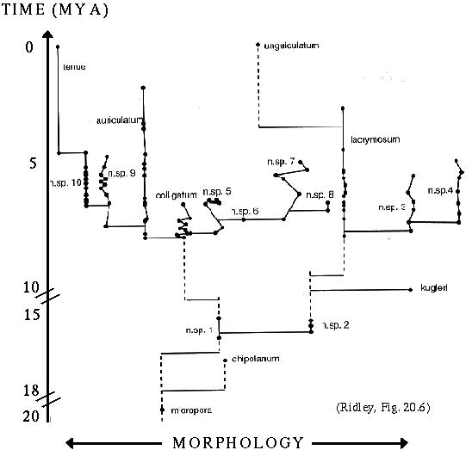
Fig. 5. Punctuated equilbria in the fossil records.

4.2. Compositional and gradual evolutions.
In Compositional evolution (2005) Richard Watson investigated some not-yet-formalized modes of evolution by natural selection. The term names “evolutionary processes involving the combination of systems and subsystems of semi-independently preadapted genetic material” (p.3). The interest of this approach is that the consideration of building blocks obeying some new rules that are inspired by the biological phenomena of sex and of symbiosis proves that in those processes non gradual emergence of novelties is possible.
The basic idea is that in terms of algorithms, interdependencies between parts of a system correspond to some kinds of possible evolutions. 1. A system with weak interdependencies between parts can undergo linear evolution: increases in complexity are linear functions of the values of the variables describing the system (for example, the if the complexity is the number of cell types, one could call linear a complexity increase where this number follows the size of the system, its volume, its number of nucleotides, etc.). Algorithms looking for optimal solutions in this way are called “hill-climbers”; they are paradigmatically gradual. They easily evolve systems more complex in a quantitative way, but they can’t reach systems that would display innovations. 2. If you have arbitrary strong links between the parts, then evolving a new complex system will take exponential time (time increases as an exponential function of the number of variables). Here, the best algorithm to find optimal solutions is the random search. 3. But if you have modular interdependencies (encapsulated parts, etc.) between parts, then evolving new complex systems is a polynomial function of the variables. (Watson 2005, 68-70) Algorithms of the class “divide-and conquer” are dividing in subparts the optimisation issue, and divide in turn each subpart in other subparts : the initial exponential complexity of the optimisation problem approached through random search is thereby divided each time that the general system is divided – so that in the end the problem has polynomial complexity. Those algorithms illustrate how to evolve systems that are not linear improvements of extant systems; but as polynomial functions of the variables, they are feasible in finite time, unlike random search processes. So with a system of this third sort, systems that would not be reachable by evolution in realistic time become reachable. This framework indeed concerns directly evolutionary innovations, because one can assume that most of the time gradual evolution (accumulation of selection on small variations on genes) relies on linear improvements of extant systems, hence seem unable to explain those innovations.
“Compositional evolution” concerns pure processes that embody those classes of algorithms with polynomial rates of complexification, and have genuine biological correspondents. After Lynn Margulis (Margulis and Sagan, 1986), biologists became indeed convinced that our mitochondria initially were symbiotic bacteria that got encapsulated and eventually fixed in the nucleus. Acquiring an innovation through symbiosis obviously skips the riddle of the selective value of inchoative stages in innovations, since it makes no sense to ask what was the value of having, for example, half a mitochondria: the symbiotic part by definition evolved as a whole... Symbiosis easily exemplifies the “mechanisms that encapsulate a group of simple entities into a complex entity” (Watson 2005, 3), and thus proceeds exactly in the way algorithmically proper to polynomial-time complexity-increasing algorithms like “divide and conquer”. Watson defined in genetic algorithms precise ways of evolving that correspond to symbiosis in quite the same way than the classic operators (mutation, crossing over, and replication) were defined by Holland (1995) in correspondence with the genetic processes of the same name.
Granted, crossover is usual in GAs, and embodies one feature of biological sex; it allows then for selection acting on blocks rather than alleles alone, which is a way to get modularity in GAs – modularity being often a key to evolvability (Altenberg and Wagner 1996). Yet Watson refined the usual crossover clause in GA, integrating various algorithmic devices (for ex. “messy GA”, according to Goldberg, Korb and Deb, 1989) in order to allow selection on blocks that take into account correlations between distant blocks, hence creation of new blocks (Watson 2005, 77). To this extent, the evolutionary potential of sex is taken into account is a more fine-grained and encompassing way here than in the usual GA research tradition – hence, the possibility of understanding necessary non-gradual evolution and the arising of innovations as outcomes of this evolution. Now, all those “encapsulation” genetic algorithms, no matter the rules that provide the encapsulation, are of the kind of polynomial-time evolutionary algorithms. This proves that biological processes formally structured like those encapsulated processes – such are symbiosis, endosymbiosis, may be lateral gene transfer – have been likely to provide evolvability towards the most complex innovations, the ones not reachable through gradual evolution.
Watson (2005) has thus shown that cumulative selection as such cannot do better than a kind of linear increase in the value of some parameters, which makes difficult to understand how some innovations could appear through such evolution in finite time. Hence evolving innovative systems in a gradual way is not plausible (at least, as a general solution, though scenario like exaptations and theories focusing on developmental variations (e.g. Kirschner an Gerhardt 2005) are explanatory here). However, adding the symbiotic and the sexual modes of evolution by selection makes available polynomial increases in the values of variables, which can account for the genuine arising of innovations that occurred in nature. This increase rests on a compositional process that would for instance embody the discontinuity in evolution proper to the mitochondria acquiring, namely a sort of evolutionary jump corresponding to the addition of the already evolved symbiotic digital organism.
So the longstanding issue of gradualism is here addressed through a conceptual move back and forth between evolutionary biology and computer science: biology provides a natural model for a kind of evolution that seems to display discontinuity (e.g. symbiosis), and hence speeds up gradual evolution; and in return computer science devises a pure kind of process – called “encapsulation” – that picks out the very structure responsible, in the symbiotic evolution, of the speeding up of the process (namely, drops from exponential to polynomial time). The bulk of Watson’s demonstration is the identity between algorithmic classes (hill-climbing, divide-and-conquer, random search) and evolutionary processes (gradual evolution, compositional evolution) – an identity which plainly makes sense in the light of the first sections of this paper. Finally, evolutionary theory, when it considers cases of evolution that are controversial on a gradualist viewpoint - because cumulative selection seems too slow to account for them – is provided with a process-model likely to explain such episode. So the solution of the gradualism issue is neither a quest of non-darwinian explanation (“order for free”, etc.), nor a reassertion of the power of cumulative selection that needs to be more deeply investigated (Mayr, 1976), but the formal designing of new modes of selective processes, of the reason of their differences, and of the differences between their evolutionary potentials. In this sense, discontinuities in evolution appear as the explananda of a variety of selective processes whose proper features and typical evolutionary patterns are demonstrated by computer science. For this reason Watson’s work seems paradigmatic of the interplay between evolutionary theory and computer science, provided that – as it is claimed here - computer simulations are a way to provide candidate process explanations for actual patterns, and null hypotheses.
Further reflexion is needed to make sense of the discontinuity which is proper to novelty. The work surveyed here provides anyway a basis of an attempt to relate and systematise the various processes of which computational models provide the pure outcomes. Discontinuity can be conceived of in terms of emergence, as opposed to adaptation continuously produced by cumulative selection (Huneman, 2008). In effect, emergence in computational systems can find a criterion, namely the unavailability of an outcome except by simulation (Bedau 1997, 2003, 2007, Huneman, 2007,Huneman & Humphreys 2008). Discontinuity and emergence characterize precisely the evolution of new fitness units, which is the target of the research program of “evolutionary transitions”, initiated by Maynard-Smith and Szathmary (1995) and Michod (1999). It is patent that “compositional evolution” as construed by Watson is likely to address cases of evolutionary transitions (Watson, 2005, 54), because its encapsulation model might generate in a more feasible and available way than gradual evolution (with its linear progression) those “entities that were capable of independent replication before transition (and) can replicate only as a part of a larger whole after it” (Maynard Smith and Szathmary, 1995) and that are the target of the investigation in “evolutionary transitions”. So once again a radical case of evolutionary innovation can find in computer science the construal of pure possible processes likely to explain it.
The fact of discontinuity will provide a basis for a classification of the evolutionary patterns resulting from the various selective processes formally investigated by computer sciences – and therefore, a basis for answering the question of the processes responsible for increases in complexity in life, in the various senses of complexity. Such issue will be addressed elsewhere.

Conclusion
The Strong AL claim is: biology is a part of a very general science of evolution, instantiated by some branches of the computer sciences. This paper tried to assess such a claim, mainly by focusing on the relationship between algorithmic modelling and genuine cases of natural selection, and by understanding what epistemological value computer simulations have for evolutionary biology.
The main result is that computational models are not a very general domain of which biology would exemplify some cases. On the contrary they mostly provide pure possible processes that might causally contribute to origin of traits or evolutionary patterns. The class of possible processes being larger than the real processes, it is obvious that not all processes simulated – not all cases of artificial life, if you prefer – are likely to be met in biology. Most of the writers are accounting for this in terms of the chemical nature of living entities, which will provide boundary conditions for those processes. Yet I argue that the right account is given by the fact that biological processes are never pure, since (§2) in biology all entities are given together in their hierarchical scales, while algorithmic devices only permit to single out one or few entities within them. In this sense they are only generating the pure processes involving solely those entities.
To this extent strong simulations do rather provide general null hypotheses for evolutionary biology – in terms of taxonomy of pure processes, mostly (but not always) selective ones. This also settles the validation paradox for biologically oriented algorithmic investigations. One major interest in this virtual exploration of selective processes is that realistic challenges to gradualism can be formulated, in terms of pure possible processes, computationally modelled, likely to feasibly generate innovations. This allows more plausible and pluralist schemata of macroevolution, which contribute to theoretical integration in biology: integrating micro- and macro- and mega-evolution (sensu Simpson, 1948); and integrating distinct approaches of innovations, from classical evolutionary theory (Mayr, 1976) and from recent trends in Evo-Devo (Müller, 2007; Gilbert, Opitz, Raff, 1996).

References.

Adami, C. 2002. “What is complexity”, Bio Essays, 24: 1085-1094.
Adami C., Ofria C., Collier T. 2000. “Evolution of biological complexity”, PNAS, 97, 9:
4463-4468.
Agrawal A. 2001. “Sexual selection and the maintenance of sexual reproduction.” Nature 411: 692-696
Bedau M. 1998. “Four puzzles about life.” Artificial life 4: 125-140
Bedau M. 1999. “Can unrealistic computer models illuminate theoretical biology”, Proceedings of the 1999 genetic and evolutionary computation conference workshop program, Florida, Wu A. ed., pp.20-23
Bedau, M. 1997. “Weak Emergence”. In J. Tomberlin (ed.), Philosophical Perspectives: Mind, Causation, and World, vol. 11, pp. 375-399. Oxford: Blackwell Publishers.
Bedau M. 2003. `Downward Causation and the Autonomy of Weak Emergence’ Principia, Revista Internacional de Epistemologia, 6: 5-50.
Bedau M., Snyder, Packard N. 1998. “A classification of long-term evolutionary dynamics”, Artificial life VI, Adami et alii eds..Cambridge: MIT Press, pp.189-198
Bonner J.T. 1998. The evolution of complexity by means of natural selection. Princeton: Princeton University Press.
Burtsev M., Red’ko V., Gusarev R., “Alife model of evolutionary emergence of purposeful adaptive behaviour”, available on www.keldysh.ru/mrbur-web/publ/ecal01full.pdf
Carroll, S. 2005. Endless forms most beautiful. NY: Sinauer.
Channon A., Damper R.I. 2000. “Towards the evolutionary emergence of complex increasingly advantageous behaviours.” International Journal of Systems science, 31 (7), 843-860
Channon A., Damper R. 1998. “Perpetuating evolutionary emergence”, in Pfeifer, R., Blumberg, B., Meyer, J. A. and Wilson, S., (eds.), Cambridge, MIT Press, pp. 534-539.
Chu J., Adami C. 1999. “A simple explanation for taxon abundance patterns.” PNAS, vol. 96 no. 26: 15017-15019.
Cracraft J. (2000) “The origin of evolutionary novelties: pattern and process at different hierarchical levels”, Evolutionary innovations, M.Nitecki (ed.), Chicago: University of Chicago Press, pp.21-43
Crubelier B., Preux P., Cambier C. 1997. « Studying adaptation with Echo », ftp://ftp.cogs.susx.ac.uk/pub/ecal97/online/F045.ps.gz
Crutchfield J. 2001. “When evolution is revolution – origins of innovation.” Evolutionary dynamics – explotring the interplay between accident, selection, neutrality and function, Crutchfield and Schuster ed. Oxwford: Oxford University Press.
Crutchfield J., van Nimwegen E. 1999. “The evolutionary unfolding of complexity”, Evolution and computation, Landweber, Winfree, Lipton, Freeland (eds.), Lectures notes in computer science. Berlin: Springer.
Crutchfield and Melanie Mitchell, “The evolution of emergent computation”, Proceedings of the national academy of science.
Crutchfield J., Mitchell M., Hraber. 1993. “Revisiting the edge of chaos : evolving cellular automata to perform computations”, Complex systems, 7:89-130
Damuth J., Heisler L. 1988. “Alternative formulations of multilevel selection.” Biology and philosophy, 4, 3: 407-430
Das R., Mitchell M., Crutchfield J.. 1994. "A Genetic Algorithm Discovers Particle-Based Computation in Cellular Automata", In Parallel Problem Solving from Nature-III, Y. Davidor, H.-P. Schwefel, and R. Männer (eds.) Berlin: Springer-Verlag, pp.344-353.
Dennett D. 1995. Darwin’s dangerous idea. New-York: Simon & Shuster.
Eldredge N. 1985. The unfinished synthesis. New-York: Oxford University Press.
Fontana W., Buss L. 1994. “What would be conserved if “the tape were played twice” ?” Proc. Natl. Ac. Sci., 91: 757-761.
Fontana W., Schuster P.. 1998. “Continuity in evolution: on the nature of transitions.” Science. 280.
Forrrest S. 1996. “Genetic algorithms.” ACM Computer surveys.
Forrest S., Jones T. 1994. “Modeling complex adaptive systems with Echo” Complex systems; mechanisms of adaptation. Stonier & Yu (Eds). Amsterdam: IOS Press, pp.3-21
Füchslin R., Mc Caskill, J. 2001. “Evolutionary self organisation of cell-free genetic coding”, PNAS, 98, 16:9185-9190
Gavrilets S. 2003. « Evolution and speciation in a hyperspace: the roles of neutrality, selection, mutation and random drift », Schuster P., Crutchfield J. (eds), Evolutionary dynamics. Exloring the interplay of selection, accident, neutrality and function. New-York: Oxford University Press
Gayon J. 1998. Darwinim’s struggle for survival. Cambridge: Cambridge University Press.
Golberg D.E., Deb K., Korb B.. 1991. “Don’t worry, be messy.” Proceedings of the Fourth International Conference on Genetic Algorithms. Belew R.K., Booker L.B. (eds.). San Mateo CA: Morgan Kaufmann, pp.24-30
Godwin B. 1996. Form and Transformation: Generative and Relational Principles in Biology. Cambridge: Cambridge University Press.
Gould S.J. 1977. Ontogeny and phylogeny. New Haven: Belknap.
Gould S.J., Eldredge N. 1977. “Punctuated equilibria” Paleobiology 3, 115
Gould, S.J., Vrba, E. 1982. “Exaptation: a missing term in the science of form.” Paleobiology VIII, 4--15.

Hillis, D. 1998. The Pattern On The Stone: The Simple Ideas That Make Computers Work. London: Basic Books.
Holland J. 1995. Hidden order. How adaptation builds complexity. Readings: Helix.
Hubbell, J. 2001. The Unified Neutral Theory of Biodiversity and Biogeography. Princeton: Princeton University Press.
Humphreys P. 2004. Extending ourselves. Oxford: Oxford University Press.
Humphreys P., Huneman P. (eds.) 2008 “Dynamic emergence.” Special issue of Minds and Machines.
Huneman P. 2008. “Emergence and adaptation”. Minds and Machines, “Dynamic emergence.” eds. Humphreys and Huneman.
Huneman, P. 2007. “Emergence made ontological ? Compositional vs. Computational emergence.” Philosophy of Science Association Conference, 2006, On line www.philsci.org, forthcoming in Philosophy of science.
Kauffmann, S. 1993. The origins of order. Oxford: Oxford University Press.
Kettlewell R. (1956), “Further selection experiments on industrial melanism in the Lepidoptera," Heredity, 10:287-301
Kirschner M., Gerhardt G. 2005. The plausibility of life: resolving Darwin’s dilemma. New Haven: Yale University Press.
Kingsolver, J.G., Koehl M.A.R. 1985. “Aerodynamics, thermoregulation, and the evolution of insect wings: differential scaling and evolutionary change”. Evolution 39: 488-504
Küppers, G., Lenhard J. 2005. ‘Validation of Simulation: Patterns in the Social and Natural Sciences’ Journal of Artificial Societies and Social Simulation vol. 8, no. 4. http://jasss.soc.surrey.ac.uk/8/4/3.html
Koza, J.R. (1992). Genetic Programming: On the Programming of Computers by Means of Natural Selection. Cambridge: MIT Press.
Lange M. 1996. “Life, “Artificial life” and scientific explanations”, Philosophy of science, 63: 225-244
Langton C. 1996. “Artificial life.” The philosophy of artificial life. Boden M. ed. Oxford: Oxford University Press.
Lenski R., Ofria C., Pennock T., Adami C. 2003. “The evolutionary origin of complex features.” Nature. vol.423: 139-144.
Mc Shea D. 1996 “Metazoan complexity and evolution: is there a trend ?” Evolution, 50 (2): 477-492.
Mc Shea D. 2005. “The evolution of complexity without natural selection: a possible large-scale trend of the fourth kind” Paleobiology 31 (2): 146-156.
Mc Shea D. 1994. “Mechanisms of large-scale evolutionary trends” Evolution, 48 (6): 1747-1763.
Margulis L., Sagan D. 1986. Origins of Sex: Three Billion Years of Genetic Recombination. New Haven: Yale University Press.
Margolus D., Toffoli J. 1987 Cellular automata. Cambridge: MIT Press
Maynard Smith J., Szathmary E. 1995. The major evolutionary transitions. New-York: Oxford University Press.
Maynard-Smith J.2000. “The concept of information in biology”. Philosophy of Science 67: 177—194.
Mayr E. 1976. “The emergence of evolutionary novelties” Evolution and the diversity of life. Harvard University Press. pp.87-113
Maley C. 2001. “Comparing causal factors in the diversification of species”, Studies in complex systems, II, Bar-Yam Y. (ed.), pp.
Maron, M.. 2004. “Evolution of industrial melanism: a spatial, predator-prey genetic algorithm”. www.brainoff.com/easy/moth/report.pdf
Michod, R. 1999. Darwinian dynamics. Oxford: Oxford University Press.
Michod R. (2005) “On the transfer of fitness from the cell to the multicellular organism.” Biology and Philosophy. 20: 967-987
Miller G., Todd P. 1995. “The role of mate choice in biocomputation; sexual selection as a process of search, optimization and diversification.” Evolution and biocomputation: computational models of evolution, Banzhaf, Eckmann (eds.), Berlin, 1995, 169-204
Mitchell M., Forrest S. 1993. “Genetic algorithms and artifical life”, Artificial life

Mitchell, M. 1998. An Introduction to Genetic Algorithms (Complex Adaptive Systems). Cambridge: MIT Press.
Müller, G. 2000. “Developmental mechanisms at the origin of evolutionary novelty: a side-effect hypothesis”, Evolutionary innovations, M.Nitecki (ed.) Chicago: University of Chicago Press: pp.99-130.
Müller G.B. and S.A. Newman. 2005. “The innovation triad: An EvoDevo agenda”.
Journal of Experimental Zoology. MDE 304: 487-503.
Müller G. B. 2007. “Evo-devo: extending the evolutionary synthesis.” Nature Reviews Genetics, published online 6 Nov 2007
Müller G.B. and G.P. Wagner. 2003. “Innovation”. Keywords and Concepts in Evolutionary Developmental Biology. B.K. Hall and W. Olson (eds.): pp 218-227.
Cambridge: Cambridge University Press.
Newman S.A. and G.B. Müller. 2005. “Origination and innovation in the vertebrate limb skeleton: An epigenetic perspective.” Journal of Experimental Zoology / MDE 304: 593-609.
Nilsson, D.-E. and S. Pelger. 1994. “A pessimistic estimate of the time required for an eye to evolve”. Proceedings of the Royal Society of London, Biological Sciences, 256: 53-58.
Okasha S. 2006. The levels of selection in evolution. Cambridge: Cambridge University Press
Pattee H. 1989.“Simulations, realizations and theories of life”, Artificial life, Langton C. et alii (eds), London: Addison Wesley, pp. 63-78.
Raff, R. The shape of life. Genes, development and the evolution of animal form. Chicago: Unievrsity of Chicago Press.
Ray T. 1992. “An approach to the synthesis of life”, Artificial life II Langton C. (ed.). London: Addison Wesley, pp.371-408
Reynolds C., “Flocks, herds and schools : a distributed behavioural model”, Computer graphics, 21 (4): 25-34 .
Sayama H. “Spontaneous evolution of self reproducing loops in cellular automata.” Studies in complex systems. Bar Yam ed., pp.362-377
Sayama H., Antony A., Salzberg C. 2003. “Genetic diversification and complex genealogy of self-replicators disovered in simple cellular automata: a preliminary report.” Journal of Three Dimensional Images, 17(4):103-109.
Simpson G. G. (1949) Meaning of evolution. Hew Haven: Yale University Press.
Watson, Richard A. (2005), Compositional evolution. The impact of sex, symbiosis and modularity on the gradualist framework of evolution. Cambridge: MIT Press.
Wilke C., Adami C. (2003) “Evolution of mutational robustness”, Mutation research, 522: 3-11
Wagner A. (1999) “Causality in complex systems.” Biology and Philosophy 14: 83–101.
Wagner A. (2005) Robustness and evolvability in living systems. Princeton: Princeton University Press
Wagner G., Altenberg L.1996. “Complex adaptations and the evolution of evolvability”, Evolution 50 (3): 967-976.
Williams G. 1992. Natural selection: domains, levels and challenges. Oxford: Oxford University Press
Williamson P.G. 1981. “Morphological stasis and developmental constraint: real problems for neo-darwinism.” Nature 294: 214-215
Winsberg, E. 2003. “Simulated Experiments: Methodology for a Virtual World.” Philosophy of Science, 70: 105-125.
Wolfram S. 1984. “Universality and complexity in cellular automata” Physica D, 10:1—35.
Wolfram,  S. 1984b. “Cellular automata as models of complexity,” Nature, vol. 311, no. 4, pp. 419-424

I warmly thank Laura Nuno de la Rosa Garcia, Sara Franceschelli and above all Anouk Barberousse for their careful reading and criticisms of this paper.
On this claim, see Lange (1996). The essential point, as he claims, is not that a feature of life is imitated by the simulation, but that it gives an insight into the reason why this feature might be displayed. See p.241 on flocking boids.
see also Antony, Salzberg, Sayama 2003.
This might in the end proves to be the main difference between simulations and the biosphere.
Mc Shea (2005) indicated that if we define complexity in non-functional terms, internal variance in life (due to the mere principlkes of heredity and variation) provides a trend toward increasing complexity. This trend is matched in some parts of the known phylogenetic tree; however this process seems like diffusion in physics. Bedau (forthc.) argues against this idea by sayingt that what is increasing in this diffusion process has not necessarily teh meaning of biologicla complexity that Mc Shea intends to study. Something is increasing, but the increase due to this diffusion has no biological meaning that could be identified within the simulation.
See simulation at http://www.blackwellpublishing.com/ridley/a-z/Evolution_of_the_eye_b.asp.
Such changes has been famously called “exaptations” by Gould and Vrba (1982).
Notice that fitness function, here, seems fixed in advance – we have mostly algorithms that embody the “artificial selection” in the sense of Channon and Damper cited above.
This is somehow the main line of Bonner’s approach of complexity, since he correlates complexity, number of cell types and size through natural selection, which is supposed to gradually improve size.
For a table of correspondance between the two fields, see e.g. the table in Watson 2005, p.42.
As Watson himself says, computer science provide “means... to identify differences in adaptive processes in a fundamental sense” (2005, p.2), i.e. in terms of rhythm and feasibility.

