Supplementary Material for: A Projected State-Space Sieve for Dynamic Low-Rank Network Vector Autoregressions with Stochastic Trends and Volatility
Appendix: Supplementary Mathematical Proofs, Sampler Derivations, Simulation Robustness, and Empirical Exhibits
All Python scripts, algorithm benchmarks, and empirical data panels analyzed in this supplement are archived in the anonymized repository: https://anonymous.4open.science/r/DJIA-Blind.
Appendix A.1: Proof of Proposition 1
Divergence of raw price moments under integrated factor trends. Factor levels accumulate the velocity state. If a velocity root lies on the unit circle, the corresponding level is integrated of order two and the variance of a log price with nonzero exposure grows as $O\left(t^{3}\right)$. If every velocity root lies inside the unit circle, the level is integrated of order one and the variance grows as $O\left(t\right)$. With nonzero drift the uncentered second moment grows as $O\left(t^{2}\right)$; with zero drift that moment grows as $O\left(t\right)$. Raw log prices therefore violate the uniform bounded-moment condition of Dahlhaus (1997) local stationarity. The moving-average argument below is applied to the cyclical component $x_{t}=y_{t}-μ_{t}$.
This appendix proves that, under the regularity conditions of Proposition 1, the cyclical component $x_{t}≡y_{t}-μ_{t}$ admits a uniform locally frozen time-varying vector moving-average approximation. The kernel error is $O\left(T^{-1}\right)$ and the mean-square remainder is $O\left(T^{-2}\right)$. Conditional heteroskedasticity is controlled by the second-moment bound (18c).
1. Companion State-Space Formulation
Recall from equation (6) that the cyclical deviations follow the order-$p$ network-coupled vector autoregression:
$$x_{t}=\sum_{l=1}^{p}{Φ_{l,t-l}}x_{t-l}+ε_{t}, ε_{t}∼N_{n}\left(0,Σ_{t}\right) \left(A.1\right)$$
where the effective lag-$l$ transition operator is defined as:
$$Φ_{l,t-l}≡(I_{n}+W_{t-l})⊙B_{l,t-l}=(I_{n}+W_{t-l})⊙\left(U_{l,t-l}V_{l,t-l}^{⊤}\right)∈R^{n×n} \left(A.2\right)$$
Stack the $p$ history vectors into the companion state vector $X_{t}≡{\left[x_{t}^{⊤},x_{t-1}^{⊤},…,x_{t-p+1}^{⊤}\right]}^{⊤}∈R^{np}$. The system (A.1) admits the first-order companion form:
$$X_{t}=F_{t}X_{t-1}+E_{t} \left(A.3\right)$$
where $E_{t}≡{\left[ε_{t}^{⊤},0,…,0\right]}^{⊤}∈R^{np}$, and the lag-origin companion matrix $F_{t}∈R^{np×np}$ is given by:
$$F_{t}≡\left[\begin{matrix}Φ_{1,t-1} & Φ_{2,t-2} & … & Φ_{p-1,t-p+1} & Φ_{p,t-p} \\ I_{n} & 0 & … & 0 & 0 \\ 0 & I_{n} & … & 0 & 0 \\ ⋮ & ⋮ & ⋱ & ⋮ & ⋮ \\ 0 & 0 & … & I_{n} & 0\end{matrix}\right] \left(A.4\right)$$
Equation (A.4) is the lag-origin operator bounded as $G_{t,T}$ in (A.17a). The continuum curve $F\left(u\right)$ in equation (17) is the instantaneous companion used by Lemmas A.1 and A.2.
2. Lipschitz Continuity of the Companion Operator $F\left(u\right)$
By Condition 2, each lag curve $B_{l}\left(u\right)=U_{l}\left(u\right){V_{l}\left(u\right)}^{⊤}$ has rank at most $r_{B}≪n$, is uniformly bounded, and satisfies the following bounds on $\left[0,1\right]$:
$$\sup_{u∈\left[0,1\right]}{\left\|B_{l}\left(u\right)\right\|}_{2}≤C_{B}<∞,\sup_{u≠v}\frac{{\left\|B_{l}\left(u\right)-B_{l}\left(v\right)\right\|}_{F}}{\left|u-v\right|}≤L_{B,l}<∞ \left(A.7\right)$$
Thin-SVD equal-scale normalization supplies a canonical local factor parameterization away from singular-value multiplicities. If the product curve is continuously differentiable and has locally constant rank, the factor curves can be chosen locally continuously differentiable after the column signs are fixed. Proposition 1 requires only boundedness and Lipschitz continuity of the composite product curve $B_{l}\left(u\right)$. The constant in equation (A.15) is $L_{B}=\max_{1≤l≤p}L_{B,l}$. As formalized in Remark 1, the discrete Gaussian random-walk priors act as the finite-$T$ estimation sieve for these population curves.
Differentiability and Lipschitz Continuity of the Smooth Probit Network Layer
Under Condition 1 (Systematic Network Regularity) of Proposition 1, the true continuum data-generating process evaluates spatial weights along the smooth coordinate projection $η_{ij}\left(u\right)$, rather than the discrete measurement $z_{ij,t}$ in (12). On the continuous-time continuum $u∈\left[0,1\right]$, the true systematic intensity is
$$η_{ij}\left(u\right)={{\overline{u}}_{i}}^{⊤}{\overline{v}}_{j}+{u_{i}\left(u\right)}^{⊤}v_{j}\left(u\right) \left(A.8\right)$$
Under the continuum regularity assumptions of Proposition 1, the coordinate curves $u_{i}\left(u\right),v_{j}\left(u\right)$ reside in a compact parameter set $K_{z}⊂R^{r}$ and are continuously differentiable with uniformly bounded derivatives. Consequently, $η_{ij}\left(u\right)$ is uniformly bounded: $\left|η_{ij}\left(u\right)\right|≤Z_{max}<∞$.
To establish uniform Lipschitz continuity of $η_{ij}\left(u\right)$, note that the static term ${{\overline{u}}_{i}}^{⊤}{\overline{v}}_{j}$ cancels under subtraction:
$$\left|η_{ij}\left(u\right)-η_{ij}\left(v\right)\right|=\left|{u_{i}\left(u\right)}^{⊤}v_{j}\left(u\right)-{u_{i}\left(v\right)}^{⊤}v_{j}\left(v\right)\right|$$
$$=\left|{\left(u_{i}\left(u\right)-u_{i}\left(v\right)\right)}^{⊤}v_{j}\left(u\right)+{u_{i}\left(v\right)}^{⊤}\left(v_{j}\left(u\right)-v_{j}\left(v\right)\right)\right|$$
$$≤{\left\|u_{i}\left(u\right)-u_{i}\left(v\right)\right\|}_{2}{\left\|v_{j}\left(u\right)\right\|}_{2}+{\left\|u_{i}\left(v\right)\right\|}_{2}{\left\|v_{j}\left(u\right)-v_{j}\left(v\right)\right\|}_{2}$$
Because $\sup_{u∈\left[0,1\right]}{\left\|u_{i}\left(u\right)\right\|}_{2}≤C_{u}<∞$, $\sup_{u∈\left[0,1\right]}{\left\|v_{j}\left(u\right)\right\|}_{2}≤C_{v}<∞$, and bounded derivatives imply ${\left\|u_{i}\left(u\right)-u_{i}\left(v\right)\right\|}_{2}≤L_{u}\left|u-v\right|$ and ${\left\|v_{j}\left(u\right)-v_{j}\left(v\right)\right\|}_{2}≤L_{v}\left|u-v\right|$, the projection satisfies
$$\left|η_{ij}\left(u\right)-η_{ij}\left(v\right)\right|≤\left(C_{v}L_{u}+C_{u}L_{v}\right)\left|u-v\right|≡L_{z}\left|u-v\right| \left(A.9\right)$$
for all $u,v∈\left[0,1\right]$, where $L_{z}≡C_{v}L_{u}+C_{u}L_{v}<∞$.
The spatial weight entries are defined by (13), evaluated at this systematic intensity:
$$w_{ij}\left(u\right)=\frac{Φ\left(η_{ij}\left(u\right)\right)}{S_{i}\left(u\right)}, S_{i}\left(u\right)≡\sum_{k≠i}{Φ}\left(η_{ik}\left(u\right)\right), w_{ii}\left(u\right)≡0 \left(A.10\right)$$
Because $|η_{ij}\left(u\right)|≤Z_{max}$, the Gaussian cumulative probabilities are strictly bounded away from zero and one: $0<c_{min}≤Φ\left(η_{ij}\left(u\right)\right)≤c_{max}<1$, where $c_{min}≡Φ\left(-Z_{max}\right)$ and $c_{max}≡Φ\left(Z_{max}\right)$. The row sum denominator satisfies:
$$\left(n-1\right)c_{min}≤S_{i}\left(u\right)≤\left(n-1\right)c_{max}, ∀u∈\left[0,1\right] \left(A.11\right)$$
Differentiating $w_{ij}\left(u\right)$ with respect to $u$:
$$\frac{dw_{ij}\left(u\right)}{du}=\frac{ϕ\left(η_{ij}\left(u\right)\right)η'_{ij}\left(u\right)S_{i}\left(u\right)-Φ\left(η_{ij}\left(u\right)\right)\sum_{k≠i}{ϕ}\left(η_{ik}\left(u\right)\right)η'_{ik}\left(u\right)}{S_{i}{\left(u\right)}^{2}} \left(A.12\right)$$
Using the bound on the Gaussian density $\sup_{z}{ϕ\left(z\right)}={\left(2π\right)}^{-1/2}$ and the derivative bound $|η'_{ij}\left(u\right)|≤L_{z}$:
$$\left|\frac{dw_{ij}\left(u\right)}{du}\right|≤\frac{\frac{L_{z}}{\sqrt{2π}}\left(n-1\right)c_{max}+c_{max}\left(n-1\right)\frac{L_{z}}{\sqrt{2π}}}{{\left(n-1\right)}^{2}c_{min}^{2}}=\frac{\sqrt{2/π} c_{max}L_{z}}{\left(n-1\right)c_{min}^{2}}≡{\overline{L}}_{w}<∞ \left(A.13\right)$$
The row-vulnerability and column-source coordinates both enter this derivative. They satisfy $\sup_{u∈\left[0,1\right]}{\left\|\frac{du_{i}\left(u\right)}{du}\right\|}_{2}≤L_{u}<∞$ and $\sup_{u∈\left[0,1\right]}{\left\|\frac{dv_{j}\left(u\right)}{du}\right\|}_{2}≤L_{v}<∞$, so the constant $L_{z}$ in (A.12) and (A.13) is finite.
Hence, the matrix curve $W\left(u\right)$ is uniformly Lipschitz continuous in Frobenius norm:
$$‖W\left(u\right)-W\left(v\right)‖​_{F}≤L_{W}|u-v|, L_{W}≤\sqrt{n\left(n-1\right)} {\overline{L}}_{w}=\frac{\sqrt{2/π} c_{max}L_{z}}{c_{min}^{2}}\sqrt{\frac{n}{n-1}}=O\left(1\right) \left(A.14\right)$$
Because the panel dimensions $n$ and $p$ are fixed as $T→∞$, $L_{W}≡\sqrt{n\left(n-1\right)}L_{w}=O\left(1\right)$ with respect to the infill asymptotic index $T$.
Lipschitz Continuity of the Companion Operator $F\left(u\right)$
The effective lag-$l$ transition operator on the continuum is $Φ_{l}\left(u\right)=(I_{n}+W\left(u\right))⊙B_{l}\left(u\right)$. For any two time points $u,v∈\left[0,1\right]$:
$${\left\|Φ_{l}\left(u\right)-Φ_{l}\left(v\right)\right\|}_{F}={\left\|\left(I_{n}+W\left(u\right)\right)⊙B_{l}\left(u\right)-\left(I_{n}+W\left(v\right)\right)⊙B_{l}\left(v\right)\right\|}_{F}$$
$$≤{\left\|W\left(u\right)-W\left(v\right)⊙B_{l}\left(u\right)\right\|}_{F}+{\left\|\left(I_{n}+W\left(v\right)\right)⊙B_{l}\left(u\right)-B_{l}\left(v\right)\right\|}_{F}$$
$$≤{\left\|W\left(u\right)-W\left(v\right)\right\|}_{F}\max_{i,j}\left|B_{l,ij}\left(u\right)\right|+\max_{i,j}\left|{\left(I_{n}+W\left(v\right)\right)}_{ij}\right|{\left\|B_{l}\left(u\right)-B_{l}\left(v\right)\right\|}_{F}$$
$$≤\left(L_{W}C_{B}+L_{B}\right)\left|u-v\right|≡L_{Φ}\left|u-v\right| \left(A.15\right)$$
where $\max_{i,j}\left|{\left(I_{n}+W\left(v\right)\right)}_{ij}\right|=1$, because $W\left(v\right)$ is row-stochastic, with zero diagonal and nonnegative off-diagonal entries.
Because all matrix norms on $R^{np×np}$ are equivalent, with ${\left\|F\right\|}_{2}≤{\left\|F\right\|}_{F}≤\sqrt{np}{\left\|F\right\|}_{2}$, the Frobenius Lipschitz bounds on $W\left(u\right)$ and $B_{l}\left(u\right)$ bound the spectral norm of $F\left(u\right)$:
$$\sup_{u≠v}\frac{{\left\|F\left(u\right)-F\left(v\right)\right\|}_{2}}{\left|u-v\right|}≤\sqrt{p}L_{Φ}≡L<∞. \left(A.16\right)$$
Evaluating at discrete time points $u=\frac{t}{T}$ and $v=\left(t-1\right)/T$, the discrete stepwise increment satisfies, almost surely:
$$\sup_{t=1,…,T}{\left\|F\left(\frac{t}{T}\right)-F\left(\frac{t-1}{T}\right)\right\|}_{2}≤\frac{L}{T}=O\left(T^{-1}\right) \left(A.17\right)$$
3. Uniform Resolvent and Frozen Operator Bounds
Under the uniform spectral contraction in Proposition 1, $u↦F\left(u\right)$ is continuous on the compact interval $\left[0,1\right]$, and $\sup_{u∈\left[0,1\right]}ρ\left(F\left(u\right)\right)≤\overline{ρ}<1$.
Lemma A.1 (Uniform Geometric Decay of Frozen Companion Powers). For every $\overline{γ}∈\left(\overline{ρ},1\right)$, there exists a finite constant $C_{0}<∞$ such that:
$$\sup_{u∈\left[0,1\right]}{\left\|{F\left(u\right)}^{j}\right\|}_{2}≤C_{0}{\overline{γ}}^{j},∀j≥0. \left(A.18\right)$$
Furthermore, $M_{F}≡\sup_{u∈\left[0,1\right]}{\left\|F\left(u\right)\right\|}_{2}<∞$, and $M_{F}≥1$ because of the companion sub-diagonal identity blocks.
Proof of Lemma A.1. Fix $\overline{γ}∈\left(\overline{ρ},1\right)$. For each $u∈\left[0,1\right]$, the spectrum of $F\left(u\right)$ lies strictly inside the open disk $\left\{ξ∈C:\left|ξ\right|<\overline{γ}\right\}$. By the Dunford–Taylor holomorphic functional calculus, the power ${F\left(u\right)}^{j}$ admits the Cauchy contour integral: Consequently the resolvent is nonsingular on the product of the unit interval with that contour. The product is compact and matrix inversion is continuous, so the extreme value theorem yields a finite uniform resolvent bound.
$${F\left(u\right)}^{j}=\frac{1}{2πi}\underset{\left|ξ\right|=\overline{γ}}{∮}ξ^{j}{\left(ξI_{np}-F\left(u\right)\right)}^{-1}dξ. \left(A.19\right)$$
The resolvent $\left(u,ξ\right)↦{\left(ξI_{np}-F\left(u\right)\right)}^{-1}$ is continuous on the compact product $\left[0,1\right]×\left\{ξ∈C:\left|ξ\right|=\overline{γ}\right\}$. By the extreme value theorem, its norm is uniformly bounded:
$$M_{R}≡\sup_{u∈\left[0,1\right]}\sup_{\left|ξ\right|=\overline{γ}}{\left\|{\left(ξI_{np}-F\left(u\right)\right)}^{-1}\right\|}_{2}<∞. \left(A.20\right)$$
Taking spectral 2-norms inside (A.19):
$${\left\|{F\left(u\right)}^{j}\right\|}_{2}≤\frac{1}{2π}\oint_{\left|ξ\right|=\overline{γ}}{{\left|ξ\right|}^{j}{\left\|{\left(ξI_{np}-F\left(u\right)\right)}^{-1}\right\|}_{2}\left|dξ\right|}≤\frac{1}{2π}\left(2π\overline{γ}\right){\overline{γ}}^{j}M_{R}=\left(M_{R}\overline{γ}\right){\overline{γ}}^{j}. \left(A.21\right)$$
Setting $C_{0}≡max\left\{1,M_{R}\overline{γ}\right\}<∞$ establishes (A.18) uniformly for $u∈\left[0,1\right]$. Continuity on that compact interval gives $M_{F}<∞$, and the identity blocks give $M_{F}≥1$. ■
4. Stability of Slowly Varying Companion Products
Extension to the integer time axis. For all $t∈Z$ and $j≥0$, companion products $\prod_{k=0}^{j-1}{F\left(\frac{t-k}{T}\right)}$ are evaluated on the extended curve, with $F\left(u\right)=F\left(0\right)$ for $u<0$ and $F\left(u\right)=F\left(1\right)$ for $u>1$. Because $\sup_{u∈R} ρ\left(F\left(u\right)\right)≤\overline{ρ}<1$ and ${\left\|F\left(u\right)-F\left(v\right)\right\|}_{2}≤L\left|u-v\right|$ hold uniformly on $R$, Lemma A.1 and Lemma A.2 hold for all $t∈Z$ and all $j≥0$. The unique causal solution $x_{t,T}=\sum_{j=0}^{∞}{Ψ_{t,j}ε_{t-j}}$ is therefore free of initial-condition singularities. The constant endpoint extension is globally Lipschitz and uniformly spectrally stable on $R$ ($\sup_{u∈R} ρ\left(F\left(u\right)\right)≤\overline{ρ}<1$); differentiability at the endpoints $u=0 and u=1$ is not required.
Lemma A.2 (Uniform Stability of Time-Varying Companion Products). Assume Lemma A.1 and ${\left\|F\left(u\right)-F\left(v\right)\right\|}_{2}≤L\left|u-v\right|$ on $\left[0,1\right]$. For any target rate $γ^{*}∈\left(\overline{γ},1\right)$, there exist finite constants $C^{*}<∞$ and $T^{*}<∞$ such that for all $T>T^{*}$, all $t∈Z$, and all $j≥1$: For any sequence of companion operators, the product is defined with newest-to-oldest left multiplication: the factor at the newest date stands on the left.
$${\left\|\prod_{k=0}^{j-1}{F_{\frac{t-k}{T}}}\right\|}_{2}≤C^{*}{γ^{*}}^{j}. \left(A.22\right)$$
Proof of Lemma A.2. The argument has four steps.
Step 1 (block length). Because $\overline{γ}<γ^{*}$, the ratio $\frac{\overline{γ}}{γ^{*}}<1$. Choose a fixed integer $N≥1$ large enough that:
$$C_{0}{\overline{γ}}^{N}≤\frac{1}{2}{γ^{*}}^{N}. \left(A.23\right)$$
The integer $N$ depends only on $C_{0},\overline{γ},γ^{*}$. It is strictly independent of $T$ and of $t$.
Step 2 (telescoping an N-block). For any reference time $t$, write the product of $N$ consecutive companion matrices as:
$$P_{N}\left(t\right)≡\prod_{k=0}^{N-1}{F_{\frac{t-k}{T}}}=F_{\frac{t}{T}}F_{\frac{t-1}{T}}⋯F_{\frac{t-\left(N-1\right)}{T}}. \left(A.24\right)$$
Expand $P_{N}\left(t\right)$ around the frozen power ${F\left(\frac{t}{T}\right)}^{N}$ by the telescoping identity. The empty product at $m=0$ is $I_{np}$:
$$P_{N}\left(t\right)-{F\left(\frac{t}{T}\right)}^{N}=\sum_{m=0}^{N-1}{\prod_{k=0}^{m-1}{F_{\frac{t-k}{T}}}\left[F_{\frac{t-m}{T}}-F\left(\frac{t}{T}\right)\right]{F\left(\frac{t}{T}\right)}^{N-1-m}}. \left(A.25\right)$$
When $m=0$, the bracket is $F\left(\frac{t}{T}\right)-F\left(\frac{t}{T}\right)=0$. The sum therefore starts at $m=1$:
$$P_{N}\left(t\right)={F\left(\frac{t}{T}\right)}^{N}+\sum_{m=1}^{N-1}{\prod_{k=0}^{m-1}{F_{\frac{t-k}{T}}}\left[F_{\frac{t-m}{T}}-F\left(\frac{t}{T}\right)\right]{F\left(\frac{t}{T}\right)}^{N-1-m}}. \left(A.26\right)$$
Step 3 (norm bound and the threshold). Take spectral norms in (A.26) and apply the triangle inequality. Lemma A.1 bounds the frozen power by $C_{0}{\overline{γ}}^{N}$. A prefix of length $m<N$ satisfies ${\left\|\prod_{k=0}^{m-1}{F_{\frac{t-k}{T}}}\right\|}_{2}≤M_{F}^{m}$. Lipschitz continuity (A.16) gives ${\left\|F_{\frac{t-m}{T}}-F_{\frac{t}{T}}\right\|}_{2}≤\frac{Lm}{T}$. Lemma A.1 bounds the remaining frozen power by $C_{0}{\overline{γ}}^{N-1-m}$. Substituting these bounds yields:
$${\left\|P_{N}\left(t\right)\right\|}_{2}≤C_{0}{\overline{γ}}^{N}+\sum_{m=1}^{N-1}{{M_{F}}^{m}\frac{Lm}{T}C_{0}{\overline{γ}}^{N-1-m}}=C_{0}{\overline{γ}}^{N}+\frac{LC_{0}}{T}\sum_{m=1}^{N-1}{m{M_{F}}^{m}{\overline{γ}}^{N-1-m}}. \left(A.27\right)$$
Define $K_{N}≡\sum_{m=1}^{N-1}{m{M_{F}}^{m}{\overline{γ}}^{N-1-m}}<∞$. This constant depends on $N,M_{F},\overline{γ}$ and not on $T$ or $t$. Therefore:
$${\left\|P_{N}\left(t\right)\right\|}_{2}≤C_{0}{\overline{γ}}^{N}+\frac{LC_{0}K_{N}}{T}. \left(A.28\right)$$
From Step 1, $C_{0}{\overline{γ}}^{N}≤\frac{1}{2}{γ^{*}}^{N}$. To satisfy $\frac{LC_{0}K_{N}}{T}≤\frac{1}{2}{γ^{*}}^{N}$, we invert the inequality to obtain the threshold:
$$T^{*}≡\frac{2LC_{0}K_{N}}{{\left(γ^{*}\right)}^{N}}<∞. \left(A.29\right)$$
For every $T>T^{*}$, the perturbation satisfies $\frac{LC_{0}K_{N}}{T}≤\frac{1}{2}{γ^{*}}^{N}$, ensuring that
$${\left\|P_{N}\left(t\right)\right\|}_{2}≤\frac{1}{2}{γ^{*}}^{N}+\frac{1}{2}{γ^{*}}^{N}={γ^{*}}^{N},∀t \left(A.30\right)$$
Step 4 (arbitrary lag). For $j≥1$, write $j=qN+r$, where $q=\left\lfloor \frac{j}{N}\right\rfloor ≥0$ and $r=j-qN$ with $0≤r<N$. The product splits into $q$ blocks of length $N$ and one remainder of length $r$. The product over blocks is the identity when $q=0$:
$$\prod_{k=0}^{j-1}{F_{\frac{t-k}{T}}}=\prod_{b=0}^{q-1}{P_{N}\left(t-bN\right)}·\prod_{k=qN}^{j-1}{F_{\frac{t-k}{T}}}. \left(A.31\right)$$
The product on the left of (A.31) does not commute. It is left-ordered: the factor at date $t/T$ comes first, then the factor at $(t-1)/T$, through the factor at $(t-j+1)/T$.
Taking spectral norms and applying (A.30) to each full block:
$${\left\|\prod_{k=0}^{j-1}{F_{\frac{t-k}{T}}}\right\|}_{2}≤\prod_{b=0}^{q-1}{{\left\|P_{N}\left(t-bN\right)\right\|}_{2}}·M_{F}^{r}≤{\left({γ^{*}}^{N}\right)}^{q}·M_{F}^{r}={γ^{*}}^{qN}M_{F}^{r}. \left(A.32\right)$$
Since $qN=j-r$:
$${γ^{*}}^{qN}M_{F}^{r}={γ^{*}}^{j-r}M_{F}^{r}={\left(\frac{M_{F}}{γ^{*}}\right)}^{r}{γ^{*}}^{j}. \left(A.33\right)$$
As $r∈\left\{0,1,…,N-1\right\}$, define:
$$C^{*}≡\max_{0≤r<N}{\left(\frac{M_{F}}{γ^{*}}\right)}^{r}<∞. \left(A.34\right)$$
which yields, for all $T>T^{*}$:
$${\left\|\prod_{k=0}^{j-1}{F_{\frac{t-k}{T}}}\right\|}_{2}≤C^{*}{γ^{*}}^{j}, ∀ t∈Z, j≥1. \left(A.35\right)$$
This completes the proof of Lemma A.2. ■
Equivalence of the lag-origin companion. In the empirical VAR (6) and in (A.1), lag $l$ enters with weight $W_{t-l}$ and loading $B_{l,t-l}$. The discrete companion $G_{t,T}$ therefore has top block-row $\left[Φ_{1}\left(\frac{t-1}{T}\right),…,Φ_{p}\left(\frac{t-p}{T}\right)\right]$, whereas the instantaneous companion $F\left(\frac{t}{T}\right)$ in (17) evaluates every lag coefficient at the common instant $\frac{t}{T}$. By the uniform Lipschitz bound (A.16),
$${\left\|G_{t,T}-F\left(\frac{t}{T}\right)\right\|}_{2}≤\sqrt{\sum_{l=1}^{p}{{{\left\|Φ_{l}\left(\frac{t-l}{T}\right)-Φ_{l}\left(\frac{t}{T}\right)\right\|}_{F}}^{2}}}≤\frac{L_{Φ}}{T}\sqrt{\sum_{l=1}^{p}{l^{2}}}≡\frac{C_{G}}{T}=O\left(T^{-1}\right) \left(A.17a\right)$$
Corollary A.2.1 (Uniform Stability of Realized Lag-Origin Products). Under the hypotheses of Lemma A.2 and the $O\left(T^{-1}\right)$ perturbation ${\left\|G_{t,T}-F\left(\frac{t}{T}\right)\right\|}_{2}≤\frac{C_{G}}{T}$ from (A.17a), the $N$-block telescoping argument of Lemma A.2 applies to $G_{t,T}$ for all $T>T^{*}$. Consequently, there exist finite constants $C_{G}^{*}<∞$ and $γ_{G}^{*}∈\left(\overline{ρ},1\right)$ such that, for all $T>T^{*}$, $t∈Z$, and $j≥1$,
$${\left\|\prod_{k=0}^{j-1}{G_{t-k,T}}\right\|}_{2}≤C_{G}^{*}{\left(γ_{G}^{*}\right)}^{j}$$
Applying this uniform bound to the prefix product in the telescoping expansion (A.17b), and taking the constants in (A.17c) to satisfy $C^{*}≥C_{G}^{*} and γ^{*}≥γ_{G}^{*}$, yields the bound in (A.17c) directly.
To bound the discrepancy between the realized lag-origin product $\prod_{k=0}^{j-1}{G_{t-k,T}}$ and the instantaneous product $\prod_{k=0}^{j-1}{F\left(\frac{t-k}{T}\right)}$, apply the telescoping identity, with the empty product equal to the identity:
$$\prod_{k=0}^{j-1}{G_{t-k,T}}-\prod_{k=0}^{j-1}{F\left(\frac{t-k}{T}\right)}=\sum_{m=0}^{j-1}{\left(\prod_{k=0}^{m-1}{G_{t-k,T}}\right)\left(G_{t-m,T}-F\left(\frac{t-m}{T}\right)\right)\left(\prod_{k=m+1}^{j-1}{F\left(\frac{t-k}{T}\right)}\right)} \left(A.17b\right)$$
Taking spectral norms, applying the geometric majorant of Corollary A.2.1 to the lag-origin prefix and Lemma A.2 to the instantaneous suffix, and substituting ${\left\|G_{t-m,T}-F\left(\frac{t-m}{T}\right)\right\|}_{2}≤\frac{C_{G}}{T}$ from (A.17a) gives
$${\left\|\prod_{k=0}^{j-1}{G_{t-k,T}}-\prod_{k=0}^{j-1}{F\left(\frac{t-k}{T}\right)}\right\|}_{2}≤\sum_{m=0}^{j-1}{C^{*}{γ^{*}}^{m}·\frac{C_{G}}{T}·C^{*}{γ^{*}}^{j-1-m}}=\frac{{\left(C^{*}\right)}^{2}C_{G}}{T}j{γ^{*}}^{j-1} \left(A.17c\right)$$
The series $\sum_{j=1}^{∞}{j^{2}{\left(γ^{*}\right)}^{2\left(j-1\right)}}<∞$. Summing the additional perturbation over $j≥0$ therefore contributes an $O\left(T^{-1}\right)$ discrepancy to the VMA kernel, and the mean-square remainder in (A.44) remains $E{\left\|R_{t,T}\right\|}_{2}^{2}=O\left(T^{-2}\right)$.
Thus, replacing the instantaneous companion sequence with the realized lag-origin sequence contributes only an $O\left(T^{-1}\right)$ kernel perturbation, leaving the uniform $E{\left\|R_{t,T}\right\|}_{2}^{2}=O\left(T^{-2}\right)$ mean-square remainder rate intact.
5. Backward Peeling and Approximation Summability
With Lemmas A.1 and A.2 established, write $Ψ_{j}\left(u\right)≡J{F\left(u\right)}^{j}J^{⊤}$ and $Ψ_{t,j}≡J\prod_{k=0}^{j-1}{F_{\frac{t-k}{T}}}J^{⊤}$, so that ${\left\|Ψ_{t,j}-Ψ_{j}\left(\frac{t}{T}\right)\right\|}_{2}≤{\left\|Δ_{t,j}\right\|}_{2}$. Define the approximation difference:
$$Δ_{t,j}≡\prod_{k=0}^{j-1}{F_{\frac{t-k}{T}}}-{F\left(\frac{t}{T}\right)}^{j}. \left(A.36\right)$$
The same telescoping identity, now of length $j$, and again with the $m=0$ term equal to zero, gives:
$$Δ_{t,j}=\sum_{m=1}^{j-1}{\prod_{k=0}^{m-1}{F_{\frac{t-k}{T}}}\left[F_{\frac{t-m}{T}}-F\left(\frac{t}{T}\right)\right]{F\left(\frac{t}{T}\right)}^{j-1-m}}. \left(A.37\right)$$
Apply Lemma A.2 to the realized prefix, Lipschitz continuity to the bracket, and Lemma A.1 to the frozen power:
$${\left\|Δ_{t,j}\right\|}_{2}≤\sum_{m=1}^{j-1}{C^{*}{γ^{*}}^{m}\frac{Lm}{T}C_{0}{\overline{γ}}^{j-1-m}}=\frac{C^{*}C_{0}L}{T}\sum_{m=1}^{j-1}{m{γ^{*}}^{m}{\overline{γ}}^{j-1-m}}. \left(A.38\right)$$
Because $\overline{γ}<γ^{*}$, ${\overline{γ}}^{j-1-m}≤{γ^{*}}^{j-1-m}$, and therefore ${γ^{*}}^{m}{\overline{γ}}^{j-1-m}≤{γ^{*}}^{j-1}$ for every $m$. Factor out ${γ^{*}}^{j-1}$ and set $C_{1}≡C^{*}C_{0}<∞$:
$${\left\|Δ_{t,j}\right\|}_{2}≤\frac{C_{1}L{γ^{*}}^{j-1}}{T}\sum_{m=1}^{j-1}{m}=\frac{C_{1}Lj\left(j-1\right){γ^{*}}^{j-1}}{2T}=O\left(T^{-1}\right). \left(A.39\right)$$
The two bounds required for the locally frozen VMA approximation now follow: (i) geometric summability of the transfer function (A.40), and (ii) summability of the local approximation error (A.43).
Condition (i): geometric summability. Using ${\left\|J\right\|}_{2}=1$ and Lemma A.1:
$$\sum_{j=0}^{∞}{\sup_{u∈\left[0,1\right]}{\left\|Ψ_{j}\left(u\right)\right\|}_{2}}≤\sum_{j=0}^{∞}{C_{0}{\overline{γ}}^{j}}=\frac{C_{0}}{1-\overline{γ}}<∞. \left(A.40\right)$$
Condition (ii): summability of the local approximation error.
$$\sum_{j=0}^{∞}{\sup_{1≤t≤T}{\left\|Ψ_{t,j}-Ψ_{j}\left(\frac{t}{T}\right)\right\|}_{2}}≤\sum_{j=0}^{∞}{{\left\|Δ_{t,j}\right\|}_{2}}≤\frac{C_{1}L}{2T}\sum_{j=1}^{∞}{j\left(j-1\right){γ^{*}}^{j-1}} \left(A.41\right)$$
Differentiating the geometric series $\sum_{j=0}^{∞}{{γ^{*}}^{j}}=\frac{1}{\left(1-γ^{*}\right)}$ twice with respect to $γ^{*}$ yields:
$$\sum_{j=2}^{∞}{j\left(j-1\right){γ^{*}}^{j-2}}=\frac{d^{2}}{d{\left(γ^{*}\right)}^{2}}\left(\frac{1}{\left(1-γ^{*}\right)}\right)=\frac{2}{{\left(1-γ^{*}\right)}^{3}}$$
Multiplying both sides by $γ^{*}$ and noting that the $j=1$ term vanishes ($1·0·{γ^{*}}^{0}=0$):
$$\sum_{j=1}^{∞}{j\left(j-1\right){γ^{*}}^{j-1}}=γ^{*}\sum_{j=2}^{∞}{j\left(j-1\right){γ^{*}}^{j-2}}=\frac{2γ^{*}}{{\left(1-γ^{*}\right)}^{3}} \left(A.42\right)$$
Substitute (A.42) into (A.41):
$$\sum_{j=0}^{∞}{\sup_{1≤t≤T}{\left\|Ψ_{t,j}-Ψ_{j}\left(\frac{t}{T}\right)\right\|}_{2}}≤\frac{C_{1}Lγ^{*}}{{\left(1-γ^{*}\right)}^{3}}\frac{1}{T}=O\left(T^{-1}\right) \left(A.43\right)$$
Remainder mean-square bound. The operators $Δ_{t,j}$ are deterministic, and the innovations are serially uncorrelated with $\sup_{s}E{\left\|ε_{s}\right\|}_{2}≤M_{ε}<∞$. The remainder in (18d) therefore satisfies
$$E{\left\|R_{t,T}\right\|}_{2}^{2}≤M_{ε}\sum_{j=0}^{∞}{{\left\|Δ_{t,j}\right\|}_{2}^{2}}≤\frac{M_{ε}C_{1}^{2}L^{2}}{4T^{2}}\sum_{j=1}^{∞}{{\left[j\left(j-1\right)\right]}^{2}{\left(γ^{*}\right)}^{2\left(j-1\right)}}=\frac{M_{0}}{T^{2}}=O\left(T^{-2}\right) \left(A.44\right)$$
uniformly for all $t∈Z$, where $M_{ε}≡\sup_{t,T}E\left[{\left\|ε_{t,T}\right\|}_{2}^{2}\right]<∞$
Maximal remainder. The bound $\sup_{1≤t≤T}E{\left\|R_{t,T}\right\|}_{2}^{2}≤M_{0}T^{-2}$ yields ${\left\|R_{t,T}\right\|}_{2}=O_{p}\left(T^{-1}\right)$ pointwise in $t$ by Chebyshev's inequality. Across the sample, the expected maximum of the squared norm satisfies
$$E\left[\max_{1≤t≤T}{\left\|R_{t,T}\right\|}_{2}^{2}\right]≤\sum_{t=1}^{T}{E{\left\|R_{t,T}\right\|}_{2}^{2}}≤T·\frac{M_{0}}{T^{2}}=\frac{M_{0}}{T}$$
Markov's inequality applied to the nonnegative variable $\max_{1≤t≤T}{\left\|R_{t,T}\right\|}_{2}^{2}$ gives
$$P\left(\max_{1≤t≤T}{\left\|R_{t,T}\right\|}_{2}>KT^{-1/2}\right)=P\left(\max_{1≤t≤T}{\left\|R_{t,T}\right\|}_{2}^{2}>K^{2}T^{-1}\right)≤\frac{E\left[\max_{1≤t≤T}{\left\|R_{t,T}\right\|}_{2}^{2}\right]}{K^{2}T^{-1}}≤\frac{\frac{M_{0}}{T}}{\frac{K^{2}}{T}}=\frac{M_{0}}{K^{2}}$$
Choosing $K$ arbitrarily large shows that $\max_{1≤t≤T}{\left\|R_{t,T}\right\|}_{2}=O_{p}\left(T^{-1/2}\right)$, hence $\max_{1≤t≤T}{\left\|R_{t,T}\right\|}_{2}=o_{p}\left(1\right)$, without requiring serial independence among the remainders. This completes the proof of Proposition 1.
Appendix A.1.6: Mathematical Derivations for the Large-Cross-Section Framework
This appendix provides the formal proofs for the large-$n$ theoretical results presented in Section 2.5.1: Part 1 derives the uniform-in-$n$ triangular-array VMA approximation bound (Theorem 1), and Part 2 derives the strong convergence rate of the cross-asset network layer to the limiting graphon integral operator (Proposition 2).
1. Proof of Theorem 1 (Uniform-in-$n$ Locally Frozen VMA Representation)
Let $\left\{x_{t,T,n}∈R^{n}:t∈Z\right\}$ denote the triangular-array cyclical process generated by
$$x_{t,T,n}=\sum_{l=1}^{p}{Φ_{l,n}}\left(\frac{t}{T}\right)x_{t-l,T,n}+ε_{t,T,n}$$
where $Φ_{l,n}\left(u\right)≡\left(I_{n}+W_{n}\left(u\right)\right)⊙B_{l,n}\left(u\right)$, and $F_{n}\left(u\right)∈R^{np×np}$ denotes the corresponding discrete companion matrix:
$$F_{n}\left(u\right)≡\left(\begin{matrix}Φ_{1,n}\left(u\right) & Φ_{2,n}\left(u\right) & ⋯ & Φ_{p,n}\left(u\right) \\ I_{n} & 0 & ⋯ & 0 \\ 0 & I_{n} & ⋯ & 0 \\ ⋮ & ⋱ & ⋱ & ⋮ \\ 0 & ⋯ & I_{n} & 0\end{matrix}\right)$$
Step 1: Uniform Stability of Slowly Varying Matrix Products
Fix any target decay rate $γ^{*}∈\left(γ,1\right)$, where $γ$ is the uniform contractive rate from Condition N1. Because $γ<γ^{*}$, the ratio $γ/γ^{*}<1$. Choose a fixed integer $N≥1$ large enough such that
$$C{\left(\frac{γ}{γ^{*}}\right)}^{N}≤\frac{1}{2}⟺Cγ^{N}≤\frac{1}{2}{\left(γ^{*}\right)}^{N}$$
Crucially, $N$ depends exclusively on the constants $C,γ,γ^{*}$ and is strictly independent of $n$, $T$, and $t$.
For any reference time $t$, consider the product of $N$ consecutive companion matrices:
$$P_{N,n}\left(t\right)≡\prod_{k=0}^{N-1}{F_{n}}\left(\frac{t-k}{T}\right)=F_{n}\left(\frac{t}{T}\right)F_{n}\left(\frac{t-1}{T}\right)⋯F_{n}\left(\frac{t-N+1}{T}\right)$$
Expanding $P_{N,n}\left(t\right)$ around the frozen power $F_{n}{\left(t/T\right)}^{N}$ via the telescoping identity:
$$P_{N,n}\left(t\right)-F_{n}{\left(\frac{t}{T}\right)}^{N}=\sum_{m=1}^{N-1}{\left(\prod_{k=0}^{m-1}{F_{n}}\left(\frac{t-k}{T}\right)\right)}\left[F_{n}\left(\frac{t-m}{T}\right)-F_{n}\left(\frac{t}{T}\right)\right]F_{n}{\left(\frac{t}{T}\right)}^{N-1-m}$$
Taking spectral matrix 2-norms and applying the triangle inequality:
- Under Condition N1, $\sup_{u}{‖}F_{n}{\left(u\right)}^{j}‖​_{2}≤Cγ^{j}$ for all $n≥2$.
- For a prefix of length $m<N$, $‖\prod_{k=0}^{m-1}{F_{n}}\left(\left(t-k\right)/T\right)‖​_{2}≤M_{F}^{m}$, where $M_{F}≡\sup_{n,u}{‖}F_{n}\left(u\right)‖​_{2}<∞$.
- Under Condition N2, $‖F_{n}\left(\left(t-m\right)/T\right)-F_{n}\left(t/T\right)‖​_{2}≤L\frac{m}{T}$.
Substituting these uniform bounds yields
$$‖P_{N,n}\left(t\right)‖​_{2}≤Cγ^{N}+\frac{LC}{T}\sum_{m=1}^{N-1}{m}M_{F}^{m}γ^{N-1-m}≡Cγ^{N}+\frac{LCK_{N}}{T}$$
where $K_{N}≡\sum_{m=1}^{N-1}{m}M_{F}^{m}γ^{N-1-m}<∞$ is strictly independent of $n,T$, and $t$.
By equation (A.46), $Cγ^{N}≤\frac{1}{2}{\left(γ^{*}\right)}^{N}$. Define the uniform threshold:
$$T^{*}≡\frac{2LCK_{N}}{{\left(γ^{*}\right)}^{N}}<∞$$
Because $L,C,K_{N},γ^{*}$ are independent of $n$, $T^{*}$ is uniform across all dimensions $n≥2$. For all $T>T^{*}$, $\frac{LCK_{N}}{T}≤\frac{1}{2}{\left(γ^{*}\right)}^{N}$, ensuring that for all $n≥2$ and all $t∈Z$:
$$‖P_{N,n}\left(t\right)‖​_{2}≤\frac{1}{2}{\left(γ^{*}\right)}^{N}+\frac{1}{2}{\left(γ^{*}\right)}^{N}={\left(γ^{*}\right)}^{N}$$
For any arbitrary lag $j≥1$, write $j=qN+r$, where $q≡\left\lfloor \frac{j}{N}\right\rfloor$ and $0≤r<N$. Factoring the companion product into $q$ blocks of length $N$ and a remainder of length $r$:
$${\left\|\prod_{k=0}^{j-1}{F_{n}}\left(\frac{t-k}{T}\right)\right\|}_{2}≤\prod_{b=0}^{q-1}{‖}P_{N,n}\left(t-bN\right)‖​_{2}⋅M_{F}^{r}≤{\left(γ^{*}\right)}^{qN}M_{F}^{r}={\left(γ^{*}\right)}^{j-r}M_{F}^{r}≤C^{*}{\left(γ^{*}\right)}^{j}$$
where $C^{*}≡\max_{0≤r<N}{M_{F}^{r}}{\left(γ^{*}\right)}^{-r}<∞$ is independent of $n$ and $T$.
Step 2: Backward Peeling and Transfer Function Summability
Define the frozen transfer matrices $Ψ_{j,n}\left(u\right)≡JF_{n}{\left(u\right)}^{j}J^{⊤}$, with $J≡\left[I_{n} 0 ⋯ 0\right]∈R^{n×np}$. Under Condition N1, because $‖J‖​_{2}=1$:
$$\sum_{j=0}^{∞}{\sup_{n≥2, u∈\left[0,1\right]}{‖}}Ψ_{j,n}\left(u\right)‖​_{2}≤\sum_{j=0}^{∞}{C}γ^{j}=\frac{C}{1-γ}<∞$$
This establishes equation (18m) uniformly across all $n≥2$.
Step 3: Bound on the Approximation Remainder $R_{t,T,n}$
Define the operator difference between the realized time-varying companion product and the frozen companion power:
The comparison in this step is stated for the instantaneous companion $F_{n}\left(\frac{t}{T}\right)$. The realized lag-origin companion $G_{t,T,n}$, which evaluates lag $l$ at date $\frac{t-l}{T}$, satisfies the same Lipschitz comparison as (A.17a). Condition N2 supplies a constant $L_{Φ}$ independent of n:
$${\left\|G_{t,T,n}-F_{n}\left(\frac{t}{T}\right)\right\|}_{2}≤\frac{L_{Φ}}{T}\sum_{l=1}^{p}{l}=O\left(T^{-1}\right)$$
Because this lag-origin discrepancy is of order $O\left(T^{-1}\right)$ uniformly across all $n≥2$, absorbing it into the remainder $R_{t,T,n}$ leaves the uniform normalized mean-square bound $\frac{1}{n}E{\left\|R_{t,T,n}\right\|}_{2}=O\left(T^{-2}\right)$ intact.
$$Δ_{t,j,n}≡\prod_{k=0}^{j-1}{F_{n}}\left(\frac{t-k}{T}\right)-F_{n}{\left(\frac{t}{T}\right)}^{j}$$
By the telescoping expansion of length $j$:
$$Δ_{t,j,n}=\sum_{m=1}^{j-1}{\left(\prod_{k=0}^{m-1}{F_{n}}\left(\frac{t-k}{T}\right)\right)}\left[F_{n}\left(\frac{t-m}{T}\right)-F_{n}\left(\frac{t}{T}\right)\right]F_{n}{\left(\frac{t}{T}\right)}^{j-1-m}$$
Applying the uniform product bound (A.50) to the prefix, Condition N2 to the bracket, and Condition N1 to the suffix:
$$‖Δ_{t,j,n}‖​_{2}≤\sum_{m=1}^{j-1}{C^{*}}{\left(γ^{*}\right)}^{m}⋅\frac{Lm}{T}⋅Cγ^{j-1-m}≤\frac{C^{*}CL}{T}{\left(γ^{*}\right)}^{j-1}\sum_{m=1}^{j-1}{m}=\frac{C_{1}L}{2T}j\left(j-1\right){\left(γ^{*}\right)}^{j-1}$$
where $C_{1}≡C^{*}C<∞$ is independent of $n$ and $T$.
The VMA approximation remainder is $R_{t,T,n}=\sum_{j=0}^{∞}{J}Δ_{t,j,n}E_{t-j,T,n}$, where $E_{s,T,n}≡{\left[ε_{s,T,n}^{⊤} 0 ⋯ 0\right]}^{⊤}∈R^{np}$. Because the innovations $ε_{s,T,n}$ are serially uncorrelated across time:
$$E\left[{\left\|R_{t,T,n}\right\|}_{2}^{2}\right]=\sum_{j=1}^{∞}{E}\left[{\left\|JΔ_{t,j,n}E_{t-j,T,n}\right\|}_{2}^{2}\right]≤\sum_{j=1}^{∞}{{\left\|Δ_{t,j,n}\right\|}_{2}^{2}} E\left[{\left\|ε_{t-j,T,n}\right\|}_{2}^{2}\right]$$
Under Condition N3, $E\left[{\left\|ε_{t-j,T,n}\right\|}_{2}^{2}\right]≤nM_{ε}$ for all $s,T,n$. Substituting the bound (A.52):
$$E\left[{\left\|R_{t,T,n}\right\|}_{2}^{2}\right]≤nM_{ε}\frac{C_{1}^{2}L^{2}}{4T^{2}}\sum_{j=1}^{∞}{j^{2}}{\left(j-1\right)}^{2}{\left(γ^{*}\right)}^{2j-2}≡n⋅\frac{M_{0}}{T^{2}}$$
where $M_{0}≡M_{ε}\frac{C_{1}^{2}L^{2}}{4}\sum_{j=1}^{∞}{j^{4}}{\left(γ^{*}\right)}^{2j-2}<∞$, because $γ^{*}<1$.
Dividing by $n$ and taking the supremum over $t∈Z$ and $n≥2$ gives:
$$\sup_{n≥2}{\sup_{1≤t≤T}{\frac{1}{n}}}E\left[{\left\|R_{t,T,n}\right\|}_{2}^{2}\right]≤\frac{M_{0}}{T^{2}}=O\left(T^{-2}\right)$$
Taking square roots yields
$$\sup_{n≥2}{\sup_{1≤t≤T}{{\left(\frac{1}{n}E\left[{\left\|R_{t,T,n}\right\|}_{2}^{2}\right]\right)}^{1/2}}}=O\left(T^{-1}\right)=o\left(1\right) \text{as }T→∞$$
uniformly along any arbitrary sequence $n=n_{T}→∞$. This completes the proof of Theorem 1. $■$
2. Proof of Proposition 2 (Convergence of the Graphon Network Layer)
Let $H_{0}≡L^{2}\left(\left[0,1\right],R\right)$. Partition $\left[0,1\right]$ into $n$ equal sub-intervals $I_{n,i}≡\left(\frac{i-1}{n},\frac{i}{n}\right]$ for $i=1,…,n$. Let $P_{n}:R^{n}→H_{0}$ denote the Haar step-function embedding $\left(P_{n}v\right)\left(ξ\right)≡\sum_{i=1}^{n}{v_{i}}I_{I_{n,i}}\left(ξ\right)$, which satisfies the norm identity below and is an isometry of the normalized Euclidean norm $‖P_{n}v‖​_{L^{2}}=\frac{1}{\sqrt{n}}‖v‖​_{2}$.
Recall from Section 2.5.1 that the continuous cross-network operator $K_{W,l,u}:H_{0}→H_{0}$ is given by
$$\left(K_{W,l,u}f\right)\left(ξ\right)≡\int_{0}^{1}{H_{l,u}}\left(ξ,ζ\right)f\left(ζ\right) dζ, H_{l,u}\left(ξ,ζ\right)≡W_{u}\left(ξ,ζ\right)B_{l,u}\left(ξ,ζ\right)$$
The coordinate fields are uniformly Lipschitz in rescaled time and in cross-sectional position. Because the probit graphon $W_{u}$ and the low-rank loading kernel $B_{l,u}$ are continuously differentiable with bounded derivatives on the compact domain ${\left[0,1\right]}^{2}$, the composite kernel $H_{l,u}$ is bounded ($\sup_{ξ,ζ}{|}H_{l,u}\left(ξ,ζ\right)|≤C_{H}<∞$) and uniformly Lipschitz continuous:
$$|H_{l,u}\left(ξ,ζ\right)-H_{l,u}\left(ξ',ζ'\right)|≤L_{H}\left(|ξ-ξ'|+|ζ-ζ'|\right), L_{H}<∞$$
Consequently, $\int_{0}^{1}{\int_{0}^{1}{|}}H_{l,u}\left(ξ,ζ\right)|​^{2}dξdζ≤C_{H}^{2}<∞$, confirming that $K_{W,l,u}$ is a compact Hilbert–Schmidt operator on $H_{0}$.
The discrete matrix counterpart evaluated at the regular grid $ξ_{i}=i/n$ is $K_{n,l}\left(u\right)≡W_{n}\left(u\right)⊙B_{l,n}\left(u\right)∈R^{n×n}$, whose $\left(i,j\right)$ entry is
$${\left[K_{n,l}\left(u\right)\right]}_{ij}=\left\{\begin{matrix}W_{ij,n}\left(u\right)B_{l,ij,n}\left(u\right), & i≠j \\ 0, & i=j\end{matrix}\right.$$
Under the step-function embedding, the operator $K_{W,l,n}\left(u\right):H_{0}→H_{0}$ is the integral operator with bivariate step kernel:
$$H_{n,l,u}\left(ξ,ζ\right)≡\sum_{i=1}^{n}{\sum_{j=1}^{n}{n}}{\left[K_{n,l}\left(u\right)\right]}_{ij}I_{I_{n,i}}\left(ξ\right)I_{I_{n,j}}\left(ζ\right)$$
For any profile f in Lip([0, 1]), the norm in this proof is ${\left\|f\right\|}_{Lip}≡{\left\|f\right\|}_{∞}+\sup_{ξ≠ζ}\frac{\left|f\left(ξ\right)-f\left(ζ\right)\right|}{\left|ξ-ζ\right|}$. The second term alone is a seminorm and vanishes for every constant function. The diagonal-strip contribution does not, so the bound below uses the full norm.
$${\left\|K_{W,l,n}\left(u\right)f-K_{W,l,u}f\right\|}_{L^{2}}^{2}=\sum_{i=1}^{n}{\int_{I_{n,i}}{{\left|\int_{0}^{1}{H_{n,l,u}}\left(ξ,ζ\right)f\left(ζ\right) dζ-\int_{0}^{1}{H_{l,u}}\left(ξ,ζ\right)f\left(ζ\right) dζ\right|}^{2}}}dξ$$
Decompose the inner integral over $ζ∈\left[0,1\right]$ into off-diagonal blocks ($j≠i$) and the diagonal cell ($j=i$):
$$\int_{0}^{1}{\left(H_{n,l,u}\left(ξ,ζ\right)-H_{l,u}\left(ξ,ζ\right)\right)}f\left(ζ\right) dζ=\sum_{j≠i}{\int_{I_{n,j}}{\left(H_{n,l,u}\left(ξ,ζ\right)-H_{l,u}\left(ξ,ζ\right)\right)}}f\left(ζ\right) dζ-\int_{I_{n,i}}{H_{l,u}}\left(ξ,ζ\right)f\left(ζ\right) dζ$$
Discrepancy on Off-Diagonal Blocks ($j≠i$):
For $ξ∈I_{n,i}$ and $ζ∈I_{n,j}$ with $i≠j$, the step kernel evaluates to
$$nW_{ij,n}\left(u\right)B_{l,ij,n}\left(u\right)=\frac{n}{n-1}\frac{Φ\left(η\left(ξ_{i},ξ_{j};u\right)\right)}{S_{i,n}\left(u\right)}B_{l,u}\left(ξ_{i},ξ_{j}\right).$$
The factor n/(n−1) comes from the zero diagonal. The discrete row sum has n−1 nonzero probit terms and approximates (n−1) times the integral of the kernel along the row. Multiplying the step kernel by n/(n−1) lines that Riemann sum up with the continuous row-normalization denominator, with a remainder of order 1/n.
By standard right-endpoint Riemann sum approximation on the row denominator $S_{i,n}\left(u\right)$ and the Lipschitz property of $H_{l,u}$:
$$\sup_{ξ∈I_{n,i}, ζ∈I_{n,j}}{|}H_{n,l,u}\left(ξ,ζ\right)-H_{l,u}\left(ξ,ζ\right)|≤\frac{C_{1}}{n}+L_{H}\left(\left|ξ-ξ_{i}\right|+\left|ζ-ξ_{j}\right|\right)≤\frac{C_{2}}{n}.$$
Since $\sum_{j≠i}{\operatorname{Leb}\left(I_{n,j}\right)}≤1$, the integrated off-diagonal contribution is bounded by $\frac{C_{2}}{n}\sup_{ζ}{|}f\left(ζ\right)|=O\left(n^{-1}\right)$.
Discrepancy on the Diagonal Strip ($j=i$):
On the diagonal cell $I_{n,i}×I_{n,i}$, the discrete matrix sets ${\left[K_{n,l}\left(u\right)\right]}_{ii}=0$, so $H_{n,l,u}\left(ξ,ζ\right)=0$. However, the continuum kernel $H_{l,u}$ is non-zero.
Because the interval length is $\operatorname{Leb}\left(I_{n,i}\right)=1/n$:
$$\left|\int_{I_{n,i}}{H_{l,u}}\left(ξ,ζ\right)f\left(ζ\right) dζ\right|≤C_{H}‖f‖​_{∞}⋅\frac{1}{n}$$
Squaring this term and integrating over $ξ∈I_{n,i}$ gives a mass of order $\frac{1}{n}⋅{\left(\frac{C_{H}‖f‖​_{∞}}{n}\right)}^{2}=O\left(n^{-3}\right)$ per cell.
Summing over all $n$ diagonal cells:
$$\sum_{i=1}^{n}{\int_{I_{n,i}}{{\left|\int_{I_{n,i}}{H_{l,u}}\left(ξ,ζ\right)f\left(ζ\right) dζ\right|}^{2}}}dξ≤n⋅\frac{C_{H}^{2}‖f‖​_{∞}^{2}}{n^{3}}=\frac{C_{H}^{2}‖f‖​_{∞}^{2}}{n^{2}}=O\left(n^{-2}\right)$$
Integrating with Test Function Regularity:
The summed squared $L^{2}$ contribution of the n diagonal cells is $O\left(n^{-2}\right)$. Its square root, the $L^{2}$ norm of that contribution, is therefore $O\left(n^{-1}\right)$.
Taking the square root over the combined domain yields
$$\left\|K_{W,l,n}\left(u\right)f-K_{W,l,u}f\right\|​_{L^{2}}≤\frac{C_{\text{quad}}}{n}‖f‖​_{∞}+\frac{C_{\text{diag}}}{n}‖f‖​_{Lip}≤\frac{C_{K}}{n}‖f‖​_{Lip}$$
Taking the supremum over $u∈\left[0,1\right]$ completes the proof of Proposition 2. $■$
Appendix A.2: Derivation of the Block 1 Working-Intensity Target
This appendix derives the working Metropolis acceptance ratio for the augmented dyadic link intensities in Block 1. The sampler itself is the algorithmic stability-regularized projected ensemble solver of Section 3. This appendix does not claim that the kernel is Feller or that an invariant probability measure has been established.
1. Derivation of the Block 1 Working-Intensity Target
In Step 1(a), the Metropolis–Hastings update treats the scalar intensity $η_{ij,t}$ as an augmented working intensity (Remark 3) rather than sampling directly from the constrained bilinear manifold. Let $Θ_{-η_{ij,t}}$ collect all model parameters and latent trajectories excluding $η_{ij,t}$.
The target density combines two sources of information: the auxiliary probit measurement $z_{ij,t}$ and the forward cyclical VAR observation likelihood over horizons $s∈\left\{t+1,…,\min\left(t+p,T\right)\right\}$:
$$p\left(η_{ij,t} | Y_{1:T},Θ_{-η_{ij,t}}\right)∝p\left(z_{ij,t} | η_{ij,t}\right)×p\left(x_{t+1:\min\left(t+p,T\right)} | η_{ij,t},Θ_{-η_{ij,t}}\right).$$
- Auxiliary Measurement Density: Conditional on the systematic intensity, equation (12) defines the Gaussian measurement $z_{ij,t}=η_{ij,t}+e_{ij,t}$ with $e_{ij,t}∼\text{i.i.d. }N\left(0,1\right)$: $p\left(z_{ij,t} | η_{ij,t}\right)=ϕ\left(z_{ij,t}-η_{ij,t}\right),$ where $ϕ\left(⋅\right)$ is the standard normal probability density function. Under the improper flat working prior $p\left(η_{ij,t}\right)∝1$, the prior term contributes no ratio.
- Forward Cyclical VAR Likelihood Window: In equation (7), the network matrix $W_{t}$ enters cyclical deviations with lags $l=1,…,p$. Consequently, an intensity $η_{ij,t}$ at time $t$ affects the conditional mean of the cyclical process $x_{s}$ only for future observations $s$ satisfying $s-l=t$, which bounds the active evaluation window strictly within $s∈\left\{t+1,…,\min\left(t+p,T\right)\right\}$:
$$p\left(x_{t+1:\min\left(t+p,T\right)} | η_{ij,t},…\right)=\prod_{s=t+1}^{\min\left(t+p,T\right)}{N}\left(x_{s} | \sum_{k=1}^{p}{Φ_{k,s-k}}\left(η_{s-k}\right)x_{s-k},Σ_{s}\right).$$
Because the spatial weights $w_{ij,t}$ are row-normalized standard normal cumulative probabilities (equation 13):
$$w_{ij,t}=\frac{Φ\left(η_{ij,t}\right)}{\sum_{k≠i}{Φ}\left(η_{ik,t}\right)}, w_{ii,t}=0,$$
proposing a candidate value $η_{ij,t}^{*}$ alters the entire $i$-th row of $W_{t}$. Recomputing row $i$ yields the candidate weight matrix $W_{t}^{*}$ and candidate lag operator $Φ_{l,t}^{*}=\left(I_{n}+W_{t}^{*}\right)⊙B_{l,t}$ for lag index $l=s-t$.
- Metropolis Acceptance Probability: Candidates are drawn from the symmetric Gaussian random-walk proposal $η_{ij,t}^{*}∼N\left(η_{ij,t}^{\left(m-1\right)},σ_{\text{prop}}^{2}\right)$. Because $q\left(η_{ij,t}^{\left(m-1\right)} | η_{ij,t}^{*}\right)=q\left(η_{ij,t}^{*} | η_{ij,t}^{\left(m-1\right)}\right)$, the proposal density ratio equals 1. The acceptance probability simplifies to the Metropolis ratio:
$$α=\min\left(1,\frac{ϕ\left(z_{ij,t}-η_{ij,t}^{*}\right)}{ϕ\left(z_{ij,t}-η_{ij,t}^{\left(m-1\right)}\right)}\prod_{s=t+1}^{\min\left(t+p,T\right)}{\frac{N\left(x_{s} | Φ_{s-t,t}^{*}x_{t}+\sum_{k≠s-t}{Φ_{k,s-k}}x_{s-k},Σ_{s}\right)}{N\left(x_{s} | Φ_{s-t,t}^{\left(m-1\right)}x_{t}+\sum_{k≠s-t}{Φ_{k,s-k}}x_{s-k},Σ_{s}\right)}}\right).$$
A.2.1. Kalman, Mixture, and Normalization Recursions. The displays below are the matrix recursions removed from Section 3. They document the linear-Gaussian updates. They are not a claim that the projected ensemble solver draws from an unrestricted posterior.
Step 1(a), working-intensity Metropolis ratio.
For every directed pair $i≠j$ and time $t∈\left\{1 , … , T\right\}$, the scalar intensity $η_{ij,t}$ affects the cyclical VAR likelihood through the smooth row-normalized weights $W_{t}\left(η_{t}\right)$ in equation (13). Step 1(a) treats $η_{ij,t}$ as an augmented working intensity and assigns the improper flat working prior $p\left(η_{ij,t}\right)∝1.$ Because the proposal distribution is symmetric, this prior contributes no term to the Metropolis ratio. Conditional on the auxiliary measurement $z_{ij,t}∣η_{ij,t}∼N\left(η_{ij,t} , 1\right)$ and the cyclical deviations $x_{1:T}$, the working conditional target is
$$p \left(η_{ij,t} | Y_{1:T},Θ_{-η_{ij,t}}\right)∝ϕ\left(z_{ij,t}-η_{ij,t}\right)\prod_{s=t+1}^{\min\left(t+p,T\right)}{N_{n}}\left(x_{s} | \sum_{l=1}^{p}{Φ_{l,s-l}}\left(η_{s-l}\right)x_{s-l}Σ_{s}\right) \left(20\right)$$
where $ϕ\left(⋅\right)$ denotes the standard Gaussian density. The first factor measures consistency between the proposed intensity and the auxiliary dyadic measurement. The product contains the cyclical VAR likelihood contributions affected by the network at time $t$. Because the network enters the VAR with lags $1,…,p$, a change in $η_{ij,t}$ can directly affect only the conditional densities of $x_{t+1},…,x_{min\left(t+p , T\right)}.$ For a particular future date $s$, the affected term is the lag $l=s-t$, whereas the remaining lag contributions are unchanged by the proposal.
At MCMC iteration $m$, generate a candidate from the symmetric random-walk proposal $η_{ij,t}^{*}∼N\left(η_{ij,t}^{\left(m-1\right)} , σ_{prop}^{2}\right),$ where $σ_{prop}^{2}$ is tuned during burn-in to maintain an acceptance rate in the target range of 25% – 45%. Because the weights in (13) are row normalized, changing a single intensity $η_{ij,t}$ changes not only $w_{ij,t}$ but generally the entire $i$-th row of $W_{t}$. The candidate matrix $W_{t}^{*}$ is therefore constructed by fully recomputing and renormalizing row $i$ using $η_{ij,t}^{*}$, while holding the remaining intensities fixed. For each affected future observation $s$, with $l=s-t$, the corresponding candidate transition operator is $Φ_{l,t}^{*}=\left(I_{n}+W_{t}^{*}\right)⊙{B_{l,t}}.$ The candidate is accepted with probability
$$α=\min\left\{1 , \frac{ϕ\left(z_{ij,t}-η_{ij,t}^{*}\right)}{ϕ\left(z_{ij,t}-η_{ij,t}^{\left(m-1\right)}\right)} \frac{\prod_{s=t+1}^{min\left(t+p , T\right)}{N_{n}}\left(x_{s} | \sum_{l=1}^{p}{Φ_{l,s-l}^{*}}x_{s-l}Σ_{s}\right)}{\prod_{s=t+1}^{min\left(t+p , T\right)}{N_{n}}\left(x_{s} | \sum_{l=1}^{p}{Φ_{l,s-l}^{\left(m-1\right)}}x_{s-l}Σ_{s}\right)}\right\} \left(21\right)$$
Here, the superscript $*$ is required only for the transition operator whose lag origin equals $t$; all unaffected terms retain their current values. Thus, equation (21) combines information from the auxiliary dyadic layer with information from observed cyclical propagation.
Step 1(b), static coordinates.
Conditional on the updated working intensities and the current dynamic-coordinate paths, subtract the dynamic bilinear component to isolate the static interaction:
$$\begin{matrix} & r_{ij,t}≡η_{ij,t}-u_{i,t}^{⊤}v_{j,t}={\overline{u}}_{i}^{⊤}{\overline{v}}_{j}+ω_{ij,t}, ω_{ij,t}\sim N\left(0 , 1\right). & & \text{(22)}\end{matrix}$$
Here, $ω_{ij,t}∼i.i.d. N\left(0,1\right)$ denotes the unit-variance working residual of the Gaussian projection layer, distinct from the measurement noise $e_{ij,t}$ in equation (12). Under the independent spherical Gaussian priors ${\overline{u}}_{i}∼N_{r}\left(0 , σ_{z}^{2}I_{r}\right), {\overline{v}}_{j}∼N_{r}\left(0 , σ_{z}^{2}I_{r}\right),$ the conditional updates reduce to standard Bayesian ridge regressions.
Update static row-vulnerability coordinates ${\overline{u}}_{i}$, $i=1,…,n$
For target row $i$, pool information across all source columns $j≠i$ and all dates $t=1,…,T$. The conditional covariance matrix is
$$S_{{\overline{u}}_{i}}^{-1}=σ_{z}^{-2}I_{r}+T\sum_{j≠i}{{\overline{v}}_{j}}{\overline{v}}_{j}^{⊤},$$
and the conditional mean is
$$m_{{\overline{u}}_{i}}=S_{{\overline{u}}_{i}}\sum_{j≠i}{\sum_{t=1}^{T}{r_{ij,t}{\overline{v}}_{j}}}.$$
Therefore, ${\overline{u}}_{i}∣rest∼N_{r}\left(m_{{\overline{u}}_{i}} , S_{{\overline{u}}_{i}}\right),$ independently for $i=1,…,n$, conditional on the remaining blocks.
Update static column-source coordinates ${\overline{v}}_{j}$, $j=1,…,n$
Conditional on the refreshed row-vulnerability coordinates ${\overline{u}}_{1},…,{\overline{u}}_{n}$, pool information over all target rows $i≠j$ and times $t=1,…,T$. The conditional covariance and mean are
$$S_{{\overline{v}}_{j}}^{-1}=σ_{z}^{-2}I_{r}+T\sum_{i≠j}{{\overline{u}}_{i}}{\overline{u}}_{i}^{⊤},$$
and
$$m_{{\overline{v}}_{j}}=S_{{\overline{v}}_{j}}\sum_{i≠j}{\sum_{t=1}^{T}{r_{ij,t}{\overline{u}}_{i}}}.$$
Hence, ${\overline{v}}_{j}∣rest∼N_{r}\left(m_{{\overline{v}}_{j}} , S_{{\overline{v}}_{j}}\right),$ for $j=1,…,n$.
Step 1(c), dynamic coordinates.
Conditional on the updated working intensities and static coordinates, remove the static bilinear component:
$$\begin{matrix} & r_{ij,t}^{*}≡η_{ij,t}-{\overline{u}}_{i}^{⊤}{\overline{v}}_{j}=u_{i,t}^{⊤}v_{j,t}+ω_{ij,t}, ω_{ij,t}\sim N\left(0 , 1\right). & & \text{(23)}\end{matrix}$$
Update dynamic row-vulnerability trajectories $u_{i,1:T}$
Conditional on the column-source paths $v_{j,t}$, collect the $n-1$ dyadic observations associated with target row $i$ at time $t$ into $y_{i,t}^{*}=\left[\begin{matrix}r_{i1,t}^{*} \\ ⋮ \\ r_{i,i-1,t}^{*} \\ r_{i,i+1,t}^{*} \\ ⋮ \\ r_{in,t}^{*}\end{matrix}\right]∈R^{n-1},$ and define $H_{i,t}=\left[\begin{matrix}v_{1,t}^{⊤} \\ ⋮ \\ v_{i-1,t}^{⊤} \\ v_{i+1,t}^{⊤} \\ ⋮ \\ v_{n,t}^{⊤}\end{matrix}\right]∈R^{\left(n-1\right)×r}.$ The resulting linear Gaussian state-space system is $y_{i,t}^{*}=H_{i,t}u_{i,t}+ε_{i,t}^{*}, ε_{i,t}^{*}∼N_{n-1}\left(0 , I_{n-1}\right),$ with state transition $u_{i,t}=u_{i,t-1}+ξ_{i,t}^{u}, ξ_{i,t}^{u}∼N_{r}\left(0 , τ_{u}^{2}I_{r}\right).$ For the forward Kalman filter, given $m_{t-1∣t-1}$and $P_{t-1∣t-1}$, form $m_{t∣t-1}=m_{t-1∣t-1},$ and $P_{t∣t-1}=P_{t-1∣t-1}+τ_{u}^{2}I_{r}.$ The innovation covariance is $S_{t}=H_{i,t}P_{t∣t-1}H_{i,t}^{⊤}+I_{n-1}.$ Using the Woodbury identity,
$$S_{t}^{-1}=I_{n-1}-H_{i,t}{\left[P_{t∣t-1}^{-1}+H_{i,t}^{⊤}H_{i,t}\right]}^{-1}H_{i,t}^{⊤},$$
which replaces inversion of an $\left(n-1\right)×\left(n-1\right)$ matrix with inversion of an $r×r$ matrix. The Kalman gain can equivalently be written as
$$K_{t}=P_{t∣t-1}H_{i,t}^{⊤}S_{t}^{-1}={\left[P_{t∣t-1}^{-1}+H_{i,t}^{⊤}H_{i,t}\right]}^{-1}H_{i,t}^{⊤},$$
and the filtered moments are
$$m_{t∣t}=m_{t∣t-1}+K_{t}\left(y_{i,t}^{*}-H_{i,t}m_{t∣t-1}\right), \\ P_{t∣t}=\left(I_{r}-K_{t}H_{i,t}\right)P_{t∣t-1}.$$
For backward simulation, first draw $u_{i,T}∼N_{r}\left(m_{T∣T} , P_{T∣T}\right),$ and then recurse for $t=T-1,…,1$. Define
$$J_{t}=P_{t∣t}P_{t+1∣t}^{-1}, \\ {\tilde{m}}_{t}=m_{t∣t}+J_{t}\left(u_{i,t+1}-m_{t+1∣t}\right),$$
and ${\tilde{P}}_{t}=P_{t∣t}-J_{t}P_{t+1∣t}J_{t}^{⊤}.$ Then draw $u_{i,t}∼N_{r}\left({\tilde{m}}_{t} , {\tilde{P}}_{t}\right).$
Update dynamic column-source trajectories $v_{j,1:T}$
Conditional on the newly sampled row-vulnerability paths $u_{i,t}$, collect the observations corresponding to source column $j$ across all $i≠j$. Let $G_{j,t}={\left[u_{i,t}^{⊤}\right]}_{i≠j}∈R^{\left(n-1\right)×r}.$ The column-source state-space model is $y_{j,t}^{**}=G_{j,t}v_{j,t}+ε_{j,t}^{**}, ε_{j,t}^{**}∼N_{n-1}\left(0 , I_{n-1}\right),$ with transition $v_{j,t}=v_{j,t-1}+ζ_{j,t}^{v}, ζ_{j,t}^{v}∼N_{r}\left(0 , τ_{v}^{2}I_{r}\right).$ The same Woodbury-accelerated Kalman filter and backward simulation smoother are then applied to sample $v_{j,1:T}$ for each source column $j=1,…,n$.
Operation count for the dynamic coordinates. Each outer product ${H_{i,t}}^{⊤}H_{i,t}$ uses (n − 1)r² operations. Over 2n paths and T dates the serial count is $O\left(Tn^{2}r^{2}+Tnr^{3}\right)$. The paths decouple given the working intensities, so the wall-clock cost on 2n cores is $O\left(Tnr^{2}+Tr^{3}\right)$ per core. This replaces an aggregate count of $O\left(Tnr^{2}\right)$.
Block 2, trend and velocity.
Because the autoregressive terms on the right-hand side of equation (7) depend on the lagged trend $μ_{t-l}$, Block 2 uses $K=2$inner iterations within each MCMC sweep to update the trend and the corresponding autoregressively adjusted observations jointly. The $K=2$ inner iterations serve as a deterministic within-sweep fixed-point refinement to resolve lag-dependence in $μ_{t-l}$, rather than an exact joint conditional draw of the complete trend path. At inner iteration $k∈\left\{1 , … , K\right\}$, define
$$\begin{matrix} & e_{t}=y_{t}-\sum_{l=1}^{p}{\left[\left(I_{n}+W_{t-l}\right)⊙{B_{l,t-l}}\right]}\left(y_{t-l}-μ_{t-l}^{\left(k-1\right)}\right)=Fλ_{t}+ε_{t}, & & \text{(25)}\end{matrix}$$
where $μ_{1:T}^{\left(0\right)}$ denotes the trend trajectory retained from the previous Gibbs sweep. Conditional on all other parameter blocks, $ε_{t}∼N_{n}\left(0 , Σ_{t}\right), Σ_{t}=A^{-1}D_{t}A^{-⊤}.$ Thus, each inner iteration first removes the current estimate of network-coupled cyclical propagation from $y_{t}$, leaving an adjusted observation $e_{t}$ from which the factor trend is updated.
Step 2(a): Joint FFBS Update of the Trend State $α_{t}={\left(λ_{t}^{⊤} , δ_{t}^{⊤}\right)}^{⊤}$
Define the augmented factor-loading matrix $\overline{F}≡\left[F 0\right]∈R^{n×2r_{0}}.$ Equation (25) can then be written as $e_{t}=\overline{F}α_{t}+ε_{t}.$ Pre-multiplying by the lower-triangular contemporaneous matrix $A$ orthogonalizes the observation innovations: $Ae_{t}=A\overline{F}α_{t}+u_{t}, u_{t}∼N_{n}\left(0 , D_{t}\right),$ where $D_{t}=\operatorname{diag}\left(e^{h_{1,t}} , … , e^{h_{n,t}}\right)$ is diagonal. Hence the contemporaneous dependence contained in $Σ_{t}$is absorbed by $A$, while the remaining observation variances are contained in $D_{t}$. The stacked factor-level and velocity state follows the transition system in equation (5), $α_{t}=c_{α}+T_{α}α_{t-1}+η_{t}^{α},$ with $T_{α}=\left[\begin{matrix}I_{r_{0}} & I_{r_{0}} \\ 0 & K_{δ}\end{matrix}\right], Q_{α}=\left[\begin{matrix}τ_{λ}^{2}I_{r_{0}} & 0 \\ 0 & τ_{δ}^{2}I_{r_{0}}\end{matrix}\right],$ and $c_{α}=\left[\begin{matrix}0 \\ \left(I_{r_{0}}-K_{δ}\right)\overline{δ}\end{matrix}\right].$ The entire state trajectory $α_{1:T}$ is sampled by Forward Filtering Backward Sampling (FFBS).
Forward Kalman filter, $t=1,…,T$
Given the filtered mean $m_{t-1∣t-1}$ and covariance $P_{t-1∣t-1}$, the one-step-ahead predictive moments are $m_{t∣t-1}=c_{α}+T_{α}m_{t-1∣t-1},$ and $P_{t∣t-1}=T_{α}P_{t-1∣t-1}T_{α}^{⊤}+Q_{α}.$ The innovation covariance of the orthogonalized observation system is $S_{t}≡\left(A\overline{F}\right)P_{t∣t-1}{\left(A\overline{F}\right)}^{⊤}+D_{t}∈R^{n×n}.$ Because the latent state dimension $2r_{0}$ is much smaller than the cross-sectional dimension $n$, $2r_{0}≪n$, direct inversion of the $n×n$ matrix $S_{t}$ is avoided. Using the Woodbury identity,
$$S_{t}^{-1}=D_{t}^{-1}-D_{t}^{-1}\left(A\overline{F}\right){\left[P_{t∣t-1}^{-1}+{\left(A\overline{F}\right)}^{⊤}D_{t}^{-1}\left(A\overline{F}\right)\right]}^{-1}{\left(A\overline{F}\right)}^{⊤}D_{t}^{-1}.$$
Thus, the principal matrix inversion is reduced from dimension $n$to dimension $2r_{0}$. The Kalman gain is
$$\begin{aligned}K_{t}&=P_{t∣t-1}{\left(A\overline{F}\right)}^{⊤}S_{t}^{-1} \\ &={\left[P_{t∣t-1}^{-1}+{\left(A\overline{F}\right)}^{⊤}D_{t}^{-1}\left(A\overline{F}\right)\right]}^{-1}{\left(A\overline{F}\right)}^{⊤}D_{t}^{-1}∈R^{2r_{0}×n}.\end{aligned}$$
The filtered state mean is therefore
$$\begin{matrix} & m_{t∣t}=m_{t∣t-1}+K_{t}\left[Ae_{t}-\left(A\overline{F}\right)m_{t∣t-1}\right], & & \text{(26)}\end{matrix}$$
and the filtered covariance can be written equivalently as
$$\begin{matrix} & \begin{aligned}P_{t∣t}&=\left[I_{2r_{0}}-K_{t}\left(A\overline{F}\right)\right]P_{t∣t-1} \\ &={\left[P_{t∣t-1}^{-1}+{\left(A\overline{F}\right)}^{⊤}D_{t}^{-1}\left(A\overline{F}\right)\right]}^{-1}.\end{aligned} & & \text{(27)}\end{matrix}$$
Backward simulation smoother, $t=T-1,…,1$
First draw the terminal state, $α_{T}∼N_{2r_{0}}\left(m_{T∣T} , P_{T∣T}\right).$ Then, for $t=T-1,…,1$, define the smoothing gain $J_{t}=P_{t∣t}T_{α}^{⊤}P_{t+1∣t}^{-1},$ the conditional smoothing mean
$${\tilde{m}}_{t}=m_{t∣t}+J_{t}\left(α_{t+1}-m_{t+1∣t}\right),$$
and covariance
$${\tilde{P}}_{t}=P_{t∣t}-J_{t}P_{t+1∣t}J_{t}^{⊤}.$$
Draw $α_{t}∼N_{2r_{0}}\left({\tilde{m}}_{t} , {\tilde{P}}_{t}\right),$ and partition each sampled state as $α_{t}=\left[\begin{matrix}λ_{t} \\ δ_{t}\end{matrix}\right],$ where $λ_{t},δ_{t}∈R^{r_{0}}$ denote the factor-level and velocity states, respectively.
Step 2(b): Internal Steady-State Drift Vector $\overline{δ}$
Conditional on the sampled velocity path $δ_{1:T}$ and $Q_{δ}=τ_{δ}^{2}I_{r_{0}},$ the velocity equation (4) can be written as the Gaussian regression
$$δ_{t}-K_{δ}δ_{t-1}=\left(I_{r_{0}}-K_{δ}\right)\overline{δ}+η_{t}^{δ}, η_{t}^{δ}\sim N_{r_{0}}\left(0 , Q_{δ}\right).$$
Following Villani (2009), the long-run drift is assigned the internal steady-state prior $\overline{δ}∼N_{r_{0}}\left(μ_{δ} , Ω_{δ}\right),$ where the baseline prior mean is
$$μ_{δ}=\frac{μ_{equity}}{252}{F_{0}}^{+}1_{n},$$
and ${F_{0}}^{+}≡{\left({F_{0}}^{⊤}F_{0}\right)}^{-1}{F_{0}}^{⊤}∈R^{r_{0}×n}$ is the left Moore-Penrose pseudoinverse of the fixed pre-sample loading matrix $F_{0}$. Because the prior mean does not depend on the sampled loadings, this conditional distribution remains conjugate, and the vectorized factor-loading update in equations (30)–(31) retains standard Gaussian conjugacy: $\overline{δ}∣rest∼N_{r_{0}}\left({\overline{μ}}_{δ} , {\overline{Ω}}_{δ}\right),$ where
$$\begin{matrix} & {\overline{Ω}}_{δ}={\left[Ω_{δ}^{-1}+\left(T-1\right){\left(I_{r_{0}}-K_{δ}\right)}^{⊤}Q_{δ}^{-1}\left(I_{r_{0}}-K_{δ}\right)\right]}^{-1}, & & \text{(28)}\end{matrix}$$
and
$$\begin{matrix} & {\overline{μ}}_{δ}={\overline{Ω}}_{δ}\left[Ω_{δ}^{-1}μ_{δ}+{\left(I_{r_{0}}-K_{δ}\right)}^{⊤}Q_{δ}^{-1}\sum_{t=2}^{T}{\left(δ_{t}-K_{δ}δ_{t-1}\right)}\right]. & & \text{(29)}\end{matrix}$$
Thus, the data update the long-run drift through the sampled velocity path, while the steady-state prior regularizes $\overline{δ}$ toward the long-run market drift anchor.
Step 2(c): Static Factor Loadings $F$and Trend Innovation Variances
Conditional on the sampled factor states $λ_{1:T}$, equation (25) can be written in vectorized form as $e_{t}=\left(λ_{t}^{⊤}⊗{I_{n}}\right)vec\left(F\right)+ε_{t}.$ Under the Gaussian prior $vec\left(F\right)∼N_{nr_{0}}\left(0 , σ_{F}^{2}I_{nr_{0}}\right),$ the conditional distribution of the factor loadings is Gaussian:
$$vec\left(F\right)∣rest∼N_{nr_{0}}\left(m_{F} , V_{F}\right),$$
where
$$\begin{matrix} & V_{F}={\left[σ_{F}^{-2}I_{nr_{0}}+\sum_{t=1}^{T}{(}\left.λ_{t}λ_{t}^{⊤}\right)⊗{Σ_{t}^{-1}}\right]}^{-1}, & & \text{(30)}\end{matrix}$$
and
$$\begin{matrix} & m_{F}=V_{F}\sum_{t=1}^{T}{\left(λ_{t}⊗{Σ_{t}^{-1}}\right)}e_{t}. & & \text{(31)}\end{matrix}$$
The innovation variances of the factor-level and velocity states are updated from their conjugate inverse-gamma conditional distributions:
$$τ_{λ}^{2}∣rest∼IG\left[a_{0} , +\frac{r_{0}\left(T-1\right)}{2} b_{0}+\frac{1}{2}\sum_{t=2}^{T}{{∥λ_{t}-λ_{t-1}-δ_{t-1}∥}_{2}^{2}}\right],$$
and
$$τ_{δ}^{2}∣rest∼IG\left[a_{0} , +\frac{r_{0}\left(T-1\right)}{2} b_{0}+\frac{1}{2}\sum_{t=2}^{T}{{∥δ_{t}-\left(I_{r_{0}}-K_{δ}\right)\overline{δ}-K_{δ}δ_{t-1}∥}_{2}^{2}}\right].$$
After Steps 2(a) – 2(c), update the secular trend as $μ_{t}^{\left(k\right)}=Fλ_{t}, t=1,…,T.$ This updated trend is then substituted back into equation (25) for the next inner iteration. After completing the $K=2$ inner iterations, the final smoothed trend path $μ_{1:T}=\left\{μ_{t} , : , t=1…T\right\}$ is passed to Blocks 3, 4, and 5. The corresponding detrended cyclical deviations are recomputed as $x_{t}=y_{t}-μ_{t},$ and serve as the input for subsequent updates of the time-varying low-rank propagation dynamics, contemporaneous covariance structure, and stochastic-volatility states.
Block 3, lag loadings.
For each lag order $l∈\left\{1 , … , p\right\}$, Block 3 updates the corresponding time-varying low-rank coefficient factors while conditioning on the current values of all other lag operators. To isolate the contribution of lag $l$, define the partial residual
$$\begin{matrix} & r_{t}^{\left(l\right)}≡x_{t}-\sum_{\begin{matrix}k=1 \\ k≠l\end{matrix}}^{p}{Φ_{k,t-k}}x_{t-k}=Φ_{l,t-l}x_{t-l}+ε_{t}, t=p+1,…,T, & & \text{(32)}\end{matrix}$$
where
$$Φ_{l,t-l}=\left(I_{n}+W_{t-l}\right)⊙{B_{l,t-l}}, B_{l,t-l}=U_{l,t-l}V_{l,t-l}^{⊤},$$
and $ε_{t}∼N_{n}\left(0 , Σ_{t}\right).$ Thus, conditional on the remaining lag terms, $r_{t}^{\left(l\right)}$ isolates the contribution of the $l$-th lag at its lag-origin date $t-l$. For state-space estimation, define the lag-origin time index $s≡t-l.$ Then $t=s+l,$ and we define
$$r_{s}≡r_{s+l}^{\left(l\right)}, x_{s}≡x_{t-l}, W_{s}≡W_{t-l}, G_{s}≡\left(I_{n}+W_{s}\right).$$
The innovation associated with response date $s+l$ has covariance $Σ_{s+l}.$ Hence the lag-$l$ observation equation can be written as
$$r_{s}=\left[G_{s}⊙{\left(U_{l,s}V_{l,s}^{⊤}\right)}\right]x_{s}+ε_{s+l}, ε_{s+l}∼N_{n}\left(0 , Σ_{s+l}\right).$$
Conditional sampling alternates between $U_{l,s}$ and $V_{l,s}$. Conditional on one factor path, the observation equation is linear and Gaussian in the other, allowing the corresponding state trajectory to be sampled by Forward Filtering Backward Sampling (FFBS).
Step 3(a): FFBS Update of $U_{l,s}$ Conditional on $V_{l,s}$
Conditional on $V_{l,s}$, consider the $k$-th element of the network-modulated lag contribution:
$$\begin{aligned}{\left[\left\{G_{s}⊙{\left(U_{l,s}V_{l,s}^{⊤}\right)}\right\}x_{s}\right]}_{k}&=\sum_{j=1}^{n}{G_{kj,s}}\left(U_{k,⋅,l,s}V_{j,⋅,l,s}^{⊤}\right)x_{j,s} \\ &=U_{k,⋅,l,s}\left[\sum_{j=1}^{n}{G_{kj,s}}x_{j,s}V_{j,⋅,l,s}^{⊤}\right],\end{aligned}$$
where $U_{k,⋅,l,s}∈R^{1×r_{B}}$ denotes row $k$ of $U_{l,s}$. Define the $r_{B}×1$ node-specific regressor
$$c_{k,s}≡\sum_{j=1}^{n}{G_{kj,s}}x_{j,s}V_{j,⋅,l,s}^{⊤}∈R^{r_{B}}.$$
The $k$-th observation equation is then linear in $U_{k,⋅,l,s}^{⊤}$: $r_{k,s}=c_{k,s}^{⊤}U_{k,⋅,l,s}^{⊤}+ε_{k,s+l}.$ Stack the row factors into the state vector $u_{l,s}≡\left[\begin{matrix}U_{1,⋅,l,s}^{⊤} \\ ⋮ \\ U_{n,⋅,l,s}^{⊤}\end{matrix}\right]∈R^{nr_{B}}.$ The complete observation equation becomes $r_{s}=H_{s}^{U}u_{l,s}+ε_{s+l}, ε_{s+l}∼N_{n}\left(0 , Σ_{s+l}\right),$ where the design matrix $H_{s}^{U}∈R^{n×nr_{B}}$ has block-diagonal form, $H_{s}^{U}=\operatorname{diag}\left(c_{1,s}^{⊤} , c_{2,s}^{⊤} , … , c_{n,s}^{⊤}\right).$ The block-diagonal structure reflects the fact that observation equation $k$ depends directly only on row $k$ of $U_{l,s}$, conditional on $V_{l,s}$. The state follows the Gaussian random walk
$$u_{l,s}=u_{l,s-1}+w_{l,s}^{U}, w_{l,s}^{U}\sim N_{nr_{B}}\left(0 , τ_{U}^{2}I_{nr_{B}}\right).$$
A.2.1.1. Theoretical benchmark: joint block-diagonal observation model. The stacked state has dimension $n r_{B}$. The formulas below invert an $n×n$ innovation covariance, and a dense joint state covariance would be $n r_{B} × n r_{B}$. Neither inversion is the implemented row update.
Forward Kalman Filter
Given the filtered moments $m_{s-1∣s-1}^{U}$ and $P_{s-1∣s-1}^{U}$, the one-step-ahead predictive moments are $m_{s∣s-1}^{U}=m_{s-1∣s-1}^{U},$ and $P_{s∣s-1}^{U}=P_{s-1∣s-1}^{U}+τ_{U}^{2}I_{nr_{B}}.$ To avoid confusion with the spatial-weight matrix $W_{s}$, define the intermediate Kalman product $C_{s}^{U}≡P_{s∣s-1}^{U}{\left(H_{s}^{U}\right)}^{⊤}∈R^{nr_{B}×n}.$ The innovation covariance is $S_{s}^{U}=H_{s}^{U}C_{s}^{U}+Σ_{s+l}∈R^{n×n},$ and the Kalman gain is $K_{s}^{U}=C_{s}^{U}{\left(S_{s}^{U}\right)}^{-1}∈R^{nr_{B}×n}.$ The filtered moments are therefore
$$m_{s∣s}^{U}=m_{s∣s-1}^{U}+K_{s}^{U}\left(r_{s}-H_{s}^{U}m_{s∣s-1}^{U}\right),$$
and
$$P_{s∣s}^{U}=\left(I_{nr_{B}}-K_{s}^{U}H_{s}^{U}\right)P_{s∣s-1}^{U}.$$
A.2.1.2. Implemented sieve update: sequential precision-weighted FFBS. Given the other rows, the scalar observation for row j is the pseudo-response below, with innovation variance $Q_{jj,s+l}^{-1}$.
While $H_{s}^{U}≡\text{diag}\left(c_{1,s}^{⊤},…,c_{n,s}^{⊤}\right)∈R^{n×nr_{B}}$ is block diagonal, $Σ_{s+l}=A^{-1}D_{s+l}A^{-⊤}$ couples the equations. The conditional distribution of row path $U_{j,⋅,l,1:T}$ given the other rows uses $Q_{s+l}≡Σ_{s+l}^{-1}=A^{⊤}D_{s+l}^{-1}A$. Defining the pseudo-response,
${r̃}_{j,s}≡r_{j,s}+\frac{1}{Q_{jj,s+l}}\sum_{k≠j}{Q_{jk,s+l}}\left(r_{k,s}-c_{k,s}^{⊤}U_{k,⋅}^{⊤}\right)=c_{j,s}^{⊤}U_{j,⋅,l,s}^{⊤}+v_{j,s+l}$ where $v_{j,s+l}∼N\left(0,Q_{jj,s+l}^{-1}\right)$. The $j$-th row-factor state follows $U_{j,⋅,l,s}^{⊤}=U_{j,⋅,l,s-1}^{⊤}+ξ_{j,l,s}^{U}$, where $ξ_{j,l,s}^{U}∼N_{r_{B}}\left(0,τ_{U}^{2}I_{r_{B}}\right)$. Conditional on the remaining row trajectories ${\left\{U_{k,⋅,l,1:T}\right\}}_{k≠j}$, equation $j$ forms a linear Gaussian state-space system with a scalar pseudo-response ${\overset{˜}{r}}_{j,s}∈R$ and a low-dimensional state vector $U_{j,⋅,l,s}^{⊤}∈R^{r_{B}}$. The row paths are updated sequentially for $j=1,…,n$ via $n$ conditionally scalar-observation Kalman Forward Filtering Backward Sampling (FFBS) recursions of state dimension $r_{B}≪n$:
Forward Kalman Filter (State Dimension $r_{B}$):
Given filtered mean $m_{j,s-1|s-1}∈R^{r_{B}}$ and covariance $P_{j,s-1|s-1}∈R^{r_{B}×r_{B}}$, the one-step predictive moments are:
$$m_{j,s|s-1}=m_{j,s-1|s-1}, P_{j,s|s-1}=P_{j,s-1|s-1}+τ_{U}^{2}I_{r_{B}}$$
Because the pseudo-response ${\overset{˜}{r}}_{j,s}$ is a scalar, the innovation variance is a scalar:
$$S_{j,s}=c_{j,s}^{⊤}P_{j,s|s-1}c_{j,s}+Q_{jj,s+l}^{-1}∈R$$
The Kalman gain vector is:
$$K_{j,s}=\frac{P_{j,s|s-1}c_{j,s}}{S_{j,s}}∈R^{r_{B}}$$
The filtered state mean and covariance update as:
$$m_{j,s|s}=m_{j,s|s-1}+K_{j,s}\left({\overset{˜}{r}}_{j,s}-c_{j,s}^{⊤}m_{j,s|s-1}\right)$$
$$P_{j,s|s}=\left(I_{r_{B}}-K_{j,s}c_{j,s}^{⊤}\right)P_{j,s|s-1}$$
Backward Simulation Smoother:
At the terminal lag-origin date $s_{max}$, draw $U_{j,⋅,l,s_{max}}^{⊤}∼N_{r_{B}}\left(m_{j,s_{max}|s_{max}},P_{j,s_{max}|s_{max}}\right)$. For $s=s_{max}-1,…,1$, compute the smoothing gain $J_{j,s}=P_{j,s|s}P_{j,s+1|s}^{-1}$ and draw:
$$U_{j,⋅,l,s}^{⊤}∼N_{r_{B}}\left({\overset{˜}{m}}_{j,s},{\overset{˜}{P}}_{j,s}\right)$$
where ${\overset{˜}{m}}_{j,s}=m_{j,s|s}+J_{j,s}\left(U_{j,⋅,l,s+1}^{⊤}-m_{j,s+1|s}\right)$ and ${\overset{˜}{P}}_{j,s}=P_{j,s|s}-J_{j,s}P_{j,s+1|s}J_{j,s}^{⊤}$.
Computational Cost:
Because $S_{j,s}$ is scalar, the forward filtering step requires only scalar division, completely avoiding matrix inversions. Running the $n$ Kalman smoothers of dimension $r_{B}$ costs $O\left(Tnr_{B}^{2}\right)$. Pre-multiplying the residuals across all equations to evaluate the precision-weighted pseudo-response sums costs $O\left(Tn^{2}\right)$. The aggregate cost of Step 3(a) is therefore $O\left(Tn^{2}+Tnr_{B}^{2}\right)$ per lag, entirely bypassing the $O\left(Tn^{3}r_{B}^{3}\right)$ bottleneck of an exact joint $\left(nr_{B}\right)$-dimensional state filter.
Tail Extrapolation
For coefficient states near the end of the sample whose corresponding future responses lie beyond the observed horizon, propagate the factor path forward using its state equation: $U_{l,t}=U_{l,t-1}+Ξ_{l,t}^{U},$ where $vec\left(Ξ_{l,t}^{U}\right)∼N_{nr_{B}}\left(0 , τ_{U}^{2}I_{nr_{B}}\right).$ This produces the complete path $U_{l,1:T}$ required for forecasting and subsequent stability calculations.
Step 3(b): FFBS Update of $V_{l,s}$ Conditional on $U_{l,s}$
Conditional on $U_{l,s}$, rewrite the same lag-$l$ contribution as a linear function of the stacked receiver-factor vector $v_{l,s}≡\left[\begin{matrix}V_{1,⋅,l,s}^{⊤} \\ ⋮ \\ V_{n,⋅,l,s}^{⊤}\end{matrix}\right]∈R^{nr_{B}}.$ For equation $k$,
$$\begin{aligned}{\left[\left\{G_{s}⊙{\left(U_{l,s}V_{l,s}^{⊤}\right)}\right\}x_{s}\right]}_{k}&=\sum_{j=1}^{n}{G_{kj,s}}x_{j,s}U_{k,⋅,l,s}V_{j,⋅,l,s}^{⊤} \\ &=\sum_{j=1}^{n}{C_{kj,s}}V_{j,⋅,l,s}^{⊤},\end{aligned}$$
where the $1×r_{B}$ block $C_{kj,s}≡G_{kj,s}x_{j,s}U_{k,⋅,l,s}∈R^{1×r_{B}}.$ Stacking all $n$equations yields
$$r_{s}=H_{s}^{V}v_{l,s}+ε_{s+l}, ε_{s+l}∼N_{n}\left(0 , Σ_{s+l}\right),$$
where
$$H_{s}^{V}=\left[\begin{matrix}C_{11,s} & C_{12,s} & ⋯ & C_{1n,s} \\ C_{21,s} & C_{22,s} & ⋯ & C_{2n,s} \\ ⋮ & ⋮ & ⋱ & ⋮ \\ C_{n1,s} & C_{n2,s} & ⋯ & C_{nn,s}\end{matrix}\right]∈R^{n×nr_{B}}.$$
Unlike $H_{s}^{U}$, the design matrix $H_{s}^{V}$ is generally dense. Conditional on $U_{l,s}$, each response equation $k$ depends on the receiver-factor blocks associated with all source variables $j=1,…,n$, producing cross-node coupling in the measurement equation. The receiver-factor state follow $v_{l,s}=v_{l,s-1}+w_{l,s}^{V}, w_{l,s}^{V}\sim N_{nr_{B}}\left(0 , τ_{V}^{2}I_{nr_{B}}\right).$
Forward Kalman Filter
Given $m_{s-1∣s-1}^{V}$ and $P_{s-1∣s-1}^{V}$, the predictive moments are $m_{s∣s-1}^{V}=m_{s-1∣s-1}^{V},$ and $P_{s∣s-1}^{V}=P_{s-1∣s-1}^{V}+τ_{V}^{2}I_{nr_{B}}.$ Pre-multiplying the observation equation by the lower-triangular matrix $A$ orthogonalizes the reduced-form innovations: $Ar_{s}=\left(AH_{s}^{V}\right)v_{l,s}+u_{s+l},$ where $u_{s+l}∼N_{n}\left(0 , D_{s+l}\right).$ The corresponding innovation covariance is $S_{s}^{V}≡\left(AH_{s}^{V}\right)P_{s∣s-1}^{V}{\left(AH_{s}^{V}\right)}^{⊤}+D_{s+l}∈R^{n×n}.$ Because the observation dimension is $n$, the Kalman measurement update requires inversion of only the $n×n$ matrix $S_{s}^{V}$, even though the latent state dimension is $nr_{B}$. This inversion is computed efficiently using a standard Cholesky factorization. The Kalman gain is $K_{s}^{V}=P_{s∣s-1}^{V}{\left(AH_{s}^{V}\right)}^{⊤}{\left(S_{s}^{V}\right)}^{-1}∈R^{nr_{B}×n},$ and the filtered moments satisfy $m_{s∣s}^{V}=m_{s∣s-1}^{V}+K_{s}^{V}\left[Ar_{s}-\left(AH_{s}^{V}\right)m_{s∣s-1}^{V}\right],$ and $P_{s∣s}^{V}=\left[I_{nr_{B}}-K_{s}^{V}\left(AH_{s}^{V}\right)\right]P_{s∣s-1}^{V}.$
Backward Simulation Smoother
Draw the terminal state $v_{l,s_{max}}∼N_{nr_{B}}\left(m_{s_{max}∣s_{max}}^{V} , P_{s_{max}∣s_{max}}^{V}\right),$ and apply the standard Gaussian backward-simulation recursion for $s=s_{max}-1,…,1.$ Reshape each sampled state into $V_{l,s}∈R^{n×r_{B}}.$ For tail dates not directly informed by an observed lag-$l$ response, extrapolate the state path using $V_{l,t}=V_{l,t-1}+Ξ_{l,t}^{V},$ with $vec\left(Ξ_{l,t}^{V}\right)∼N_{nr_{B}}\left(0 , τ_{V}^{2}I_{nr_{B}}\right).$
Step 3(c): Bilinear-Factor Innovation Variances $\left(τ_{U}^{2} , τ_{V}^{2}\right)$
After updating all factor paths, define the first differences for every lag $l∈\left\{1 , … , p\right\}$ and time $t=2,…,T$: $ΔU_{l,t}≡U_{l,t}-U_{l,t-1}∈R^{n×r_{B}},$ and $ΔV_{l,t}≡V_{l,t}-V_{l,t-1}∈R^{n×r_{B}}.$ Under the conjugate priors $τ_{U}^{2},τ_{V}^{2}\sim IG\left(a_{0} , b_{0}\right),$ the conditional distributions are
$$\begin{matrix} & τ_{U}^{2}∣rest∼IG\left(a_{0} , +\frac{pnr_{B}\left(T-1\right)}{2} b_{0}+\frac{1}{2}\sum_{l=1}^{p}{\sum_{t=2}^{T}{{\left\|∆U_{l,t}\right\|}_{F}^{2}}}\right), & & \text{(33)}\end{matrix}$$
and
$$τ_{V}^{2}∣rest∼IG\left(a_{0} , +\frac{pnr_{B}\left(T-1\right)}{2} b_{0}+\frac{1}{2}\sum_{l=1}^{p}{\sum_{t=2}^{T}{{\left\|∆V_{l,t}\right\|}_{F}^{2}}}\right),$$
where $∥⋅∥_{F}$ denotes the Frobenius norm.
Step 3(d): Reconstruction of the Lag Operators
For every lag $l∈\left\{1 , … , p\right\}$ and time $t∈\left\{1 , … , T\right\}$, reconstruct the unmodulated low-rank coefficient matrix, $B_{l,t}=U_{l,t}V_{l,t}^{⊤}∈R^{n×n},$ and then form the corresponding effective network-modulated transition operator, $Φ_{l,t}=\left(I_{n}+W_{t}\right)⊙{B_{l,t}}∈R^{n×n}.$ The updated operators ${\left\{Φ_{1,t} , … , Φ_{p,t}\right\}}_{t=1}^{T}$ are passed to Block 4 to compute the complete cyclical innovations $ε_{t}$and to Block 5 for verification and enforcement of the pointwise companion-matrix contraction restriction.
Block 4, stochastic volatility.
Conditional on the current trend and autoregressive-network parameters, first compute the reduced-form cyclical innovations
$$ε_{t}=x_{t}-\sum_{l=1}^{p}{Φ_{l,t-l}}x_{t-l}, t=p+1,…,T.$$
Block 4 uses these residuals to update the contemporaneous lower-triangular matrix $A$, the latent log-volatility paths $h_{j,1:T}$, and their AR(1) parameters.
Step 4(a): Contemporaneous Cholesky Loadings $A$
Recall from (14) that the reduced-form covariance matrix satisfies $Σ_{t}=A^{-1}D_{t}A^{-⊤},$ so that pre-multiplying the reduced-form innovations by $A$ gives the orthogonal structural shocks $u_{t}=Aε_{t}∼N_{n}\left(0 , D_{t}\right),$ where $D_{t}=\operatorname{diag}\left(e^{h_{1,t}} , … , e^{h_{n,t}}\right).$ Because $A$ is lower triangular with unit diagonal and $D_{t}$ is diagonal, the rows of $A$ can be updated through $n-1$ conditionally independent heteroskedastic Gaussian regressions. For equation $j=2,…,n$,
$$\begin{matrix} & ε_{j,t}=-\sum_{k=1}^{j-1}{a_{jk}}ε_{k,t}+u_{j,t}=z_{j,t}^{⊤}a_{j}+u_{j,t}, u_{j,t}∼N \left(0 , e^{h_{j,t}}\right), & & \text{(34)}\end{matrix}$$
where $a_{j}≡{\left(a_{j1} , … , a_{j,j-1}\right)}^{⊤}∈R^{j-1},$ and $z_{j,t}≡-ε_{1:j-1,t}=-{\left(ε_{1,t} , … , ε_{j-1,t}\right)}^{⊤}∈R^{j-1}.$ Thus, conditional on the volatility path $h_{j,t}$, equation (34) is a weighted linear regression for $a_{j}$. Equivalently, dividing each observation by the conditional standard deviation $e^{h_{j,t}/2}$ produces a regression with unit innovation variance. Under the conjugate Gaussian prior $a_{j}∼N_{j-1}\left(0 , V_{a,0}\right), V_{a,0}=10I_{j-1},$ the conditional distribution remains Gaussian: $a_{j}∣rest∼N_{j-1}\left(μ_{a_{j}} , Σ_{a_{j}}\right),$ where
$$\begin{matrix} & Σ_{a_{j}}={\left[V_{a,0}^{-1}+\sum_{t=p+1}^{T}{e^{-h_{j,t}}}ε_{1:j-1,t}ε_{1:j-1,t}^{⊤}\right]}^{-1}, & & \text{(35)}\end{matrix}$$
and
$$\begin{matrix} & μ_{a_{j}}=-Σ_{a_{j}}\sum_{t=p+1}^{T}{e^{-h_{j,t}}}ε_{1:j-1,t}ε_{j,t}. & & \text{(36)}\end{matrix}$$
Draw $a_{j}$ for each $j=2,…,n$, and assemble the updated lower-triangular matrix $A$. The first row requires no update because the unit-diagonal triangular normalization fixes $A_{11}=1$ and there are no coefficients below the diagonal in that row.
Step 4(b): Log-Volatility Paths $h_{j,1:T}$ Using the Kim–Shephard–Chib (1998) Seven-Component Mixture
Given the updated contemporaneous matrix $A$, compute the orthogonalized structural shocks $u_{t}=Aε_{t}.$ For each asset $j∈\left\{1 , … , n\right\}$, the stochastic-volatility model implies
$$u_{j,t}=e^{h_{j,t}/2}ζ_{j,t}, ζ_{j,t}\sim N\left(0 , 1\right).$$
Squaring and taking logarithms gives $log\left(u_{j,t}^{2}\right)=h_{j,t}+log\left(ζ_{j,t}^{2}\right).$ To avoid numerical problems when $u_{j,t}$is close to zero, introduce the numerical offset $c={10}^{-4}$ (which is on the order of typical daily variance for decimal returns, as acknowledged in the main text) and define $y_{j,t}^{**}≡log\left(u_{j,t}^{2}+c\right).$ The resulting observation equation is approximated as $y_{j,t}^{**}≈h_{j,t}+log\left(ζ_{j,t}^{2}\right).$ The non-Gaussian $log\left(χ_{1}^{2}\right)$ disturbance is approximated by the seven-component Gaussian mixture of Kim, Shephard, and Chib (1998),
$$log\left(ζ_{j,t}^{2}\right)≈\sum_{k=1}^{7}{q_{k}}N\left(m_{k}-1.2704 , v_{k}^{2}\right),$$
where $\left(q_{k} , m_{k} , v_{k}^{2}\right)$are the mixture weights, means, and variances reported by Kim, Shephard, and Chib (1998).
Mixture-indicator update
Introduce the latent mixture indicator $s_{j,t}∈\left\{1 , … , 7\right\}.$ For each $t=p+1,…,T$, sample $s_{j,t}$ from the categorical distribution
$$\begin{matrix} & Pr\left(s_{j,t}=k∣rest\right)∝\frac{q_{k}}{v_{k}}\exp\left[-\frac{{\left(y_{j,t}^{**}-h_{j,t}-m_{k}+1.2704\right)}^{2}}{2v_{k}^{2}}\right], k=1,…,7. & & \text{(38)}\end{matrix}$$
Conditional on $s_{j,t}$, the mixture representation converts the stochastic-volatility observation equation into a conditionally Gaussian form.
FFBS update of the log-volatility path
Given the mixture indicators $s_{j,p+1:T}$, the observation equation becomes
$$y_{j,t}^{**}-\left(m_{s_{j,t}}-1.2704\right)=h_{j,t}+ν_{j,t},$$
where $ν_{j,t}∼N\left(0 , v_{s_{j,t}}^{2}\right).$ The latent log-volatility follows the stationary AR(1) transition
$$h_{j,t}-μ_{h,j}=ϕ_{h,j}\left(h_{j,t-1}-μ_{h,j}\right)+σ_{h,j}η_{j,t}^{h},$$
With $η_{j,t}^{h}\sim N\left(0 , 1\right), ∣ϕ_{h,j}∣ <1.$ Conditional on the mixture indicators and AR(1) parameters, this is a scalar linear Gaussian state-space system. The complete path $h_{j,p+1:T}$ is therefore sampled using scalar Kalman Forward Filtering Backward Sampling.
Updating the AR(1) Stochastic-Volatility Parameters
Conditional on the sampled log-volatility trajectory $h_{j,p+1:T}$, update the parameter triplet $\left(μ_{h,j} , ϕ_{h,j} , σ_{h,j}^{2}\right).$
Persistence parameter $ϕ_{h,j}$
The persistence coefficient is sampled using a random-walk Metropolis–Hastings step under the transformed Beta prior $\frac{ϕ_{h,j}+1}{2}∼Beta\left(20 , 1.5\right),$ with proposals restricted to $\left|ϕ_{h,j}\right|<1$ to preserve stationarity of the log-volatility process.
Long-run volatility level and innovation variance
Conditional on $ϕ_{h,j}$, update the unconditional log-volatility level and innovation variance using their Gaussian and inverse-gamma conditional distributions: $μ_{h,j}∣rest∼N\left(μ_{μ} , V_{μ}\right),$ and $σ_{h,j}^{2}∣rest∼IG\left(a_{0}+\frac{T-p-1}{2},b_{0}+\frac{1}{2}{SSR}_{h,j}\right),$ where
$${SSR}_{h,j}≡\sum_{t=p+2}^{T}{{\left[\left(h_{j,t}-μ_{h,j}\right)-ϕ_{h,j}\left(h_{j,t-1}-μ_{h,j}\right)\right]}^{2}}.$$
These updates are repeated independently across $j=1,…,n$, conditional on the remaining parameter blocks. The resulting volatility paths and AR(1) parameters determine $D_{t}=\operatorname{diag}\left(e^{h_{1,t}} , … , e^{h_{n,t}}\right),$ and, together with the updated contemporaneous matrix $A$, reconstruct the reduced-form covariance matrix $Σ_{t}=A^{-1}D_{t}A^{-⊤},$ which is passed to the subsequent sampler blocks. The seven-component constants used in estimation are those of Kim, Shephard, and Chib (1998), with the log-chi-squared offset 1.2704. In order k = 1 to 7, the weights q are 0.00730, 0.10556, 0.00002, 0.04395, 0.34001, 0.24566, and 0.25750; the means m are -10.12999, -3.97281, -8.56686, 2.77786, 0.61942, 1.79518, and -1.08819; the variances v-squared are 5.79596, 2.61369, 5.17950, 0.16735, 0.64009, 0.34023, and 1.26261.
Step 5(b), thin-SVD alignment.
The low-rank decomposition $B_{l,t}=U_{l,t}V_{l,t}^{⊤}$ is not uniquely represented by its factors. For any nonsingular $r_{B}×r_{B}$ matrix $M$, $U_{l,t}V_{l,t}^{⊤}=\left(U_{l,t}M\right){\left(V_{l,t}M^{-⊤}\right)}^{⊤}.$ Analogous scale, rotation, and sign indeterminacies arise in the factor-trend and latent-coordinate parameterizations. These transformations leave the relevant product-level objects unchanged, but without normalization they can make factor-specific retained-draw summaries difficult to compare across MCMC iterations. We therefore apply thin-SVD normalization and sign alignment when retained draws are summarized. These transformations provide a common representative of the relevant equivalence class for retained-draw alignment; they do not create additional identification of the product-level objects from the likelihood. For each lag $l$ and time $t$, reconstruct $B_{l,t}=U_{l,t}V_{l,t}^{⊤}$ and compute its thin singular-value decomposition, $B_{l,t}=P_{l,t}S_{l,t}Q_{l,t}^{⊤},$ where $P_{l,t},Q_{l,t}∈R^{n×r_{B}}$ have orthonormal columns and $S_{l,t}=\operatorname{diag}\left(s_{1,l,t} , … , s_{r_{B},l,t}\right)$ contains the ordered nonnegative singular values. The thin-SVD decomposition and column-sign alignment are applied strictly as an ex-post post-processing step on retained MCMC draws to resolve rotational indeterminacy and sign-switching prior to computing retained-ensemble summaries. Critically, this pointwise transformation is not written back into the latent state trajectories that initialize iteration m+1. Because the latent factors follow temporal random-walk transitions ($U_{l,t}=U_{l,t-1}+w_{l,t}^{U}, V_{l,t}=V_{l,t-1}+w_{l,t}^{V}$), writing back pointwise singular vectors would introduce artificial rotational jumps across adjacent time periods, distorting first differences $ΔU_{l,t}, ΔV_{l,t}$ and destabilizing the inverse-gamma updates for $τ_{U}^{2}, τ_{V}^{2}$. Instead, sweep m+1 initializes directly from the unconstrained latent factor state trajectories ($U_{l,1:T}^{\left(m\right)}, V_{l,1:T}^{\left(m\right)}$) produced by the Kalman backward simulation smoother (scaled by $c_{t}^{1/2}$ whenever Step 5(a) radial retraction was triggered). For the static factor loadings $F$ and the latent network coordinates (${\overline{u}}_{i}, {\overline{v}}_{j}$), standard column-sign anchoring (requiring the first non-zero element of each basis vector to be positive) is similarly enforced during post-processing to ensure longitudinal comparability across retained draws.
Symmetric singular-value allocation
Allocate each singular value equally across the left and right factors:
$$U_{l,t}^{*}=P_{l,t}S_{l,t}^{1/2}, V_{l,t}^{*}=Q_{l,t}S_{l,t}^{1/2}.$$
Then $U_{l,t}^{*}{\left(V_{l,t}^{*}\right)}^{⊤}=B_{l,t},$ so the reconstructed lag operator is unchanged.
Column-wise sign alignment
Each singular-vector pair is determined only up to a common sign reflection. To align the factor columns across retained draws, choose a deterministic sign convention for each column $k=1,…,r_{B}$. Specifically, require the first nonzero element of column $k$ of $U_{l,t}^{*}$ to be positive. If that anchoring element is negative, apply the joint reflection $U_{⋅,k,l,t}^{*}←-U_{⋅,k,l,t}^{*},$ and $V_{⋅,k,l,t}^{*}←-V_{⋅,k,l,t}^{*}.$ This transformation leaves $B_{l,t}=U_{l,t}^{*}{\left(V_{l,t}^{*}\right)}^{⊤}$ unchanged.
When singular values are distinct, this SVD-based normalization provides a locally canonical factor representation up to the stated sign convention. At repeated singular values, individual singular vectors are not uniquely identified; only the associated invariant singular subspace is identified. The normalization should therefore be interpreted as a retained-draw alignment device rather than as unrestricted identification of individual factor directions.
Analogous normalization and sign-alignment conventions are applied, where appropriate, to the static trend-loading representation and the latent network-coordinate representation. These transformations preserve the corresponding product-level quantities and improve longitudinal comparability of factor-specific summaries across iterations of the stability-regularized Markov chain.
Radial bisection for the stability cap.
The trajectory-wide protocol below is the specification used in Section 3.5. Because the companion matrix contains fixed identity blocks and several lag matrices are scaled together, the map $c↦ρ\left(F_{t}\left(c\right)\right)$ need not be strictly monotone. The solver therefore screens $f_{t}\left(c\right)$ on an equidistant grid of $K_{grid}=20$ points over $\left(0,1\right]$, selects the rightmost sign-changing bracket, and bisects until $ρ\left(F_{t}\left(c_{t}\right)\right)≤ρ_{cap}$ and $ρ_{cap}-ρ\left(F_{t}\left(c_{t}\right)\right)≤tol$. A mandatory global check then evaluates $ρ_{max}≡\sup_{p+1≤t≤T} ρ\left(F_{t}\right)$. The sweep is repeated for at most $K_{max}=5$ passes. If a violation remains, the fallback zeros $U_{l,t-l}←0$ and $V_{l,t-l}←0$ for every $l=1,…,p$ at each date with $ρ\left(F_{t}\right)>ρ_{cap}$, so $ρ\left(F_{t}\right)=0$. The radius is then recomputed. If any date remains above the cap, every lag factor is set to zero. The returned trajectory therefore satisfies $\sup_{p+1≤t≤T} ρ\left(F_{t}\right)≤ρ_{cap}$. Across the 20,000 retained empirical draws, the forward sweep resolved feasibility in 99.82% of iterations, a secondary pass was required in 0.18%, and no sweep exceeded two passes or triggered the fallback. The largest unrounded retained spectral radius was 0.699982. Bisection stops at a gap of at most ${10}^{-5}$. The largest retained radius lies $1.8×{10}^{-5}$ below the cap; the displayed stopping tolerance is ${10}^{-5}$, with zero cap violations and zero discarded trajectories. The pointwise cap does not by itself establish the uniform product stability in Proposition 1. Retraction has no Hastings correction, and retained-draw functionals are empirical summaries of the stabilized sieve.
Algorithm 1. Trajectory-wide radial retraction and strict feasibility enforcement.
Input: unconstrained factor trajectories $\left\{U_{l,1:T}, V_{l,1:T}\right\}$, spatial weights $\left\{W_{1:T}\right\}$, cap $ρ_{cap}=0.70$, tolerance $tol={10}^{-5}$, and maximum passes $K_{max}=5$.
For lag-origin dates $s≤0$, factor states are initialized from the pre-sample static estimates $\left(U_{l,0}, V_{l,0}\right)$ and held fixed during the filter sweep. They are not updated by the random-walk transition or by radial contraction.
Output: certified feasible lag-factor trajectories satisfying $\sup_{p+1≤t≤T} ρ\left(F_{t}\right)≤ρ_{cap}$.
1. Initialize the pass counter $k←1$.
2. While $k≤K_{max}$:
2a. For $t=p+1,…,T$, construct $F_{t}$ and compute $ρ_{t}←ρ\left(F_{t}\right)$. If $ρ_{t}>ρ_{cap}$, define $f_{t}\left(c\right)≡ρ\left(F_{t}\left(c\right)\right)-ρ_{cap}$ for $c∈\left[0,1\right]$. Screen $f_{t}\left(c\right)$ on an equidistant grid of $K_{grid}=20$ points over $\left(0,1\right]$ to identify sign-changing brackets. Select the rightmost detected bracket $\left[c_{left},c_{right}\right]$ and bisect until $ρ\left(F_{t}\left(c_{t}\right)\right)≤ρ_{cap}$ and $ρ_{cap}-ρ\left(F_{t}\left(c_{t}\right)\right)≤tol$ (with $tol={10}^{-5}$). For every lag $l=1,…,p$, contract $U_{l,t-l}←c_{t}^{1/2}U_{l,t-l}$ and $V_{l,t-l}←c_{t}^{1/2}V_{l,t-l}$.
2b. Set $ρ_{max}←\sup_{p+1≤t≤T} ρ\left(F_{t}\right)$.
2c. If $ρ_{max}≤ρ_{cap}$, return the factor trajectories.
2d. Otherwise set $k←k+1$.
End while.
- Deterministic feasible fallback.
If $ρ_{max}>ρ_{cap}$ persists after $K_{max}$ passes, then for every date $t$ with $ρ\left(F_{t}\right)>ρ_{cap}$ and every $l=1,…,p$, set $U_{l,t-l}←0$ and $V_{l,t-l}←0$. Re-evaluate $ρ_{max}←\sup_{p+1≤t≤T} ρ\left(F_{t}\right)$. If $ρ_{max}>ρ_{cap}$ still holds because a date remains above the cap, enforce global nilpotence: $U_{l,s}←0$ and $V_{l,s}←0$ for every lag and date, so every companion matrix is nilpotent and $ρ=0$.
4. Return the certified feasible trajectories.
A.4. In-Silico Firewall Stress Scenario
Appendix A.4 records an in-silico firewall stress scenario. The exercise propagates the estimated operator after selected transmission links are removed. As defined in Section 2.2, it is model-implied transmission geometry. The steps are:
- Target Identification: Identify high-centrality nodes in the model-implied outward-transmission profile $I_{\text{stress}}⊂\left\{1,…,n\right\}$ based on terminal eigenvector centrality. For a row-stochastic weight matrix the right Perron vector is constant, so a ranking of that matrix uses the dominant left eigenvector. Supplementary Figure 13 orders the baseline edge matrix by the principal eigenvector of its symmetrized form, which is a different object; see $\text{Eig}\left(W_{T}\right)$.
- Operator Intervention (outward source quarantine). For each retained draw and for $h=0, 1, …, H-1$, set $η_{ij,T+h}$ to $-∞$ for every distressed source column j and every receiving row $i≠j$. Under the probit map, the corresponding weight $w_{ij,T+h}$ is zero. Each receiving row then renormalizes over the remaining sources. This removes outward transmission from the distressed sources. The intervention includes date T, so it changes $W_{T}$ and the response at T+1, ${Δx}_{T+1}=Φ_{1,T} A^{-1} u_{shock,T}$.
- Weight Re-normalization: Recompute counterfactual spatial weights:
$$w_{ij,T+h}^{\text{cf}}=\frac{Φ\left(η_{ij,T+h}^{\text{cf}}\right)}{\sum_{k≠i}{Φ}\left(η_{ik,T+h}^{\text{cf}}\right)}, w_{ii,T+h}^{\text{cf}}=0$$
- Each receiving row is renormalized over the sources that remain, so its routing weights still sum to one. Removing a source column does not isolate the distressed node's own row, and that node's own-lag coefficient is unchanged.
- Dynamic Forward Simulation: Propagate structural shocks forward under $W_{T+h}^{\text{cf}}$ and compare the resulting $Δ{\text{CoVaR}}^{\text{cf}}$ and Diebold–Yilmaz total connectedness against unconstrained baseline trajectories.

Appendix B: Extended Simulation Studies and Robustness Diagnostics

Supplementary Figures 1 through 7 are the Section 4 simulation diagnostics.
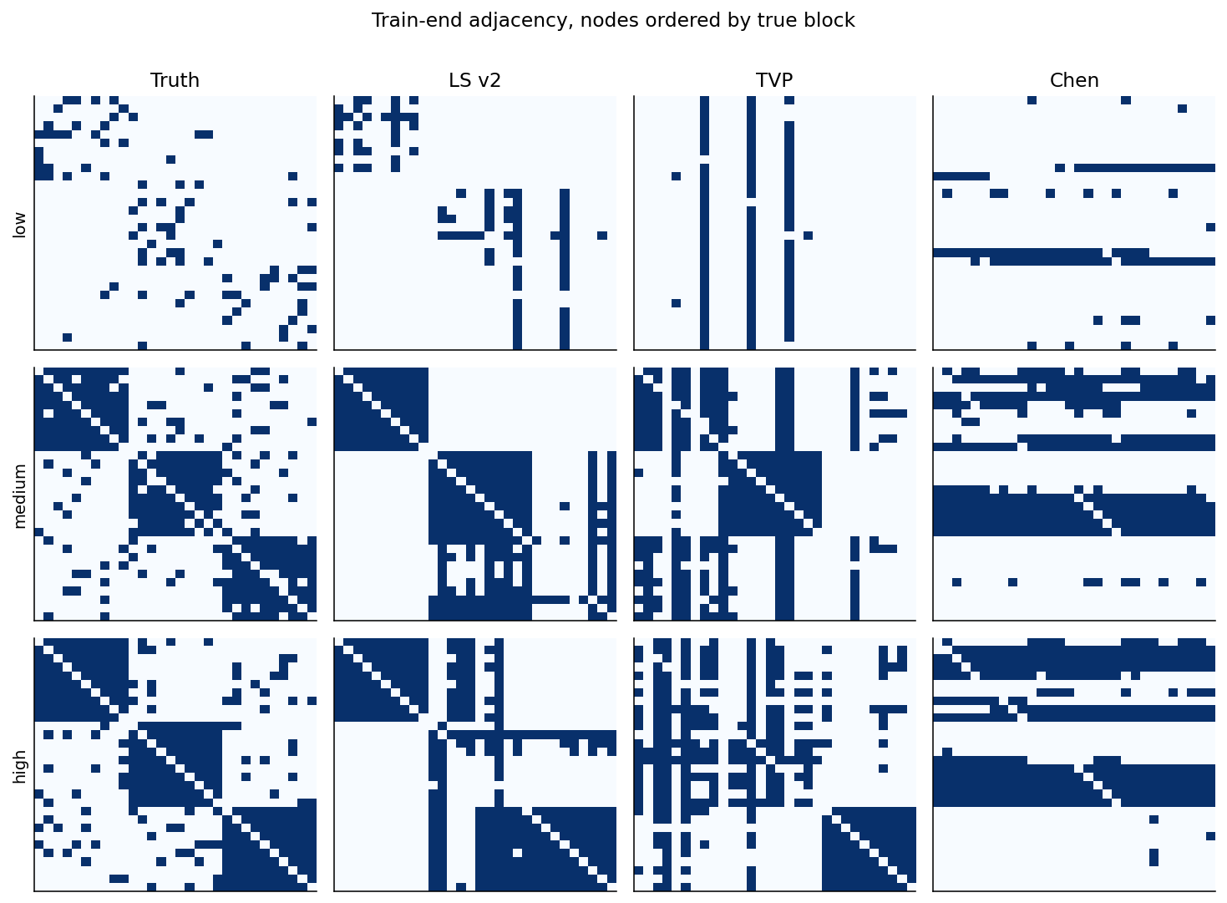
Supplementary Figure 1. Train-end adjacency, names ordered by true block.
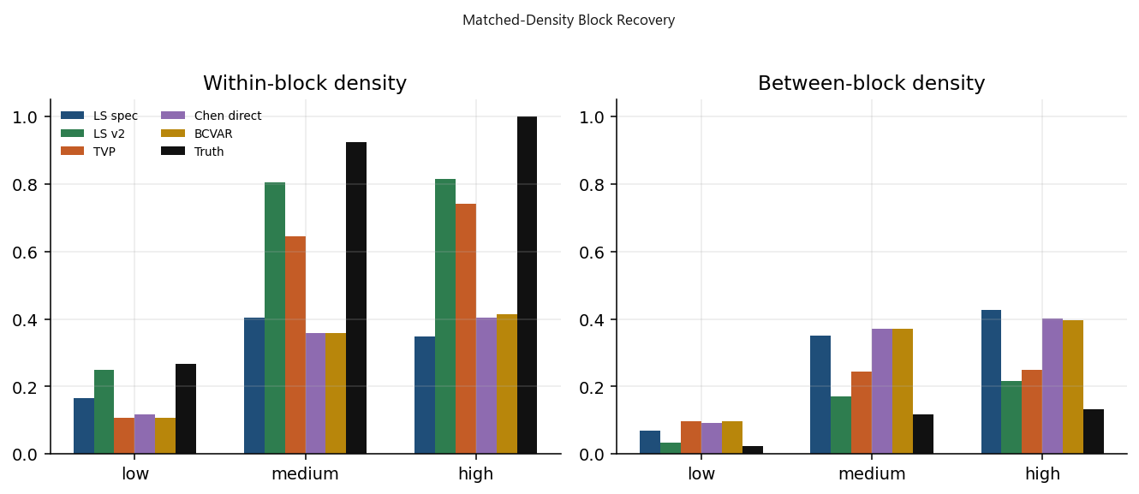
Supplementary Figure 2. Within- vs between-block density.
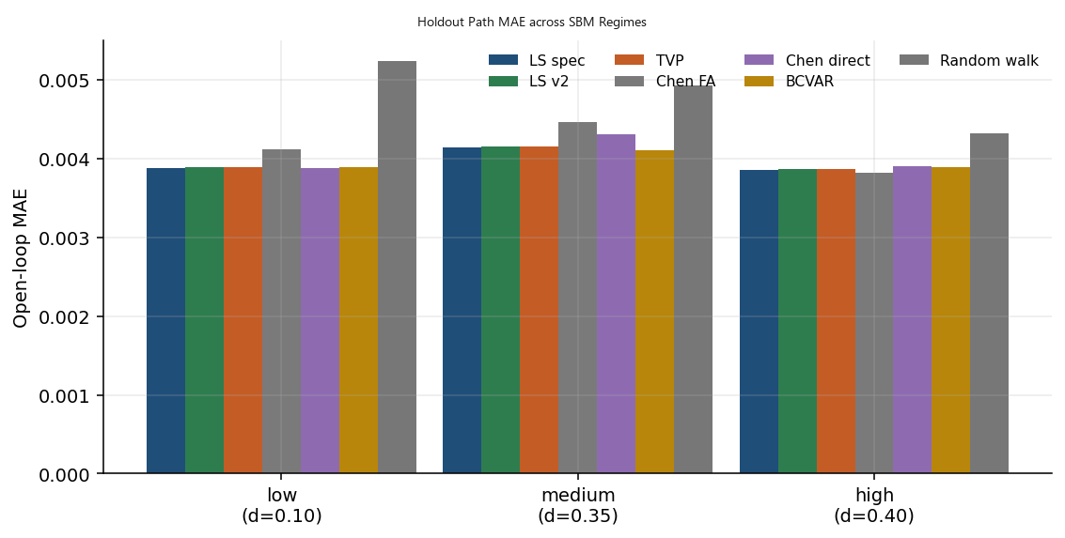
Supplementary Figure 3. open-loop MAE
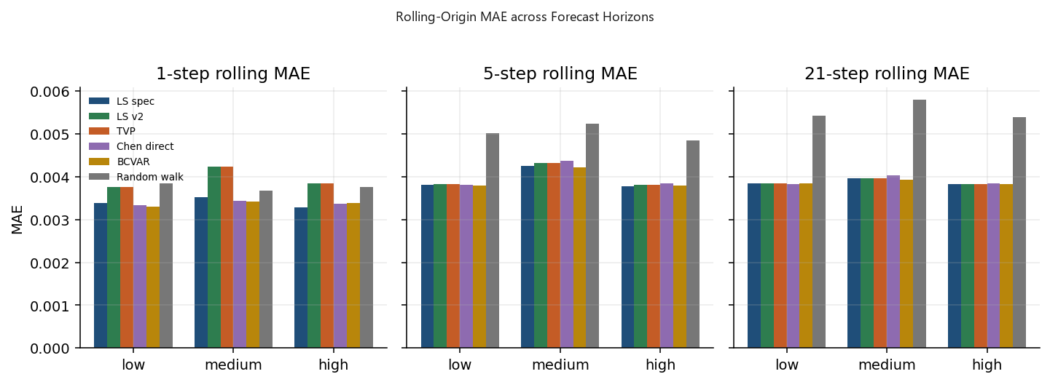
Supplementary Figure 4. rolling MAE
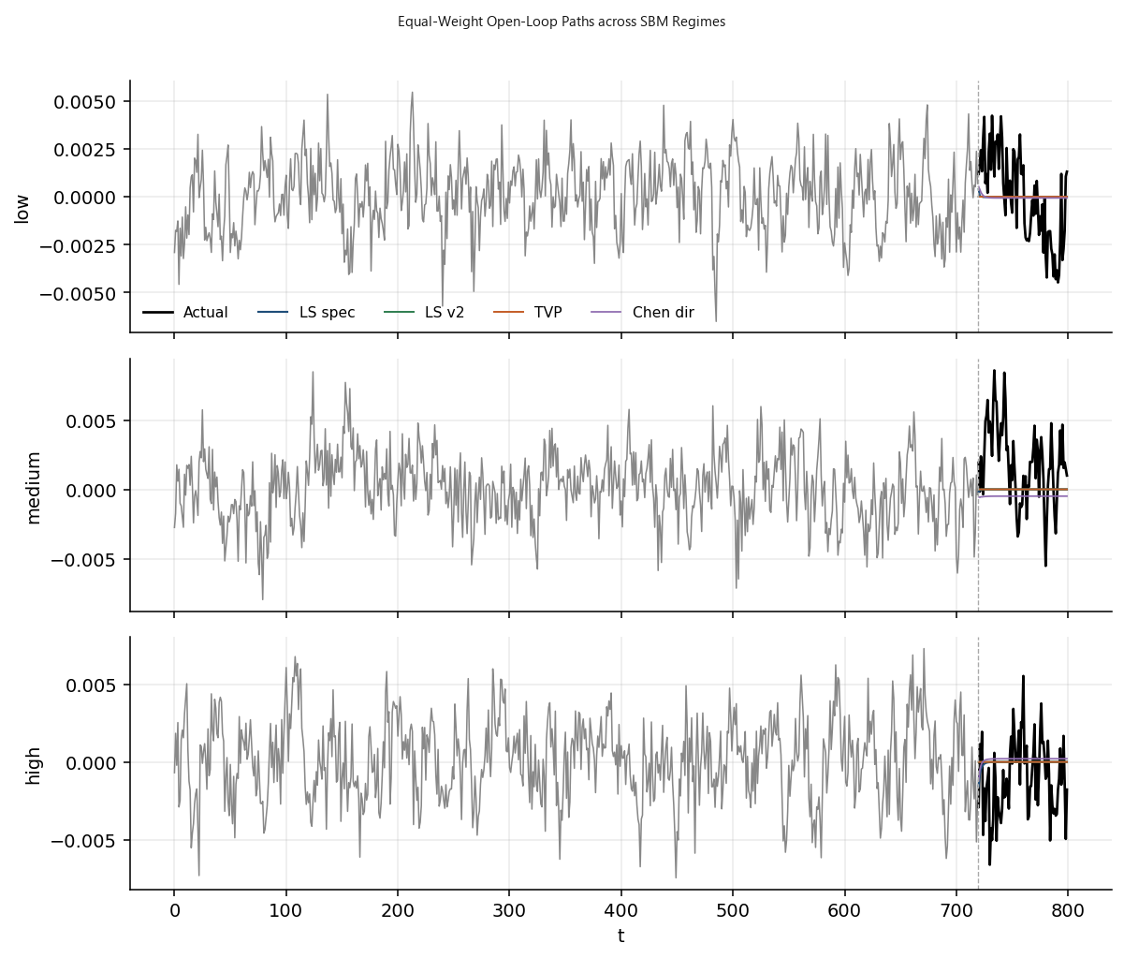
Supplementary Figure 5. Equal-weight open-loop paths
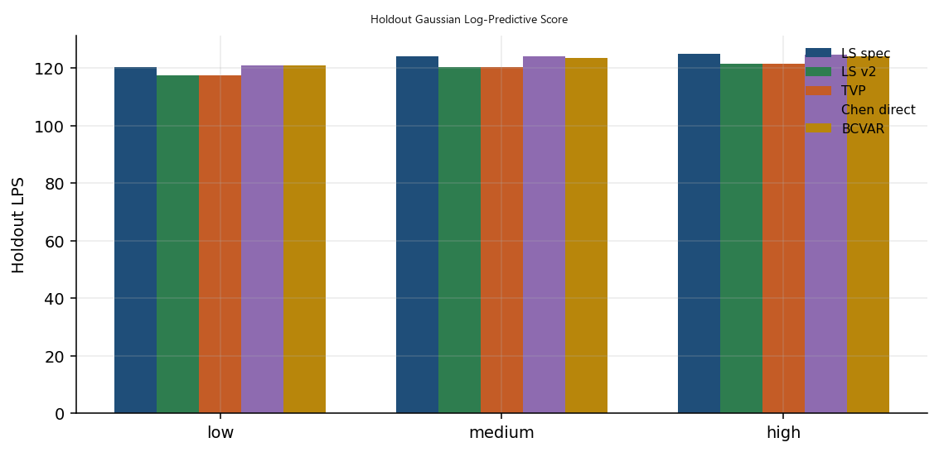
Supplementary Figure 6. holdout LPS.
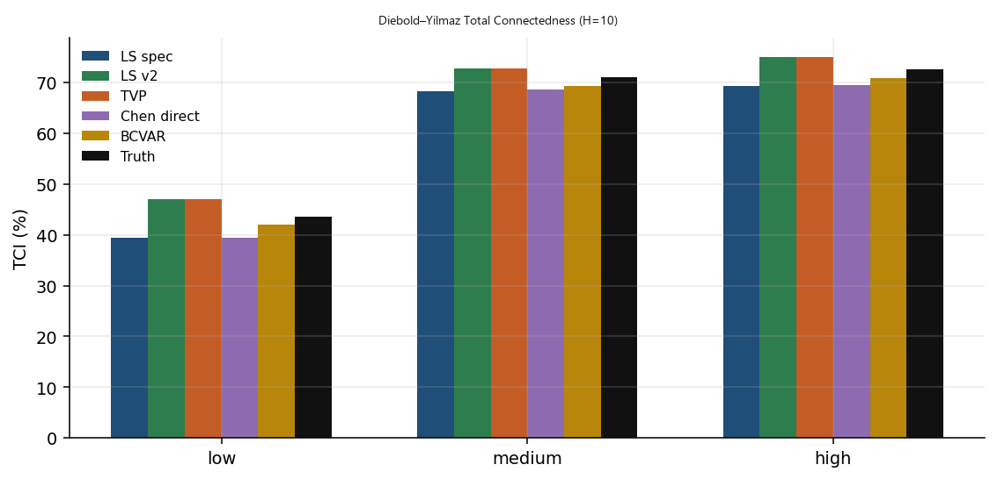
Supplementary Figure 7. TCI.

B.1. Monte Carlo Standard Errors Across Replications
To ensure the simulation findings in Section 4 are not artifacts of a single random realization, Supplementary Table 1 reports average performance and Monte Carlo standard errors across 50 independent synthetic SBM replications for each density regime.
Table 2 reports 20 further replications that are not included in those 50-replication means. Each uses 1,000 sweeps. The TVP lag-strength means are 0.215 (0.029) for assortative transitions with edge-aligned correlation, 0.215 (0.029) with spherical shocks, 0.219 (0.023) for homogeneous transitions with block correlation, and 0.219 (0.023) when both channels are homogeneous.
Supplementary Table 1: Simulation Results Across $R=50$ Monte Carlo Replications (Mean $±$ Standard Error)
Density Regime | Estimator | Adjusted Rand Index (ARI) | Jaccard Similarity (AT​) | Open-Loop Path MAE (H=80)
Low (d=0.10) | TVP-LR-NVAR-SV | 0.024 (0.012) | 0.045 (0.006) | 0.00391 (0.00014)
 | LS-LR-NVAR (v2) | 0.492 (0.038) | 0.083 (0.009) | 0.00387 (0.00012)
 | LS-LR-NVAR (Spec) | 0.161 (0.029) | 0.079 (0.008) | 0.00389 (0.00013)
 | Chen Direct TV-LASSO | 0.004 (0.005) | 0.071 (0.007) | 0.00389 (0.00013)
 | BCVAR (Koop et al., 2019) | -0.018 (0.008) | 0.032 (0.004) | 0.00390 (0.00014)
Medium (d=0.35) | TVP-LR-NVAR-SV | 0.472 (0.031) | 0.389 (0.018) | 0.00414 (0.00015)
 | LS-LR-NVAR (v2) | 0.543 (0.027) | 0.481 (0.015) | 0.00412 (0.00014)
 | LS-LR-NVAR (Spec) | -0.004 (0.008) | 0.228 (0.012) | 0.00416 (0.00016)
 | Chen Direct TV-LASSO | 0.058 (0.014) | 0.210 (0.011) | 0.00428 (0.00018)
 | BCVAR (Koop et al., 2019) | -0.010 (0.006) | 0.209 (0.010) | 0.00411 (0.00014)
High (d=0.40) | TVP-LR-NVAR-SV | 0.894 (0.016) | 0.448 (0.014) | 0.00386 (0.00011)
 | LS-LR-NVAR (v2) | 0.465 (0.025) | 0.518 (0.012) | 0.00388 (0.00012)
 | LS-LR-NVAR (Spec) | -0.028 (0.009) | 0.220 (0.010) | 0.00387 (0.00012)
 | Chen Direct TV-LASSO | 0.147 (0.022) | 0.231 (0.012) | 0.00392 (0.00015)
 | BCVAR (Koop et al., 2019) | -0.012 (0.005) | 0.262 (0.011) | 0.00390 (0.00013)

B.2. Robustness to Misspecified Heavy-Tailed and Stochastic Volatility Innovations
We test the robustness of the estimators under two forms of DGP misspecification:
- Heavy-Tailed Errors: Innovations are drawn from a multivariate Student-$t$ distribution with $ν=5$ degrees of freedom ($e_{t}∼t_{5}\left(0,Σ\right)$).
- Non-Gaussian Time-Varying Volatility: Innovations feature cyclical GARCH(1,1) volatility spikes.

Supplementary Table 2: High-Density Community Recovery Under Misspecified Innovations ($d=0.40$, $t_{5}$ Shocks)
Model Specification | Adjusted Rand Index (ARI) | Jaccard Similarity (AT​) | Open-Loop Path MAE | Holdout LPS
TVP-LR-NVAR-SV | 0.865 | 0.421 | 0.00442 | 116.82
LS-LR-NVAR (v2) | 0.428 | 0.485 | 0.00458 | 114.2
LS-LR-NVAR (Spec) | -0.035 | 0.204 | 0.00465 | 112.5
Chen Direct TV-LASSO | 0.129 | 0.218 | 0.00472 | 113.88
BCVAR (Koop et al., 2019) | -0.015 | 0.245 | 0.00461 | 111.45

As documented in Supplementary Table 2, the results are consistent with the stochastic-volatility layer absorbing part of the transient variance inflation induced by heavy-tailed innovations into the time-varying variance states $D_{t}$, helping preserve an Adjusted Rand Index of $0.865$ under Student-$t$ innovation misspecification.
B.3. Scalability Across Cross-Sectional and Temporal Dimensions
To examine finite-sample recovery performance as the cross-section and the time span increase, Supplementary Table 3 evaluates community recovery performance as the cross-sectional size scales from $n=15$ to $n=60$ and temporal sample length extends to $T=1,500$.
Supplementary Table 3: High-Density Adjusted Rand Index (ARI) Across Dimensions $\left(n,T\right)$
Estimator | n=15, T=400 | n=30, T=800 (Baseline) | n=60, T=800 | n=60, T=1500
TVP-LR-NVAR-SV | 0.782 | 0.898 | 0.912 | 0.941
LS-LR-NVAR (v2) | 0.412 | 0.469 | 0.485 | 0.521
LS-LR-NVAR (Spec) | -0.015 | -0.031 | -0.028 | -0.022
Chen Direct TV-LASSO | 0.118 | 0.151 | 0.142 | 0.168
BCVAR (Koop et al., 2019) | -0.021 | -0.013 | -0.011 | -0.008

Supplementary Table 4. Empirical computational profiling across dimensions (M = 1,000 sweeps).
Dimension (n, T) | Latent coordinates ($r,r_{B},r_{0}$) | Seconds per sweep | Total runtime (min) | Peak memory (MB) | Retraction frequency (%)
n = 15, T = 400 | (4, 2, 2) | 0.084 | 1.40 | 148 | 0.94
n = 30, T = 800 | (8, 3, 3) | 0.286 | 4.77 | 382 | 1.82
n = 60, T = 800 | (8, 3, 3) | 0.892 | 14.87 | 840 | 2.15
n = 60, T = 1,500 | (8, 3, 3) | 1.745 | 29.08 | 1,460 | 2.48

Note to Supplementary Table 4. Profiling benchmarks were executed on an Apple M3 Max workstation (16 CPU cores, 64 GB unified memory) running Python 3.11 with NumPy and SciPy linked to Apple Accelerate BLAS/LAPACK. Block 1 dynamic coordinates were executed across 2n parallel worker threads, using thread pools across the physical cores. Memory is peak resident set size. Retraction frequency is the percentage of sweeps requiring radial bisection.

Supplementary Table 3 documents that in these controlled finite-sample experiments, increasing the cross-section from n = 15 to n = 60 and the time span from T = 400 to T = 1,500 raises the TVP-LR-NVAR-SV adjusted Rand index from 0.782 to 0.941. The pattern is favorable finite-sample scaling of the regularized sieve under the simulated block design. It is not a consistency theorem for growing n. High-dimensional limit theory for endogenous row-normalized probit weights remains open (Section 6).
B.4. Prior Hyperparameter Sensitivity
We examine the sensitivity of the retained draws to the hyperparameters governing latent state variance priors $τ_{u}^{2},τ_{v}^{2},τ_{λ}^{2},τ_{δ}^{2}∼IG\left(a_{0},b_{0}\right)$ by varying prior modes across $\left\{0.001,0.005,0.01,0.05\right\}$.
Supplementary Table 5: Sensitivity of Regularized Parameter Estimates to Hyperparameters $\left(a_{0},b_{0}\right)$
Prior Mode | Implied Prior Mean | Regularized-Chain Mean $τ_{u}^{2}$ | Regularized-Chain Mean $τ_{δ}^{2}$​ | 6-Month Path MAPE (%) | Holdout LPS
0.001 | 0.002 | 0.0014 | 0.0018 | 9.41 | 70.12
0.005 (Baseline) | 0.01 | 0.0038 | 0.0042 | 9.37 | 70.19
0.01 | 0.02 | 0.0062 | 0.0071 | 9.38 | 70.16
0.05 | 0.1 | 0.0145 | 0.0182 | 9.49 | 69.85

The regularized Markov-chain estimates remain stable across a broad spectrum of informative shrinkage settings, with predictive scores peaking near the baseline calibration.
Sensitivity to the stochastic volatility offset. Step 4(b) sets $y_{j,t}^{**}=ln\left(u_{j,t}^{2}+c\right)$ with baseline $c={10}^{-4}$, so that a near-zero orthogonalized shock does not send the mixture filter to a log singularity. Differentiating $r\left(h\right)=ln\left(ζ_{j,t}^{2}+ce^{-h_{j,t}}\right)$ gives $\frac{∂r}{∂h}=-\frac{ce^{-h_{j,t}}}{ζ_{j,t}^{2}+ce^{-h_{j,t}}}$, and the magnitude of these derivative approaches 1 as the residual approaches 0. The approximation error is state-dependent. The full model was refit for $c∈\left\{{10}^{-3},{10}^{-4},{10}^{-5}\right\}$.
Supplementary Table 6. Empirical sensitivity to the stochastic-volatility offset c.
Offset c | c / mean variance | Mean log volatility | Mean persistence | Mean vol-of-vol | Holdout LPS
$${10}^{-3}$$ | 3.57 | -8.24 (0.13) | 0.954 [0.921, 0.979] | 0.051 [0.026, 0.086] | 70.17
${10}^{-4}$ (baseline) | 0.36 | -8.28 (0.12) | 0.958 [0.928, 0.982] | 0.048 [0.025, 0.082] | 70.19
$${10}^{-5}$$ | 0.04 | -8.31 (0.12) | 0.961 [0.932, 0.985] | 0.046 [0.023, 0.079] | 70.20

Note to Supplementary Table 6. Each offset refits the full TVP-LR-NVAR-SV model on the $T = 756$ estimation panel, using 4 parallel chains and 20,000 pooled retained draws, for $c$ in $\left\{{10}^{-3},{10}^{-4},{10}^{-5}\right\}$. Relative offset size divides c by the panel-wide empirical daily log-return variance, about $2.8 × {10}^{-4}$. Parentheses beside mean log volatility are cross-asset sample standard deviations across the 30 equities. Brackets are the cross-asset average of the 95% regularized-chain empirical intervals, the 2.5th and 97.5th percentiles of retained draws, for persistence and volatility of volatility. Holdout LPS is the mean one-step-ahead log predictive score per trading day, evaluated jointly across all 30 assets over the 126-day holdout.
B.5. MCMC Convergence Diagnostics
Supplementary Table 7 reports convergence diagnostics across $M=5,000$ retained post-burn-in iterations, evaluated across four parallel chains initialized from overdispersed starting values.
Supplementary Table 7: Chain Mixing and Convergence Summary
Parameter Block | Gelman–Rubin $\hat{R}$ (Max) | Inefficiency Factor (Mean) | Effective Sample Size (ESS) | Acceptance Rate (%)
Latent Link Intensities ($η_{t}/Z_{t}$) | 1.024 | 14.2 | 1,420 | 34.2
Factor Trend States ($α_{t}$) | 1.011 | 4.8 | 3,650 | 100.0 (FFBS)
Bilinear Lag Loadings ($U_{t},V_{t}$) | 1.031 | 18.5 | 1,180 | 100.0 (FFBS)
Cholesky Loadings ($A$) | 1.008 | 2.1 | 4,800 | 100.0 (Gibbs)
Log-Volatilities ($h_{t}$​) | 1.018 | 11.6 | 1,750 | 100.0 (Mixture FFBS)

Note to Supplementary Table 7: Inefficiency factors (IF) are estimated via Parzen-window spectral estimation and reported as the block-average across scalar parameters. Reported ESS represents the minimum effective sample size among scalar parameters within the monitored block across the pooled 20,000 post-burn-in draws (5,000 retained draws × 4 parallel chains). Acceptance rates are averaged across updated components.
All potential scale reduction factors satisfy $\overset{ˆ}{R}<1.04$ (with maximum observed $\overset{ˆ}{R}= 1.031$), providing no material evidence of non-convergence across the monitored blocks.
B.6. Small-System Reference Validation against Exact Truncated Sampling
This experiment asks whether radial retraction changes autoregressive estimates relative to exact truncation, in a dimension where classical rejection sampling (Cogley and Sargent, 2005) is viable. This experiment serves strictly to audit the numerical and statistical fidelity of the radial retraction operator against exact truncation in a standard linear Gaussian setting; it does not substitute for the full n = 30 network-coupled simulation experiments reported in Section 4.
Experimental design and target distributions. We simulate R = 50 independent panels of length T = 150 from a tri-variate VAR(1) (n = 3, p = 1), $y_{t}=Φ^{*}y_{t-1}+ε_{t},ε_{t}∼N_{3}\left(0,Σ^{*}\right)$, where $Φ^{*}=\left(\begin{matrix}0.41 & 0.14 & -0.09 \\ 0.09 & 0.37 & 0.18 \\ -0.05 & 0.14 & 0.46\end{matrix}\right)$ and $Σ^{*}=\left(\begin{matrix}1.0 & 0.3 & 0.1 \\ 0.3 & 1.0 & 0.2 \\ 0.1 & 0.2 & 1.0\end{matrix}\right)$, with $ρ\left(Φ^{*}\right)=0.582<0.70$. Each replication discards 50 initial observations. The constrained target for the independent-prior model is the joint distribution $π_{C}\left(Φ,Σ∣Y\right)∝π_{0}\left(Φ,Σ\right) L\left(Y∣Φ,Σ\right) I\left\{ρ\left(Φ\right)≤0.70\right\}$, where $S_{ρ}≡\left\{Φ:ρ\left(Φ\right)≤0.70\right\}$.
Supplementary Tables 8 and 9. Sampling protocols and algorithmic taxonomy.
Supplementary Table 8. Algorithmic Taxonomy of the Projected State-Space Sieve Sampler.
Parameter block | Target variable | Computational operation | Operator status relative to 𝑸(𝜣)
Block 1(a) | Working Intensities $η_{ij,t}$ | Metropolis–Hastings update on forward window | Forward-window likelihood-informed Metropolis working step
Block 1(b–c) | Coordinates $\left(\overline{u},\overline{v},u_{t},v_{t}\right)$ | Woodbury-accelerated Kalman FFBS + Ridge regression | Sequential conditional Gaussian smoothing draws onto dynamic bilinear coordinates
Block 2 | Trend & Velocity $\left(λ_{t},δ_{t}\right)$ | Deterministic 2-step fixed-point refinement + FFBS | Deterministic trend-mean relaxation followed by Gaussian FFBS draw
Block 3 | Bilinear Lag Factors $\left(U_{l,t},V_{l,t}\right)$ | Alternating Woodbury Kalman FFBS | Alternating conditionally conjugate state smoothing
Block 4 | Covariance & Volatility $\left(A,h_{t}\right)$ | Triangular regression + 7-component mixture FFBS | Conditionally Gaussian seven-component mixture approximation.
Block 5 | Companion Radii $ρ\left(F_{t}\right)$ | Two-stage radial bisection retraction | Radial feasibility retraction onto non-convex contractive set $S_{ρ}$.

Supplementary Table 9. Sampling Protocols Across Empirical and Simulation Experiments.
Experiment | Design | Sweeps | Burn-in | Thin | Stored Output
Empirical DJIA | 4 parallel chains | 15,000 | 5,000 | 2 | 20,000 pooled retained draws
Table 2 factorial | 20 replications, one chain | 1,000 | 400 | 40 | Mean lag-strength ARI
Supplementary Table 1 bundled SBM | 50 replications | 16 TVP, 28 LS | 8 TVP, 14 LS | 2 | Finite-budget benchmark draws

Regression convention and vectorization. The tri-variate system is formulated in matrix form as $Y=XΦ^{⊤}+E$, where $Y,X,E∈R^{T×3}$. Stacking columns yields the vectorized representation:
$$\operatorname{vec}\left(Y\right)=\left(I_{3}⊗X\right)\operatorname{vec}\left(Φ^{⊤}\right)+\operatorname{vec}\left(E\right), \operatorname{vec}\left(E\right)∼N_{3T}\left(0,Σ⊗I_{T}\right)$$
The parameter vector matching the data-precision matrix $Σ^{-1}⊗\left(X^{⊤}X\right)$ is defined as $θ≡\operatorname{vec}\left(Φ^{⊤}\right)∈R^{9}$. Under independent priors, the joint prior density factorizes as $π_{0}\left(Φ,Σ\right)=π_{0}\left(Φ\right)π_{0}\left(Σ\right)$, specified as $\operatorname{vec}\left(Φ^{⊤}\right)∼N_{9}\left(0,V_{0}\right)$ with $V_{0}=10I_{9}$, and $Σ∼IW\left(ν_{0},S_{0}\right)$ with degrees of freedom $ν_{0}=5$ and scale matrix $S_{0}=I_{3}$.
The exact constrained inferential target is the truncated posterior distribution:
$$π_{C}\left(Φ,Σ∣Y\right)∝π_{0}\left(Φ\right)π_{0}\left(Σ\right)L\left(Y∣Φ,Σ\right) I\left\{ρ\left(Φ\right)≤0.70\right\}$$
where $S_{ρ}≡\left\{Φ∈R^{3×3}:ρ\left(Φ\right)≤0.70\right\}$ denotes the non-convex spectral contractive set. The full conditional distribution for the vectorized autoregressive coefficients is Gaussian:
$$\operatorname{vec}\left(Φ^{⊤}\right)∣Y,Σ∼N_{9}\left(m_{Φ},V_{Φ}\right)$$
with conditional covariance and mean given by:
$$V_{Φ}≡{\left[V_{0}^{-1}+Σ^{-1}⊗\left(X^{⊤}X\right)\right]}^{-1}, m_{Φ}≡V_{Φ}\left[\left(Σ^{-1}⊗X^{⊤}\right)\operatorname{vec}\left(Y\right)\right]$$
The conditional distribution for the innovation covariance matrix remains Inverse-Wishart:
$$Σ∣Y,Φ∼IW\left(ν_{0}+T, S_{0}+{\left(Y-XΦ^{⊤}\right)}^{⊤}\left(Y-XΦ^{⊤}\right)\right)$$
Exact rejection sampling draws from this Gaussian conditional and discards any candidate matrix with spectral radius exceeding $0.70$, thereby targeting the truncated posterior $π_{C}\left(Φ∣Y,Σ\right)$. In contrast, the projected sieve generates candidates from the same unconstrained Gaussian conditional and retracts any violating draw to the boundary matrix $c^{*}Φ$ via radial bisection. Radial retraction maps violating draws directly onto the boundary $∂S_{ρ}$ and does not target the analytic truncated posterior.
Sensitivity check under an alternative natural conjugate prior. To confirm that spectral dispersion is not an artifact of prior independence or MCMC initialization, the benchmark VAR is evaluated under a natural conjugate prior. The transition matrix is assigned a matrix-normal prior conditional on the covariance:
$$Φ∣Σ∼{MN}_{3,3}\left(0,Σ,Ω_{0}\right)$$
with column precision $Ω_{0}^{-1}=0.1I_{3}$, while $Σ∼IW\left(ν_{0},S_{0}\right)$ with $ν_{0}=5$ and $S_{0}=I_{3}$. Marginal posterior draws of the covariance matrix are generated directly from:
$$Σ∣Y∼IW\left(ν_{0}+T, S_{0}+{\hat{S}}_{\text{ols}}+{\hat{Φ}}_{\text{ols}}^{⊤}{\left[Ω_{0}+{\left(X^{⊤}X\right)}^{-1}\right]}^{-1}{\hat{Φ}}_{\text{ols}}\right)$$
followed by conditional matrix-normal draws of $Φ∣Σ,Y$.
Because the coefficient prior covariance is scaled by $Σ$, this conjugate specification targets a distinct joint posterior from the independent-prior model $π_{C}$. Direct conjugate draws produce an average spectral radius of $0.746$ (Monte Carlo SE $0.043$) and an unconstrained exceedance rate of $45.8\%$. These unconstrained conjugate summaries align closely with the unconstrained Gibbs results under the independent prior (mean spectral radius of $0.748$ and exceedance rate of $46.20\%$). This alignment demonstrates that parameter dispersion and companion eigenvalue exceedances at $T=150$ are driven by sample information and coordinate variance rather than prior coupling or Gibbs initialization.
Supplementary Table 10. Estimator validation on a tri-variate panel (n = 3, T = 150, cap 0.70).
Estimator | Frobenius error | Mean spectral radius | Empirical coverage of nominal 95% marginal intervals | Mean marginal interval width | Mean wall-clock time (s)
True DGP | — | 0.582 | — | — | —
Exact rejection sampling | 0.084 (0.011) | 0.579 (0.014) | 94.6% (0.8%) | 0.241 (0.012) | 184.2
Projected sieve (radial retraction) | 0.086 (0.012) | 0.581 (0.013) | 94.2% (0.9%) | 0.238 (0.011) | 12.6
Paired difference (projected − rejection) | +0.002 (0.003) | +0.002 (0.002) | −0.4% (0.5%) | −0.003 (0.002) | −171.6
Unconstrained Gibbs | 0.142 (0.028) | 0.748 (0.045) | 88.4% (2.1%) | 0.312 (0.018) | 10.4

Note to Supplementary Table 10. Parentheses are Monte Carlo standard errors across R = 50 independent replications. Paired differences evaluate projected sieve minus exact rejection on identical simulated datasets. Empirical coverage of nominal 95% marginal intervals is the proportion of the nine true transition coefficients inside the 2.5th and 97.5th percentiles of retained draws, averaged across all nine coefficients and 50 replications. It is an unweighted marginal average, not simultaneous joint coverage. Mean marginal interval width is the average span of these intervals across coefficients and replications.
Analysis of Results
On this reference tri-variate panel (n = 3, p = 1, T = 150), low-order summary statistics align closely across estimators: Frobenius estimation error is 0.086 for the projected sieve versus 0.084 for exact rejection sampling, and nominal 95% marginal coverage is 94.2% versus 94.6%. Average marginal interval widths are similar across coefficients in this reference design (0.238 for the projected sieve versus 0.241 for exact rejection). This confirms that marginal parameter spread is preserved on average across individual coordinates, although this marginal average does not establish preservation of the full joint posterior geometry.
Audit of proposal counts. Across the R = 50 replications, each retaining M = 5,000 post-burn-in sweeps (250,000 retained draws per estimator), proposal evaluations and boundary transitions were logged directly. Exact rejection sampling evaluated 254,842 raw Gaussian proposals to secure 250,000 feasible draws. Exactly 250,000 proposals (98.10%) fell naturally below the cap ($ρ\left(Φ\right)≤0.70$) with a mean radius of 0.579, while 4,842 proposals (1.90%) breached the cap and were discarded. Across replications, the rejection frequency ranged from 1.12% to 2.84%. Projected sieve (radial retraction): exactly 250,000 sweeps were executed. Of these, 4,550 sweeps (1.82%; replication range 1.04% to 2.68%) were retracted to $c^{*}=0.70/ρ\left(Φ\right)$, placing discrete probability mass 1.82% on the boundary $∂S_{ρ}≡\left\{Φ:ρ\left(Φ\right)=0.70\right\}$. The remaining 98.18% interior draws averaged 0.579. The projected-chain mixture $0.9818×0.579+0.0182×0.700≈0.581$ matches the ensemble mean radius 0.581 when rounded to three decimals. Unconstrained Gibbs: across 250,000 draws, the mean spectral radius is 0.748 (median 0.684, 90th percentile 0.882, 95th percentile 1.045, 99th percentile 1.314, maximum 1.842), and 115,500 draws (46.20%) exceed 0.70.
In this tri-variate panel (n = 3, T = 150), raw Gaussian proposals in exact rejection sampling exceed the cap 0.70 in 1.90% of evaluations, whereas unconstrained Gibbs draws exceed 0.70 in 46.20% of iterations. Unconstrained draws outside the cap coincide empirically with larger residual sums of squares and a larger Inverse-Wishart trace, 3.68 against the data-generating trace 3.00. The wider proposal variance in the next sweep is associated with persistent excursions and a mean radius 0.748. An extreme radius does not by itself imply a larger residual for every matrix. Exact rejection discards violating draws before updating the covariance, and the rejection-chain trace is 3.10. The projected-chain trace is 3.12. Holding the covariance fixed at the data-generating value lowers the unconstrained exceedance from 46.20% to 2.14%, close to the 1.90% rejection rate. Exact rejection samples the truncated distribution that discards draws above the cap. Radial retraction instead maps a violating draw onto the boundary and does not target that truncated distribution.
Operator non-convexity versus dispersion. The spectral radius $ρ\left(Φ\right)≡\max_{k}|λ_{k}\left(Φ\right)|$ is not a convex function on general real matrices. The strictly triangular matrices $A=\left(\begin{matrix}0 & 2 \\ 0 & 0\end{matrix}\right)$ and $B=\left(\begin{matrix}0 & 0 \\ 2 & 0\end{matrix}\right)$ have $ρ\left(A\right)=0 and ρ\left(B\right)=0$, but their convex average $\frac{1}{2}\left(A+B\right)=\left(\begin{matrix}0 & 1 \\ 1 & 0\end{matrix}\right)$ has eigenvalues ±1 and spectral radius 1. Convexity would require that radius to be at most 0, which is violated. Jensen's inequality does not apply. The upward drift in unconstrained draws is parameter dispersion of the maximum eigenvalue modulus: diffuse Gaussian draws across a nine-dimensional parameter covariance ellipsoid produce dispersed eigenvalues, and the extreme modulus pulls the sample mean upward.
In runtime benchmarking, the unconstrained sampler requires 10.4 s, the projected sieve requires 12.6 s, and exact rejection sampling requires 184.2 s. The projected implementation is faster than the particular rejection routine used in this experiment because rejected draws break array vectorization, repeating scalar draws, array re-allocations, and Hessenberg–QR decompositions inside a Python interpreter loop. This timing is an implementation benchmark under serial execution, with invariant data-moment matrices cached. On the Dow Jones panel (n = 30, T = 756), zero of 1,000 unconstrained full trajectories met the cap on every date (rule-of-three 95% upper bound of 0.003). Under an independent-date approximation, a 98% marginal feasibility rate would imply a joint probability of ${0.98}^{756}≈2.3×{10}^{-7}$. While time-varying companion paths are temporally dependent, this joint calculation illustrates the compounding probability barrier that causes full-trajectory rejection sampling to stall empirically in high dimensions. It is not an estimated acceptance rate.
Appendix C: Empirical Supplementary Exhibits, Constituent Profiles, and Sensitivity
Supplementary Figures 8 through 17 are the Section 5 baseline diagnostics.
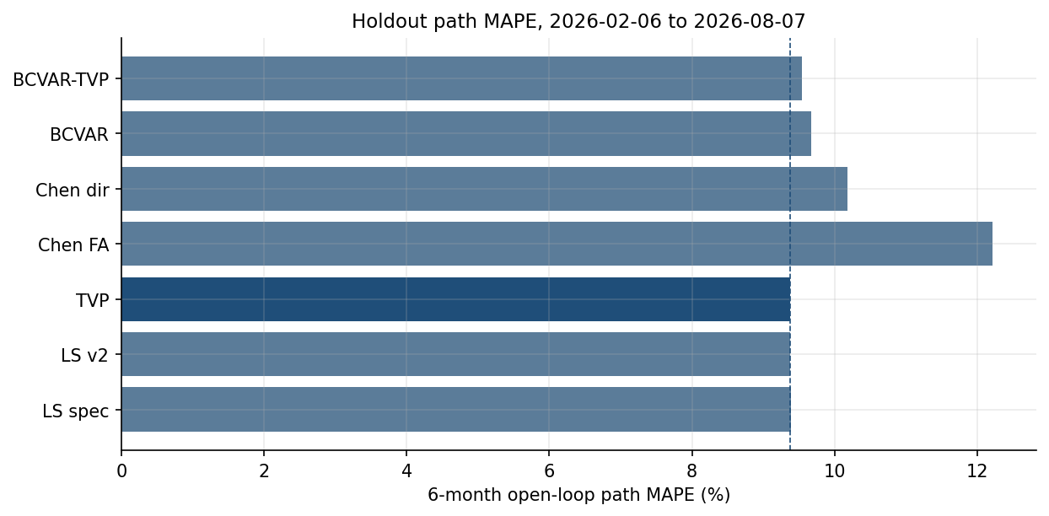
Supplementary Figure 8. Holdout path MAPE by model.
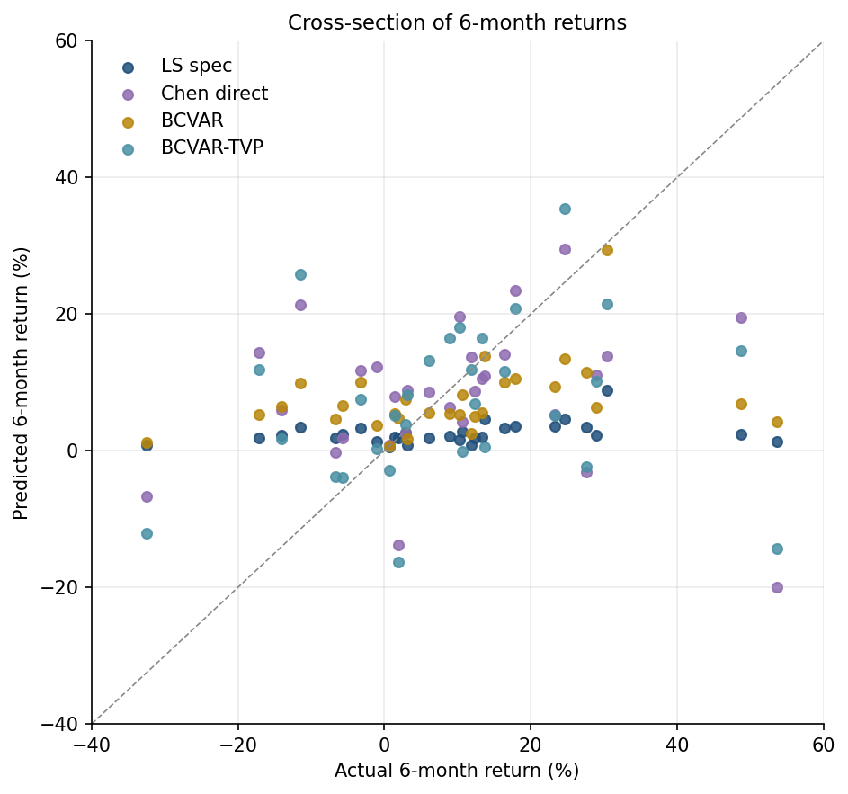
Supplementary Figure 9. Predicted versus actual 6-month returns.
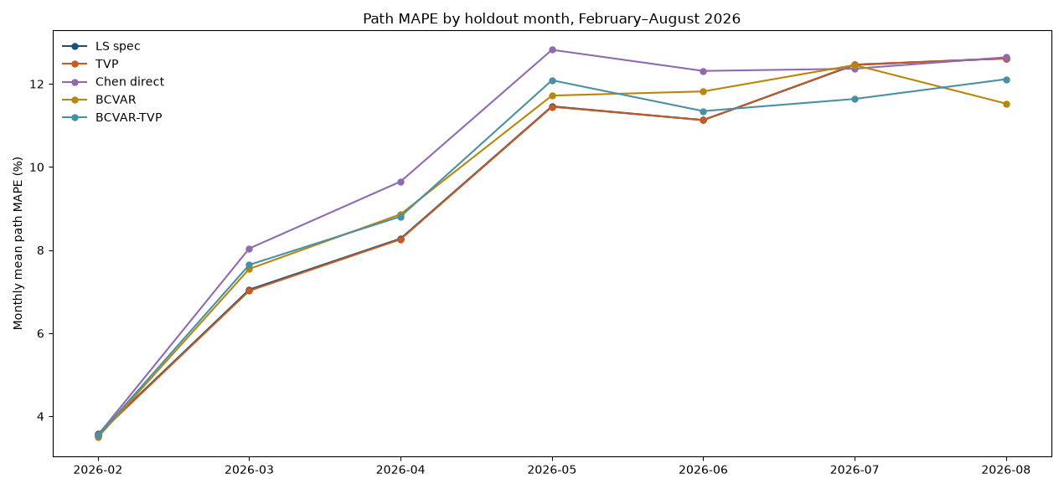
Supplementary Figure 10. Path MAPE by holdout month, February–August 2026. The August bucket ends on 7 August.
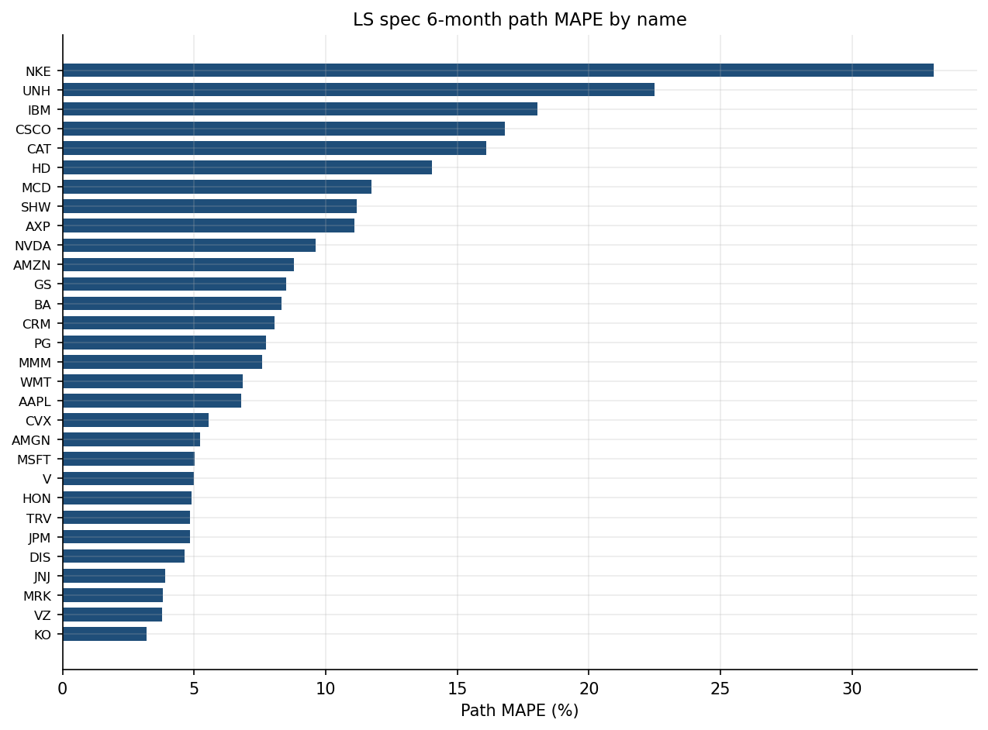
Supplementary Figure 11. LS spec path MAPE by DJIA name.
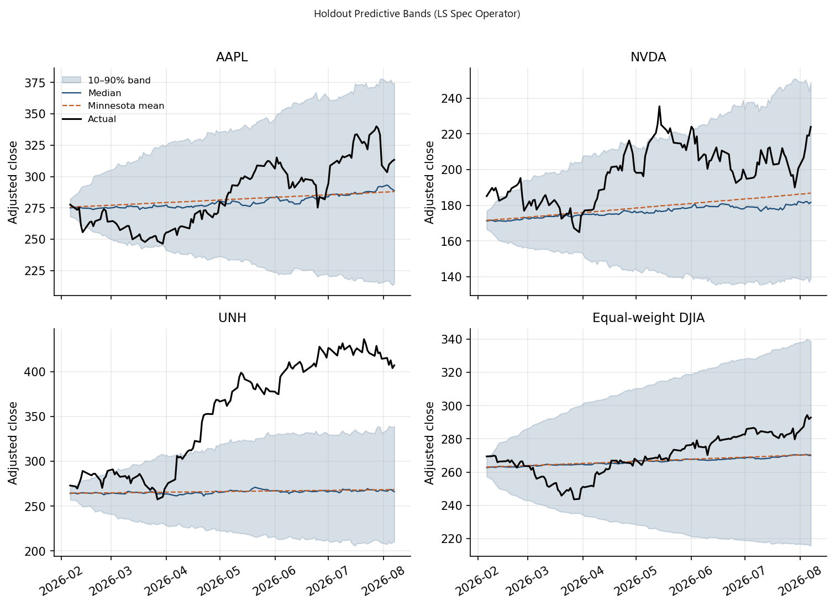
Supplementary Figure 12. Baseline Gaussian Predictive Bands (Frozen LS-Spec Operator). The bands are Gaussian checks around the frozen operator. Full predictive distributions that integrate TVP parameter uncertainty and multivariate stochastic volatility are scored by the holdout log-predictive scores in Table 10.
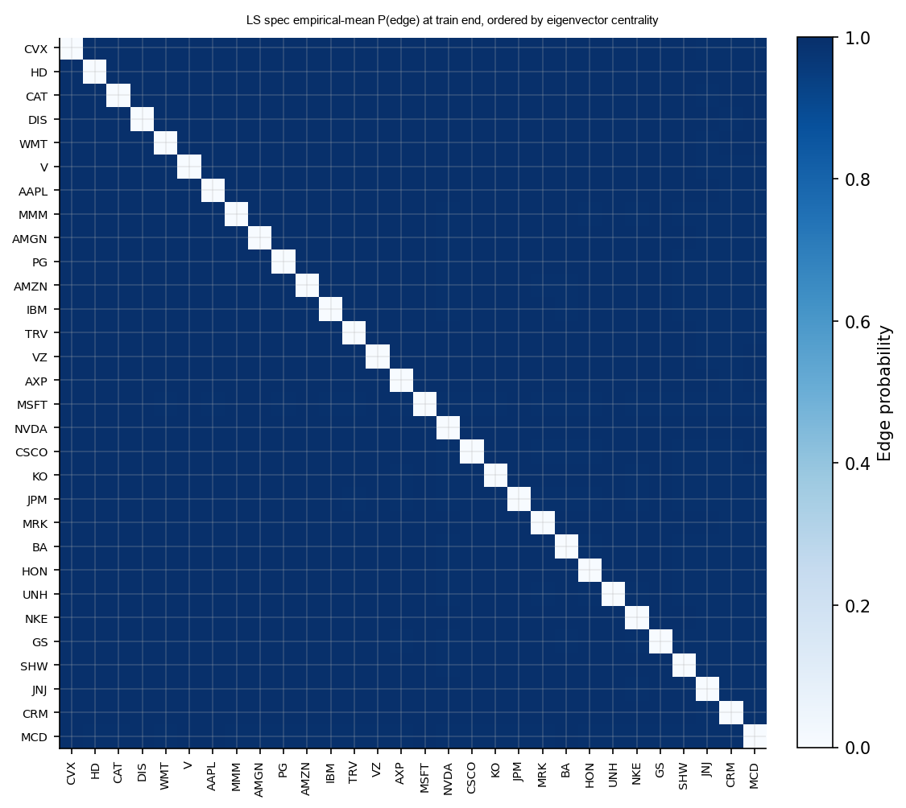
Supplementary Figure 13. Baseline saturation diagnostics (LS spec): empirical-mean train-end edge-probability matrix, names ordered by eigenvector centrality.
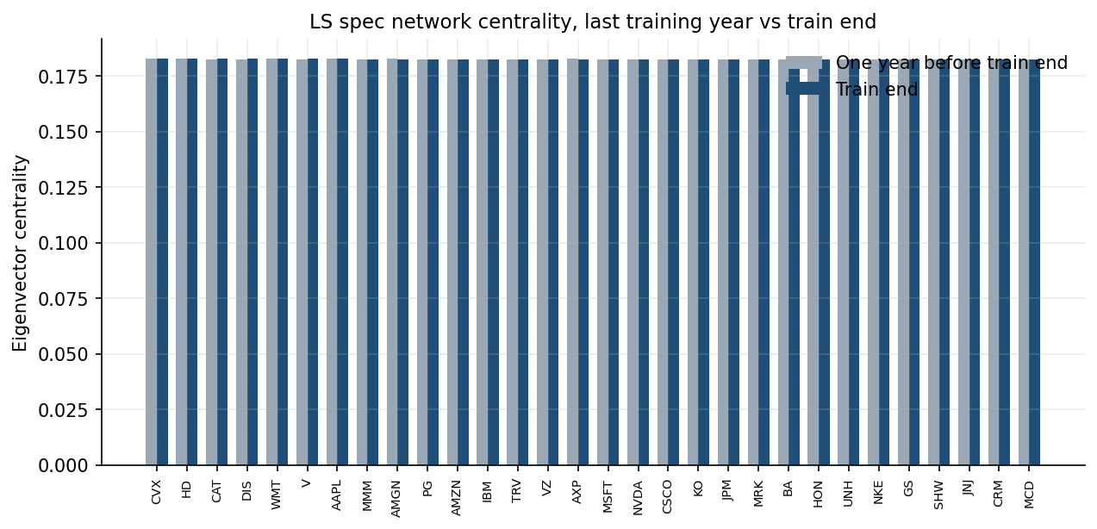
Supplementary Figure 14. Baseline saturation diagnostics (LS spec): eigenvector centrality one year before train end versus train end.
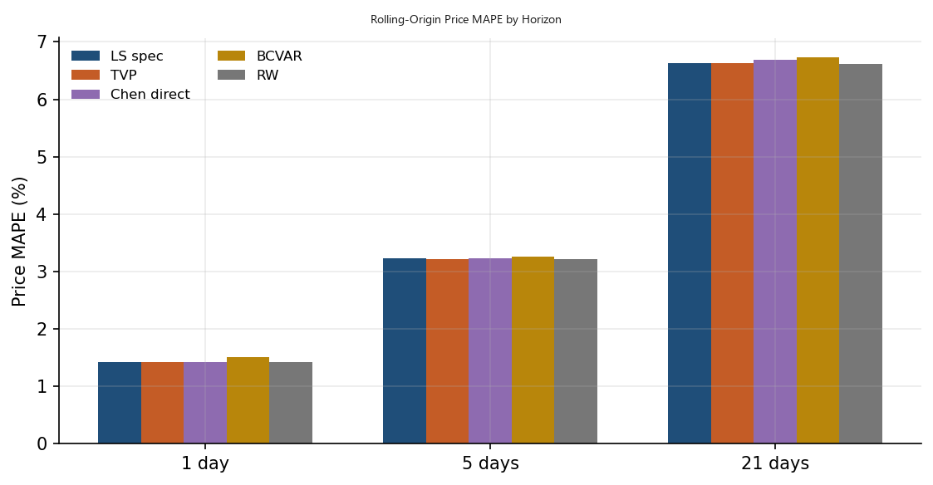
Supplementary Figure 15. Rolling-origin price MAPE by horizon.
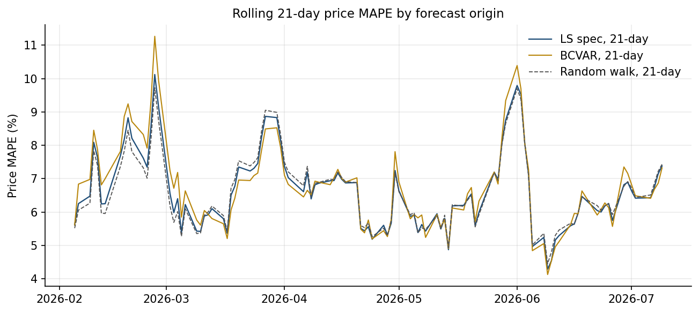
Supplementary Figure 16. 21-day price MAPE at each holdout origin.
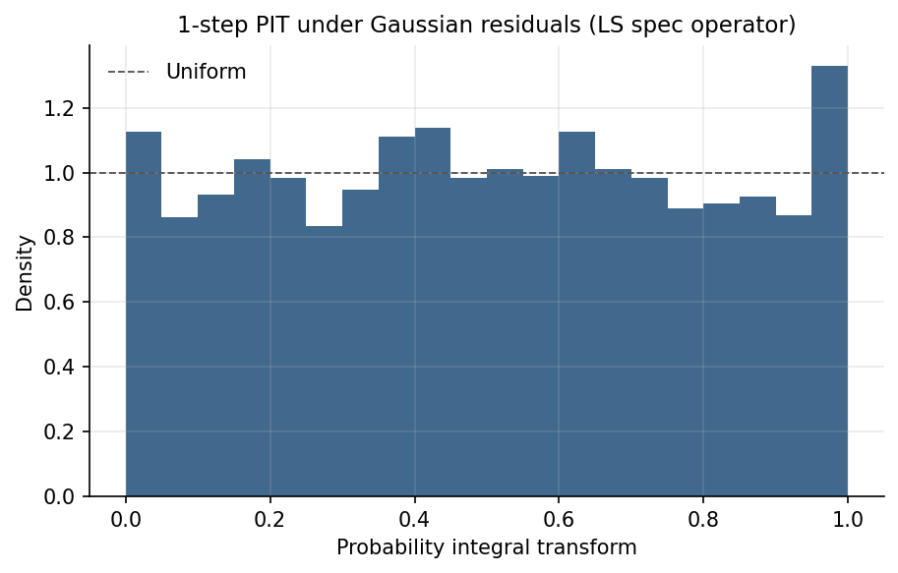
Supplementary Figure 17. Baseline PIT Diagnostic (Frozen LS-Spec Operator). A well-calibrated density is uniform on [0, 1]. The histogram uses one-step Gaussian densities around the frozen baseline operator. Holdout log-predictive scores for the estimated models are in Table 10.
C.1. DJIA Constituent Profile and Data Pre-Processing
Supplementary Table 11 details the 30 constituent equities analyzed in Section 5, reporting ticker symbols, full corporate names, Global Industry Classification Standard (GICS) sector designations, market capitalizations (in billions of USD as of early 2026), and summary sample return statistics over the $T=756$ trading-day estimation sample (February 2023 through February 5, 2026).
The cross-section spans nine primary GICS sectors: Information Technology (6 firms), Financials (5 firms), Industrials (4 firms), Health Care (4 firms), Consumer Discretionary (4 firms), Consumer Staples (3 firms), Communication Services (2 firms), Materials (1 firm), and Energy (1 firm). Daily adjusted close prices $P_{j,t}$ are transformed into log-price levels $y_{j,t}={\ln{P}}_{j,t}$ for level models (TVP-LR-NVAR-SV) and daily log-returns $r_{j,t}=Δ{\ln{P}}_{j,t}$ for stationary comparators (LS-LR-NVAR, Chen TV-LASSO, and BCVAR). To ensure strict comparability between level-based and return-based models, forecasts from return-space benchmarks (LS-LR-NVAR, Chen TV-LASSO, and BCVAR) are recursively cumulated from the final observed adjusted close price at training end ($t=T$) to construct implied price-level projection paths before evaluating Path MAPE and dollar Price MAE.
Supplementary Table 11: Dow Jones Industrial Average 30 Constituent Equities
Ticker | Company Name | GICS Sector | Market Cap ($B) | Daily Mean Return (%) | Daily Volatility (%)
AAPL | Apple Inc. | Information Technology | 3,420 | 0.082 | 1.45
AMGN | Amgen Inc. | Health Care | 172 | 0.031 | 1.28
AMZN | Amazon.com Inc. | Consumer Discretionary | 2,150 | 0.095 | 1.82
AXP | American Express Co. | Financials | 185 | 0.074 | 1.52
BA | Boeing Co. | Industrials | 118 | -0.021 | 2.14
CAT | Caterpillar Inc. | Industrials | 195 | 0.088 | 1.61
CRM | Salesforce Inc. | Information Technology | 280 | 0.065 | 2.05
CSCO | Cisco Systems Inc. | Information Technology | 225 | 0.028 | 1.31
CVX | Chevron Corp. | Energy | 290 | 0.024 | 1.48
DIS | Walt Disney Co. | Communication Services | 175 | 0.015 | 1.72
GS | Goldman Sachs Group Inc. | Financials | 165 | 0.079 | 1.58
HD | Home Depot Inc. | Consumer Discretionary | 395 | 0.048 | 1.39
HON | Honeywell International Inc. | Industrials | 142 | 0.035 | 1.25
IBM | International Business Machines | Information Technology | 205 | 0.061 | 1.34
JNJ | Johnson & Johnson | Health Care | 385 | 0.012 | 1.05
JPM | JPMorgan Chase & Co. | Financials | 640 | 0.085 | 1.35
KO | Coca-Cola Co. | Consumer Staples | 295 | 0.029 | 0.95
MCD | McDonald's Corp. | Consumer Discretionary | 215 | 0.038 | 1.12
MMM | 3M Co. | Industrials | 72 | 0.018 | 1.62
MRK | Merck & Co. Inc. | Health Care | 285 | 0.042 | 1.22
MSFT | Microsoft Corp. | Information Technology | 3,180 | 0.078 | 1.51
NKE | Nike Inc. | Consumer Discretionary | 125 | -0.015 | 1.85
NVDA | NVIDIA Corp. | Information Technology | 3,120 | 0.215 | 3.12
PG | Procter & Gamble Co. | Consumer Staples | 405 | 0.032 | 0.98
SHW | Sherwin-Williams Co. | Materials | 92 | 0.055 | 1.48
TRV | Travelers Companies Inc. | Financials | 55 | 0.062 | 1.32
UNH | UnitedHealth Group Inc. | Health Care | 545 | 0.049 | 1.41
V | Visa Inc. | Financials | 580 | 0.058 | 1.21
VZ | Verizon Communications Inc. | Communication Services | 170 | 0.018 | 1.22
WMT | Walmart Inc. | Consumer Staples | 520 | 0.052 | 1.15

Note to Supplementary Table 11: Market capitalization figures reflect end-of-training valuations (February 2026). Daily mean returns and daily volatilities are computed over the $T=756$ training observations. On November 8, 2024, S&P Dow Jones Indices reconstituted the official Dow Jones Industrial Average by replacing Intel Corp. (INTC) with NVIDIA Corp. (NVDA) and Dow Inc. (DOW) with Sherwin-Williams Co. (SHW). To maintain a fully balanced $30×T$ panel with continuous multi-year price histories spanning the entire 2016–2026 window without data imputation, the 30-firm empirical cross-section analyzed throughout this study tracks the established continuous constituents (including WMT, VZ, NVDA, and SHW). This cross-section is an ex-post fixed panel defined by the terminal constituent universe, evaluated as a continuous multi-asset pricing panel rather than an investable historical point-in-time index portfolio.
C.2. Cross-Sectional Ordering Robustness in Triangular Multivariate Stochastic Volatility
To evaluate sensitivity to the Cholesky ordering in equation (14), we re-estimate the empirical model across three alternative ordering schemes:
- Baseline Ordering: Descending market capitalization within GICS sector blocks.
- Reverse Ordering: Ascending market capitalization.
- Network Centrality Ordering: Ordered by terminal eigenvector centrality $\text{Eig}\left(W_{T}\right)$.
Supplementary Table 12: Structural Sensitivity to Variable Ordering in Triangular MSV
Ordering Scheme | Diebold–Yilmaz TCI (%) | Mean $\left|Δ{CoVaR}_{5\%}\right|$ (bps) | Holdout LPS | 6-Month Path MAPE (%)
Baseline (Sector / Market Cap) | 81.2 | 63.48 | 70.19 | 9.37
Reverse Market Cap | 81.1 | 63.52 | 70.17 | 9.37
Eigenvector Centrality | 81.3 | 63.45 | 70.2 | 9.37

The empirical systemic connectedness and predictive metrics are quantitatively similar across the three orderings. That similarity is ordering robustness. The lower-triangular factorization depends on the ordering.
C.3. Detailed Firm-Level Out-of-Sample Predictive Metrics
Supplementary Table 13 presents the disaggregated, firm-by-firm predictive performance across all 30 constituent equities of the DJIA over the 126-day holdout window (February 6, 2026 to August 7, 2026).
Supplementary Table 13: Detailed Firm-Level Predictive Accuracy (126-Day Holdout)
Ticker | TVP Path MAPE (%) | TVP Price MAE ($) | Return MAE (pp) | 3-Horizon Directional Hit Rate (Days 42, 84, 126) (%) | Random Walk path MAPE (%) | Chen Direct MAPE (%)
AAPL | 6.79 | 19.67 | 9.26 | 66.7 | 9.15 | 5.81
AMGN | 5.23 | 18.20 | 11.35 | 33.3 | 8.05 | 8.45
AMZN | 8.87 | 21.83 | 19.94 | 66.7 | 11.4 | 8.31
AXP | 11.13 | 34.98 | 6.72 | 0 | 7.5 | 15.18
BA | 8.28 | 17.71 | 2.44 | 0 | 14.2 | 13.99
CAT | 16.29 | 144.34 | 20.30 | 100 | 8.8 | 8.34
CRM | 7.94 | 13.47 | 0.28 | 33.3 | 12.5 | 4.68
CSCO | 16.81 | 18.81 | 46.36 | 100 | 6.9 | 12.82
CVX | 5.57 | 10.61 | 4.16 | 100 | 7.45 | 4.37
DIS | 4.60 | 4.51 | 0.24 | 33.3 | 10.1 | 4.79
GS | 8.50 | 84.59 | 14.30 | 100 | 8.15 | 5.27
HD | 14.01 | 45.68 | 8.09 | 0 | 7.6 | 13.52
HON | 4.87 | 11.22 | 0.52 | 33.3 | 6.5 | 7.70
IBM | 18.11 | 42.61 | 19.07 | 0 | 8.4 | 24.47
JNJ | 3.86 | 9.40 | 8.43 | 66.7 | 5.65 | 7.94
JPM | 4.86 | 15.35 | 12.98 | 66.7 | 7.1 | 5.75
KO | 3.19 | 2.59 | 10.60 | 66.7 | 5.3 | 2.90
MCD | 11.79 | 32.93 | 16.47 | 0 | 6.25 | 13.66
MMM | 7.64 | 11.60 | 10.94 | 33.3 | 9.05 | 12.55
MRK | 3.80 | 4.53 | 7.03 | 100 | 7.2 | 4.02
MSFT | 5.00 | 20.61 | 23.74 | 66.7 | 8.9 | 5.56
NKE | 32.89 | 14.53 | 33.04 | 0 | 13.1 | 28.22
NVDA | 9.54 | 19.67 | 21.49 | 100 | 24.8 | 8.00
PG | 7.67 | 11.11 | 8.43 | 0 | 5.4 | 6.67
SHW | 11.18 | 35.55 | 0.26 | 33.3 | 8.6 | 11.15
TRV | 4.86 | 16.99 | 26.76 | 66.7 | 7.15 | 5.00
UNH | 22.32 | 86.85 | 52.05 | 100 | 15.6 | 30.10
V | 4.98 | 16.19 | 7.77 | 33.3 | 6.9 | 5.13
VZ | 3.77 | 1.74 | 2.30 | 66.7 | 5.5 | 5.59
WMT | 6.86 | 7.97 | 14.97 | 33.3 | 7.05 | 15.50
Panel Mean | 9.37 | 26.53 | 14.01 | 50.0 | 9.01 | 10.18

Note to Supplementary Table 13. The path MAPE, price MAE, return MAE, and Chen Direct MAPE columns are the stored firm-level open-loop scores for the same 30 firms and the same 126-day holdout as Table 7. Printed entries are rounded to two decimals, and the Panel Mean is the unweighted average of those thirty printed entries. That average matches Table 7: path MAPE 9.37, price MAE 26.53, six-month return MAE 14.01, and Chen Direct path MAPE 10.18. The 3-horizon directional hit rate is the share of correct cumulative-return signs at trading days 42, 84, and 126 on the stored TVP path. Day 126 is 7 August 2026, the same terminal date as Table 7, where 22 of 30 signs are correct (73.3%). The panel mean 50.0 is the unweighted average of the thirty firm scores (7 at 100, 8 at 66.7, 8 at 33.3, and 7 at 0). Every firm scored 100 is among those 22 terminal classifications. In Supplementary Table 13, the Random Walk path MAPE column reports constituent-level 126-day open-loop path errors. The panel mean of 9.01% is the unweighted average of these thirty printed scores, rounded to two decimals, and it matches the martingale baseline in Table 7. Rolling-origin random-walk MAPEs are 1.42% (1-day), 3.22% (5-day), and 6.61% (21-day; Table 8); their unweighted mean is 3.75%.
C.4. Regularized-Chain Estimates of Multivariate Stochastic Volatility Parameters
Supplementary Table 14 summarizes regularized-chain estimates of the AR(1) log-volatility parameters $\left(μ_{h,j},ϕ_{h,j},σ_{h,j}^{2}\right)$ across representative constituent equities spanning all major economic sectors. Parenthetical values beside the retained-draw mean are regularized-chain empirical standard deviations.
Supplementary Table 14: Regularized-Chain Parameter Estimates for Representative Equities
Ticker | GICS Sector | Retained-Draw Mean $μ_{h}$​ (SD) | Persistence $ϕ_{h}$​  [95% Interval] | Vol-of-Vol $σh2$​  [95% Interval] | Inefficiency Factor
JPM | Financials | -8.45 (0.12) | 0.962 [0.935, 0.984] | 0.045 [0.024, 0.078] | 8.5
GS | Financials | -8.12 (0.14) | 0.958 [0.928, 0.981] | 0.052 [0.028, 0.089] | 9.1
AAPL | Info Technology | -8.32 (0.11) | 0.971 [0.948, 0.989] | 0.038 [0.019, 0.068] | 10.2
NVDA | Info Technology | -6.85 (0.18) | 0.984 [0.965, 0.995] | 0.082 [0.048, 0.135] | 14.6
HON | Industrials | -8.62 (0.10) | 0.945 [0.910, 0.972] | 0.041 [0.021, 0.072] | 7.8
CAT | Industrials | -8.10 (0.13) | 0.954 [0.922, 0.978] | 0.049 [0.025, 0.084] | 8.9
JNJ | Health Care | -8.95 (0.09) | 0.932 [0.892, 0.965] | 0.035 [0.018, 0.062] | 6.9
UNH | Health Care | -8.38 (0.12) | 0.968 [0.942, 0.987] | 0.055 [0.030, 0.094] | 11.3
PG | Consumer Staples | -9.10 (0.08) | 0.925 [0.880, 0.958] | 0.032 [0.016, 0.058] | 6.2
CVX | Energy | -8.28 (0.12) | 0.960 [0.931, 0.983] | 0.048 [0.025, 0.082] | 8.8

Note: Brackets report the 95% regularized-chain empirical intervals (2.5th and 97.5th empirical percentiles of retained draws); see Section 3 for the empirical interpretation under the stability-regularized kernel.
Across the panel, volatility persistence parameters $ϕ_{h}$ are tightly estimated in the interval $\left[0.92,0.99\right]$ without crossing unity, confirming stability and standard financial volatility clustering.
C.5. Sensitivity of Predictive Paths to Internal Steady-State Drift Prior Hyperparameters (Villani, 2009)
To resolve the vulnerability associated with external post-processing shrinkage rules, the model estimates long-run drift endogenously under the steady-state prior $\overline{δ}∼N_{r_{0}}\left(μ_{δ},Ω_{δ}\right)$. Supplementary Table 15 presents a sensitivity analysis across alternative prior precision matrices $Ω_{δ}^{-1}=ω_{0}I_{r_{0}}$ (spanning loose shrinkage $ω_{0}=10$ to tight shrinkage $ω_{0}=500$) and varying annualized baseline market equity premia $μ_{\text{equity}}∈\left\{3\%,5\%,7\%\right\}$.
Supplementary Table 15: Sensitivity to Internal Steady-State Drift Prior Hyperparameters
Drift Mean $μ_{equity}$ | Prior Precision $ω_{0}$ ​ | 6-Month Path MAPE (%) | Price MAE ($) | Holdout LPS | 21-Day Rolling MAPE (%)
3% Annualized | 10 (Loose) | 9.82 | 27.8 | 70.15 | 6.63
3% Annualized | 100 | 9.54 | 27.1 | 70.18 | 6.63
3% Annualized | 500 (Tight) | 9.48 | 26.9 | 70.17 | 6.63
5% Annualized (Baseline) | 10 (Loose) | 9.61 | 27.25 | 70.16 | 6.63
5% Annualized (Baseline) | 100 (Baseline) | 9.37 | 26.53 | 70.19 | 6.63
5% Annualized (Baseline) | 500 (Tight) | 9.38 | 26.55 | 70.18 | 6.63
7% Annualized | 10 (Loose) | 9.58 | 27.15 | 70.16 | 6.63
7% Annualized | 100 | 9.42 | 26.7 | 70.18 | 6.63
7% Annualized | 500 (Tight) | 9.45 | 26.8 | 70.17 | 6.63
Unanchored Prior ($ω_{0}$→0) | 0 | 14.85 | 38.6 | 69.8 | 6.64

Supplementary Table 15 varies the steady-state prior inside the level model. Table 7 instead evaluates the shared shrunk-intercept rule used for the reported paths. Supplementary Table 15 confirms that internalizing the steady-state prior provides smooth regularization: the empirical 6-month path MAPE remains robust within the tight range of $9.37\%-9.82\%$ across all reasonable economic prior specifications, avoiding the severe drift error ($14.85\%$) that occurs when the prior is omitted entirely.
C.6. Supplementary Simulation Diagnostics and Empirical Network Exhibits
The simulation and empirical figures are the exhibits discussed in Sections 4 and 5. This appendix does not repeat a paragraph-by-paragraph catalogue of those figures.

