Instructions TP10
You are now participating in an economic experiment funded by various research support foundations.
Please read the following instructions carefully. The instructions will provide you with all the information you require for participation in the experiment. Please ask for assistance if there is something that you do not understand. Your question will be answered at your workplace. There is a strict prohibition of communication during the experiment.
You will receive an initial endowment of 5 dollars at the beginning of the experiment. You can earn additional money over the course of the experiment by collecting points. All of the points that you accrue over the course of the experiment will be converted to dollars at the end of the experiment. Please note that:

1 point = 20 cents

At the end of the experiment, you will receive the income you earned over the course of the experiment plus the 5 dollars of initial endowment in cash.

The experiment
In this experiment, any participant can be randomly assigned to the role of participant A, participant B, or participant C. Each participant A is associated with a participant B in a group of two. Participant C is matched with a group composed of a participant A and a participant B. No participant knows with whom they are associated so all decisions are made anonymously.

Participant A's decision:
- Participant A receives 120 points at the beginning of the experiment.
- Participant B receives no points.
- Participant A can decide how many points to transfer to participant B.
- The experimenter doubles each point A transfers to B.
- So each point which A transfers to B reduces A's income by one point and increases B's income by two points.
- The formula for calculating income is as follows:

Participant A's income: 120 – transfer

Participant B's income: 0 + 2*transfer

The following examples will clarify the income formulas:
- Example 1: A transfers 0 points to B. The incomes are then 120 for A and 0 for B.
- Example 2: A transfers 20 points to B. The incomes are then 100 for A and 40 for B.
- Example 3: A transfers 80 points to B. The incomes are then 40 for A and 160 for B.

The experiment consists of two stages:
Stage 1:
- In stage 1, C decides if they will constrain A to transfer at least 10 points to B, or if they will allow A to decide freely.

Stage 2:
- In stage 2, A decides how many points they will transfer to B. The number lies between 10 and 120 if C constrains A to transfer at least 10 points, or between 0 and 120 if C does not constrain A to transfer at least 10 points.
- Participant A must decide how many points they will transfer to B before they know whether or not C will constrain A to transfer at least 10 points.

Participant B's decision:
- Participant B plays a passive role during the experiment.
- This means that participant B will not make any direct decision during the experiment.

Participant C's decision:
- Participant C acts as a third party in the relationship between A and B.
- Before participant A decides how many points they wish to transfer to B, participant C can determine a minimum transfer.
- C can constrain participant A to transfer B at least 10 points.
- C can also decide not to limit participant A and thus leave A’s transfer decision completely free.
- The income of participant C is completely independent of both their own decision and participant A's decision regarding how many points transfer to B.
- Participant C will only be paid the initial endowment of 5 dollars.

There are two cases:
Case 1: Participant C constrains participant A to transfer at least 10 points to participant B. In this case, participant A can transfer any number of points between 10 and 120 to B.
Case 2: Participant C allows participant A to decide on their transfer freely and does not constrain A to transfer at least 10 points to participant B. In this case, participant A can transfer any number of points between 0 and 120 to B.

- C makes their decision with the help of the following screen:
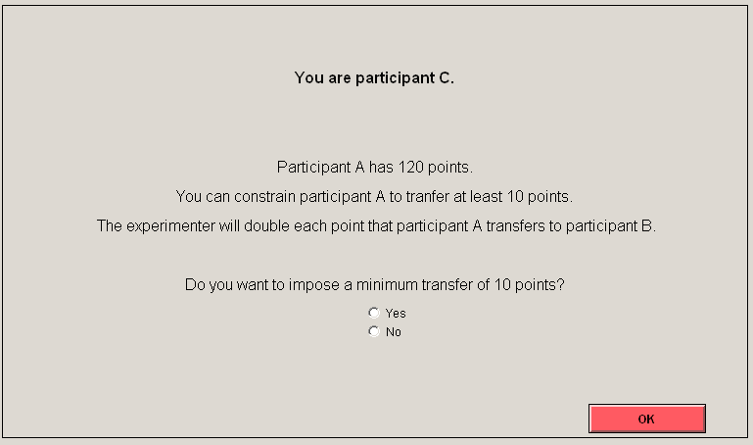

- Participant A must decide how many points they will transfer to B before knowing whether or not C will constrain A to transfer at least 10 points to B.
- This means that participant A must make two decisions (Case 1 and Case 2).
- Participant A makes their entries with the help of this screen:

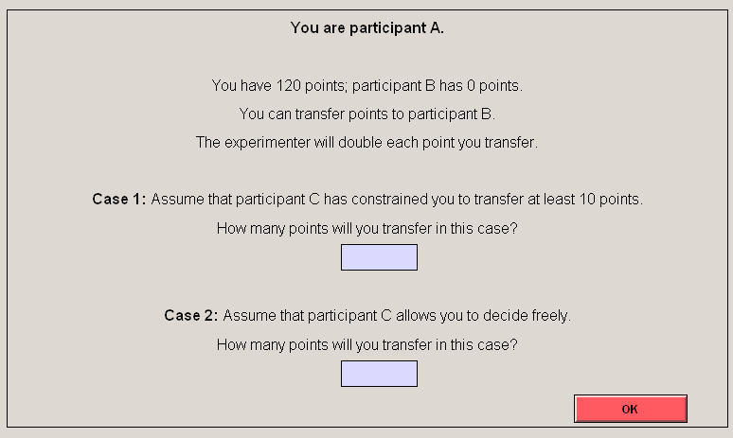
- Therefore, participant A indicates how many points they transfer to B when C constrains A to transfer at least 10 points (Case 1) and how many points they transfer to B when A is free to decide (Case 2).
- Which of the decisions is relevant for participant A depends on what C decides.
- If C constrains A to transfer at least 10 points, the decision A indicates under case 1 applies.
- If C leaves A to choose freely, the number of points A indicates under case 2 applies.

After decisions have been made:
- The experiment is completed as soon as A has decided how many points they transfer to B.
- After the decisions have been made, the participants answer a questionnaire.
- A final income screen will inform you of the decisions and the resulting incomes.
- Your point income will be converted to dollars and paid out in cash to you together with your initial endowment.

Do you have any questions?

