OPTIMIZELY
Behavioral Targeting and Intelligence: how it works and where it runs
For solutions engineers
Prepared for | Solutions engineers
Prepared by | Optimizely
Version | 3.0
Date | October 3, 2026
Classification | Internal: Optimizely only

Contents
What we built
How it differs from recommendations and from personalization, and why
Both engines on one page
Now watch it: one visitor, one click
Then go through it, one moment at a time
Customers choose it for different reasons
One visitor's first click becomes the slot's answer in five steps
Six quantities carry the mechanism, and each one can be worked by hand
Learning waits behind the dial, and every decision keeps a receipt
It runs at the edge, and every setting is a published document
The site connects once, and privacy holds on every request
Every ask says what we need and what we use it for
The interactive page puts every constant on a slider

For solutions engineers. The story first and why customers choose it, then one visitor walked through, the arithmetic as worked examples, learning and the receipt, where the engine runs and how it is configured, integration and privacy, and what a customer provides.

What we built
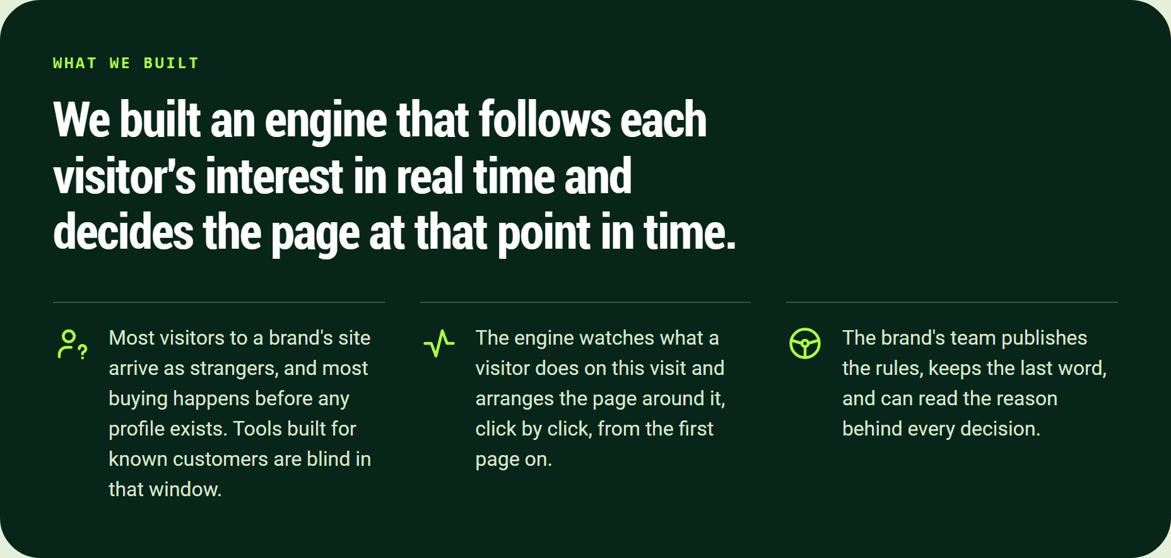
We built an engine that follows each visitor's interest in real time and decides the page at that point in time.
We built an engine that follows each visitor's interest in real time and decides the page at that point in time.
- Most visitors to a brand's site arrive as strangers, and most buying happens before any profile exists. Tools built for known customers are blind in that window.
- The engine watches what a visitor does on this visit and arranges the page around it, click by click, from the first page on.
- The brand's team publishes the rules, keeps the last word, and can read the reason behind every decision.

How it differs from recommendations and from personalization, and why
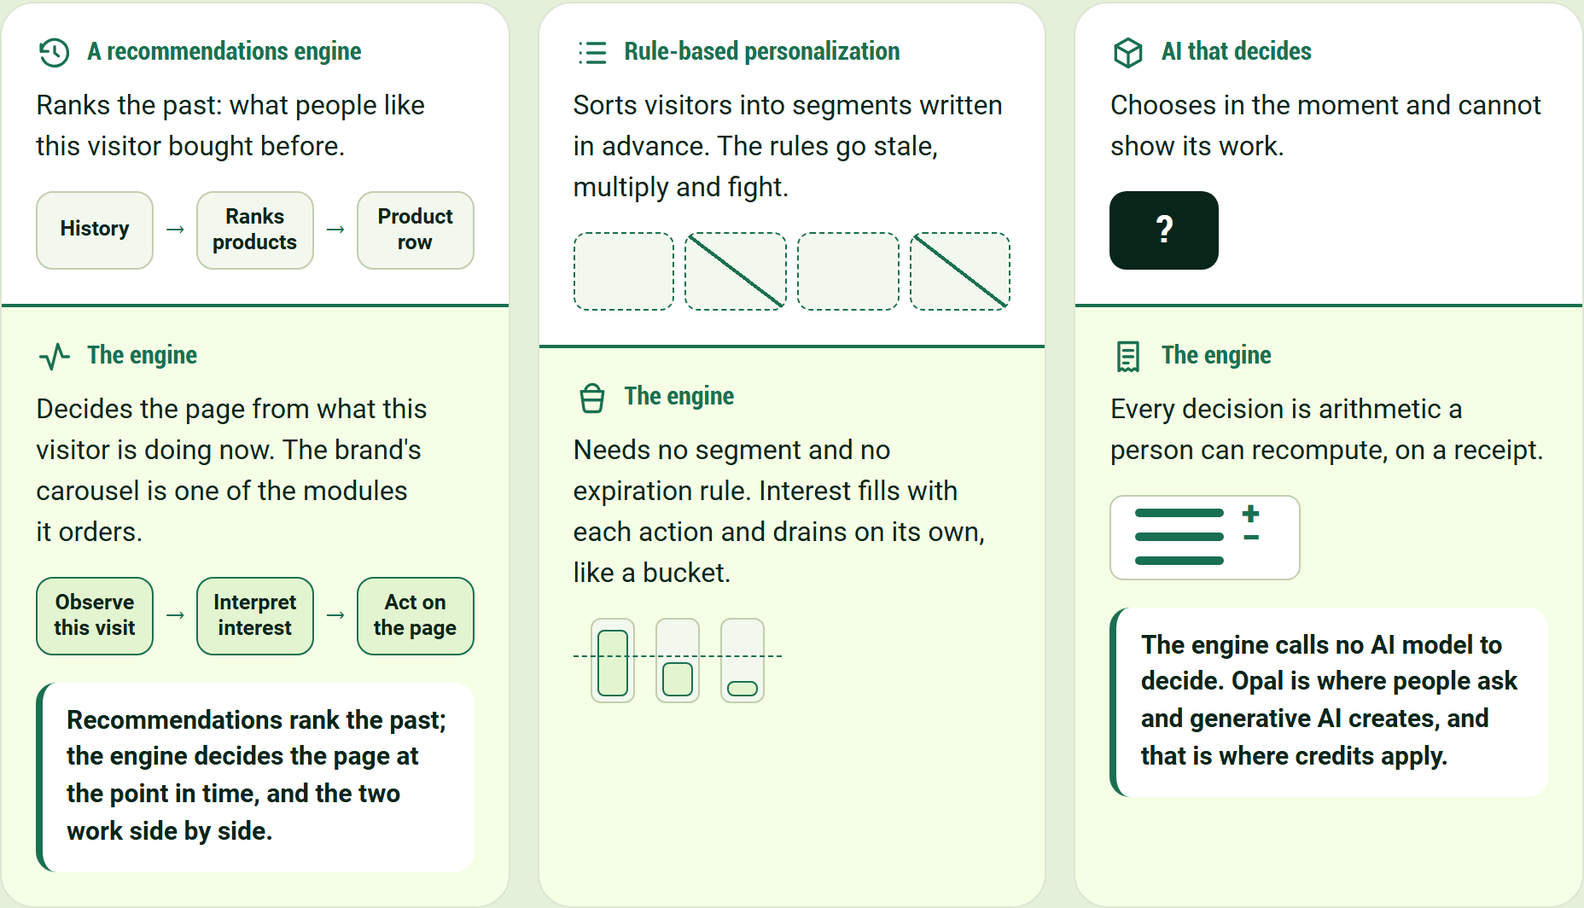
Recommendations rank the past; the engine decides the page at the point in time, and the two work side by side.
A recommendations engine
Ranks the past: what people like this visitor bought before.
History → Ranks products → Product row
The engine
Decides the page from what this visitor is doing now. The brand's carousel is one of the modules it orders.
Observe this visit → Interpret interest → Act on the page
Recommendations rank the past; the engine decides the page at the point in time, and the two work side by side.
Rule-based personalization
Sorts visitors into segments written in advance. The rules go stale, multiply and fight.
The engine
Needs no segment and no expiration rule. Interest fills with each action and drains on its own, like a bucket.
AI that decides
Chooses in the moment and cannot show its work.
The engine
Every decision is arithmetic a person can recompute, on a receipt.
The engine calls no AI model to decide. Opal is where people ask and generative AI creates, and that is where credits apply.

Both engines on one page
One engine keeps choosing the products. The other decides the experience around them.
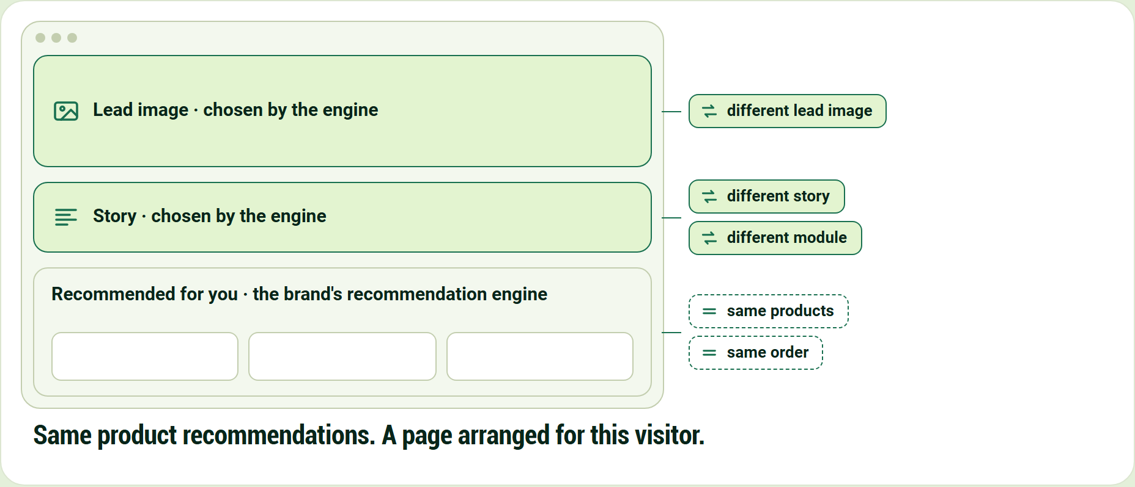
Same product recommendations. A page arranged for this visitor.
Lead image · chosen by the engine
Story · chosen by the engine
Recommended for you · the brand's recommendation engine
- same products
- same order
- different lead image
- different story
- different module

Same product recommendations. A page arranged for this visitor.

Now watch it: one visitor, one click
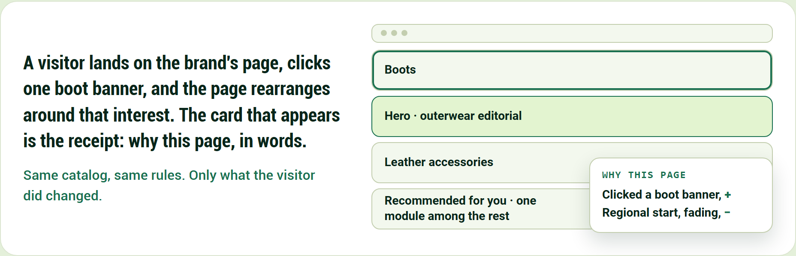
Same catalog, same rules. Only what the visitor did changed.
A visitor lands on the brand's page, clicks one boot banner, and the page rearranges around that interest. The card that appears is the receipt: why this page, in words.
Same catalog, same rules. Only what the visitor did changed.
- Hero · outerwear editorial
- Boots
- Leather accessories
- Recommended for you · one module among the rest

Why this page
- Clicked a boot banner, +
- Regional start, fading, −

Then go through it, one moment at a time
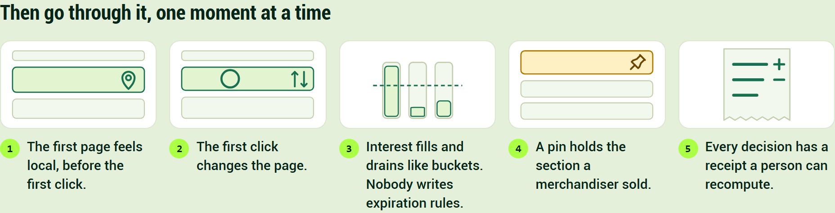
Then go through it, one moment at a time
- The first page feels local, before the first click.
- The first click changes the page.
- Interest fills and drains like buckets. Nobody writes expiration rules.
- A pin holds the section a merchandiser sold.
- Every decision has a receipt a person can recompute.

Customers choose it for different reasons
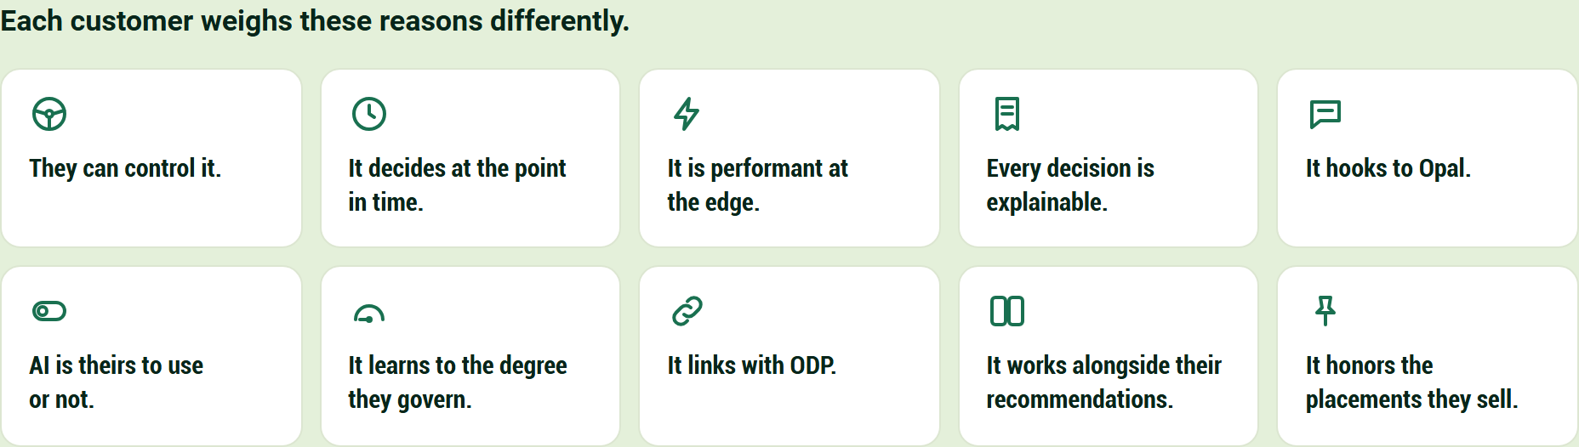
Each customer weighs these reasons differently.
- They can control it.
- It decides at the point in time.
- It is performant at the edge.
- Every decision is explainable.
- It hooks to Opal.
- AI is theirs to use or not.
- It learns to the degree they govern.
- It links with ODP.
- It works alongside their recommendations.
- It honors the placements they sell.

One visitor's first click becomes the slot's answer in five steps
A stranger in Illinois, arriving from a paid-social ad for a wool coat, views a tailored wool coat, and the figure follows that one view to the edit, a four-piece slot on the homepage.
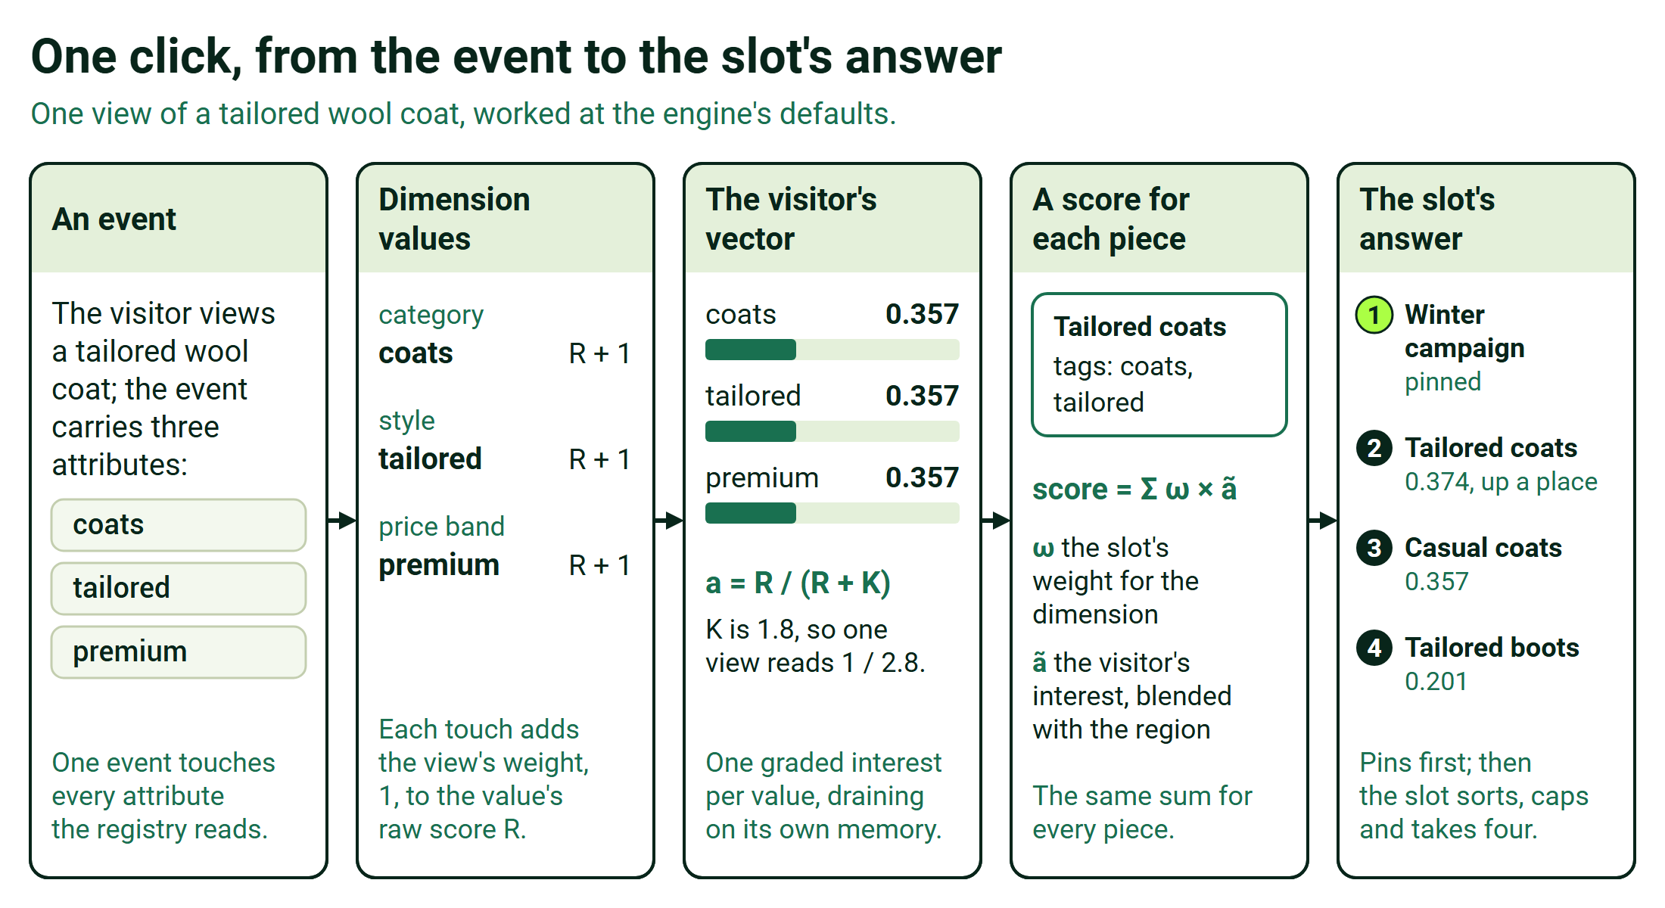
One click, from the event to the slot's answer
- An event. The visitor views a tailored wool coat, and the event carries the product id and the attributes the registry reads: coats, tailored and premium.
- Dimension values. The registry turns the one view into three touches, on category, style and price band, and each adds the view's weight, 1, to that value's raw score R.
- The visitor's vector. Each value now reads 1/(1 + 1.8) = 0.357; the three sum to 1.07, so λ, the region's share of the blend, falls from 1 to 0.48.
- A score for each piece. Each piece in the edit that may show scores the slot's weight times the visitor's blended interest for each of its tags, added up, plus the ad's seed of 0.06 on pieces tagged coats.
- The slot's answer. The pinned winter campaign keeps place 1; the tailored coats, at 0.374, now pass the casual coats, at 0.357, which led on arrival.

The same arithmetic orders a page's modules. On the coat's page, the styling story rises for a visitor leaning tailored, and the recommendations carousel is one of the six modules the engine orders, still choosing its own products.
An ordering is a ranking, so six modules in ten arrival contexts are sixty numbers to learn, not 720 orders to test. A merchandiser sets each arrival context's starting order, and the layout's rules say which sections are fixed, movable or required.
Every decision runs the same ten steps, from identity and consent to outcomes and the dial; under each step is what governs it.
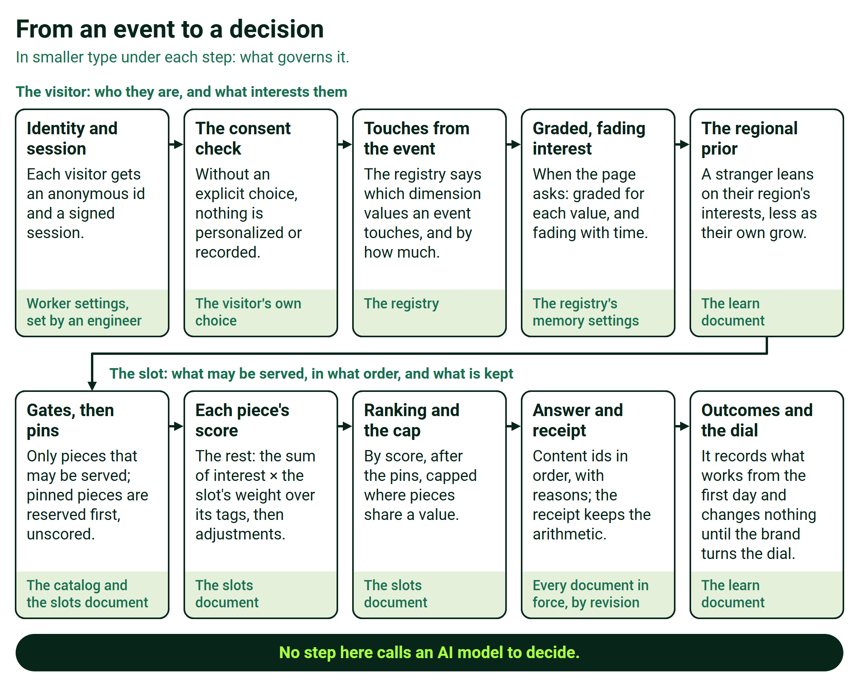
From an event to a decision

Six quantities carry the mechanism, and each one can be worked by hand
Each card shows one quantity at the engine's defaults, worked by hand on an example invented for this page.
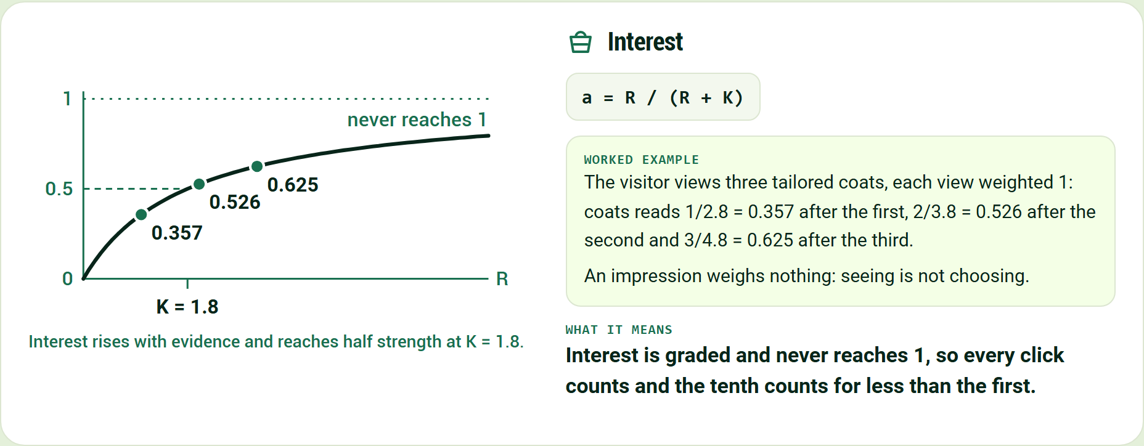
Interest rises with evidence and reaches half strength at K = 1.8.
Interest
a = R / (R + K)
The visitor views three tailored coats, each view weighted 1: coats reads 1/2.8 = 0.357 after the first, 2/3.8 = 0.526 after the second and 3/4.8 = 0.625 after the third.
An impression weighs nothing: seeing is not choosing.
Interest is graded and never reaches 1, so every click counts and the tenth counts for less than the first.
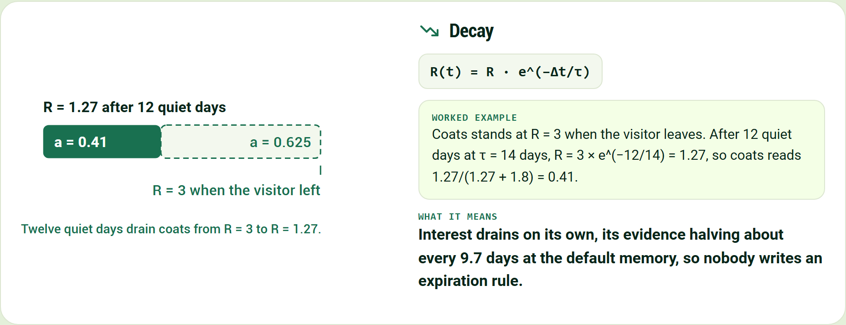
Twelve quiet days drain coats from R = 3 to R = 1.27.
Decay
R(t) = R · e^(−Δt/τ)
Coats stands at R = 3 when the visitor leaves. After 12 quiet days at τ = 14 days, R = 3 × e^(−12/14) = 1.27, so coats reads 1.27/(1.27 + 1.8) = 0.41.
Interest drains on its own, its evidence halving about every 9.7 days at the default memory, so nobody writes an expiration rule.
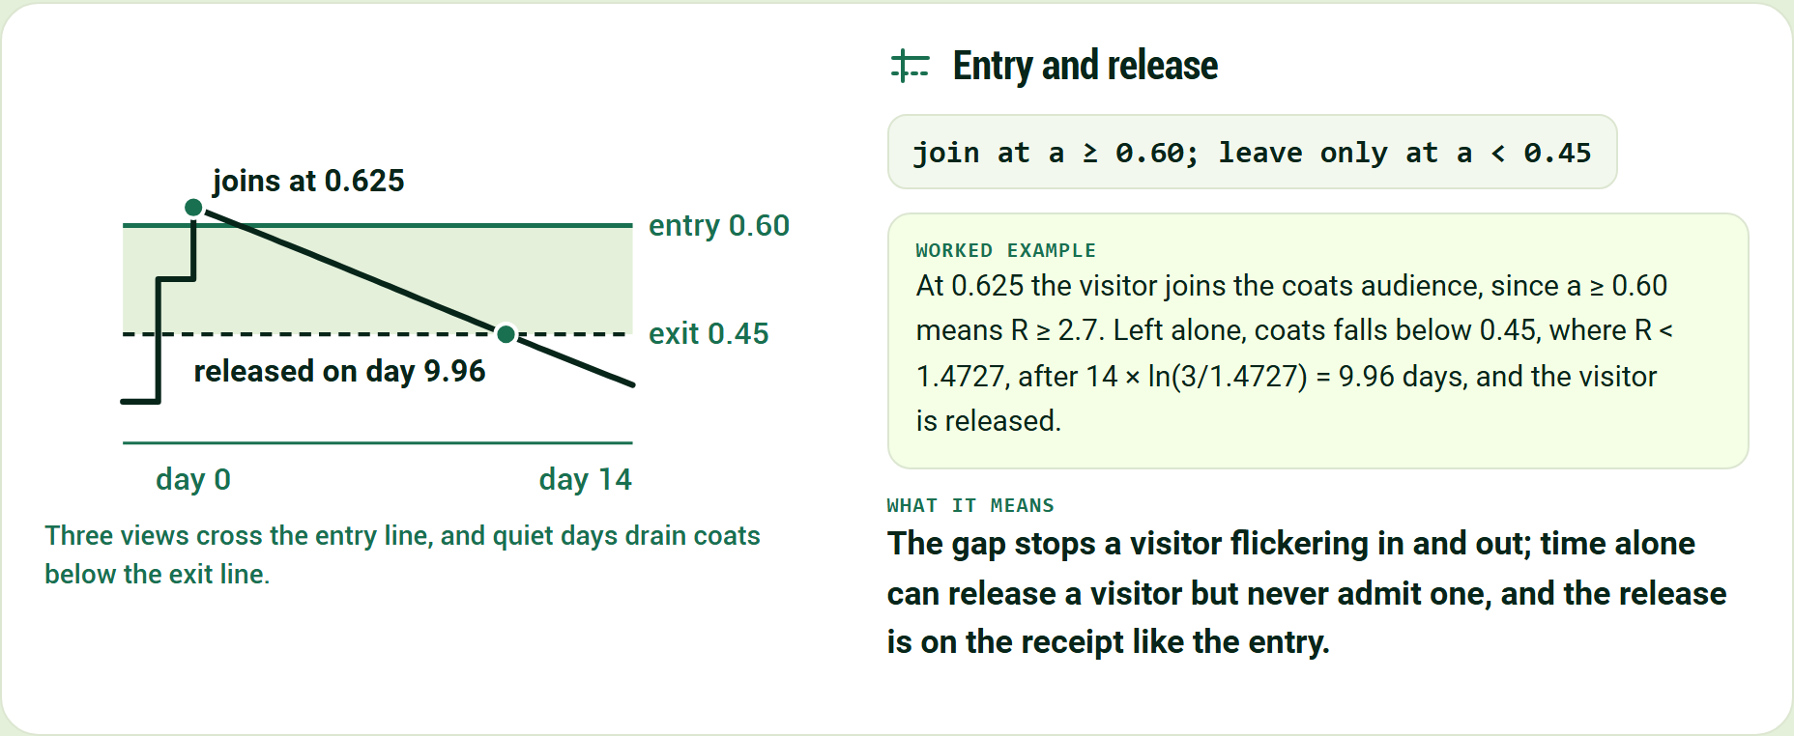
Three views cross the entry line, and quiet days drain coats below the exit line.
Entry and release
join at a ≥ 0.60; leave only at a < 0.45
At 0.625 the visitor joins the coats audience, since a ≥ 0.60 means R ≥ 2.7. Left alone, coats falls below 0.45, where R < 1.4727, after 14 × ln(3/1.4727) = 9.96 days, and the visitor is released.
The gap stops a visitor flickering in and out; time alone can release a visitor but never admit one, and the release is on the receipt like the entry.
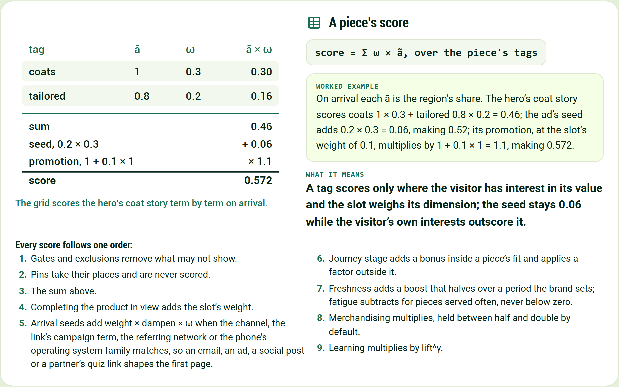
The grid scores the hero's coat story term by term on arrival.
A piece's score
score = Σ ω × ã, over the piece's tags
On arrival each ã is the region's share. The hero's coat story scores coats 1 × 0.3 + tailored 0.8 × 0.2 = 0.46; the ad's seed adds 0.2 × 0.3 = 0.06, making 0.52; its promotion, at the slot's weight of 0.1, multiplies by 1 + 0.1 × 1 = 1.1, making 0.572.
A tag scores only where the visitor has interest in its value and the slot weighs its dimension; the seed stays 0.06 while the visitor's own interests outscore it.
Every score follows one order:
- Gates and exclusions remove what may not show.
- Pins take their places and are never scored.
- The sum above.
- Completing the product in view adds the slot's weight.
- Arrival seeds add weight × dampen × ω when the channel, the link's campaign term, the referring network or the phone's operating system family matches, so an email, an ad, a social post or a partner's quiz link shapes the first page.
- Journey stage adds a bonus inside a piece's fit and applies a factor outside it.
- Freshness adds a boost that halves over a period the brand sets; fatigue subtracts for pieces served often, never below zero.
- Merchandising multiplies, held between half and double by default.
- Learning multiplies by lift^γ.

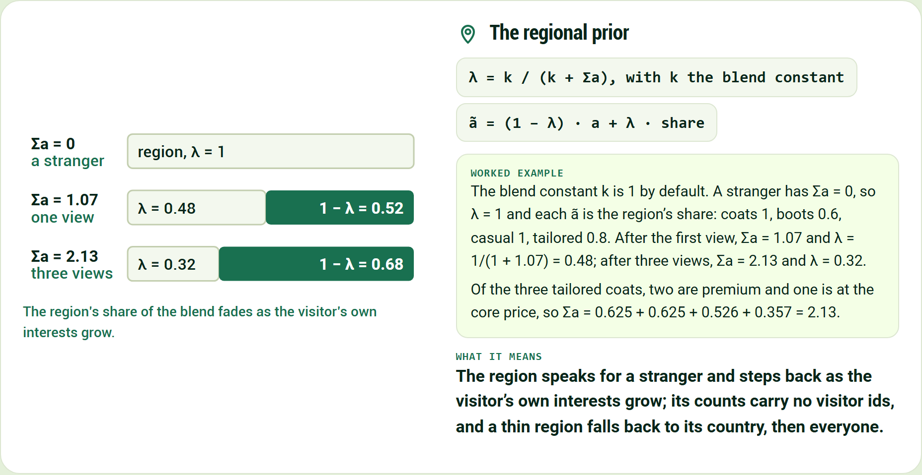
The region's share of the blend fades as the visitor's own interests grow.
The regional prior
λ = k / (k + Σa), with k the blend constant
ã = (1 − λ) · a + λ · share
The blend constant k is 1 by default. A stranger has Σa = 0, so λ = 1 and each ã is the region's share: coats 1, boots 0.6, casual 1, tailored 0.8. After the first view, Σa = 1.07 and λ = 1/(1 + 1.07) = 0.48; after three views, Σa = 2.13 and λ = 0.32.
Of the three tailored coats, two are premium and one is at the core price, so Σa = 0.625 + 0.625 + 0.526 + 0.357 = 2.13.
The region speaks for a stranger and steps back as the visitor's own interests grow; its counts carry no visitor ids, and a thin region falls back to its country, then everyone.
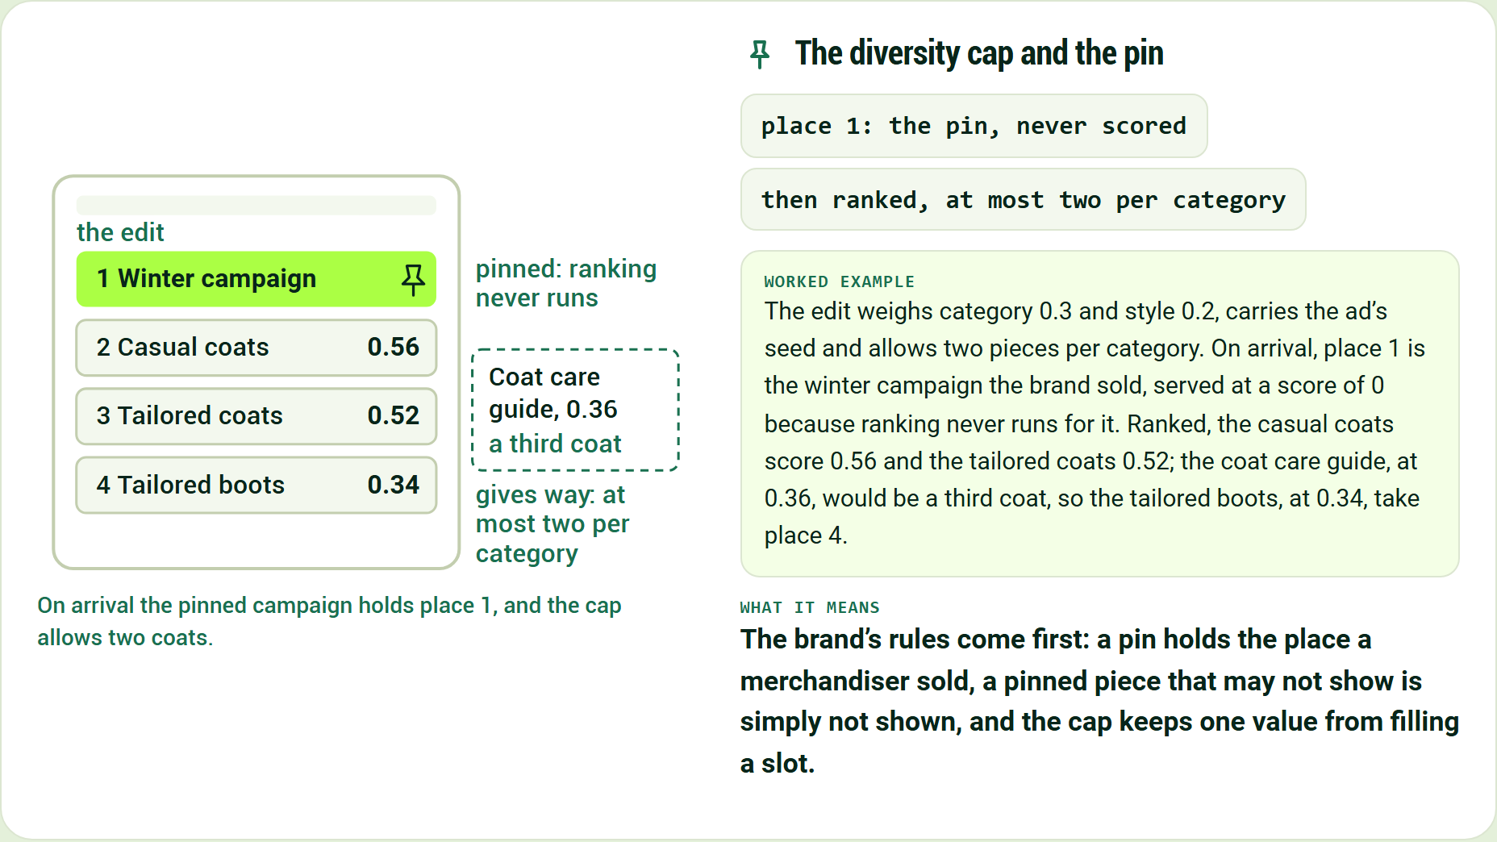
On arrival the pinned campaign holds place 1, and the cap allows two coats.
The diversity cap and the pin
place 1: the pin, never scored
then ranked, at most two per category
The edit weighs category 0.3 and style 0.2, carries the ad's seed and allows two pieces per category. On arrival, place 1 is the winter campaign the brand sold, served at a score of 0 because ranking never runs for it. Ranked, the casual coats score 0.56 and the tailored coats 0.52; the coat care guide, at 0.36, would be a third coat, so the tailored boots, at 0.34, take place 4.
The brand's rules come first: a pin holds the place a merchandiser sold, a pinned piece that may not show is simply not shown, and the cap keeps one value from filling a slot.
The engine's defaults are K = 1.8, an entry line at 0.60, an exit line at 0.45, a memory τ of 14 days and a blend constant k of 1; the example brand weighs a view 1, as the engine's own table does, and its slot weights and its region's shares are invented for this page.

Learning waits behind the dial, and every decision keeps a receipt
The figure shows the learning dial, the holdout that keeps a comparison, and the receipt for the tailored coats after the first click.
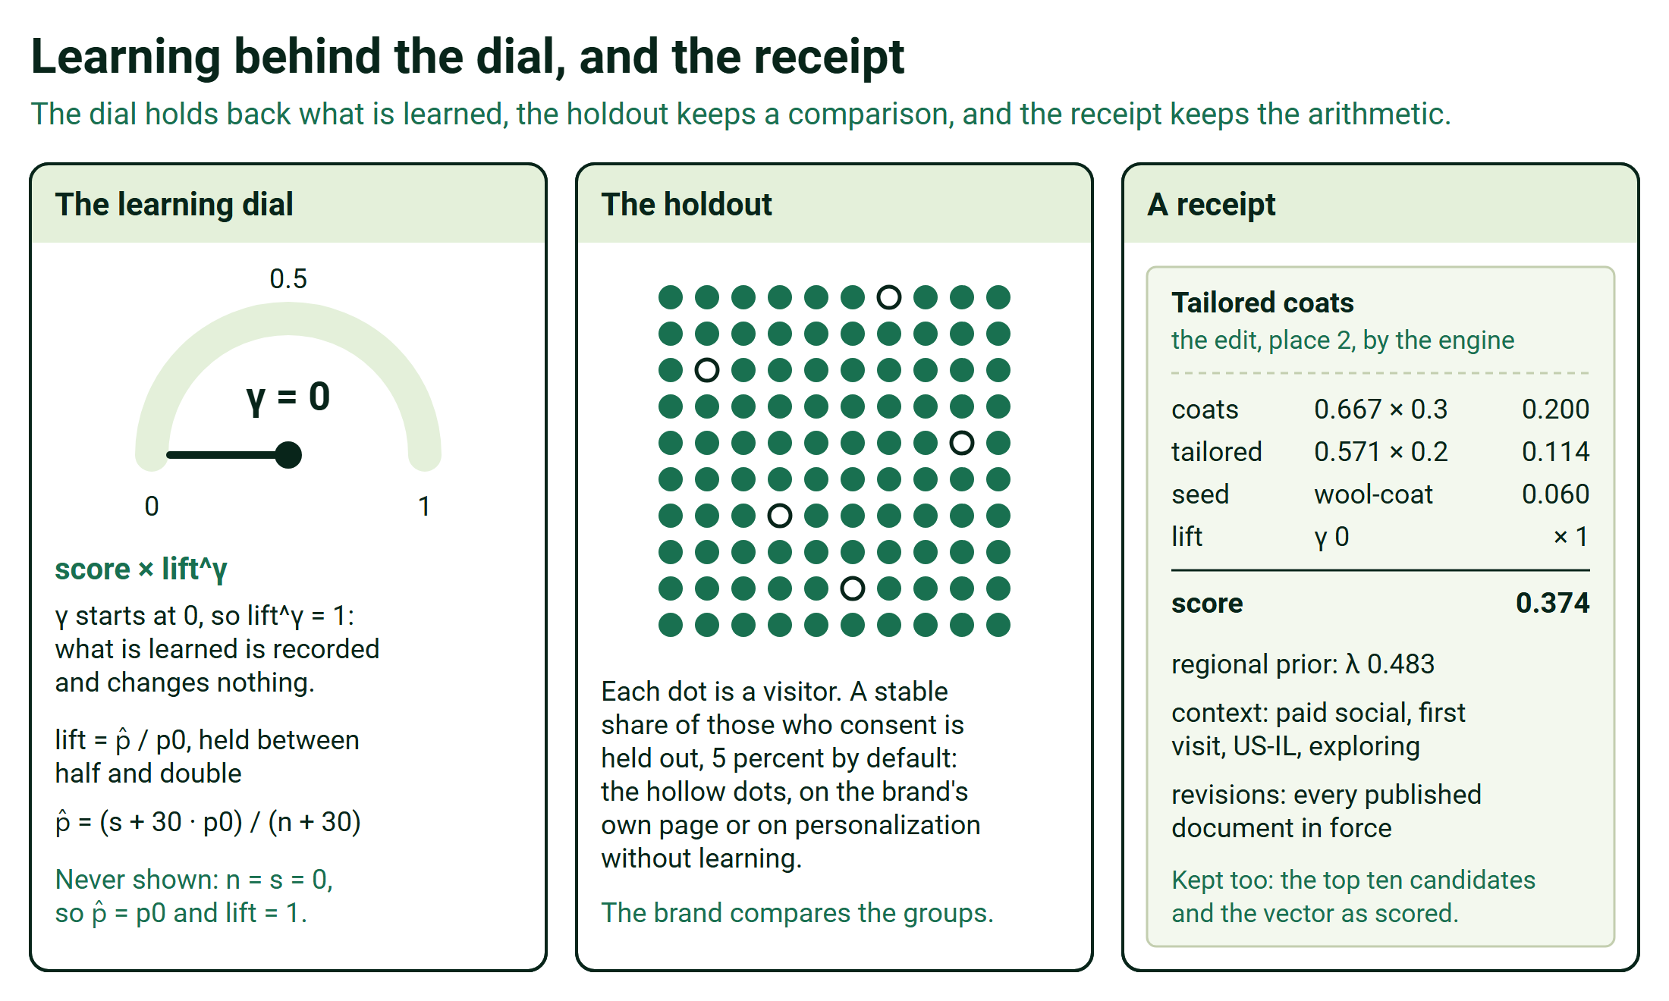
Learning behind the dial, and the receipt
It records what works from the first day and changes nothing until the brand turns the dial.
- An outcome is credited to the last decision before it for the same visitor, session and piece: by default within 30 minutes for a click, 6 hours for an add to cart and 7 days for a purchase.
- If the visitor buys the tailored boots the edit served, the purchase is credited to that decision and counted for that piece in its context.
- Learning compares each piece with its slot's usual rate in the same context, pooling similar contexts when one is thin, and each slot learns toward the outcome the brand names: clicks, adds to cart, purchases, revenue or margin.
- The holdout keeps a stable share of consenting visitors on the brand's own page or on personalization without learning, and the brand measures lift against it on its own numbers.
- Exploration, off unless the brand turns it on, gives a share of views to less-tried pieces, and neighboring modules sometimes swap places so learning can tell position from appeal.
- Every answer carries the reasons that placed each piece; the receipt keeps the arithmetic and what is needed to replay it, so a replay of its slot comes out the same.

It runs at the edge, and every setting is a published document
The figure shows what runs where: the Worker, what each Worker keeps, each deployment's own storage, and the products beside it.
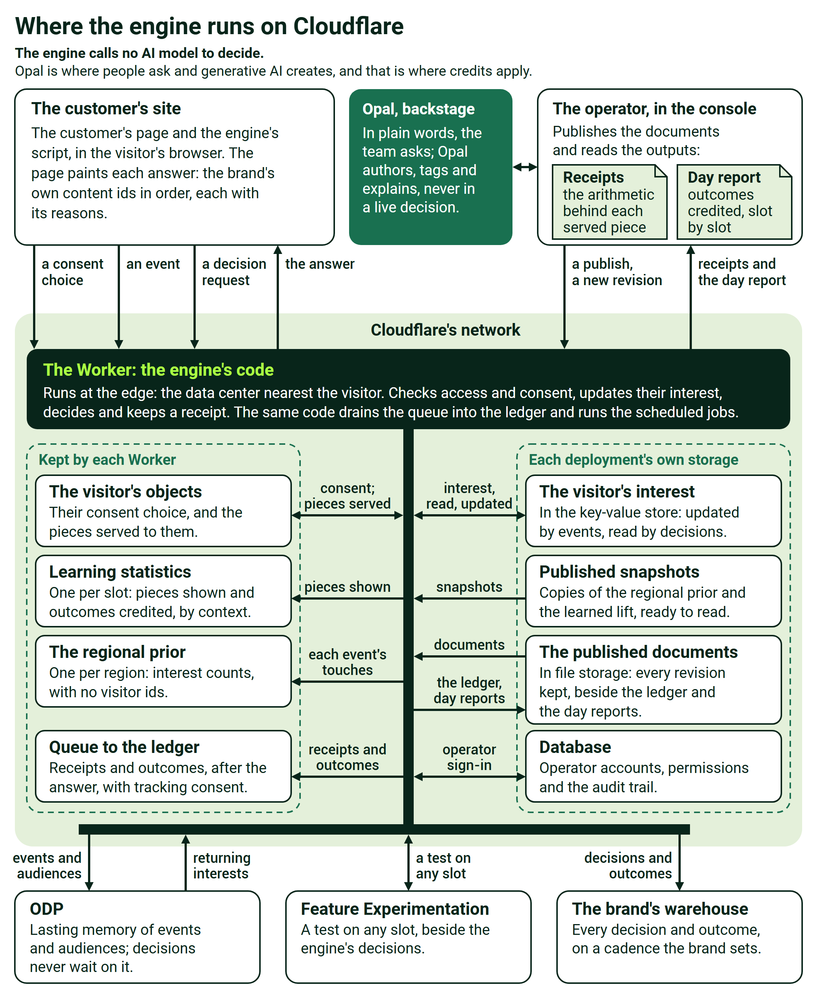
Where the engine runs on Cloudflare
The engine is one Worker per deployment, in the data center nearest each request. Each customer has its own deployment for staging and for production, and each brand inside it is a tenant whose data never pools with another's.
We aim to make each decision within about 200 milliseconds at the edge; on average we see 50 to 250 milliseconds, and tens of milliseconds once the engine has seen the visitor.
A decision is arithmetic over the visitor's state and the brand's published settings, held at the edge, with no AI model and no round trip to a central database. Every decision and outcome also lands in the brand's own warehouse, on a cadence the brand sets, from a minute to a day.
Four published documents hold everything the brand tunes; the console and the API change them, every save becomes a new revision, and a change is in force without a software release.
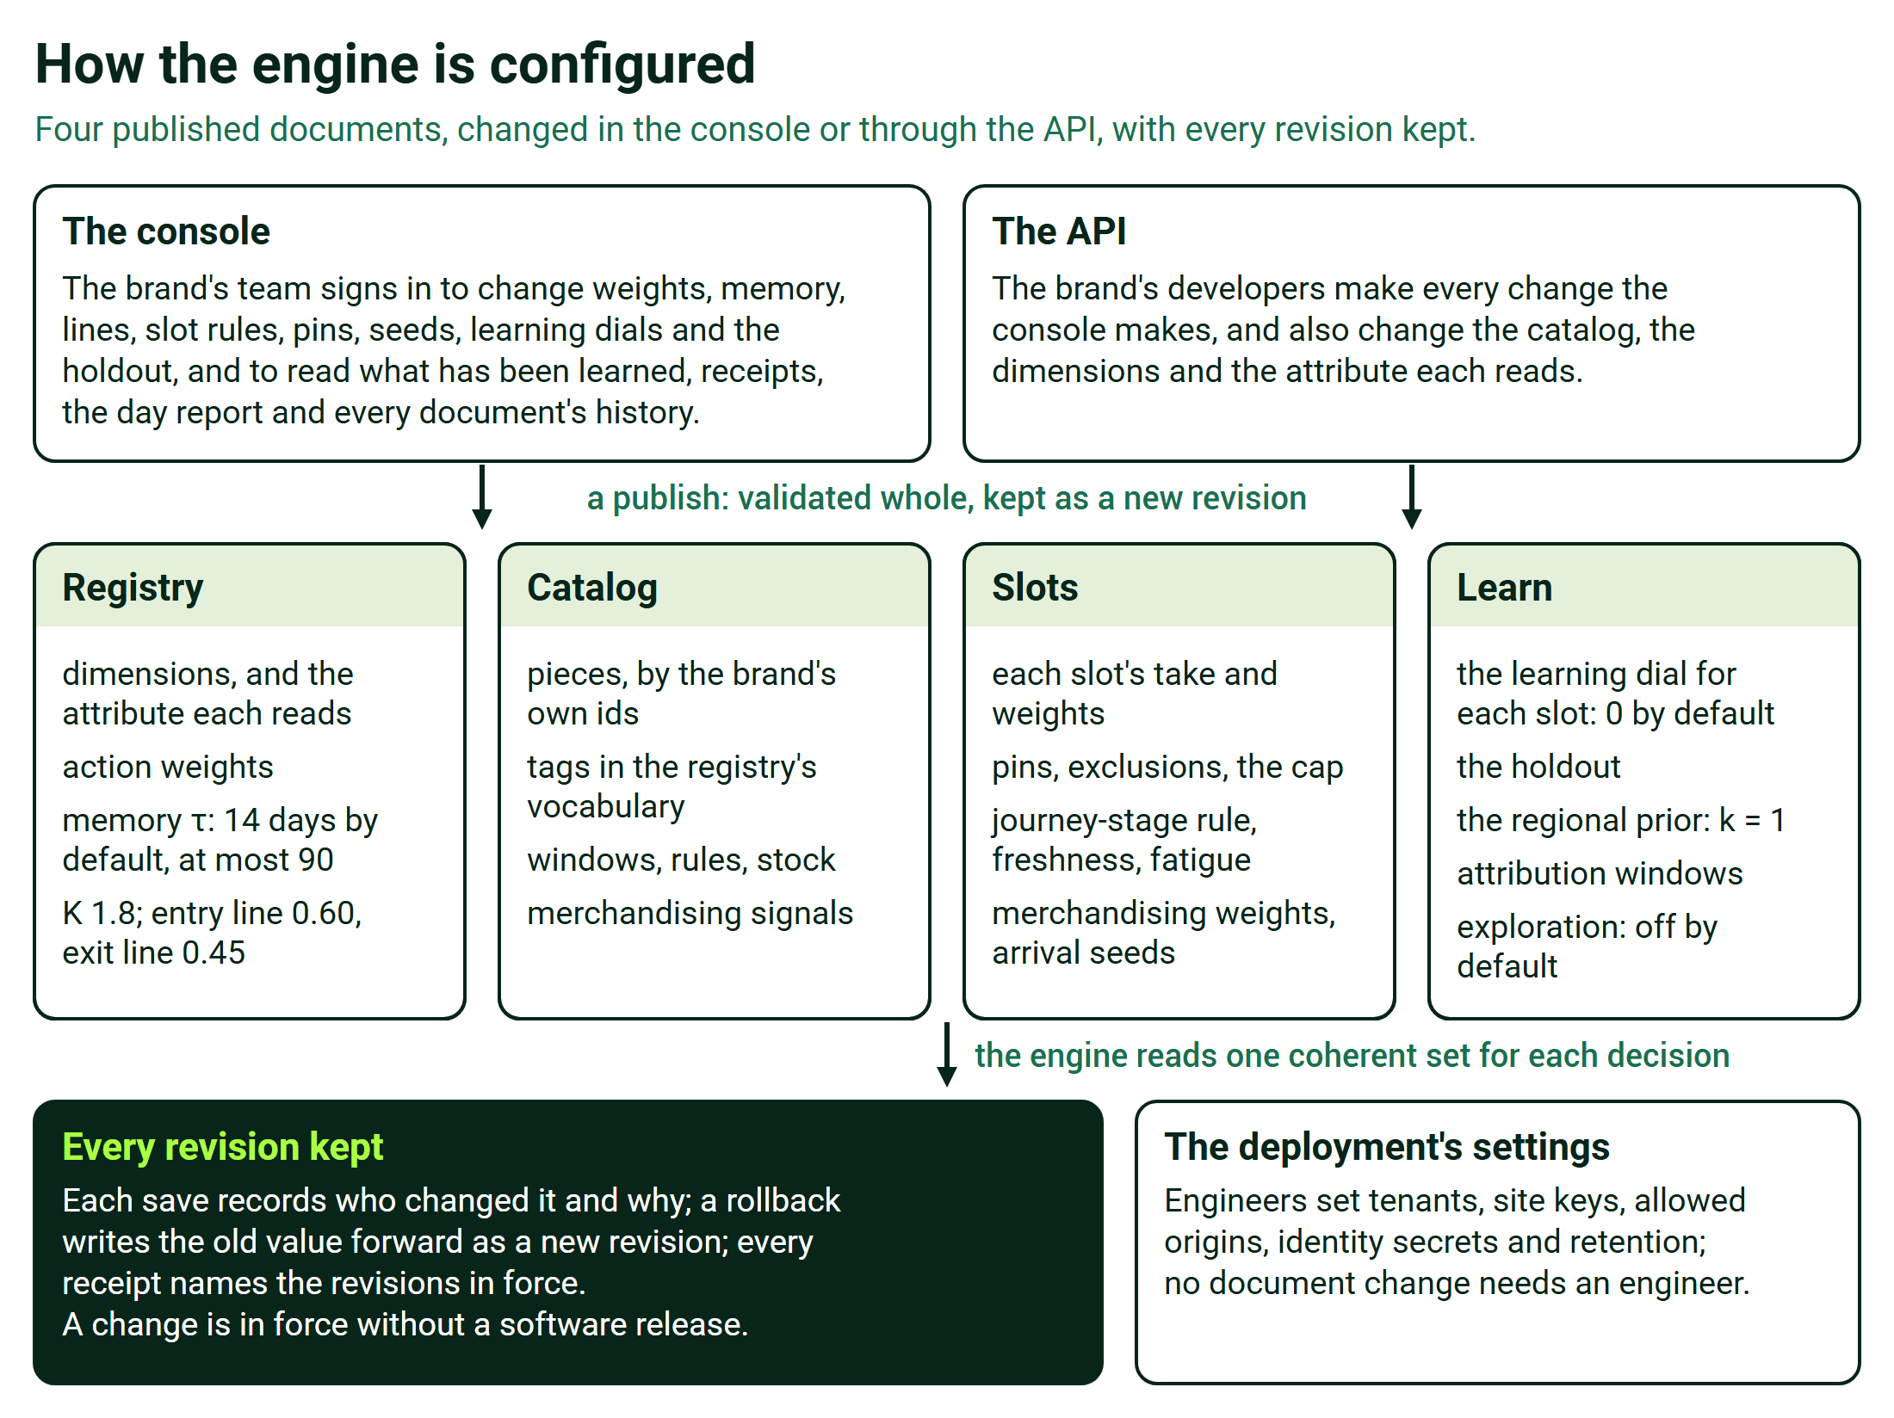
How the engine is configured
Imported priors, a warehouse's starting beliefs per piece and context, sit beside them.

The site connects once, and privacy holds on every request
One script starts the visitor's session, sends events or reads the brand's existing data layer, and receives every slot's decision by id in one call.
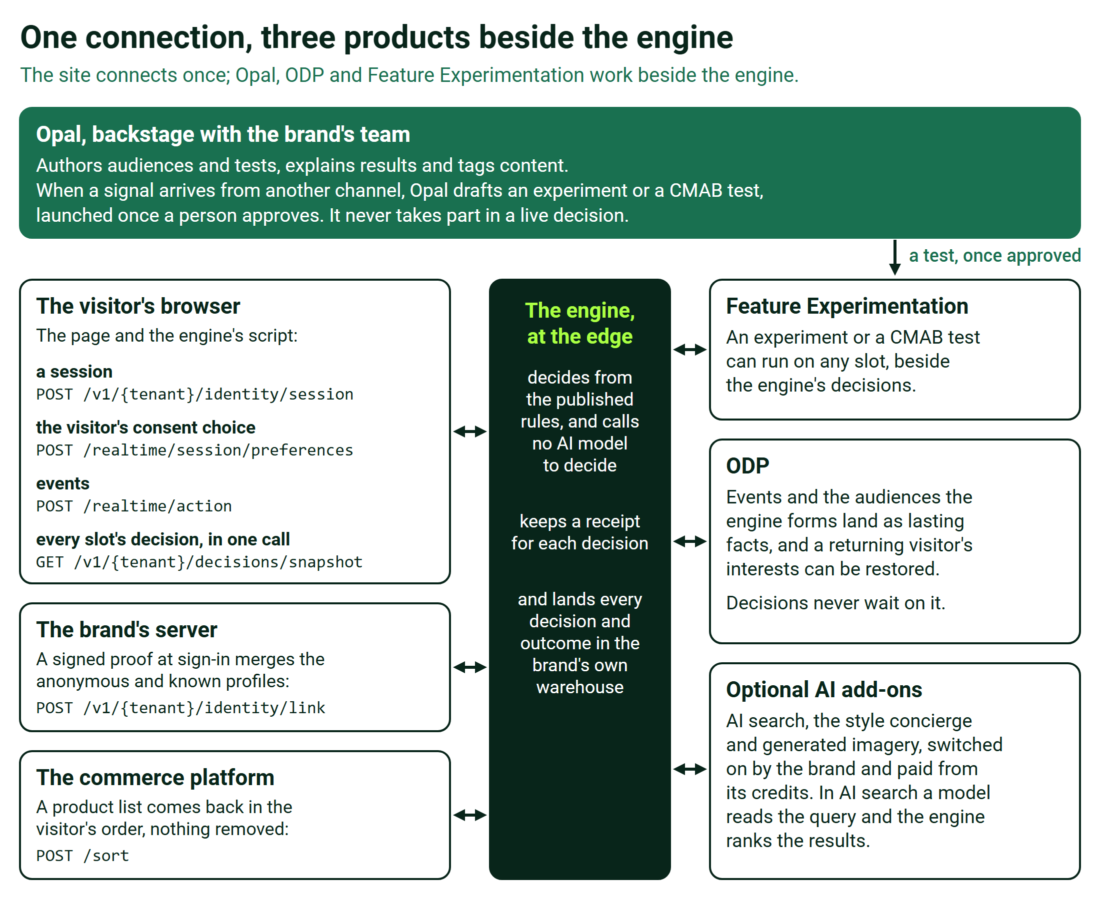
One connection, three products beside the engine
When no answer arrives in time, the site's own default stands, and the brand's server can fetch the first page's decisions before the page is sent.
The front end is built once, and every other capability is switched on in configuration. Developers work from the integration kit: the SDK, the API reference, the payload schemas and a staging connection check.
When Opal proposes tags for thinly labeled content, a person approves, edits or rejects each one before it is used.
The engine calls no AI model to decide. Opal is where people ask and generative AI creates, and that is where credits apply. Where Opal and AI Credits Fit, and Where They Never Do sets out the boundary.
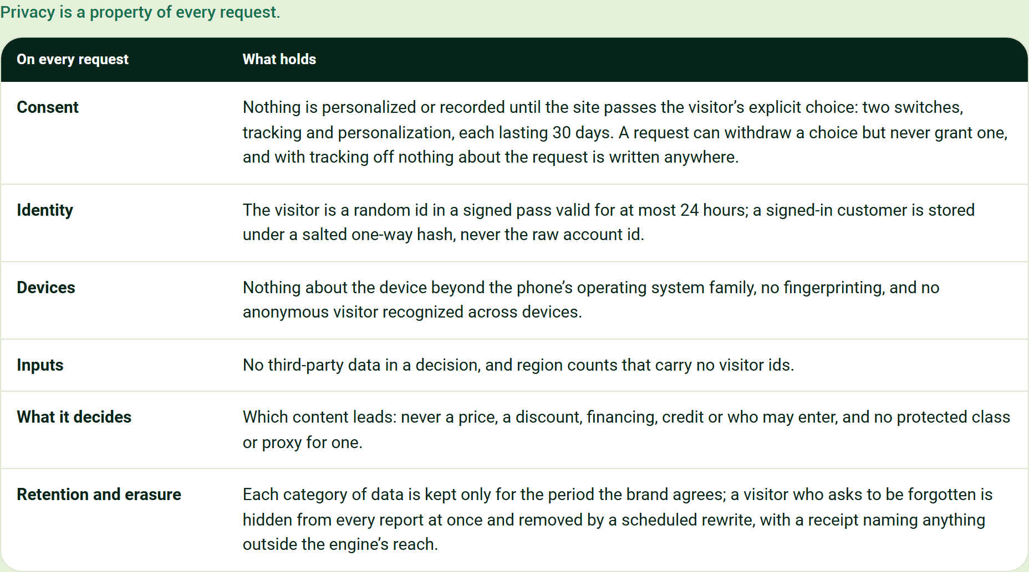
Privacy is a property of every request.
On every request | What holds
Consent | Nothing is personalized or recorded until the site passes the visitor's explicit choice: two switches, tracking and personalization, each lasting 30 days. A request can withdraw a choice but never grant one, and with tracking off nothing about the request is written anywhere.
Identity | The visitor is a random id in a signed pass valid for at most 24 hours; a signed-in customer is stored under a salted one-way hash, never the raw account id.
Devices | Nothing about the device beyond the phone's operating system family, no fingerprinting, and no anonymous visitor recognized across devices.
Inputs | No third-party data in a decision, and region counts that carry no visitor ids.
What it decides | Which content leads: never a price, a discount, financing, credit or who may enter, and no protected class or proxy for one.
Retention and erasure | Each category of data is kept only for the period the brand agrees; a visitor who asks to be forgotten is hidden from every report at once and removed by a scheduled rewrite, with a receipt naming anything outside the engine's reach.

Every ask says what we need and what we use it for
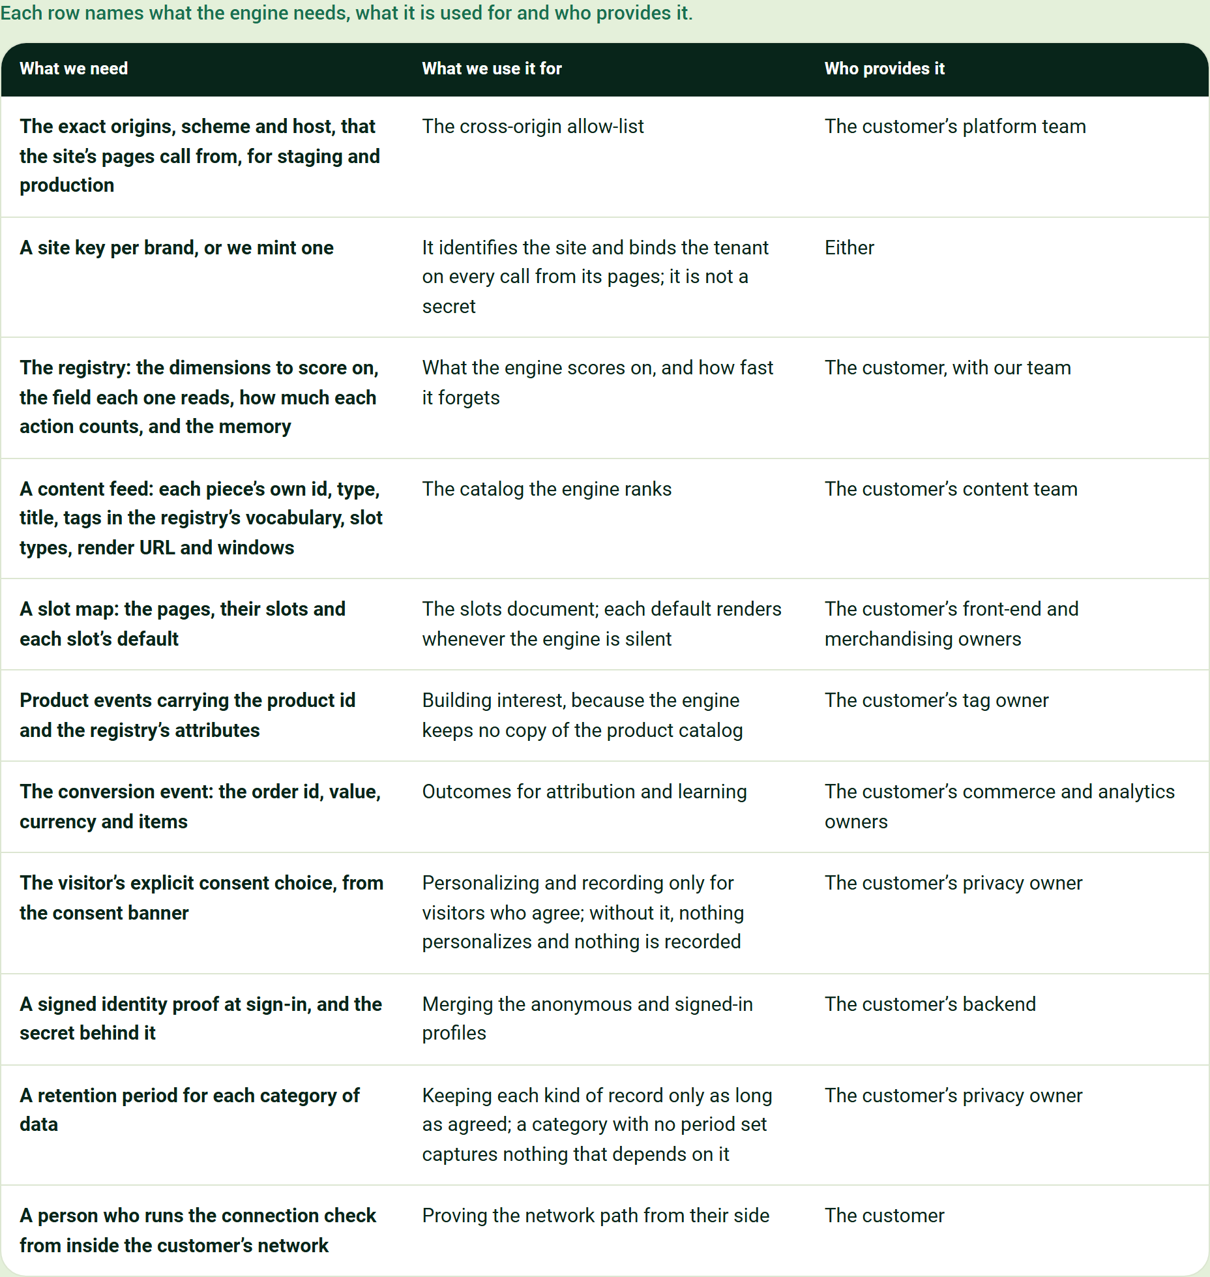
Each row names what the engine needs, what it is used for and who provides it.
What we need | What we use it for | Who provides it
The exact origins, scheme and host, that the site's pages call from, for staging and production | The cross-origin allow-list | The customer's platform team
A site key per brand, or we mint one | It identifies the site and binds the tenant on every call from its pages; it is not a secret | Either
The registry: the dimensions to score on, the field each one reads, how much each action counts, and the memory | What the engine scores on, and how fast it forgets | The customer, with our team
A content feed: each piece's own id, type, title, tags in the registry's vocabulary, slot types, render URL and windows | The catalog the engine ranks | The customer's content team
A slot map: the pages, their slots and each slot's default | The slots document; each default renders whenever the engine is silent | The customer's front-end and merchandising owners
Product events carrying the product id and the registry's attributes | Building interest, because the engine keeps no copy of the product catalog | The customer's tag owner
The conversion event: the order id, value, currency and items | Outcomes for attribution and learning | The customer's commerce and analytics owners
The visitor's explicit consent choice, from the consent banner | Personalizing and recording only for visitors who agree; without it, nothing personalizes and nothing is recorded | The customer's privacy owner
A signed identity proof at sign-in, and the secret behind it | Merging the anonymous and signed-in profiles | The customer's backend
A retention period for each category of data | Keeping each kind of record only as long as agreed; a category with no period set captures nothing that depends on it | The customer's privacy owner
A person who runs the connection check from inside the customer's network | Proving the network path from their side | The customer

Optional, each with its use: candidate product lists from the commerce platform, for re-ranking; a catalog-search service, for AI search; historical rows, which start known customers warm; regional sales from the brand's warehouse, which set each region's starting lean; and a warehouse destination for the receipts and outcomes.

The interactive page puts every constant on a slider
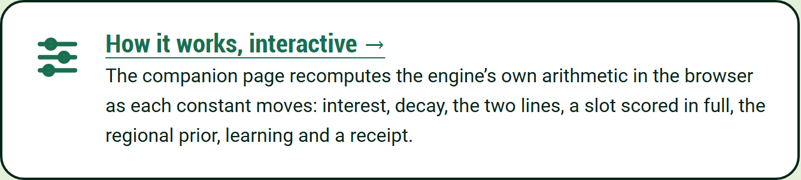
The companion page recomputes the engine's own arithmetic in the browser as each constant moves: interest, decay, the two lines, a slot scored in full, the regional prior, learning and a receipt.
How it works, interactive

