OPTIMIZELY
Behavioral Targeting and Intelligence: battlecard
For account executives
Prepared for | Account executives
Prepared by | Optimizely
Version | 3.0
Date | October 3, 2026
Classification | Internal: Optimizely only

Contents
Four pillars carry the pitch, each with a proof
Customers choose it for different reasons
Six objections have short answers
Six questions lead to six measures
Each demo shows part of the story
Four sentences are said word for word

For account executives: the whole story on one sheet, to read before a call.
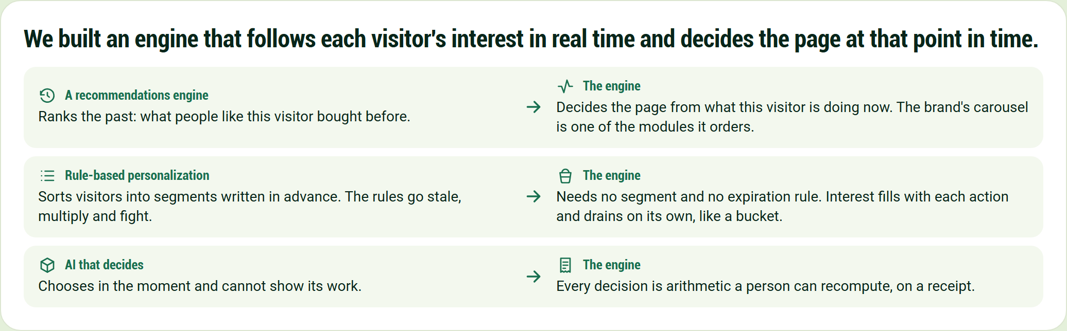
We built an engine that follows each visitor's interest in real time and decides the page at that point in time.
We built an engine that follows each visitor's interest in real time and decides the page at that point in time.
A recommendations engine
Ranks the past: what people like this visitor bought before.
The engine
Decides the page from what this visitor is doing now. The brand's carousel is one of the modules it orders.
Rule-based personalization
Sorts visitors into segments written in advance. The rules go stale, multiply and fight.
The engine
Needs no segment and no expiration rule. Interest fills with each action and drains on its own, like a bucket.
AI that decides
Chooses in the moment and cannot show its work.
The engine
Every decision is arithmetic a person can recompute, on a receipt.

Four pillars carry the pitch, each with a proof
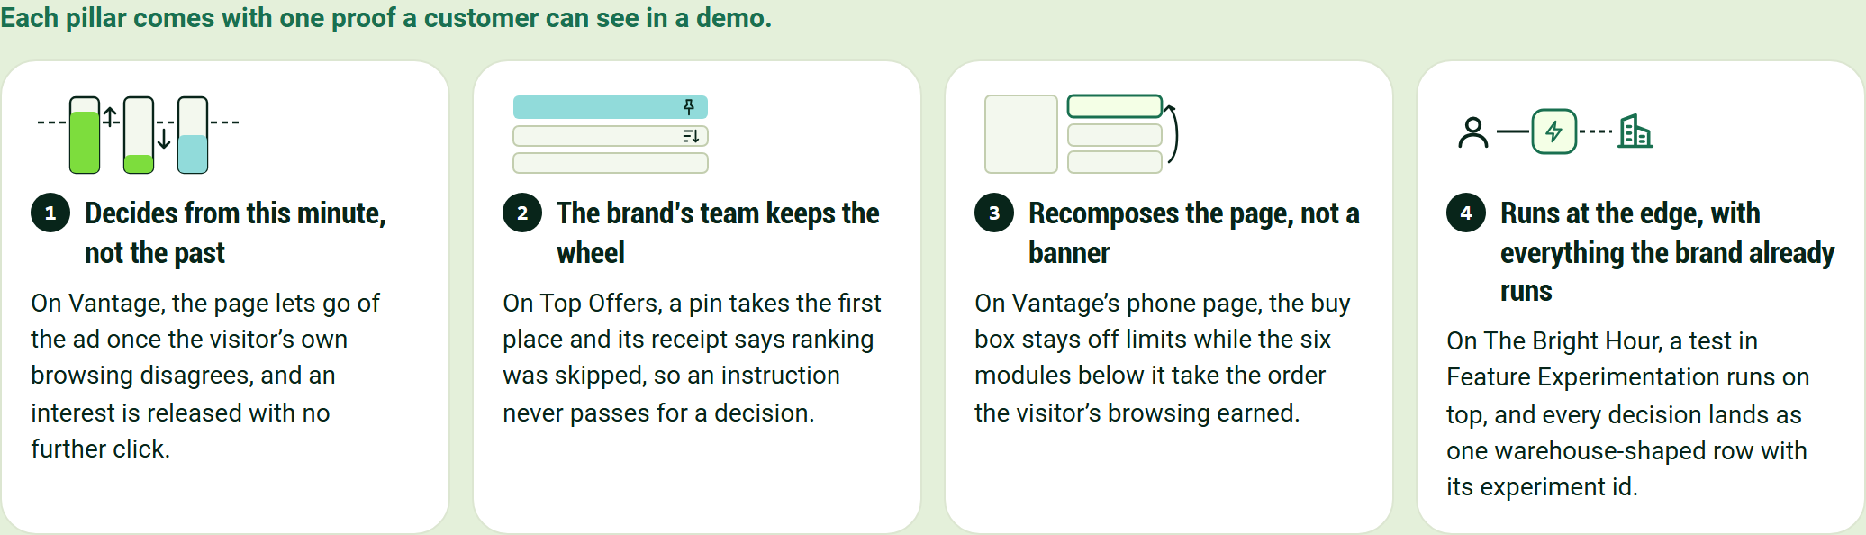
Each pillar comes with one proof a customer can see in a demo.
Decides from this minute, not the past
On Vantage, the page lets go of the ad once the visitor's own browsing disagrees, and an interest is released with no further click.
The brand's team keeps the wheel
On Top Offers, a pin takes the first place and its receipt says ranking was skipped, so an instruction never passes for a decision.
Recomposes the page, not a banner
On Vantage's phone page, the buy box stays off limits while the six modules below it take the order the visitor's browsing earned.
Runs at the edge, with everything the brand already runs
On The Bright Hour, a test in Feature Experimentation runs on top, and every decision lands as one warehouse-shaped row with its experiment id.

Customers choose it for different reasons
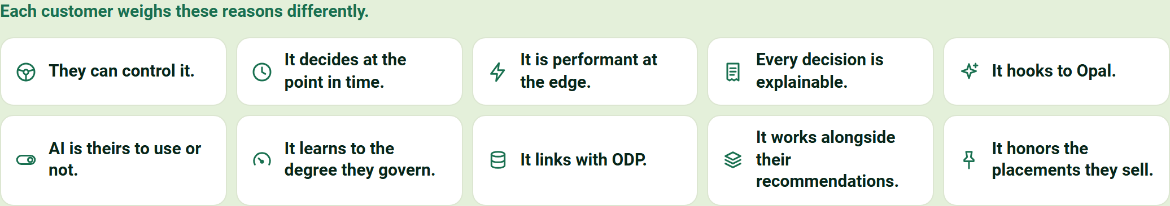
Each customer weighs these reasons differently.
- They can control it.
- It decides at the point in time.
- It is performant at the edge.
- Every decision is explainable.
- It hooks to Opal.
- AI is theirs to use or not.
- It learns to the degree they govern.
- It links with ODP.
- It works alongside their recommendations.
- It honors the placements they sell.

Six objections have short answers
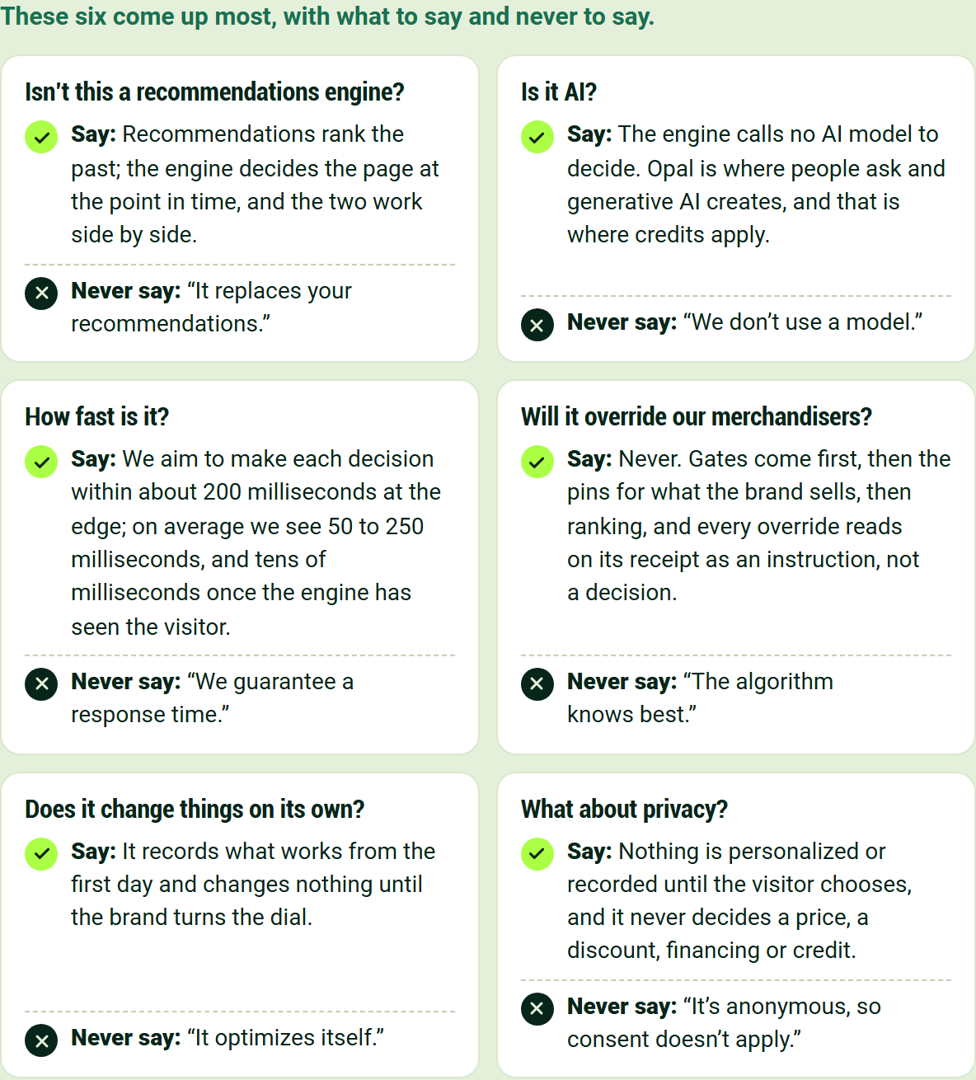
These six come up most, with what to say and never to say.
Isn't this a recommendations engine?
Say: Recommendations rank the past; the engine decides the page at the point in time, and the two work side by side.
Never say: "It replaces your recommendations."
Is it AI?
Say: The engine calls no AI model to decide. Opal is where people ask and generative AI creates, and that is where credits apply.
Never say: "We don't use a model."
How fast is it?
Say: We aim to make each decision within about 200 milliseconds at the edge; on average we see 50 to 250 milliseconds, and tens of milliseconds once the engine has seen the visitor.
Never say: "We guarantee a response time."
Will it override our merchandisers?
Say: Never. Gates come first, then the pins for what the brand sells, then ranking, and every override reads on its receipt as an instruction, not a decision.
Never say: "The algorithm knows best."
Does it change things on its own?
Say: It records what works from the first day and changes nothing until the brand turns the dial.
Never say: "It optimizes itself."
What about privacy?
Say: Nothing is personalized or recorded until the visitor chooses, and it never decides a price, a discount, financing or credit.
Never say: "It's anonymous, so consent doesn't apply."

Six questions lead to six measures
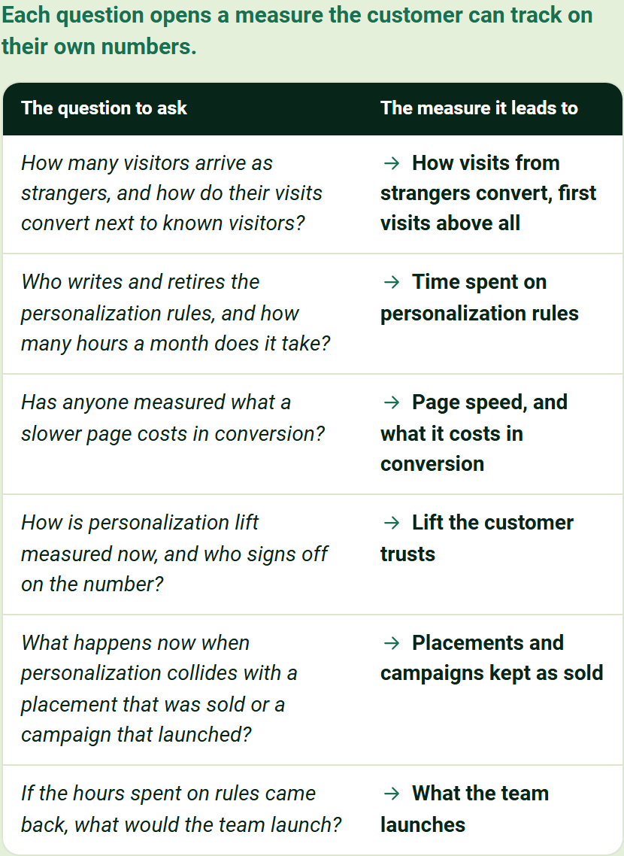
Each question opens a measure the customer can track on their own numbers.
The question to ask | The measure it leads to
How many visitors arrive as strangers, and how do their visits convert next to known visitors? | How visits from strangers convert, first visits above all
Who writes and retires the personalization rules, and how many hours a month does it take? | Time spent on personalization rules
Has anyone measured what a slower page costs in conversion? | Page speed, and what it costs in conversion
How is personalization lift measured now, and who signs off on the number? | Lift the customer trusts
What happens now when personalization collides with a placement that was sold or a campaign that launched? | Placements and campaigns kept as sold
If the hours spent on rules came back, what would the team launch? | What the team launches

Each demo shows part of the story
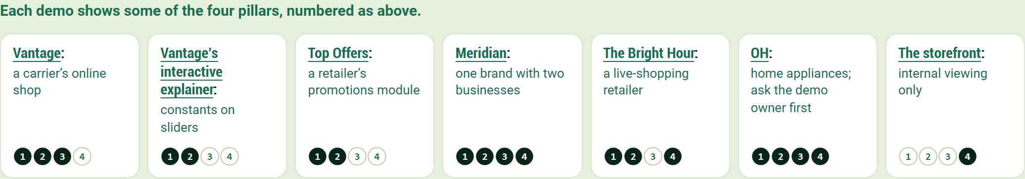
Each demo shows some of the four pillars, numbered as above.
- Vantage: a carrier's online shop
- Vantage's interactive explainer: constants on sliders
- Top Offers: a retailer's promotions module
- Meridian: one brand with two businesses
- The Bright Hour: a live-shopping retailer
- OH: home appliances; ask the demo owner first
- The storefront: internal viewing only

Four sentences are said word for word
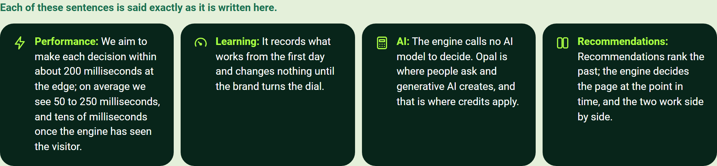
Each of these sentences is said exactly as it is written here.
- Performance: We aim to make each decision within about 200 milliseconds at the edge; on average we see 50 to 250 milliseconds, and tens of milliseconds once the engine has seen the visitor.
- Learning: It records what works from the first day and changes nothing until the brand turns the dial.
- AI: The engine calls no AI model to decide. Opal is where people ask and generative AI creates, and that is where credits apply.
- Recommendations: Recommendations rank the past; the engine decides the page at the point in time, and the two work side by side.

