**The 5-vector narrow-band pipeline**

The 5-vector narrow-band pipeline is an algorithm for gravitational waves searches from pulsars. Please cite the following references if you have used this pipeline, or part of it, in one of your searches.

**Method paper:** [**http://adsabs.harvard.edu/abs/2014PhRvD..89f2008A**](http://adsabs.harvard.edu/abs/2014PhRvD..89f2008A)

**Algorithm paper:** [**http://adsabs.harvard.edu/abs/2017CQGra..34m5007M**](http://adsabs.harvard.edu/abs/2017CQGra..34m5007M)

For any question, concerns etc. please contact

Simone Mastrogiovanni

**Email:** [simone.mastrogiovanni@roma1.infn.it](mailto:simone.mastrogiovanni@roma1.infn.it)

[mastrosi@apc.in2p3.fr](mailto:mastrosi@apc.in2p3.fr)

**General flowchart**

The narrow-band pipeline is divided in two blocks:

* **A main body**: which is almost fully automatized. This part takes care of performing the analysis up to the preparation of the data for the “outlier selection”. The following figure show the flowchart of the main body.  
  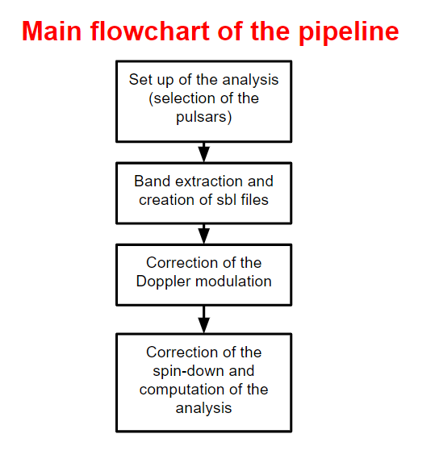
* **A post-processing:** which selects the outliers, perform the follow-up and in case compute the upper-limits on the gravitational-wave strain amplitude. This part is not fully automatized but scripts are available.

**Software requirements:**

In order to run the narrow-band code, you will need

1. SNAG toolbox: a collection of codes for gravitational waves that you can here: <http://www.roma1.infn.it/~frasca/snag/default.htm>
2. The narrow-band distribution: You can find it in the git LIGO (https://git.ligo.org/CW/software/narrow_band_5vec)
3. A version of MATLAB > 2014

**Set up of the analysis:**

Since the narrow-band code can not be compatible with the future SNAG distribution, it is strongly suggested to run

**>addpath(genpath('D:\Snag'))**

**>addpath(genpath('**[**D:\intoccabili**](../../../../../D:/intoccabili)**'))**

**NOTE: Always follow this order in adding packages as some SNAG functions might change in the future and they conflict my their versions in the narrow-band.**

This will add temporary add the narrow-band codes as MATLAB known routines with the highest priority. This means that, given two codes with the same name, MATLAB will also call the one that it founds in the “intoccabili” folder. This will prevent incompatibilities from future distributions of SNAG.

* The first step is to setup a folder in which you will gather all the ephemeris files for the pulsars of which you would like to perform the analysis. The ephemeris files should be given either in *.par or *.txt formats. An example of an artificial ephemeris created for the Hardware injection Pulsar 8 follows. **IMPORTANT**: The frequency and spin-down in the ephemeris are the ones given by the radio astronomers.  
    
    
    
   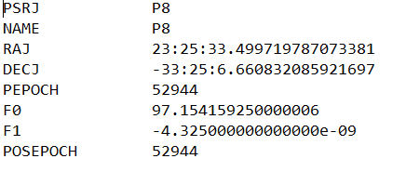
* Ones that you have created a folder with the ephemeris, do create in the sampe folder a *.txt file containing the path to the ephemeris files.
* Create now a folder in which you would like to save the results of the narrow-band search. This folder can be wherever you want (relative to the ephemerides folder)  
    
  **>mkdir narrow_band_example**
* Now run the command  
    
  >create_narrow_band('list_par.txt','D:\narrow-band-example\',0.001,57693,57693+30)  
    
  This takes as inputs the list of ephemeris files with their path, the path where you want to create the narrow-band analysis, the width factor \delta for the narrow-band, and the starting and end time of the analysis. After the script has finished, i) your narrow-band folder will be populated with folders named after the ephemerides, ii) a script called “script_sbl_product.m” will be created in the narrow-band folder. iii) a *.mat file called “out.mat” will be created in your narrow-band folder. See figure below.  
  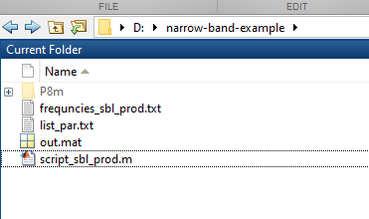

**Band extraction**Using the scripts that we have generated in the previous part, we are going to extract data for each pulsar around its searched frequency. The frequency that we are going to extract is computed taking into account the frequency narrow-region that we want to analyze taking into account all the possible modulations given by the Doppler effect and the spin-down of the pulsar.

* Now we should run the script “script_sbl_product.m”. This script will need to be completed by the user. Prepare two files (one for each detector) containing the list of the SFDB path and file name and put the name of these files in the script. See figure below. Then run the script. The script will populate each pulsar folder with its *.sbl file, which is a file containing the data extracted around the frequency of the analysis.  
  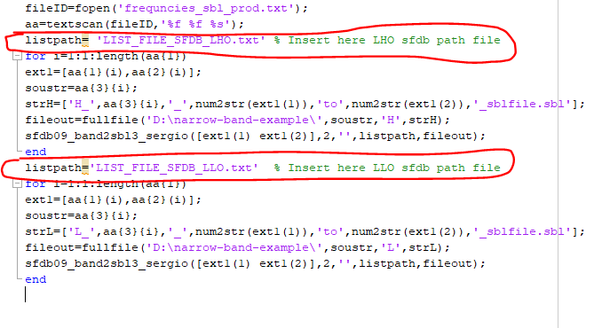
* At this level you may decide to download the narrow-band analysis folder on another machine without any problem. In such a way to parallelize the following steps.
* Now load the “out.mat” file created by the create_narrow_band function and call  
    
  create_narrow_band('list_par.txt','D:\narrow-band-example\',0.001,57693,57693+30,out,string_science)

This second call will populate the pulsars analysis folders with several scripts, which we will use to perform the analysis.

**NOTE: now you have to provide also a cell array that contains a string for each detector. This string is the file path of the science segments for each detector.**

* Each pulsar folder will appear now as in the following figure.  
  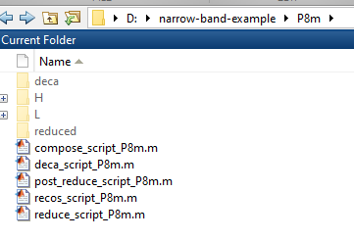  
  In each pulsar folder are present:  
  1. The folder “”H” and “L” in which the analysis results of the single detectors LHO and LLO will be saved.
  2. The folder “deca” in which the joint analysis of the two detectors will be saved
  3. The folder “reduced” in which the selection of local peaks in the narrow-band explored for the joint analysis will be done.
  4. Several scripts that are used to run the analysis and I will explain in the next sections.

**Doppler correction**

The first step of the actual analysis is to produce time-series which are demodulated according to the Doppler effect.

* Go to a pulsar folder and simply run the script “recos_script_pulsar.m”. This script can take several hours and at the end will create two new files in the Pulsar/H/ and Pulsar/L/ directories.  
  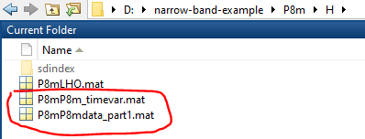
* The file “*_timevar.mat” contains a time vector corresponding to the data samples, which is corrected for the Doppler modulation. The file also contains time vectors that correspond to the corrections done.
* The file “*_data_part1.mat” contains the Doppler corrected time series, which will be needed for the analysis. The array of the data, if you want to check it, is called **g**

**Correction of the spin-down and computation of the analysis**

In this part we are going to create the files containing the final analysis for the single detectors.

* Run the script “reduce_script_pulsars.m”. This script will compute the spin-down correction and the matched filter in the narrow-band analyzed and will save the results in Pulsar/H/sdindex and Pulsar/H/sdindex. The script may need a modification by the user (see picture below).
* **NOTE:** In the new version, science segments path should be already included.  
  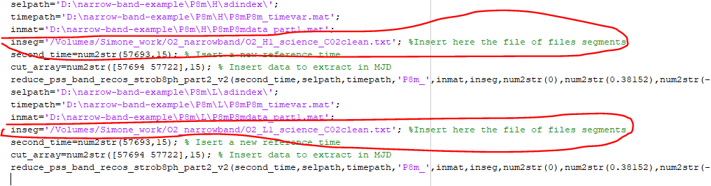

The “inseg” variable is the path of a “txt” file containing the list of science segments for the run. These are usually done in GPS in the format   
  
START_GPS1 END_GPS1  
START_GPS2 END_GPS2

The results are composed by the following files.  
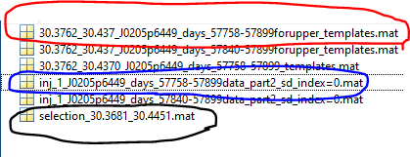  
  
A file containing the 5-vectors used for the analysis (red circle), a file containing the results of the analysis (blue circle), a file containing the time-series filtered by the science segments (black circle). Let us focus on the results file

There is a result file for each spin-down explored. Each of this result files contains the following variables.

1. Sfft: An array containing the values of the detection statistic.
2. Sfftshifted: Array containing the values of the detection statistic interpolated at half bin
3. Count_sd: The distance in spin-down bins from the observed value of this analysis file
4. Gg_sc_clean: a gd object containing the data series correcte for the Doppler and spin-down
5. Hvectors: A structure containing the vectors of the matched filter in the narrow-band analyzed. One for the plus polarization and one for the cross polarization.
6. Info: A structure containing several information, such as the frequency bin, observation time etc.