SIMONE MAGGI  Via Celeste Negarville 26A,Turin, Italy | +393461323382  simone.maggi.work@gmail.com. , | LinkedIn | Portfolio | 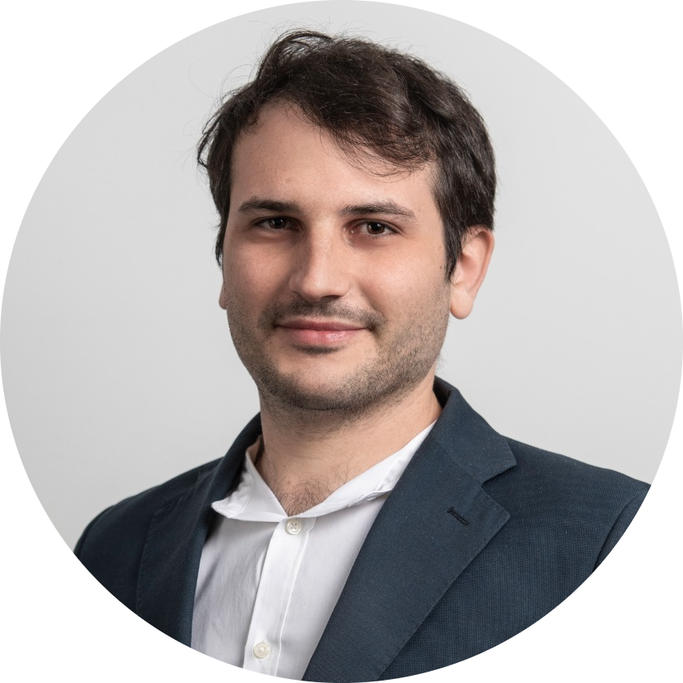

About me
Graduated with excellent mark in an Applied Math Master of Science, with a Bachelor degree in Computer Engineering and a successful working experience in AI for robotics. I am astonished by the rapid evolution of AI and I yearn for being part of this development to deliver its potential to society. Currently, I am eager to tackle new challenges in this field.
Skills
- Programming: Development skills in Python (Pandas, Pytorch for Deep Learning, Scikit-learn) and R. Knowledge of data visualization libraries(Matplotlib, Seaborn). Working experience in designing applications with Object-Oriented architecture using modern C++. Knowledge of WPF UI development using C#. Knowledge of Java and C. Use of GIT.
- Statistical Machine Learning: Rigorous knowledge of Statistics (Frequentist, Bayesian, Hypothesis Testing) to model uncertainty of the data and provide evidences and insights. Knowledge of time series data analisys (ARIMA). Deep understanding of the Supervised/Unsupervised ML models (Statistical Regressions, Decision Trees, SVM, Clustering, PCA). Experience in the implementation of Deep Learning Models with Pytorch and Keras (CNN, Variational Autoencoder, GAN, Adversarial Autoencoder).
- Database Management: Knowledge of SQL, relational algebra and PHP for database interactions.
- System: Good knowledge of Unix kernel-based operative systems.
Experience
Research and Development Specialist Nov 2021 - Present
CPM S.P.A - DURR Turin, Italy
- AI for Robotics: Implemented a new service with big impact on the company, in the field of Artificial Intelligence in Robotics (SLAM LiDAR navigation of Autonomous Guided Vehicle).
- Self-Aware: Drive the project from beginning to end with immediate high responsibility of final decision-making.
- Team Working: Part of a small(<5) and dynamic team where effective communication is the key.
- Communication: Clear and simple presentations to deliver the results to the Stakeholders (Durr, Germany).
Research and Development Intern Jun 2021 – Nov 2021
CPM S.P.A. - DURR Turin, Italy
- AGILE: Master a new subject 'AGV & SLAM Navigation' independently while delivering and testing piece of software(C++, Python, C#).
Machine Learning Intern Mar 2018 - June 2018
SAN s.r.l Turin, Italy
- Supervised Classification of ECG signals:
ETL: Filter, Normalize and Label the biometric signals, and upload the processed data in a DataBase.
ML: Implemented algorithm to extract biometric indicators (Python) from data to feed a Neural Network(TensorFlow) (86% accuracy). Train directly a multilayer 1-D CNN (Keras) on the signal (95% accuracy).

Education
M. Sc. Stochastics and Data Science, University of Turin : 110/110 cum laude Sep 2018 - Apr 2021
Core topics: Statistical Machine Learning, Time Series analisys, Statistical Inference, Bayesian statistics, Probability.
Thesis: Semi-Supervised Irregular heartbeats detection using Deep Generative modelling.
Implemented a novel model derived from an Adversarial AutoEncoder (in Pytorch CUDA), capable of detecting irregularities in ECG signals by modelling its normal behaviour(0.95 ROC-AUC on MIT-BIH data comparable with State-of-Art).

Bachelor in Computer Engineering, Politecnico of Turin: 104/110 Sep 2015 - Oct 2018
Language
English – Proficient User Italian – Native User French – Beginner

