Maps with ggplot2’s extension ggmap

Simone Santoni

2024-12-02

Synopsis

This notebook shows how to create maps with ggmap

# Notebook setup

## Load libraries

We import tidyverse’s tibble and ggmap to create the maps. The former is a data manipulation library, while the latter is an extension of ggplot2 that allows us to create maps.

library(tibble)   
library(ggmap)

## Toy dataset

The data consists of a single point, namely, the location of New York Univerty. The dataset is a tibble with three columns, a label for NYU, see name, and lon and lat pair. As we know, tibble allows to initialize a dataset ‘visually’ by means of the tribble function.

unis = tribble(  
 ~name, ~lon, ~lat,  
 "New York University", -73.9965, 40.7295  
)

# Create a geo-spatial chart

## Fetching a map

The geospatial chart creating process is straightforward. We use [ggmap](https://cran.r-project.org/web/packages/ggmap/readme/README.html)’s get_map function to download the map of the area we are interested in. In this case, we are interested in the map of New York City. The function requires the following arguments:

* center: the coordinates of the area we are interested in *OR* the name of an entity, e.g., “New York”
* zoom: the zoom level
* size: the size of the map
* maptype: the type of map we want to download

It is worh noticinging that ggmap can retrieve maps from Google Maps or Stadia. In both cases, you have to register your application to get an API key.[1] The below code snippet uses Google Maps. In this case, the center of the can be a precise pair of coordinates or the name of the area we are interested in. The map type is set to hybrid, which is a mix of satellite and road maps.

ny_map <- get_googlemap(  
 #center = c(lon = -74.0060, lat = 40.7128),  
 center = "New York",  
 zoom = 11,  
 size = c(1200, 1200),  
 maptype = "hybrid",  
 source = "google"  
)  
ny_map

## Plot some geo-located entities

It is possible to map the data using a typical ‘pipeline’ approach a’ la tidyverse.

get_googlemap(  
 center = c(lon = -74.0060, lat = 40.7128),  
 markers = unis[, c("lon", "lat")],  
 zoom = 11,  
 size = c(1200, 1200),  
 maptype = "hybrid",  
) |> ggmap()

|  |
| --- |
| Figure 1: Map of New York City with a marker for NYU |

Alternatively, we can use the geom_point function to plot the data.

ggmap(ny_map) +  
 geom_label(data = unis, color = "purple", label = unis$name, size = 5) +  
 theme_nothing()

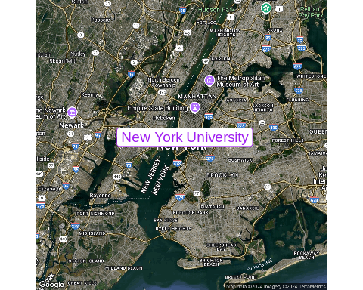

Map of New York City with a label for NYU

1. Having loaded ggmap, one can register an API key on a temporary basis with register_google(key = "[your key]") or permanently using register_google(key = "[your key]", write = TRUE).