Hypothesis
- There is a lag between when we invest in certain marketing activities (excluding Pay Per Click Brand) and when we observe an effect on the number of customers acquired and consequently on the Customer Acquisition Cost;
- The distance between cause and effect depends on both the channels (push vs pull) and, of course, seasonality.
Questions
- How would you proceed to address the hypothesis?
- What types of analysis would you conduct?
- Which methodologies would you use?
- What relevant information do you think is missing?

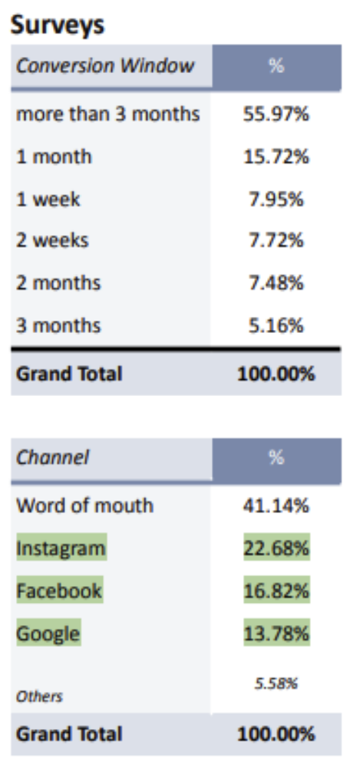

COSA HO FATTO
- Corretto formula in Excel, Sheet2, Colonna C, che aveva un errore
- Analizzato il foglio “Weekly Overview” per capirne la struttura e i dati in esso contenuti
- Analizzato il foglio “Sheet 2” per capirne la struttura e i dati in esso contenuti
- Scartato foglio “Sheet 2” in quanto mi sembra perfettamente ricordante con un subset di Weekly Overview
- Creato repo con gitignore, requirements e virtual environment
- Cominciato analisi… [NO DATA CLEANING TIPO MISSING DATA, ETC… PERCHE’ DATASET SEMBRA GIA’ ABBASTANZA PRIVO DI ERRORI]

STRUTTURA REPORT (CON EVENTUALE STREAMLIT ALLA FINE PER MOSTRARE FINDINGS, ETC…)
1️⃣ Executive Summary (1 pagina massimo)

Questa è la parte che conta davvero.

Struttura:

🎯 Objective

Validate whether marketing investments (excluding PPC Brand) generate a delayed effect on new customer acquisition and CAC, and estimate the lag by channel.

🔎 Key Findings (bullet secchi)

Esempio (fittizio):

A measurable lag effect exists for upper-funnel channels.

Facebook and Instagram show peak impact between week 2–4.

Retargeting channels show near-immediate response.

Evaluating CAC on a weekly basis underestimates performance of push channels by ~18%.

💡 Business Implication

Weekly CAC reporting is biased against long-lag channels.

Budget decisions based on short-term efficiency may distort allocation.

A lag-adjusted evaluation window is recommended.

Se scrivi questo bene, hai già fatto metà lavoro.

2️⃣ Data & Methodology

Qui devi essere chiaro ma non verboso.

Dataset

Weekly granularity

Marketing spend by channel

1st Time Buyers

Sessions

Promotional periods included

Data Preparation

CAC computed weekly

Lag variables created (1–12 weeks)

Promo dummies included

Seasonality controlled (week-of-year)

Methods Used

Correlation with lag structure

Distributed lag regression

Significance testing of coefficients

Sensitivity analysis

Non serve 3 pagine di formula.

Serve far capire che sai cosa stai facendo.

3️⃣ Exploratory Analysis

Qui metti grafici:

Spend vs 1st Time Buyer

CAC over time

Promo periods evidenziati

Correlation heatmap lag

E scrivi solo insight, non descrizione grafico.

NON:
“The graph shows…”

MA:
“Customer acquisition spikes during BFCM independent of spend, indicating promotional distortion.”

Questo cambia tutto.

4️⃣ Lag Analysis Results (core del blocco)

Per ogni canale:

Coefficienti lag

Effetto cumulato

Peak response week

Esempio di scrittura potente:

Facebook impact builds gradually, with 65% of total effect materializing between week 2 and week 4.
This confirms push-driven delayed conversion behavior.

Qui devi sembrare sicuro e sintetico.

5️⃣ Impact on CAC Evaluation

Qui arriva il colpo da senior.

Confronti:

CAC weekly

CAC lag-adjusted (cumulato)

E scrivi:

Short-term CAC evaluation penalizes upper-funnel channels and over-rewards bottom-funnel channels.

Boom.

Questo è decisionale.

6️⃣ Limitations

Importantissimo.

No user-level data

Attribution model unknown

No LTV

No cross-channel interaction modeling

Potential multicollinearity

Questo ti protegge e ti alza di livello.

7️⃣ Recommendations & Next Steps

Qui devi dimostrare visione.

Esempio:

Implement Marketing Mix Model with adstock transformation

Shift from weekly to rolling 4-week CAC

Test incrementality for push channels

Introduce marginal CAC framework

Chiudi con una frase forte tipo:

Marketing performance evaluation should align with channel response dynamics rather than calendar-based reporting windows.

Pulito. Strategico. Senior.

