Plot Deconstruction

2024-05-15

#Import Dataset and load packages   
  
chl_data<- read.csv("data/Chlorophyll_data.csv")  
library(ggplot2)

# Creating New Plot after deconstruction  
# We added the geom_smooth() function and altered the x and y axis scales   
# We altered the colors to optimize visualization  
ggplot(data = chl_data) +   
 geom_point(mapping = aes(x = Year, y = chl.a, color=Area)) +  
 geom_smooth(mapping = aes(x = Year, y = chl.a, color=Area)) +  
 labs(x= "Year", y=bquote(Chlorophyll ~ Concentration~(mgm^{-3}))) +  
 scale_y_continuous(limits = c(0,1.5))

## `geom_smooth()` using method = 'loess' and formula = 'y ~ x'

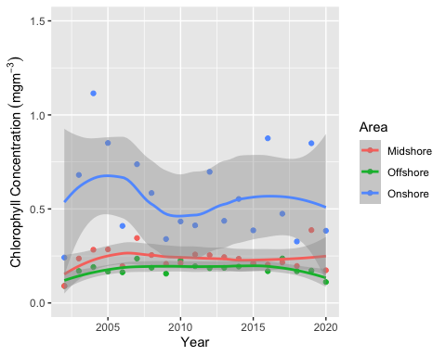

ggsave("my_plot.pdf")

## Saving 5 x 4 in image  
## `geom_smooth()` using method = 'loess' and formula = 'y ~ x'